Supplementary Information

Field-free orbital torque switching enabled by built-in magnetic asymmetry

Qu Yang¹, Shu Hui Lee¹, Shilei Ding¹, Shan Shyan Kuan¹, Wen Siang Lew^{1*}

¹ School of Physical and Mathematical Sciences, Nanyang Technological University, 21 Nanyang Link, Singapore 637371, Singapore

Supplementary Note 1: Vibrating Sample Magnetometry (VSM) characterization of Ti/TiO_{x}-capped Co/Pt heterostructures
Figure S1 shows representative in-plane and out-of-plane VSM hysteresis loops of Co/Pt multilayers capped with Ti or TiO_{x} layer. All samples exhibit clear perpendicular magnetic anisotropy (PMA). From the out-of-plane loops, the anisotropy field H_{k} is found to vary between approximately 4,000 and 8,000 Oe, while the coercive field H_{c} lies in the range of 190-300 Oe. The saturation magnetization M_{s} is estimated to be 180-260 emu cm⁻³, consistent with reported values for ultrathin Co/Pt multilayers¹. The appearance of a double hysteresis loop in the VSM of the [Pt/Co]₆ stack indicates the presence of magnetically inequivalent Co layers that reverse at distinct fields. This behavior is most likely associated with variations in interfacial anisotropy and exchange coupling across the multilayer, potentially enhanced by interfacial oxidation or CoO formation. Such magnetic subdivision is commonly observed in Pt/Co multilayers and reflects interface‑dominated magnetic behavior²⁻⁴. The evolution of these features with Ti and TiO_{x} capping thickness suggests that partial oxidation and oxygen redistribution near the top interface can modify the interfacial magnetic properties.
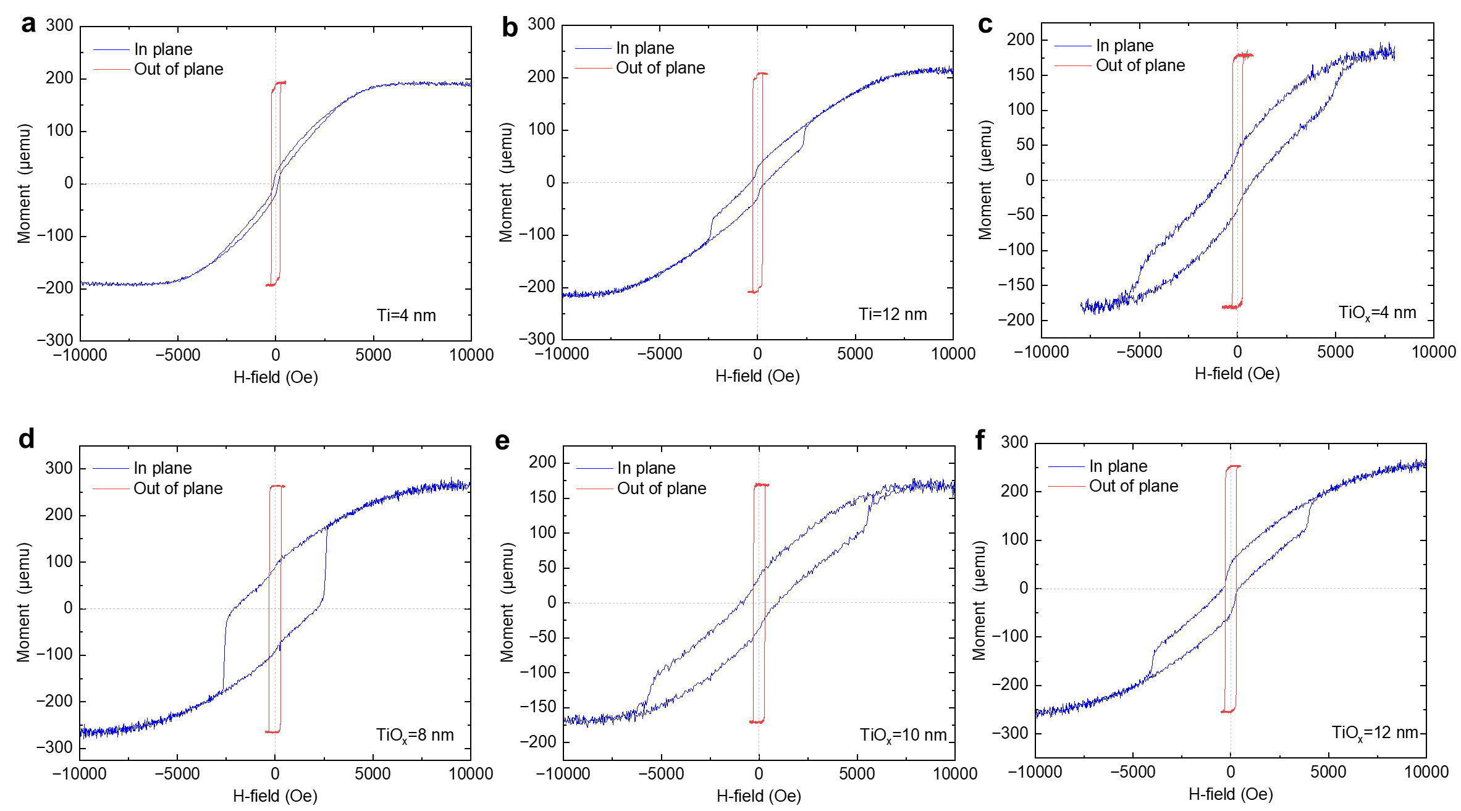
Figure S1. Representative in-plane and out-of-plane VSM hysteresis loops of Ti- and TiO_{x}-capped Co/Pt heterostructures with different capping-layer thicknesses.

Supplementary Note 2: Electric field measurement
To evaluate the damping-like and field-like torque efficiencies, $ξ_{DL(FL)}^{E}$, the longitudinal voltage V_{xx} was measured directly using a Keithley 2400 source meter in two-wire sensing mode, as schematically illustrated in Fig. S2a. The electric field was calculated as E_{xx} = V_{xx}/L, where L = 60 μm is the channel length of the Hall bar devices. The extracted effective fields were then plotted as a function of the applied current density J_{c}, as shown in Fig. S2b.
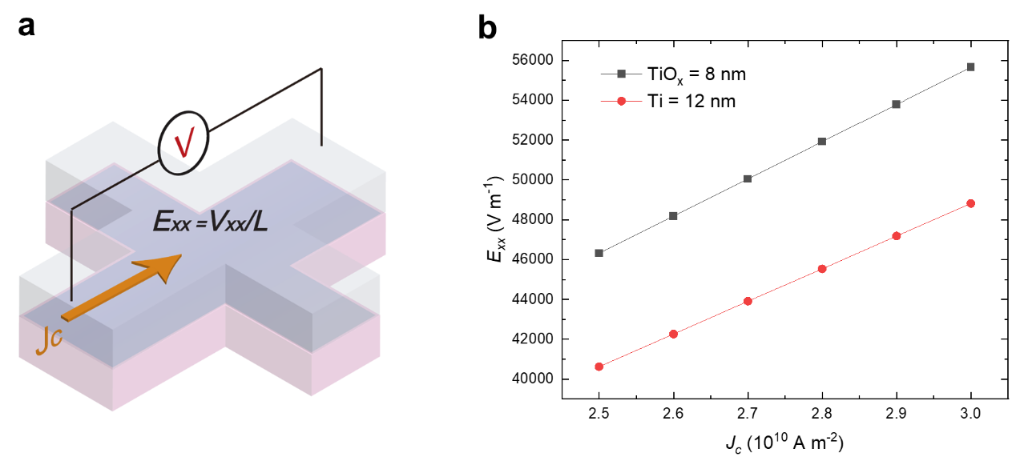
Figure S2| Electric-field calibration for torque efficiency extraction. a, Schematic of the longitudinal voltage (V_{xx}) measurement configuration used to determine the electric field. b, Electric field (E_{xx}) as a function of current density J_{c}.

Supplementary Note 3: Harmonic Hall voltage measurements
Harmonic Hall voltage measurements were employed to quantitatively characterize the effective magnetic fields arising from OHE/SHE induced torques under an a.c. current excitation⁵⁻⁷. From the angular dependence of the second-harmonic Hall response, the longitudinal damping-like effective field ($H_{L}$) and the transverse field-like effective field ($H_{T}$) were extracted following standard harmonic Hall analysis procedures^{5,6}. As illustrated in Figure S3a, low-frequency (307.1 Hz) a.c. currents with amplitudes of 10.3-12.36 mA were applied to patterned Hall bars, corresponding to current densities of (6.29-7.54) × 10¹⁰ A m⁻² for TiO_{x}-capped devices and (2.5-3.0) × 10¹⁰A m⁻² for Ti-capped devices. The first-harmonic (V_{ω}) and second-harmonic (V_{2ω}) Hall voltages were measured simultaneously using a lock-in amplifier. To fully resolve the torque components, four sets of second-harmonic measurements were carried out by sweeping a small in-plane magnetic field along the longitudinal (∥), transverse (⊥), 45°, and 135° directions relative to the current flow. The damping-like and field-like torque efficiencies are defined as$ξ_{DL(FL)}^{E}=\frac{2e}{ћ}t_{FM}M_{s}\frac{H_{DL(FL)}}{E}$ ^{5,8-10}, where t_{FM} and M_{s} refer to the ferromagnetic layer thickness and saturation magnetization, and the E-field measurement is explained in Supplementary Note 2. The effective orbital Hall angle is given by $ϴ_{OH}^{eff}{=ρ ξ_{DL}^{E}=ξ}_{DL}^{j}=\frac{2e}{ћ}t_{FM}M_{s}\frac{H_{DL}}{J_{c}}$ ^{7,8,11-13}, where J_{c} is the applied charge density. The field-like torque efficiency $ξ_{FL}^{E}$ of the present heterostructures lies in the range of (0.046 ± 0.009)~(0.70 ± 0.04) × 10⁵ Ω⁻¹ m⁻¹, as summarized in Fig. S3b.
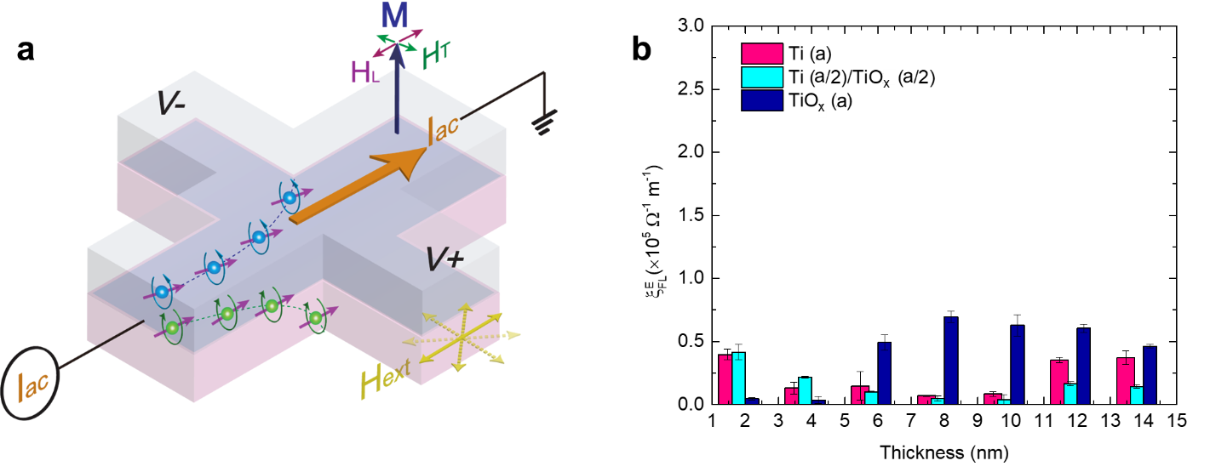
Figure S3 | Harmonic Hall measurement configuration and Field-like torque efficiencies.
a, Schematic illustration of the harmonic Hall measurement geometry used to extract current-induced orbital torques, showing the applied a.c. current $I_{ac}$, magnetization $M$, and the longitudinal ($H_{L}$) and transverse ($H_{T}$) in-plane magnetic fields. b, Thickness dependence of the field-like torque efficiency $ξ_{FL}^{E}$for Ti, Ti (a/2)/TiO_{x} (a/2), and TiO_{x} capping layers. Error bars represent standard deviations obtained from multiple measurements.

Supplementary Note 4: Harmonic Hall quantification of damping-like torque efficiency in (Co/Pt)₆ multilayers with Ti/TiO_{x} bilayer capping layers.
To clarify the role of internal interfaces in orbital torque generation, harmonic Hall measurements were performed on (Co/Pt)₆ multilayers capped with Ti/TiO_{x} bilayers while varying the Ti and TiO_{x} thickness ratios at fixed total capping thicknesses of 8 nm and 12 nm (Fig. S4a, b). For both thicknesses, the extracted damping-like torque efficiency, $ξ_{DL}^{E}$, remains comparatively small across all Ti/TiO_{x} thickness combinations than that observed in single-layer Ti or TiO_{x} capping structures.
This suppression can be understood in terms of orbital transport. In single-layer systems, the generated orbital current propagates toward the ferromagnet over an orbital diffusion length $λ_{L}$ and is converted into spin current at the interface with an orbital transparency $T_{L}$⁹. In the bilayer configuration, the internal Ti/TiO_{x} interface introduces additional orbital scattering and partial reflection, effectively reducing both the effective diffusion length and the transmitted orbital current reaching the Co/Pt interface. The resulting decrease in effective orbital transparency $T_{L}^{eff}$limits orbital-to-spin conversion, leading to reduced $ξ_{DL}^{E}$. These results indicate that the internal Ti/TiO_{x} interface acts as a dissipative boundary for orbital angular momentum transport, preventing constructive enhancement of charge–orbital–spin conversion in the bilayer structures.

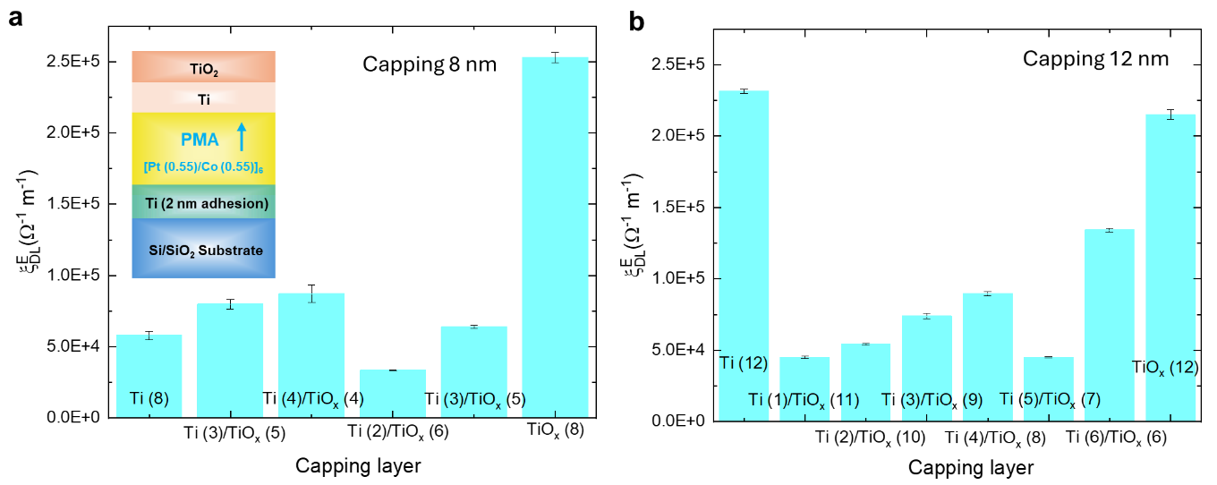
Figure S4 | Harmonic Hall quantification of the effective damping-like torque efficiency $ξ_{DL}^{E}$ in (Co/Pt)₆ multilayers with Ti/TiO_{x} bilayer capping layers at total thicknesses of 8 nm and 12 nm.

Supplementary Note 5: Verification of out-of-plane effective component via current-induced anomalous Hall effect (AHE) loop shifts
Following established approaches for identifying out-of-plane effective component in conventional spin–orbit torque (SOT) systems^{14,15}, the current-induced shift of the AHE hysteresis loop, ΔH_{shift} , is employed to quantify the effective field associated with the out-of-plane effective component. Upon increasing the applied current density J_{c}, ΔH_{shift} also increases, as shown in Fig. 3a~c for the TiO_{x} (8 nm) and in Fig. S5 for the Ti (12 nm) capped device. The loop shift is defined as ΔH_{shift} $={(H}_{+}+H_{-})/2$, where $H_{+}$ and $H_{-}$ are the positive and negative magnetization reversal fields, respectively. Analogous to the extraction of the damping-like and field-like torque efficiencies^{5,8-10}, the effective out-of-plane componet efficiency can be estimated as $ξ_{Z}^{E}= \frac{2e}{ћ}t_{FM}M_{s}\frac{{ΔH}_{shift}}{ΔE}$ An out-of-plane effective tilt angle is then defined as η = arctan ($ξ_{Z}^{E}/ξ_{DL}^{E}(y)$), where $ξ_{DL}^{E}(y)$ is the damping-like torque efficiency as discussed in Fig.2c. For both TiO_{x} (8 nm) and Ti (12 nm) capped samples, η reaches approximately 13°, as described in the main text. The results indicate that although the in-plane (y-polarized) component remains dominant, a sizable out-of-plane effective component contribution, (accounting for ~20% of the total damping-like torque efficiency) is present, enabling deterministic field-free switching.

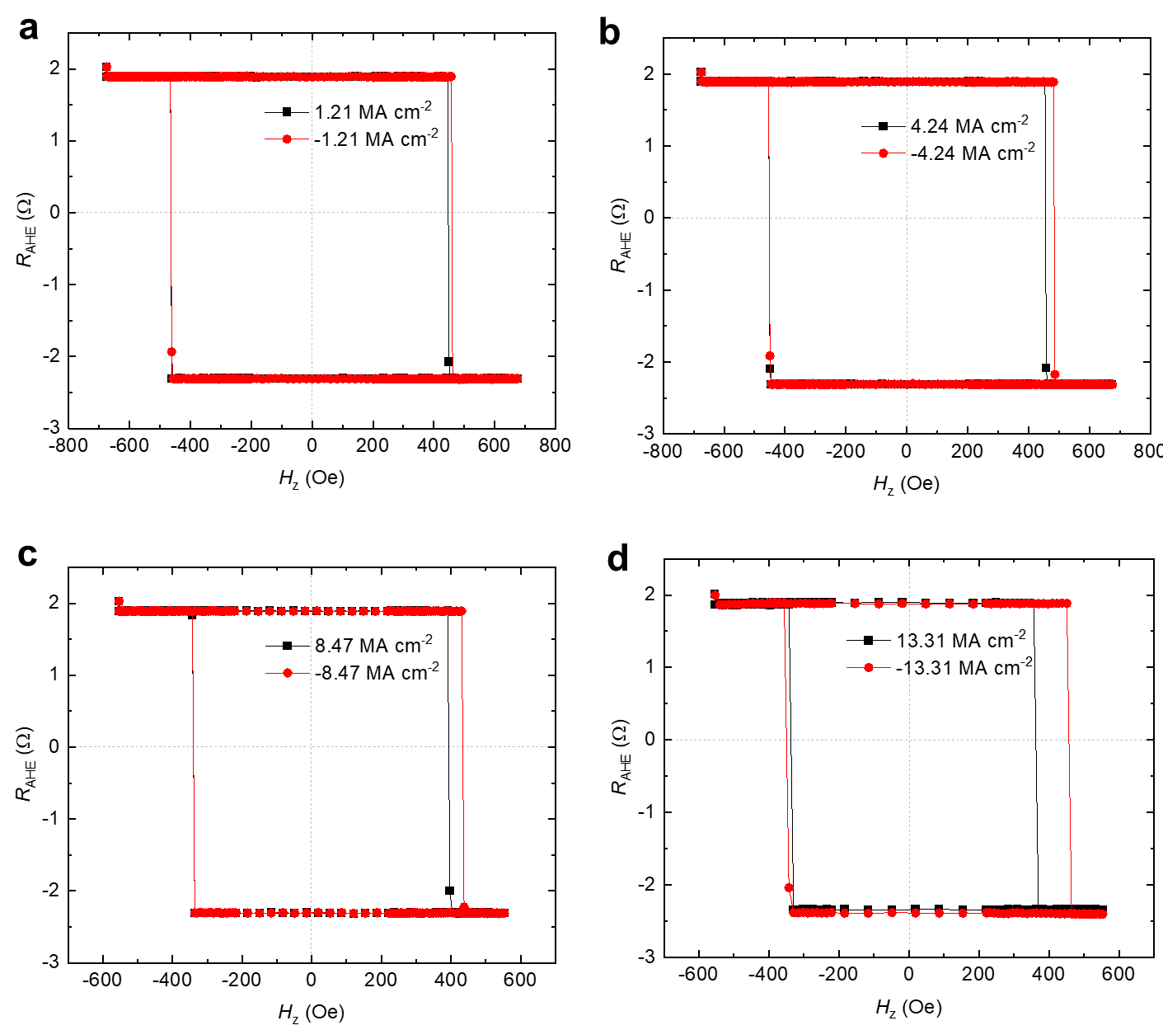
Figure S5 | Current-induced AHE loop shifts in a Ti (12 nm) capped device. a, AHE loops measured at J_{c} = ±1.21 MA cm⁻², b, J_{c}= ±4.24 MA cm⁻², c, J_{c}= ±8.47 MA cm⁻² and d, J_{c}= ±13.31 MA cm⁻².

Supplementary Note 6: Field-free orbital-torque switching loops for TiO_{x}-capped and Ti (12 nm)-capped samples
Figure S6 summarizes the current-induced magnetization switching loops measured for TiO_{x}-capped and Ti (12 nm)-capped (Co/Pt)₆ multilayers. Deterministic field-free switching of perpendicular magnetization is clearly observed. The switching polarity reverses with the direction of the prior field-assisted initialization and the behavior remains reproducible in the absence of any external magnetic field. This confirms the presence of an intrinsic symmetry-breaking mechanism within the heterostructure. As discussed in Fig.3f, the switching efficiency of the TiO_{x}-capped and Ti (12 nm)-capped samples follows the magnitude of the damping-like torque efficiency $ξ_{DL}^{E}$. In contrast, the 6 nm Pt-capped control sample does not exhibit field-free switching under identical measurement conditions.
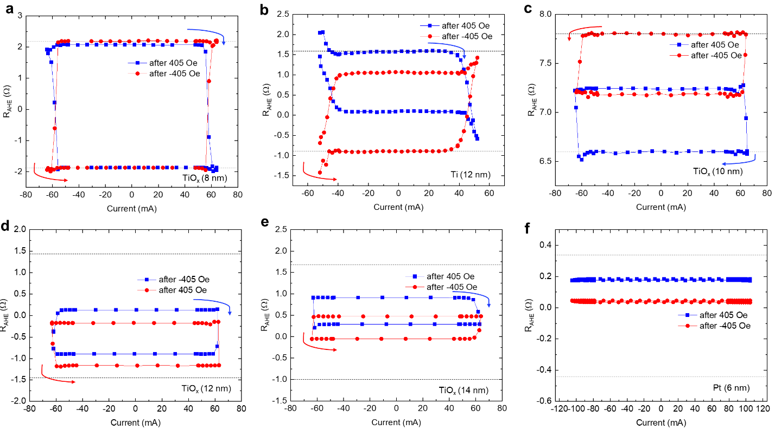
Figure S6 | Deterministic field-free switching of perpendicular magnetization driven by orbital torque. Representative switching loops for the TiO_{x} (8~14 nm, a, c, d, e) samples, Ti (12 nm, b) sample and Pt (6 nm, f) sample under zero external magnetic field. The dash lines represent the max Hall resistance values in the field-assisted (±405 Oe) switching.

Supplementary Note 7: XPS Analysis of TiO_{x} Capping Layers with 4 nm and 8 nm Thickness
As mentioned in the main text, to elucidate the chemical evolution induced by TiO_{x} capping, X-ray photoelectron spectroscopy (XPS) measurements were performed on samples with TiO_{x} thicknesses of 4 nm and 8 nm. The Ti 2p spectra shown in Fig. S7a for both thicknesses exhibit characteristic Ti⁴⁺ and Ti²⁺ components, indicating partially oxidized Ti states. No substantial change in the Ti valence composition is observed between 4 nm and 8 nm, suggesting similar oxidation states within the TiO_{x} layers. In contrast, the Co 2p spectra reveal pronounced interfacial chemical modification. For TiO_{x} = 4 nm (Fig. 4c), clear satellite features and peak positions corresponding to CoO and Co₃O₄ are observed, providing direct evidence of oxygen diffusion from TiO_{x} capping layer toward the Co interface and partial oxidation of Co. For TiO_{x} = 8 nm (Fig. S7b), the overall Co signal intensity decreases due to the limited probing depth of XPS; however, the spectral features remain consistent with interfacial Co oxidation, indicating that the oxidation trend persists with increasing TiO_{x} thickness. These results demonstrate that TiO_{x} capping promotes oxygen redistribution toward the Co interface, leading to the formation of cobalt oxide phases and establishing a pronounced vertical chemical asymmetry across the heterostructure. This modification in the Co/TiO_{x} interfacial chemistry¹⁶, such as oxygen exchange or interfacial electronic structure effects, can further lead to the enhancement of the orbital current generation and orbital transfer^{17,18}.

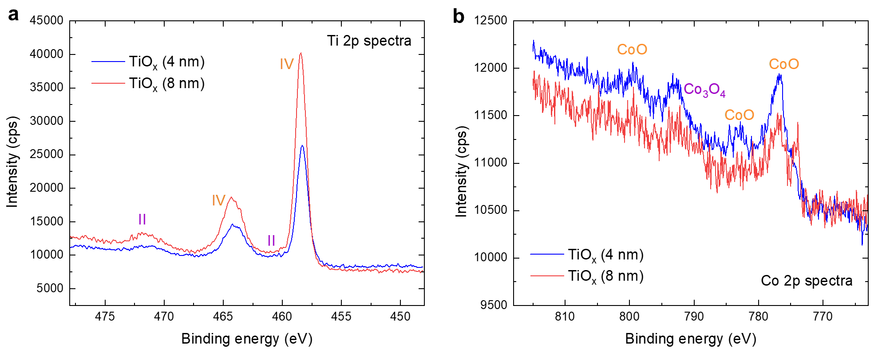
Figure S7 | Ti 2p and Co 2p XPS spectra of samples with TiO_{x} capping layers of 4 nm and 8 nm thickness, showing Ti²⁺/Ti⁴⁺ components and interfacial Co oxidation signatures.

References
1 Charilaou, M. et al. Magnetic properties of ultrathin discontinuous Co/Pt multilayers: comparison with short-range ordered and isotropic CoPt 3 films. Phys. Rev. B 93, 224408 (2016).
2 Anyfantis, D. I. et al. Magnetic anisotropies and exchange bias of Co/CoO multilayers with intermediate ultrathin Pt layers. Mater. 16, 1378 (2023).
3 Das, T. et al. Anomalous enhancement in interfacial perpendicular magnetic anisotropy through uphill diffusion. Sci. Rep.4, 5328 (2014).
4 Ehrler, R. et al. Manifold role of a Ta adhesion layer in pressure-tuned Co/Pt multilayers. Phys. Rev. B 112, 094452 (2025).
5 Hayashi, M., Kim, J., Yamanouchi, M. & Ohno, H. Quantitative characterization of the spin-orbit torque using harmonic Hall voltage measurements. Phys. Rev. B 89, 144425 (2014).
6 Kim, J. et al. Layer thickness dependence of the current-induced effective field vector in Ta| CoFeB| MgO. Nat. Mater. 12, 240-245 (2013).
7 Yang, Y. et al. Orbital torque switching in perpendicularly magnetized materials. Nat. Commun. 15, 8645 (2024).
8 Hayashi, H. et al. Observation of long-range orbital transport and giant orbital torque. Commun. Phys. 6, 32 (2023).
9 Lyalin, I. & Kawakami, R. K. Interface transparency to orbital current. Phys. Rev. B 110, 104418 (2024).
10 Nguyen, M.-H., Ralph, D. & Buhrman, R. Spin torque study of the spin Hall conductivity and spin diffusion length in platinum thin films with varying resistivity. Phys. Rev. Lett. 116, 126601 (2016).
11 Skowroński, W. et al. Determination of spin Hall angle in heavy-metal/Co-Fe-B-based heterostructures with interfacial spin-orbit fields. Phys. Rev. Appl. 11, 024039 (2019).
12 Lee, S. H. et al. Complementary interactions of orbital momentum and topological spin states in ferromagnet/Cu/Bi 0.85 Sb 0.15 structures. Phys. Rev. Appl. 23, 054003 (2025).
13 Zhu, L., Ralph, D. C. & Buhrman, R. A. Maximizing spin-orbit torque generated by the spin Hall effect of Pt. Appl. Phys. Rev. 8 (2021).
14 Yu, G. et al. Switching of perpendicular magnetization by spin–orbit torques in the absence of external magnetic fields. Nat. Nanotechnol. 9, 548-554 (2014).
15 Pai, C.-F., Mann, M., Tan, A. J. & Beach, G. S. Determination of spin torque efficiencies in heterostructures with perpendicular magnetic anisotropy. Phys. Rev. B 93, 144409 (2016).
16 Krishnia, S. et al. Interfacial spin-orbitronic effects controlled by different oxidation levels at the Co/Al interface. Phys. Rev. Appl. 24, 024055 (2025).
17 Huang, Q. et al. Current-induced magnetization switching in light-metal-oxide/ferromagnetic-metal bilayers via orbital Rashba effect. Nano Lett. 23, 11323-11329 (2023).
18 Ding, S. et al. Harnessing orbital-to-spin conversion of interfacial orbital currents for efficient spin-orbit torques. Phys. Rev. Lett. 125, 177201 (2020).

