Supplementary Information for: Bird Returns on Public Investment in the Conservation Reserve Program

List of Grassland Bird Species
Table A1 lists the grassland bird species included in our analysis. The first column reports the grassland bird species identified from the eBird raw checklist data and used in the regression analysis of grassland bird responses to CRP. The second column indicates whether each species is available in the Partners in Flight (2024) database. The species with available Partners in Flight population estimates were used in the counterfactual analysis, where we combined the eBird Status product with species-level population estimates from Partners in Flight (2024). Of the 40 grassland bird species included in the regression analysis, 33 were available in Partners in Flight (2024) and therefore included in the counterfactual analysis.

Shift-Share IV Estimation Results
Tables A2 through A4 presents the shift-share IV regression results for the three species groups in different seasons throughout a year. Columns (1), (3), (5), and (7) in Table A2, A3, A4 correspond to the results presented in Figure 2, 3, and 4, respectively.
Columns (2), (4), (6), and (8) estimate a regression model similar to Equation (3) and (4), except that we replace year fixed effects with state-by-year fixed effects to account for time-varying unobserved confounders at the state-level. Our results for grassland birds are highly robust to the addition of state-by-year fixed effects, and to a lesser extent for wetland and game birds, although most of the inconsistent estimates lack statistical power in either specification.

Robustness Check: First Stage Estimation of Bird Outcomes
Our primary estimates of relative bird abundance and richness conditional on effort variables were based on a log-linear Poisson regression framework adapted from Liang et al. (2020). To assess the robustness of this modelling approach, we compared it with an alternative specification using an untransformed Poisson model that retains zero-count observations. Table A5 presents the IV estimates of CRP effects on grassland, wetland, and game bird abundance using both methods. Columns (1), (3), (5) report the estimates based on the log-linear Poisson model, while columns (2), (4), (6) show results from the raw Poisson specification.
The estimated CRP effects were consistent across both models. A 1 SD increase in CRP share led to a 0.482 SD increase in grassland bird abundance estimated using the log-linear model, and a 0.51 unit increase under the raw Poisson specification for grassland abundance estimation, both statistically significant. These results confirmed that excluding zero-count checklists in the log-linear model does not bias our results, and the primary findings were robust to alternative model specifications for estimating the relative bird abundance and richness.

Robustness Check: Pre-Trend for Bird Outcomes
Figure A2 presents the pre-trend test results, where we estimated the following regression model:
$std\left({\hat{Γ}}_{cy}\right)=β_{0}std\left({\hat{CRP Share}}_{c,y-10}\right)+\sum_{τ=2003}^{2007}{β_{tau}\left[std\left({\hat{CRP Share}}_{c,y-10}\right)⋅1\{y=τ\}\right]}+β_{2}std\left(controls_{cy}\right)+γ_{c}+λ_{y}+ϵ_{cy}$, (A1)
where the left-hand-side variable $std\left({\hat{Γ}}_{cy}\right)$ was the estimated breeding season bird abundance at the county-year level, standardized to mean 0 and SD 1. $std\left({\hat{CRP Share}}_{c,y-10}\right)$ was the share of a county area enrolled in CRP 10 years prior to year $y$ (i.e., the share component in our shift-share instrument), similarly standardized to mean 0 and SD 1. The controls variables and fixed effects were identical to those in Equation (4). Standard errors $ϵ_{cy}$ were clustered at the county-level. The sample period for this pre-trend test spanned from 2002 to 2007, prior to the first significant change in the national enrollment cap set by the 2008 Farm Bill. The coefficients of interest are $β_{2003}$, $β_{2004}$, …, and $β_{2007}$, which capture the year-by-year differences in bird abundance between high versus low CRP enrollment counties in the past, relative to 2002, the base year. Statistically significant coefficient estimates would suggest the presence of pre-trends, thereby violating our shift-share IV assumption.
Figure A2 shows that none of the year-by-year coefficients were statistically different from zero, failing to provide evidence of pre-trends in bird outcomes across counties with different levels of past CRP enrollment levels. These results lend support to the identification strategy from our shift-share instrument.

Robustness Check: Spatial Displacement
Our shift-share IV used the product of the historical own-county exposure share and national enrollment cap changes to instrument for the concurrent endogenous own-county enrollment share. One threat to our identification was the spatial spillover effect. If bird activities in a county were affected by the CRP practices in neighboring counties, we would have violated the Stable Unit Treatment Value Assumption (SUTVA) and our estimates would be biased. We tested for SUTVA violation in Table A6. We averaged CRP enrollment share across a county and its bordering counties. This approach allowed the past CRP exposure to affect not only enrollment in the own county, but also its neighboring counties, which in turns allowed own county bird activities to be impacted by CRP practices at a broader geographic unit. Table A6 shows that the results from this alternative approach were quantitatively similar to our preferred estimates, suggesting that our findings were not likely to be confounded by spatial displacement.

Counterfactual Analysis under State-Level Constraints
Figure A1 presents the same set of counterfactual scenarios shown in Figure 5 but imposed the state-level constraints on CRP acreage or budget rather than the region-wide constraints. Under these scenarios, additional CRP enrollment was allocated within each state by prioritizing counties with the lowest rental rates or counties with the highest birds-per-dollar spent, and enrollment continues until the state-specific acreage or budget cap was reached. Panels (a) through (d) of Figure A1 corresponded to the summary statistics reported in Table 1 under the state-level constraint scenarios.

Counterfactual Analysis for Bobolink Populations
To complement the species-group counterfactual presented in the main text, we also estimated the Bobolink population that could have been conserved in 2024 if CRP acreage had not declined relative to its 2007 level. This species-specific exercise follows the same logic as the main text grassland bird counterfactual but focuses on Bobolink alone.
We began by computing the current (2024) county-level Bobolink population by integrating the eBird Status data (Fink et al. 2023) with the national Bobolink population estimates from Partners in Flight (2024). The procedure is described by:
$$Population_{i,c}=rel. abundance share_{i,c}×Population_{i} (A2)$$
where $Population_{i,c}$ was the total population for species $i$ (Bobolink in this example) in county $c$, $rel. abundance share_{i,c}$ was the relative abundance share for species $i$ in county $c$, and $Population_{i}$ was the national population estimate for species $i$.
Next, we calculated the percentage difference in Bobolink population for a county c given the counterfactual allocation of CRP land as
$Δ\%\left({Population}_{c}\right)= β_{CRP}^{IV\left(\%\right)}×\left(CRP Share_{c}^{counterfactual}-CRP Share_{c}\right) (A3)$
where $β_{CRP}^{IV\left(\%\right)}$ was the percentage change in grassland bird abundance per 1 percentage point change in share of land area enrolled in CRP, an elasticity version of the original $β_{CRP}^{IV}$ estimate on an SD bird – SD CRP scale that we estimated in Equation (4). $(CRP Share_{c}^{counterfactual}-CRP Share_{c})$ was the percentage point difference between current CRP share in county $c$ and that under the counterfactual CRP enrollment level. Combined with the county-level population estimates, we then converted the percentage population difference to the population gain in each county under the counterfactual CRP enrollment level, given by
$Population conserved from CRP_{i,c}^{counterfactual}= Population_{i, c}×Δ\%\left({Population}_{c}\right) (A4)$
Our counterfactual suggests that 1.7 million Bobolinks could have been conserved in 2024 if CRP acreage had not declined relative to 2007. This species-specific estimate is directly comparable to the counterfactual exercise for the broader grassland bird group in the main text.

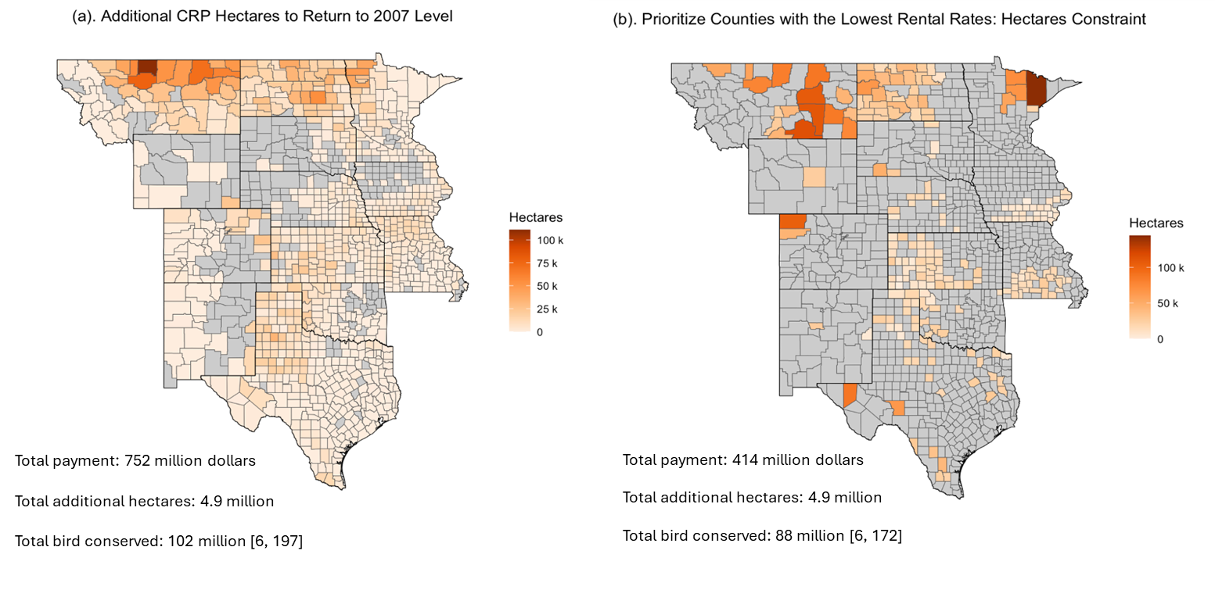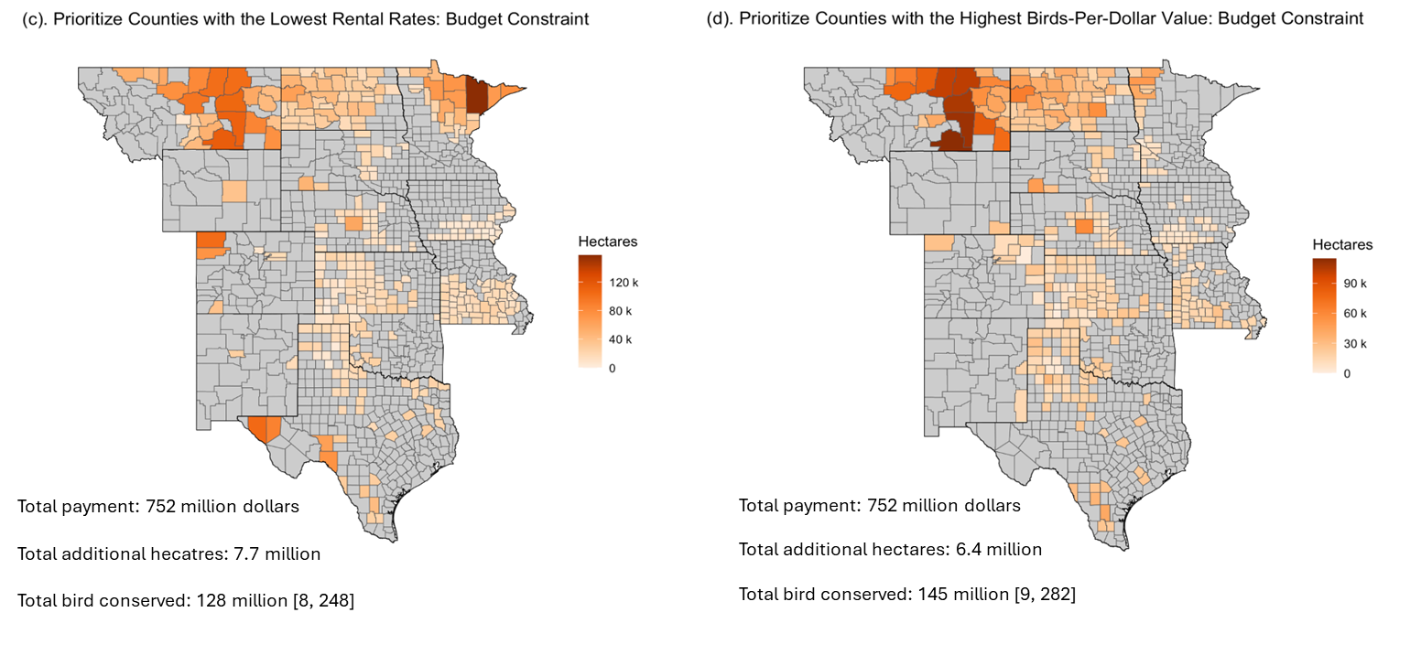Figure A1 (a). Allocation of hectares needed for counties to return to their 2007 enrollment levels. (b). Hectares needed from counties with the lowest rental rates to recover the same amount of CRP acreage in each state as in (a). (c). Hectares needed from counties with the lowest rental rates to match the same amount of additional CRP expenditure in each state as in (a). (d). Hectares needed from counties with the highest birds-per-dollar value to match the same amount of additional CRP expenditure in each state as in (a). Numbers in the brackets denote 95% confidence intervals for the estimated number of birds conserved. Note that the sample only includes counties where the current enrollment levels are below their respective 2007 levels.

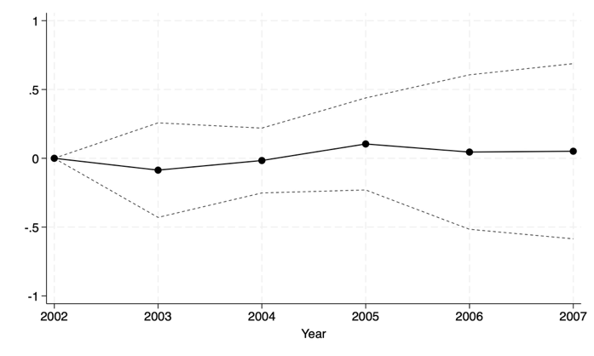
- Grassland Bird
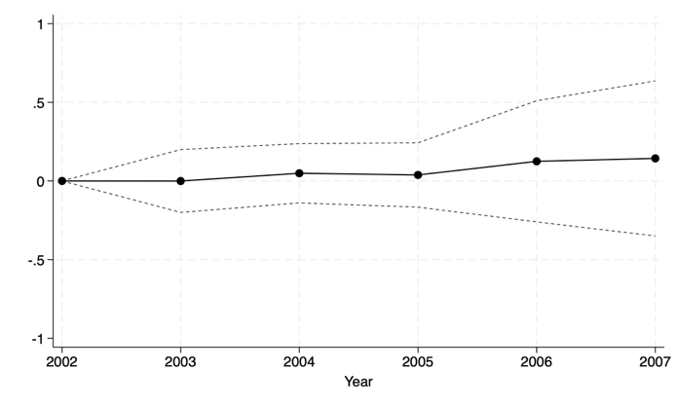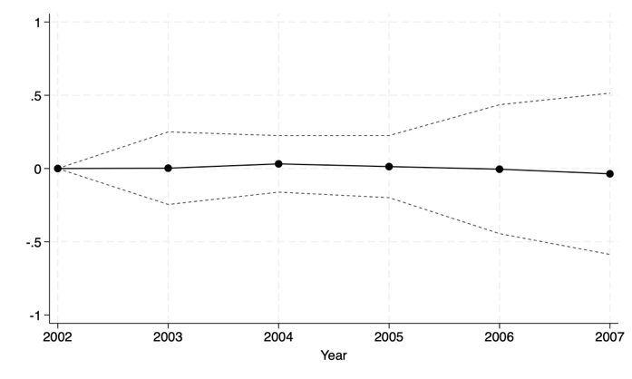
(b) Wetland Bird (c) Game Bird
Figure A2 (a). Effect of lagged CRP share on grassland bird abundance. (b). Effect of lagged CRP share on wetland bird abundance. (c). Effect of lagged CRP share on game bird abundance. Black solid circles are point estimates, and dotted black lines are the 95% confidence intervals.

Table A1: List of grassland bird species from different sources
eBird checklists | Partners in Flight (2024) | Breeding Season
American Bittern |  | 6/7 - 7/27
Baird's Sparrow | Yes | 5/17 - 7/27
Bobolink | Yes | 6/7 - 7/13
Brewer's Sparrow | Yes | 6/7 - 7/13
Brown-headed Cowbird | Yes | 5/24 - 6/28
Burrowing Owl | Yes | 5/17 - 8/3
Cassin's sparrow | Yes | 5/31 - 8/10
Chestnut-collared Longspur | Yes | 5/10 - 8/17
Clay-colored Sparrow | Yes | 6/7 - 7/20
Dickcissel | Yes | 6/14 - 8/3
Eastern Kingbird | Yes | 6/7 - 7/20
Eastern Meadowlark | Yes | 5/3 - 7/20
Ferruginous Hawk | Yes | 5/10 - 7/27
Field Sparrow | Yes | 5/24 - 9/14
Golden Eagle | Yes | 6/7 - 8/24
Grasshopper Sparrow | Yes | 6/7 - 7/20
Henslow's Sparrow | Yes | 5/17 - 8/10
Horned Lark | Yes | 5/31 - 8/17
Lark Bunting | Yes | 5/31 - 7/6
Lark Sparrow | Yes | 5/31 - 7/13
LeConte's Sparrow | Yes | 6/7 - 8/24
Loggerhead Shrike | Yes | 5/24 - 7/20
Long-billed Curlew |  | 5/17 - 6/14
Marbled Godwit |  | 5/31 - 6/28
McCown's Longspur | Yes | 5/3 - 7/20
Merlin | Yes | 5/31 - 7/27
Mountain Plover |  | 5/10 - 7/13
Nelson's Sparrow | Yes | 6/21 - 8/24
Northern Harrier | Yes | 6/7 - 7/6
Prairie Falcon | Yes | 5/17 - 7/6
Savannah Sparrow | Yes | 6/7 - 8/3
Scissor-tailed Flycatcher | Yes | 5/31 - 8/24
Sprague's Pipit | Yes | 5/17 - 7/27
Swainson's Hawk | Yes | 5/17 - 7/27
Upland Sandpiper |  | 5/31 - 6/28
Vesper Sparrow | Yes | 5/24 - 7/27
Western Kingbird | Yes | 6/7 - 7/20
Western Meadowlark | Yes | 5/10 - 8/24
Willet |  | 5/31 - 6/28
Wilson's Phalarope |  | 6/7 - 7/6

Table A2: Shift-share IV estimating the effects of CRP on grassland birds
 | Breeding |  | Nonbreeding |  | Prebreeding |  | Postbreeding
 | (1) | (2) | (3) | (4) | (5) | (6) | (7) | (8)
Panel A: Abundance
CRP Share | 0.482** | 0.429* | 0.407 | 0.393 | -0.238 | -0.213 | 0.199 | 0.228
 | (0.230) | (0.240) | (0.577) | (0.589) | (0.223) | (0.230) | (0.244) | (0.271)
Observations | 8325 | 8325 | 4783 | 4783 | 8444 | 8444 | 7891 | 7891
IV First Stage F-statistics | 31.16 | 30.03 | 7.62 | 7.15 | 24.97 | 26.29 | 16.84 | 15.20
Panel B: Richness
CRP Share | 0.442** | 0.525** | 0.261 | 0.242 | -0.190 | -0.058 | 0.194 | 0.257
 | (0.216) | (0.244) | (0.449) | (0.445) | (0.230) | (0.231) | (0.230) | (0.243)
Observations | 8507 | 8507 | 4814 | 4814 | 8606 | 8606 | 8002 | 8002
IV First Stage F-statistics | 34.04 | 32.27 | 8.11 | 7.64 | 27.30 | 29.05 | 19.48 | 17.88
Land Cover Controls | Yes | Yes | Yes | Yes | Yes | Yes | Yes | Yes
Weather Controls | Yes | Yes | Yes | Yes | Yes | Yes | Yes | Yes
County FE | Yes | Yes | Yes | Yes | Yes | Yes | Yes | Yes
Year FE | Yes | No | Yes | No | Yes | No | Yes | No
State by Year FE | No | Yes | No | Yes | No | Yes | No | Yes
Notes: *p < 0.1, **P < 0.05, ***P < 0.01. Standard errors in parentheses are clustered at the county level. Outcome variables are relative abundance and richness. All variables are standardized to mean zero and SD one. Columns (1), (3), (5), (7) specify county and year fixed effects, and columns (2), (4), (6), (8) specify county and state-by-year fixed effects.

Table A3: Shift-share IV estimating the effects of CRP on wetland birds
 | Breeding |  | Nonbreeding |  | Prebreeding |  | Postbreeding
 | (1) | (2) | (3) | (4) | (5) | (6) | (7) | (8)
Panel A: Abundance
CRP Share | 0.133 | 0.145 | 0.028 | 0.142 | -0.010 | 0.059 | 0.050 | 0.118
 | (0.123) | (0.139) | (0.234) | (0.228) | (0.127) | (0.138) | (0.147) | (0.160)
Observations | 8905 | 8905 | 5750 | 5750 | 8921 | 8921 | 9048 | 9048
IV First Stage F-statistics | 40.26 | 38.47 | 22.72 | 22.04 | 26.06 | 26.56 | 26.84 | 25.83
Panel B: Richness
CRP Share | 0.129 | 0.136 | -0.187 | -0.127 | -0.167 | -0.126 | 0.093 | 0.133
 | (0.131) | (0.144) | (0.158) | (0.157) | (0.117) | (0.123) | (0.147) | (0.158)
Observations | 9070 | 9070 | 5795 | 5795 | 9032 | 9032 | 9139 | 9139
IV First Stage F-statistics | 43.73 | 41.18 | 23.09 | 22.55 | 27.64 | 28.29 | 28.77 | 27.45
Land cover controls | Yes | Yes | Yes | Yes | Yes | Yes | Yes | Yes
Weather controls | Yes | Yes | Yes | Yes | Yes | Yes | Yes | Yes
County FE | Yes | Yes | Yes | Yes | Yes | Yes | Yes | Yes
Year FE | Yes | No | Yes | No | Yes | No | Yes | No
State by Year FE | No | Yes | No | Yes | No | Yes | No | Yes
Notes: *p < 0.1, **P < 0.05, ***P < 0.01. Standard errors in parentheses are clustered at the county level. Outcome variables are relative abundance and richness. All variables are standardized to mean zero and SD one. Columns (1), (3), (5), (7) specify county and year fixed effects, and columns (2), (4), (6), (8) specify county and state-by-year fixed effects.

Table A4: Shift-share IV estimating the effects of CRP on game birds
 | Breeding |  | Nonbreeding |  | Prebreeding |  | Postbreeding
 | (1) | (2) | (3) | (4) | (5) | (6) | (7) | (8)
Panel A: Abundance
CRP Share | 0.094 | 0.052 | -0.180 | -0.244 | -0.227* | -0.212 | 0.210 | 0.215
 | (0.148) | (0.167) | (0.248) | (0.253) | (0.120) | (0.131) | (0.211) | (0.221)
Observations | 9165 | 9165 | 7217 | 7217 | 8769 | 8769 | 8300 | 8300
IV First Stage F-statistics | 36.42 | 34.21 | 17.70 | 17.62 | 30.11 | 29.57 | 22.21 | 22.22
Panel B: Richness
CRP Share | 0.011 | -0.048 | -0.206 | -0.271 | -0.349*** | -0.340** | 0.233 | 0.205
 | (0.153) | (0.165) | (0.241) | (0.260) | (0.124) | (0.134) | (0.206) | (0.209)
Observations | 9351 | 9351 | 7308 | 7308 | 8906 | 8906 | 8403 | 8403
IV First Stage F-statistics | 40.54 | 37.47 | 19.46 | 19.49 | 32.81 | 32.05 | 24.98 | 24.89
Land cover controls | Yes | Yes | Yes | Yes | Yes | Yes | Yes | Yes
Weather controls | Yes | Yes | Yes | Yes | Yes | Yes | Yes | Yes
County FE | Yes | Yes | Yes | Yes | Yes | Yes | Yes | Yes
Year FE | Yes | No | Yes | No | Yes | No | Yes | No
State by Year FE | No | Yes | No | Yes | No | Yes | No | Yes
Notes: *p < 0.1, **P < 0.05, ***P < 0.01. Standard errors in parentheses are clustered at the county level. Outcome variables are relative abundance and richness. All variables are standardized to mean zero and SD one. Columns (1), (3), (5), (7) specify county and year fixed effects, and columns (2), (4), (6), (8) specify county and state-by-year fixed effects.

Table A5: Shift-share IV estimating the effects of CRP on breeding season birds from different effort adjustment method
 | Grassland Bird |  | Wetland Bird |  | Game Bird
 | (1) | (2) | (3) | (4) | (5) | (6)
CRP Share | 0.482** | 0.510** | 0.133 | 0.031 | 0.094 | 0.096
 | (0.230) | (0.248) | (0.123) | (0.037) | (0.148) | (0.092)
Observations | 8325 | 8325 | 8905 | 8905 | 9165 | 9165
IV First Stage F-statistics | 31.16 | 31.16 | 40.26 | 40.26 | 36.42 | 36.42
Land cover controls | Yes | Yes | Yes | Yes | Yes | Yes
Weather controls | Yes | Yes | Yes | Yes | Yes | Yes
County FE | Yes | Yes | Yes | Yes | Yes | Yes
Year FE | Yes | Yes | Yes | Yes | Yes | Yes
Notes: *p < 0.1, **P < 0.05, ***P < 0.01. Standard errors in parentheses are clustered at the county level. Outcome variables are relative abundance. All variables are standardized to mean zero and SD one. Columns (1), (3), (5) estimate the first-stage abundance based on the log-linear Poisson model, and columns (2), (4), (6) estimate the first-stage abundance from the raw Poisson model.

Table A6: Shift-share IV testing spatial displacement of birds and Stable Unit Treatment Value Assumption violations
 | (1)  Grassland Bird | (2)  Wetland Bird | (3)  Game Bird
Panel A: Abundance
CRP Share of Own and Border Counties | 0.492** | 0.141 | 0.106
 | (0.228) | (0.128) | (0.154)
Observations | 8294 | 8876 | 9139
IV First Stage F-statistics | 64.04 | 69.73 | 71.87
Panel B: Richness
CRP Share of Own and Border Counties | 0.446** | 0.131 | 0.015
 | (0.208) | (0.135) | (0.158)
Observations | 8475 | 9040 | 9323
IV First Stage F-statistics | 71.33 | 76.38 | 80.6
Land Cover Controls | Yes | Yes | Yes
Weather Controls | Yes | Yes | Yes
County FE | Yes | Yes | Yes
Year FE | Yes | Yes | Yes
Notes: *p < 0.1, **P < 0.05, ***P < 0.01. Standard errors in parentheses are clustered at the county level. Outcome variables are breeding season relative abundance and richness. All variables are standardized to mean zero and SD one.

