Supplementary appendix
This appendix forms part of the submission for:
Lifetime pregnancy loss and later-life depressive symptoms among middle-aged and older women in China: a national cross-sectional and prospective study
Contents
eMethods
• eMethod 1. Participant enrolment procedures and linkage across CHARLS waves
• eMethod 2. Definition of pregnancy-loss variables
• eMethod 3. Definition of depressive symptom outcomes
• eMethod 4. Covariates, missingness, and analytic samples
• eMethod 5. STROBE statement
• eMethod 6. Statistical modelling, sensitivity analyses, and supplementary figure construction
Supplementary tables
• Supplementary Table 1. Baseline characteristics of participants included and excluded from the cross-sectional and prospective analyses
• Supplementary Table 2. Logistic regression of baseline characteristics predicting exclusion or loss to follow-up in the prospective analysis
• Supplementary Table 3. Percentages of missing values in each variable
• Supplementary Table 4. Cross-sectional associations between lifetime pregnancy loss and prevalent depressive symptoms: full model set for the primary exposure
• Supplementary Table 5. Prospective associations between lifetime pregnancy loss and incident depressive symptoms: full model set for the primary exposure
• Supplementary Table 6. Subtype-specific associations of induced abortion, spontaneous abortion, and stillbirth with prevalent depressive symptoms
• Supplementary Table 7. Subtype-specific associations of induced abortion, spontaneous abortion, and stillbirth with incident depressive symptoms
• Supplementary Table 8. Dose-response associations between pregnancy loss count and prevalent depressive symptoms
• Supplementary Table 9. Dose-response associations between pregnancy loss count and incident depressive symptoms
• Supplementary Table 10. Same-sample attenuation analyses for the cross-sectional association between pregnancy loss and depressive symptoms
• Supplementary Table 11. Same-sample attenuation analyses for the prospective association between pregnancy loss and incident depressive symptoms
• Supplementary Table 12. Cross-sectional subgroup analyses and interaction p values
• Supplementary Table 13. Prospective subgroup analyses and interaction p values
• Supplementary Table 14. Sensitivity analyses
• Supplementary Table 15. Joint-effects model results and observed prevalence or risk
Supplementary figures
• Supplementary Figure 1. Study flow for the cross-sectional and prospective analyses
• Supplementary Figure 2. Follow-up structure and cumulative incidence patterns
• Supplementary Figure 3. Sequential attenuation after progressive covariate adjustment
• Supplementary Figure 4. Secondary exposure and sensitivity analyses

eMethods
eMethod 1. Participant enrolment procedures and linkage across CHARLS waves
We used the China Health and Retirement Longitudinal Study (CHARLS), a nationally representative cohort of Chinese adults aged 45 years or older and their spouses. Participant records from the 2014 life history survey were linked to the 2015, 2018, and 2020 waves using the CHARLS identifier.
For the cross-sectional analysis, we began with all participants interviewed in 2018 and restricted the sample to women aged 45 years or older. Women were retained if lifetime pregnancy-loss history from the 2014 life history module and CESD-10 data in 2018 were both available. The final 2018 analytic sample included 8,368 women.
For the prospective analysis, we assembled a female cohort observed across the 2015, 2018, and 2020 waves and linked these records to the 2014 life history module. Women were eligible if baseline age, pregnancy-loss exposure, and baseline depressive symptom status were available. We excluded women with depressive symptoms at baseline in 2015 and those without usable follow-up information for incident outcome definition. The final incident cohort included 4,145 women.
eMethod 2. Definition of pregnancy-loss variables
Lifetime pregnancy loss was derived from the 2014 CHARLS life history survey using retrospectively reported pregnancy outcomes. We counted induced abortion, spontaneous abortion, and stillbirth events recorded in the reproductive history module.
The primary exposure was any pregnancy loss, defined as at least one induced abortion, spontaneous abortion, or stillbirth versus none. We also created subtype-specific indicators for induced abortion history, spontaneous abortion history, and stillbirth history.
To examine exposure gradients, we summed the number of losses across these event types and grouped women into 0 losses, 1 loss, or 2 or more losses. A capped ordinal count variable was additionally analysed as a linear trend term.
eMethod 3. Definition of depressive symptom outcomes
Depressive symptoms were measured with the 10-item Center for Epidemiologic Studies Depression Scale (CESD-10) in CHARLS 2015, 2018, and 2020. Item responses were combined into a total score using standard CHARLS coding procedures.
The primary cross-sectional outcome was depressive symptoms in 2018, defined as CESD-10 score of 10 or greater. The principal sensitivity outcome used a higher threshold of 12 or greater.
For the prospective analysis, baseline depressive symptoms were defined in 2015. Incident depressive symptoms were defined as the first follow-up wave with CESD-10 score of 10 or greater among women free of baseline depressive symptoms. Follow-up time was assigned as 3 years for incident cases first identified in 2018 and 5 years for women remaining event-free until 2020 or first becoming positive in 2020.
eMethod 4. Covariates, missingness, and analytic samples
Covariates were selected a priori and entered in sequential blocks. Minimally adjusted models included age, residence, and marital or partnered status. Extended models additionally included smoking, alcohol drinking, work status, retirement, pension receipt, and menopausal status where available. Fully adjusted models additionally included self-rated health, sleep duration, functional limitation, and physician-diagnosed chronic conditions.
Functional limitation variables were represented by activities of daily living (ADL) and instrumental activities of daily living (IADL). Chronic disease indicators included hypertension, dyslipidaemia, diabetes, heart disease, kidney disease, digestive disease, arthritis, asthma, lung disease, and liver disease.
Complete-case analysis was used for each model, so analytic n varied as additional covariates were introduced. Variable-level missingness is summarised in Supplementary Table 3, and same-sample attenuation analyses were used to distinguish changes due to covariate expansion from changes due to sample restriction.
eMethod 5. STROBE statement
The checklist below maps the major STROBE items for observational studies to the current manuscript draft and supplementary appendix.
Section/item | No | Recommendation | Where addressed in current draft
Title and abstract | 1 | Identify the design and summarise key findings. | Summary; Title
Background and rationale | 2 | Explain the scientific background and rationale. | Introduction paragraphs 1-4
Objectives | 3 | State prespecified objectives and hypotheses. | Introduction final paragraph
Study design | 4 | Present key elements of study design early in the paper. | Methods: Study design and data source
Setting | 5 | Describe setting, locations, and relevant dates. | Methods: Study design and data source
Participants | 6 | Give eligibility criteria and participant selection methods. | Methods: Study populations; Table 1; Supplementary Figure 1
Variables | 7 | Clearly define outcomes, exposures, predictors, and effect modifiers. | Methods: Exposure assessment; Outcome assessment; Covariates
Data sources and measurement | 8 | Give sources of data and details of assessment methods. | Methods: Exposure assessment; Outcome assessment; Covariates; eMethods 2-4
Bias | 9 | Describe efforts to address potential sources of bias. | Methods: Covariates; Statistical analysis; Discussion limitations
Study size | 10 | Explain how study size was arrived at. | Methods: Study populations; Results participant characteristics
Quantitative variables | 11 | Explain handling of quantitative variables and groupings. | Methods: Exposure assessment; Statistical analysis; eMethod 2
Statistical methods | 12 | Describe all statistical methods, missing data handling, subgroup analyses, and sensitivity analyses. | Methods: Statistical analysis; eMethod 6
Participants flow | 13 | Report numbers of individuals at each stage of study. | Results; Table 1; Supplementary Figure 1
Descriptive data | 14 | Give characteristics of study participants and information on exposures and confounders. | Results participant characteristics; Table 1; Supplementary Table 1
Outcome data | 15 | Report numbers of outcome events or summary measures. | Results; Tables 1-2; Figures 1-3; Supplementary Tables 4-15
Main results | 16 | Give unadjusted and adjusted estimates with precision. | Results; Table 2; Figures 1-3; Supplementary Tables 4-15
Other analyses | 17 | Report subgroup analyses, interactions, and sensitivity analyses. | Results subgroup and robustness analyses; Supplementary Tables 12-15; Supplementary Figures 2-4
Key results | 18 | Summarise key results with reference to study objectives. | Discussion paragraph 1
Limitations | 19 | Discuss limitations and potential bias or imprecision. | Discussion limitations paragraph
Interpretation | 20 | Give a cautious interpretation of results. | Discussion
Generalisability | 21 | Discuss external validity of results. | Discussion final limitation statements
Funding and role of funders | 22 | Give the source of funding and role of funders. | Summary; Declarations

eMethod 6. Statistical modelling, sensitivity analyses, and supplementary figure construction
Cross-sectional associations between pregnancy-loss exposures and prevalent depressive symptoms were estimated with logistic regression. Prospective associations with incident depressive symptoms were estimated with Cox proportional hazards regression using time to first event. Unadjusted, minimally adjusted, extended, and fully adjusted models were prespecified for the primary exposure.
Additional analyses included subtype-specific models, dose-response models based on lifetime loss count, same-sample attenuation analyses, and exploratory subgroup analyses with multiplicative interaction terms. Sensitivity analyses used the higher CESD-10 threshold, restriction to postmenopausal women in the cross-sectional sample, and restriction to complete 2018 and 2020 follow-up in the prospective sample.
Supplementary Figure 1 shows participant derivation. Supplementary Figure 2 summarises follow-up structure and cumulative incidence patterns. Supplementary Figure 3 visualises sequential attenuation after progressive covariate adjustment. Supplementary Figure 4 summarises subtype-specific and sensitivity analyses in a compact display aligned with the supplementary tables.

Supplementary Tables
Supplementary Table 1. Baseline characteristics of participants included and excluded from the cross-sectional and prospective analyses
Panel A. 2018 women aged 45 years or older: included (n=8368) vs excluded (n=1883)
Characteristic | Included | Excluded | P value
Age, years | 61.40 +/- 9.73 | 63.89 +/- 12.51 | <0.001
Married or partnered, n (%) | 6874 (82.1%) | 1397 (74.2%) | <0.001
Rural residence, n (%) | 5156 (61.6%) | 933 (49.5%) | <0.001
Self-rated health score | 2.97 +/- 1.01 | 3.01 +/- 1.03 | 0.209
Night sleep duration, h | 6.00 +/- 2.09 | 6.31 +/- 2.17 | <0.001
Ever smoked, n (%) | 670 (8.0%) | 134 (7.3%) | 0.314
Current alcohol drinking, n (%) | 1181 (14.1%) | 240 (13.0%) | 0.242
Currently working, n (%) | 5031 (60.2%) | 772 (42.0%) | <0.001
Retired, n (%) | 1000 (12.0%) | 303 (16.8%) | <0.001
Receiving pension, n (%) | 4509 (61.6%) | 1091 (72.1%) | <0.001
IADL limitation score | 0.55 +/- 1.10 | 1.04 +/- 1.67 | <0.001
ADL limitation score | 0.45 +/- 1.06 | 0.68 +/- 1.48 | <0.001
Hypertension, n (%) | 3210 (38.4%) | 762 (40.8%) | 0.055
Dyslipidaemia, n (%) | 1956 (23.4%) | 400 (21.4%) | 0.076
Diabetes, n (%) | 1183 (14.1%) | 235 (12.6%) | 0.079
Heart disease, n (%) | 1970 (23.5%) | 394 (21.1%) | 0.026
Kidney disease, n (%) | 761 (9.1%) | 155 (8.3%) | 0.277
Digestive disease, n (%) | 2832 (33.9%) | 553 (29.6%) | <0.001
Arthritis, n (%) | 3811 (45.6%) | 714 (38.2%) | <0.001
Asthma, n (%) | 446 (5.3%) | 109 (5.8%) | 0.437
Lung disease, n (%) | 1178 (14.1%) | 232 (12.4%) | 0.060
Liver disease, n (%) | 535 (6.4%) | 111 (5.9%) | 0.479
Postmenopausal, n (%) | 6988 (83.9%) | 1451 (80.3%) | <0.001

Panel B. Prospective baseline-eligible women: included (n=4145) vs excluded (n=4558)
Characteristic | Included | Excluded | P value
Any pregnancy loss, n (%) | 1171 (28.3%) | 1298 (28.5%) | 0.833
Age, years | 58.55 +/- 9.09 | 61.18 +/- 10.25 | <0.001
Married or partnered, n (%) | 3655 (88.2%) | 3626 (79.6%) | <0.001
Rural residence, n (%) | 2434 (58.7%) | 2919 (64.0%) | <0.001
Self-rated health score | 3.27 +/- 0.92 | 2.76 +/- 0.95 | <0.001
Night sleep duration, h | 6.60 +/- 1.89 | 5.85 +/- 2.18 | <0.001
Ever smoked, n (%) | 304 (7.3%) | 466 (10.2%) | <0.001
Current alcohol drinking, n (%) | 618 (14.9%) | 631 (13.8%) | 0.167
Currently working, n (%) | 2617 (64.2%) | 2584 (57.7%) | <0.001
Retired, n (%) | 536 (13.1%) | 430 (9.6%) | <0.001
Receiving pension, n (%) | 1557 (46.0%) | 1939 (53.4%) | <0.001
ADL limitation score | 0.20 +/- 0.64 | 0.68 +/- 1.26 | <0.001
IADL limitation score | 0.22 +/- 0.63 | 0.78 +/- 1.27 | <0.001
Hypertension, n (%) | 1120 (32.0%) | 1489 (37.4%) | <0.001
Dyslipidaemia, n (%) | 625 (18.1%) | 819 (21.3%) | <0.001
Diabetes, n (%) | 345 (9.9%) | 503 (12.8%) | <0.001
Heart disease, n (%) | 590 (16.9%) | 966 (24.4%) | <0.001
Kidney disease, n (%) | 228 (6.5%) | 443 (11.2%) | <0.001
Digestive disease, n (%) | 1055 (30.1%) | 1624 (40.7%) | <0.001
Arthritis, n (%) | 1457 (41.6%) | 2237 (56.1%) | <0.001
Asthma, n (%) | 121 (3.4%) | 261 (6.5%) | <0.001
Lung disease, n (%) | 316 (9.0%) | 590 (14.8%) | <0.001
Liver disease, n (%) | 162 (4.6%) | 284 (7.2%) | <0.001

Note: Values are presented as n (%), mean (SD), or as otherwise shown. Included and excluded groups are shown separately for the cross-sectional and prospective analyses.

Supplementary Table 2. Logistic regression of baseline characteristics predicting exclusion or loss to follow-up in the prospective analysis
Panel A. Predictors of any exclusion from the prospective analysis (n=5285, excluded=2722)
Predictor | Analytic n | Excluded n | OR (95% CI) | P value
Any pregnancy loss, n (%) | 5285 | 2722 | 1.12 (0.98, 1.28) | 0.098
Age, years | 5285 | 2722 | 1.01 (1.00, 1.02) | 0.033
Married or partnered, n (%) | 5285 | 2722 | 0.65 (0.55, 0.78) | <0.001
Rural residence, n (%) | 5285 | 2722 | 1.08 (0.94, 1.23) | 0.296
Self-rated health score | 5285 | 2722 | 0.67 (0.62, 0.72) | <0.001
Night sleep duration, h | 5285 | 2722 | 0.90 (0.87, 0.92) | <0.001
Ever smoked, n (%) | 5285 | 2722 | 1.22 (0.98, 1.51) | 0.072
Current alcohol drinking, n (%) | 5285 | 2722 | 0.91 (0.77, 1.07) | 0.258
Currently working, n (%) | 5285 | 2722 | 1.09 (0.91, 1.30) | 0.357
Retired, n (%) | 5285 | 2722 | 0.75 (0.60, 0.94) | 0.013
Receiving pension, n (%) | 5285 | 2722 | 0.85 (0.72, 1.01) | 0.069
ADL limitation score | 5285 | 2722 | 1.22 (1.11, 1.34) | <0.001
IADL limitation score | 5285 | 2722 | 1.49 (1.37, 1.63) | <0.001
Hypertension, n (%) | 5285 | 2722 | 0.96 (0.84, 1.10) | 0.539
Dyslipidaemia, n (%) | 5285 | 2722 | 0.98 (0.84, 1.16) | 0.839
Diabetes, n (%) | 5285 | 2722 | 0.94 (0.77, 1.15) | 0.559
Heart disease, n (%) | 5285 | 2722 | 1.05 (0.89, 1.23) | 0.584
Kidney disease, n (%) | 5285 | 2722 | 1.06 (0.85, 1.33) | 0.596
Digestive disease, n (%) | 5285 | 2722 | 1.19 (1.05, 1.35) | 0.007
Arthritis, n (%) | 5285 | 2722 | 1.19 (1.06, 1.35) | 0.005
Asthma, n (%) | 5285 | 2722 | 1.07 (0.78, 1.47) | 0.668
Lung disease, n (%) | 5285 | 2722 | 1.09 (0.88, 1.33) | 0.435
Liver disease, n (%) | 5285 | 2722 | 1.13 (0.87, 1.47) | 0.369

Panel B. Predictors of loss to follow-up among baseline depression-free women (n=3115, lost=552)
Predictor | Analytic n | Excluded n | OR (95% CI) | P value
Any pregnancy loss, n (%) | 3115 | 552 | 1.09 (0.87, 1.36) | 0.444
Age, years | 3115 | 552 | 1.05 (1.03, 1.06) | <0.001
Married or partnered, n (%) | 3115 | 552 | 0.88 (0.67, 1.14) | 0.329
Rural residence, n (%) | 3115 | 552 | 0.76 (0.61, 0.95) | 0.016
Self-rated health score | 3115 | 552 | 1.03 (0.92, 1.15) | 0.657
Night sleep duration, h | 3115 | 552 | 1.05 (1.00, 1.10) | 0.063
Ever smoked, n (%) | 3115 | 552 | 1.10 (0.78, 1.53) | 0.595
Current alcohol drinking, n (%) | 3115 | 552 | 0.74 (0.55, 0.98) | 0.035
Currently working, n (%) | 3115 | 552 | 0.73 (0.56, 0.95) | 0.020
Retired, n (%) | 3115 | 552 | 1.06 (0.78, 1.45) | 0.692
Receiving pension, n (%) | 3115 | 552 | 0.76 (0.57, 1.01) | 0.055
ADL limitation score | 3115 | 552 | 0.92 (0.78, 1.09) | 0.319
IADL limitation score | 3115 | 552 | 1.24 (1.07, 1.43) | 0.003
Hypertension, n (%) | 3115 | 552 | 0.97 (0.78, 1.20) | 0.783
Dyslipidaemia, n (%) | 3115 | 552 | 1.02 (0.79, 1.33) | 0.863
Diabetes, n (%) | 3115 | 552 | 1.11 (0.81, 1.51) | 0.524
Heart disease, n (%) | 3115 | 552 | 1.11 (0.86, 1.44) | 0.412
Kidney disease, n (%) | 3115 | 552 | 1.05 (0.71, 1.55) | 0.809
Digestive disease, n (%) | 3115 | 552 | 1.13 (0.91, 1.40) | 0.257
Arthritis, n (%) | 3115 | 552 | 0.85 (0.69, 1.04) | 0.121
Asthma, n (%) | 3115 | 552 | 0.78 (0.45, 1.34) | 0.368
Lung disease, n (%) | 3115 | 552 | 1.15 (0.82, 1.60) | 0.416
Liver disease, n (%) | 3115 | 552 | 1.14 (0.74, 1.77) | 0.557

Note: Odds ratios estimate the association between baseline characteristics and prospective exclusion or loss to follow-up.

Supplementary Table 3. Percentages of missing values in each variable
Panel A. Cross-sectional candidate sample (n=10251)
Variable | Non-missing n | Missing n | Missing %
Age, years | 10240 | 11 | 0.1%
Married or partnered, n (%) | 10251 | 0 | 0.0%
Rural residence, n (%) | 10251 | 0 | 0.0%
Self-rated health score | 9490 | 761 | 7.4%
Night sleep duration, h | 10207 | 44 | 0.4%
IADL limitation score | 10200 | 51 | 0.5%
ADL limitation score | 10066 | 185 | 1.8%
CESD-10 score | 9318 | 933 | 9.1%
Any pregnancy loss, n (%) | 9088 | 1163 | 11.3%
Induced abortion history, n (%) | 9088 | 1163 | 11.3%
Spontaneous abortion history, n (%) | 9088 | 1163 | 11.3%
Stillbirth history, n (%) | 9088 | 1163 | 11.3%
Age at menarche, years | 119 | 10132 | 98.8%
Postmenopausal, n (%) | 10137 | 114 | 1.1%
Age at menopause, years | 1020 | 9231 | 90.0%

Panel B. Prospective candidate sample before baseline restrictions (n=12044)
Variable | Non-missing n | Missing n | Missing %
Age, years | 10273 | 1771 | 14.7%
Married or partnered, n (%) | 10278 | 1766 | 14.7%
Rural residence, n (%) | 10294 | 1750 | 14.5%
Self-rated health score | 9629 | 2415 | 20.1%
Night sleep duration, h | 9419 | 2625 | 21.8%
ADL limitation score | 9968 | 2076 | 17.2%
IADL limitation score | 10204 | 1840 | 15.3%
CESD-10 score at baseline | 9579 | 2465 | 20.5%
Baseline depressive symptoms (CESD-10 >=10), n (%) | 9579 | 2465 | 20.5%
Any pregnancy loss, n (%) | 10288 | 1756 | 14.6%
induced_abortion_history | 10288 | 1756 | 14.6%
spontaneous_abortion_history | 10288 | 1756 | 14.6%
stillbirth_history | 10288 | 1756 | 14.6%
Depressive symptoms at 2018 follow-up, n (%) | 9318 | 2726 | 22.6%
Depressive symptoms at 2020 follow-up, n (%) | 9283 | 2761 | 22.9%
Any follow-up record, n (%) | 12044 | 0 | 0.0%
Incident depressive symptoms, n (%) | 9106 | 2938 | 24.4%
Follow-up years | 8657 | 3387 | 28.1%

Note: Missingness percentages were calculated from the model-ready datasets used for this submission.

Supplementary Table 4. Cross-sectional associations between lifetime pregnancy loss and prevalent depressive symptoms: full model set for the primary exposure
Exposure | Model 1: unadjusted: n | Model 1: unadjusted: cases | Model 1: unadjusted: estimate | Model 1: unadjusted: p | Model 2: minimally adjusted: n | Model 2: minimally adjusted: cases | Model 2: minimally adjusted: estimate | Model 2: minimally adjusted: p | Model 3: extended: n | Model 3: extended: cases | Model 3: extended: estimate | Model 3: extended: p | Model 4: fully adjusted: n | Model 4: fully adjusted: cases | Model 4: fully adjusted: estimate | Model 4: fully adjusted: p
Any pregnancy loss | 8372 | 3689 | 1.02 (0.93, 1.12) | 0.679 | 8368 | 3686 | 1.12 (1.02, 1.24) | 0.020 | 7251 | 3167 | 1.20 (1.08, 1.34) | <0.001 | 7152 | 3157 | 1.11 (0.99, 1.24) | 0.086

Note: Model 1 was unadjusted; model 2 adjusted for age, residence, and marital status; model 3 additionally adjusted for smoking, drinking, work, retirement, pension, and menopausal status; and model 4 additionally adjusted for self-rated health, sleep duration, ADL, IADL, and chronic conditions.

Supplementary Table 5. Prospective associations between lifetime pregnancy loss and incident depressive symptoms: full model set for the primary exposure
Exposure | Model 1: unadjusted: n | Model 1: unadjusted: events | Model 1: unadjusted: estimate | Model 1: unadjusted: p | Model 2: minimally adjusted: n | Model 2: minimally adjusted: events | Model 2: minimally adjusted: estimate | Model 2: minimally adjusted: p | Model 3: extended: n | Model 3: extended: events | Model 3: extended: estimate | Model 3: extended: p | Model 4: fully adjusted: n | Model 4: fully adjusted: events | Model 4: fully adjusted: estimate | Model 4: fully adjusted: p
Any pregnancy loss | 4145 | 2000 | 0.99 (0.89, 1.09) | 0.782 | 4145 | 2000 | 1.07 (0.97, 1.18) | 0.180 | 3290 | 1598 | 1.08 (0.97, 1.21) | 0.177 | 2563 | 1262 | 1.01 (0.89, 1.15) | 0.873

Note: Model 1 was unadjusted; model 2 adjusted for age, residence, and partnered status at baseline; model 3 additionally adjusted for smoking, drinking, work, retirement, pension, self-rated health, and sleep duration at baseline; and model 4 additionally adjusted for ADL, IADL, and chronic conditions at baseline.

Supplementary Table 6. Subtype-specific associations of induced abortion, spontaneous abortion, and stillbirth with prevalent depressive symptoms
Exposure | Model 1: unadjusted: n | Model 1: unadjusted: cases | Model 1: unadjusted: estimate | Model 1: unadjusted: p | Model 2: minimally adjusted: n | Model 2: minimally adjusted: cases | Model 2: minimally adjusted: estimate | Model 2: minimally adjusted: p | Model 3: extended: n | Model 3: extended: cases | Model 3: extended: estimate | Model 3: extended: p | Model 4: fully adjusted: n | Model 4: fully adjusted: cases | Model 4: fully adjusted: estimate | Model 4: fully adjusted: p
Induced abortion history | 8372 | 3689 | 0.92 (0.83, 1.03) | 0.141 | 8368 | 3686 | 1.07 (0.95, 1.19) | 0.266 | 7251 | 3167 | 1.17 (1.03, 1.32) | 0.015 | 7152 | 3157 | 1.08 (0.94, 1.24) | 0.267
Spontaneous abortion history | 8372 | 3689 | 1.13 (0.97, 1.32) | 0.115 | 8368 | 3686 | 1.13 (0.97, 1.32) | 0.129 | 7251 | 3167 | 1.16 (0.98, 1.37) | 0.088 | 7152 | 3157 | 1.08 (0.90, 1.30) | 0.399
Stillbirth history | 8372 | 3689 | 1.24 (0.95, 1.62) | 0.113 | 8368 | 3686 | 1.16 (0.88, 1.52) | 0.284 | 7251 | 3167 | 1.16 (0.86, 1.55) | 0.331 | 7152 | 3157 | 1.07 (0.78, 1.48) | 0.675

Note: Subtype-specific cross-sectional models evaluated induced abortion, spontaneous abortion, and stillbirth history separately.

Supplementary Table 7. Subtype-specific associations of induced abortion, spontaneous abortion, and stillbirth with incident depressive symptoms
Exposure | Model 1: unadjusted: n | Model 1: unadjusted: events | Model 1: unadjusted: estimate | Model 1: unadjusted: p | Model 2: minimally adjusted: n | Model 2: minimally adjusted: events | Model 2: minimally adjusted: estimate | Model 2: minimally adjusted: p | Model 3: extended: n | Model 3: extended: events | Model 3: extended: estimate | Model 3: extended: p | Model 4: fully adjusted: n | Model 4: fully adjusted: events | Model 4: fully adjusted: estimate | Model 4: fully adjusted: p
Induced abortion history | 4145 | 2000 | 0.89 (0.79, 0.99) | 0.038 | 4145 | 2000 | 0.99 (0.88, 1.11) | 0.828 | 3290 | 1598 | 1.03 (0.90, 1.17) | 0.693 | 2563 | 1262 | 0.99 (0.85, 1.16) | 0.916
Spontaneous abortion history | 4145 | 2000 | 1.07 (0.92, 1.25) | 0.388 | 4145 | 2000 | 1.10 (0.94, 1.29) | 0.216 | 3290 | 1598 | 1.09 (0.91, 1.30) | 0.338 | 2563 | 1262 | 1.06 (0.86, 1.30) | 0.589
Stillbirth history | 4145 | 2000 | 1.10 (0.83, 1.46) | 0.506 | 4145 | 2000 | 1.03 (0.77, 1.37) | 0.848 | 3290 | 1598 | 1.00 (0.73, 1.37) | 1.000 | 2563 | 1262 | 0.80 (0.55, 1.18) | 0.259

Note: Subtype-specific prospective models evaluated induced abortion, spontaneous abortion, and stillbirth history separately.

Supplementary Table 8. Dose-response associations between pregnancy loss count and prevalent depressive symptoms
Comparison | Model 2: minimally adjusted: n | Model 2: minimally adjusted: cases | Model 2: minimally adjusted: estimate | Model 2: minimally adjusted: p | Model 3: extended: n | Model 3: extended: cases | Model 3: extended: estimate | Model 3: extended: p | Model 4: fully adjusted: n | Model 4: fully adjusted: cases | Model 4: fully adjusted: estimate | Model 4: fully adjusted: p | Trend, minimally adjusted: n | Trend, minimally adjusted: cases | Trend, minimally adjusted: estimate | Trend, minimally adjusted: p | Trend, extended: n | Trend, extended: cases | Trend, extended: estimate | Trend, extended: p | Trend, fully adjusted: n | Trend, fully adjusted: cases | Trend, fully adjusted: estimate | Trend, fully adjusted: p
1 pregnancy loss vs 0 | 8368 | 3686 | 1.12 (1.00, 1.25) | 0.043 | 7251 | 3167 | 1.17 (1.04, 1.32) | 0.008 | 7152 | 3157 | 1.10 (0.97, 1.25) | 0.149 | 8368 | 3686 | 1.08 (1.01, 1.16) | 0.028 | 7251 | 3167 | 1.15 (1.06, 1.24) | <0.001 | 7152 | 3157 | 1.07 (0.99, 1.17) | 0.096
2 or more pregnancy losses vs 0 | 8368 | 3686 | 1.13 (0.96, 1.34) | 0.141 | 7251 | 3167 | 1.28 (1.07, 1.54) | 0.007 | 7152 | 3157 | 1.13 (0.93, 1.37) | 0.233 | 8368 | 3686 | 1.08 (1.01, 1.16) | 0.028 | 7251 | 3167 | 1.15 (1.06, 1.24) | <0.001 | 7152 | 3157 | 1.07 (0.99, 1.17) | 0.096
Trend per higher category |  |  |  |  |  |  |  |  |  |  |  |  | 8368 | 3686 | 1.08 (1.01, 1.16) | 0.028 | 7251 | 3167 | 1.15 (1.06, 1.24) | <0.001 | 7152 | 3157 | 1.07 (0.99, 1.17) | 0.096

Note: Dose-response models compared one loss and two or more losses with no loss and additionally estimated a linear trend across capped loss-count categories.

Supplementary Table 9. Dose-response associations between pregnancy loss count and incident depressive symptoms
Comparison | Model 2: minimally adjusted: n | Model 2: minimally adjusted: events | Model 2: minimally adjusted: estimate | Model 2: minimally adjusted: p | Model 3: extended: n | Model 3: extended: events | Model 3: extended: estimate | Model 3: extended: p | Model 4: fully adjusted: n | Model 4: fully adjusted: events | Model 4: fully adjusted: estimate | Model 4: fully adjusted: p | Trend, minimally adjusted: n | Trend, minimally adjusted: events | Trend, minimally adjusted: estimate | Trend, minimally adjusted: p | Trend, extended: n | Trend, extended: events | Trend, extended: estimate | Trend, extended: p | Trend, fully adjusted: n | Trend, fully adjusted: events | Trend, fully adjusted: estimate | Trend, fully adjusted: p
1 pregnancy loss vs 0 | 4145 | 2000 | 1.11 (0.99, 1.23) | 0.071 | 3290 | 1598 | 1.10 (0.97, 1.24) | 0.133 | 2563 | 1262 | 1.03 (0.89, 1.19) | 0.661 | 4145 | 2000 | 1.03 (0.95, 1.10) | 0.473 | 3290 | 1598 | 1.04 (0.96, 1.13) | 0.319 | 2563 | 1262 | 0.99 (0.90, 1.10) | 0.914
2 or more pregnancy losses vs 0 | 4145 | 2000 | 0.97 (0.81, 1.16) | 0.735 | 3290 | 1598 | 1.02 (0.84, 1.25) | 0.808 | 2563 | 1262 | 0.95 (0.75, 1.20) | 0.644 | 4145 | 2000 | 1.03 (0.95, 1.10) | 0.473 | 3290 | 1598 | 1.04 (0.96, 1.13) | 0.319 | 2563 | 1262 | 0.99 (0.90, 1.10) | 0.914
Trend per higher category |  |  |  |  |  |  |  |  |  |  |  |  | 4145 | 2000 | 1.03 (0.95, 1.10) | 0.473 | 3290 | 1598 | 1.04 (0.96, 1.13) | 0.319 | 2563 | 1262 | 0.99 (0.90, 1.10) | 0.914

Note: Dose-response models compared one loss and two or more losses with no loss and additionally estimated a linear trend across capped loss-count categories.

Supplementary Table 10. Same-sample attenuation analyses for the cross-sectional association between pregnancy loss and depressive symptoms
Model | Analytic n | Cases or events | Estimate | P value
Base covariates only | 7152 | 3157 | 1.15 (1.04, 1.28) | 0.009
Plus sociodemographic and lifestyle covariates | 7152 | 3157 | 1.20 (1.08, 1.34) | <0.001
Plus self-rated health and sleep | 7152 | 3157 | 1.13 (1.01, 1.26) | 0.037
Plus functional limitation | 7152 | 3157 | 1.13 (1.01, 1.27) | 0.037
Plus multimorbidity | 7152 | 3157 | 1.11 (0.99, 1.24) | 0.086

Note: Attenuation analyses were run on the same complete-case sample for all sequential models, so changes in estimates reflect covariate expansion rather than changes in analytic n.

Supplementary Table 11. Same-sample attenuation analyses for the prospective association between pregnancy loss and incident depressive symptoms
Model | Analytic n | Cases or events | Estimate | P value
Base covariates only | 2563 | 1262 | 1.05 (0.92, 1.19) | 0.493
Plus sociodemographic and lifestyle covariates | 2563 | 1262 | 1.04 (0.91, 1.18) | 0.593
Plus functional limitation | 2563 | 1262 | 1.03 (0.91, 1.18) | 0.619
Plus multimorbidity | 2563 | 1262 | 1.01 (0.89, 1.15) | 0.873

Note: Attenuation analyses were run on the same complete-case sample for all sequential models, so changes in estimates reflect covariate expansion rather than changes in analytic n.

Supplementary Table 12. Cross-sectional subgroup analyses and interaction p values
Subgroup | Analytic n | Cases or events | Estimate | P value | P for interaction
Overall | 7152 | 3157 | 1.11 (0.99, 1.24) | 0.086
Age group |  |  |  |  | 0.988
45-59 | 2963 | 1257 | 1.13 (0.95, 1.34) | 0.181
60-69 | 2656 | 1187 | 1.16 (0.95, 1.41) | 0.144
>=70 | 1533 | 713 | 1.06 (0.82, 1.38) | 0.650
Residence |  |  |  |  | 0.666
Urban | 2675 | 953 | 1.05 (0.87, 1.27) | 0.589
Rural | 4477 | 2204 | 1.13 (0.97, 1.31) | 0.108
Marital status |  |  |  |  | 0.470
Married/partnered | 5855 | 2502 | 1.13 (1.00, 1.29) | 0.054
Other | 1297 | 655 | 1.02 (0.77, 1.35) | 0.890
Smoking status |  |  |  |  | 0.041
No | 6586 | 2877 | 1.07 (0.95, 1.21) | 0.279
Yes | 566 | 280 | 1.75 (1.16, 2.65) | 0.008
Drinking status |  |  |  |  | 0.804
No | 6101 | 2722 | 1.11 (0.98, 1.26) | 0.111
Yes | 1051 | 435 | 1.10 (0.83, 1.48) | 0.507
Working status |  |  |  |  | 0.205
No | 3246 | 1412 | 0.96 (0.80, 1.14) | 0.624
Yes | 4906 | 2224 | 1.18 (1.02, 1.35) | 0.022
Self-rated health |  |  |  |  | 0.318
Good | 2037 | 1337 | 0.97 (0.78, 1.20) | 0.750
Fair | 3586 | 1440 | 1.19 (1.01, 1.39) | 0.032
Poor | 1529 | 380 | 1.14 (0.86, 1.51) | 0.369
Night sleep duration |  |  |  |  | 0.262
<6 h | 2889 | 1675 | 1.03 (0.86, 1.23) | 0.751
6-8 h | 3607 | 1251 | 1.23 (1.04, 1.45) | 0.015
>8 h | 656 | 231 | 1.04 (0.67, 1.62) | 0.854
ADL limitation |  |  |  |  | 0.761
None | 5666 | 2161 | 1.14 (1.00, 1.29) | 0.053
Any limitation | 1486 | 996 | 1.06 (0.82, 1.38) | 0.651
Hypertension |  |  |  |  | 0.489
No | 4407 | 1849 | 1.09 (0.94, 1.26) | 0.259
Yes | 2745 | 1308 | 1.14 (0.94, 1.37) | 0.177
Dyslipidaemia |  |  |  |  | 0.567
No | 5471 | 2341 | 1.14 (1.00, 1.30) | 0.059
Yes | 1681 | 816 | 1.00 (0.79, 1.26) | 0.996
Diabetes |  |  |  |  | 0.281
No | 6132 | 2631 | 1.08 (0.95, 1.23) | 0.225
Yes | 1020 | 526 | 1.26 (0.93, 1.72) | 0.139
Menopause status |  |  |  |  | 0.352
Premenopause | 1071 | 429 | 1.00 (0.75, 1.34) | 0.979
Postmenopause | 6081 | 2728 | 1.13 (0.99, 1.28) | 0.064

Note: Interaction p values are exploratory and were derived from multiplicative interaction terms in cross-sectional logistic models.

Supplementary Table 13. Prospective subgroup analyses and interaction p values
Subgroup | Analytic n | Cases or events | Estimate | P value | P for interaction
Overall | 2563 | 1262 | 1.01 (0.89, 1.15) | 0.873
Age group |  |  |  |  | 0.571
45-59 | 1240 | 583 | 0.97 (0.80, 1.17) | 0.748
60-69 | 960 | 489 | 1.15 (0.93, 1.43) | 0.196
>=70 | 363 | 190 | 0.87 (0.61, 1.26) | 0.468
Residence |  |  |  |  | 0.513
Urban | 971 | 396 | 0.95 (0.77, 1.18) | 0.651
Rural | 1592 | 866 | 1.06 (0.90, 1.25) | 0.478
Marital status |  |  |  |  | 0.534
Married/partnered | 2243 | 1103 | 1.00 (0.87, 1.15) | 0.989
Other | 320 | 159 | 0.97 (0.66, 1.43) | 0.884
Smoking status |  |  |  |  | 0.518
No | 2376 | 1162 | 0.99 (0.87, 1.14) | 0.934
Yes | 187 | 100 | 1.48 (0.89, 2.43) | 0.128
Drinking status |  |  |  |  | 0.850
No | 2145 | 1056 | 1.00 (0.87, 1.16) | 0.948
Yes | 418 | 206 | 1.17 (0.85, 1.61) | 0.344
Working status |  |  |  |  | 0.454
No | 1171 | 547 | 0.96 (0.79, 1.17) | 0.715
Yes | 1926 | 980 | 0.99 (0.85, 1.14) | 0.844
Self-rated health |  |  |  |  | 0.444
Good | 330 | 218 | 1.19 (0.86, 1.63) | 0.288
Fair | 1527 | 762 | 1.02 (0.86, 1.20) | 0.852
Poor | 706 | 282 | 0.87 (0.65, 1.17) | 0.350
Night sleep duration |  |  |  |  | 0.559
<6 h | 718 | 404 | 1.08 (0.86, 1.36) | 0.498
6-8 h | 1543 | 703 | 0.94 (0.78, 1.12) | 0.467
>8 h | 302 | 155 | 0.93 (0.61, 1.43) | 0.749
ADL limitation |  |  |  |  | 0.715
None | 2246 | 1077 | 1.03 (0.90, 1.19) | 0.665
Any limitation | 317 | 185 | 0.88 (0.60, 1.27) | 0.482
Hypertension |  |  |  |  | 0.997
No | 1770 | 833 | 1.02 (0.87, 1.20) | 0.805
Yes | 793 | 429 | 1.03 (0.82, 1.30) | 0.774
Dyslipidaemia |  |  |  |  | 0.158
No | 2117 | 1043 | 0.97 (0.84, 1.12) | 0.697
Yes | 446 | 219 | 1.22 (0.90, 1.64) | 0.201
Diabetes |  |  |  |  | 0.424
No | 2315 | 1136 | 1.00 (0.87, 1.14) | 0.947
Yes | 248 | 126 | 1.02 (0.66, 1.59) | 0.914
Heart disease |  |  |  |  | 0.226
No | 2155 | 1037 | 1.04 (0.90, 1.20) | 0.573
Yes | 408 | 225 | 0.93 (0.68, 1.28) | 0.678

Note: Interaction p values are exploratory and were derived from multiplicative interaction terms in prospective Cox models.

Supplementary Table 14. Sensitivity analyses
Panel A. Cross-sectional sensitivity analyses
Analysis | Exposure | Analytic n | Cases or events | Estimate | P value
Cross-sectional: CESD-10 >=12 | Any pregnancy loss | 7152 | 2502 | 1.11 (0.98, 1.25) | 0.105
Cross-sectional: CESD-10 >=12 | Induced abortion history | 7152 | 2502 | 1.06 (0.92, 1.22) | 0.444
Cross-sectional: CESD-10 >=12 | Spontaneous abortion history | 7152 | 2502 | 1.14 (0.94, 1.38) | 0.181
Cross-sectional: CESD-10 >=12 | Stillbirth history | 7152 | 2502 | 1.21 (0.87, 1.67) | 0.260
Cross-sectional: postmenopausal only | Any pregnancy loss | 6081 | 2728 | 1.13 (0.99, 1.28) | 0.064
Cross-sectional: postmenopausal only | Induced abortion history | 6081 | 2728 | 1.11 (0.96, 1.29) | 0.158
Cross-sectional: postmenopausal only | Spontaneous abortion history | 6081 | 2728 | 1.09 (0.89, 1.34) | 0.383
Cross-sectional: postmenopausal only | Stillbirth history | 6081 | 2728 | 1.10 (0.79, 1.55) | 0.570
Cross-sectional: full model without menopause adjustment | Any pregnancy loss | 7178 | 3163 | 1.10 (0.98, 1.24) | 0.093
Cross-sectional: full model without menopause adjustment | Induced abortion history | 7178 | 3163 | 1.08 (0.94, 1.24) | 0.263
Cross-sectional: full model without menopause adjustment | Spontaneous abortion history | 7178 | 3163 | 1.08 (0.89, 1.29) | 0.435
Cross-sectional: full model without menopause adjustment | Stillbirth history | 7178 | 3163 | 1.06 (0.77, 1.46) | 0.711

Panel B. Prospective sensitivity analyses
Analysis | Exposure | Analytic n | Cases or events | Estimate | P value
Prospective: incident CESD-10 >=12 | Any pregnancy loss | 2539 | 949 | 1.04 (0.89, 1.20) | 0.646
Prospective: incident CESD-10 >=12 | Induced abortion history | 2539 | 949 | 0.99 (0.82, 1.18) | 0.875
Prospective: incident CESD-10 >=12 | Spontaneous abortion history | 2539 | 949 | 1.12 (0.89, 1.41) | 0.318
Prospective: incident CESD-10 >=12 | Stillbirth history | 2539 | 949 | 0.79 (0.51, 1.23) | 0.289
Prospective: complete follow-up only | Any pregnancy loss | 2486 | 1185 | 1.02 (0.90, 1.17) | 0.730
Prospective: complete follow-up only | Induced abortion history | 2486 | 1185 | 0.98 (0.84, 1.16) | 0.853
Prospective: complete follow-up only | Spontaneous abortion history | 2486 | 1185 | 1.10 (0.90, 1.36) | 0.356
Prospective: complete follow-up only | Stillbirth history | 2486 | 1185 | 0.83 (0.56, 1.23) | 0.349

Note: Sensitivity analyses include the higher CESD-10 threshold, restriction to postmenopausal women, restriction to complete follow-up, and alternative model specifications.

Supplementary Table 15. Joint-effects model results and observed prevalence or risk
Panel A. Cross-sectional joint effects of pregnancy loss history and multimorbidity
Group | Analytic n | Cases or events | Observed prevalence or risk | Adjusted estimate | P value
No loss + <2 chronic conditions | 2289 | 767 | 33.5% | 1.00 (ref)
Pregnancy loss + <2 chronic conditions | 834 | 291 | 34.9% | 1.21 (1.02, 1.43) | 0.030
No loss + >=2 chronic conditions | 2850 | 1465 | 51.4% | 2.13 (1.90, 2.40) | <0.001
Pregnancy loss + >=2 chronic conditions | 1278 | 644 | 50.4% | 2.40 (2.07, 2.78) | <0.001

Panel B. Prospective joint effects of pregnancy loss history and multimorbidity
Group | Analytic n | Cases or events | Observed prevalence or risk | Adjusted estimate | P value
No loss + <2 chronic conditions | 1171 | 513 | 43.8% | 1.00 (ref)
Pregnancy loss + <2 chronic conditions | 359 | 161 | 44.8% | 1.14 (0.96, 1.37) | 0.143
No loss + >=2 chronic conditions | 963 | 545 | 56.6% | 1.47 (1.30, 1.67) | <0.001
Pregnancy loss + >=2 chronic conditions | 401 | 210 | 52.4% | 1.46 (1.24, 1.72) | <0.001

Note: Observed prevalence or risk values are descriptive. Adjusted estimates derive from joint-effects models combining pregnancy-loss history with multimorbidity burden.

Supplementary Figures
Supplementary Figure 1. Study flow for the cross-sectional and prospective analyses
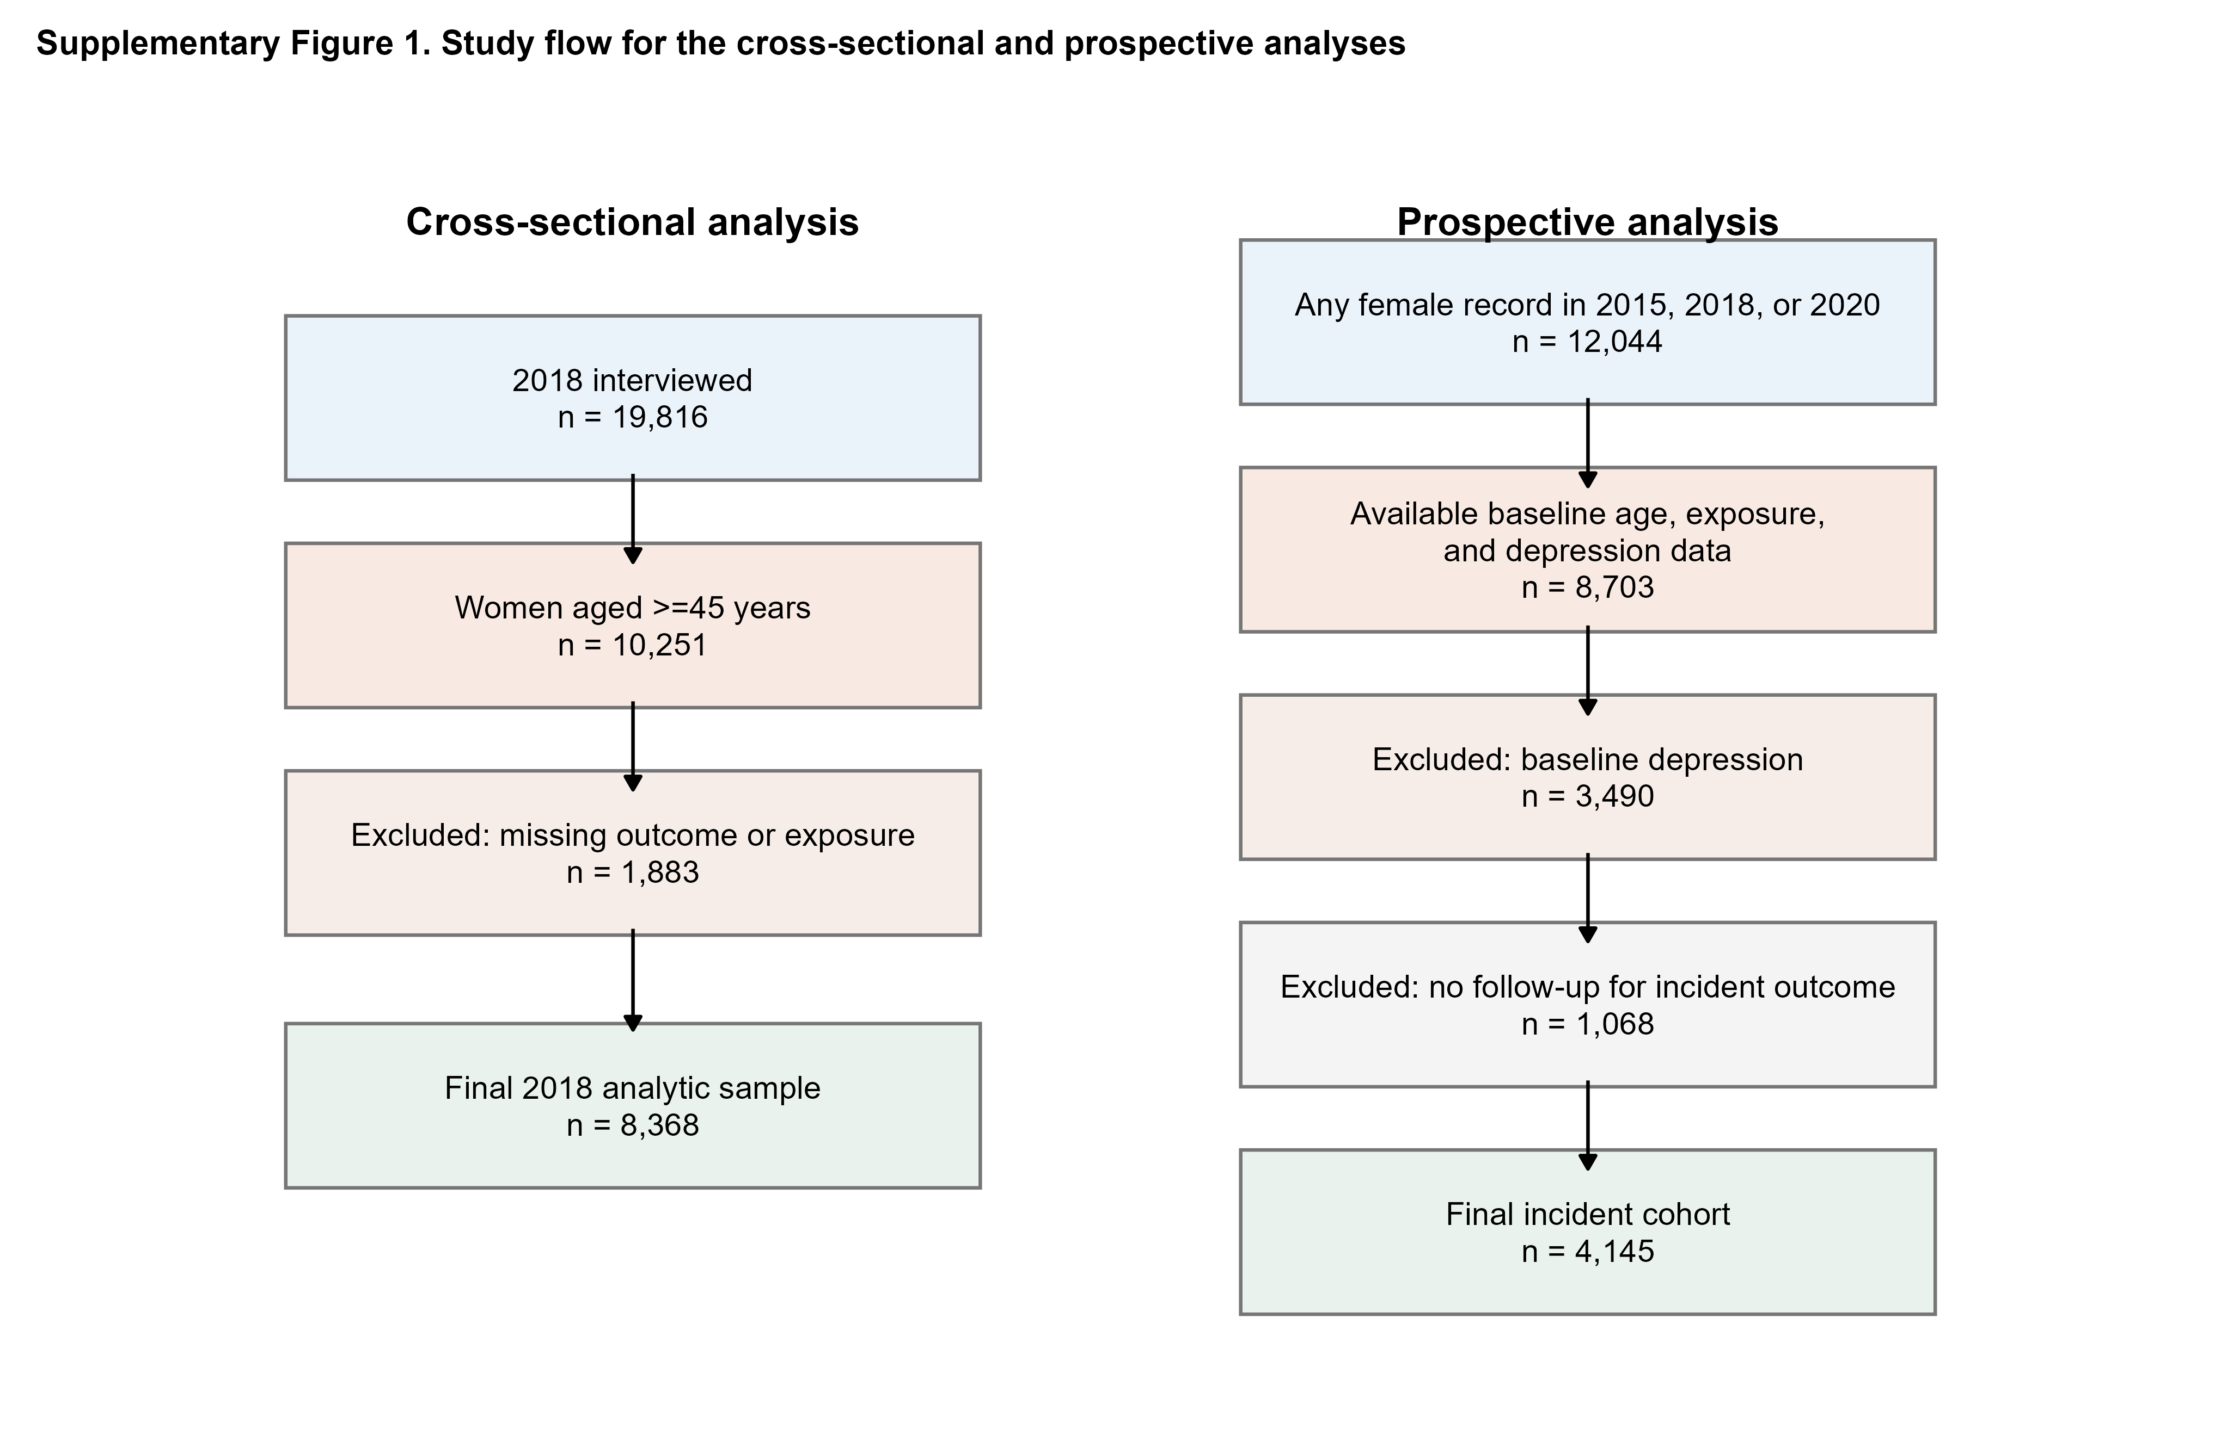
Note: The flowchart shows derivation of the 2018 cross-sectional sample and the 2015-2020 incident cohort after application of exposure, outcome, and follow-up requirements.

Supplementary Figure 2. Follow-up structure and cumulative incidence patterns
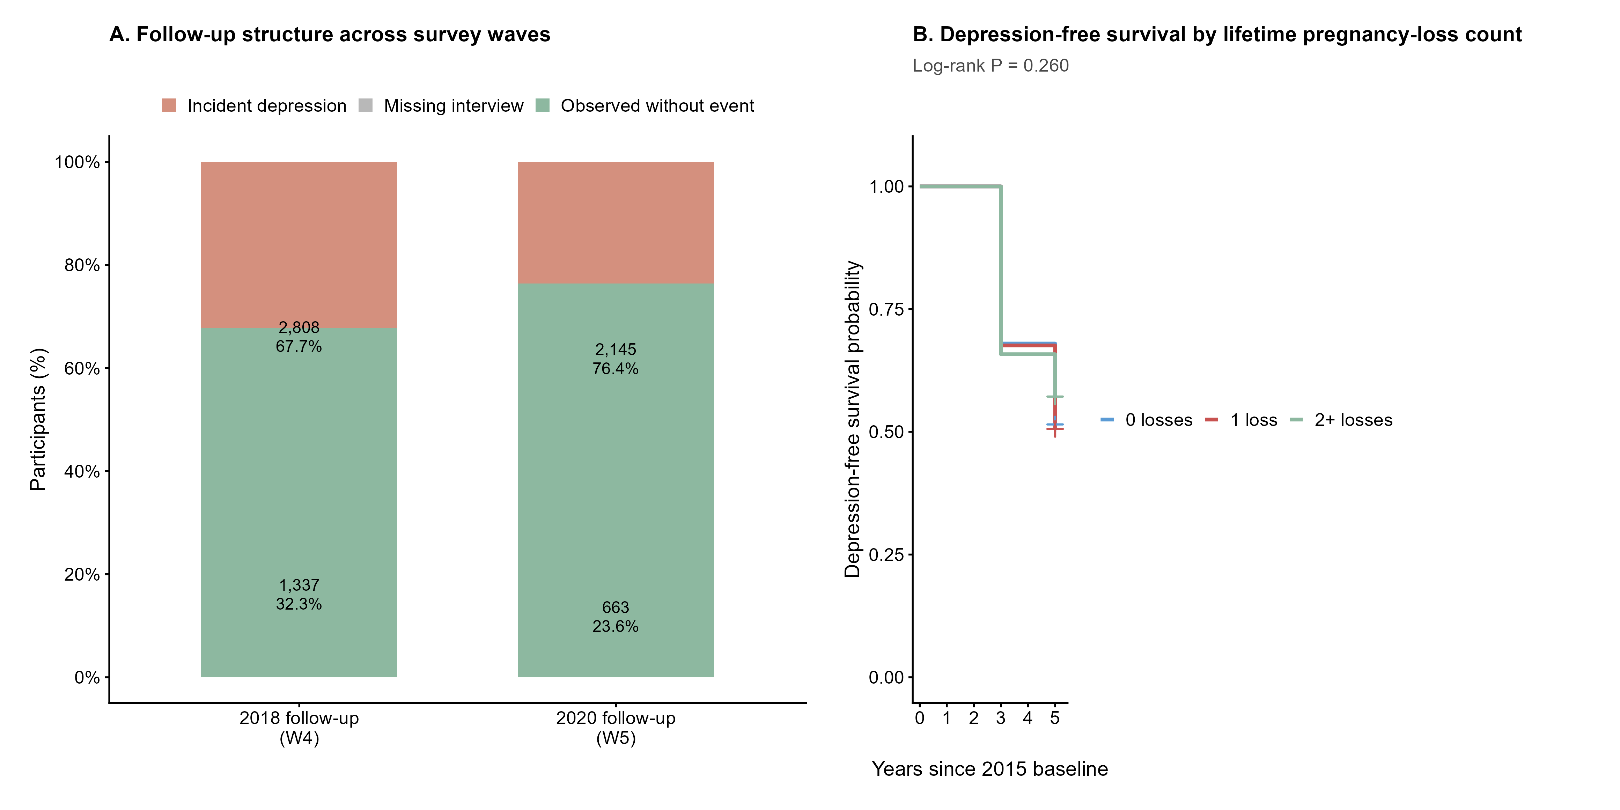
Note: Panel A summarises follow-up availability across waves 4 and 5. Panel B shows depression-free survival by lifetime pregnancy-loss count.

Supplementary Figure 3. Sequential attenuation after progressive covariate adjustment
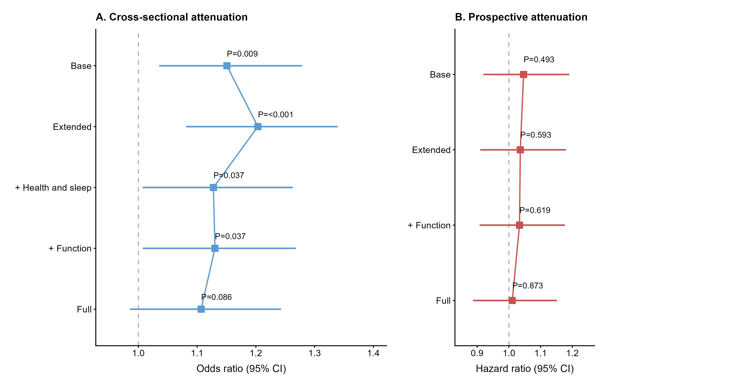
Note: Sequential attenuation plots show how the association between pregnancy loss and depressive symptoms changed after progressive adjustment for later-life health burden.

Supplementary Figure 4. Secondary exposure and sensitivity analyses
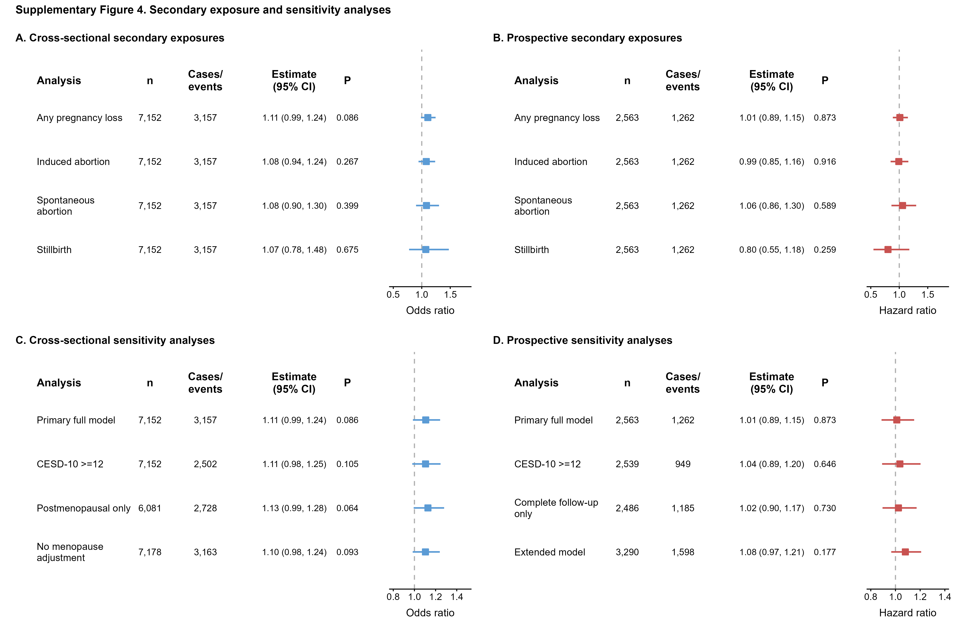
Note: Secondary exposure and sensitivity panels summarise subtype-specific associations and robustness analyses for both study designs.

