Supplementary Methods
MRI image quality control
Here, we implemented a rigorous, four-stage quality-control (QC) framework¹ integrating automated metrics with expert visual inspection to ensure the reliability of MRI images. This stringent framework enabled robust detection of imaging artifacts and acquisition errors, thereby safeguarding the accuracy and reliability of the neuroimaging data.
Step 1 | Initial QC of raw MRI images. We first excluded low-quality scans with evident acquisition-related issues. For datasets with established QC guidelines (dHCP, HCP-Development, HCP-Aging, HCP-Young Adult, and ABCD), we adhered to their recommended inclusion criteria. For the BCP dataset, all scans were independently reviewed by two experienced pediatric neuroradiologists. For the remaining datasets, we applied automated QC using MRIQC², extracting non-reference image quality metrics for T1w and T2w data. Structural images were flagged as outliers if they deviated beyond 1.5×IQR in the adverse direction in at least three metrics: entropy-focus criterion (EFC), foreground-background energy ratio (FBER), coefficient of joint variation (CJV), contrast-to-noise ratio (CNR), signal-to-noise ratio (SNR), and Dietrich’s SNR (SNRd).
Step 2 | Processing feasibility check. All remaining scans were submitted to the full MRI processing pipeline (see Methods). Scans that failed at any stage of pre- or post-processing were discarded.
Step 3 | Surface QC. Cortical surface quality was quantified using the Euler number estimated using FSQC², which is a topological index reflecting reconstruction defects. Images with Euler numbers falling below the study-specific threshold (Q1 − 1.5×IQR) were excluded.
Step 4 | Expert visual inspection. To further ensure data integrity, all scans passing automated QC underwent a two-round visual inspection by a team of anatomically trained raters. Discrepancies were resolved through group discussion to ensure consistent application of criteria. MRI scans were assessed for artifacts, as well as the accuracy of cortical segmentation, surface reconstruction, and spatial registration; T2w images were additionally evaluated for abnormal myelination patterns based on T1/T2 ratio. Finally, only participants passing all QC stages were retained for downstream analyses.
MRI data processing
For neonates with postmenstrual ages between 32 and 44 weeks from the developing Human Connectome Project (dHCP), we processed images using the officially recommended dHCP pipelines³, which are specifically optimized to accommodate the substantial anatomical and contrast differences between neonatal and adult brain imaging. Briefly, motion-corrected and reconstructed images were first bias-corrected and brain-extracted, followed by tissue segmentation into cerebrospinal fluid, white matter, and gray matter using the Draw-EM algorithm⁴. White matter masks were then separated into left and right hemispheres and used to generate topologically corrected white matter surfaces. Pial surfaces were obtained by expanding the white matter surfaces toward the gray–cerebrospinal fluid interface.
For participants aged 0–2 years, whose brain scans exhibit extremely low and dynamic tissue contrast due to ongoing myelination and maturation, we utilized iBEAT v2.0⁵ to process the MRI images. This pipeline has demonstrated superior accuracy and robustness in processing infant MRI data compared to existing methods⁵, leveraging deep learning techniques to perform preprocessing, skull stripping, tissue segmentation, topology correction, and surface reconstruction. Specifically, processing began with intensity inhomogeneity correction to mitigate bias fields and enhance tissue contrast uniformity, followed by skull stripping using two patch-based deep convolutional networks to accurately remove non-brain tissues. Tissue segmentation was then performed using an age-specific deep learning-based segmentation model, classifying the cerebrum into gray matter, white matter, and cerebrospinal fluid. The brain was subsequently partitioned into left and right hemispheres to enable hemisphere-specific analyses. Topology correction was applied to ensure that the cortical surfaces conformed to spherical topology constraints, using a learning-based approach to adaptively identify and correct topological defects, thereby eliminating artifacts introduced during segmentation. Cortical surface reconstruction was then conducted by generating inner (white matter) and outer (pial) surfaces using deformable surface models.
For participants aged two years and older, images were processed using FreeSurfer⁶ with the standard recon-all pipeline. The automated workflow began with motion correction, followed by non-uniform intensity normalization to correct for field inhomogeneities. Images were then registered to Talairach space and further intensity-normalized to improve tissue contrast and facilitate robust segmentation. Skull stripping was subsequently performed to remove non-brain tissues. Within the brain-extracted volumes, additional intensity normalization was applied, and white matter was segmented guided by intensity, spatial, and neighborhood priors. Surfaces were then reconstructed through volumetric filling, tessellation, and topology correction. The final white and pial surfaces were subsequently generated by deforming the initial surface along intensity gradients. Finally, the resulting surfaces were smoothed, inflated, and mapped onto a spherical coordinate system via spherical registration.

Supplementary Figures
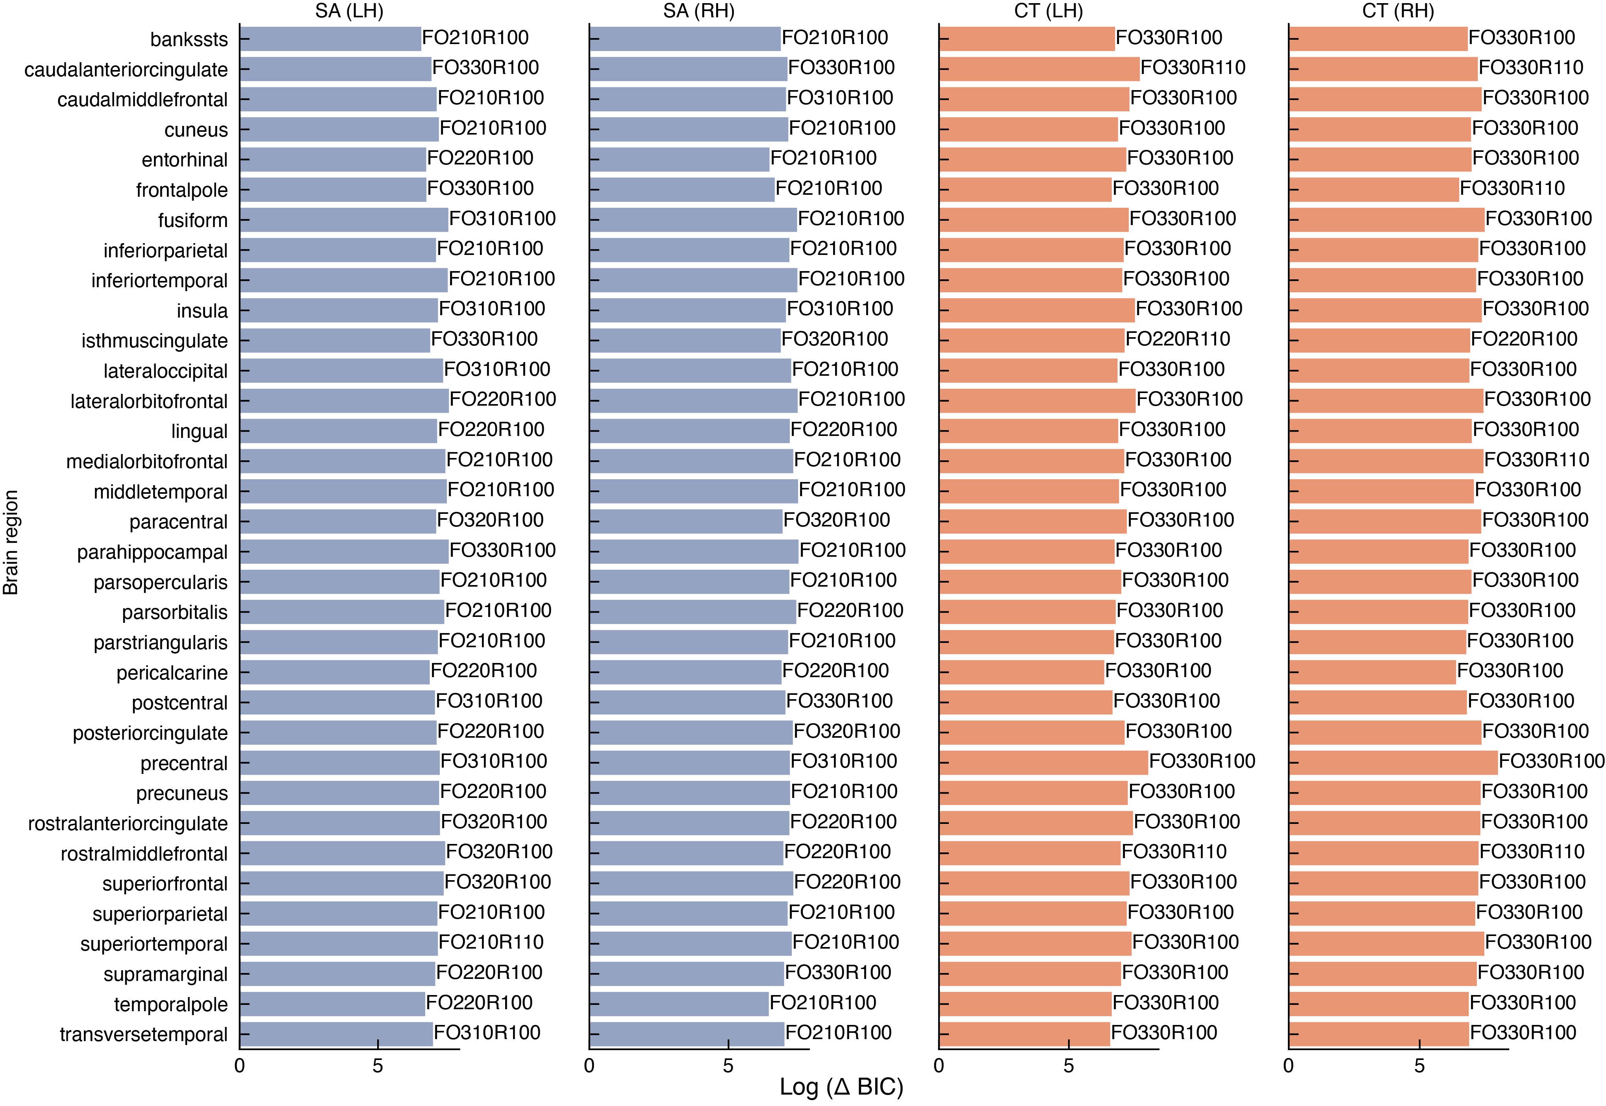Fig. S1 | Optimization of parameters in GAMLSS models. Relative improvements in model performance, quantified by the Bayesian information criterion (BIC), across multiple candidate GAMLSS configurations under the generalized gamma distribution. Values denote the log-scaled difference in BIC between the optimal model (lowest BIC) and base configuration. Model specifications annotated near bars indicate the fractional polynomial structure defined as baseFO[a][b][c]R[x][y][z], where a–c denotes the number of fractional polynomial terms included for the age effects on μ, σ, and ν, respectively, and x–z indicates whether random effects were estimated for each corresponding parameter.

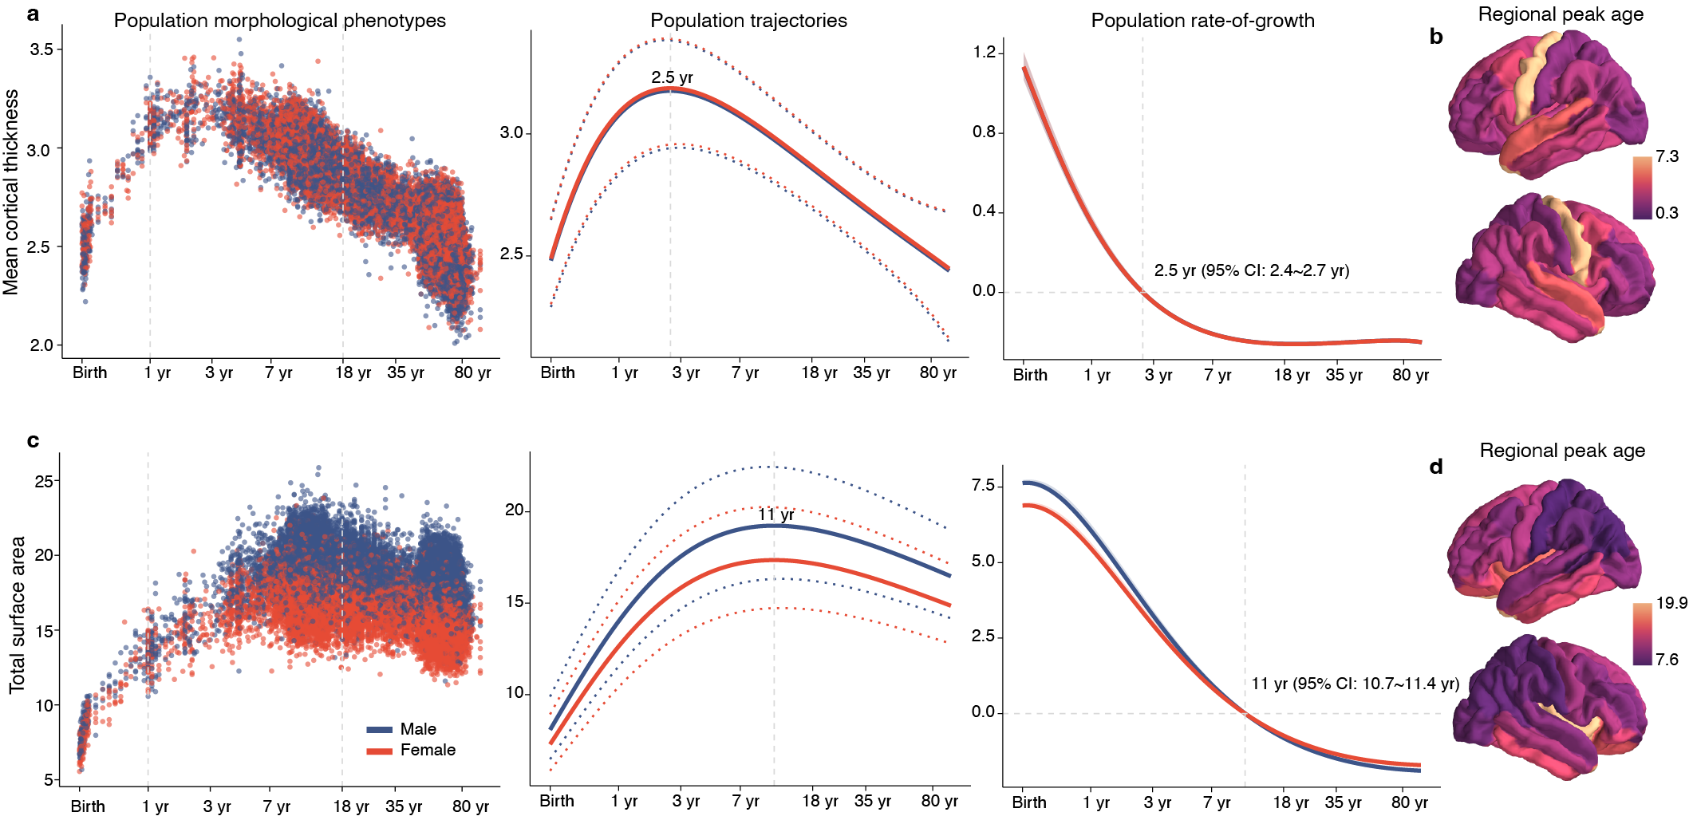
Fig. S2 | Lifespan trajectories of typical cortical development. a,c, Distribution of mean cortical thickness (CT) and total surface area (SA) across 60,234 healthy controls from birth to 100 years after rigorous quality control (left). Normative developmental trajectories were estimated using GAMLSS framework (middle), controlling for batch effects and stratified by sex (female, red; male, blue). Both CT and SA exhibited distinct, nonlinear lifespan trajectories, with median, 2.5th, and 97.5th centiles indicated by solid and dotted lines. Rates of age-related change (right) and corresponding 95% confidence intervals were derived using sex-stratified bootstrapping. b,d, Peak ages of CT and SA trajectories across 68 cortical regions defined by the Desikan–Killiany atlas, highlighting spatially heterogeneous maturational timing across the cortex. All trajectories are plotted against log-transformed age on the x-axis, with the y-axis expressed in the native units of each MRI-derived metric (mm for cortical thickness and 10,000 mm² for surface area).

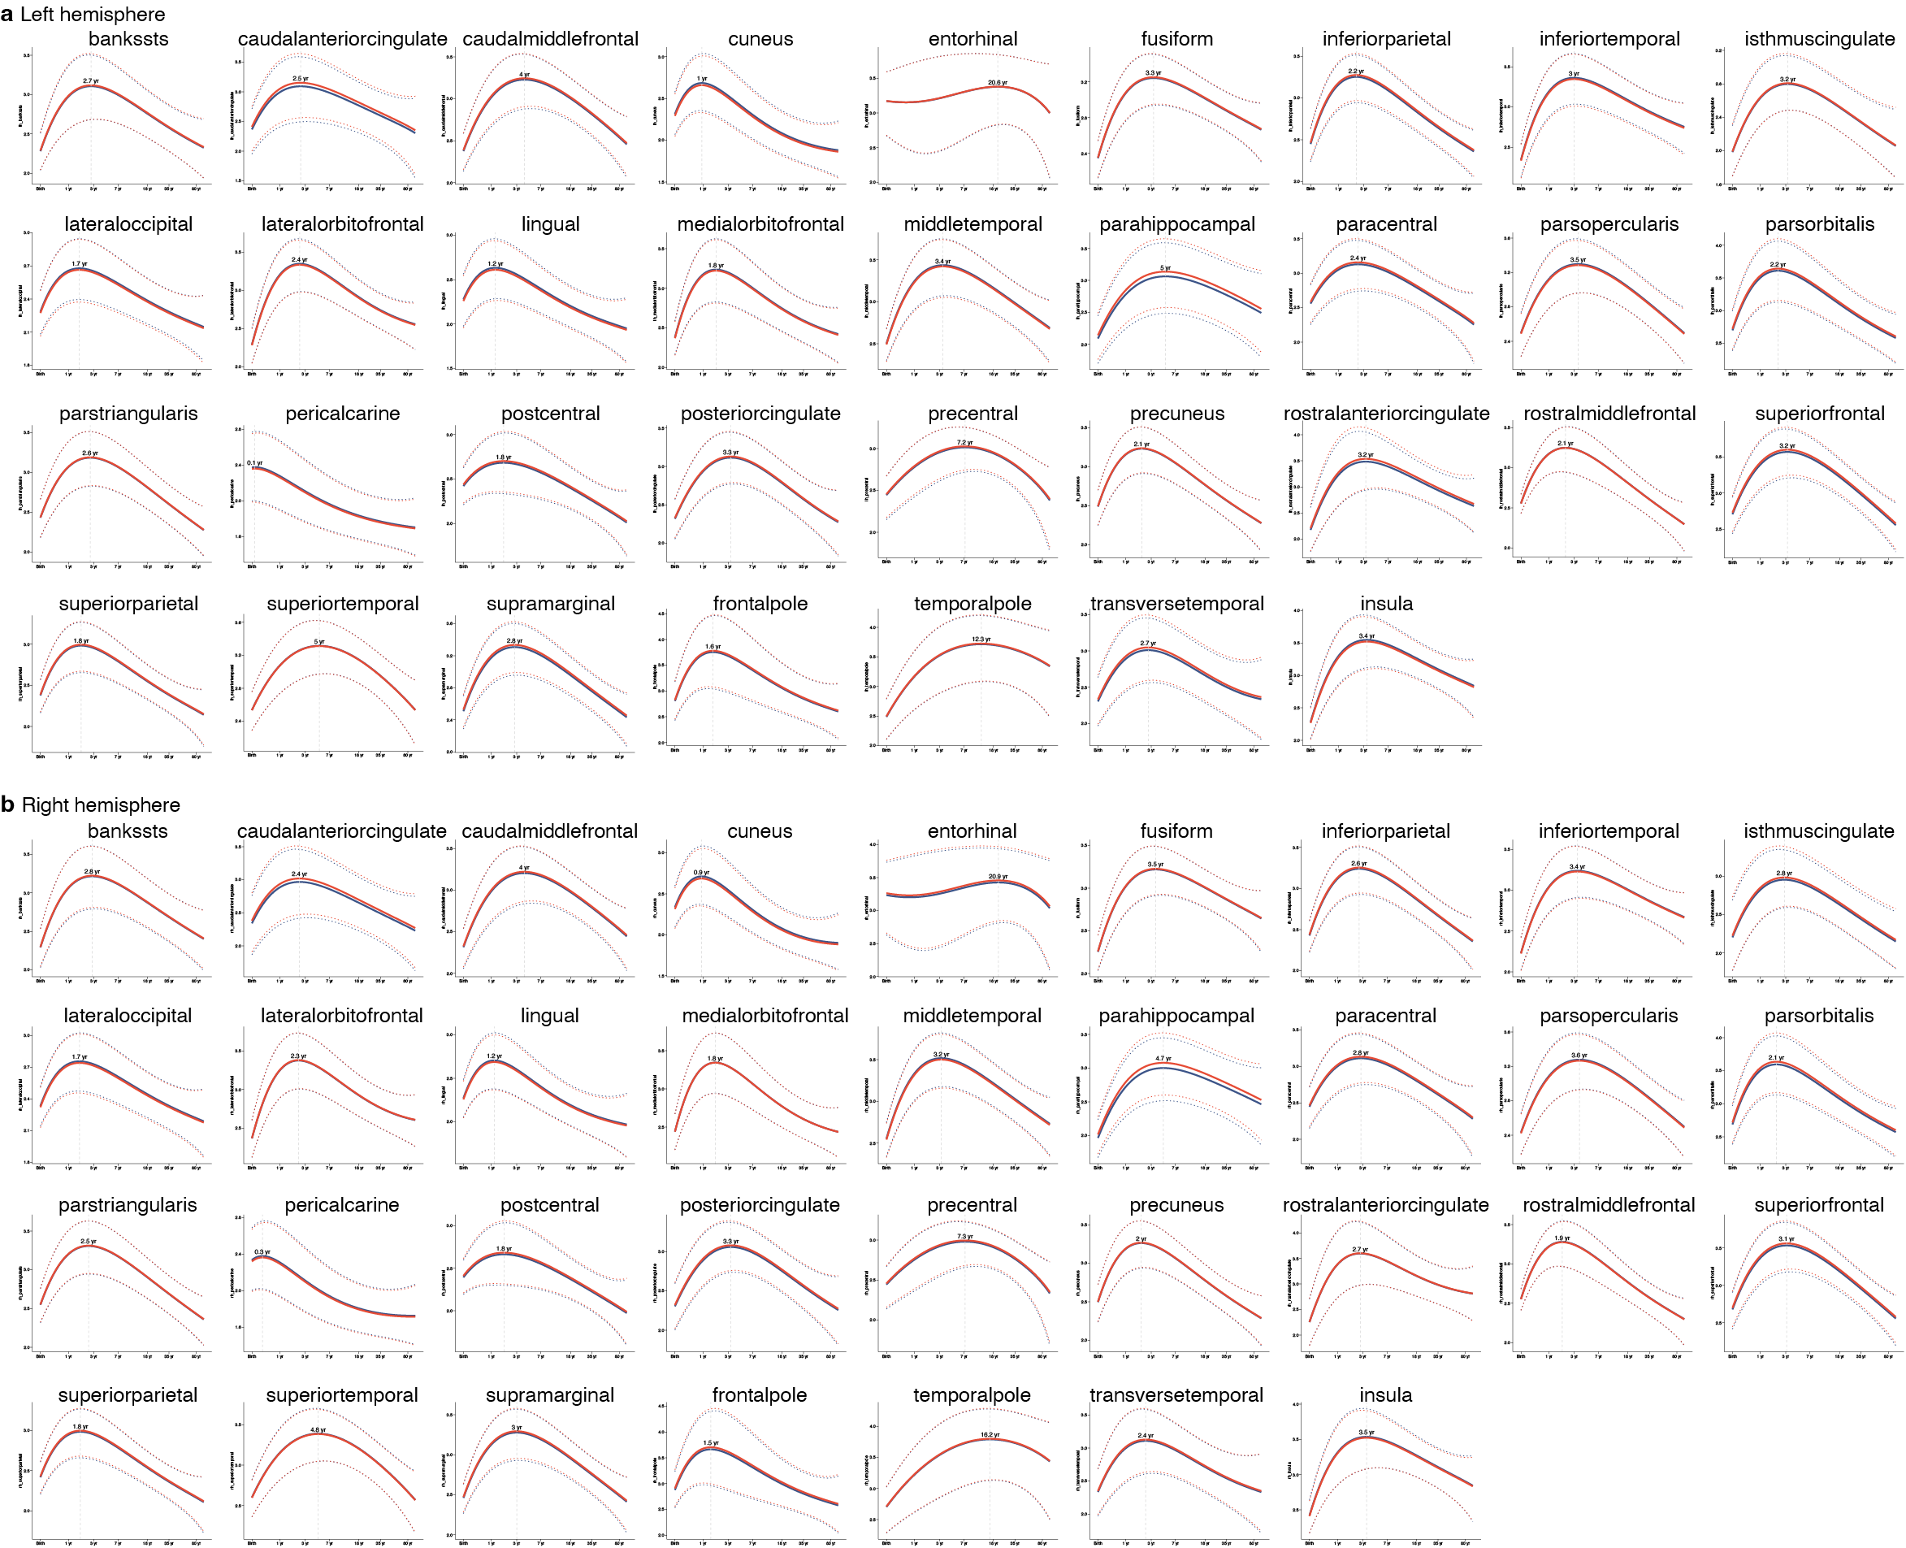
Fig. S3 | Regional lifespan trajectories of typical development for cortical thickness. a,b, Developmental trajectories of cortical thickness across 68 cortical regions defined by the Desikan–Killiany atlas, estimated using GAMLSS, controlling for batch effects and stratified by sex (female, red; male, blue). Solid lines represent the median trajectories, and dotted lines indicate the 2.5th and 97.5th centiles.
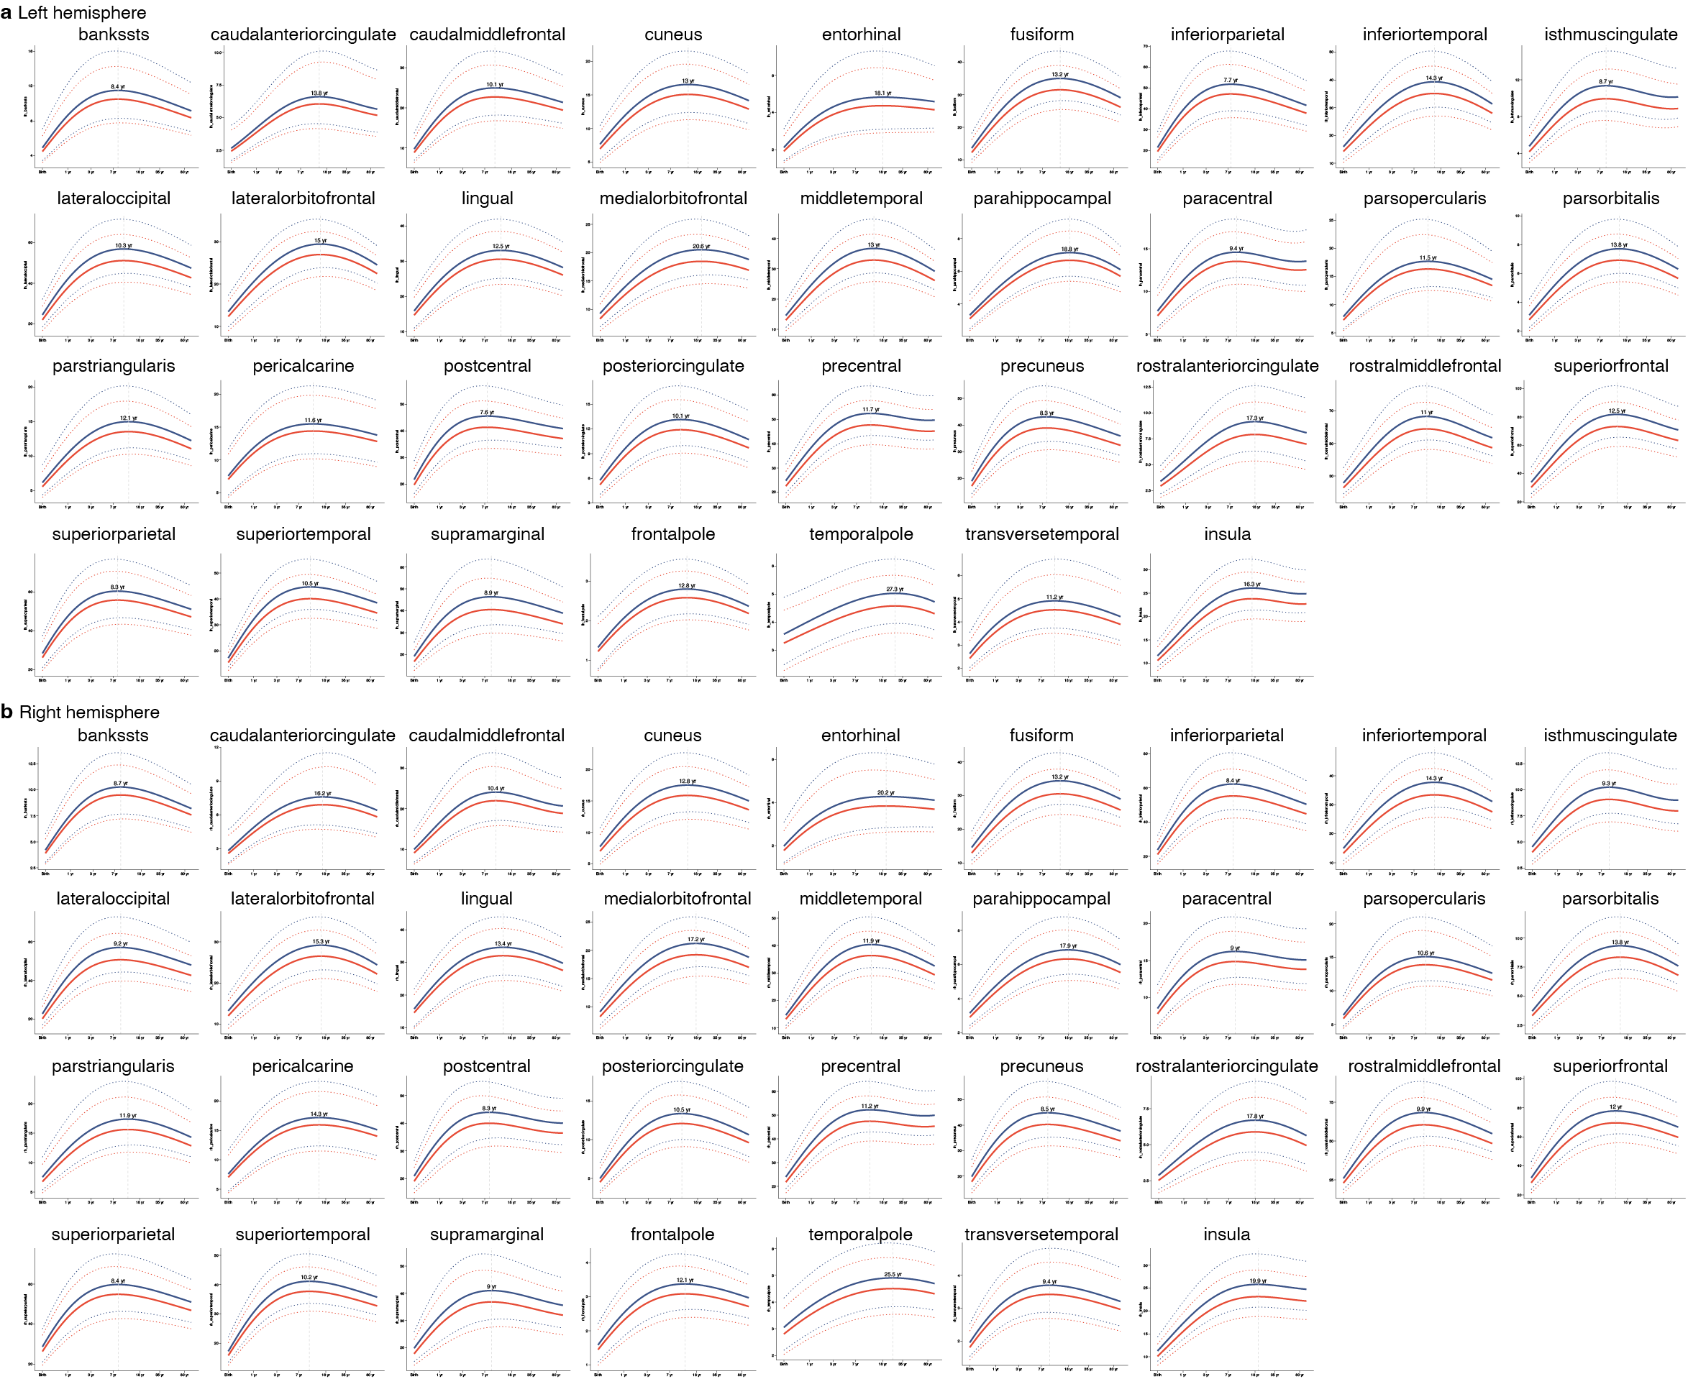
Fig. S4 | Regional lifespan trajectories of typical development for surface area. a,b, Developmental trajectories of surface area across 68 cortical regions defined by the Desikan–Killiany atlas, estimated using GAMLSS, controlling for batch effects and stratified by sex (female, red; male, blue). Solid lines represent the median trajectories, and dotted lines indicate the 2.5th and 97.5th centiles.

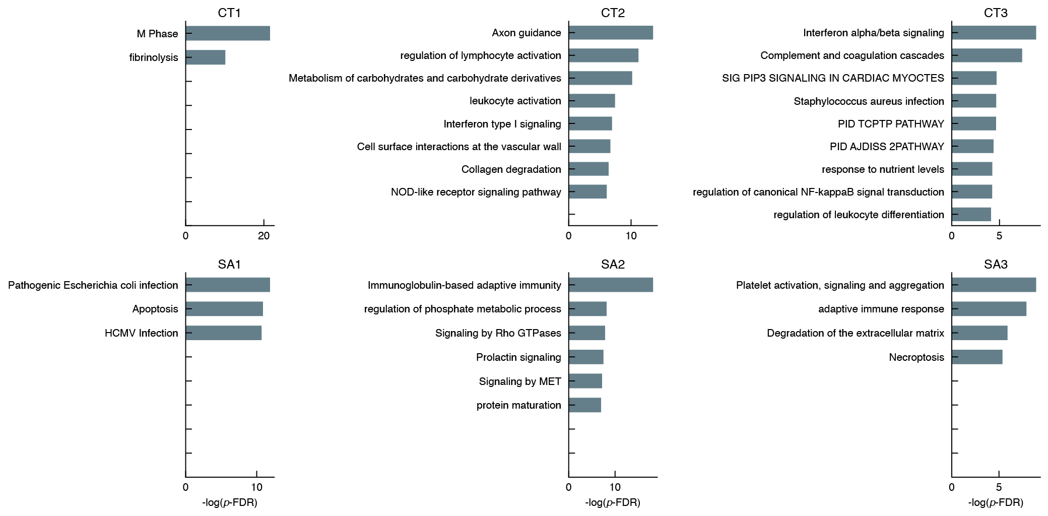
Fig. S5 | Subtype-specific biological processes. Biological processes enriched for plasma proteins that were significantly altered relative to healthy controls and uniquely associated with each ASD subtype. Shown are processes selectively enriched in proteins specific to each subtype, highlighting distinct molecular pathways underlying ASD heterogeneity.

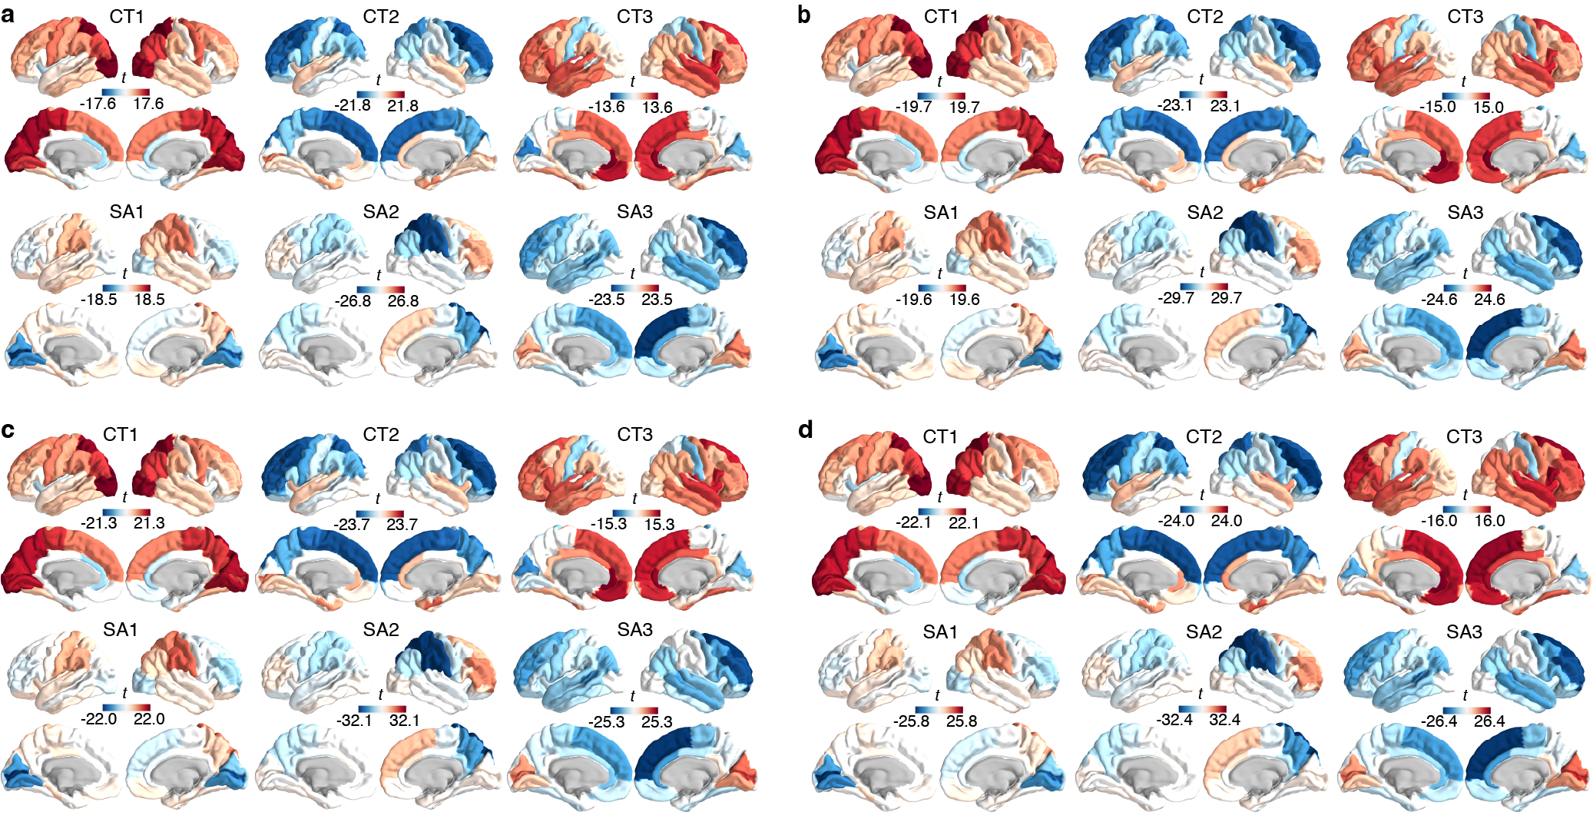
Fig. S6 | Validation of ASD subtypes. a–d, To evaluate the reproducibility of ASD subtypes, individuals with ASD were randomly subsampled at proportions ranging from 50% to 80%, and the categorical multilayer community detection was repeated. The resulting deviation patterns remained highly consistent across subsampling levels and closely recapitulated the primary findings, supporting the robustness and reproducibility of the identified subtypes.

References
1. Sun, L., et al. Human lifespan changes in the brain's functional connectome. Nat Neurosci 28, 891-901 (2025).
2. Esteban, O., et al. MRIQC: Advancing the automatic prediction of image quality in MRI from unseen sites. PLoS One 12, e0184661 (2017).
3. Makropoulos, A., et al. The developing human connectome project: A minimal processing pipeline for neonatal cortical surface reconstruction. Neuroimage 173, 88-112 (2018).
4. Makropoulos, A., et al. Automatic whole brain MRI segmentation of the developing neonatal brain. IEEE Trans Med Imaging 33, 1818-1831 (2014).
5. Wang, L., et al. iBEAT V2.0: a multisite-applicable, deep learning-based pipeline for infant cerebral cortical surface reconstruction. Nat Protoc 18, 1488-1509 (2023).
6. Dale, A.M., Fischl, B. & Sereno, M.I. Cortical surface-based analysis. I. Segmentation and surface reconstruction. Neuroimage 9, 179-194 (1999).

