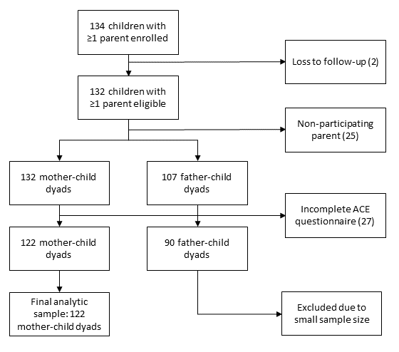
Supplementary Figure 1. Flow diagram of participant inclusion, exclusion, and availability of ACE questionnaire data, resulting in the final analytic sample of 122 mother-child dyads.

Supplementary File 1. The ACE questionnaire used in the study.
The following questions are all about the first 18 years of your life. Try to remember what happened to you as a child. In case you are in doubt, please choose the best answer.
- Did a parent or other adult in the household often or very often:
- Swear at you, insult you, put you down, or humiliate you?
  - Yes
  - No
  - Prefer not to answer
- Act in a way that made you afraid that you might be physically hurt?
  - Yes
  - No
  - Prefer not to answer

- Did a parent or other adult in the household often or very often:
- Push, grab, slap, or throw something at you?
  - Yes
  - No
  - Prefer not to answer
- Ever hit you so hard that you had marks or were injured?
  - Yes
  - No
  - Prefer not to answer

- Did an adult or person at least 5 years older than you ever…
- Touch or fondle you or have you touch their body in a sexual way?
  - Yes
  - No
  - Prefer not to answer
- Attempt or actually have oral, anal, or vaginal intercourse with you?
  - Yes
  - No
  - Prefer not to answer

- Did you often or very often feel that …
- No one in your family loved you or thought you were important or special?
  - Yes
  - No
  - Prefer not to answer
- Your family didn’t look out for each other, feel close to each other, or support each other?
  - Yes
  - No
  - Prefer not to answer
- Did you often or very often feel that …
- You didn’t have enough to eat, had to wear dirty clothes, and had no one to protect you?
  - Yes
  - No
  - Prefer not to answer
- Your parents were too drunk or high to take care of you or take you to the doctor if you needed it?
  - Yes
  - No
  - Prefer not to answer

- Were your parents ever separated or divorced?
  - Yes
  - No
  - Prefer not to answer

- Was your mother or stepmother…
- Often or very often pushed, grabbed, slapped, or had something thrown at her?
  - Yes
  - No
  - Prefer not to answer
- Sometimes, often, or very often kicked, bitten, hit with a fist, or hit with something hard?
  - Yes
  - No
  - Prefer not to answer
- Ever repeatedly hit at least a few minutes or threatened with a gun or knife?
  - Yes
  - No
  - Prefer not to answer

- Did you live with anyone who was a problem drinker or alcoholic or who used street drugs?
  - Yes
  - No
  - Prefer not to answer

- Was a household member depressed or mentally ill, or did a household member attempt suicide?
  - Yes
  - No
  - Prefer not to answer

- Did a household member go to prison?
  - Yes
  - No
  - Prefer not to answer

Supplementary Table 1. Overview of the specific adverse events corresponding to the questions in the survey as presented in supplementary information 1.
ACE category | Label | ACE-items
ACE 1 | Emotional Abuse | 1a and 1b
ACE 2 | Physical Abuse | 2a and 2b
ACE 3 | Sexual Abuse | 3a and 3b
ACE 4 | Emotional Neglect | 4a and 4b
ACE 5 | Physical Neglect | 5a and 5b
ACE 6 | Parental Separation or Divorce | 6
ACE 7 | Mother treated violently | 7a, 7b and 7c
ACE 8 | Household Substance Abuse | 8
ACE 9 | Household Mental Illness | 9
ACE 10 | Incarcerated Household Member | 10

​Supplementary Table 2. Sociodemographic characteristics of the study population (N = 122), stratified by maternal ACE categories.
Variable |  | N | None | Moderate | High | p-value¹
CHILD CHARACTERISTICS |  | 122 | N = 38 (31%) | N = 68 (57%) | N = 16 (13%)
Gestational age (weeks) |  |  |  |  |  | 0.4
Mean (SD) |  |  | 37 (4) | 35 (5) | 36 (4)
Birth weight (grams) |  |  |  |  |  | >0.9
Mean (SD) |  |  | 2,766 (1,035) | 2,634 (1,136) | 2,683 (988)
Child sex |  |  |  |  |  | >0.9
Female |  |  | 7 (44%) | 33 (49%) | 19 (50%)
Male |  |  | 9 (56%) | 35 (51%) | 19 (50%)
MATERNAL CHARACTERISTICS |  | 117 | N = 37 (32%) | N = 65 (56%) | N = 15 (13%)
Maternal age (years) |  |  |  |  |  | 0.5
Mean (SD) |  |  | 36.35 (4.50) | 35.43 (4.72) | 36.93 (3.69)
Religious belief |  |  |  |  |  | 0.2
No religion |  |  | 25 (68%) | 46 (71%) | 7 (47%)
Religious |  |  | 12 (32%) | 19 (29%) | 8 (53%)
Country of birth |  |  |  |  |  | 0.8
Netherlands |  |  | 25 (68%) | 48 (74%) | 11 (73%)
Other |  |  | 12 (32%) | 17 (26%) | 4 (27%)
Education level |  |  |  |  |  | >0.9
Higher education |  |  | 27 (73%) | 50 (77%) | 12 (80%)
Middle education |  |  | 7 (19%) | 12 (18%) | 2 (13%)
Lower education |  |  | 3 (8.1%) | 3 (4.6%) | 1 (6.7%)
Employment status |  |  |  |  |  | 0.7
Fulltime employed |  |  | 14 (38%) | 32 (49%) | 9 (60%)
Part-time employed |  |  | 16 (43%) | 23 (35%) | 4 (27%)
Other |  |  | 7 (19%) | 10 (15%) | 2 (13%)
Monthly family income |  |  |  |  |  | 0.7
High |  |  | 19 (51%) | 24 (37%) | 6 (40%)
Middle |  |  | 12 (32%) | 30 (46%) | 7 (47%)
Low |  |  | 6 (16%) | 11 (17%) | 2 (13%)
Psychiatric status² |  |  |  |  |  | 0.008
Any previous diagnosis |  |  | 3 (8.1%) | 20 (31%) | 6 (40%)
No history of mental illness |  |  | 34 (92%) | 45 (69%) | 9 (60%)
Neighbourhood SEP³ |  |  |  |  |  | 0.9
Mean (SD) |  |  | -0.04 (0.31) | 0.00 (0.32) | 0.00 (0.27)
Note. The number of mothers is lower than the number of children because twins were included as separate observations.
¹Pearson’s Chi-squared, Fisher’s exact, and Wilcoxon rank-sum tests were applied according to variable type and cell counts.
²Psychiatric status includes (previous) diagnosis for attention deficit hyperactivity disorder (ADHD),
anxiety disorder, depression, panic disorder, postnatal depression, and post-traumatic stress syndrome (PTSD).
³Neighbourhood SEP was assessed using the SES-WOA score from Statistics Netherlands, a composite index based on neighbourhood income, education, employment, and housing characteristics (range -0.826 to 0.818).

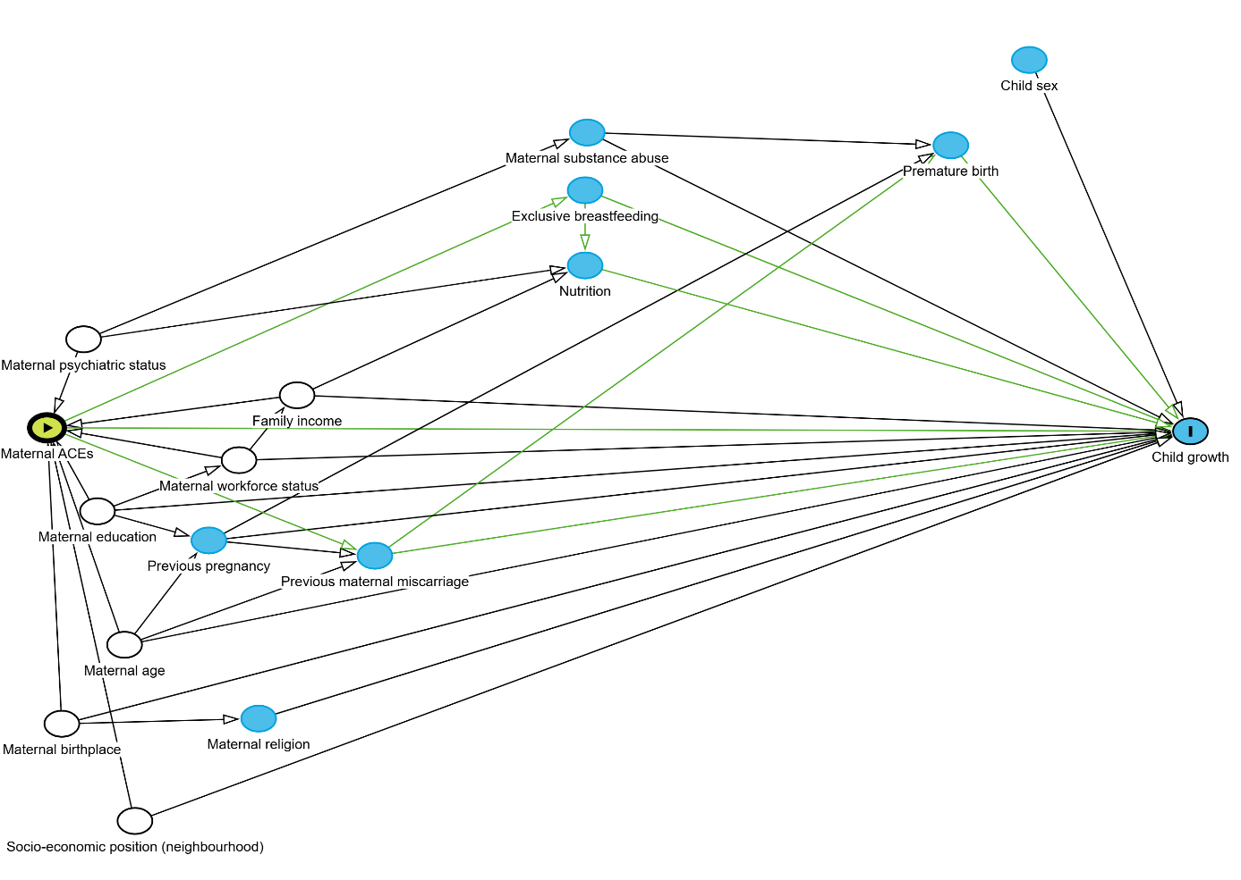
Supplementary Figure 2. Directed acyclic graph (DAG) illustrating the hypothesised relationships between maternal adverse childhood experiences (ACEs) and child growth. Nodes represent variables and arrows indicate assumed causal pathways. The green nodes and arrows indicate the minimally sufficient adjustment set identified to estimate the total effect of maternal ACEs on child growth. Blue nodes represent variables not included in the adjustment set, and white nodes represent additional background variables included in the causal model.
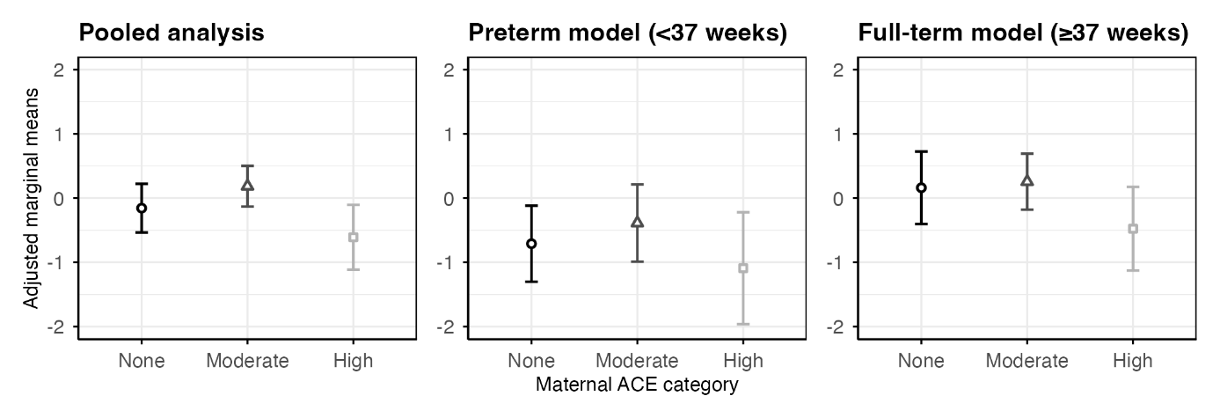
Supplementary Figure 3. Adjusted marginal means of infant weight z-scores by maternal ACE exposure category across three analyses. The figure shows adjusted marginal means with 95% confidence intervals for the pooled analysis (left), the preterm model (<37 weeks; middle), and the full-term model (≥37 weeks; right). Maternal ACE exposure was categorised as no exposure, moderate exposure (1–3 ACEs), or high exposure (≥4 ACEs).

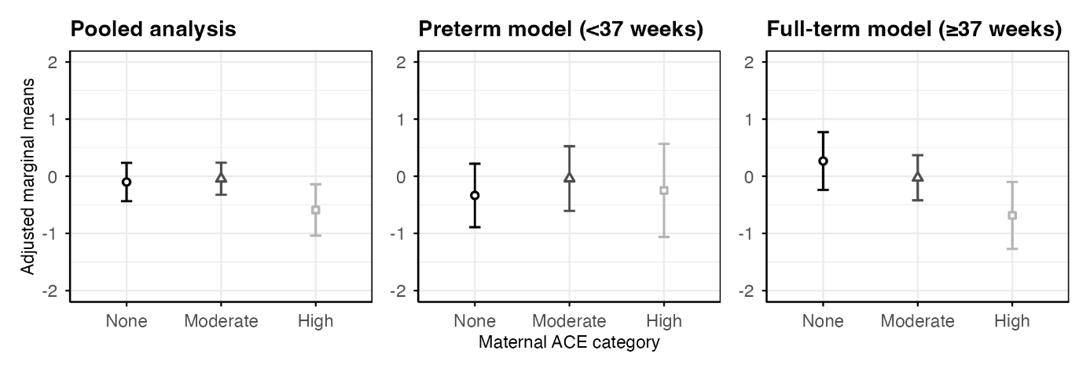
Supplementary Figure 4. Adjusted marginal means of infant length z-scores by maternal ACE exposure category across three analyses. The figure shows adjusted marginal means with 95% confidence intervals for the pooled analysis (left), the preterm model (<37 weeks; middle), and the full-term model (≥37 weeks; right). Maternal ACE exposure was categorised as no exposure, moderate exposure (1–3 ACEs), or high exposure (≥4 ACEs).

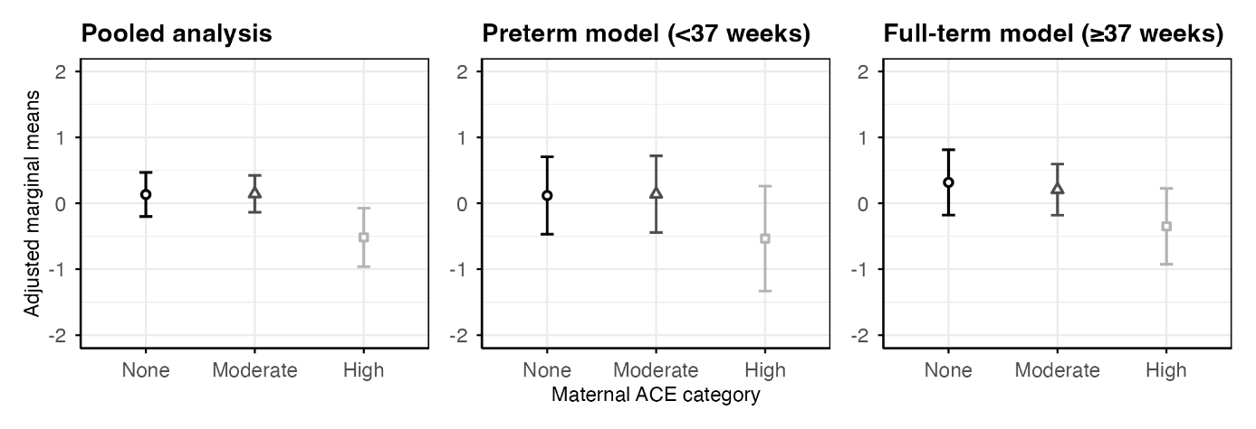
Supplementary Figure 5. Adjusted marginal means of infant head circumference z-scores by maternal ACE exposure category across three analyses. The figure shows adjusted marginal means with 95% confidence intervals for the pooled analysis (left), the preterm model (<37 weeks; middle), and the full-term model (≥37 weeks; right). Maternal ACE exposure was categorised as no exposure, moderate exposure (1–3 ACEs), or high exposure (≥4 ACEs).
Supplementary Table 3. Full output of the adjusted mixed effects model for weight z-scores.
POOLED MODEL
Term | Estimate | CI-lower | CI-upper | SE | df | p-value
(Intercept) | 0,404 | -1,043 | 1,851 | 0,730 | 104,688 | 0,581
age | 0,578 | 0,116 | 1,040 | 0,233 | 112,482 | 0,015 | *
Maternal ACEs - None | -0,254 | -0,756 | 0,249 | 0,253 | 105,739 | 0,319
Maternal ACEs - High | -0,748 | -1,396 | -0,101 | 0,326 | 105,488 | 0,024 | *
Prematurity | 0,063 | -0,389 | 0,515 | 0,228 | 105,296 | 0,782
Education.L | 0,145 | -0,402 | 0,692 | 0,276 | 104,923 | 0,601
Education.Q | -0,029 | -0,449 | 0,391 | 0,212 | 104,810 | 0,892
Workforce status - Parttime employed | 0,066 | -0,301 | 0,432 | 0,185 | 105,794 | 0,723
Workforce status - Other | -0,416 | -0,941 | 0,110 | 0,265 | 104,411 | 0,120
Income.L | -0,109 | -0,528 | 0,310 | 0,211 | 106,497 | 0,607
Income.Q | 0,168 | -0,121 | 0,457 | 0,146 | 104,490 | 0,251
Neighbourhood SEP | 0,383 | -0,172 | 0,937 | 0,279 | 103,210 | 0,174
Psychiatric status - No history | 0,095 | -0,301 | 0,490 | 0,199 | 105,585 | 0,635
Maternal age | -0,008 | -0,050 | 0,035 | 0,021 | 104,115 | 0,726
Birth country - Not Netherlands | -0,010 | -0,395 | 0,376 | 0,195 | 103,890 | 0,961
Maternal ACEs - None:Prematurity | -0,185 | -0,921 | 0,551 | 0,371 | 104,687 | 0,619
Maternal ACEs - High:Prematurity | -0,091 | -1,095 | 0,914 | 0,506 | 102,895 | 0,858
PRETERM MODEL
Term | Estimate | CI-lower | CI-upper | SE | df | p-value
(Intercept) | -0,975 | -2,776 | 0,826 | 0,894 | 44,130 | 0,281
age | 0,515 | -0,105 | 1,134 | 0,308 | 48,979 | 0,101
Maternal ACEs - None | -0,322 | -0,816 | 0,172 | 0,245 | 44,017 | 0,196
Maternal ACEs - High | -0,703 | -1,394 | -0,011 | 0,343 | 43,870 | 0,046 | *
Education.L | 1,201 | 0,307 | 2,095 | 0,444 | 44,276 | 0,010 | *
Education.Q | -0,674 | -1,291 | -0,057 | 0,306 | 44,092 | 0,033 | *
Workforce status - Parttime employed | 0,193 | -0,297 | 0,684 | 0,243 | 44,165 | 0,431
Workforce status - Other | -0,615 | -1,337 | 0,107 | 0,358 | 43,888 | 0,093 | .
Income.L | -0,456 | -1,015 | 0,103 | 0,277 | 44,136 | 0,107
Income.Q | 0,382 | -0,004 | 0,768 | 0,191 | 44,037 | 0,052 | .
Neighbourhood SEP | 0,264 | -0,398 | 0,926 | 0,328 | 43,975 | 0,426
Psychiatric status - No history | 0,269 | -0,283 | 0,822 | 0,274 | 44,131 | 0,331
Maternal age | 0,023 | -0,031 | 0,077 | 0,027 | 43,994 | 0,399
Birth country - Not Netherlands | -0,452 | -1,038 | 0,134 | 0,291 | 43,968 | 0,127
FULL-TERM MODEL
Term | Estimate | CI-lower | CI-upper | SE | df | p-value
(Intercept) | 0,881 | -1,471 | 3,234 | 1,172 | 51,272 | 0,455
age | 0,640 | -0,072 | 1,352 | 0,356 | 62,056 | 0,077 | .
Maternal ACEs - None | -0,095 | -0,644 | 0,453 | 0,273 | 49,870 | 0,729
Maternal ACEs - High | -0,732 | -1,416 | -0,048 | 0,340 | 49,936 | 0,036 | *
Education.L | -0,346 | -1,076 | 0,383 | 0,363 | 50,286 | 0,345
Education.Q | 0,094 | -0,516 | 0,704 | 0,304 | 51,333 | 0,759
Workforce status - Parttime employed | -0,177 | -0,697 | 0,342 | 0,258 | 49,196 | 0,496
Workforce status - Other | -0,607 | -1,372 | 0,158 | 0,381 | 50,929 | 0,117
Income.L | 0,084 | -0,588 | 0,756 | 0,335 | 51,191 | 0,803
Income.Q | -0,199 | -0,641 | 0,243 | 0,220 | 49,571 | 0,371
Neighbourhood SEP | 0,311 | -0,549 | 1,172 | 0,428 | 48,833 | 0,470
Psychiatric status - No history | 0,049 | -0,493 | 0,591 | 0,270 | 48,980 | 0,856
Maternal age | -0,015 | -0,081 | 0,051 | 0,033 | 50,779 | 0,646
Birth country - Not Netherlands | 0,047 | -0,502 | 0,596 | 0,273 | 49,770 | 0,864
Note. Fixed-effect estimates from adjusted linear mixed-effects models for weight z-scores. Moderate maternal ACE exposure (1–3 ACEs) was the reference category. Models were adjusted for maternal sociodemographic and clinical covariates; the pooled model additionally included prematurity and ACE × prematurity interaction terms. 95% confidence intervals shown. . p < 0.10; * p < 0.05; ** p < 0.01.

Supplementary Table 4. Full output of the adjusted mixed effects model for length z-scores.
POOLED MODEL
Term | Estimate | CI-lower | CI-upper | SE | df | p-value
(Intercept) | 0,036 | -1,234 | 1,305 | 0,640 | 102,138 | 0,956
age | 0,312 | -0,050 | 0,674 | 0,182 | 86,229 | 0,090 | .
Maternal ACEs - None | 0,139 | -0,307 | 0,586 | 0,225 | 109,275 | 0,537
Maternal ACEs - High | -0,644 | -1,221 | -0,068 | 0,291 | 110,001 | 0,029 | *
Prematurity | 0,127 | -0,270 | 0,524 | 0,200 | 104,418 | 0,528
Education.L | 0,284 | -0,198 | 0,765 | 0,243 | 104,395 | 0,245
Education.Q | -0,157 | -0,526 | 0,212 | 0,186 | 102,902 | 0,401
Workforce status - Parttime employed | 0,111 | -0,211 | 0,432 | 0,162 | 104,041 | 0,496
Workforce status - Other | -0,195 | -0,657 | 0,267 | 0,233 | 102,839 | 0,405
Income.L | -0,164 | -0,530 | 0,202 | 0,185 | 102,317 | 0,377
Income.Q | 0,168 | -0,085 | 0,422 | 0,128 | 102,430 | 0,191
Neighbourhood SEP | 0,571 | 0,083 | 1,058 | 0,246 | 101,642 | 0,022 | *
Psychiatric status - No history | -0,063 | -0,411 | 0,284 | 0,175 | 104,398 | 0,719
Maternal age | -0,001 | -0,039 | 0,036 | 0,019 | 102,038 | 0,941
Birth country - Not Netherlands | -0,143 | -0,483 | 0,197 | 0,172 | 103,804 | 0,406
Maternal ACEs - None:Prematurity | -0,401 | -1,047 | 0,246 | 0,326 | 102,868 | 0,222
Maternal ACEs - High:Prematurity | 0,307 | -0,574 | 1,188 | 0,444 | 100,819 | 0,491
PRETERM MODEL
Term | Estimate | CI-lower | CI-upper | SE | df | p-value
(Intercept) | -0,686 | -2,371 | 0,999 | 0,836 | 43,823 | 0,416
age | -0,135 | -0,669 | 0,399 | 0,262 | 29,978 | 0,609
Maternal ACEs - None | -0,295 | -0,757 | 0,166 | 0,229 | 43,549 | 0,204
Maternal ACEs - High | -0,208 | -0,852 | 0,436 | 0,319 | 42,657 | 0,518
Education.L | 0,615 | -0,223 | 1,453 | 0,416 | 44,134 | 0,146
Education.Q | -0,355 | -0,932 | 0,223 | 0,286 | 43,597 | 0,222
Workforce status - Parttime employed | 0,379 | -0,078 | 0,836 | 0,227 | 43,110 | 0,102
Workforce status - Other | -0,090 | -0,763 | 0,584 | 0,334 | 42,846 | 0,790
Income.L | -0,310 | -0,833 | 0,213 | 0,259 | 43,823 | 0,239
Income.Q | 0,318 | -0,042 | 0,678 | 0,179 | 43,398 | 0,082 | .
Neighbourhood SEP | 0,527 | -0,090 | 1,143 | 0,306 | 42,846 | 0,092 | .
Psychiatric status - No history | -0,016 | -0,533 | 0,502 | 0,257 | 43,965 | 0,952
Maternal age | 0,019 | -0,031 | 0,070 | 0,025 | 43,238 | 0,450
Birth country - Not Netherlands | -0,144 | -0,690 | 0,402 | 0,271 | 42,880 | 0,598
FULL-TERM MODEL
Term | Estimate | CI-lower | CI-upper | SE | df | p-value
(Intercept) | 1,571 | -0,564 | 3,707 | 1,064 | 52,024 | 0,146
age | 0,785 | 0,281 | 1,290 | 0,252 | 60,487 | 0,003 | **
Maternal ACEs - None | 0,292 | -0,208 | 0,793 | 0,249 | 51,751 | 0,246
Maternal ACEs - High | -0,658 | -1,282 | -0,035 | 0,310 | 51,695 | 0,039 | *
Education.L | -0,106 | -0,769 | 0,557 | 0,330 | 51,507 | 0,750
Education.Q | -0,151 | -0,705 | 0,403 | 0,276 | 51,960 | 0,587
Workforce status - Parttime employed | -0,305 | -0,779 | 0,170 | 0,236 | 51,378 | 0,203
Workforce status - Other | -0,617 | -1,313 | 0,078 | 0,347 | 52,118 | 0,081 | .
Income.L | 0,090 | -0,521 | 0,700 | 0,304 | 52,083 | 0,769
Income.Q | -0,126 | -0,528 | 0,277 | 0,201 | 51,169 | 0,533
Neighbourhood SEP | 0,647 | -0,141 | 1,434 | 0,392 | 51,603 | 0,105
Psychiatric status - No history | -0,174 | -0,669 | 0,320 | 0,246 | 51,136 | 0,482
Maternal age | -0,036 | -0,097 | 0,024 | 0,030 | 51,825 | 0,230
Birth country - Not Netherlands | -0,274 | -0,776 | 0,228 | 0,250 | 52,214 | 0,278
Note. Fixed-effect estimates from adjusted linear mixed-effects models for length z-scores. Moderate maternal ACE exposure (1–3 ACEs) was the reference category. Models were adjusted for maternal sociodemographic and clinical covariates; the pooled model additionally included prematurity and ACE × prematurity interaction terms. 95% confidence intervals shown. . p < 0.10; * p < 0.05; ** p < 0.01.

Supplementary Table 5. Full output of the adjusted mixed effects model for head circumference z-scores.
POOLED MODEL
Term | Estimate | CI-lower | CI-upper | SE | df | p-value
(Intercept) | 0,579 | -0,710 | 1,867 | 0,650 | 101,597 | 0,375
age | -0,875 | -1,265 | -0,485 | 0,196 | 90,608 | 0,000 | **
Maternal ACEs - None | 0,035 | -0,403 | 0,473 | 0,221 | 99,887 | 0,874
Maternal ACEs - High | -0,563 | -1,127 | 0,000 | 0,284 | 99,244 | 0,050 | .
Prematurity | -0,098 | -0,507 | 0,311 | 0,206 | 102,266 | 0,636
Education.L | 0,183 | -0,305 | 0,670 | 0,246 | 103,401 | 0,459
Education.Q | -0,181 | -0,554 | 0,192 | 0,188 | 103,476 | 0,338
Workforce status - Parttime employed | 0,258 | -0,081 | 0,597 | 0,171 | 100,924 | 0,134
Workforce status - Other | 0,183 | -0,286 | 0,652 | 0,236 | 102,448 | 0,441
Income.L | -0,083 | -0,477 | 0,312 | 0,199 | 101,886 | 0,679
Income.Q | -0,024 | -0,287 | 0,238 | 0,132 | 100,807 | 0,853
Neighbourhood SEP | 0,264 | -0,226 | 0,755 | 0,247 | 101,688 | 0,288
Psychiatric status - No history | -0,212 | -0,570 | 0,145 | 0,180 | 99,547 | 0,241
Maternal age | -0,004 | -0,042 | 0,034 | 0,019 | 101,569 | 0,851
Birth country - Not Netherlands | -0,198 | -0,550 | 0,154 | 0,178 | 101,692 | 0,267
Maternal ACEs - None:Prematurity | -0,122 | -0,783 | 0,538 | 0,333 | 102,176 | 0,714
Maternal ACEs - High:Prematurity | -0,277 | -1,164 | 0,610 | 0,447 | 101,474 | 0,537
PRETERM MODEL
Term | Estimate | CI-lower | CI-upper | SE | df | p-value
(Intercept) | 1,626 | 0,001 | 3,250 | 0,801 | 36,420 | 0,050 | .
age | -0,936 | -1,621 | -0,250 | 0,338 | 37,310 | 0,009 | **
Maternal ACEs - None | -0,020 | -0,444 | 0,403 | 0,209 | 35,934 | 0,923
Maternal ACEs - High | -0,673 | -1,280 | -0,067 | 0,301 | 42,471 | 0,030 | *
Education.L | 0,605 | -0,315 | 1,524 | 0,459 | 53,324 | 0,193
Education.Q | -0,521 | -1,130 | 0,087 | 0,304 | 53,446 | 0,092 | .
Workforce status - Parttime employed | 0,919 | 0,418 | 1,420 | 0,248 | 42,978 | 0,001 | **
Workforce status - Other | 0,872 | 0,203 | 1,541 | 0,333 | 48,000 | 0,012 | *
Income.L | 0,050 | -0,496 | 0,597 | 0,269 | 33,509 | 0,852
Income.Q | -0,012 | -0,353 | 0,328 | 0,167 | 31,504 | 0,942
Neighbourhood SEP | 0,272 | -0,308 | 0,852 | 0,288 | 44,022 | 0,349
Psychiatric status - No history | -0,460 | -0,962 | 0,042 | 0,247 | 32,481 | 0,071 | .
Maternal age | -0,047 | -0,096 | 0,003 | 0,024 | 37,803 | 0,065 | .
Birth country - Not Netherlands | -0,187 | -0,759 | 0,384 | 0,283 | 42,907 | 0,512
FULL-TERM MODEL
Term | Estimate | CI-lower | CI-upper | SE | df | p-value
(Intercept) | 0,158 | -1,943 | 2,258 | 1,047 | 51,888 | 0,881
age | -0,739 | -1,204 | -0,273 | 0,233 | 58,807 | 0,002 | **
Maternal ACEs - None | 0,110 | -0,382 | 0,601 | 0,245 | 51,441 | 0,656
Maternal ACEs - High | -0,556 | -1,169 | 0,056 | 0,305 | 51,371 | 0,074 | .
Education.L | 0,040 | -0,612 | 0,692 | 0,325 | 51,333 | 0,903
Education.Q | -0,034 | -0,579 | 0,511 | 0,272 | 52,010 | 0,901
Workforce status - Parttime employed | -0,065 | -0,531 | 0,401 | 0,232 | 51,050 | 0,782
Workforce status - Other | -0,301 | -0,985 | 0,383 | 0,341 | 51,889 | 0,381
Income.L | -0,256 | -0,856 | 0,344 | 0,299 | 51,956 | 0,396
Income.Q | -0,226 | -0,622 | 0,170 | 0,197 | 51,014 | 0,257
Neighbourhood SEP | 0,107 | -0,667 | 0,880 | 0,385 | 51,124 | 0,783
Psychiatric status - No history | -0,176 | -0,662 | 0,311 | 0,242 | 50,876 | 0,472
Maternal age | 0,013 | -0,046 | 0,073 | 0,029 | 51,779 | 0,650
Birth country - Not Netherlands | 0,001 | -0,491 | 0,493 | 0,245 | 51,534 | 0,997
Note. Fixed-effect estimates from adjusted linear mixed-effects models for head circumference z-scores. Moderate maternal ACE exposure (1–3 ACEs) was the reference category. Models were adjusted for maternal sociodemographic and clinical covariates; the pooled model additionally included prematurity and ACE × prematurity interaction terms. 95% confidence intervals shown. . p < 0.10; * p < 0.05; ** p < 0.01.

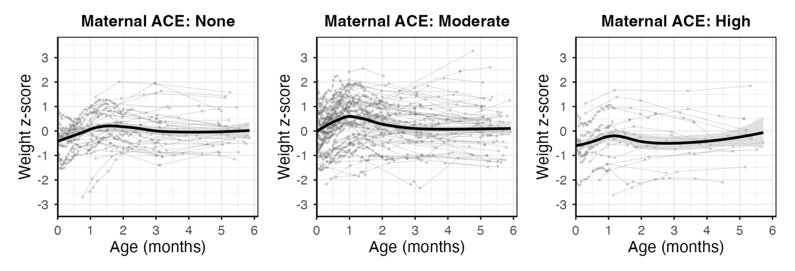
Supplementary Figure 6. Observed individual weight z-score trajectories during the first 6 months of life, stratified by maternal ACE category.

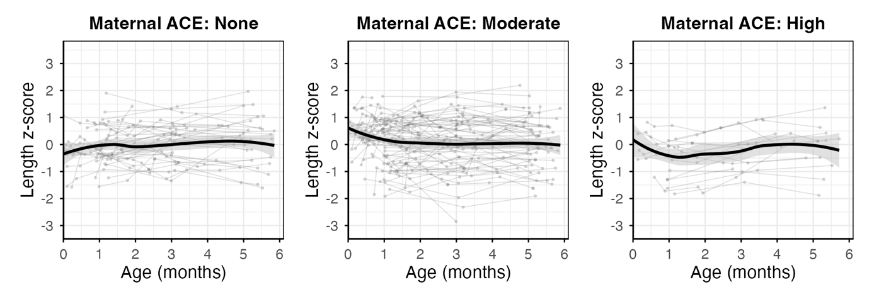
Supplementary Figure 7. Observed individual length z-score trajectories during the first 6 months of life, stratified by maternal ACE category.

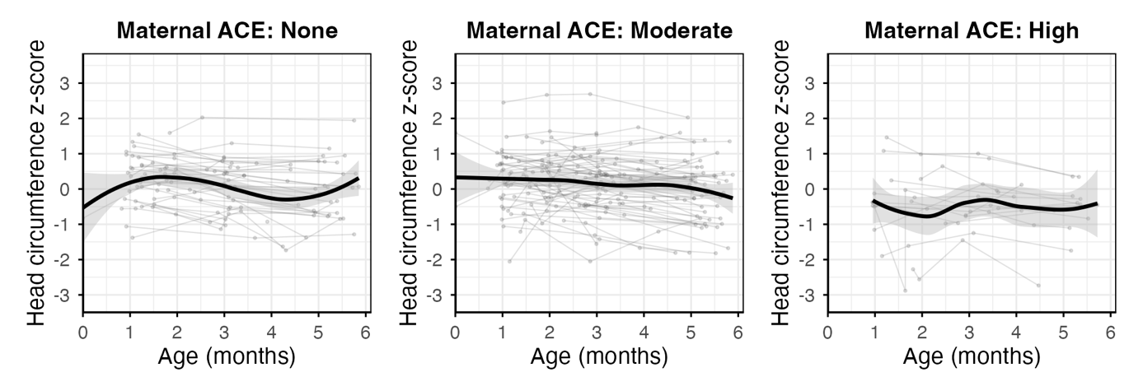
Supplementary Figure 8. Observed individual head circumference z-score trajectories during the first 6 months of life, stratified by maternal ACE category.

