Winners wave wings: courtship display increases mating success in Rhagoletis juglandis (Diptera: Tephritidae)

Journal of Insect Biology

Sophia C. Anner¹, Marlee Mincher¹, and Alycia C. R. Lackey¹
¹ Department of Biology, University of Louisville, Louisville, KY
Corresponding author: Sophia C. Anner (sophia.anner@louisville.edu)

Supp. Table 1: AIC results for generalized linear models with binomial distribution with and without trimming copulation durations under 10 minutes. “Outcome” is copulation success and “restricted” is a yes/no variable.
model name | # trials | model structure | K | AICc | ∆AICc | AICc weight
Trimmed (only trials with copulation duration >10 min) | 24 | outcome ~ restricted | 2 | 62.22 | 0 | 0.99
Full (all trials) | 29 | outcome ~ restricted | 2 | 72.54 | 10.33 | 0.01
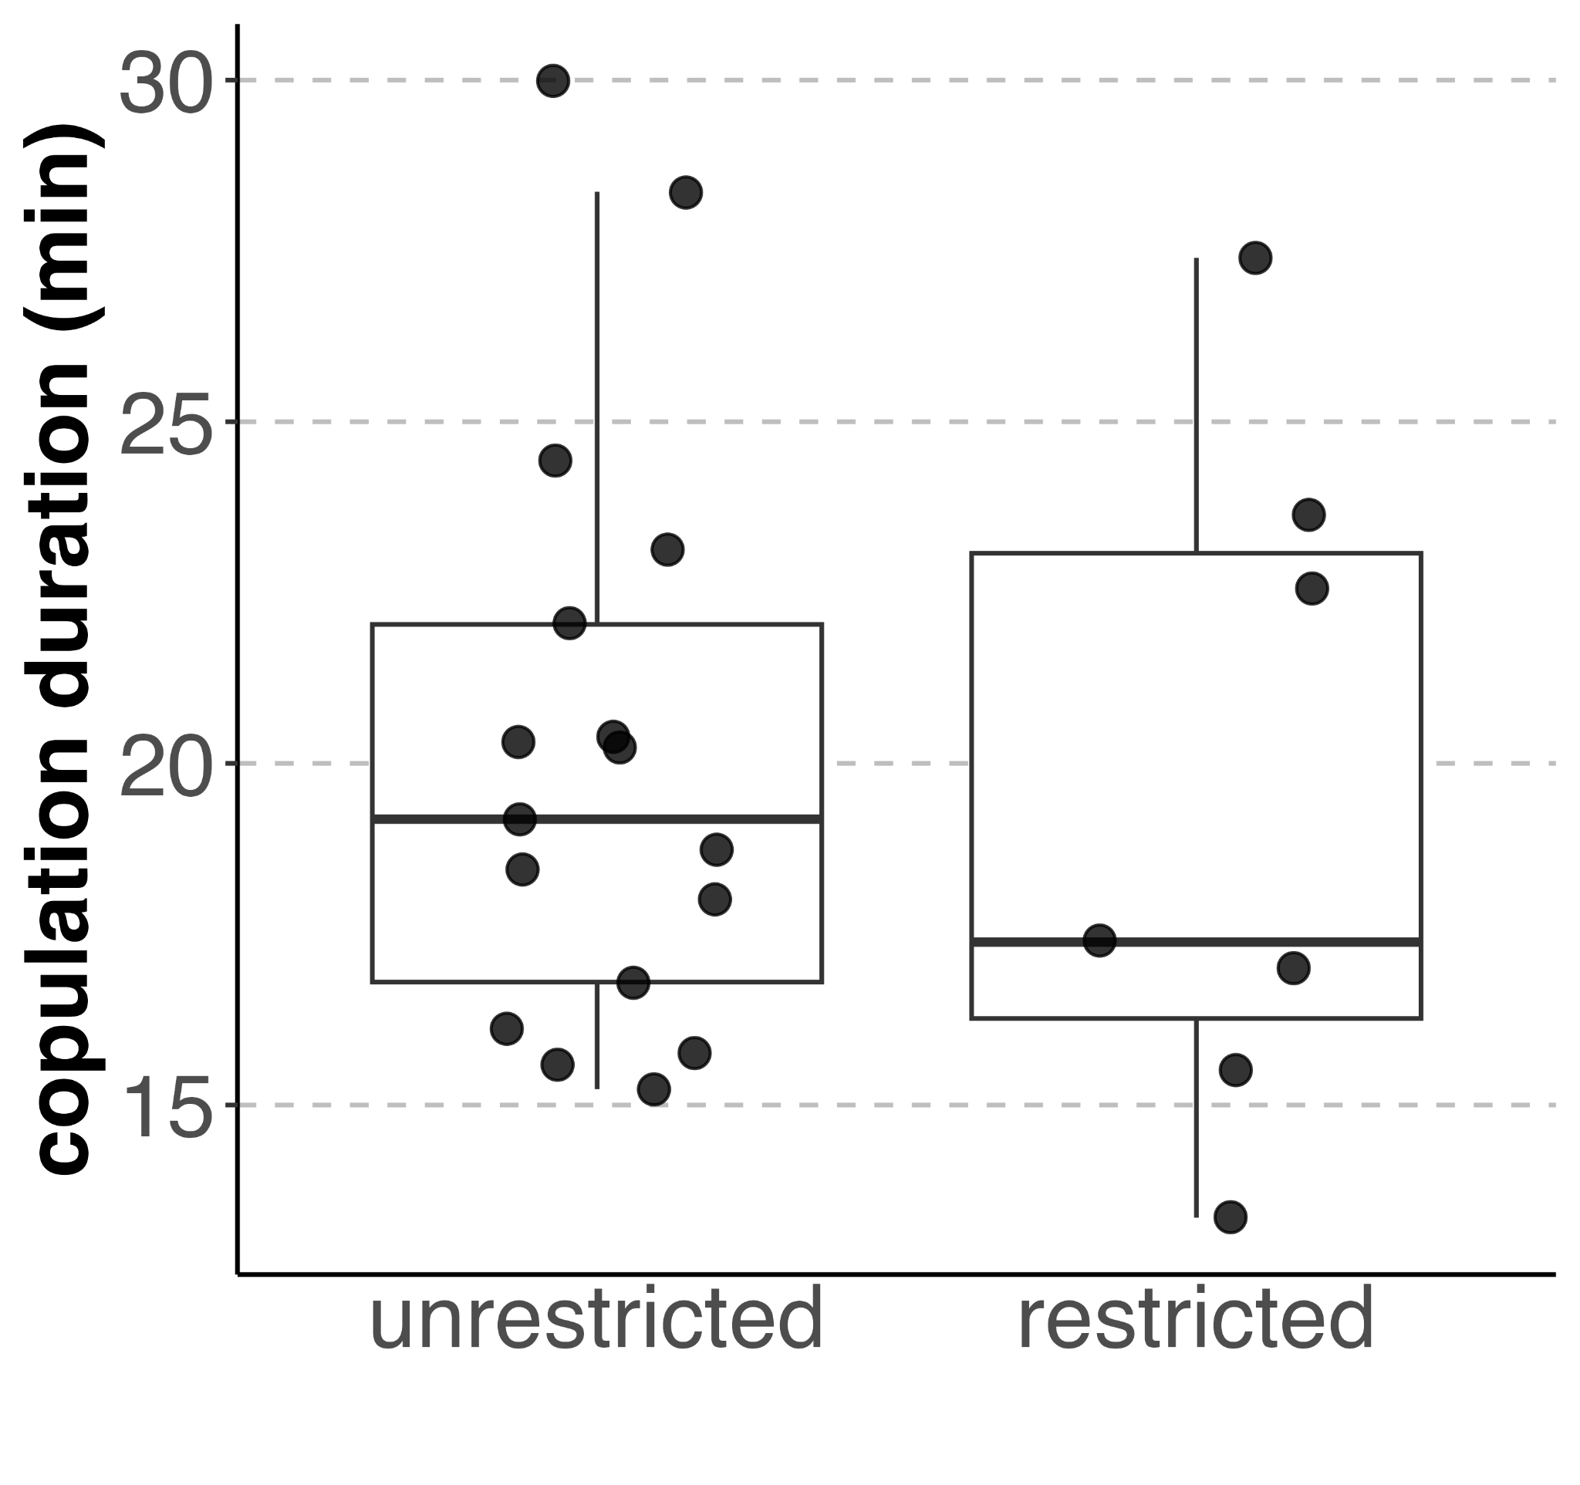
Supp. Fig. 1 Boxplots of copulation duration for trials in which successful males were restricted and unable to perform the wing display or unrestricted. Points are data for individual trials.

ESM 2 Video excerpt from trial where unrestricted male successfully copulates. Copulation at 56 seconds.
ESM 3 Video excerpt from trial where restricted male successfully copulates. Copulation at 42 seconds.

