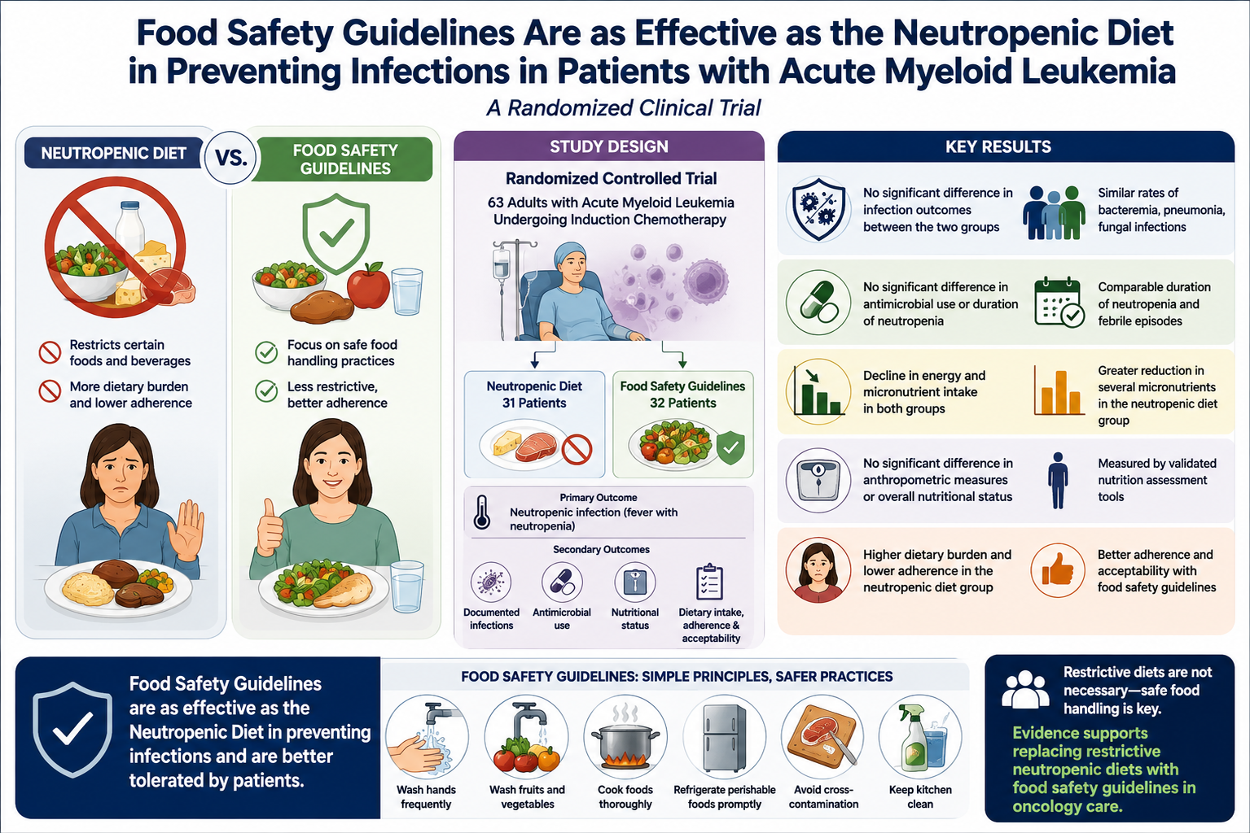
Graphical Abstract. Comparison of neutropenic diet versus food safety guidelines in patients with acute myeloid leukemia undergoing induction chemotherapy. The neutropenic diet restricts certain foods and beverages, leading to greater dietary burden and lower adherence, whereas food safety guidelines focus on safe food handling practices with less restriction and better adherence. The primary outcome (neutropenic infection) and secondary outcomes (documented infections, antimicrobial use, nutritional status, dietary intake, adherence, and acceptability) showed no significant difference between the two groups, except for greater micronutrient reductions and lower adherence in the neutropenic diet group. Key message: Restrictive diets are not necessary safe food handling is key.

