Table 1. Search strategies for PubMed and Scopus databases
Pubmed:1290
(((((((((((((Infertility [Title/Abstract]) OR (Sterility, Reproductive [Title/Abstract])) OR (Reproductive Sterility [Title/Abstract])) OR (Sterility [Title/Abstract])) OR (Subfertility [Title/Abstract])) OR (Sub-Fertility [Title/Abstract])) AND (Depression [Title/Abstract])) OR (Depressive Symptoms [Title/Abstract])) OR (Depressive Symptom [Title/Abstract])) OR (Symptom, Depressive [Title/Abstract])) OR (Emotional Depression [Title/Abstract])) OR (Depression, Emotional [Title/Abstract]))) AND (((((((Psychosocial Intervention [MeSH Terms]) OR (Psychosocial Interventions [Title/Abstract])) OR (social support [Title/Abstract])) OR (couples therapy [Title/Abstract])) OR (psycho-education [Title/Abstract])) OR (internet-based intervention [Title/Abstract])) OR (behavioral therapy [Title/Abstract]))
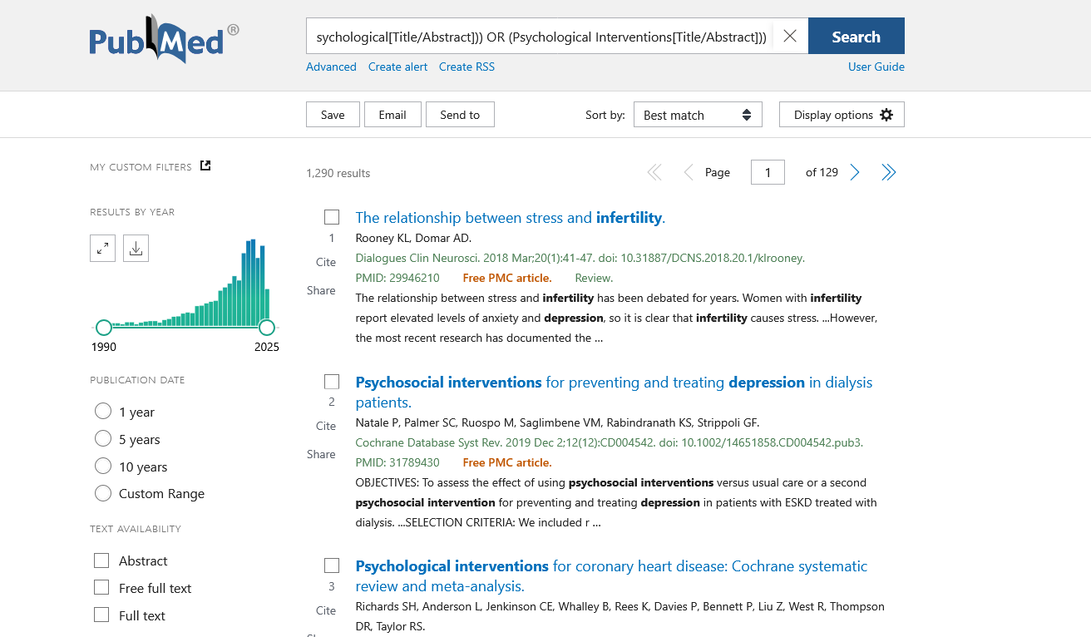
Scopus=769
( TITLE-ABS-KEY ( infertility ) OR TITLE-ABS-KEY ( sterility ) OR TITLE-ABS-KEY ( subfertility ) OR TITLE-ABS-KEY ( sub-fertility ) AND TITLE-ABS-KEY ( psychosocial AND intervention ) OR TITLE-ABS-KEY ( psychosocial AND interventions ) OR TITLE-ABS-KEY ( social AND support ) OR TITLE-ABS-KEY ( couples AND therapy ) OR TITLE-ABS-KEY ( psycho-education ) OR TITLE-ABS-KEY ( internet-based AND intervention ) OR TITLE-ABS-KEY ( behavioral AND therapy ) AND TITLE-ABS-KEY ( depression ) OR TITLE-ABS-KEY ( depressive AND symptom ) OR TITLE-ABS-KEY ( depressive AND symptoms ) OR TITLE-ABS-KEY ( emotional AND depression ) )

