Supplementary Information
Pilot-Scale Flow Synthesis of Hydantoins via the Bucherer-Bergs Reaction
Matthew T. Graves, Kyle N. Brunner, Christian E. Schafmeister*
Department of Chemistry, Temple University, 1901 N. 13th Street, Philadelphia PA, 19122
*To whom correspondence should be addressed: meister@temple.edu

Table of contents
Table of contents…………………………..………………………………………………………..………….……………S1
General Methods…………………………………………………………………………………………………….……….S2
Cyanide Safety………………………………………………………………………………………………………………..S2
Flow Chemistry Equipment……………………………………………………………….……….……………………..S2
Small Scale Flow System………………………………………………………………………………………..S2
Large Scale Flow System………………………………………………………………………………………..S3
Experimental Procedures and Compound Characterization Data…………………………………..……….S3
Small scale optimization of the flow synthesis of hydantoins……………………………………….S3
Small scale continuous flow synthesis of hydantoins………………………………………..……….S4
Large scale optimization of the flow synthesis of hydantoins……………………………………….S5
Large scale continuous flow synthesis of hydantoins………………………………………………….S6
Pilot scale continuous flow synthesis of hydantoins…………………………………………………..S7
Aqueous Reagent Stability………………………………………………………………………………………………..S8
Crystal Structures……………………………………………………………………………………………………………S9
NMR Spectra…………………………………………………………………………………………………………………S10
¹H NMR Compound 1…………..….…………………………………………………………….…………….S10
¹³C NMR Compound 1…………..….………………….…………….………………………….…………….S10
¹H NMR Compound 2…………………………….……………………..……………………….…………….S11
¹³C NMR Compound 2…………..….……………………..…………………………………….…………….S11
¹H NMR Compound 3…..…………………….………………………………………………….…………….S12
¹³C NMR Compound 3…………..….……………………..…………………………………….…………….S12
¹H NMR Compound 4…..…………………….………………………………………………….…………….S13
¹³C NMR Compound 4…………..….……………………..…………………………………….…………….S13
¹H-¹⁵N HSQC NMR Compound 4………………………………………………..…………….……………S14
Reaction LCMS UV Spectra……………………………………………………………………………………………..S14

1. General Methods
All commercially available reagents were used as received without additional purification. Reaction analysis and high resolution mass spectroscopy was performed via LCMS on an Agilent 1260-90 (Ascentis Express C18 Column, Dimensions: 5.0 cm x 2.1 mm, 2.7 µm packing) coupled to an Agilent 6520 Accurate Mass Measurement Q-ToF (ESI Source) with a 5-100% water/acetonitrile (0.1% formic acid) gradient at a flow rate of 1.0 mL/min. NMR experiments were performed on a Bruker 500 MHz instrument. Chemical shifts (δ) are reported related to CDCl₃ or DMSO-d₆ residual solvent peaks and indicated in parts per million (ppm). The splitting patterns are abbreviated as follows: s (singlet), d (doublet), dd (doublet of doublets), dt (doublet of triplets), ddd (doublet of doublet of doublets), ddt (doublet of doublet of triplets), t (triplet), and m (multiplet). High-resolution mass spectroscopy was performed on Agilent 6520 Accurate Mass Measurement Q-ToF with 1260/90 UHPLC chromatography system. 1-benzyl 2-(tert-butyl) (R)-4-oxopyrrolidine-1,2-dicarboxylate (compound 1) was used as the starting material and was purchased from WuXi Apptec.

2. Cyanide Safety
All cyanide solutions were prepared and handled in a single fume hood with appropriate PPE and dedicated cyanide-waste containers; quenching and disposal followed institutional protocols. Airborne HCN was monitored with a BW Solo single-gas HCN detector throughout setup, operation, and workup.

3. Flow Chemistry Equipment
For all flow reactions, a Vapourtec R-Series flow system was used. This system consists of an R2C+ pump module containing two solvent pumps, each with a solvent selection valve that controls between reagent solution and solvent sources. The flow system also contains an R4 reactor heater module that is used to house up to four reactors and heat them. Finally, the last component of the system is another solvent selection valve, to control between waste and product collection.

3.1 Small scale flow system
Figure S1: Small scale detailed flow system scheme.
For small scale experiments, a single Vapourtec PFA tubing reactor (10 mL) was used, set to the temperatures outlined in Table 1. The back pressure was controlled by two, 8 bar back pressure regulator cartridges which provides a system pressure of 17 bar, with 1 bar of back pressure provided by the reactor itself.

3.2 Large scale flow system
Figure S2: Large scale detailed flow system scheme.
For large scale experiments, four reactors were used. The first reactor position contains a Vapourtec heated mixing PFA tube reactor (0.4 mL reagent heating volume, 10 mL reactor volume) that preheats the reagent solutions prior to their mixing in the reactor tubing. The next three reactor positions contain a Vapourtec PFA tube reactors (10 mL), providing a total reactor volume of 40 mL. The back pressure is controlled by two Vapourtec back pressure regulators, one 8 bar and one 6 bar. This, with 3 bar of back pressure provided by the reactors, provides a system pressure of 17 bar. For large scale experiments all four reactor positions were set to 95 °C.

4. Experimental procedures and compound characterization data
4.1 Small scale optimization of the flow synthesis of hydantoins
A stock organic solution of compound 1 (4.02 g, 1 eq) was dissolved in organic solvent (20 mL) and degassed and placed on the A reagent line of the flow system. A stock aqueous solution was prepared by dissolving KCN (0.87 g, 1.05 eq) and (NH₄)₂CO₃ (3.88 g, 3.2 eq) in deionized water (20 mL) and placed on the B reagent line of the flow system. These stock solutions were used for five flow reactions under the conditions outlined in Table 1 and run using the Vapourtec R-series software. Prior to each reaction, the flow system was flushed simultaneously with 10 mL of both water and organic solvent. For each reaction, solvent was flowed through the system to ensure stable temperature and 17 bar of system pressure, and the flow stream was switched to flow 2 mL of each reagent solution into the flow system. After this, the flow stream is switched to solvents to push the reagents through the flow system. 6mL aliquot of the product solution was collected for each run. Samples were analyzed by LCMS to assess conversion, and yield were determined by UV quantitation performed at 220 nm, which corresponds to the strong absorbance band of the benzyloxycarbonyl (Cbz) group present on all compounds. As compounds 2 and 3 are both products of interest and coelute on LCMS, their peaks were integrated together, and the ratio between the two was determined by NMR. Peak identities were verified by retention time and mass spectra from the LCMS trace.

Table S1: Small Scale Optimization
Entry | RTD (min) | T (C) | Organic Solvent | Compound 1 Yield | Compound 2 & 3 Yield | Compound 4 Yield | Notes
1 | 20 | 130 | Ethanol | 0.78% | 41.5% | 57.72%
2 | 20 | 120 | Ethanol | 5.3% | 61.9% | 32.80%
3 | 15 | 130 | Ethanol | 1.9% | 52.7% | 45.40%
4 | 15 | 120 | Ethanol | 1.28% | 72.9% | 25.2%
5 | 15 | 110 | Ethanol | 1.57% | 86.7% | 10.99%
6 | 15 | 100 | Ethanol | 1.81% | 93.6% | 4.85%
7 | 15 | 90 | Ethanol | 2.00% | 95.07% | 2.93% | Brief Pressure "Spikes"
8 | 10 | 120 | Ethanol | 1.28% | 76.8% | 3.24%
9 | 10 | 110 | Ethanol | 2.49% | 88.9% | 5.02%
10 | 10 | 100 | Ethanol | 1.73% | 94.0% | 4.31%
11 | 10 | 90 | Ethanol | 5.2% | 94.0% | 0.80% | Brief Pressure "Spikes"
12 | 7.5 | 100 | Ethanol | 2.40% | 93.9% | 3.67%
13 | 10 | 90 | Methanol | 6.62% | 89.8% | 3.01% | Brief Pressure "Spikes," precipitate in product
14 | 10 | 90 | Isopropyl Alcohol | 1.38% | 92.6% | 5.99% | Brief Pressure "Spikes," precipitate in product
15 | 10 | 90 | Ethyl Acetate | 37.3% | 15.1% | 47.6% | Brief Pressure "Spikes"
16 | 10 | 95 | Ethanol | 1.65% | 95.6% | 2.72% | Optimized Conditions
1-benzyl 2-(tert-butyl) (R)-4-oxopyrrolidine-1,2-dicarboxylate (compound 1)
¹H NMR (500 MHz, CDCl₃) δ 7.37 – 7.29 (m, 5H), 5.25 – 5.09 (m, 2H), 4.71 (ddd, J = 20.7, 10.5, 2.3 Hz, 1H), 4.03 – 3.87 (m, 2H), 2.92 (td, J = 19.0, 10.5 Hz, 1H), 2.54 (dd, J = 18.9, 2.4 Hz, 1H), 1.40 (d, rotamers observed, 9H); ¹³C NMR (126 MHz, CDCl₃, rotamers observed) δ 208.34, 207.68, 170.71, 155.11, 154.46, 136.18, 136.03, 129.12, 128.93, 128.68, 128.65, 128.41, 128.21, 128.19, 83.22, 82.92, 77.41, 77.36, 77.16, 76.91, 69.55, 67.77, 57.00, 52.89, 52.72, 41.46, 40.88, 28.01, 27.90, 27.80; HRMS-ESI m/z calculated for (M + Na)⁺ 342.1317, found 342.1308.

7-benzyl 8-(tert-butyl) (5R,8R)-2,4-dioxo-1,3,7-triazaspiro[4.4]nonane-7,8-dicarboxylate (compound 2)
¹H NMR (500 MHz, CDCl3) δ 7.37 – 7.29 (m, 5H), 6.70 (d, J = 17.6 Hz, 1H), 5.21 – 5.08 (m, 2H), 4.44 (ddd, J = 22.0, 9.7, 1.3 Hz, 1H), 3.89 (d, J = 23.7 Hz, 2H), 2.78 (ddd, J = 23.6, 13.8, 9.7 Hz, 1H), 2.08 (dd, J = 13.9, 4.4 Hz, 1H), 1.42 (d, rotamers observed, 9H); ¹³C NMR (126 MHz, CDCl₃, rotamers observed) δ 173.23, 173.05, 172.99, 172.77, 155.03, 154.98, 154.12, 153.69, 136.02, 135.92, 128.69, 128.61, 128.41, 128.36, 128.14, 128.07, 83.66, 83.50, 77.41, 77.36, 77.16, 76.91, 67.85, 67.83, 66.84, 59.50, 58.98, 56.71, 56.38, 40.25, 39.35, 28.02, 27.82; HRMS-ESI C₁₉H₂₃N₃O₆ m/z calculated for (M + Na)⁺ 412.1484, found 412.1478.

7-benzyl 8-(tert-butyl) (5S,8R)-2,4-dioxo-1,3,7-triazaspiro[4.4]nonane-7,8-dicarboxylate (compound 3)
¹H NMR (500 MHz, CDCl₃) δ 7.37 – 7.30 (m, 6H), 5.23 – 5.05 (m, 2H), 4.52 (dt, J = 19.0, 8.2 Hz, 1H), 4.00 – 3.86 (m, 2H), 2.57 (dd, J = 16.1, 8.3 Hz, 2H), 1.40 (d, rotamers observed, 9H); ¹³C NMR (126 MHz, CDCl₃, rotamers observed) δ 173.31, 172.87, 170.38, 160.36, 160.03, 159.69, 159.36, 157.85, 157.58, 155.82, 155.36, 135.08, 134.92, 128.83, 128.77, 128.32, 128.23, 118.07, 115.80, 113.53, 111.27, 84.60, 84.32, 77.42, 77.36, 77.16, 76.91, 69.04, 67.82, 67.17, 58.99, 58.59, 55.52, 40.30, 39.33, 27.83, 27.78; HRMS-ESI C₁₉H₂₃N₃O₆ m/z calculated for (M + Na)⁺ 412.1484, found 412.1484.

(8R)-7-((benzyloxy)carbonyl)-2,4-dioxo-1,3,7-triazaspiro[4.4]nonane-8-carboxylic acid
(compound 4)
¹H NMR (500 MHz, DMSO) δ 10.83 (d, J = 5.4 Hz, 1H), 8.01 – 7.83 (m, 1H), 7.46 – 7.18 (m, 5H), 5.17 – 4.99 (m, 2H), 4.46 (s, 4H), 4.34 (dt, J = 39.0, 8.3 Hz, 2H), 3.87 (dd, J = 19.4, 11.2 Hz, 1H), 3.41 (dd, J = 16.7, 11.3 Hz, 1H), 2.68 (ddd, J = 20.9, 13.2, 8.3 Hz, 1H), 2.15 – 1.96 (m, 1H); ¹³C NMR (126 MHz, DMSO) δ 176.74, 173.07, 172.74, 156.05, 153.68, 153.36, 136.57, 128.40, 128.32, 127.86, 127.71, 127.37, 127.01, 66.33, 66.30, 64.64, 63.88, 58.08, 57.65, 52.39, 51.91, 40.02, 39.95, 39.85, 39.78, 39.69, 39.52, 39.35, 39.19, 39.02, 37.97, 37.09; ¹⁵N NMR (51 MHz DMSO) δ 352.75, 145.69, 99.12; HRMS-ESI m/z calculated for (M + H)⁺ 334.1039, found 334.1045.

4.2 Small scale continuous flow synthesis of hydantoins
A stock organic solution of compound 1 (10.06 g, 1 eq) was dissolved in organic solvent (50 mL) and degassed and placed on the A reagent line of the flow system. A stock aqueous solution was prepared by dissolving KCN (2.18 g, 1.05 eq) and (NH₄)₂CO₃ (9.71 g, 3.2 eq) in deionized water (50 mL) and placed on the B reagent line of the flow system. The reactor temperature was set to 95 °C, and the pumps were each set to 0.5 mL/minutes to ensure an RT of 10 minutes. After flushing simultaneously with 80 mL of each solvent, the flow stream was switched to the reagent streams. During 1.5 hours of operation, the system pressure was monitored, and the product collection was segmented to ensure consistent reactivity. After 45 mL of each reagent solution had been consumed, the system was flushed simultaneously with 40 mL of each solvent to flush to push the remaining reaction mixture and clean the system. Each product fraction collected was analyzed by LCMS to assess conversion, and yield was determined by UV quantitation performed at 220 nm, which corresponds to the strong absorbance band of the benzyloxycarbonyl (Cbz) group present on all compounds. Peak identities were verified by retention time and mass spectra from the LCMS trace.

Table S2: Small scale continuous flow monitoring
Entry | Reaction Volume (mL) | Compound 2&3 Yield
1 | 0-10 | 96.8%
2 | 10-24 | 96.5%
3 | 24-38 | 96.6%
4 | 38-52 | 96.4%
5 | 52-66 | 96.0%
6 | 66-80 | 97.0%
7 | 80-90 | 96.7%
 | Average Yield | 96.6%
 | Standard Deviation | 0.3%

4.3 Large scale Verification of the flow synthesis of hydantoins
A stock organic solution of compound 1 (2.01 g, 1 eq) was dissolved in organic solvent (10 mL) and degassed and placed on the A reagent line of the flow system. A stock aqueous solution was prepared by dissolving KCN (0.436 g, 1.05 eq) and (NH₄)₂CO₃ (1.94 g, 3.2 eq) in deionized water (10 mL) and placed on the B reagent line of the flow system. The reactor temperature was set to 95 °C, and the pumps were each set to 2.0 mL/min to ensure an RT of 10 minutes. Solvent was flowed through the system to ensure stable temperature and 17 bar of system pressure, after which the flow was switched to introduce 8 mL of each reagent solution into the flow system. After this, the flow stream was switched back to solvents to flush the reagents through the flow system. A 20 mL aliquot of the product solution was collected and analyzed by LCMS to assess conversion, and yield was determined by UV quantitation performed at 220 nm, which corresponds to the strong absorbance band of the benzyloxycarbonyl (Cbz) group present on all compounds. Peak identities were verified by retention time and mass spectra from the LCMS trace.

4.4 Large scale continuous flow synthesis of hydantoins
A stock organic solution of compound 1 (201.1 g, 1 eq) was dissolved in EtOH (1 L) and degassed and placed on the A reagent line of the flow system. A stock aqueous solution was prepared by dissolving KCN (43.6 g, 1.05 eq) and (NH₄)₂CO₃ (194.1 g, 3.2 eq) in deionized water (1 L) and placed on the B reagent line of the flow system. The reactor temperature was set to 95 °C, and the pumps were each set to 2.0 mL/min to ensure an RT of 10 minutes. After flushing simultaneously with 100 mL of each solvent, the flow stream was switched to the reagent streams. During 8 hours of operation, the system pressure was monitored, and the product collection was segmented to ensure consistent reactivity. This resulted in 0.950 L of each reagent solution being consumed, and then the system was flushed simultaneously with 160 mL of each solvent to flush out the remaining reaction mixture and clean the system. Each collected product fraction was analyzed via LCMS. Following analysis, the product was extracted twice with 1 L EtOAc before being concentrated under reduced pressure. This resulted in 217.1 g of product.

Table S3: Large scale continuous flow monitoring
Entry | Volume (mL) | Compound 2&3 Yield
1 | 0-45 | 96.8%
2 | 180-225 | 96.7%
3 | 405-450 | 97.2%
4 | 630-675 | 97.2%
5 | 855-900 | 97.3%
6 | 1080-1125 | 97.4%
7 | 1305-1350 | 97.2%
8 | 1530-1575 | 97.3%
9 | 1755-1800 | 97.1%
 | Average | 97.1%
 | Standard Deviation | 0.2%

4.5 Pilot scale continuous flow synthesis of hydantoins
A stock organic solution of compound 1 (599.1 g, 1 eq) was dissolved in EtOH (3 L) and degassed and placed on the A reagent line of the flow system. A stock aqueous solution was prepared by dissolving KCN (130.9 g, 1.05 eq) and (NH₄)₂CO₃ (582.1 g, 3.2 eq) in deionized water (3 L) and placed on the B reagent line of the flow system. The reactor temperature was set to 95 °C, and the pumps were each set to 2.0 mL/min to ensure an RT of 10 minutes. After flushing simultaneously with 100 mL of each solvent, the flow stream was switched to the reagent streams. During 24.2 hours of operation, the system pressure was monitored, and the product collection was segmented to ensure consistent reactivity. The first product segmentation, after 8 hours, was performed manually; the second, after 16 hours, was performed automatically by the flow system. This resulted in 2.9 L of each reagent solution being consumed, and then the system was flushed simultaneously with 320 mL of each solvent to flush out the remaining reaction mixture and clean the system. Each collected product fraction was analyzed via LCMS. Following analysis, the solution was neutralized with 4.0 M HCl in a well-ventilated fume hood with cyanide gas monitoring, then extracted twice with 1 L portions of 1 L EtOAc before being concentrated under reduced pressure. This resulted in 679.3 g of isolated product.

Table S4: Pilot scale continuous flow monitoring
Entry | Volume (L) | Compound 2&3 Yield
1 | 0-2.0 | 97.2%
2 | 2.0-4.0 | 96.8%
3 | 4.0-5.8 | 96.6%
 | Average | 96.9%
 | Standard Deviation | 0.3%

5. Aqueous Reagent Stability
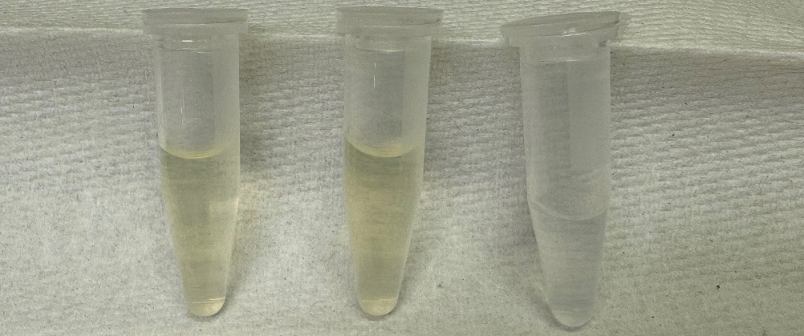
Figure S3: Image of the aqueous solutions kept in a clear vial, an amber vial, and an amber vial with an inert atmosphere (from left to right).

A stock solution was prepared by dissolving 0.131 g KCN and 0.582 g (NH₄)₂CO₃ into 3 mL DI H₂O. This solution was then divided into one clear and two amber vials. One of the amber vials then had N₂ bubbled through for 15 minutes. After 5 days these solutions were each transferred to a clear 1.5 mL centrifuge tube to visually confirm prevention the solution turning yellow.

6. Crystallography characterization data
Table S5: Crystallography Data
 | Compound 1 | Compound 2
Structure | 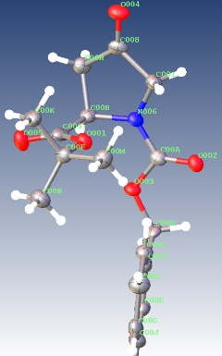 | 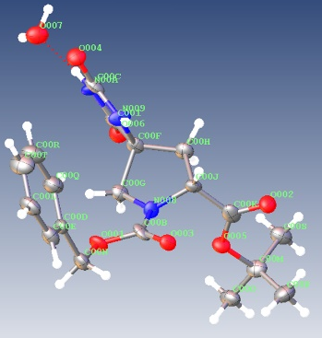
CCD Code | 2495123 | 2495118
Chemical Formula | C₁₇H₂₁NO₅ | C₁₉H₂₃N₃O₆
Formula Weight | 319.36 g/mol | 389.40 g/mol
Crystal Size (mm) | 0.201 x 0.084 x 0.023 | 0.268 x 0.061 x 0.045
Temperature (K) | 100.15 | 99.98
Crystal System | Monoclinic | Monoclinic
Space Group | P2₁ | P2₁
a (Å) | 5.9478(11) | 12.6575(3)
b (Å) | 11.610(3) | 6.12640(10)
c (Å) | 11.906(3) | 12.8359(3)
α (°) | 90 | 90
β (°) | 99.989(6) | 91.1190(10)
γ (°) | 90 | 90
Volume (Å) | 809.7(3) | 995.17(4)
Z | 2 | 2
ρ_{calc} (g/cm³) | 1.310 | 1.300
 | 3.474 to 42.888 | 6.888 to 130.212
  2Θ range for data collection (°)
Index Ranges | -6 ≤ h ≤ 6, -11 ≤ k ≤ 11,  -12 ≤ l ≤ 12 | -14 ≤ h ≤ 14, -7 ≤ k ≤ 7,  -15 ≤ l ≤ 15
Reflections Collected | 8290 | 19521
Independent Reflections | 1831 [R_{int}=0.1197, R_{sigma}=0.0922] | 3347 [R_{int}=0.0474, R_{sigma}=0.0319]
Data / Restraints/ Parameters | 1831 / 1 / 212 | 3347 / 1 / 268
Goodness-of-Fit on F2 | 0.813 | 1.076
Final R Indexes [I>=2σ (I)] | R1 = 0.0459, wR2 = 0.1166 | R₁ = 0.0269, wR₂ = 0.0654
Final R Indexes [All Data] | R1 = 0.0602, wR2 = 0.1316 | R₁ = 0.0282, wR₂ = 0.0654
Largest Diff Peak/Hole (eÅ⁻³) | 0.17 / -0.15 | 0.15 / -0.15

7. NMR Spectra
7.1 ¹H NMR of compound 1
7.2 ¹³C NMR of compound 1
7.3 ¹H NMR of compound 2
7.4 ¹³C NMR of compound 2
7.5 ¹H NMR of compound 3
7.6 ¹³C NMR of compound 3
7.7 ¹H NMR of compound 4

7.8 ¹³C NMR of compound 4
7.9 ¹H-¹⁵N HSQC NMR of Compound 4
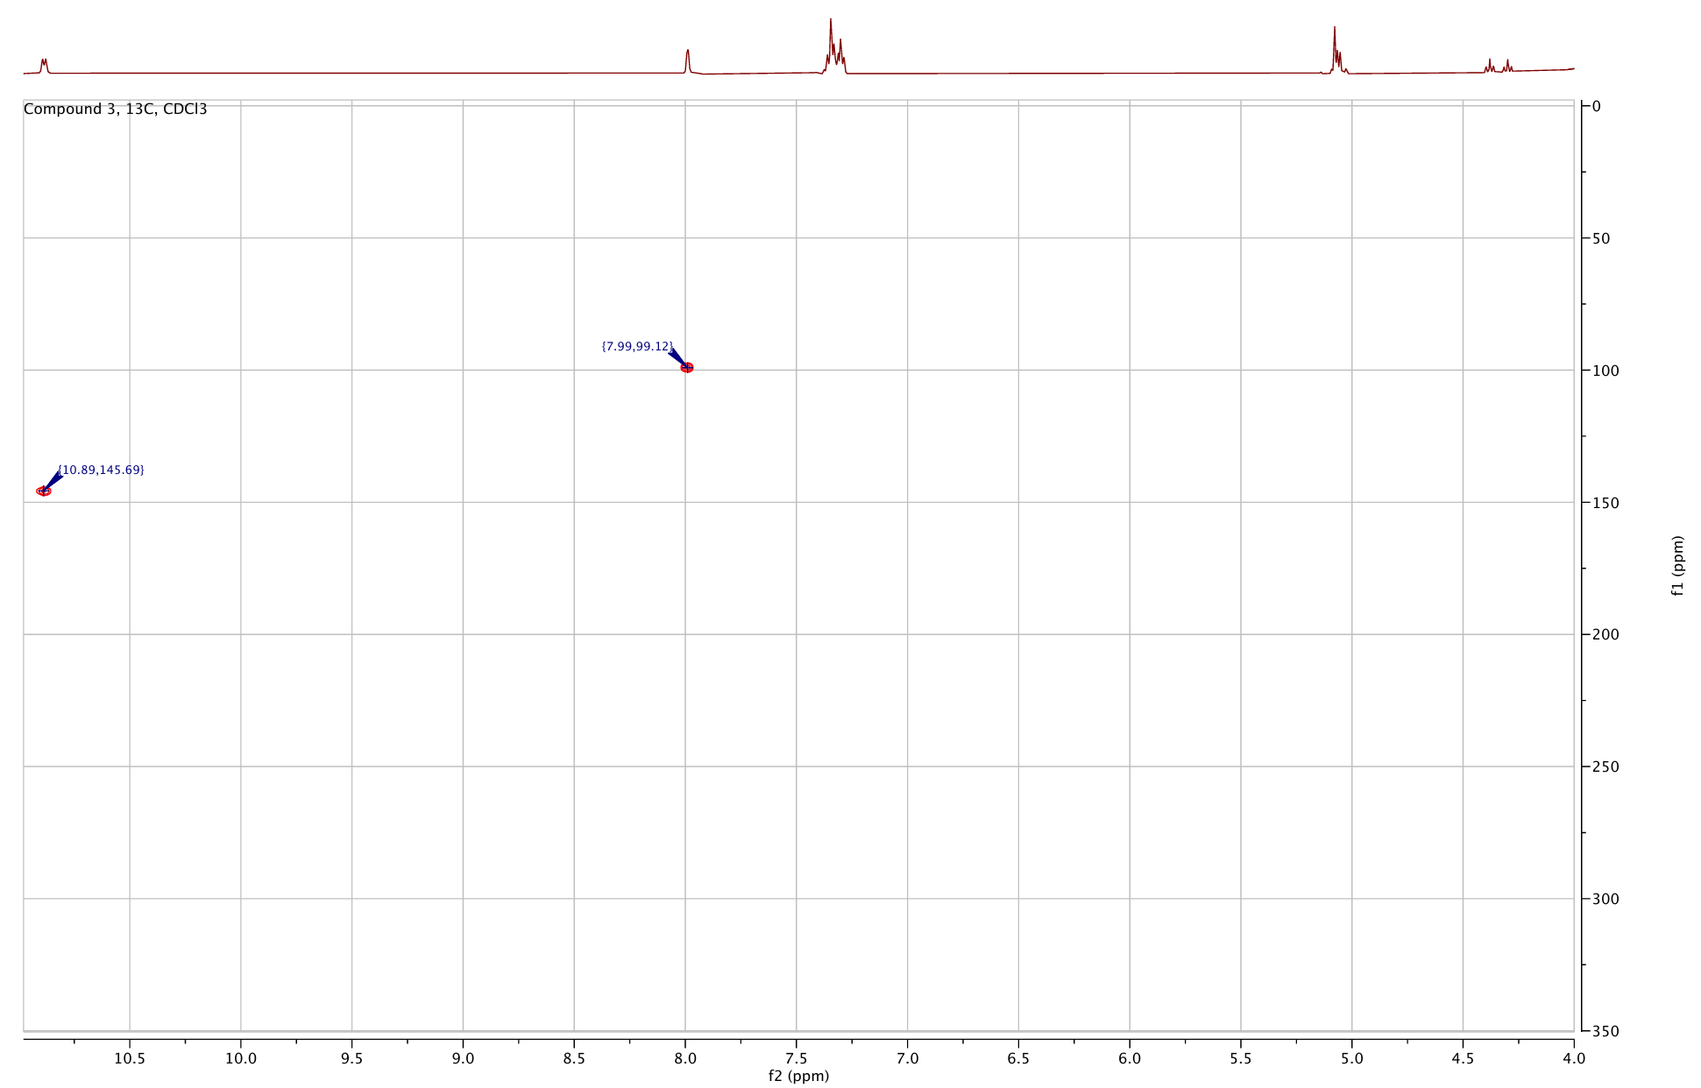
Proton Chemical Shift | ¹⁵Nitrogen Chemical Shift | Functional Group
7.99 | 99.12 | Amide
10.89 | 145.69 | Imide

8. Reaction LCMS UV Spectra
Compounds 2 & 3

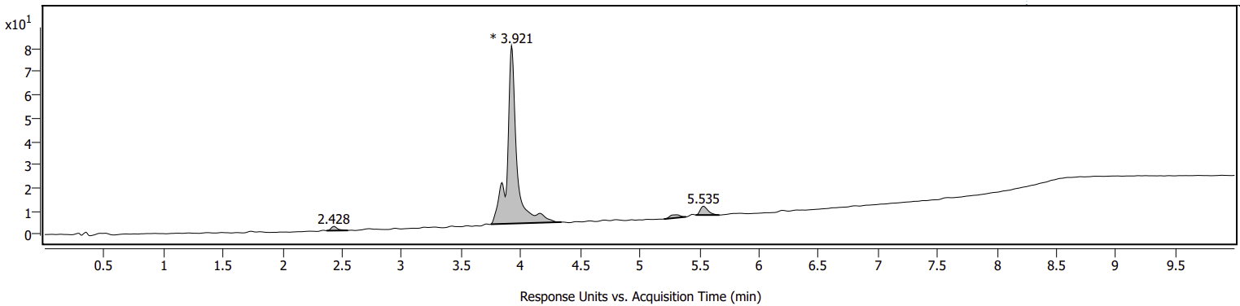
Impurity from SM
Compound 1
Compound 4
LC chromatogram of reaction at 220 nm.

