Supplementary Information for
Integrated food-system and conservation measures enhance functional connectivity of global protected areas while advancing food security and health
Zhongci Deng^{1,17}, Shuaipeng Chen^{2,17}, Cai Li^{3,17}, Patrick José von Jeetze^{4,5,17}, Yi Yang^{6,*}, Chen Chang¹, David R. Williams⁷, Benjamin Leon Bodirsky^{4,8}, Alexander Popp^{4,9}, Justin Andrew Johnson¹⁰, Nathaniel D. Mueller¹¹, Yuanchao Hu¹², Xiaoxi Wang^{4,13}, Keke Li^{1,14}, Wenping Liu^{2,*}, Guangyi Zhai¹, Wei Zhou¹, Jingyu Wang¹, Michalis Hadjikakou¹⁵, Brett A Bryan¹⁵, Zhen Wang^{1,16,*}
¹College of Resources and Environment, Huazhong Agricultural University; Wuhan 430070, China.
²College of Horticulture and Forestry Sciences, Huazhong Agricultural University; Wuhan 430070, China.
³College of Public Administration, Huazhong Agricultural University; Wuhan 430070, China.
⁴Potsdam Institute for Climate Impact Research (PIK), Member of the Leibniz Association, PO Box 601203, 14412 Potsdam, Germany.
⁵Albrecht Daniel Thaer-Institute of Agricultural and Horticultural Sciences, Humboldt University of Berlin; Berlin, Germany.
⁶Key Laboratory of the Three Gorges Reservoir Region’s Eco-Environment, Ministry of Education, Chongqing University; Chongqing 400044, China.
⁷Sustainability Research Institute, School of Earth and Environment, University of Leeds; Leeds, UK.
⁸World Vegetable Center, Bangkok, Thailand.
⁹Faculty of Organic Agricultural Sciences, University of Kassel; Witzenhausen, Germany.
¹⁰Department of Applied Economics, University of Minesota; 1940 Buford Ave, Saint Paul, MN, USA.
¹¹Institute on the Environment (IonE), University of Minnesota; 1954 Buford Avenue, Saint Paul, 55108, Minnesota, USA.
¹²School of Ecology, Environment & Resources, Guangdong University of Technology; Guangzhou 510006, China.
¹³China Academy for Rural Development and Department of Agricultural Economics and Management, Zhejiang University; Hangzhou, China.
¹⁴Climate Change and Carbon Neutrality Lab, Henan University; Zhengzhou 450046, China.
¹⁵School of Life and Environmental Sciences, Deakin University; Melbourne, Vic, Australia.
¹⁶Interdisciplinary Research Center for Territorial Spatial Governance and Green Development, Huazhong Agricultural University; Wuhan 430070, China.
¹⁷These authors contributed equally to this work.
*Corresponding author. Email: Yi Yang: yi.yang@cqu.edu.cn; Wenping Liu: liuwenping@mail.hzau.edu.cn; Zhen Wang: sinoo@mail.hzau.edu.cn

Table of Contents
S1. Materials and Methods 3
S1.1. Framework 3
S1.2. Model of Production and its Impacts on the Environment (MAgPIE) 3
S1.2.1. Food demand 5
S1.2.2. Agricultural Production 11
S1.2.3. Land pools 12
S1.2.4. Irrigation 13
S1.2.5. International trade 13
S1.2.6. Technological change 14
S1.3. Spatial Economic Allocation Landscape Simulator (SEALS) 15
S1.3.1. Allocation Algorithm 16
S1.3.2. Land cover allocation 16
S1.3.3. SEALS land allocation procedure 17
S1.3.4. Model Calibration 17
S1.3.5. Calibration Parameters 18
S1.3.6. limitations 19
S1.4. Projection of Human Footprint Index (HFI) 19
S1.4.1. Built environments 22
S1.4.2. Cropland and pasture 23
S1.4.3. Population density 23
S1.4.4. Nighttime lights 23
S1.4.5. Roads and railways 23
S1.4.6. Navigable waterways 24
S1.4.7. Human footprint index (HFI) 24
S1.5. Circuit-theoretic computations for landscape ecology (Circuitscape) 25
S1.5.1. Mammal Movement Probability 26
S1.5.2. Protected Area Isolation 26
S1.5.3. Protected Areas 26
S2. Scenario description 27
S2.1. Supply-side (Sup) actions 27
S2.2. Demand-side (Dem) actions 27
S2.3. Ecosystem stewardship (EcoS) actions 28
S3. Supplementary Results 30
Reference 41

S1. Materials and Methods

S1.1. Framework
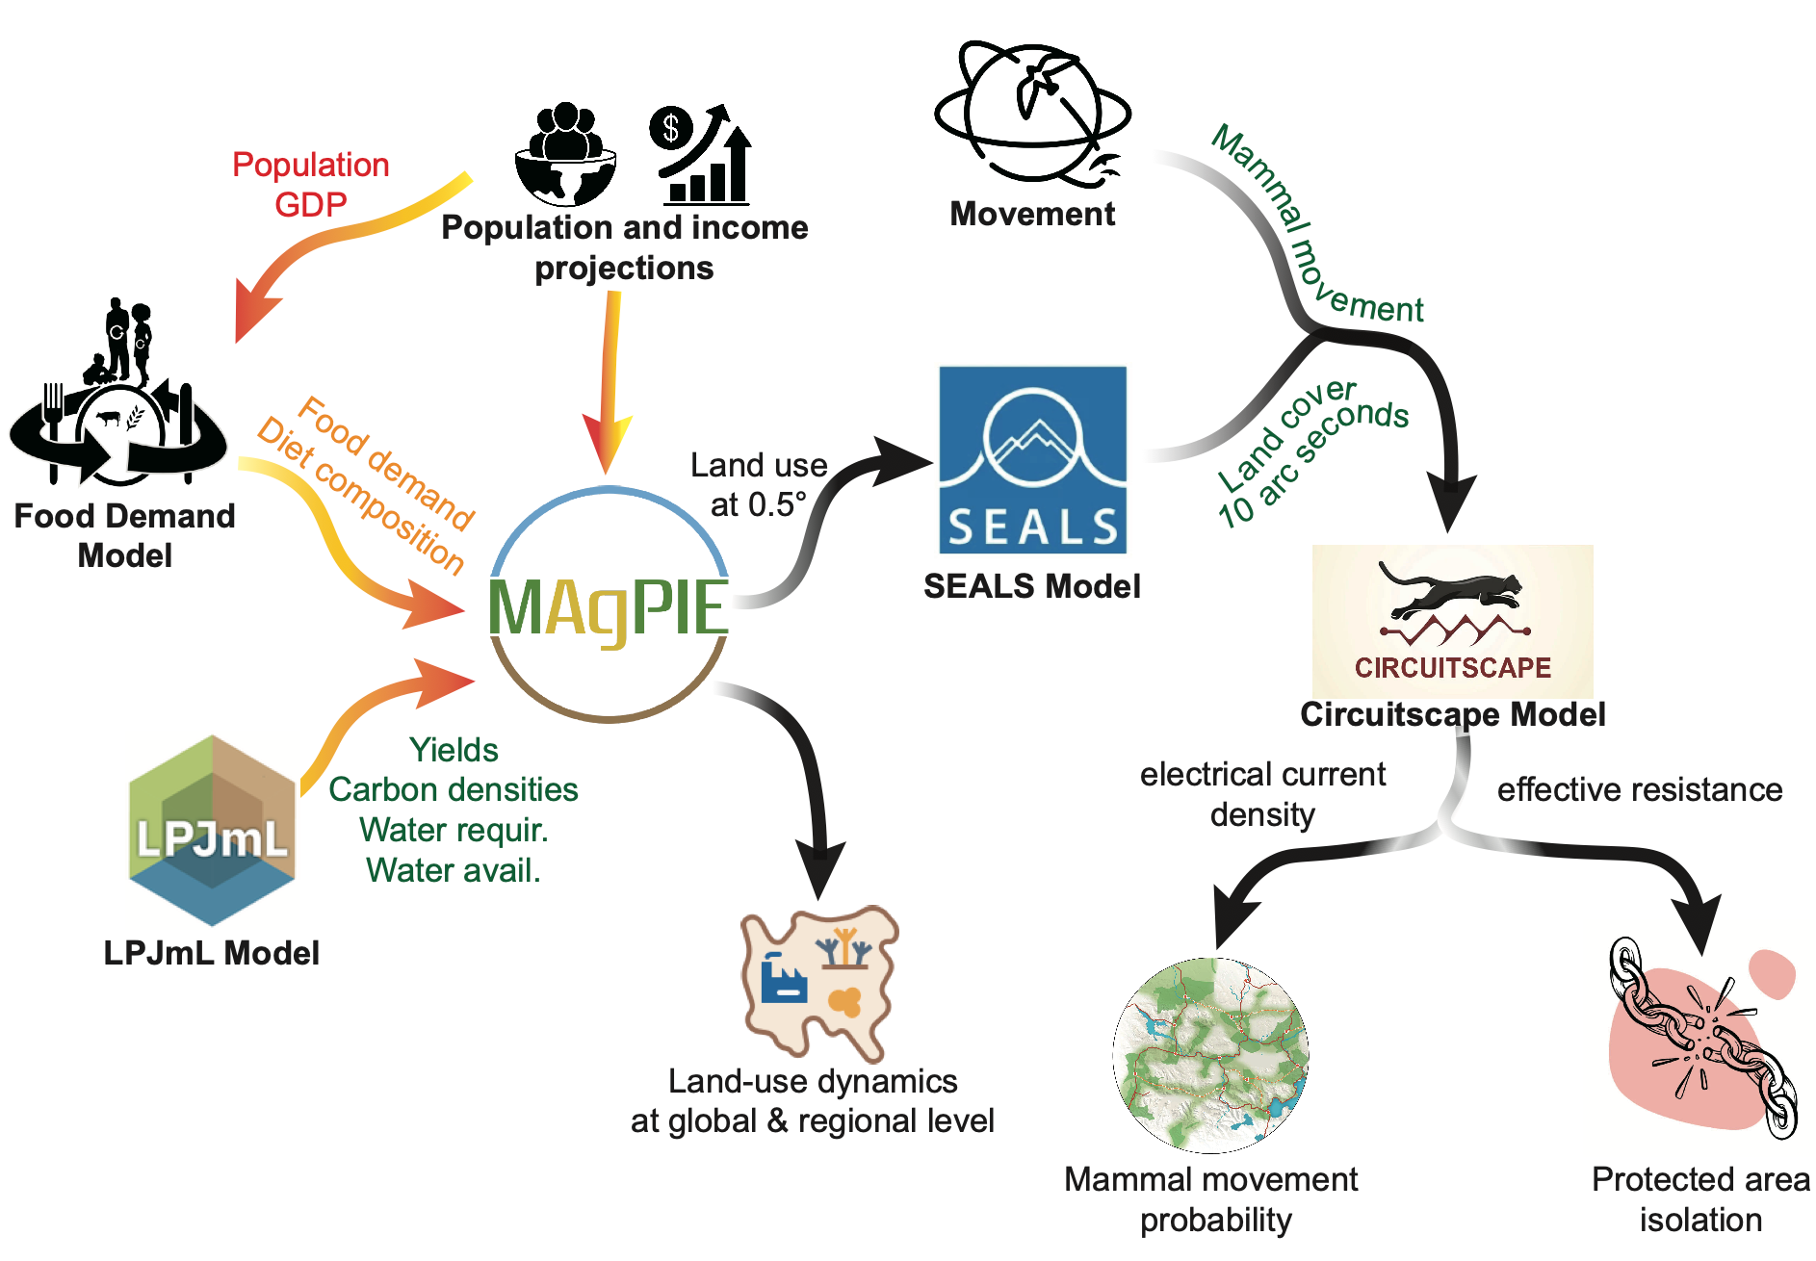
Supplementary Figure 1. Integrated MAgPIE-SEALS-Circuitscape Modeling framework for assessing functional connectivity in global protected areas. SEALS takes the land use data from MAgPIE and allocates projected land cover changes at a high spatial resolution (10 arc seconds). Circuitscape borrows algorithms from electronic circuit theory to predict connectivity in heterogeneous landscapes.

S1.2. Model of Production and its Impacts on the Environment (MAgPIE)
The Model of Production and its Impact on the Environment (MAgPIE, v4.8.2; https://doi.org/10.5281/zenodo.13833444)¹ is an open-source, modular framework designed to model land systems. It operates at two spatial levels: a coarse level that divides the world into twelve regions based on socioeconomic characteristics, and a finer subregional level that clusters regions according to biophysical properties relevant to agricultural production. The coarse regions primarily define socioeconomic constraints, such as food demand, trade patterns, and interest rates, with smaller economies aggregated and larger ones, like the USA, China, and India, represented individually. At the finer scale, land competition, agricultural production, and irrigation processes are modelled using spatial clusters derived from biophysical data at the 0.5° grid cell level. Key inputs include crop and pasture yield potentials, terrestrial carbon densities, and water availability, which are sourced from the Lund-Potsdam-Jena managed land (LPJmL) model². For presenting the results, the 12 world regions are aggregated into six continental regions based on their geographic distribution (Table S1).

Supplementary Table 1. ISO3 codes of countries grouped according to the regional classification adopted in this study.
MAgPIE region | Reporting continent(s) | ISO3 (continent)
CAZ | North America; Oceania | AUS (Oceania), CAN (North America), NZL (Oceania)
CHA | Asia | CHN (Asia), TWN (Asia)
EUR | Europe | AUT (Europe), BEL (Europe), BGR (Europe), CYP (Europe), CZE (Europe), DEU (Europe), DNK (Europe), ESP (Europe), EST (Europe), FIN (Europe), FRA (Europe), GBR (Europe), GRC (Europe), HRV (Europe), HUN (Europe), IRL (Europe), ITA (Europe), LTU (Europe), LUX (Europe), LVA (Europe), NLD (Europe), POL (Europe), PRT (Europe), ROU (Europe), SVK (Europe), SVN (Europe), SWE (Europe)
IND | Asia | IND (Asia)
JPN | Asia | JPN (Asia)
LAM | North America; South America | ARG (South America), BLZ (North America), BOL (South America), BRA (South America), CHL (South America), COL (South America), CRI (North America), CUB (North America), DOM (North America), ECU (South America), GTM (North America), GUF (South America), GUY (South America), HND (North America), HTI (North America), JAM (North America), MEX (North America), NIC (North America), PAN (North America), PER (South America), PRI (North America), PRY (South America), SLV (North America), SUR (South America), TTO (North America), URY (South America), VEN (South America)
MEA | Africa; Asia | ARE (Asia), DZA (Africa), EGY (Africa), IRN (Asia), IRQ (Asia), ISR (Asia), JOR (Asia), KWT (Asia), LBN (Asia), LBY (Africa), OMN (Asia), SAU (Asia), SDN (Africa), SYR (Asia), TUN (Africa)
NEU | Europe;  North America | ALB (Europe), BIH (Europe), CHE (Europe), GRL (North America), ISL (Europe), MKD (Europe), MNE (Europe), NOR (Europe), SJM (Europe), SRB (Europe), TUR (Europe)
OAS | Asia; Oceania | AFG (Asia), BGD (Asia), BRN (Asia), BTN (Asia), IDN (Asia), KHM (Asia), KOR (Asia), LAO (Asia), LKA (Asia), MMR (Asia), MNG (Asia), MYS (Asia), NCL (Oceania), NPL (Asia), PAK (Asia), PHL (Asia), PNG (Oceania), PRK (Asia), THA (Asia), TLS (Asia), VNM (Asia)
REF | Asia; Europe | ARM (Europe), AZE (Europe), BLR (Europe), GEO (Europe), KAZ (Europe), KGZ (Asia), RUS (Europe), TJK (Asia), TKM (Asia), UKR (Europe), UZB (Asia)
SSA | Africa | AGO (Africa), BDI (Africa), BEN (Africa), BFA (Africa), BWA (Africa), CAF (Africa), CIV (Africa), CMR (Africa), COD (Africa), COG (Africa), ETH (Africa), GAB (Africa), GHA (Africa), GIN (Africa), GMB (Africa), GNB (Africa), GNQ (Africa), KEN (Africa), LBR (Africa), LSO (Africa), MDG (Africa), MLI (Africa), MOZ (Africa), MRT (Africa), MWI (Africa), NAM (Africa), NER (Africa), NGA (Africa), REU (Africa), RWA (Africa), SEN (Africa), SLE (Africa), SSD (Africa), SWZ (Africa), TCD (Africa), TGO (Africa), TZA (Africa), UGA (Africa), ZAF (Africa), ZMB (Africa), ZWE (Africa)
USA | North America | USA (North America)
Note: MAgPIE regions are the socioeconomic regions used internally for model optimization. The continent names in parentheses indicate the reporting regions used to aggregate and interpret results in the main text.

S1.2.1. Food demand
Food demand in MAgPIE model represents the total amount of food that needs to be supplied for human consumption. It comprises two components: dietary intake, which refers to the amount of food actually consumed by people, and household food waste, which refers to the share of final household consumption that is discarded before consumption. Together, these two components determine the total food demand entering the agricultural production system. The food demand (Supplementary Figure 6) is determined at the country level accounting for changes in population, demographic structure, body-weight distribution, and dietary composition³, which were simulated using an open-source food demand model written in the programming language GAMS. It is an updated version of Bodirsky et al.⁴, which has been also used in FAOs outlook “Future of food and agriculture: Alternative pathways to 2050”⁵. For a more detailed calculation process, please refer to Bodirsky et al.³.
The EAT-Lancet diet is based on minimum and maximum recommended daily intakes for different food groups⁶. Minimum per capita intakes are formulated for legumes, fruits, vegetables and nuts. In countries where per capita intakes of these food groups do not meet the recommended levels, intakes are increased to these minimum levels. Maximum intakes are set for sugar, oils, poultry, eggs, red meat and dairy products. Where per capita intakes exceed the recommended amounts, intakes of these food groups are reduced to meet the recommendations (Supplementary Figure 2).
Supplementary Figure 2 Global food consumption in baseline and Dem involved diet under different SSPs. Per capita calorie intake per day across different food groups and for recommended intake levels. In the baseline scenario, calorie intake is derived from projected population growth, demographic changes and per capita income, while EAT-Lancet diet for the different food groups is based on Willett et al.⁶; Note: The baseline diet applies to all scenarios that do not involve Dem actions, including BAU, Sup, EcoS, and Sup–EcoS scenarios. In contrast, the Dem-involved diet refers to shifting the current diet toward the EAT-Lancet healthy diet, and applies to scenarios including Dem, Sup–Dem, Dem–EcoS, and Integrated.

Supplementary Figure 3 Regional changes in calorie intake between 2020 and 2070 of different food groups.

Differences in dietary intake are a central determinant of food demand variations across scenarios, reflecting both cultural preferences and economic conditions. These demand-side dynamics interact closely with supply-side strategies, including shifts in production efficiency, agricultural practices, and food system losses. MAgPIE incorporates all major crop and livestock commodities, as well as non-food agricultural products and associated supply chain losses (Supplementary Figure 4).
Land competition is modelled through cost-effectiveness trade-offs between crop and livestock production, while also accounting for land conservation targets embedded in each scenario. Crucially, regional disparities play a significant role: regions with high population growth and lower agricultural efficiency (e.g., Sub-Saharan Africa or South Asia) face different trade-offs compared to regions with high productivity and stabilized diets (e.g., Europe or North America). These spatial differences in dietary patterns, technological capacity, and land availability lead to heterogeneous outcomes in food demand across the globe (Supplementary Figure 5-6).
Supplementary Figure 4 Global agricultural demand across different demand categories under different scenarios. Overall changes in agricultural demand expressed in gigatonnes of dry matter (GtDM) per year across different demand categories under different scenarios. Food crops mediated by biotic pollination include oil crops such as sunflower or rapeseed, legumes, and fruits, vegetables and nuts.

Supplementary Figure 5 Projected in regional agricultural demand in 2070 across different demand categories and different scenarios. Note: Results for SSP1 and SSP3 are presented in Supplementary Figure 18-19.

Supplementary Figure 6 Regional changes in agricultural demand between 2020 and 2070 for different scenarios, separated into different commodity groups. Note: Results for SSP1 and SSP3 are presented in Supplementary Figure 20-21.

We explicitly assume that the share of final household consumption wasted at the household level reaches 20% by 2050 only in scenarios involving Dem actions, consistent with approximately half the level observed in high-income countries (Supplementary Figure 7). All other scenarios, including the BAU, retain the baseline household food-waste levels throughout the projection period.
Supplementary Figure 7 Food waste under the baseline and diet change scenarios for SSP1-SSP3. Note: scenarios involving Dem actions, consistent with approximately half the level observed in high-income countries. All other scenarios, including the BAU, retain the baseline household food-waste levels throughout the projection period.

S1.2.2. Agricultural Production
Agricultural production in MAgPIE comprises both crop and livestock production. Crop and livestock production are endogenously determined to meet agricultural demand under biophysical, socioeconomic, and land-use constraints⁷. Agricultural demand includes food, feed, bioenergy, material use, seed, and other non-food demands. The model allocates production across regions by minimizing total production costs while considering land, water, trade, technological change, and conservation targets⁸. Crop production is calculated from crop-specific harvested areas and yields. Harvested areas are determined through the model’s land-allocation decisions, while yields are based on spatially explicit biophysical inputs from Lund-Potsdam-Jena managed land model (LPJmL)² and are further adjusted by technological change and management intensity within MAgPIE. LPJmL provides grid-level information on potential crop yields under rainfed and irrigated conditions, pasture productivity, irrigation water availability, and vegetation carbon densities. These inputs allow MAgPIE to represent spatial differences in agricultural productivity and land-use suitability. Livestock production is determined by demand for livestock products, feed requirements, pasture availability, and livestock production efficiencies. The model links livestock output to feed demand and pasture use, thereby coupling livestock production with crop production and land competition.

S1.2.3. Land pools
The land use types modelled in MAgPIE include cropland, pasture, primary forest, secondary forest, forestry, other land (terrestrial non-forest ecosystems), and built-up areas (Supplementary Figure 8). The spatial distribution of these land use types is based on the Land Use Harmonization (LUH2v2) dataset⁹, with forest and non-forest ecosystems' distribution coordinated through spatial relocation, referencing the Forest Resources Assessment report¹⁰. The areas allocated to cropland (both rainfed and irrigated), pasture, forests, and other lands are determined endogenously during model execution, while urban areas are assumed to remain constant. The model also incorporates a dynamic forestry sector¹¹ with afforestation for carbon dioxide removal (CDR). Afforestation can either be prescribed exogenously, based on national policies implemented (NPI) or the Paris Agreement’s nationally determined contributions (NDCs), or modeled endogenously based on cost incentives for CDR. R. Vegetation growth (for forest, forestry, and non-forest areas) follows S-shaped growth curves, with parameters drawn from Braakhekke et al.¹². Spatially explicit land conservation schemes are implemented to prevent the expansion of cropland, pasture, and forestry into natural vegetation, including primary and secondary forests as well as non-forest ecosystems, in areas designated by predefined conservation templates (Supplementary Figure 9).
Supplementary Figure 8. Spatially explicit land use as derived from the LUH2v2 dataset and used for the initialization of MAgPIE. Forest areas were adjusted with data from MacDicken et al.¹⁰.
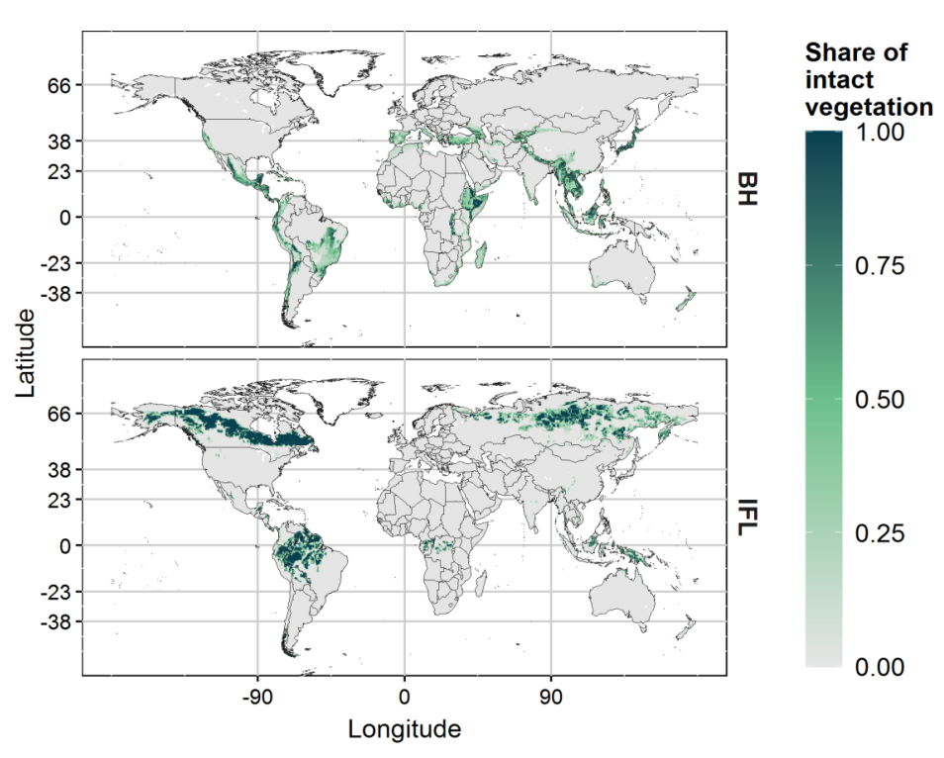
Supplementary Figure 9. Conservation templates for the enlargement of protected areas. Spatially explicit information for the reactive and proactive conservation schemes is based on the biodiversity hotspots (BH, top) and intact forest landscapes (LFI, bottom) maps.

S1.2.4. Irrigation
MAgPIE models irrigation and irrigation expansion endogenously. To which extent cropland is irrigated depends on the yield gain that can be achieved through irrigation in a specific location for the respective crop, unit costs for irrigation area expansion, as well as water demand for irrigation. Irrigation water demand, in turn, depends on local water availability in the growing period in the respective simulation cluster, crop irrigation water requirements, and regionally specific irrigation efficiency. Water availability for irrigation in the growing period as well as crop-specific irrigation water requirements per hectare of irrigated land are derived using the global vegetation, hydrology, and crop-growth model LPJmL^{2,13}.

S1.2.5. International trade
International trade in the model occurs after meeting regional minimum self-sufficiency requirements, implying that some part of the food demand in every world region is produced domestically. Self-sufficiency ratios describe how much of the regional agricultural demand quantity has to be produced within a region. For instance, a ratio for cereals of 0.80 means that 80% of cereals are produced domestically, whereas 20% are imported. Self-sufficiency ratios smaller than one indicate that the region imports from the world market, while self-sufficiencies greater than one indicate that the region produces for export. The MAgPIE model implemented two virtual trading pools which allocate the global demand to the different supply regions. The demand which enters the first pool is allocated according to fixed criteria. Self-sufficiency ratios determine how much is produced domestically, and export shares determine the share of each region in global exports. Although the initial self-sufficiencies for this pool stay constant over time, the final self-sufficiencies do change since domestic demand and population change over time. The demand which enters the second pool is allocated according to comparative advantage criteria to the supply regions. The criteria, under given constraints like crop rotation or water availability, are biophysical yield, production costs and technological change leading to yield increase. This implies that the model optimizes supply with the goal of minimizing global production costs and produces in those cells where it is most economical compared to other cells. Detailed information on the model can be found in Schmitz et al.¹⁴.

S1.2.6. Technological change
Technological change (TC) drives sustainable intensification to increase the production to meet domestic demand in the model. TC is endogenously modelled based on a measure of the agricultural land-use intensity (Supplementary Figure 10), which is an index measuring human-induced productivity through activities such as R&D, infrastructure, and management but excluding productivity changes due to changes in biophysical conditions¹⁵.
Supplementary Figure 10 Land-use intensity factor τ. The τ factor reflects the degree of crop yield amplification caused by human activities; Solid lines τ factor in an SSP2. The transparent area shows the factor range between SSP1 and SSP3 scenarios.

S1.3. Spatial Economic Allocation Landscape Simulator (SEALS)
The spatial arrangement of land cover and its changes play a crucial role in determining the functional connectivity of protected areas¹⁶, which is fundamental to maintaining biodiversity and ecosystem resilience by facilitating species movement and gene flow¹⁷⁻¹⁹. However, land-cover change—driven by anthropogenic land-use transitions—can lead to habitat fragmentation²⁰, disrupting ecological corridors²¹ and isolating conservation sites. Assessing these impacts requires spatially explicit land-cover data at fine resolutions. Yet, the coarse spatial resolution (0.5°) of the original MAgPIE model limits its ability to capture such landscape-scale dynamics that influence connectivity patterns under global land-use change. To overcome this limitation, we integrate the SEALS (Spatial Economic Allocation Landscape Simulator) model, which downscales projected land-use changes in MAgPIE to a field-scale resolution of 10 arc-seconds (~300 m).

S1.3.1. Allocation Algorithm
SEALS enables a more detailed and spatially realistic representation of land-cover transitions by incorporating key spatial and biophysical characteristics. Specifically, land-use allocation is guided by adjacency relationships, physical suitability, and conversion eligibility. The initial land-cover configuration is based on a high-resolution map from the European Space Agency’s Climate Change Initiative (ESA-CCI) for the year 2020, in which 37 original land-cover classes are aggregated into seven functional types: cropland, grassland, forest, non-forest vegetation (e.g., shrubland or herbaceous cover), urban, barren land, and water (Table S2). SEALS then generates spatial adjacency maps for each functional type, quantifying the likelihood of land-cover change based on both proximity and pixel agglomeration. Physical suitability is evaluated by integrating high-resolution soil organic carbon (SOC) data²² and topographic information. By combining these spatial rules with biophysical constraints, SEALS simulates fine-scale land-cover dynamics that align more closely with real-world patterns. For a more detailed description of the SEALS model framework and its implementation, please refer to Johnson et al.²³ and Jeetze et al.²⁴.

Supplementary Table 2. Relation between MAgPIE, SEALS, and ESA-CCI LULC classes.
SEALS LULC types | Combined ESA-CCI LULC types | MAgPIE LULC types
Urban | 190 | Urban
Cropland | 10, 11, 12, 20 | Cropland
Grassland/pasture | 130 | Pasture
Forest | 40, 50, 60, 61, 62, 70, 71, 72, 80, 81, 82, 90, 100, 151, 160, 170 | Primary forest, secondary forest, forest
Non-forest vegetation | 30, 110, 120, 121, 122, 140, 150, 151, 152, 153, 180 | Other land
Water | 210 | —
Barren | 200, 201, 202, 220 | —
No data | 255 | —

S1.3.2. Land cover allocation
SEALS identifies the net change in each land-use type at the 0.5 degree resolution and produces a net change vector $n_{c}$, in which each entry represents the net change of $i$-th land-use type in the grid cell $c$. SEALS the uses a $n$ by $i$ matrix of coefficients that describe how each $n$-th spatial information affect the expansion probability of the $i$-th land use type in each grid cell. The coefficients in this matrix were empirically derived by iteratively applying the allocation model on a time series of LULC maps for the year 2000 to 2010 from ESA-CCI. The coefficients that were most predictive on withheld data (2011-2015) were then selected to be used for future LULC projections.

S1.3.3. SEALS land allocation procedure
- Define a vector $n_{c}$, which includes the net hectarage change for each $i$-th LULC class that might expand in each $c$-th 0.5 degree grid cell.
- Define the starting condition of the landscape based on the current 300 meters resolution ESA-CCI LULC map, where $L_{x,t}$ defines the starting condition in pixel $x$ and time $t$.
- The spatial allocation algorithm is the defined by $S(n_{c}, L_{c,x,t}, p_{x,i}, a_{x,i,j}, e_{x})$ = $L_{x,t+1}$, which takes the net area change $n_{c}$ and an existing LULC map ($L_{x,t}$) and produces a LULC map for a future time step based on three factors:
  - $p_{x,i}$ the physical suitability of pixel $x$ to be converted into LULC class $i$
  - $a_{x,i,j}$ the adjacency effect on the pixel conversion suitability to LULC class $i$ in cell $x$ based on the relative adjacency impact of LULC class $j$.
  - $e_{x}$ a binary map indicating whether pixel x is allowed to transition to LULC class $i$. This mask is defined by predefined conversion rules, including allowable transitions among LULC classes and restrictions that prevent conversion into non-convertible areas such as cities and water bodies.
- The physical suitability, adjacency effect, and binary map are combined with the required net change $n_{c}$ to generate a change-weighted suitability map $C$. This map indicates where each required LULC expansion is most likely to be allocated.
- All candidate pixel-level conversions are ranked according to their values in $C$, producing a conversion order map R. Lower value in R indicate higher-priority conversions that are allocated earlier.
- Starting with the first conversion in R, convert to the target LULC class and reduce the remaining amount of conversion necessary in $n_{c}$ by the amount converted. This allocation process is repeated sequentially for the ranked conversions in $R$ until the required net change has been fully allocated, that is, until $n_{c}$= 0 for all target LULC classes in all coarse grid cells.

S1.3.4. Model Calibration
A key component in SEALS is that it downscales according to observed relationships present in timeseries input data. Specifically, SEALS uses a spatial allocation approach that has been calibrated on ESA-CCI’s 1992-2015 time series using an iterative gaussian L1-loss function minimization approach. The approach uses the following algorithm:
- Define a baseline condition (year 2000 for this example).
- Define a projection year in the set of observed years after the baseline year (2010) and aggregate the net-change between the two years for each coarse resolution (0.5 degree) grid-cell. This defines the amount of change in each LULC class that our allocation algorithm will project.
- Allocate the net change of each LULC class using only the baseline map and a spatial allocation algorithm, $S(p1)$, where $p1$ is the parameter set used in the allocation and is initially set to an arbitrary value.
- Calculate how accurate the projected LULC map for 2010 is compared to the observed 2010 LULC map. Specifically, compute the difference score, which is the summation of five L1-difference functions, one for each LULC transition that calculates how different (in terms of Gaussian-blurred distance) each class is in the projected map compared to the observed map. This generates a score for the quality of fit for the current set of parameters.
- Iteratively for each parameter in ${p1}_{i}$, increase the parameter by X% (initially 10), rerun step 4 with the new parameter, observe the new similarity score, then decrease it by 10% and rerun
- After calculating the change in fit from each parameter increase and decrease in step 5, identify which change had the greatest improvement in the similarity score. Update the parameter set to include the single best change, and then repeat steps 3-6 until no additional improvements can be made

S1.3.5. Calibration Parameters
The results from the calibration exercise are reported in Table S3. The first column is the name of the input regressor, while the values in columns 2-6 are the optimized values from the calibration algorithm for the five types of observed land-use changes. Of the regressors listed, “presence” variables simply are a 0-1 variable derived from the LULC map on what is the baseline class in 2020. The adjacency regressors are a Gaussian convolution of the presences maps with different sigmas chosen to represent nearby adjacency impact vs. adjacency effects that have further away. To make this definition more intuitive, we denote the distance of the adjacency effect by the number of kilometers away where the effect falls below 5%. Finally, at the end of the list of regressors are all the static variables used as inputs to the regression.

Supplementary Table 3. Parameters derived during calibration of the SEALS model.
Regressor Name | urban | cropland | grassland | forest | Non-forest natural
Urban presence | 0.00000 | -0.03222 | 0.01389 | -0.01389 | -0.01667
Cropland presence | -0.02778 | 0.00000 | 0.01667 | 0.01111 | 0.00433
Grassland presence | 0.00556 | 0.01889 | 0.00000 | 0.04167 | -0.02611
Forest presence | -0.01944 | -0.01667 | -0.00267 | 0.00000 | 0.03344
Non-forest natural presence | 0.01000 | 0.14444 | 0.06011 | 0.02000 | 0.00000
Water presence | 0.00000 | 0.00000 | 0.00000 | 0.00000 | 0.00000

S1.3.6. limitations
The implementation of SEALS used in this study has several limitations. First, SEALS functions as an allocation algorithm rather than a full land-use change model such as Dyna-CLUE²⁵ or CLUMondo²⁶. As a result, it tends to reproduce historical land-use patterns when allocating land at fine spatial resolutions and does not explicitly account for connectivity. Incorporating connectivity into the allocation process would likely yield substantially different, and potentially more ecologically coherent, fine-scale landscape patterns. Nevertheless, when coupled with a model such as MAgPIE, many of these limitations are mitigated because the underlying land-use dynamics are simulated at coarser resolutions. A more practical justification for using SEALS is computational: very few land-use change models can be applied globally at sufficiently high resolution to support ecosystem-service or connectivity analyses.
A second limitation is that, although SEALS is computationally efficient and can be applied globally within sub-hour runtimes, calibrating the model requires running the allocation algorithm thousands to millions of times—an effort that currently exceeds our computational capacity. Consequently, the calibration procedure described above was conducted on a subset of globally distributed 1-degree tiles. The resulting regression coefficients were then averaged to derive the final parameter set used for the global simulations. Future work could address this limitation through increased computing resources, algorithmic improvements, or the development of spatially varying coefficients for downscaling.

S1.4. Projection of Human Footprint Index (HFI)
We constructed a Human Footprint Index (HFI) based on a hybrid approach integrating both dynamic scenario-based layers and static infrastructure assumptions. Dynamic variables including Built Environments (urban), Croplands, Pastures, and Population density were sourced from MAgPIE model outputs and SSP databases (Supplementary Figure 11-12), aligned with Shared Socioeconomic Pathways (SSPs). Static variables such as roads, railways, night lights, and navigable water were assumed constant over time due to the lack of forward projections (Table S4). All layers were resampled to a uniform spatial resolution before aggregation. All variables were normalized to a 0–10 scale before aggregation (Table S5), following the methodology in Venter et al.²⁷.
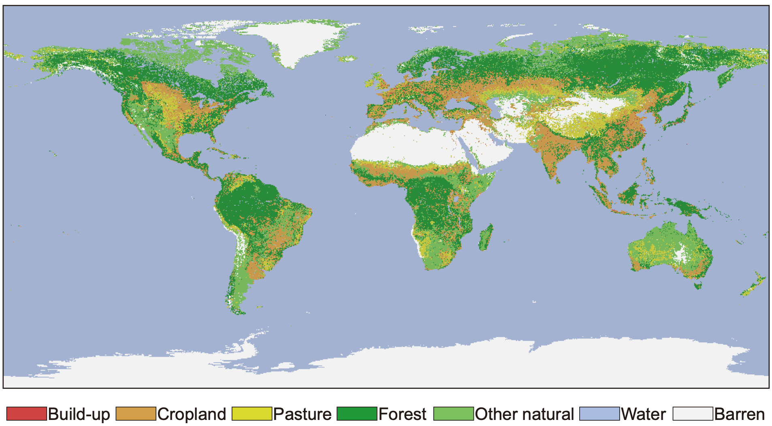
Supplementary Figure 11. ESA-CCI LULC map for the year 2020.
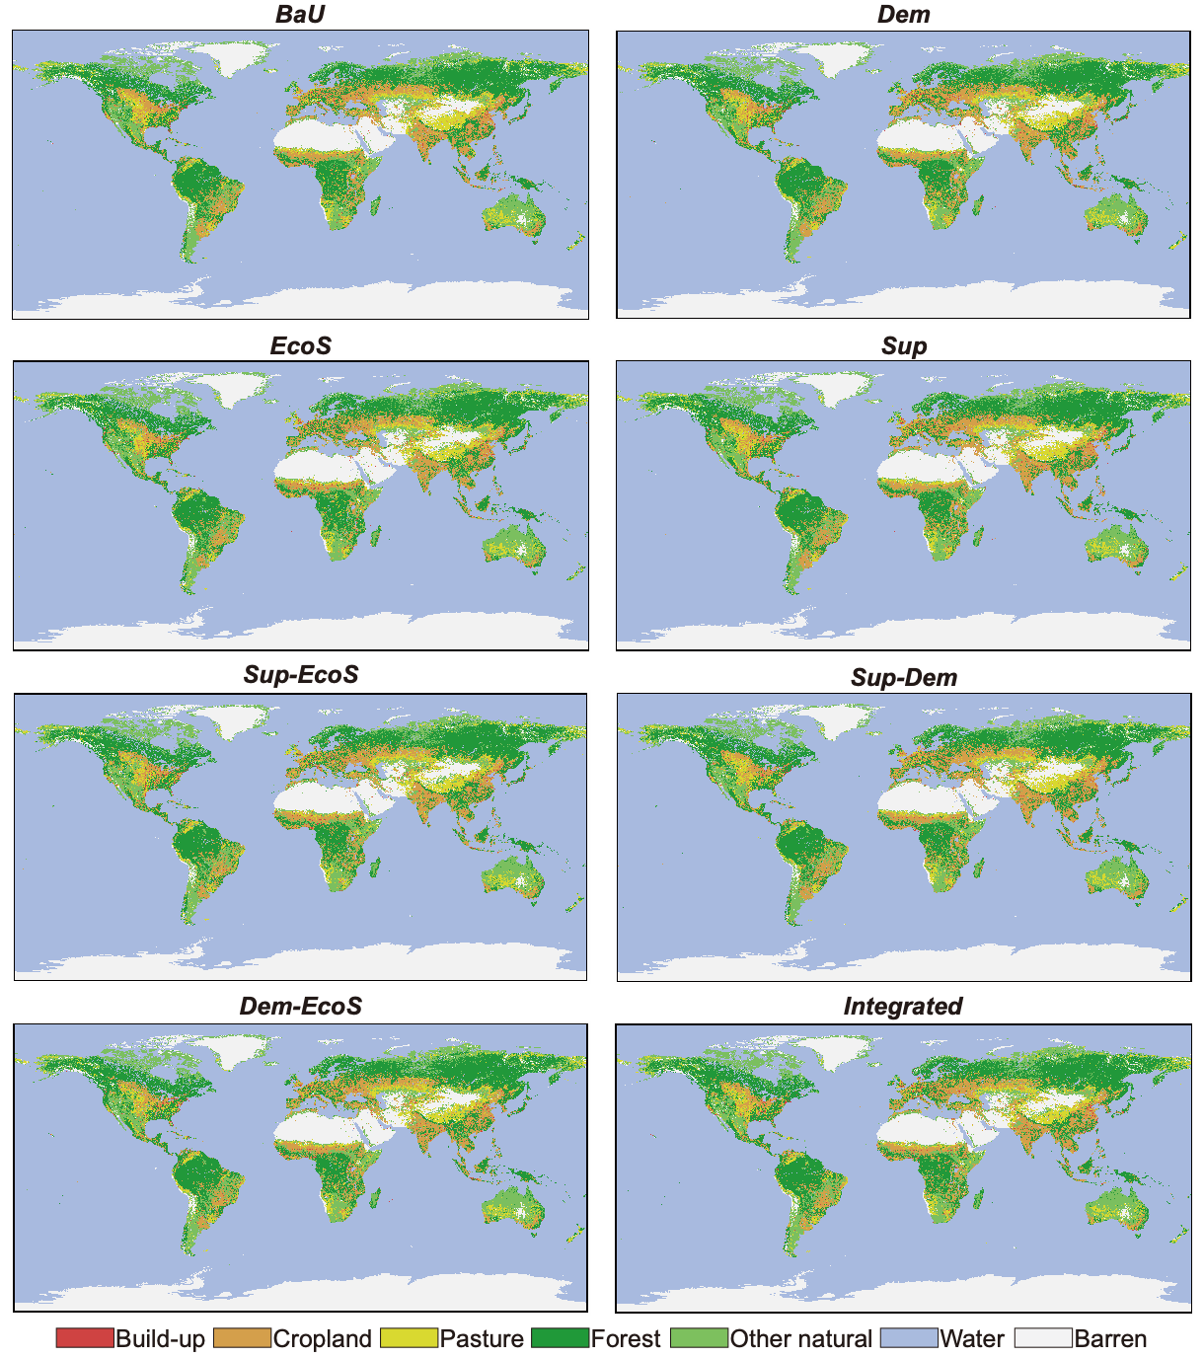
Supplementary Figure 12. Projected high-resolution LULC for the year 2070 under different scenarios. Spatially-explicit land-use projections at 0.5 degree are based on MAgPIE output and transferred to a spatial resolution of 10 arc-second by the LULC allocation model SEALS. BaU (business-as-usual, continuation of current trends), Sup (supply-side actions including high productivity growth rate and increased food trade), Dem (demand-side actions including diet changes and food waste reduction), EcoS (ecosystem stewardship focusing on halting biodiversity decline, expanding protected areas coverage by 30%, and maintaining 20% semi-natural vegetation), Sup–Dem (combined supply- and demand-side actions), Sup–EcoS (supply-side plus ecosystem stewardship), Dem–EcoS (demand-side plus ecosystem stewardship), and Integrated (joint implementation of all three action domains); b) shows results at regional level for 2050. Red dots denote the net change in agricultural land, calculated as the sum of cropland and pasture change.

Supplementary Table 4. Components of the Human Footprint Index and their data sources, assumptions, and temporal dynamics
Module | Data Source | Time | Temporal Dynamics | Spatial Resolution
Urban | Model output | 2020; 2070 | Yes | 300m
Cropland | Model output | 2020; 2070 | Yes | 300m
Pasture | Model output | 2020; 2070 | Yes | 300m
Popdensity | Population projections²⁸ | 2020; 2070 | Yes | 1km
Roads | OpenStreetMap /GRIP²⁹ | 2018 | No | vector
Railways | VMap0 (NGA)¹ | 1990 | No | vector
Lights | VIIRS³⁰ | 2020 | No | 1km
Navwater | Venter et al.²⁷ | 2009 | No | vector

Supplementary Table 5. The framework of mapping annual Human Footprint at the global scale as illustrated in Venter et al.²⁷
Pressure | Score | Details
Urban | 0, 10 | All areas mapped as build given score of 10
Cropland | 0, 7 | All areas mapped as crops given score of 7
Pasture | 0, 4 | All areas mapped as pasture given score of 7
Popdensity | 0–10 Continuous | $$Score=3.333×log⁡(popdens+1)$$
Roads | 0, 8 Direct impacts  0-4 Indirect impacts | 500 m either side of roads given a direct pressure score of 8  Starting 500m out from road, pressure score of 4 exponentially decaying out to 15 km.
Railways | 0, 8 | 500 m either side of railways given a direct pressure score of 8  Starting 500 m out from road
Lights | 0–10 Continuous | Equal quintile bins
Navwater | 0–4 | pressure score of 4 exponentially decaying out to 15 km.

S1.4.1. Built environments
Built environments represent human-constructed areas that support intensive human activity. Within the HFI framework, these areas primarily correspond to urban land, including buildings, paved surfaces, and urban green spaces. Such environments provide limited suitable habitat for most species of conservation concern and generally deliver low levels of ecosystem services^{31,32}.
To identify built environments, we integrate land-use projections from MAgPIE with fine-scale land-cover allocations generated by the SEALS model. MAgPIE produces land-use distributions at a 0.5° resolution, which are subsequently downscaled by SEALS to approximately 300 m, ensuring consistency with large-scale model outputs while capturing local spatial heterogeneity. Based on this coupled framework, we map urban land for 2020 and 2070 and assume that urban extent remains constant across scenarios. For consistency with other pressure layers, the resulting built-environment maps are finally aggregated to a spatial resolution of 1 km. All pixels classified as built environments are assigned a pressure score of 10.

S1.4.2. Cropland and pasture
Cropland and pasture constitute two additional dominant forms of human land use that intensify anthropogenic pressure on natural ecosystems through land conversion, habitat fragmentation, and structural simplification of landscapes. Croplands are characterized by the cultivation of annual or perennial crops for food, feed, and bioenergy production, whereas pasture lands are primarily dedicated to grazing-based livestock systems. Both land-use types substantially reduce habitat suitability for many native species and alter ecosystem functioning.
These land uses are derived from the same coupled MAgPIE–SEALS modelling framework, which generates spatially explicit representations of cropland and pasture for 2020 and 2070 under consistent land-use assumptions. Unlike built environments, cropland and pasture exhibit more dynamic spatial patterns, reflecting shifts in agricultural expansion and reallocation driven by changing production demands and land-use strategies. Following the Human Footprint methodology, cropland pixels are assigned a pressure score of 7, while pasture pixels are assigned a score of 4. These layers are also aggregated to a spatial resolution of 1 km.

S1.4.3. Population density
With increasing population, human-induced environmental pressures become more likely to threaten biodiversity and degrade habitat quality. In this study, we use population density data derived from Wang et al.²⁸, which provide spatially explicit and temporally consistent global population distributions under different SSPs.

S1.4.4. Nighttime lights
Nighttime light provides a unique means of detecting human activities from satellites and is widely used to quantify human pressures on natural ecosystems. In this study, we use nighttime light data for the year 2020 derived from the Visible Infrared Imaging Radiometer Suite (VIIRS), which provides stable and high-quality observations of artificial illumination at the global scale³⁰. Compared with earlier DMSP-based products, VIIRS offers improved radiometric performance and finer spatial detail, enabling a more reliable representation of contemporary human activity patterns. In the future scenarios, nighttime light was held constant at its 2020 level because scenario-specific projections of nighttime light were unavailable.

S1.4.5. Roads and railways
Road networks form a major interface between natural and human environments and strongly influence the spatial distribution of human pressures³³. In this study, we use global road data from the Global Roads Inventory Project (GRIP)²⁹, which provides a harmonized and comprehensive compilation of road networks by integrating multiple national and regional datasets into a globally consistent product. GRIP covers major road classes at a fine spatial resolution and ensures cross-country comparability, making it suitable for global Human Footprint assessments. Consistent with previous HFI studies, trails and minor roads are excluded from the analysis. In addition, global railway data are obtained from the National Geospatial-Intelligence Agency (NGA; https://gis-lab.info/qa/vmap0-eng.html). These road and railway layers were also assumed to remain constant across future scenarios.

S1.4.6. Navigable waterways
Navigable waterways represent another important pathway through which human activities interact with aquatic ecosystems, facilitating transportation while also increasing risks of pollution and habitat disturbance³⁴. The pressure associated with navigable waterways is quantified following the general principles of the Human Footprint framework proposed by Venter et al.³⁵. Navigable waterways are identified based on two criteria: (1) river channels with a minimum water depth exceeding 2 m, and (2) proximity to illuminated areas, defined as being within 4 km of a lit pixel, indicating active navigation and human use. Spatial delineation is achieved by integrating river and coastline data from the NGA with hydrological layers from HydroSHEDS, which provide high-resolution river network information³⁶. This combined approach enables the generation of a globally consistent layer representing waterways likely subjected to sustained navigational pressure. These navigable waterways were also assumed to remain constant across future scenarios.

S1.4.7. Human footprint index (HFI)
The HFI is obtained by summing all pressure layers for each grid cell, resulting in a spatially explicit index that ranges from 0 to 50, where higher values indicate stronger cumulative human pressure. This integrated framework generates global HFI maps for 2020 and 2070 across different scenarios, enabling direct comparison of both spatial patterns and temporal dynamics of human influence. The resulting distributions capture how alternative socio-economic pathways and food system transformation and targeted ecosystem stewardship reshape the intensity and geographic configuration of anthropogenic pressures on ecosystems, thereby providing a consistent basis for evaluating scenario-specific impacts on functional connectivity of global protected area (Supplementary Figure 13).
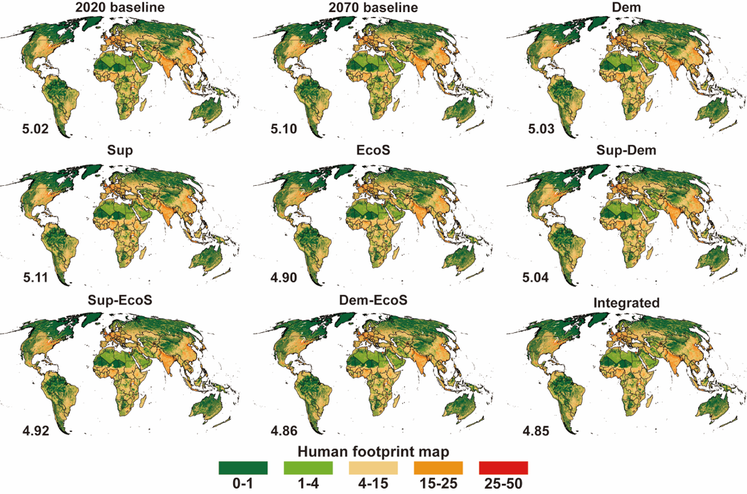
Supplementary Figure 13 The global human footprint map for different scenarios. Note: Numbers in each panel indicate the global mean value.

S1.5. Circuit-theoretic computations for landscape ecology (Circuitscape)
We assessed global connectivity using Circuitscape³⁷, an open-source software developed in Julia that is widely applied in ecological connectivity analyses and conservation planning (https://circuitscape.org/). This approach treats a gridded resistance-to-movement surface as a conductive layer where neighboring grid cells are connected by resistors, whose level of resistance represents the friction of the landscape to animal movement (i.e., low-resistance grid cells are most likely to be traversed). Electrical current, injected at a source node representing a source of animal movement, flows across all neighboring landscape grid cells (resistors) in the circuit to a ground node representing the destination of animal movement. Connectivity is then evaluated in two distinct ways: (a) from the effective resistance between nodes on a circuit (i.e., protected area (PA) isolation), measuring the degree to which the source node is isolated from the ground node and (b) from the pattern of electrical current flow (i.e., mammal movement probabilities) across the resistance-to-movement surface. Two input layers were required: (1) a resistance surface representing the landscape’s permeability to mammal movement, and (2) a raster of source and destination areas, here defined as the global distribution of protected areas.
To quantify resistance, we employed the data and linear mixed-effects movement model of Tucker et al.¹⁷ which estimates mammal displacement distances as a function of environmental and biological predictors. Specifically, we used the 0.95 quantile of 10-day net displacement distances for 48 medium- to large-bodied mammal species (2.4–3940 kg; 624 individual GPS tracks). Predictors included the Human Footprint Index (HFI), Normalized Difference Vegetation Index (NDVI), body mass, and trophic guild, with species treated as a random effect. Land-use change projections were used to update HFI for 2020 and 2070, producing resistance surfaces under 16 scenarios. We focused on long-distance, large-scale movements that more realistically reflect dispersal between protected areas, which underpins both genetic exchange and climate adaptation.
The predicted resistance surface, based on the herbivore movement model, was renormalized to represent the permeability of the global landscape to mammal movement. Permeability was then converted to a movement resistance surface using a linear inverse function (i.e., Resistance = 1-Permeability), and zero values were replaced with 0.0001. Following established methodologies, we further adjusted the initial resistance surface (M) using percentage slope to account for the increased energy expenditure required to traverse steep terrain, using the Equation S1:
$$M={M_{1}}^{1-\frac{S}{max⁡(s)}}$$
where $M_{1}$ represents the resistance surface before correction, $S$ represents the terrain slope. Subsequently, the movement resistance surface was resampled from a 1 km² grid to approximately 70 km² (using a Mollweide equal-area projection).

S1.5.1. Mammal Movement Probability
We applied Circuitscape’s “all-to-one” mode to predict the net probability of mammal movement between nodes. In each run, the centroid of one PA was designated the ground node, while all other PAs acted as current sources. Current injection was scaled to PA size (1 A per km²), under the assumption that larger PAs harbor more dispersers. Resulting current flow maps were further scaled by the area and Biodiversity Intactness Index (BII) of the destination PA to capture its capacity to receive migrants. Repeating this process for every PA and summing the results yielded continental-scale movement probability maps. To remove continental size effects, values in each continental map were divided by the total land area of that continent before the maps were merged into a global mammal movement probability map.

S1.5.2. Protected Area Isolation
To calculate PA isolation, we used Circuitscape’s “one-to-all” mode. Each PA centroid was sequentially set as a current source, with all others grounded. Effective resistance between the source and the rest of the network was then calculated, providing a measure of PA isolation that is independent of current magnitude. This procedure was repeated for all PAs globally, producing isolation maps at continental scales.

S1.5.3. Protected Areas
Protected areas were primarily derived from the May 2020 release of the World Database on Protected Areas (WDPA; https://www.protectedplanet.net/). Because China’s national protected areas had been removed from the WDPA after April 2018, we supplemented the WDPA with protected-area data released by Chinese authorities (http://www.geodata.cn/). The final protected-area layer therefore combined WDPA records with China-specific protected-area data. In accordance with WDPA guidelines, we excluded PAs with no reported area, a “Proposed” status, or UNESCO–MAB designations. To represent sources and destinations, we used rasterized PA centroids rather than full boundaries, enabling current flow within PAs. PAs smaller than half a grid cell (~35 km²) were excluded to ensure functionality as dispersal nodes. Connectivity models were run separately by continent (excluding Antarctica, islands <2500 km², and islands with <2 PAs). Europe and Asia were merged into “Eurasia,” and Oceania with Australia, to minimize edge effects.

S2. Scenario description
We adopted the “middle-of-the-road” Shared Socioeconomic Pathway (SSP2) as our reference scenario. SSP2 assumes continued moderate population growth, reaching a global peak of 9.4 billion by 2070, coupled with uneven economic growth, ongoing globalization, and gradual socioeconomic convergence across countries, while also incorporating currently implemented land-use regulations. In six additional scenarios, we evaluated different combinations of supply-side, demand-side, and conservation measures aimed at enhancing the functional connectivity of global protected areas; all scenarios were implemented within the SSP2 pathway. The additional scenarios correspond to each action separately and to combined-action scenarios, in which actions are paired or combined as the integrated action portfolio of all three actions. Further details on the intervention components are provided in the following section.

S2.1. Supply-side (Sup) actions
The supply-side actions comprise two components: improving agricultural production efficiency and increasing trade in agricultural goods. Improvements in production efficiency include lowering interest rates in low-income countries—facilitating investment and thereby increasing agricultural output—and enhancing livestock productivity by aligning production efficiency and feed-use profiles with the SSP1 trajectory. The trade component reduces self-sufficiency rates for livestock products by 10% by 2030 and by an additional 10% after 2050, while crop self-sufficiency rates are reduced by 20% by 2030 and by a further 10% after 2050.

S2.2. Demand-side (Dem) actions
The demand-side actions consist of two components: diet changes and reductions in food waste. The diet changes are guided by the minimum and maximum recommended daily intakes for different food groups, while allowing substantial cross-country variation in dietary patterns within these recommended ranges (Table S6). Minimum per capita intakes are specified for legumes, fruits, vegetables, and nuts. In countries where current intake levels fall below these thresholds, consumption is increased to meet the minimum recommendations. Maximum intake thresholds are set for sugar, oils, poultry, eggs, red meat, and dairy products. Where current intake exceeds these levels, consumption is reduced accordingly. In addition, we assume convergence toward a healthy body mass index of 20–25. The food-waste reduction component constrains current food losses and waste to a maximum of 20%.

Supplementary Table 6. Grouping of scenario assumptions
MAgPIE food category | EAT-Lancet category | Lower bound | Upper bound
Wheat; Tropical cereals; Rice; Maize; Brans | Whole grains | 232 | —
Pulses; Soybean; Groundnuts | Legumes | 100 | —
Potatoes; Tropical roots | Tubers or starchy vegetables | 0 | 50
Sunflower; Other oil crops incl. rapeseed; Fruits, vegetables, nuts | Fruits; Vegetables; Nuts | 525 | —
Dairy | Dairy foods | 0 | 250
Ruminant meat | Beef and lamb | 0 | 7
Monogastric meat | Pork | 0 | 7
Poultry meat | Chicken and other poultry | 0 | 29
Eggs | Eggs | 0 | 13
Fish | Fish | — | 28
Oils | Added fats | 0 | 51.8
Sugar; Molasses; Sugar beet; Sugar cane | Added sugars | 0 | 31

S2.3. Ecosystem stewardship (EcoS) actions
The ecosystem-stewardship intervention comprises a suite of conservation measures designed to strengthen biosphere integrity. Relative to the BAU scenario, the extent of protected areas is expanded by 2055 Mha to achieve the GBF commitment of conserving at least 30% of global terrestrial land by 2030. The expansion prioritizes regions of highest global conservation value (Supplementary Figure 14), including Key Biodiversity Areas (KBAs), Biodiversity Hotspots (BHs) and Ecoregions with high beta-diversity (EBDs)³⁸, as well as the Critical Connectivity Areas (CCAs) identified by Brennan et al.¹⁶. Our choice to expand protected areas within KBAs, BHs, EBDs, and CCAs is guided by current evidence on global conservation priorities and reflects an effort to balance multiple conservation objectives, including the protection of globally important regions and the maintenance of species movements^{16,38}. Nonetheless, this represents only one plausible pathway for implementing the GBF 30×30 target, intended to illustrate how strategic land protection could support global biodiversity conservation. We assume that, within these conservation priority areas, restoration targets for different land-cover types follow pre-industrial (1750) reference conditions derived from the LUH2 (v2) dataset⁹. In addition, the EcoS actions incorporates a set of interventions aimed at addressing major drivers of biodiversity loss outside protected areas. These measures include retaining at least 20% semi-natural vegetation (SNV) in managed landscapes by 2030 and implementing a no-net-biodiversity-loss scheme at the biome level after 2030³⁹. The requirement to maintain at least 20% SNV within managed landscapes is directly implemented in the MAgPIE model by reserving 20% of potentially cultivable cropland for SNV. Further methodological details can be found in Jeetze et al.⁴⁰. The no-net-biodiversity-loss mechanism prevents any decline in the Biodiversity Intactness Index (BII)⁴¹ for each biome³⁹ within a given MAgPIE region and biogeographic realm. Consequently, any reduction in the biome-level, area-weighted mean BII, such as that caused by cropland expansion or urban development, must be compensated by increasing the extent of land-use categories with higher BII scores within the same biome. In this way, the no-net-loss rule functions as an additional safeguard for areas outside designated conservation priorities, discouraging avoidable conversions to agricultural land. The BII coefficients associated with individual land-use classes in MAgPIE follow Leclère et al.⁴¹, with additional methodological details described in Jeetze et al.⁴⁰.
Supplementary Figure 14 Baseline protected area and stimulated enlargement of protected areas in conservation priority area. The protected area baseline was taken from the WDPA Database and held constant after 2020⁴². Conservation priority areas include Key Biodiversity Areas (KBAs), Biodiversity Hotspots (BHs) and Ecoregions with high beta-diversity (EBDs), as well as the Critical Connectivity Areas (CCAs)⁴³.

S3. Supplementary Results
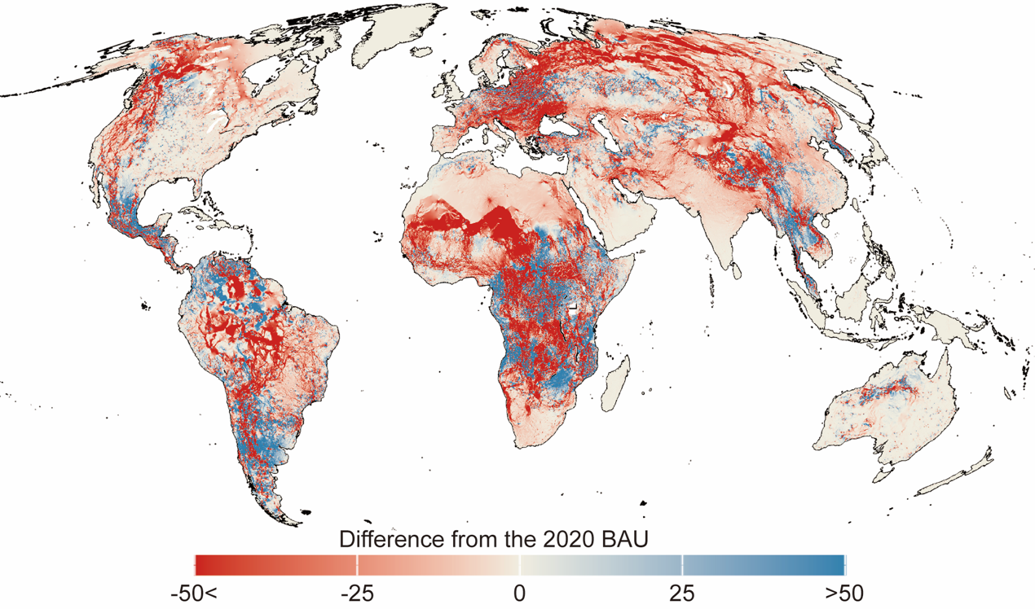
Supplementary Figure 15. Changes in mammal movement probability (MMP) between 2020 and 2070 under the baseline scenario.
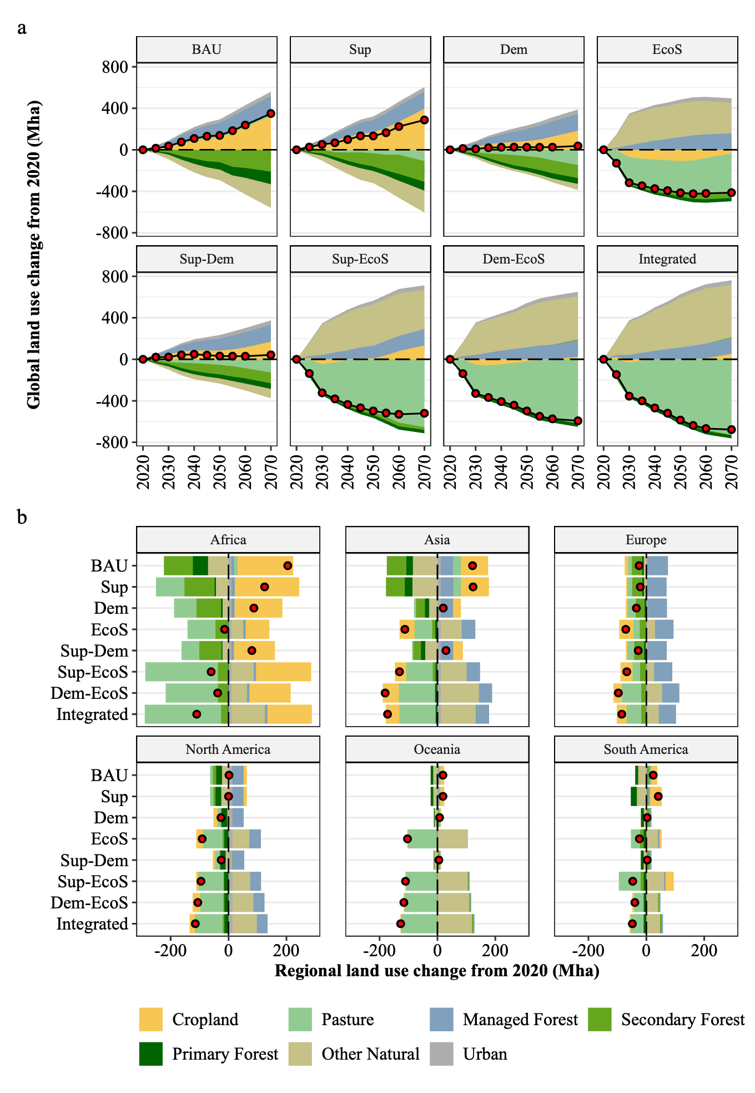
Supplementary Figure 16. Global and regional projections of land-use change of major land types over time between 2020 and 2070 for different scenarios. a) shows projected changes in global land use compared to 2020 across eight scenarios; b) shows results at regional level for 2070. Red dots denote the net change in agricultural land, calculated as the sum of cropland and pasture change. BAU (baseline), Sup (supply-side actions including high productivity growth rate and increased food trade), Dem (demand-side actions including diet changes and food waste reduction), EcoS (ecosystem stewardship focusing on halting biodiversity decline, expanding protected areas coverage by 30%, and maintaining 20% semi-natural vegetation), Sup–Dem (combined supply- and demand-side actions), Sup–EcoS (combined supply-side and ecosystem stewardship), Dem–EcoS (combined demand-side and ecosystem stewardship), and Integrated (joint implementation of all three action domains).

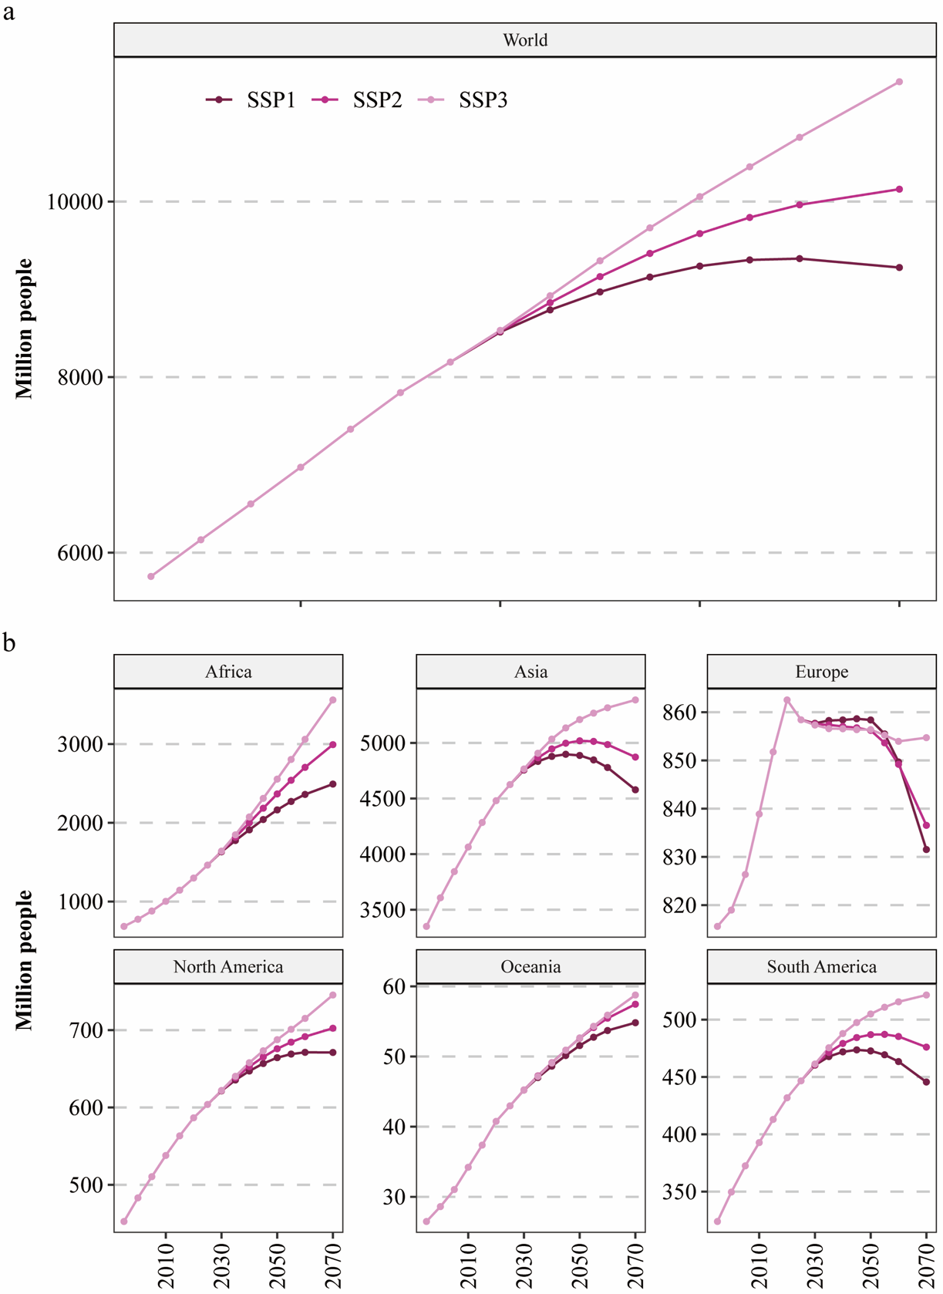
Supplementary Figure 17. Projected population trajectories by region under different SSPs. Regional country composition is detailed in Supplementary Table 2.
S4. Sensitivity analysis
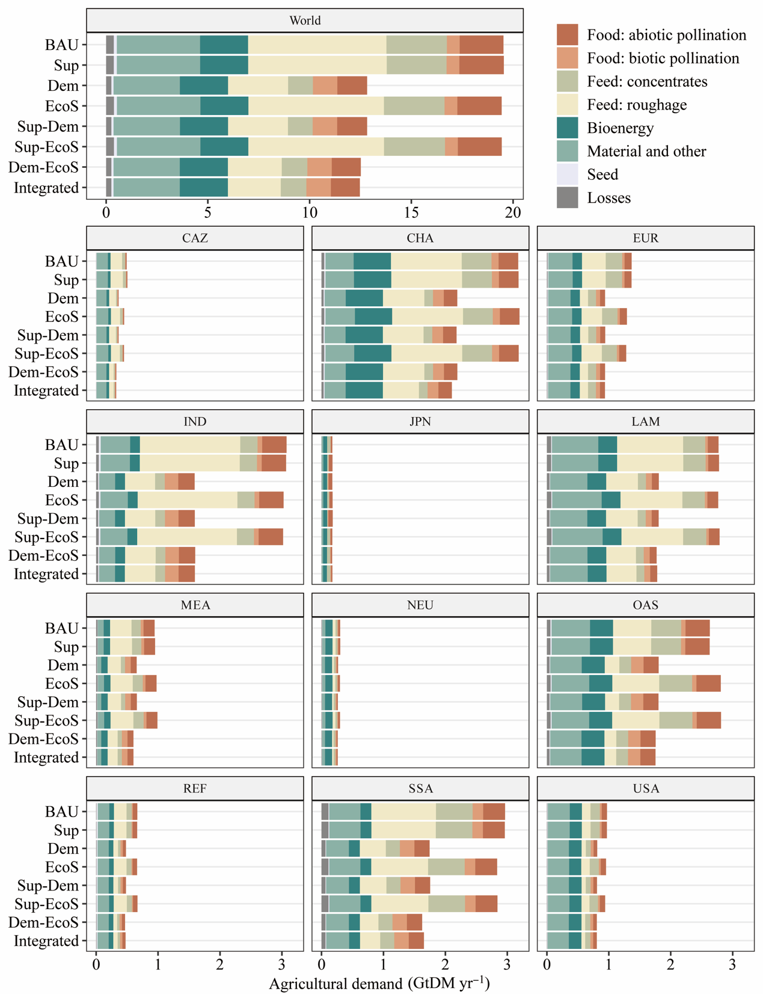
Supplementary Figure 18 Projected in regional agricultural demand in 2070 across different demand categories and different scenarios under SSP1.

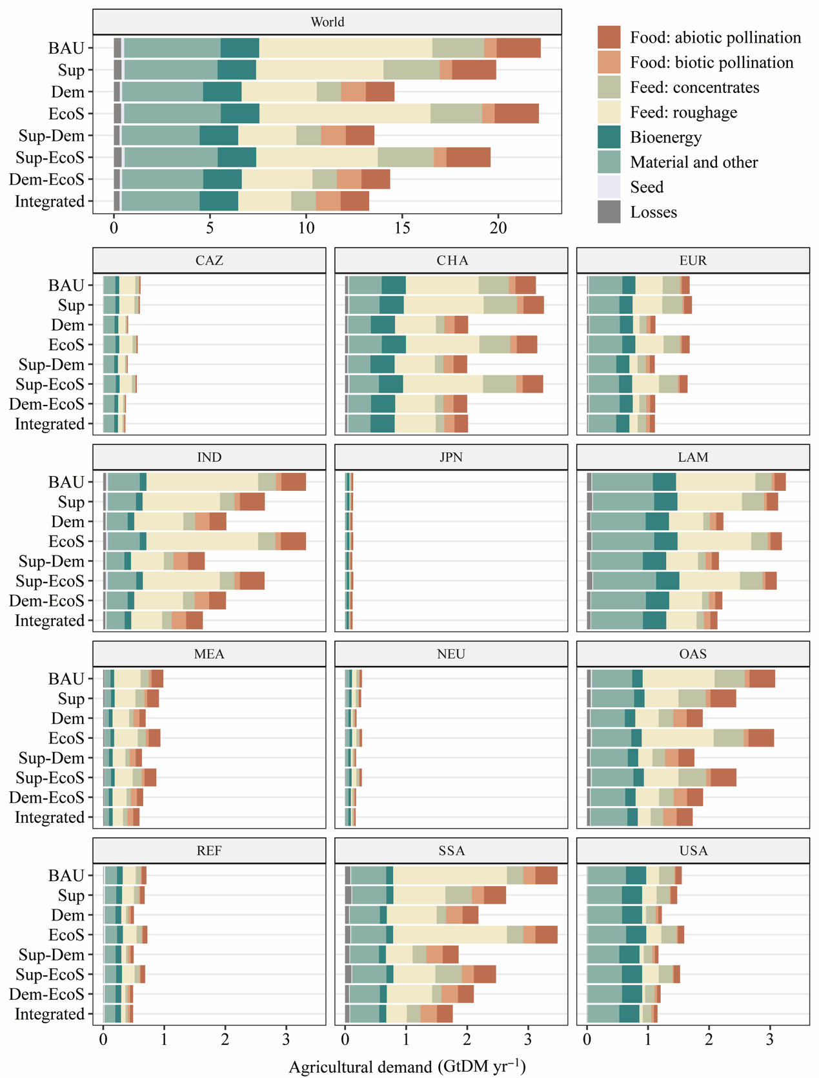
Supplementary Figure 19 Projected in regional agricultural demand in 2070 across different demand categories and different scenarios under SSP3.

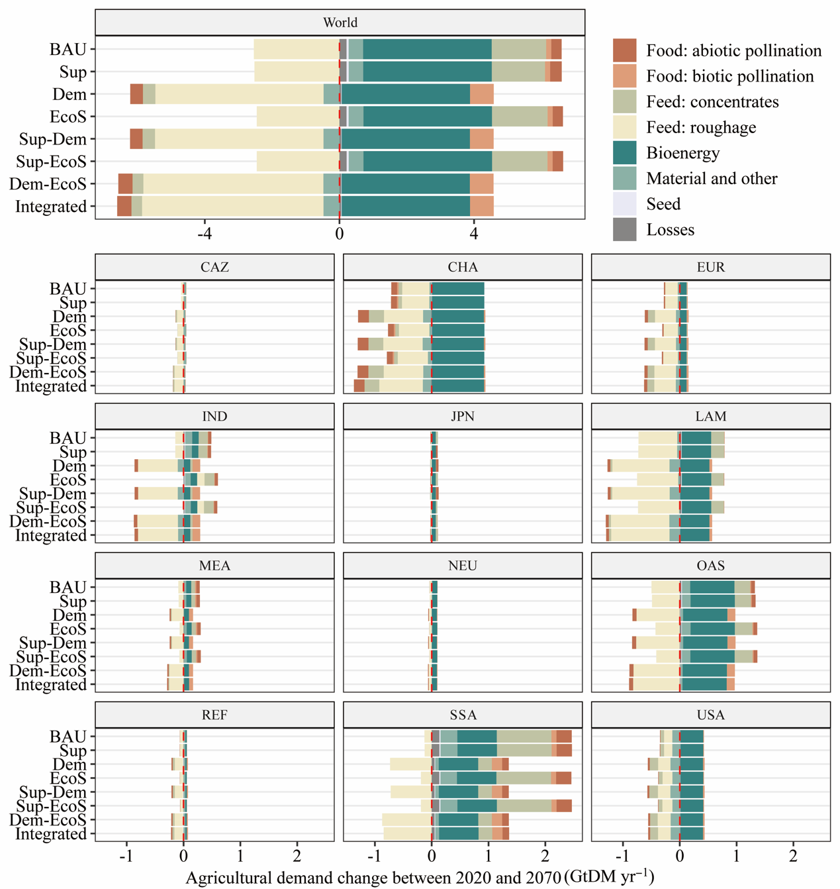
Supplementary Figure 20 Regional changes in agricultural demand between 2020 and 2070 under disaggregated by commodity group for SSP1.

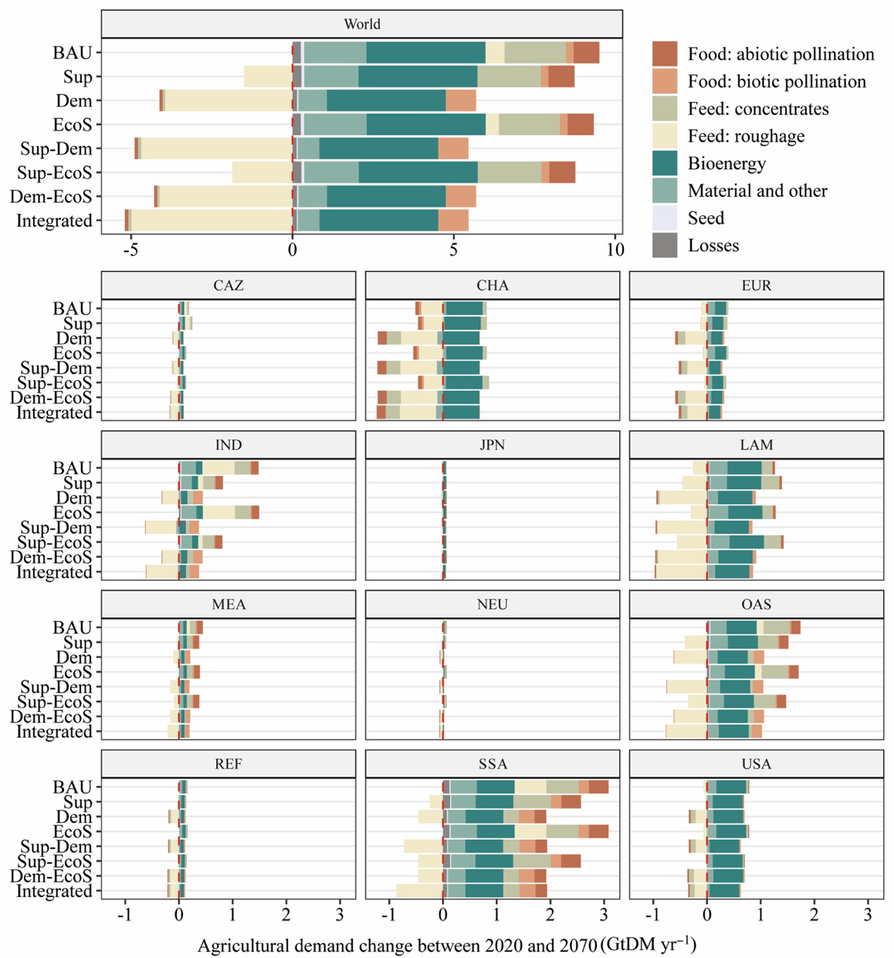
Supplementary Figure 21 Regional changes in agricultural demand between 2020 and 2070 under disaggregated by commodity group for SSP3.

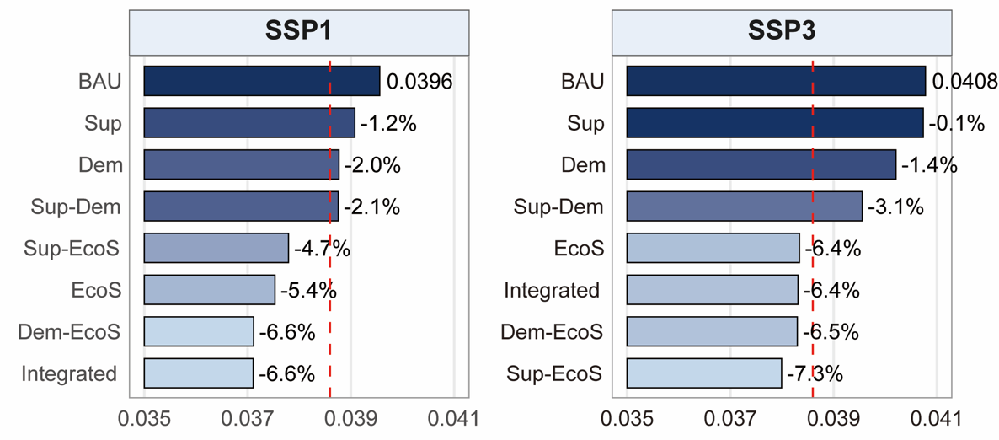
Supplementary Figure 22 Global projections of protected area isolation (PAI) under SSP1 and SSP3 trajectories

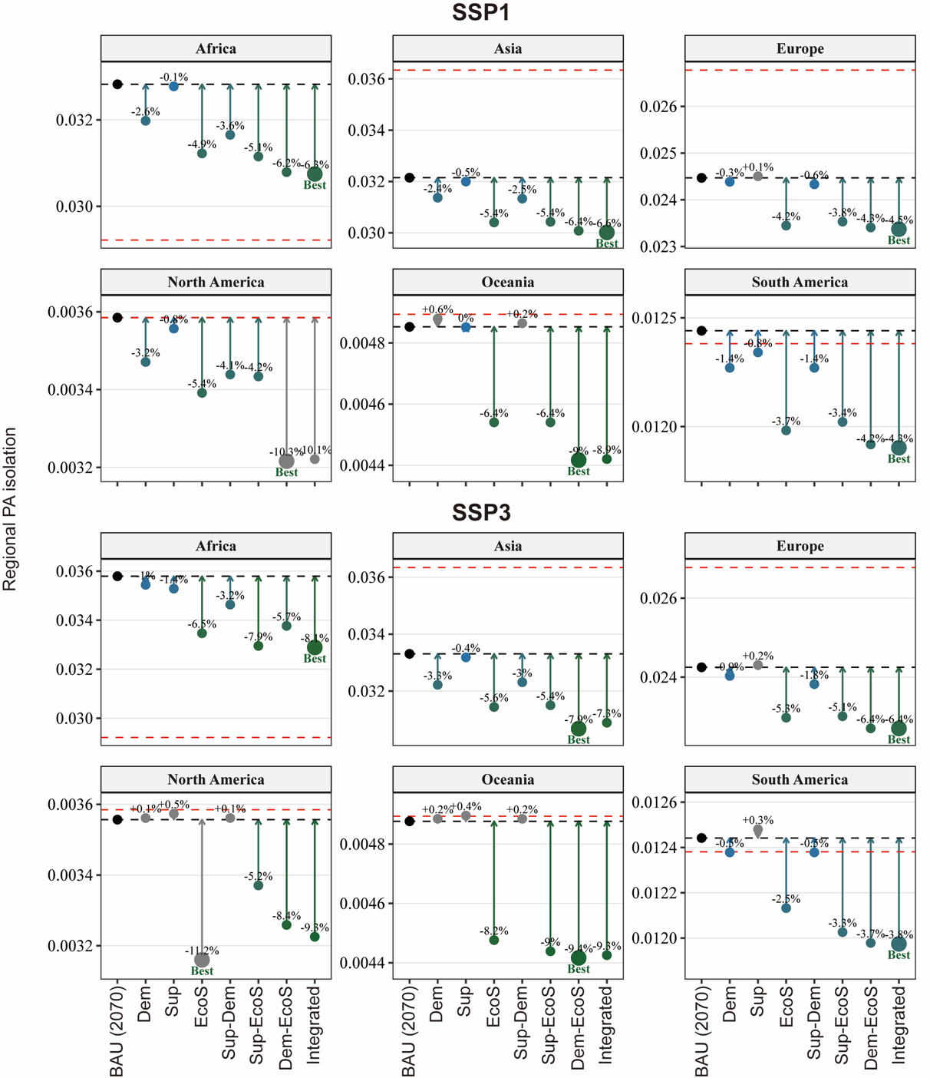
Supplementary Figure 23 Regional-level projections of protected area isolation (PAI) across scenarios under SSP1 and SSP3 trajectories. The red dashed line indicates the 2020 baseline.

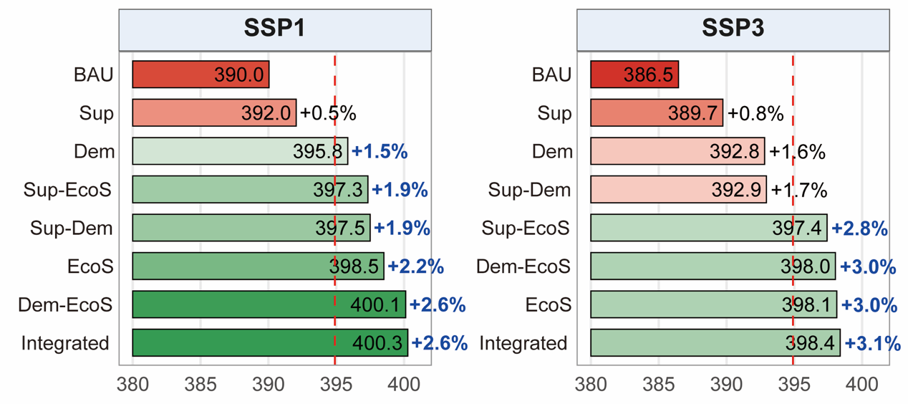
Supplementary Figure 24 Global projections of Mammal movement probability (MMP) under SSP1 and SSP3 trajectories

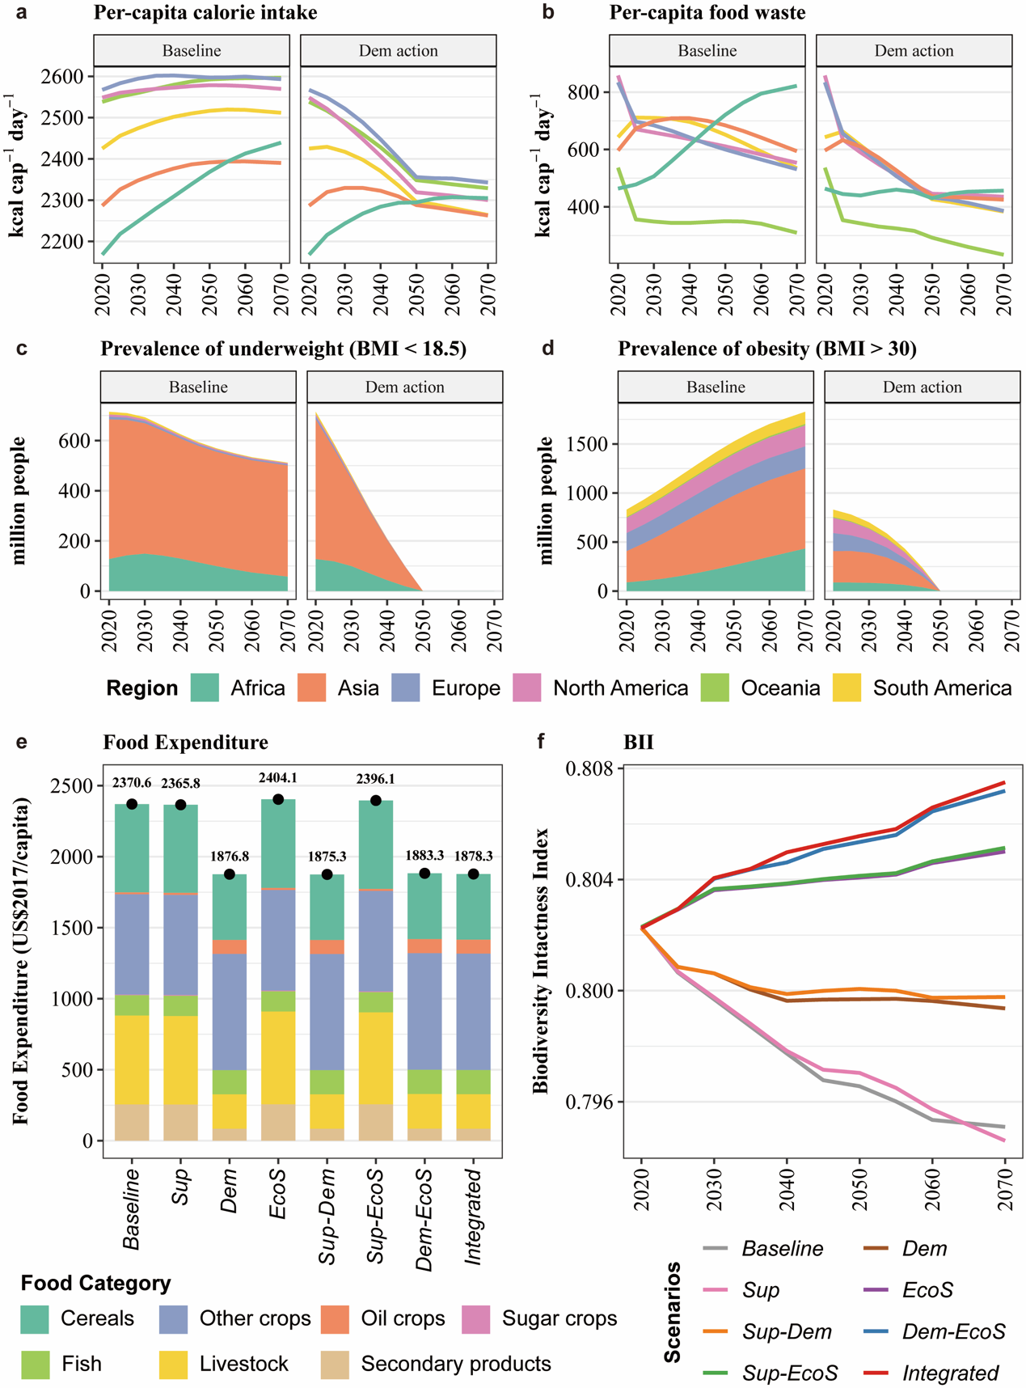
Supplementary Figure 25 Key socio-economic drivers and developments under SSP1 trajectory. a) per-capita calorie intake at regional level; b) per-capita food waste; c) prevalence of underweight (body mass index <18.5) and d) prevalence of obesity (BMI > 30); e) food expenditure at global level and f) biodiversity intactness index (BII) at global level. Note: Panels a–d include only the Baseline and demand-side actions, as interventions without demand-side measures do not change dietary intake or food waste, and thus do not affect underweight or obesity.
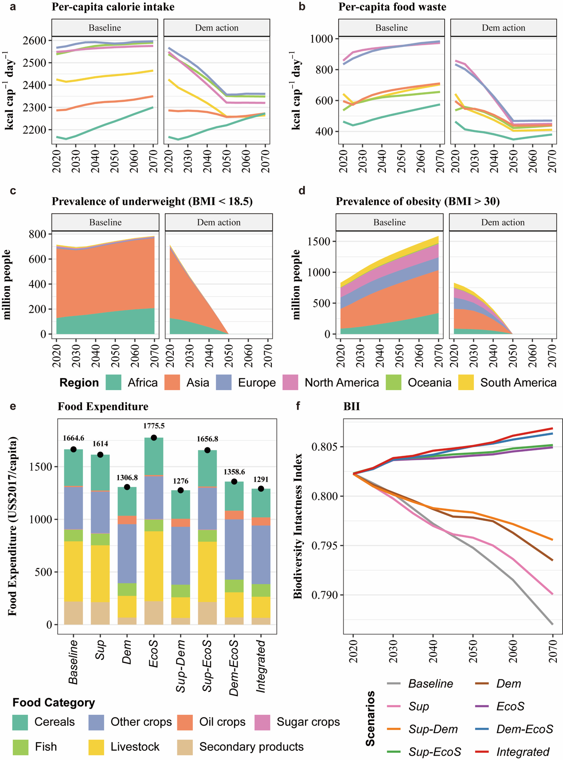
Supplementary Figure 26 Key socio-economic drivers and developments under SSP3 trajectory. a) per-capita calorie intake at regional level; b) per-capita food waste; c) prevalence of underweight (body mass index <18.5) and d) prevalence of obesity (BMI > 30); e) food expenditure at global level and f) biodiversity intactness index (BII) at global level. Note: Panels a–d include only the Baseline and demand-side actions, as interventions without demand-side measures do not change dietary intake or food waste, and thus do not affect underweight or obesity.

Reference
1 Dietrich Jan Philipp, B., Benjamin Leon, Weindl, Isabelle, et al. MAgPIE - An Open Source land-use modeling. Zenodo (2023). https://doi.org/https://doi.org/10.5281/zenodo.7551451
2 Schaphoff, S. et al. LPJmL4 – a dynamic global vegetation model with managed land – Part 1: Model description. Geosci. Model Dev. 11, 1343-1375 (2018). https://doi.org/10.5194/gmd-11-1343-2018
3 Bodirsky, B. L. et al. The ongoing nutrition transition thwarts long-term targets for food security, public health and environmental protection. Scientific Reports 10, 19778 (2020). https://doi.org/10.1038/s41598-020-75213-3
4 Bodirsky, B. L. et al. Global Food Demand Scenarios for the 21st Century. PLOS ONE 10, e0139201 (2015). https://doi.org/10.1371/journal.pone.0139201
5 FAO. Future of Food and Agriculture 2018: Alternative Pathways to 2050. (FAO, Rome, Italy, 2018).
6 Willett, W. et al. Food in the Anthropocene: the EAT-Lancet Commission on healthy diets from sustainable food systems. Lancet 393, 447-492 (2019). https://doi.org/10.1016/S0140-6736(18)31788-4
7 Stevanović, M. et al. Mitigation Strategies for Greenhouse Gas Emissions from Agriculture and Land-Use Change: Consequences for Food Prices. Environmental Science & Technology 51, 365-374 (2017). https://doi.org/10.1021/acs.est.6b04291
8 Dietrich, J. P., Schmitz, C., Lotze-Campen, H., Popp, A. & Müller, C. Forecasting technological change in agriculture—An endogenous implementation in a global land use model. Technological Forecasting and Social Change 81, 236-249 (2014). https://doi.org/https://doi.org/10.1016/j.techfore.2013.02.003
9 Hurtt, G. C. et al. Harmonization of global land use change and management for the period 850–2100 (LUH2) for CMIP6. Geosci. Model Dev. 13, 5425-5464 (2020). https://doi.org/10.5194/gmd-13-5425-2020
10 MacDicken, K. G. Global Forest Resources Assessment 2015: What, why and how? Forest Ecology and Management 352, 3-8 (2015). https://doi.org/https://doi.org/10.1016/j.foreco.2015.02.006
11 Mishra, A. et al. Estimating global land system impacts of timber plantations using MAgPIE 4.3.5. Geosci. Model Dev. 14, 6467-6494 (2021). https://doi.org/10.5194/gmd-14-6467-2021
12 Braakhekke, M. C. et al. Modeling forest plantations for carbon uptake with the LPJmL dynamic global vegetation model. Earth Syst. Dynam. 10, 617-630 (2019). https://doi.org/10.5194/esd-10-617-2019
13 Humpenöder, F. et al. Overcoming global inequality is critical for land-based mitigation in line with the Paris Agreement. Nature Communications 13, 7453 (2022). https://doi.org/10.1038/s41467-022-35114-7
14 Schmitz, C. et al. Trading more food: Implications for land use, greenhouse gas emissions, and the food system. Global Environmental Change 22, 189-209 (2012). https://doi.org/10.1016/j.gloenvcha.2011.09.013
15 Wang, X. et al. Beyond land-use intensity: Assessing future global crop productivity growth under different socioeconomic pathways. Technological Forecasting and Social Change 160, 120208 (2020). https://doi.org/https://doi.org/10.1016/j.techfore.2020.120208
16 Brennan, A. et al. Functional connectivity of the world’s protected areas. Science 376, 1101-1104 (2022). https://doi.org/doi:10.1126/science.abl8974
17 Tucker, M. A. et al. Moving in the Anthropocene: Global reductions in terrestrial mammalian movements. Science 359, 466-469 (2018). https://doi.org/doi:10.1126/science.aam9712
18 Pacifici, M., Di Marco, M. & Watson, J. E. M. Protected areas are now the last strongholds for many imperiled mammal species. Conservation Letters 13, e12748 (2020). https://doi.org/https://doi.org/10.1111/conl.12748
19 Brodie, J. F. et al. A well-connected Earth: The science and conservation of organismal movement. Science 388, eadn2225 (2025). https://doi.org/doi:10.1126/science.adn2225
20 Ward, M. et al. Just ten percent of the global terrestrial protected area network is structurally connected via intact land. Nature Communications 11, 4563 (2020). https://doi.org/10.1038/s41467-020-18457-x
21 Haddad, N. M. Corridors for people, corridors for nature. Science 350, 1166-1167 (2015). https://doi.org/doi:10.1126/science.aad5072
22 Hengl, T. et al. SoilGrids250m: Global gridded soil information based on machine learning. PLOS ONE 12, e0169748 (2017). https://doi.org/10.1371/journal.pone.0169748
23 Johnson, J. A. et al. (2021).
24 von Jeetze, P. J. et al. Projected landscape-scale repercussions of global action for climate and biodiversity protection. Nature Communications 14, 2515 (2023). https://doi.org/10.1038/s41467-023-38043-1
25 Verburg, P. H. & Overmars, K. P. Combining top-down and bottom-up dynamics in land use modeling: exploring the future of abandoned farmlands in Europe with the Dyna-CLUE model. Landscape Ecology 24, 1167-1181 (2009). https://doi.org/10.1007/s10980-009-9355-7
26 Wolff, S., Schrammeijer, E. A., Schulp, C. J. E. & Verburg, P. H. Meeting global land restoration and protection targets: What would the world look like in 2050? Global Environmental Change 52, 259-272 (2018). https://doi.org/https://doi.org/10.1016/j.gloenvcha.2018.08.002
27 Venter, O. et al. Sixteen years of change in the global terrestrial human footprint and implications for biodiversity conservation. Nature Communications 7, 12558 (2016). https://doi.org/10.1038/ncomms12558
28 Wang, X., Meng, X. & Long, Y. Projecting 1 km-grid population distributions from 2020 to 2100 globally under shared socioeconomic pathways. Scientific Data 9, 563 (2022). https://doi.org/10.1038/s41597-022-01675-x
29 Meijer, J. R., Huijbregts, M. A., Schotten, K. C. & Schipper, A. M. Global patterns of current and future road infrastructure. Environmental Research Letters 13, 064006 (2018).
30 Li, X., Zhou, Y., Zhao, M. & Zhao, X. A harmonized global nighttime light dataset 1992–2018. Scientific Data 7, 168 (2020). https://doi.org/10.1038/s41597-020-0510-y
31 Aronson, M. F. J. et al. A global analysis of the impacts of urbanization on bird and plant diversity reveals key anthropogenic drivers. Proceedings of the Royal Society B: Biological Sciences 281, 20133330 (2014). https://doi.org/doi:10.1098/rspb.2013.3330
32 Lin, B. B., Philpott, S. M. & Jha, S. The future of urban agriculture and biodiversity-ecosystem services: Challenges and next steps. Basic and Applied Ecology 16, 189-201 (2015). https://doi.org/10.1016/j.baae.2015.01.005
33 Trombulak, S. C. & Frissell, C. A. Review of Ecological Effects of Roads on Terrestrial and Aquatic Communities. Conservation Biology 14, 18-30 (2000). https://doi.org/https://doi.org/10.1046/j.1523-1739.2000.99084.x
34 Wolter, C. Conservation of fish species diversity in navigable waterways. Landscape and Urban Planning 53, 135-144 (2001). https://doi.org/https://doi.org/10.1016/S0169-2046(00)00147-X
35 Venter, O. et al. Global terrestrial Human Footprint maps for 1993 and 2009. Scientific Data 3, 160067 (2016). https://doi.org/10.1038/sdata.2016.67
36 Lehner, B. & Grill, G. Global river hydrography and network routing: baseline data and new approaches to study the world's large river systems. Hydrological Processes 27, 2171-2186 (2013). https://doi.org/https://doi.org/10.1002/hyp.9740
37 Anantharaman, R., Hall, K., Shah, V. & Edelman, A. Circuitscape in Julia: High performance connectivity modelling to support conservation decisions. arXiv preprint arXiv:1906.03542 (2019).
38 Dinerstein, E. et al. A “Global Safety Net” to reverse biodiversity loss and stabilize Earth’s climate. Science Advances 6, eabb2824 (2020). https://doi.org/doi:10.1126/sciadv.abb2824
39 Olson, D. M. et al. Terrestrial Ecoregions of the World: A New Map of Life on Earth: A new global map of terrestrial ecoregions provides an innovative tool for conserving biodiversity. BioScience 51, 933-938 (2001). https://doi.org/10.1641/0006-3568(2001)051[0933:Teotwa]2.0.Co;2
40 von Jeetze, P. et al. Conservation outcomes of dietary transitions across different values of nature. Nature Sustainability 8, 1130-1142 (2025). https://doi.org/10.1038/s41893-025-01595-9
41 Leclère, D. et al. Bending the curve of terrestrial biodiversity needs an integrated strategy. Nature 585, 551-556 (2020). https://doi.org/10.1038/s41586-020-2705-y
42 UNEP-WCMC. (Cambridge, UK: UNEP-WCMC and IUCN, March 2022).
43 von Jeetze, P. et al. Dietary change is not a prerequisite for effective biodiversity conservation but reduces socioeconomic obstacles. (2024).

