Supplementary information

Anderson JW, Shaikh N, Cooper GF, Visweswaran S. The Limits of Prediction-Based Algorithmic Fairness in Clinical Models: A Utility-Theoretic Perspective.

UTICalc Decision Problem

We can represent the catheterization problem as an influence diagram (ID). Figure 1 shows a simplified ID that shows the relationships between clinical variables C, race R, Latent confounder L, UTICalc prediction of UTI $\hat{y}$, true UTI status y, and utility of the clinical outcome U. Persistent association between race and UTI that is not fully explained by the observed clinical variables has been reported in the literature. Even after adjusting for factors in $C,$(e.g., duration of fever), the association between race and UTI persists, suggesting the presence of an unmeasured or latent confounder $L$.

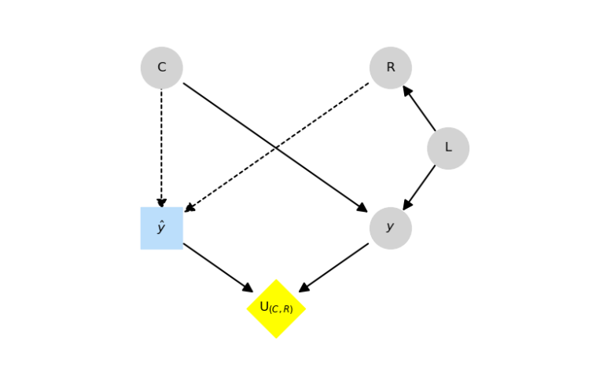
Supplementary Figure 1. Simplified influence diagram representing the UTI catheterization decision problem.

Our original fairness analysis of UTICalc can be contrasted with the decision-theoretic approach proposed in this study, reflecting the well-known distinction in the fairness literature between equal treatment and equal outcomes. Equal treatments require parity in predictions across groups, while equal outcomes require parity in final outcomes (which requires incorporating utility). The removal of race as a predictor in UTICalc V3 was intended to promote equal treatment by reducing disparities in catheterization recommendations. Our proposed decision-theoretic approach aims to measure disparities in outcomes following treatment decisions. The presence of such disparities would warrant a new bias mitigation approach centered around outcomes and requiring the incorporation of utilities. Both perspectives offer valid ethical justifications. Given that the clinical variables $C$ do not mediate the relationship between race and UTI, excluding race as a predictor prevents its influence on catheterization decisions and promotes equal opportunity. However, since race is associated with UTI, it may be correlated with outcomes regardless of its influence on the catheterization decision. It could be argued that fairness should also encompass outcomes where treatment efficacy is critical. The lack of fairness analyses of actual post-treatment outcomes is the primary motivation for this study.

Additional Figures and Tables
Supplementary Table 1. Demographic and Clinical Predictors of the UTICalc Database¹⁴.
 | Count (%)
Predictor | Training Database  (n = 1686) | Testing Database  (n = 384)
Age (months)
2–11 | 1229 (72.9) | 231 (60.2)
12–23 | 457 (27.1) | 153 (39.8)
Sex/circumcision
Male | 470 (27.9) | 93 (24.2)
Circumcised — No | 73 (4.3) | 23 (6.0)
Circumcised — Yes | 319 (18.9) | 52 (13.5)
Circumcised — Unknown* | 78 (4.6) | 18 (4.7)
Female | 1216 (72.1) | 291 (75.8)
Race
White | 1167 (69.2) | 200 (52.1)
Black | 426 (25.3) | 133 (34.6)
Other | 80 (4.7) | 19 (4.9)
Missing* | 13 (0.8) | 32 (8.3)
Duration of fever (hours)
≥48 | 565 (33.5) | 142 (37.0)
<48 | 1076 (63.8) | 230 (59.9)
Unknown* | 45 (2.7) | 12 (3.1)
Maximum reported temperature (°C)
≥39 | 1017 (60.3) | 252 (65.6)
<39 | 664 (39.4) | 132 (34.4)
Unknown* | 5 (0.3) | 0
Other source of fever
None | 1045 (62.0) | 136 (35.4)
Possible | 576 (34.2) | 241 (62.8)
Unequivocal* | 65 (3.9) | 7 (1.8)
UTI
Yes | 542 (32.1) | 30 (7.8)
No | 1144 (67.9) | 354 (92.2)

Supplementary Table 2. Bootstrapping results for recalibrated versions of UTICalc. The p-values are the probability of observing a difference as extreme as (or more extreme than) the observed difference from the test data, assuming that the true difference is zero.
Metric | V1 | V3 | Diff | p-value
EU | 0.9501  $±$ 0.0017 | 0.9496  $±$ 0.0042 | -0.0004  $±$ 0.0037 | 1.0000
EU Parity | -0.0121  $±$0.0037 | -0.008  $±$ 0.0073 | 0.0041  $±$0.0069 | 0.5560
Catheterization Rate | 0.5103  $±$ 0.1667 | 0.4966  $±$ 0.1667 | -0.0137  $±$ 0.1671 | 0.8490
Equal Opportunity | 0.0291  $±$ 0.1563 | 0.0237  $±$ 0.375 | -0.0054  $±$ 0.3123 | 0.9810

Supplementary Table 3. Bootstrapping results for both original and recalibrated versions of UTICalc. The p-values are the probability of observing a difference as extreme as (or more extreme than) the observed difference from the test data, assuming that the true difference is zero.
Metric | V1 | V3 | Diff | p-value
Original
ECE | 0.0299  $±$ 0.0403 | 0.0425  $±$ 0.0411 | 0.0125  $±$ 0.0372 | 0.6550
ECE Parity | 0.0034  $±$ 0.0506 | 0.0511  $±$ 0.0415 | 0.0478  $±$ 0.0522 | 0.1000
Recalibrated
ECE | 0.0128  $±$ 0.0299 | 0.0067  $±$ 0.0298 | -0.0062  $±$ 0.0349 | 0.7520
ECE Parity | 0.031  $±$ 0.0469 | 0.0055  $±$0.0352 | -0.0255  $±$0.0489 | 0.3110

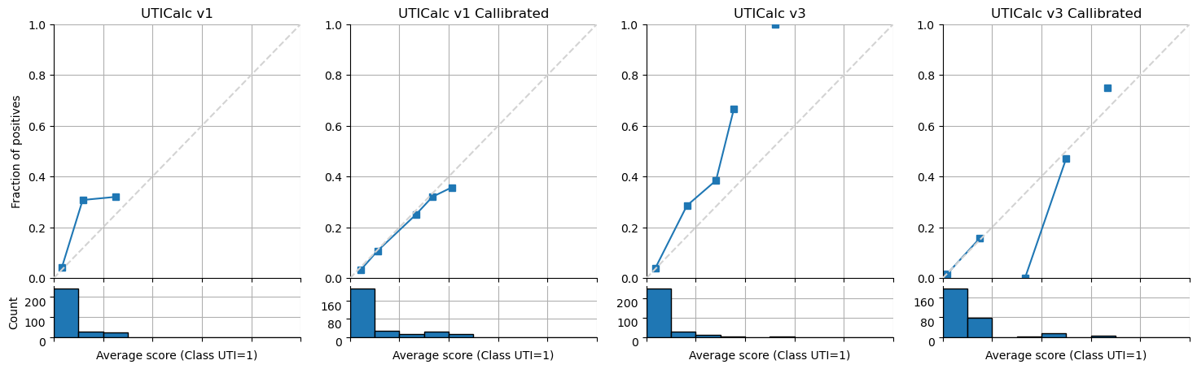
Supplementary Figure 2. Reliability diagrams for UTICalc V1 and UTICalc V3 before and after recalibration. The two plots on the left depict calibration of UTICalc V1, and the two plots on the right depict calibration of UTICalc V3.

*Patients with missing data were excluded from analysis.

