Supplementary Figures.
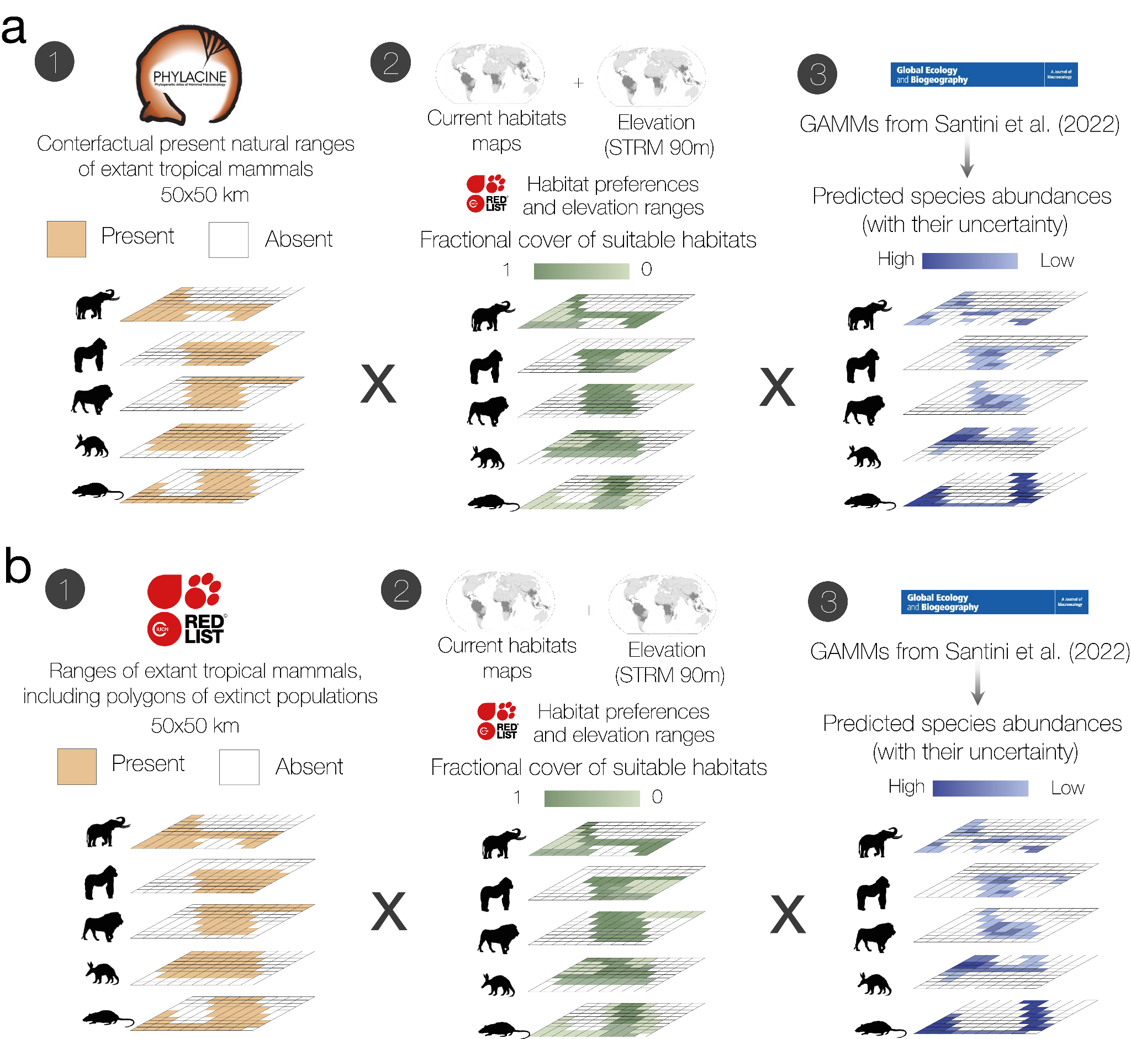

Figure S1 | Workflow of reconstruction of the baseline scenarios of wild and extant tropical mammal abundances. Panel a depicts the construction of the baseline scenario (BL) combining the unimpacted present natural ranges from PHYLACINE for extant tropical mammals (1), with fractional covers of suitable habitats based in the distribution of habitats under potential natural vegetation maps, elevation rasters, and species-specific habitat preferences and elevation ranges (2), and predicted species abundances and their uncertainty per grid cell based on generalized additive mixed models (3). Panel b depicts the construction of the second and conservative baseline scenario (BL_{IUCN}) combining the IUCN range maps of tropical extant mammals including polygons of extinct populations instead of the present natural ranges from PHYLACINE (1), with fractional covers of suitable habitats based in the distribution of habitats under potential natural vegetation maps, elevation rasters, and species-specific habitat preferences and elevation ranges (2), and predicted species abundances and their uncertainty per grid cell based on generalized additive mixed models (3).
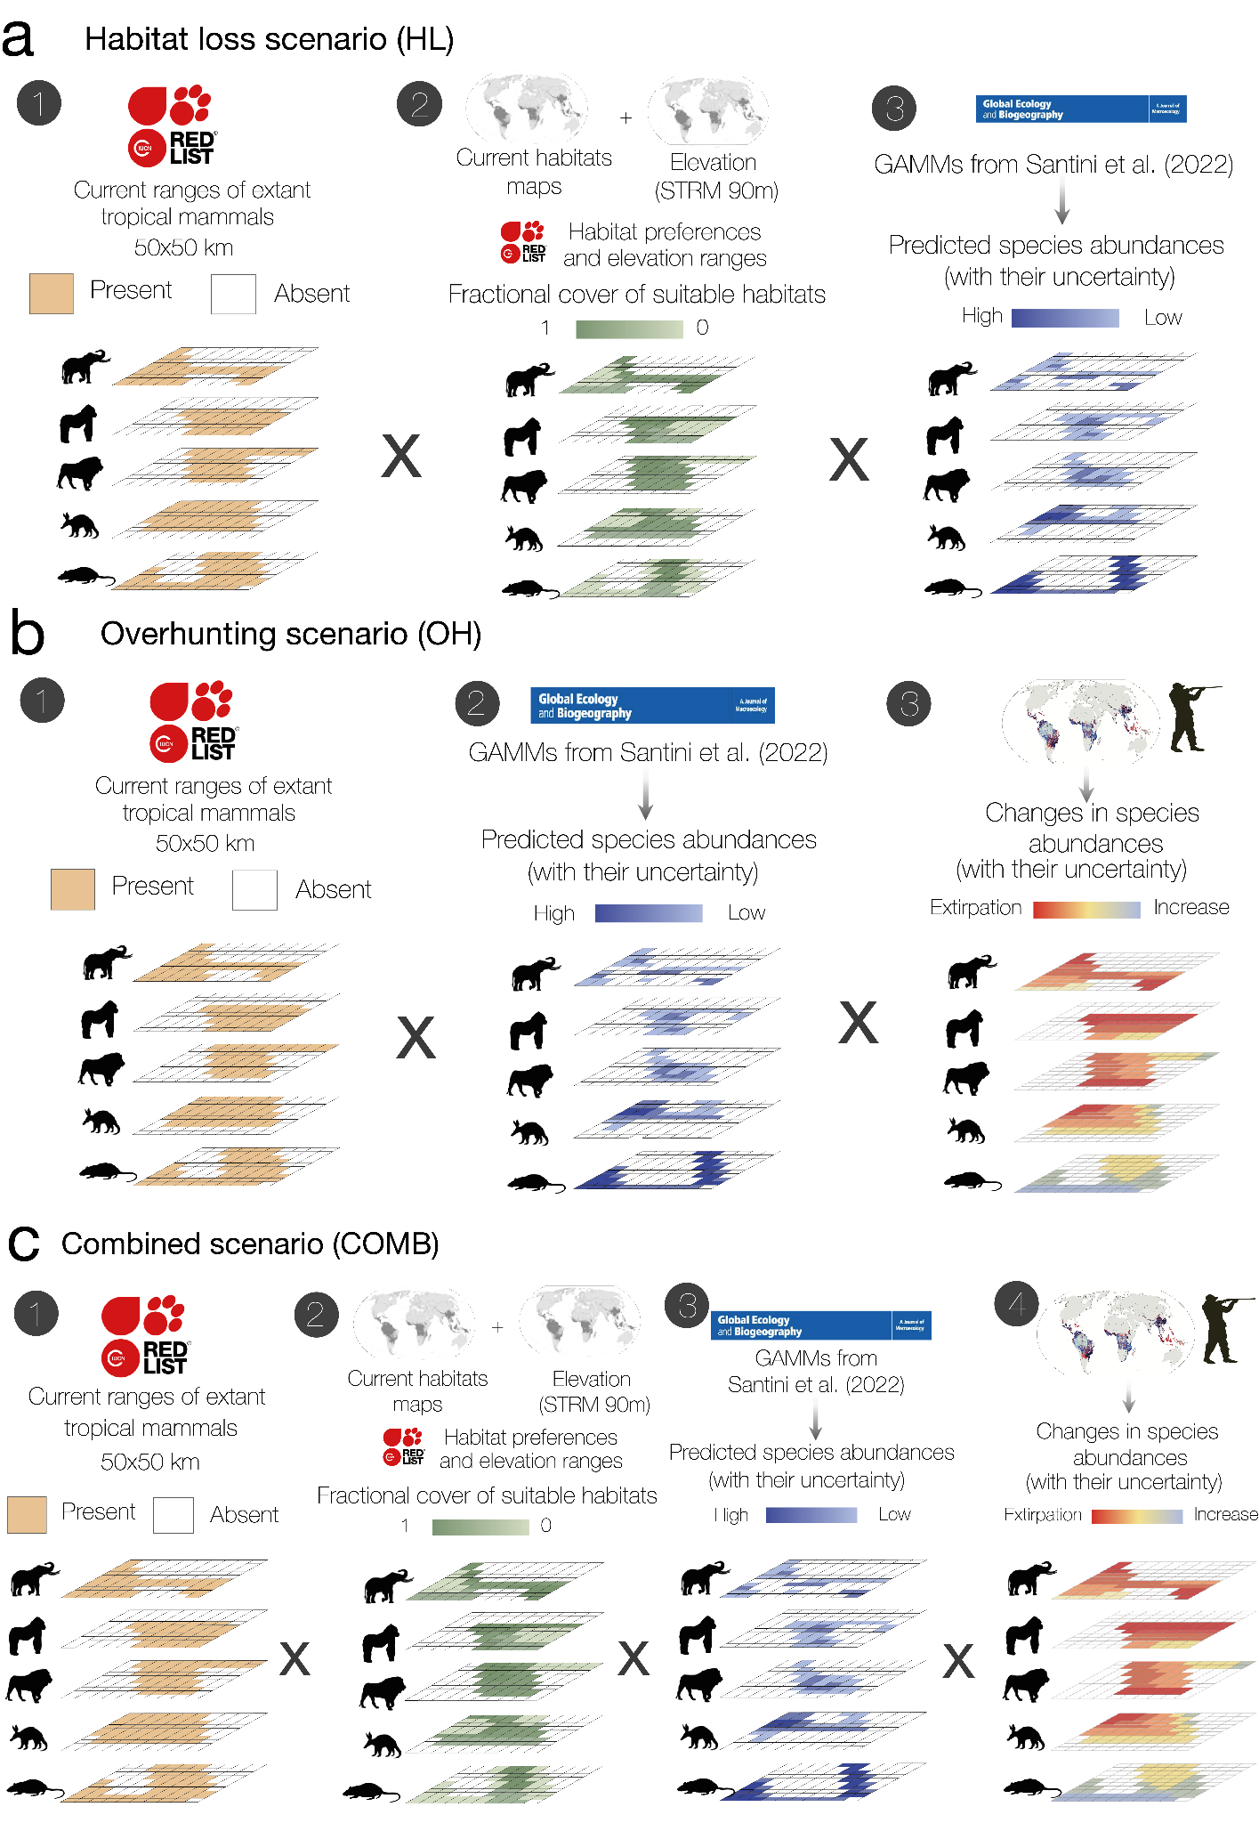

Figure S2 | Workflow of reconstruction of anthropogenic scenarios of wild and extant tropical mammal abundances. Panel a depicts the construction of the habitat loss scenario (HL) combining current ranges of extant tropical mammals (1), with fractional covers of suitable habitats based on the distribution of current habitats, elevation rasters, and species-specific habitat preferences and elevation ranges (2), and predicted species abundances and their uncertainty per grid cell based on generalized additive mixed models (3). Panel b depicts the construction of the overhunting scenario (OH) by combining current ranges of extant tropical mammals (1), predicted species abundances and their uncertainty per grid cell based on generalized additive mixed models (2), and species-specific abundance response ratios and their uncertainty per grid cell predicted based on hunting pressure models (3). Panel c depicts the construction of combined scenario (COMB) combining current ranges of extant tropical mammals (1), with fractional covers of suitable habitats based in the distribution of current habitats, elevation rasters, and species-specific habitat preferences and elevation ranges (2), predicted species abundances and their uncertainty per grid cell based on generalized additive mixed models (3), and species-specific abundance response ratios and their uncertainty per grid cell predicted based on hunting pressure models (4).

