Supplementary material to the
Brief report / Short communication

Airborne fungal spores over Pannonian plain – full season measurements following the standard Hirst volumetric method

Branko Sikoparija¹*, Isidora Simović¹, Marijana Vasić², Ljiljana Janjušević¹, Ljiljana Šašić Zorić¹

¹BioSensе Institute - Research Institute for Information Technologies in Biosystems, University of Novi Sad, Novi Sad, Serbia
²Department for Biology and Ecology, Faculty of Sciences, University of Novi Sad, Novi Sad, 21000, Serbia

*Corresponding author: Branko Sikoparija, BioSensе Institute – Research Institute for Information Technologies in Biosystems, University of Novi Sad, Dr Zorana Djindjica 1, 21000 Novi Sad, Serbia; e-mail: sikoparijabranko@biosense.rs

Supplementary Figure S1. Micrographs depicting morphology of identified fungal spores: (A) Alternaria, (B) Cladosporium, (C) Epicoccum, (D) Ganoderma), (E) Agaricaceae-morphotype, (F) Drechslera-morphotype.

(A)  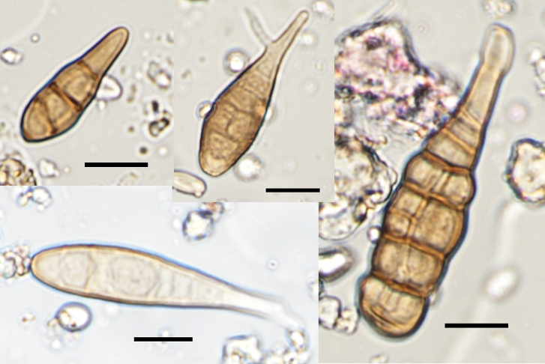 | (B)  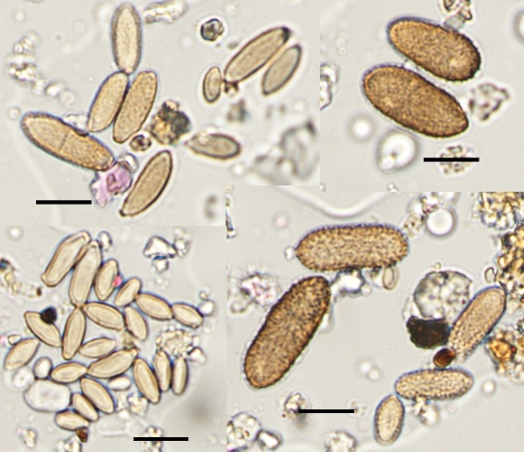 | (C)  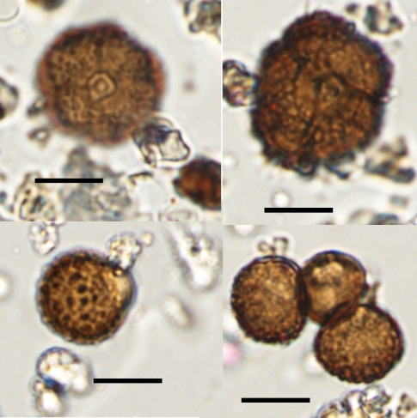
(D)  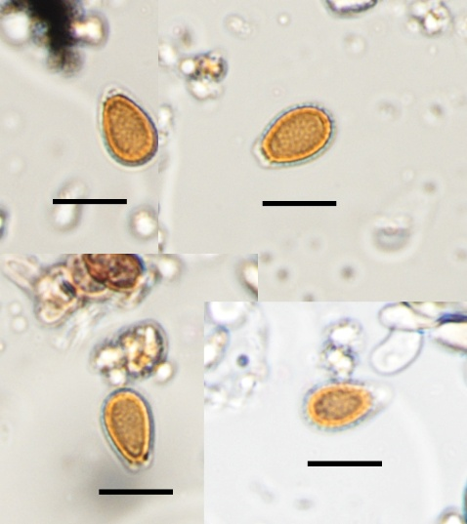 | (E)  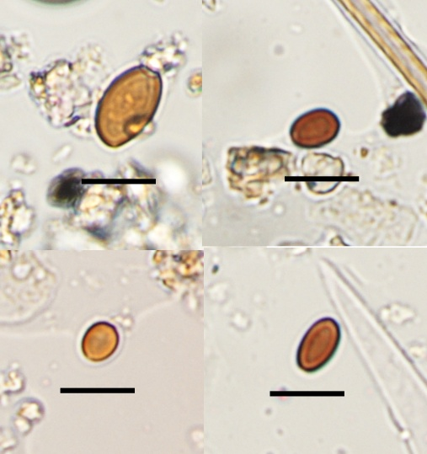 | (F)  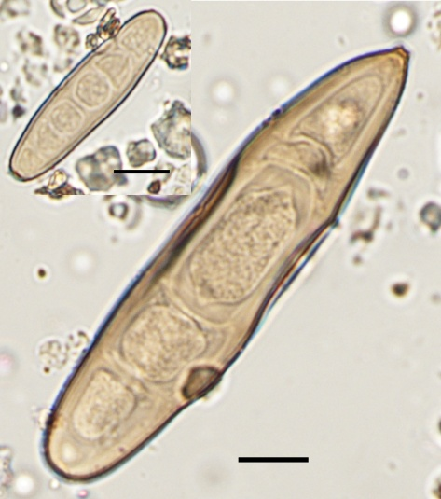

Supplementary Figure S2. Box and whiskers plots of diurnal variation in identified fungal spores: (A) from 6 April 2023 to 5 April 2024, (B) May-November, (C) December-April (“X” indicates mean value). Mind the difference in y-axis.

(A)  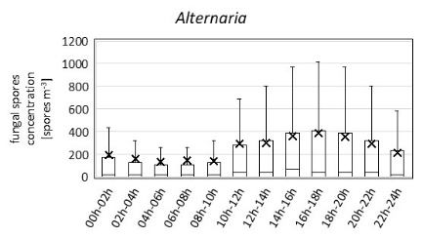 | (B)  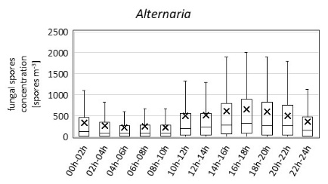 | (C)  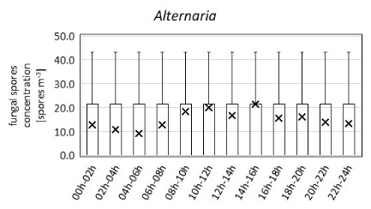
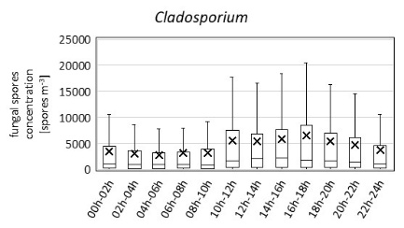 | 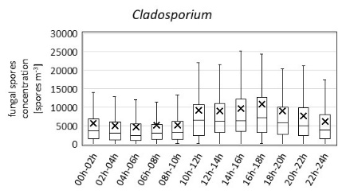 | 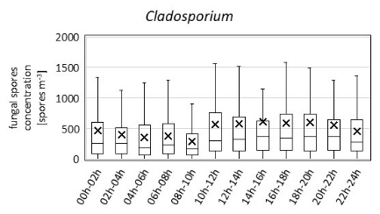
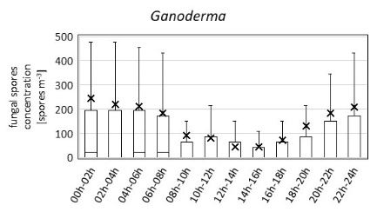 | 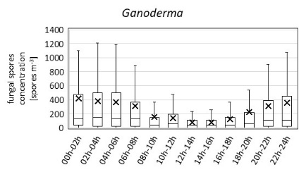 | 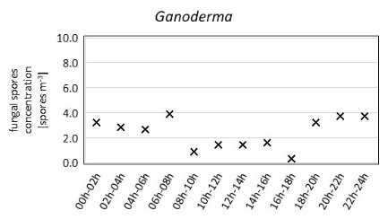
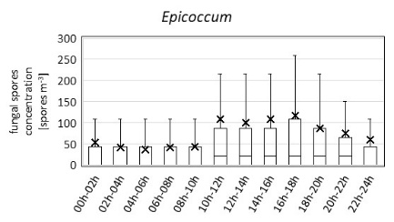 | 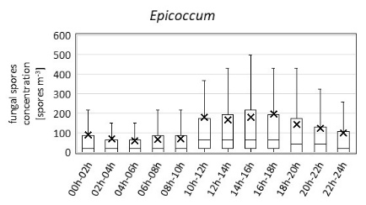 | 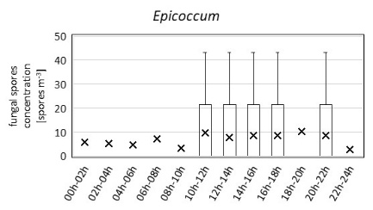
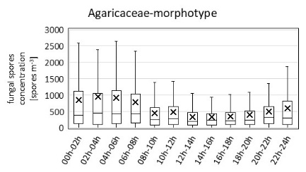 | 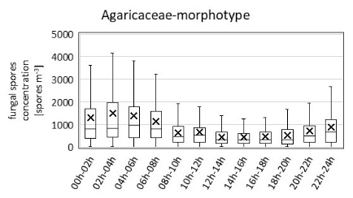 | 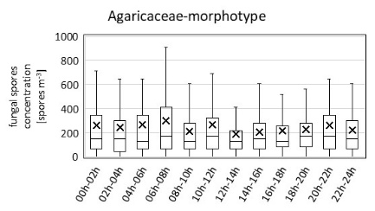
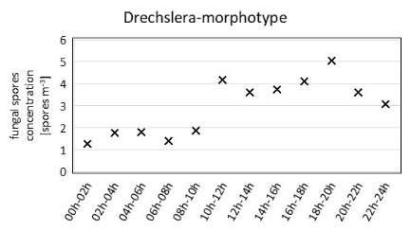 | 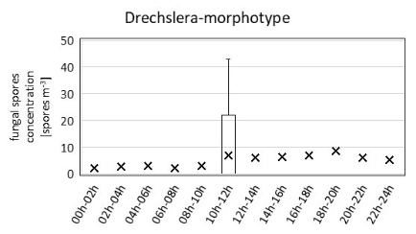 | 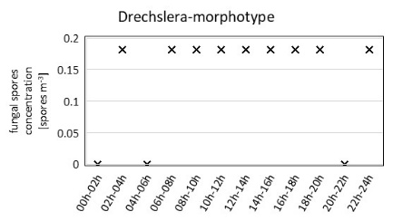

Supplementary Table S2. Spearman’s Rho, correlation coefficients calculated for daily concentrations of airborne fungal spores and meteorological parameters: maximal air temperature (Tmax), minimal air temperature (Tmin), average air temperature (Tavg), average relative humidity (RH), average water vapor pressure (WVP), average wind speed (WS), average cloudiness (CL), insolation hours (IH), precipitation sum (PP) in the intensive season (May-November).

INTENSIVE SEASON  (May-November) | Total fungal spores | Unidentified | Alternaria | Cladosporium | Agaricaceae-morphotype | Drechslera-morphotype | Epicoccum | Ganoderma
Tmax | 0.595** | 0.148* | 0.754** | 0.594** | 0.270** | 0.653** | 0.592** | 0.717**
Tmin | 0.570** | 0.393** | 0.634** | 0.554** | 0.180** | 0.523** | 0.463** | 0.567**
Tavg | 0.574** | 0.192** | 0.715** | 0.569** | 0.254** | 0.641** | 0.543** | 0.662**
RH | -0.118 | 0.331** | -0.358** | -0.162* | -0.010 | -0.361** | -0.285** | -0.266**
WVP | 0.586** | 0.420** | 0.623** | 0.560** | 0.255** | 0.534** | 0.457** | 0.593**
WS | -0.169* | 0.028 | -0.167* | -0.133* | -0.303** | -0.245** | -0.154* | -0.284**
IH | 0.239** | -0.128* | 0.406** | 0.261** | 0.117 | 0.487** | 0.250** | 0.351**
CL | -0.214** | 0.219** | -0.388** | -0.237** | -0.149* | -0.408** | -0.349** | -0.410**
PP | -0.075 | 0.368** | -0.271** | -0.106 | -0.127* | -0.263** | -0.287** | -0.240**
* p<0.05, **p<0.01

Supplementary Table S2. Spearman’s Rho correlation coefficients calculated for daily concentrations of airborne fungal spores and meteorological parameters: maximal air temperature (Tmax), minimal air temperature (Tmin), average air temperature (Tavg), average relative humidity (RH), average water vapor pressure (WVP), average wind speed (WS), average cloudiness (CL), insolation hours (IH), precipitation sum (PP) measured in the low season (December-April).

LOW SEASON  (December-April) | Total fungal spores | Unidentified | Alternaria | Cladosporium | Agaricaceae-morphotype | Drechslera-morphotype | Epicoccum | Ganoderma
Tmax | 0.580** | 0.365** | 0.486** | 0.518** | 0.545** | 0.253** | 0.174* | 0.354**
Tmin | 0.615** | 0.425** | 0.504** | 0.544** | 0.546** | 0.223** | 0.073 | 0.312**
Tavg | 0.610** | 0.420** | 0.513** | 0.546** | 0.569** | 0.240** | 0.156 | 0.348**
RH | -0.284** | -0.036 | -0.265** | -0.278** | -0.295** | 0.017 | -0.165* | -0.069
WVP | 0.653** | 0.526** | 0.522** | 0.581** | 0.583** | 0.310** | 0.141 | 0.402**
WS | 0.095 | 0.048 | 0.250** | 0.074 | 0.063 | -0.015 | 0.066 | -0.063
IH | 0.049 | -0.017 | 0.132 | 0.055 | 0.067 | 0.028 | 0.098 | 0.110
CL | 0.169* | 0.186* | 0.136 | 0.124 | 0.102 | 0.006 | -0.110 | -0.016
PP | 0.099 | 0.273** | 0.093 | 0.029 | 0.078 | 0.079 | -0.020 | -0.004
* p<0.05, **p<0.01

