Supplementary Information
for “Early KDIGO trajectories after sepsis-associated acute kidney injury onset: an exploratory retrospective cohort study using MIMIC-IV”
Zihan Liu¹, Yueming Chen², Ning Zhou^{2*}
1 First Affiliated Hospital of Jinan University, Guangzhou, Guangdong, China
2 Central People's Hospital of Zhanjiang, Zhanjiang, Guangdong, China
*Corresponding author: Ning Zhou (zjzhou121@163.com)

Supplementary contents
Supplementary Figures: Figure S1, three-class LCMM trajectories; Figure S2, ROC curves; Figure S3, calibration curves; Figure S4, decision curves; Figure S5, Kaplan–Meier survival curves.
Supplementary Tables: Table S1, missingness and multiple imputation settings; Table S2, likelihood ratio tests and DeLong tests; Table S3, cross-tabulation of the simplified rule-based groups and the four-class LCMM categories; Table S4, discordant external analysis in eICU; Table S5, results of the three-class LCMM sensitivity analysis; Table S6, abbreviations; Table S7, time-window definitions, clinical meaning, and rationale for multivariable adjustment covariates; Table S8, discrimination performance at the optimal thresholds; Table S9, simplified rule-based algorithm and operational outcome definition; Table S10, model fit and classification quality of candidate LCMM models; Table S11, multiple imputation settings and missing-data diagnostics; Table S12, sensitivity analyses for alternative coding strategies; Table S13, included-versus-excluded audit comparison under the 96-hour landmark design; and Table S14, comparison between the complete-case and full landmark samples.

Supplementary Figure Legends

Figure S1. Three-class LCMM trajectories
The three-class model reproduced an overall gradient of low, intermediate, and high kidney injury burden, but provided less clinical granularity than the four-class main model.
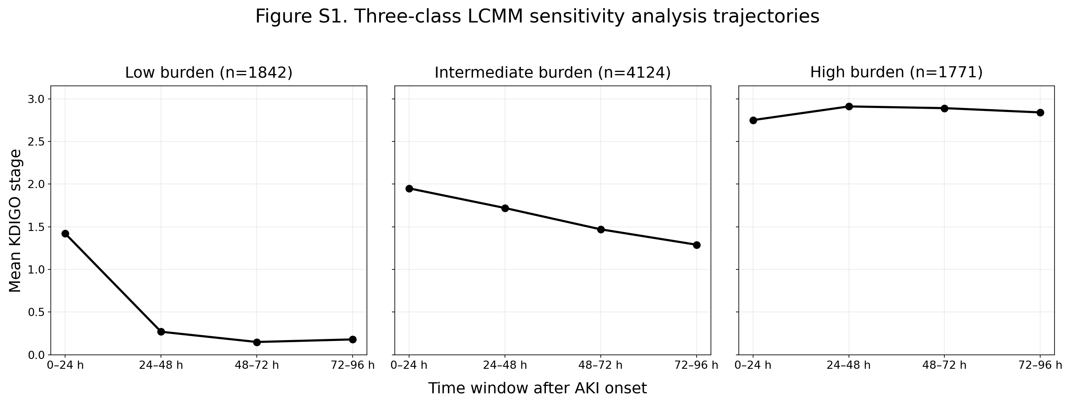

Figure S2. ROC curves for different models predicting 30-day mortality and day-7 persistent AKI or death
Panel A shows ROC curves for 30-day mortality after the landmark time. Panel B shows ROC curves for day-7 persistent AKI or death.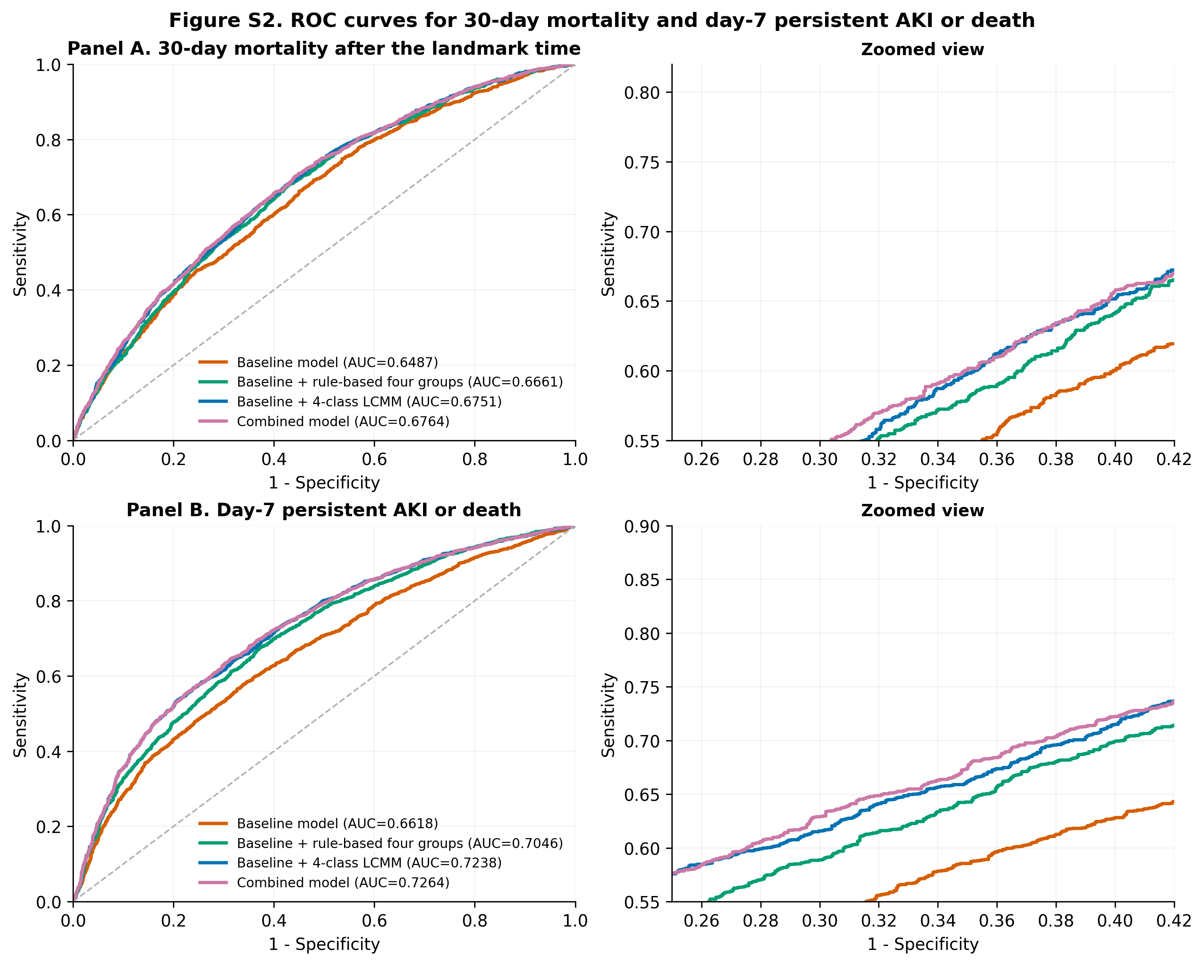

Figure S3. Calibration curves for different models predicting 30-day mortality and day-7 persistent AKI or death
Panel A shows calibration curves for 30-day mortality after the landmark time. Panel B shows calibration curves for day-7 persistent AKI or death.
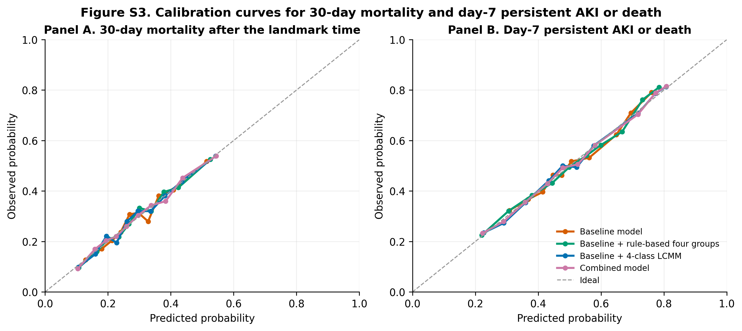

Figure S4. Decision curves for different models predicting 30-day mortality and day-7 persistent AKI or death
Panel A shows decision curves for 30-day mortality after the landmark time. Panel B shows decision curves for day-7 persistent AKI or death.
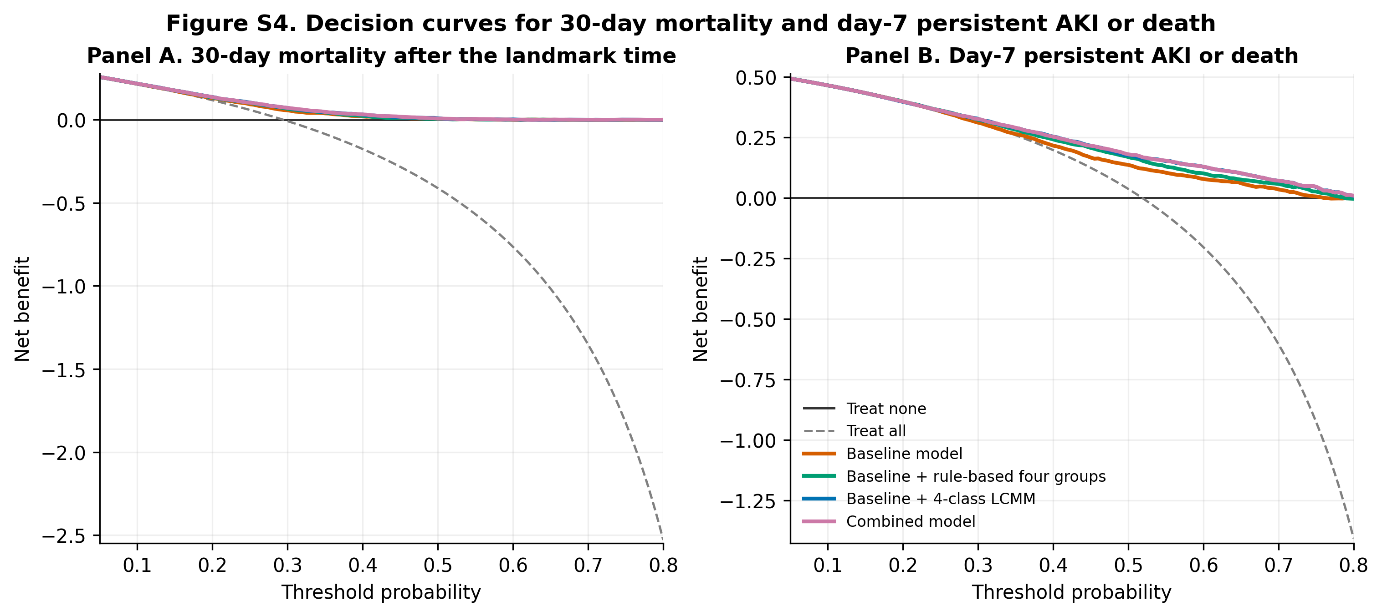

Figure S5. Kaplan–Meier survival curves for 30-day mortality after the landmark time stratified by the four-class LCMM trajectories
The curves show 30-day survival probabilities after the landmark time across the four LCMM trajectory classes. The number-at-risk table is shown below the curves.

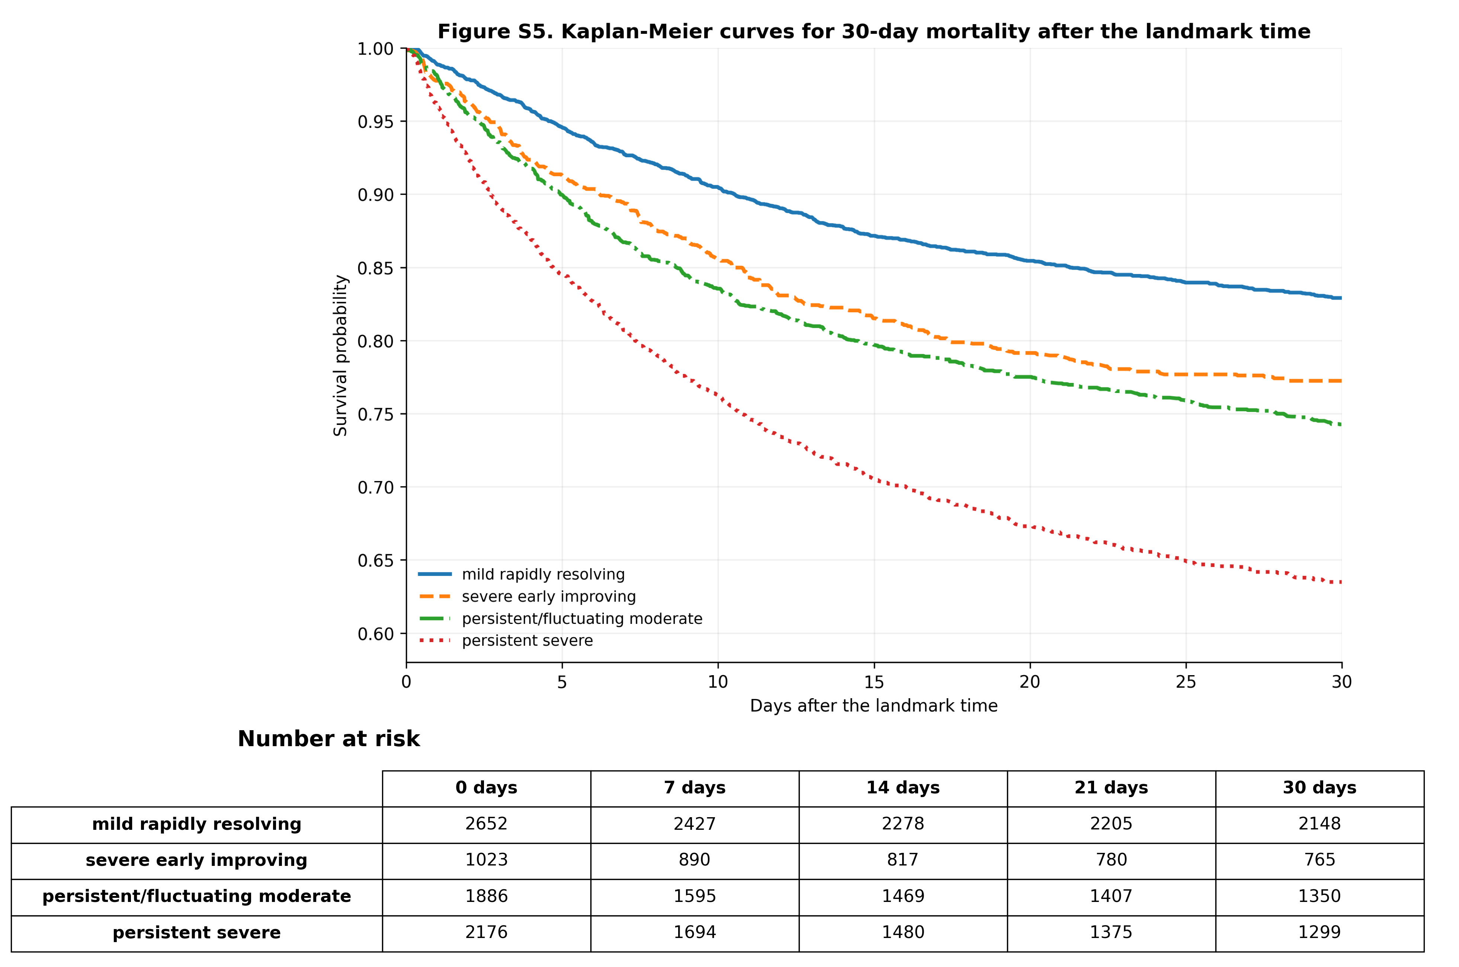

Supplementary Tables

Table S1. Missingness and multiple imputation settings
Variable | Number missing | Missing proportion (%)
Baseline serum creatinine | 16 | 0.21
First lactate within 24 hours after AKI onset | 2536 | 32.78
Four-class trajectory group | 0 | 0.0
Age | 0 | 0.0
Sex (male) | 0 | 0.0
Non-renal SOFA proxy within 24 hours after AKI onset | 0 | 0.0
Maximum KDIGO stage within 24 hours after AKI onset | 0 | 0.0
Chronic kidney disease | 0 | 0.0
Vasopressor use within 24 hours after AKI onset | 0 | 0.0
Invasive mechanical ventilation within 24 hours after AKI onset | 0 | 0.0
Septic shock proxy within 24 hours after AKI onset | 0 | 0.0
30-day mortality after the landmark time | 0 | 0.0
Day-7 persistent AKI or death | 0 | 0.0
Note. MICE was performed using 20 imputations and 20 iterations. Missingness was concentrated mainly in lactate (32.78%), with minimal missingness in baseline serum creatinine (0.21%).

Table S2. Likelihood ratio tests and DeLong tests for model comparison
Test | Comparison | P value
Likelihood ratio test | 30-day mortality: baseline covariate model vs baseline covariate model + simplified rule-based four-group classification | 9.19×10^-16
Likelihood ratio test | 30-day mortality: baseline covariate model vs baseline covariate model + four-class LCMM | 1.03×10^-23
Likelihood ratio test | 30-day mortality: simplified rule-based model vs combined model | 1.87×10^-10
Likelihood ratio test | 30-day mortality: four-class LCMM model vs combined model | 1.05×10^-2
Likelihood ratio test | Day-7 persistent AKI or death: baseline covariate model vs baseline covariate model + simplified rule-based four-group classification | 2.15×10^-54
Likelihood ratio test | Day-7 persistent AKI or death: baseline covariate model vs baseline covariate model + four-class LCMM | 4.71×10^-86
Likelihood ratio test | Day-7 persistent AKI or death: simplified rule-based model vs combined model | 6.57×10^-35
Likelihood ratio test | Day-7 persistent AKI or death: four-class LCMM model vs combined model | 1.24×10^-3
DeLong test | 30-day mortality: baseline covariate model vs baseline covariate model + simplified rule-based four-group classification | 1.82×10^-5
DeLong test | 30-day mortality: baseline covariate model vs baseline covariate model + four-class LCMM | 1.45×10^-7
DeLong test | 30-day mortality: simplified rule-based four-group classification vs four-class LCMM | 2.43×10^-2
DeLong test | Day-7 persistent AKI or death: baseline covariate model vs baseline covariate model + simplified rule-based four-group classification | 1.04×10^-17
DeLong test | Day-7 persistent AKI or death: baseline covariate model vs baseline covariate model + four-class LCMM | 2.71×10^-27
DeLong test | Day-7 persistent AKI or death: simplified rule-based four-group classification vs four-class LCMM | 1.80×10^-6

Table S3. Cross-tabulation of the simplified rule-based groups and the four-class LCMM categories
Simplified rule-based group | Mild rapidly resolving | Severe early improving | Persistent/fluctuating moderate | Persistent severe | Total
Rapidly resolving | 1618 | 590 | 0 | 0 | 2208
Persistent mild-to-moderate | 170 | 126 | 166 | 0 | 462
Worsening/fluctuating | 864 | 256 | 1242 | 850 | 3212
Persistent severe | 0 | 51 | 478 | 1326 | 1855
Note. The rapidly resolving rule-based group contained both the mild rapidly resolving and severe early improving LCMM subgroups, whereas the worsening/fluctuating group spanned all four LCMM classes.

Table S4. Discordant external analysis in eICU
External rule-based group | n | In-hospital deaths | In-hospital mortality (%) | Adjusted OR (95% CI) | P value
Rapidly resolving | 900 | 245 | 27.22 | 1.00 (reference) | —
Persistent mild-to-moderate | 148 | 58 | 39.19 | 1.73 (1.20–2.48) | 0.003
Worsening/fluctuating | 767 | 258 | 33.64 | 1.39 (1.12–1.72) | 0.002
Persistent severe | 202 | 49 | 24.26 | 0.92 (0.65–1.32) | 0.666
Note. The rapidly resolving group was used as the reference. These findings should be interpreted as discordant external evidence rather than confirmatory external validation.

Table S5. Results of the three-class LCMM sensitivity analysis
Three-class LCMM trajectory | n | Adjusted OR for 30-day mortality (95% CI) | P value | Adjusted OR for day-7 persistent AKI or death (95% CI) | P value
Low burden | 1842 | 1.00 (reference) | — | 1.00 (reference) | —
Intermediate burden | 4124 | 1.66 (1.26–2.21) | <0.001 | 2.39 (2.02–2.83) | <0.001
High burden | 1771 | 3.29 (2.56–4.23) | <0.001 | 8.37 (6.62–10.58) | <0.001
Note. The three-class model reproduced the overall prognostic gradient but compressed clinically meaningful heterogeneity relative to the four-class main model.

Table S6. Abbreviations
Abbreviation | Full term
AKI | acute kidney injury
SA-AKI | sepsis-associated acute kidney injury
ICU | intensive care unit
KDIGO | Kidney Disease: Improving Global Outcomes
MIMIC-IV | Medical Information Mart for Intensive Care IV
eICU | eICU Collaborative Research Database
LCMM | latent class mixed model
MICE | multiple imputation by chained equations
AIC | Akaike information criterion
BIC | Bayesian information criterion
AUC | area under the receiver operating characteristic curve
ROC | receiver operating characteristic curve
SOFA | Sequential Organ Failure Assessment
CKD | chronic kidney disease
OR | odds ratio
CI | confidence interval

Table S7. Time-window definitions, clinical meaning, and rationale for multivariable adjustment covariates
Variable | Time window | Clinical meaning | Rationale for inclusion
Age | Baseline | Demographic characteristic | Basic characteristic associated with short-term mortality and kidney outcomes in SA-AKI
Sex | Baseline | Demographic characteristic | May affect AKI severity, organ support requirements, and prognosis
Chronic kidney disease | Baseline | Pre-existing kidney vulnerability | Reflects baseline renal reserve and long-term kidney risk
Baseline serum creatinine | Baseline | Baseline kidney function | Used to characterize prior renal function and interpret subsequent KDIGO staging
Non-renal SOFA proxy within 24 h after AKI onset | 0–24 h after AKI onset | Non-renal acute illness severity | Used to adjust for systemic critical illness burden
Maximum KDIGO stage within 24 h after AKI onset | 0–24 h after AKI onset | Early kidney injury burden | Used to adjust for initial kidney injury severity
Vasopressor use within 24 h after AKI onset | 0–24 h after AKI onset | Circulatory support requirement | Reflects hemodynamic instability and shock-related risk
Invasive mechanical ventilation within 24 h after AKI onset | 0–24 h after AKI onset | Organ support requirement | Reflects overall illness severity
Septic shock proxy within 24 h after AKI onset | 0–24 h after AKI onset | Infection-related circulatory failure risk | Reflects sepsis severity
First lactate within 24 h after AKI onset | 0–24 h after AKI onset | Tissue hypoperfusion and metabolic stress | Reflects systemic hypoperfusion and disease severity
Note. These variables were prespecified before model fitting on the basis of clinical relevance, prior literature, and data availability within the early post-onset window.

Table S8. Discrimination performance of different models at the optimal thresholds
Outcome | Model | Optimal threshold | AUC | Sensitivity | Specificity | PPV | NPV | Accuracy
30-day mortality | Baseline covariate model | 0.2879 | 0.6487 | 0.6377 | 0.5765 | 0.3855 | 0.7924 | 0.5945
30-day mortality | Baseline + simplified rule-based classification | 0.2713 | 0.6661 | 0.7168 | 0.5328 | 0.3900 | 0.8187 | 0.5870
30-day mortality | Baseline + four-class LCMM | 0.2877 | 0.6751 | 0.6501 | 0.6168 | 0.4142 | 0.8088 | 0.6266
30-day mortality | Combined model | 0.2867 | 0.6764 | 0.6638 | 0.6045 | 0.4116 | 0.8119 | 0.6220
Day-7 persistent AKI or death | Baseline covariate model | 0.5649 | 0.6618 | 0.4776 | 0.7639 | 0.6853 | 0.5759 | 0.6154
Day-7 persistent AKI or death | Baseline + simplified rule-based classification | 0.5192 | 0.7046 | 0.6627 | 0.6376 | 0.6632 | 0.6371 | 0.6506
Day-7 persistent AKI or death | Baseline + four-class LCMM | 0.5407 | 0.7238 | 0.5974 | 0.7507 | 0.7207 | 0.6339 | 0.6712
Day-7 persistent AKI or death | Combined model | 0.5589 | 0.7264 | 0.5685 | 0.7771 | 0.7330 | 0.6258 | 0.6689
Note. Thresholds were determined using the Youden index. PPV indicates positive predictive value; NPV, negative predictive value.

Table S9. Simplified rule-based four-group algorithm and operational definition of the secondary outcome
Section | Item | Operational definition | Remarks
A | Rapidly resolving | No increase in KDIGO stage across the four consecutive 24-hour windows, and KDIGO stage = 0 in the fourth window. | Mutually exclusive rule; priority below worsening/fluctuating.
A | Persistent mild-to-moderate | Monotonic non-increasing trajectory across the four windows, but not meeting the criteria for rapidly resolving or persistent severe. | Residual category for monotonic non-increasing trajectories.
A | Worsening/fluctuating | Any increase in KDIGO stage between adjacent windows. | Highest hierarchical priority; once met, the patient is assigned to this group.
A | Persistent severe | Monotonic non-increasing trajectory across the four windows and either KDIGO stage ≥2 in the fourth window, or KDIGO stage = 1 in the fourth window with KDIGO stage 3 appearing at least twice across the four windows. | Priority below rapidly resolving but above persistent mild-to-moderate.
B | T0 and landmark time | T0 was defined as AKI onset; the landmark time was defined as 96 hours after AKI onset. | Primary outcome was calculated from the landmark time.
B | 30-day all-cause mortality | All-cause death within 30 days after the 96-hour landmark time. | Primary outcome.
B | Day-7 persistent AKI | Operationally defined using the maximum KDIGO stage in the day-7 assessment window; maximum stage ≥1 was classified as persistent AKI, and maximum stage = 0 as no persistent AKI. | Intended to represent delayed kidney recovery or sustained kidney injury risk; not equivalent to all existing definitions of persistent AKI or AKD.
B | Day-7 persistent AKI or death | Persistent AKI on day 7 or death before day 7 after AKI onset. | Key secondary outcome.
B | Handling of death before day 7 and unevaluable day-7 status | Patients who died before day 7 were included in the composite endpoint. Patients without day-7 evaluability and without death before day 7 were excluded from the main analysis; alternative coding strategies were assessed in sensitivity analyses. | Used to address potential endpoint misclassification.

Table S10. Model fit and classification quality of candidate LCMM models
Model/approach | Classes | Log-likelihood | AIC | BIC | Converged | Min class size | Min class (%) | Mean max posterior probability | Remarks
One-class initialization model (m1) | 1 | -39911.882769 | 79833.766 | 79868.534 | Yes | 7737 | 100.00 | 1.0000 | Used for initialization of multi-class models
Exploratory two-class model | 2 | NR | NR | NR | NR | NR | NR | NR | Not retained in the final reproducible main analysis
Final three-class model (m3_final) | 3 | -38687.302878 | 77400.606 | 77491.005 | Yes | 1771 | 22.89 | 0.8472 | Prespecified sensitivity analysis model
Final four-class model (m4_final) | 4 | -38445.022179 | 76918.044 | 77015.397 | Yes | 1023 | 13.22 | 0.8763 | Main analysis model
Expanded models with ≥5 classes | ≥5 | NR | NR | NR | NR | NR | NR | NR | Not retained in the final reproducible main analysis
Note. NR indicates that the corresponding quantitative metrics were not retained in the archived final analysis outputs.

Table S11. Multiple imputation settings and summary of missing-data diagnostics

Part A. Variable-level missingness and imputation roles

Variable | Role in main analysis | Number missing | Missing proportion (%) | Imputed | Imputation method | Used as predictor
Four-class trajectory group | Exposure | 0 | 0.0 | No | Not imputed | Yes
Age | Covariate | 0 | 0.0 | No | Not imputed | Yes
Male sex | Covariate | 0 | 0.0 | No | Not imputed | Yes
Non-renal SOFA proxy within 24 h after AKI onset | Covariate | 0 | 0.0 | No | Not imputed | Yes
Maximum KDIGO stage within 24 h after AKI onset | Covariate | 0 | 0.0 | No | Not imputed | Yes
Chronic kidney disease | Covariate | 0 | 0.0 | No | Not imputed | Yes
Baseline serum creatinine | Covariate | 16 | 0.21 | Yes | PMM | Yes
Vasopressor use within 24 h after AKI onset | Covariate | 0 | 0.0 | No | Not imputed | Yes
Invasive mechanical ventilation within 24 h after AKI onset | Covariate | 0 | 0.0 | No | Not imputed | Yes
Septic shock proxy within 24 h after AKI onset | Covariate | 0 | 0.0 | No | Not imputed | Yes
First lactate within 24 h after AKI onset | Covariate | 2536 | 32.78 | Yes | PMM | Yes
30-day mortality after the landmark time | Outcome | 0 | 0.0 | No | Not imputed | Yes
Day-7 persistent AKI or death | Outcome | 0 | 0.0 | No | Not imputed | Yes

Part B. Summary of imputation settings

Item | Description
Imputation framework | Multiple imputation by chained equations (mice)
Number of imputations (m) | 20
Number of iterations per imputation | 20
Random seed | 20260409
Imputed variables | Baseline serum creatinine and first lactate within 24 hours after AKI onset
Imputation method | Predictive mean matching (PMM) for both partially missing covariates
Predictor matrix | Default mice predictor matrix with diagonal elements set to zero; prespecified exposures, outcomes, and covariates were allowed as predictors
Auxiliary variables | No auxiliary variables beyond prespecified analysis variables were added
Main reported analysis | Complete-case analysis
Robustness analysis | MICE was used to assess whether missing-data handling materially changed effect direction, effect magnitude, or risk ordering
Complete-case sample size | 5198
Number excluded from complete-case analysis | 2539
Note. This table summarizes the variables included in the multiple imputation procedure, the extent of missingness, and key imputation settings.

Table S12. Sensitivity analyses using alternative coding strategies for the composite endpoint of day-7 persistent AKI or death
Trajectory class | Original coding OR (95% CI) | P value | Excluding unevaluable patients OR (95% CI) | P value | Missing-outcome imputation OR (95% CI) | P value | Extreme-case analysis OR (95% CI) | P value
Mild rapidly resolving | 1.00 (reference) | — | 1.00 (reference) | — | 1.00 (reference) | — | 1.00 (reference) | —
Severe early improving | 1.48 (1.20–1.83) | <0.001 | 1.81 (1.40–2.33) | <0.001 | 1.98 (1.59–2.45) | <0.001 | 1.66 (1.32–2.09) | <0.001
Persistent/fluctuating moderate | 2.52 (2.14–2.97) | <0.001 | 3.00 (2.47–3.64) | <0.001 | 3.15 (2.73–3.63) | <0.001 | 2.21 (1.86–2.63) | <0.001
Persistent severe | 5.87 (4.78–7.21) | <0.001 | 8.26 (6.31–10.80) | <0.001 | 7.82 (6.22–9.83) | <0.001 | 5.22 (4.05–6.71) | <0.001
Note. The mild rapidly resolving class was used as the reference group.

Table S13. Baseline characteristics of included and excluded audit groups under the 96-hour landmark design
Variable | Excluded group (n=13,426) | Included group (n=7,737) | Interpretation
Sample size, n | 13,426 | 7,737 | Numbers of excluded and included patients in the main analysis
Age, mean (years) | 66.9 | 63.7 | Excluded patients were slightly older on average
Age, median (years) | 68 | 65 | Consistent with the mean difference
Male sex, % | 58.6 | 58.3 | Similar sex composition
ICU length of stay, median (days) | 2.28 | 9.56 | Included patients had to survive and remain observed through 96 hours
Total hospital length of stay, median (days) | 7.02 | 16.93 | Included patients had longer overall hospitalization
In-hospital mortality, % | 17.24 | 24.48 | Percentage of deaths during the entire hospitalization
30-day mortality after AKI onset, % | 22.01 | 27.05 | Not recalculated from the landmark time
Complete four-window KDIGO sequence, % | 12.73 | 100.00 | Included patients all met this requirement by definition
Alive at 96 hours, % | 85.77 | 100.00 | Included patients all met this requirement by definition
Under observation at 96 hours, % | 0.63 | 100.00 | Included patients all met this requirement by definition
Note. This table describes differences between included and excluded audit groups in order to assess potential selection bias and limited generalizability introduced by the landmark design.

Table S14. Comparison between the complete-case sample and the full landmark sample
Variable | Full landmark sample (n=7,737) | Complete-case sample (n=5,198)
Chronic kidney disease, % | 23.0 | 25.3
Baseline serum creatinine, mg/dL | 1.1 | 1.2
Non-renal SOFA proxy within 24 h after AKI onset, median | 1 | 2
Vasopressor use within 24 h after AKI onset, % | 47.1 | 58.2
Invasive mechanical ventilation within 24 h after AKI onset, % | 70.8 | 79.6
Septic shock proxy within 24 h after AKI onset, % | 18.4 | 27.4
30-day mortality after the landmark time, % | 28.1 | 29.4
Day-7 persistent AKI or death, % | 47.7 | 51.8
Note. This table compares the complete-case sample with the full landmark sample with respect to baseline kidney function, illness severity, organ support requirements, and event rates.

