Methods

Genome dataset and sequence retrieval

Newly generated MPXV clade Ib genomes from Rio de Janeiro (n = 8) were analyzed alongside publicly available genomes retrieved from GISAID (EPI_SET_260501mw; https://doi.org/10.55876/gis8.260501mw). Only complete or near-complete genomes (≤25% ambiguous sites or gaps) with associated sampling date and country of origin were included. The final dataset comprised 439 MPXV clade I genomes representing global diversity. Metadata were curated to ensure consistency in sampling dates and geographic annotations.
To root the phylogeny, five representative MPXV clade Ia genomes (EPI_ISL_13056233; EPI_ISL_13056238; EPI_ISL_13056241; EPI_ISL_13056250; EPI_ISL_19502309) were included as outgroup sequences.

Sequence alignment

Multiple sequence alignment was performed using squirrel (https://github.com/aineniamh/squirrel), a pipeline optimized for MPXV genomes, with default parameters¹. The alignment was manually inspected to ensure consistency and remove problematic regions when necessary. Terminal regions with excessive missing data were trimmed to minimize alignment artifacts.

Maximum likelihood phylogenetic inference

An initial phylogenetic tree was reconstructed under a maximum likelihood (ML) framework using IQ-TREE2². The HKY substitution model was applied, as selected based on prior knowledge of MPXV evolutionary dynamics. Branch support was assessed using the approximate likelihood ratio test (aLRT) and ultrafast bootstrap (UFBoot) with 1,000 replicates each³. The resulting tree was used as the basis for downstream temporal and phylogeographic analyses.

Temporal signal and molecular clock analysis

The temporal structure of the dataset was evaluated by root-to-tip regression of genetic divergence against sampling date. Sequences with inconsistent temporal signal were inspected but retained given the overall moderate correlation, supporting molecular clock inference.
Time-scaled phylogenies were reconstructed using TreeTime⁴, incorporating sampling dates under a strict molecular clock model. The molecular clock rate was estimated directly from the data. Node dates and confidence intervals were inferred, and ancestral state reconstruction for geographic location was performed using a discrete trait model.

Phylogeographic reconstruction

Discrete phylogeographic inference implemented in TreeTime was used to estimate the most probable geographic origin of ancestral nodes. Locations were coded at the country level. Posterior probabilities were used to assess the confidence of inferred transitions, including the introduction of MPXV clade Ib into Brazil and subsequent dissemination patterns.

Bayesian phylodynamic analysis

To validate the robustness of the temporal and phylogeographic inferences, a subset of sequences corresponding to the European–Brazilian lineage (MPOX-EU-BR) was analyzed using BEAST v1.10⁵. A strict molecular clock model was applied, informed by the rate estimated in TreeTime as a prior (lognormal distribution). An exponential growth coalescent model was used to capture early epidemic dynamics.
Markov chain Monte Carlo (MCMC) chains were run for sufficient length to ensure convergence, with effective sample sizes (ESS) >200 for all key parameters. Maximum clade credibility (MCC) trees were summarized after removal of burn-in, and results were compared with TreeTime estimates for consistency.

Results
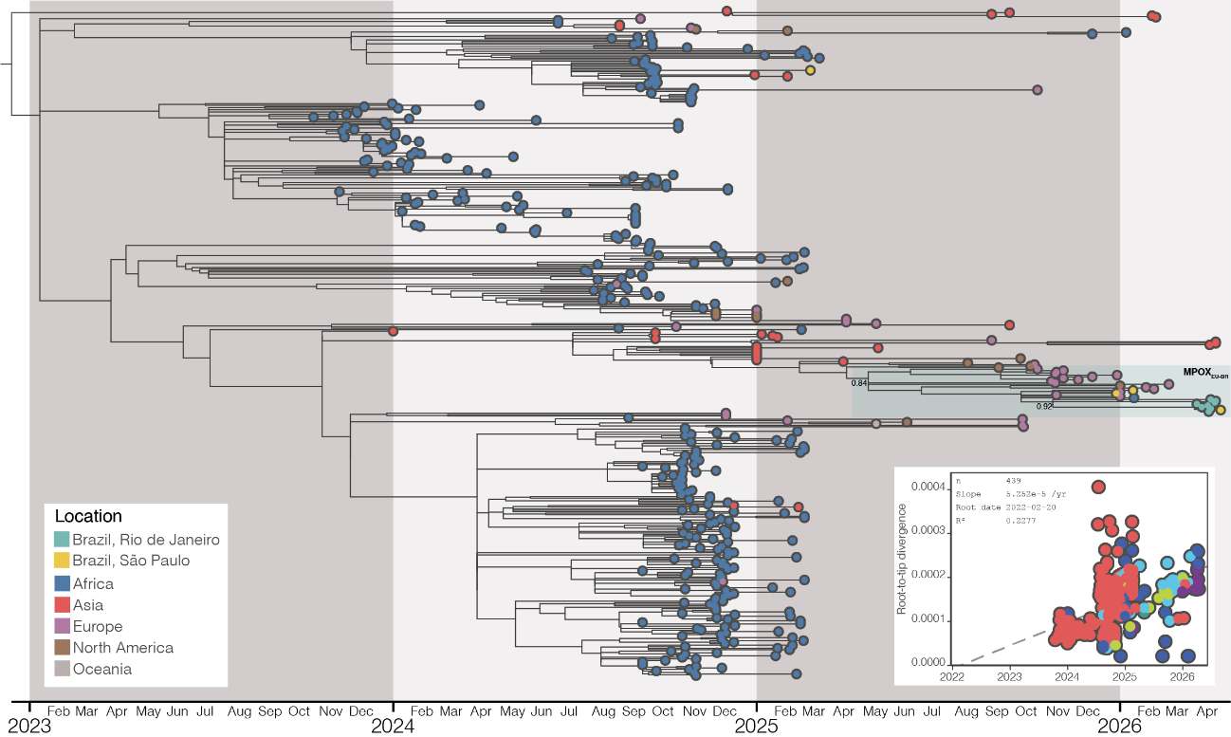

Supplementary Figure 1 | Global phylogeny and temporal signal of MPXV clade Ib genomes. Time-scaled phylogenetic tree of MPXV clade I genomes (n = 439) with associated sampling dates and locations, including newly generated sequences from Brazil. Brazilian genomes cluster within a predominantly European lineage, with a distinct subclade comprising sequences from Rio de Janeiro and São Paulo. Branch colors indicate sampling location, and branch lengths are scaled in time. Root-to-tip regression analysis of genetic divergence against sampling date demonstrates a moderate temporal signal (R² = 0.23), supporting the use of molecular clock models for downstream phylodynamic analyses.

REFERENCES
1. O’Toole, Á. et al. Human outbreak detection and best practice MPXV analysis and interpretation with squirrel. Virus Evolution 12, veaf095 (2026).
2. Minh, B. Q. et al. IQ-TREE 2: New Models and Efficient Methods for Phylogenetic Inference in the Genomic Era. Molecular Biology and Evolution 37, 1530–1534 (2020).
3. Anisimova, M. & Gascuel, O. Approximate Likelihood-Ratio Test for Branches: A Fast, Accurate, and Powerful Alternative. Systematic Biology 55, 539–552 (2006).
4. Sagulenko, P., Puller, V. & Neher, R. A. TreeTime: Maximum-likelihood phylodynamic analysis. Virus Evolution 4, (2018).
5. Suchard, M. A. et al. Bayesian phylogenetic and phylodynamic data integration using BEAST 1.10. Virus Evolution 4, (2018).

