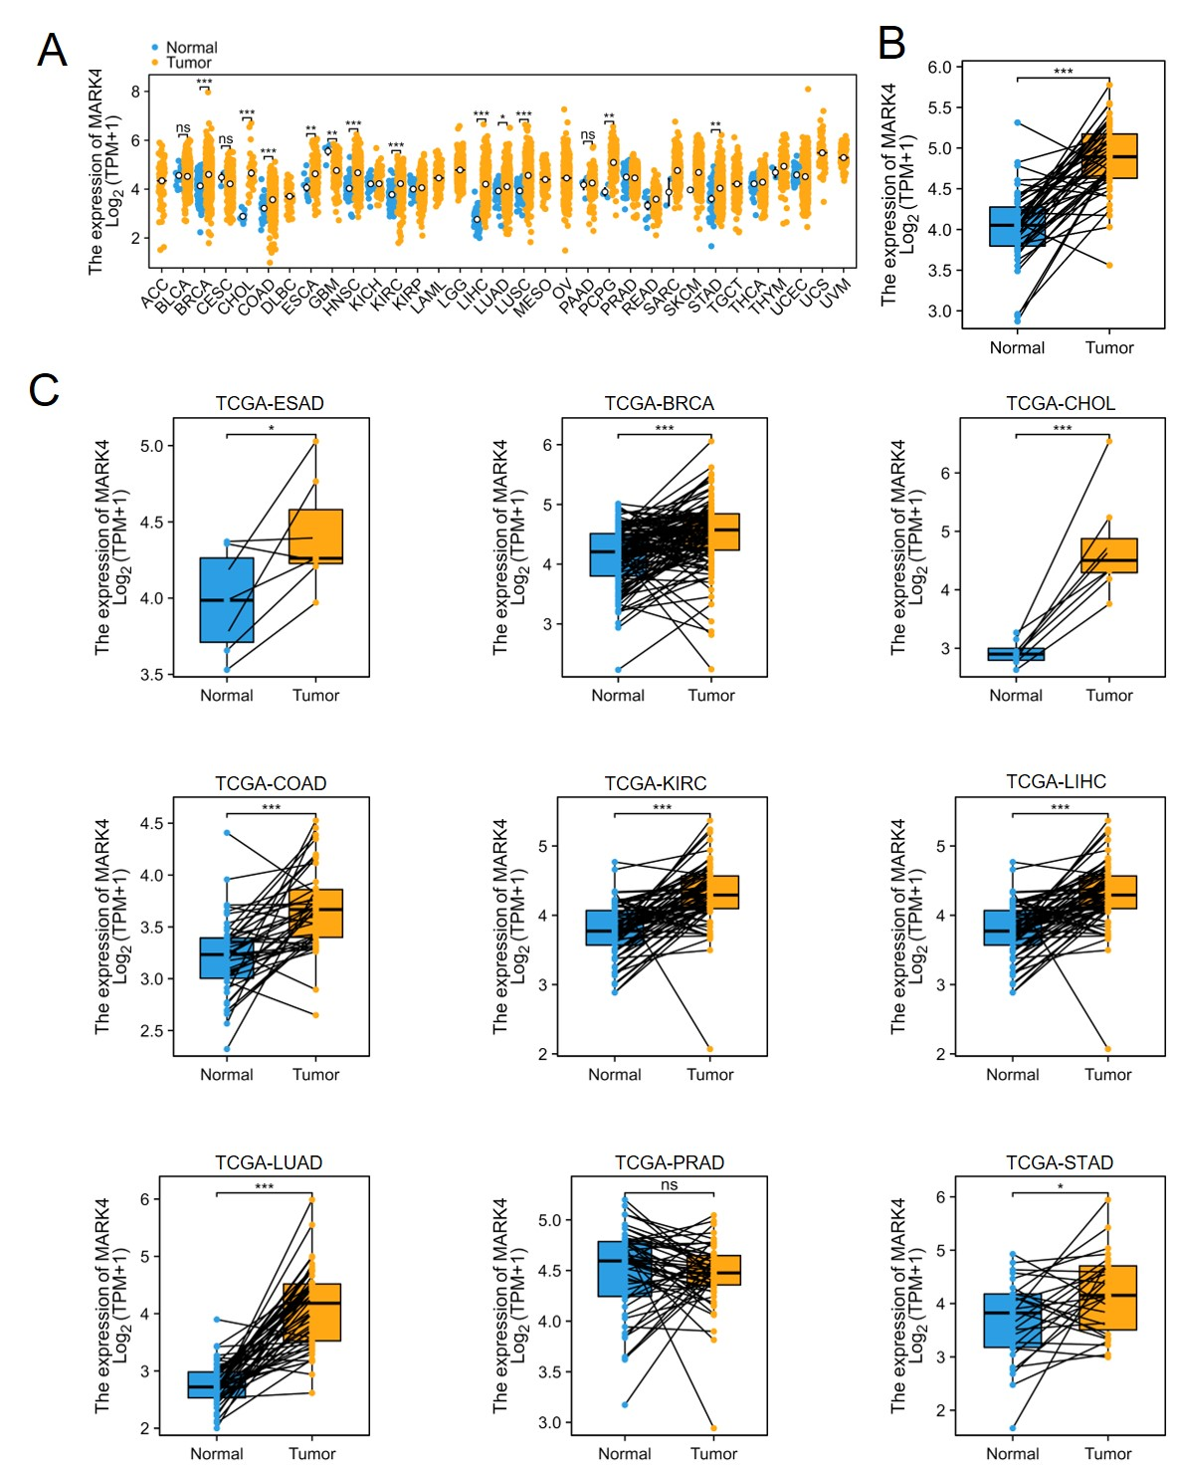
Supplementary Figure 1. The different mRNA expression of MARK4 in tumor and normal samples. (A) The mRNA expression of MARK4 in pan-cancers. (B) MARK4 mRNA expression in HNSCC compared with the adjacent normal tissues. (C) The expression of MARK4 mRNA in different tissues was compared with that in the adjacent normal tissues.

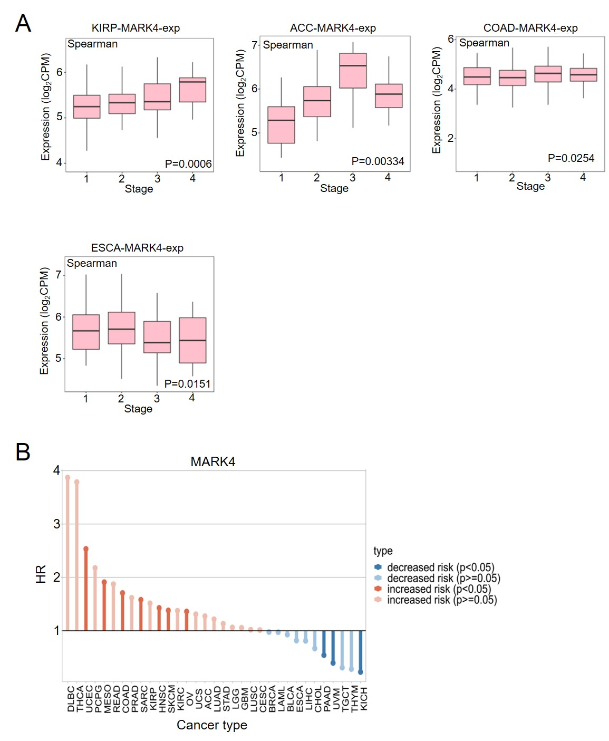
Supplementary Figure 2. The more progressed the tumor, the greater the expression of MARK4. (A) Associations between MARK4 expression and overall survival across human cancers. Data from TISIDB dataset (http://cis.hku.hk/TISIDB/index.php). (B) The expression of MARK4 is linked to an elevated risk of multiple tumors. Data from TISCH database (http://tisch.comp-genomics.org/).

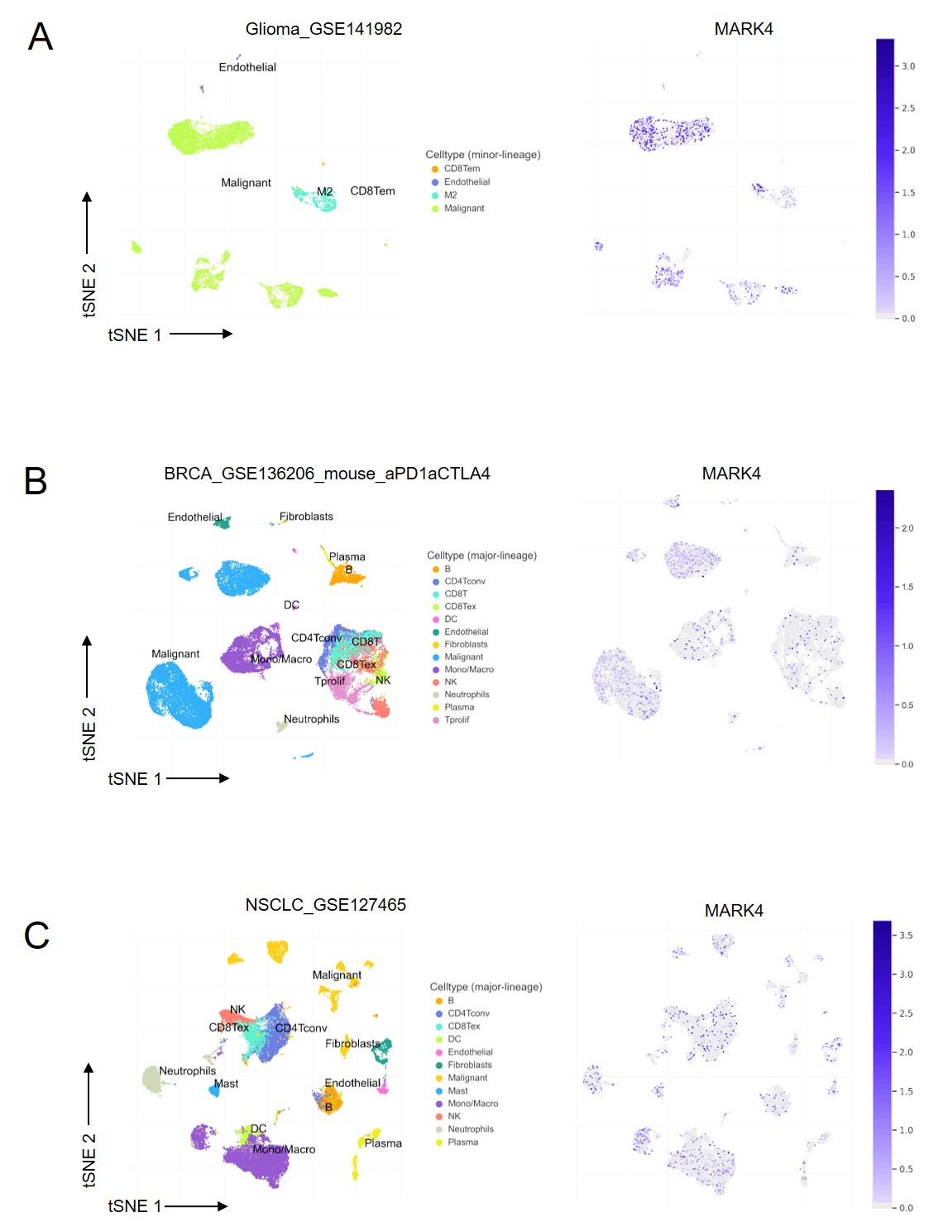
Supplementary Figure 3. MARK4 is principally expressed in tumor cells (malignant), mononuclear/macrophage cells, and epithelial cells. (A-C) Analysis of MARK4 gene expression in various tumours using the pan-cancer single-cell sequencing data set from the TISCH database (http://tisch.comp-genomics.org/).

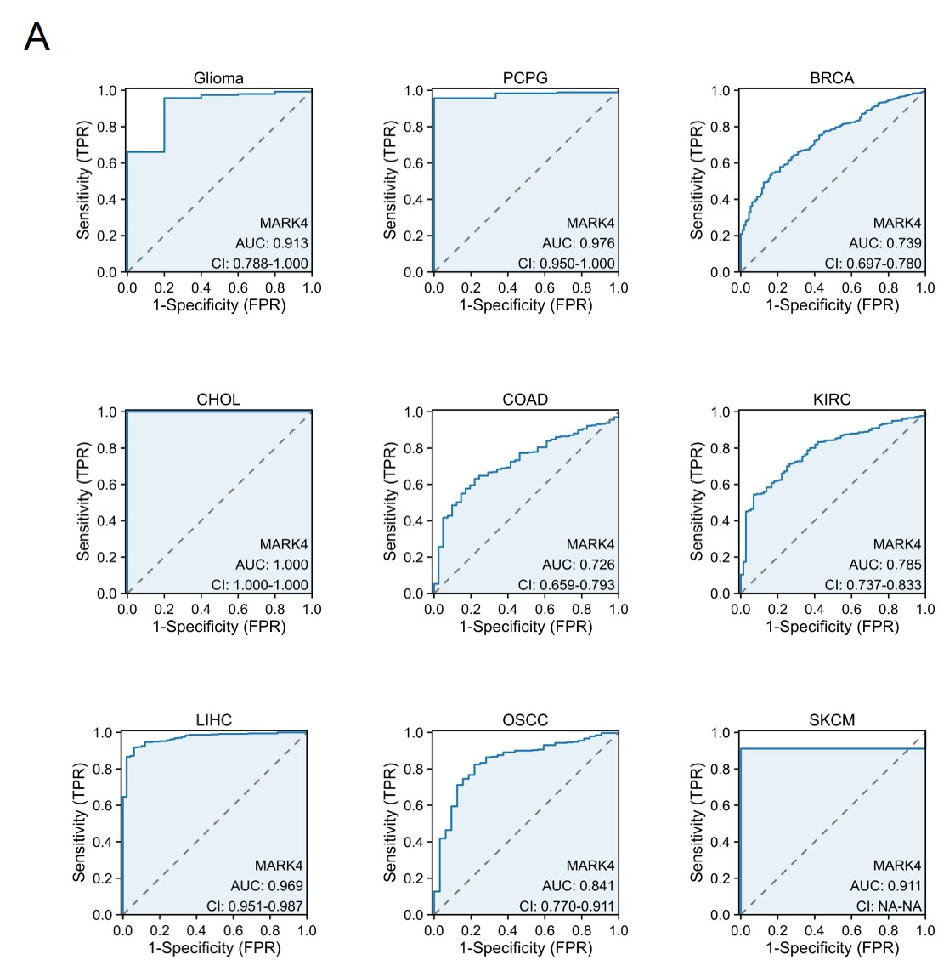
Supplementary Figure 4. MARK4 is an excellent diagnostic biomarker for CHOL, LIHC and PCPG tumor types. (A) ROC curve evaluating the efficacy of MARK4 in identifying various tumors.

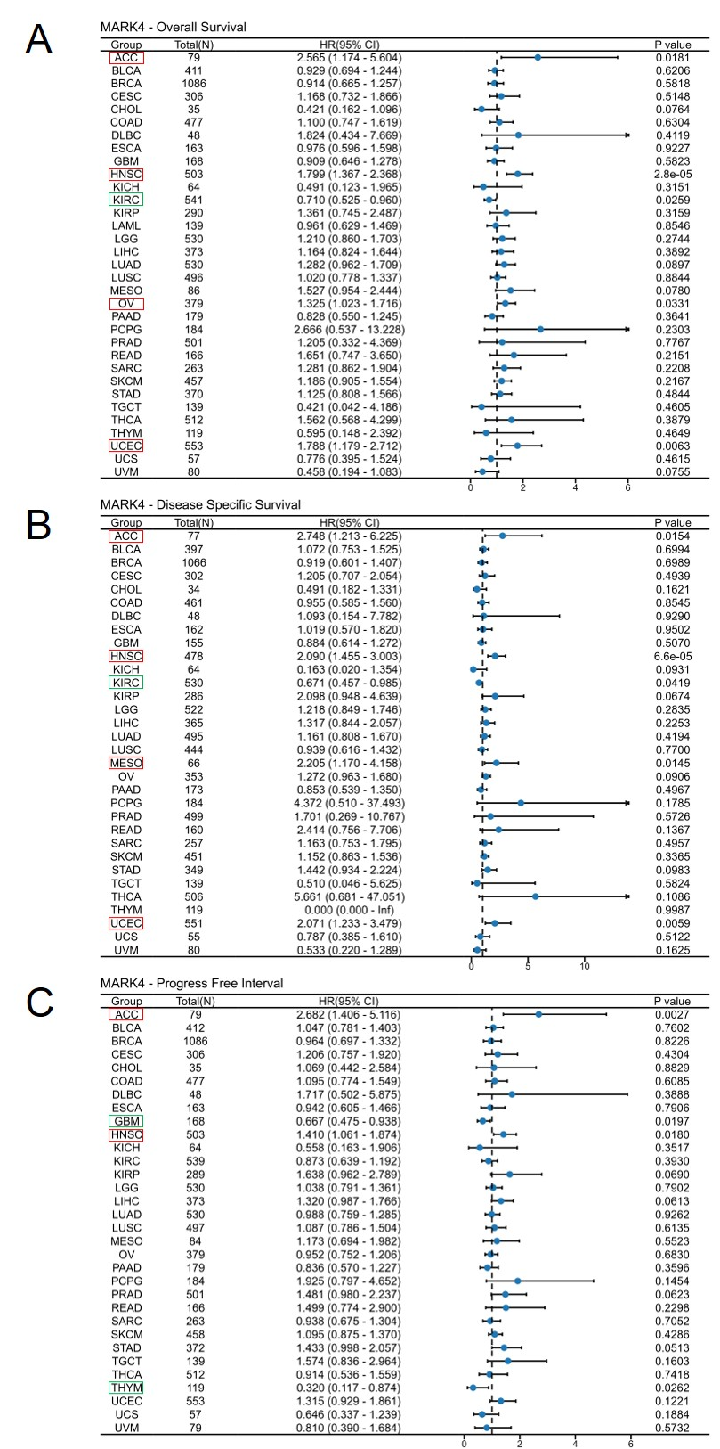
Supplementary Figure 5. MARK4 presents diagnostic and prognostic utility in various cancers. (A-C) Forest plots were used for pan-cancer analyses of MARK4 and OS (A), and DSS (B), DFI (C).

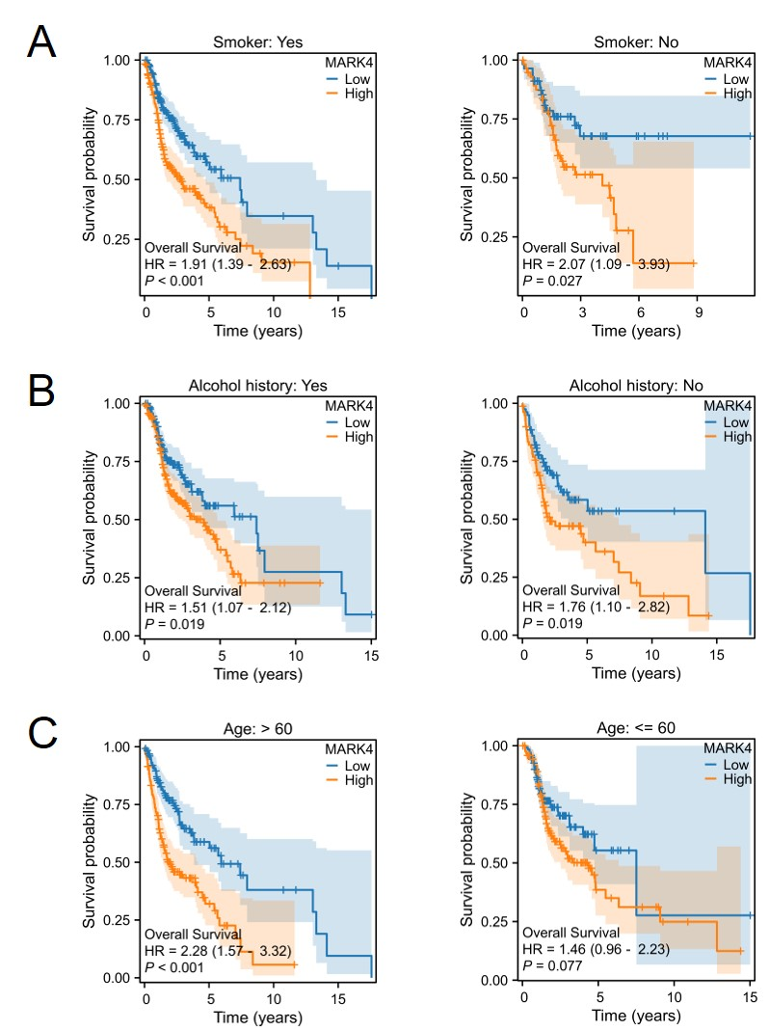
Supplementary Figure 6. The subclinical prognostic indicators of patients influenced by MARK4 were analyzed. (A-C) Association of MARK4 expression and clinicopathological characteristics. (A) Smoker, (B) Alcohol history, (C) age.

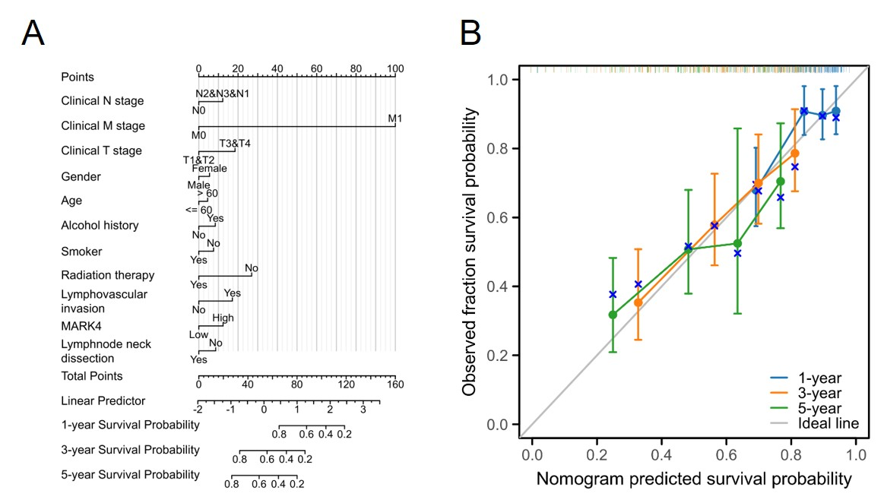
Supplementary Figure 7. A quantitative approach for predicting the HNSCC patient's OS probability at 1, 3, and 5 years. Cox regression analysis was employed to assess the independent prognostic factors and generate a nomogram and calibration plot for determining the predicted survival probabilities at 1, 3, and 5 years. (A) A nomogram for predicting the probability of OS at 1, 3, and 5 years for HNSCC patients. OS, referring to overall survival. (B) The calibration plot based on the generated nomogram for predicting the probability of OS at 1, 3, and 5 years. The abscissa is the survival probability predicted by the model, and the ordinate is the actual observed survival probability. Each point represents the model-predicted survival probability and the actual observed survival probability. The gray diagonal line is the ideal line.

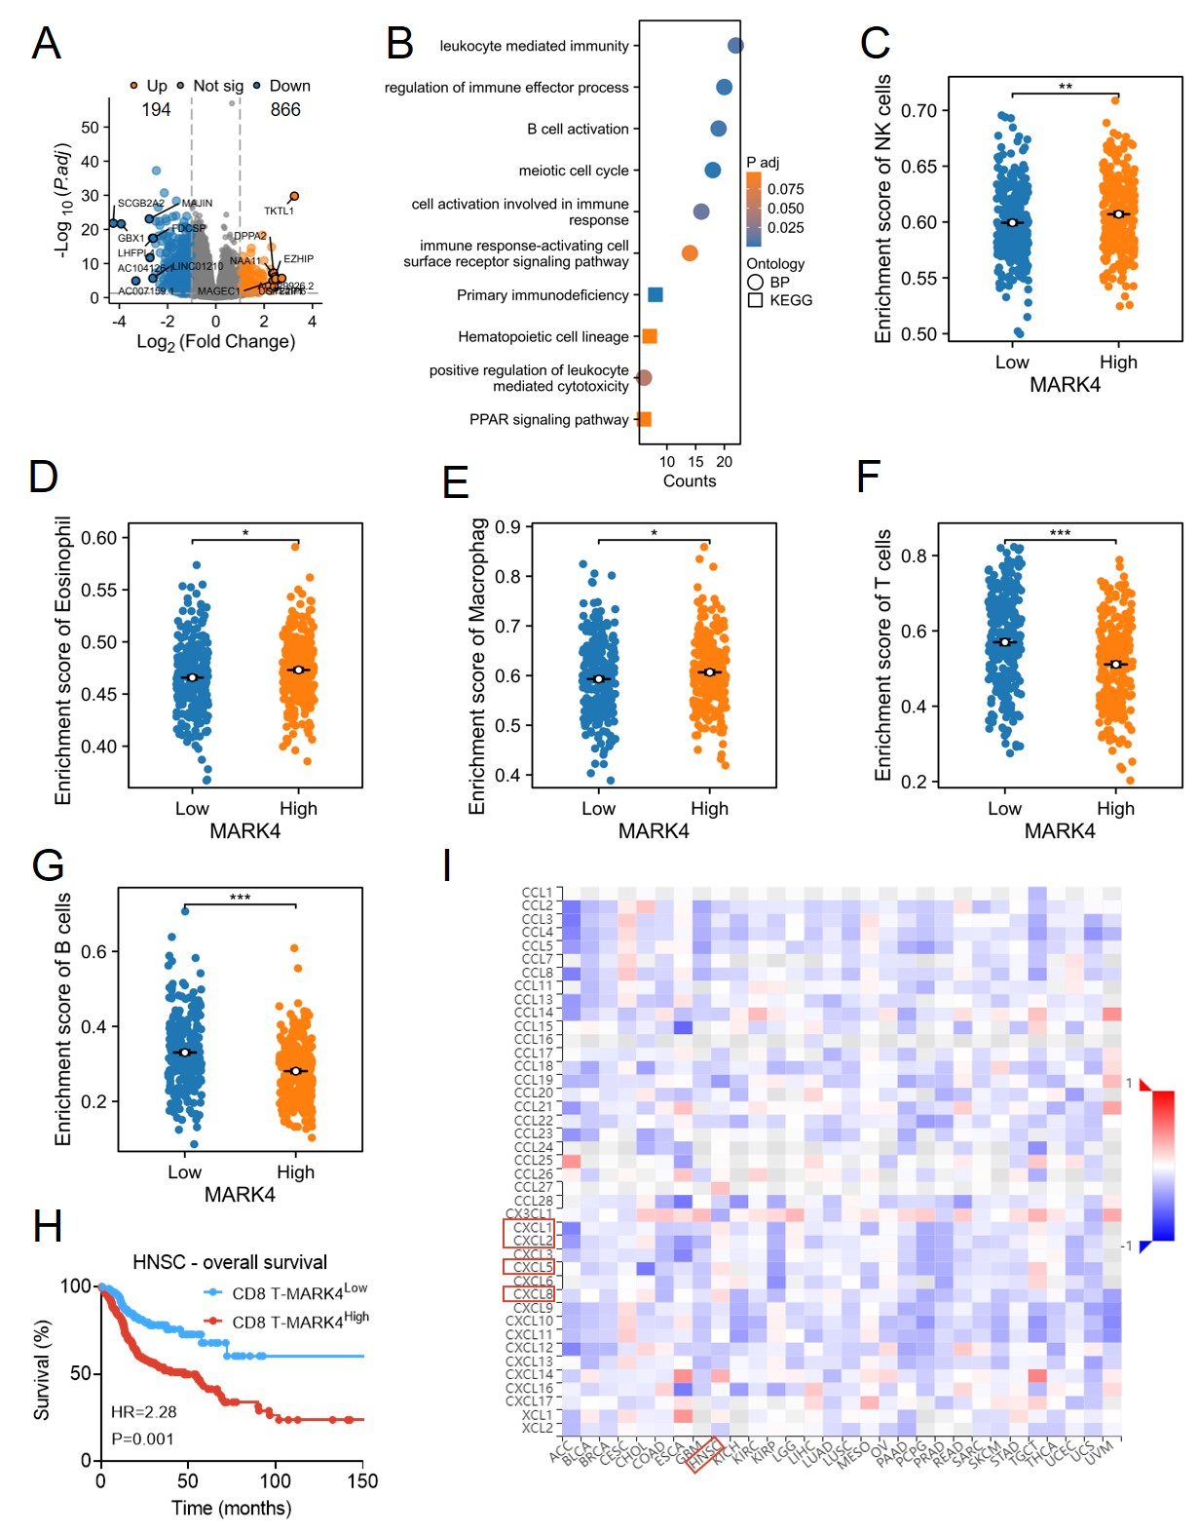
Supplementary Figure 8. MARK4 can have an effect on the percentage of immune cells in the HNSCC tumor tissues. (A) Volcano plots displaying the most significantly up- or down-regulated DEGs. (B) Scatter plots showing top ten KEGG pathways enriched for genes changed significantly between MARK4-high vs. MARK4-low. All genes were statistically changed (|log2(FC)|>1.2 & P value <0.05). (C-G) Scatter plots showing difference in NK,Eosinophil, macrophages, T cell, and B cell infiltration levels between the MARK4-high and -low groups. (H) The association of MARK4 expression in CD8 T cells with the tumor survival of HNSCC. (I) Spearman correlations between expression of MARK4 and chemokines across human cancers. Data from TISIDB dataset (http://cis.hku.hk/TISIDB/index.php).

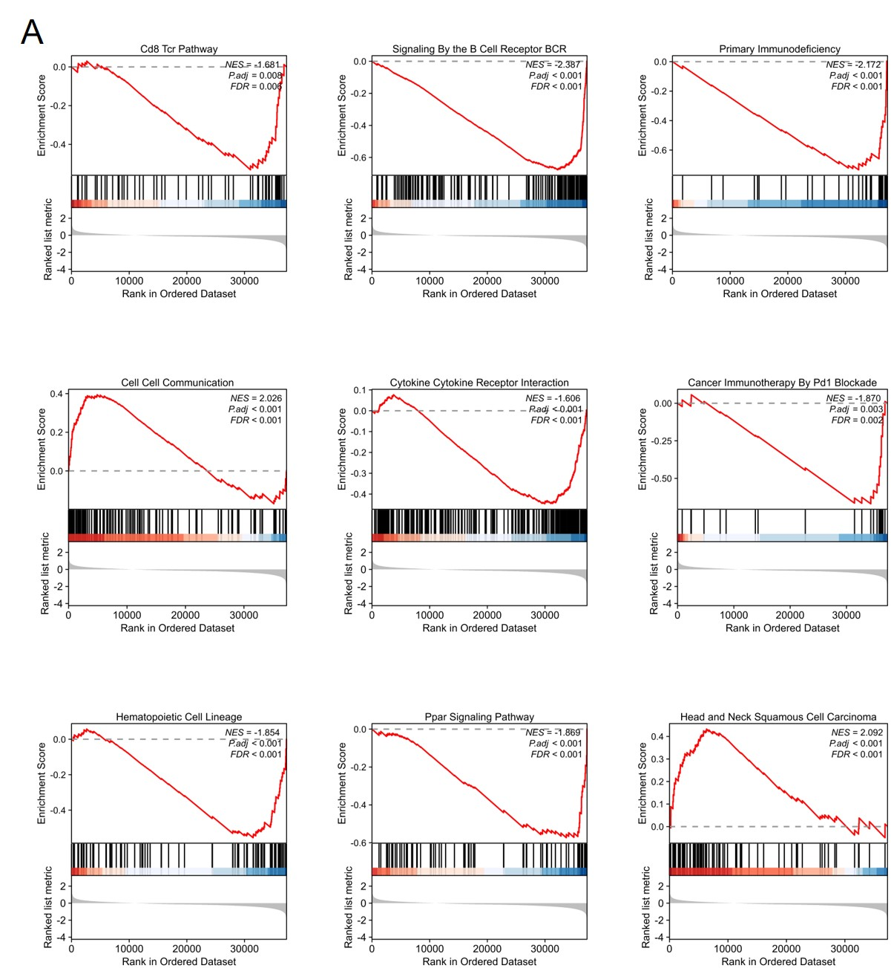
Supplementary Figure 9. GSEA enrichment plots. (A) Several pathways and biological processes were differentially enriched in MARK4 related HNSCC.

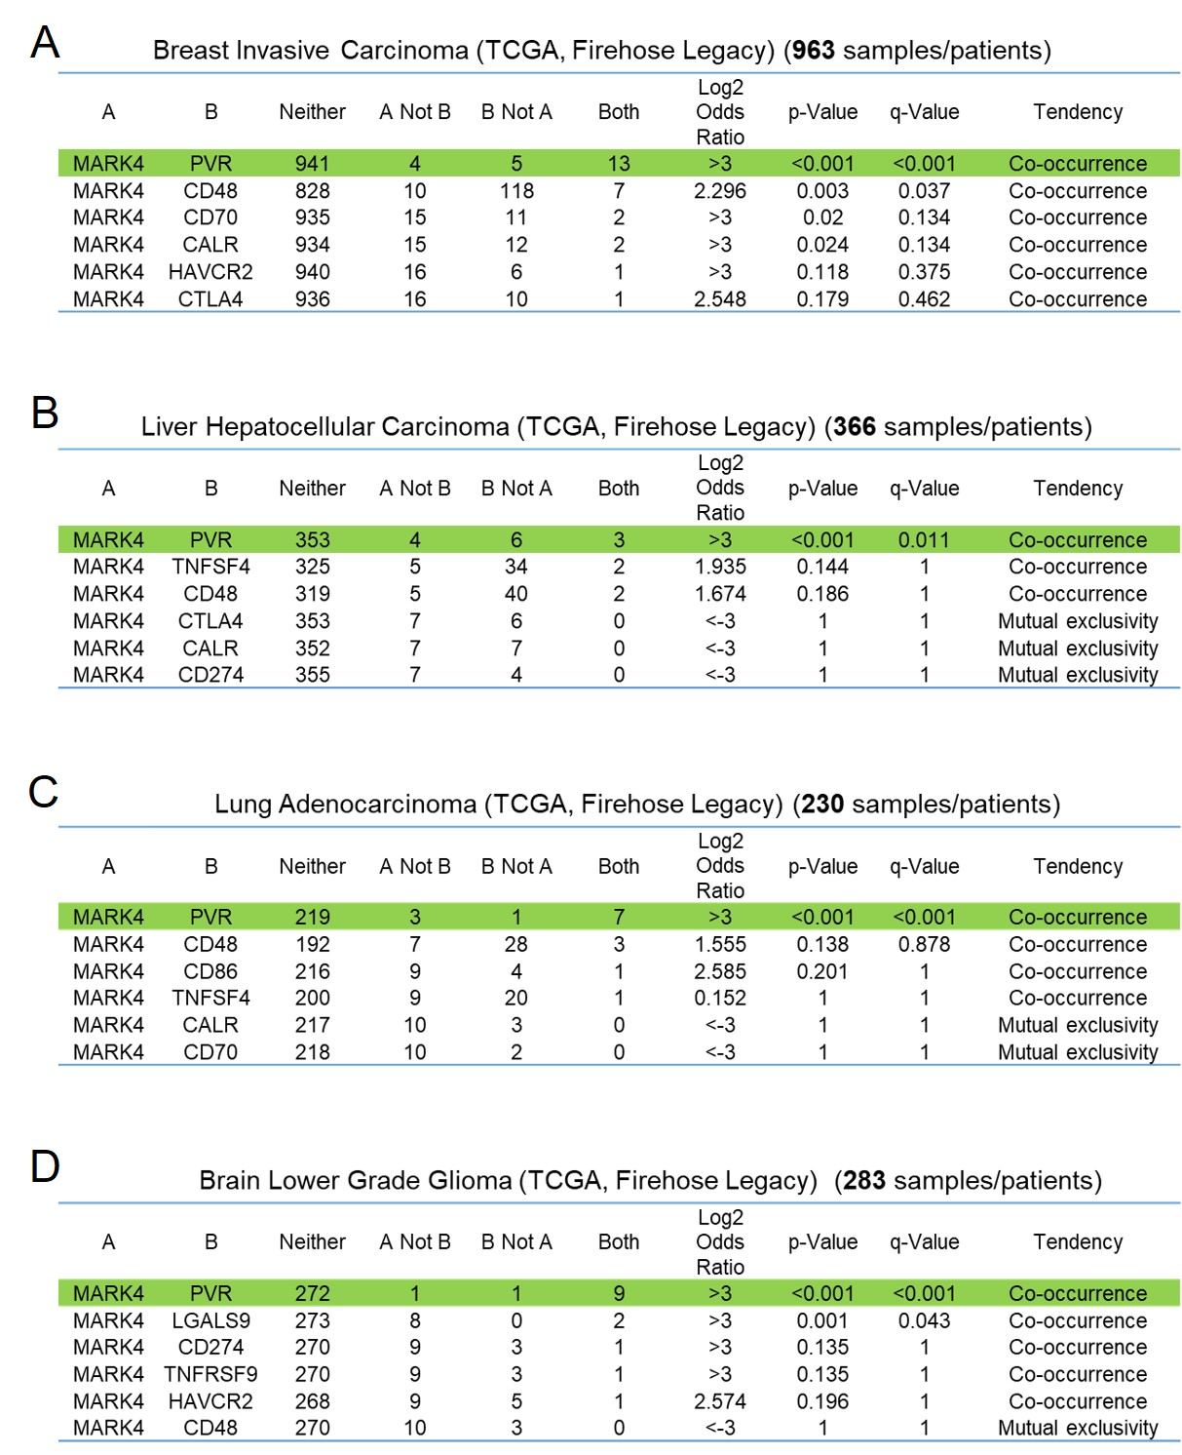
Supplementary Figure 10. The table demonstrates the co-expression relationship between MARK4 and PVR expression within multiple tumors. (A-D) The altered relationship between MARK4 and each immune checkpoint are indicated as a co‐occurrence or mutual exclusivity. The log2 odds ratio, P value, Q value, tendency, and significance are individually presented for each combination. Q and P values < 0.05 are considered statistically significant.

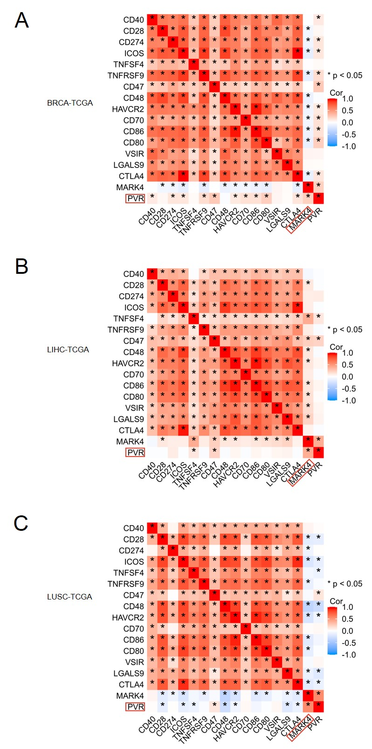
Supplementary Figure 11. The table demonstrates a positive correlation between MARK4 and PVR expression within multiple tumors. (A-C) The heatmap illustrating the correlation analysis between MARK4 and the expression of immune checkpoint molecules.

