Supplementary Information for
Synergistic effect of CuO@NiO@Fe₂O₃ heterostructure on photocatalytic efficiency and cyclic stability in wastewater treatment

- Synthesis of monometallic and bimetallic counterparts
To evaluate the synergistic effect of the trimetallic CuO@NiO@Fe₂O₃ nanocomposite, monometallic and bimetallic counterparts were synthesized using the same wet chemical method.

  - Monometallic Nanoparticles
Synthesis of CuO nanoparticles
CuO nanoparticles were synthesized via a chemical reduction method at room temperature. Initially, 10 mM copper nitrate and 1 mM trisodium citrate were dissolved in distilled water under constant stirring. To this solution, 50 mM sodium borohydride was introduced as a reducing agent, which induced a rapid color transition to dark gray and subsequently black, signifying the nucleation of copper-based species. The reaction mixture was stirred for an additional 10 minutes to ensure completion, after which the process was quenched with ethanol. The CuO precipitates were isolated via centrifugation, washed thoroughly with distilled water, and subsequently dried in an oven at 100 °C for 8 hours to obtain the final nanoparticle powder.
Synthesis of NiO nanoparticles
NiO nanoparticles were synthesized via a chemical reduction method at room temperature. Initially, 25 mM nickel sulfate and 2.5 mM trisodium citrate were dissolved in distilled water under constant stirring. To this mixture, 50 mM sodium borohydride was introduced as a reducing agent, which induced a rapid color transition to dark gray and subsequently black, signifying the nucleation of nickel-based species. The reaction mixture was stirred for an additional 10 minutes to ensure reaction completion, after which the process was quenched with ethanol. The NiO precipitates were isolated via centrifugation, washed thoroughly with distilled water to remove residual reagents, and subsequently dried in an oven at 100 °C for 8 hours to obtain the final nanoparticle powder.
Synthesis of Fe₂O₃ nanoparticles
Fe₂O₃ nanoparticles were synthesized via a chemical reduction method at room temperature. Initially, 50 mM ferric nitrate and 5 mM trisodium citrate were dissolved in distilled water under constant stirring. To this solution, 100 mM sodium borohydride was introduced as a reducing agent, inducing a rapid color transition to dark gray and subsequently black, signifying the nucleation of iron-based species. The reaction mixture was stirred for an additional 10 minutes to ensure completion, after which the process was quenched with ethanol. The Fe₂O₃ precipitates were isolated via centrifugation, washed thoroughly with distilled water, and subsequently dried in an oven at 100 °C for 8 hours to obtain the final nanoparticle powder.

1.2 Bimetallic Nanoparticles
Synthesis of CuO@NiO nanoparticles
CuO@NiO nanocomposites were synthesized through a multi-step chemical reduction process at room temperature. Initially, 1 mM trisodium citrate and 10 mM copper nitrate were dissolved in distilled water under constant stirring. To this solution, 50 mM sodium borohydride was introduced as a reducing agent, resulting in an immediate color transition to dark gray and subsequently black, signifying the formation of copper-based nuclei. After a 15-second interval, a nickel-precursor stock solution (comprising 25 mM nickel sulfate and 2.5 mM trisodium citrate) was added to the mixture. The resulting suspension was stirred for an additional 10 minutes to ensure a complete reaction, after which the process was quenched with ethanol. The CuO@NiO precipitates were isolated via centrifugation and washed thoroughly with distilled water to remove residual reagents. Finally, the obtained particles were dried in an oven at 100 °C for 8 hours.
Synthesis of CuO@Fe₂O₃ nanoparticles
The CuO@Fe₂O₃ nanocomposites were synthesized via a sequential chemical reduction method at room temperature. Initially, 10 mM copper nitrate was dissolved in distilled water containing 1 mM trisodium citrate under constant stirring. To this solution, 100 mM sodium borohydride was introduced as a reducing agent, leading to a rapid color transition to dark gray and subsequently black, indicating the formation of copper-based nuclei. Following a 60-second interval, an iron-precursor stock solution (containing 50 mM ferric nitrate and 5 mM trisodium citrate) was added to the mixture. The resulting suspension was stirred for an additional 10 minutes to ensure reaction completion, after which the process was quenched with ethanol. The CuO@Fe₂O₃ precipitates were isolated via centrifugation, washed thoroughly with distilled water, and subsequently dried in an oven at 100 °C for 8 hours to obtain the final nanocomposite powder.
Synthesis of NiO@Fe₂O₃ nanoparticles
The NiO@Fe₂O₃ nanocomposites were synthesized through a sequential chemical reduction process at room temperature. Initially, 25 mM nickel sulfate and 2.5 mM trisodium citrate were dissolved in distilled water under constant stirring. To this mixture, 100 mM sodium borohydride was added as a reducing agent, resulting in a color transition to dark gray and subsequently black, signifying the formation of nickel-based nuclei. Following a 60-second interval, an iron-precursor stock solution (comprising 50 mM ferric nitrate and 5 mM trisodium citrate) was introduced into the reaction. The resulting suspension was stirred for an additional 10 minutes to ensure reaction completion, after which the process was quenched with ethanol. The NiO@Fe₂O₃ precipitates were isolated via centrifugation, washed thoroughly with distilled water, and subsequently dried in an oven at 100 °C for 8 hours.

- Surface morphology and chemical compositons of bimetallic counterparts
The surface morphology and elemental distribution of the synthesized bimetallic CuO@Fe₂O₃ and NiO@Fe₂O₃ samples were characterized using scanning electron microscopy (SEM) and energy dispersive x-ray spectroscopy (EDS).

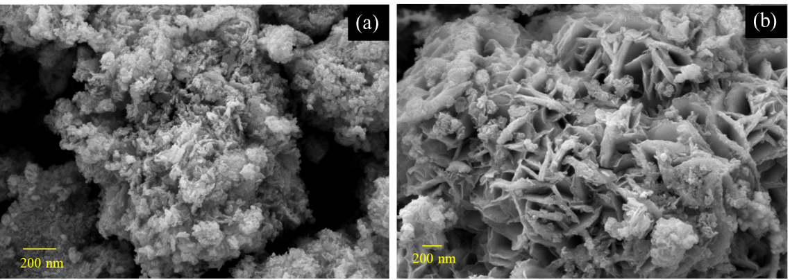
Fig. S1 SEM images of the synthesized bimetallic nanoparticles: (a) CuO@Fe₂O₃ and (b) NiO@Fe₂O₃

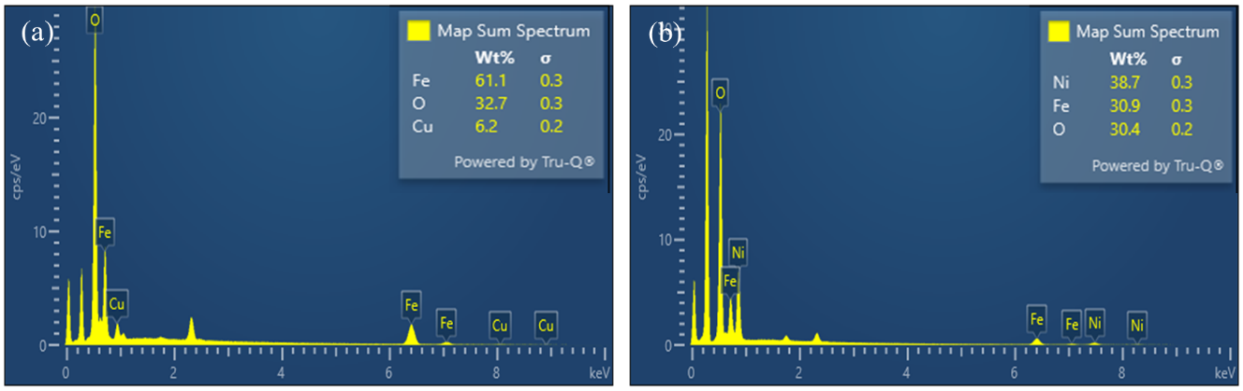
Fig. S2 EDS spectra of the bimetallic nanoparticles: (a) CuO@Fe₂O₃ and (b) NiO@Fe₂O₃

3. Point of zero charges (pH_{pzc}) of CuO@NiO@Fe₂O₃ nanoparticles
The point of zero charge (pHpzc) of the synthesized CuO@NiO@Fe₂O₃ nanocomposite was determined using the salt addition (pH drift) method.

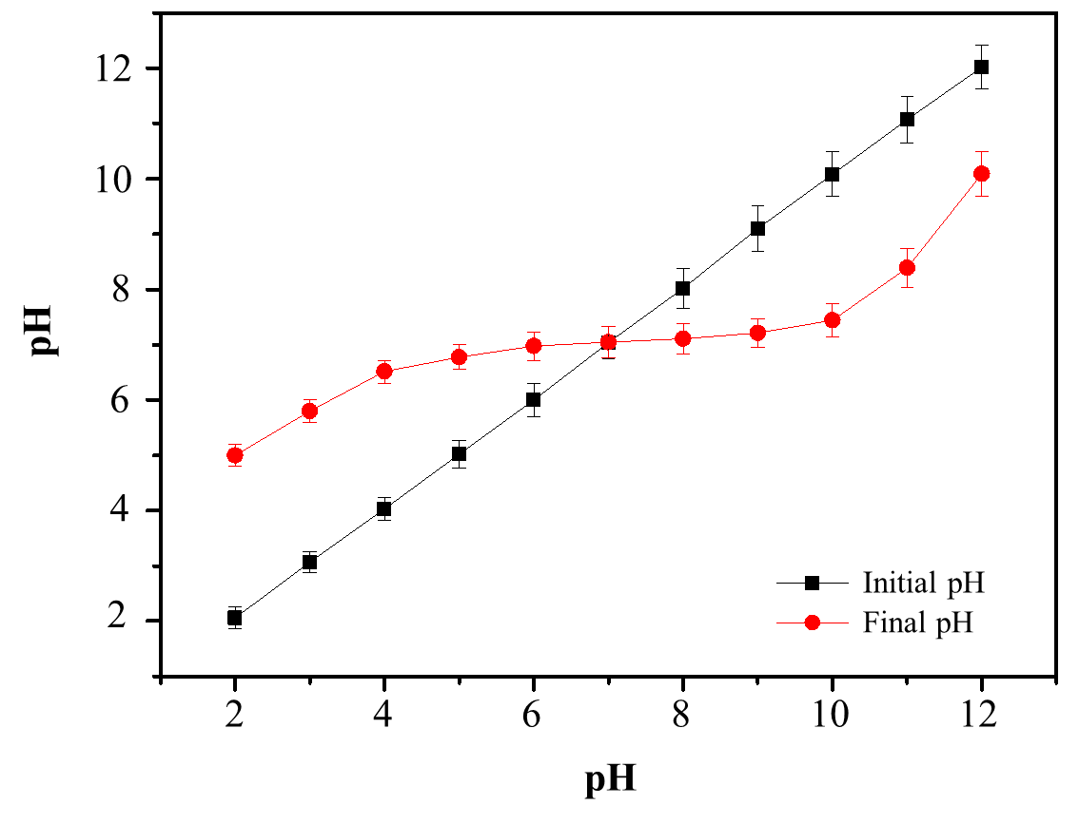
Fig. S3 Determination of the point of zero charges (pH_{pzc}) of the CuO@NiO@Fe₂O₃ TMNPs

