Supplementary Fig. 1. Mass spectral data of I. obliquus-mediated degradation products of a lignin model dimer.

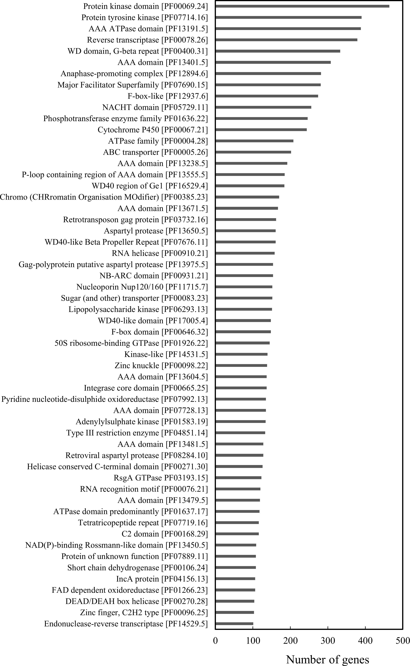

Supplementary Fig. 2. Distribution of I. obliquus genes in different Pfam categories. Pfam categories containing more than 100 genes are shown.
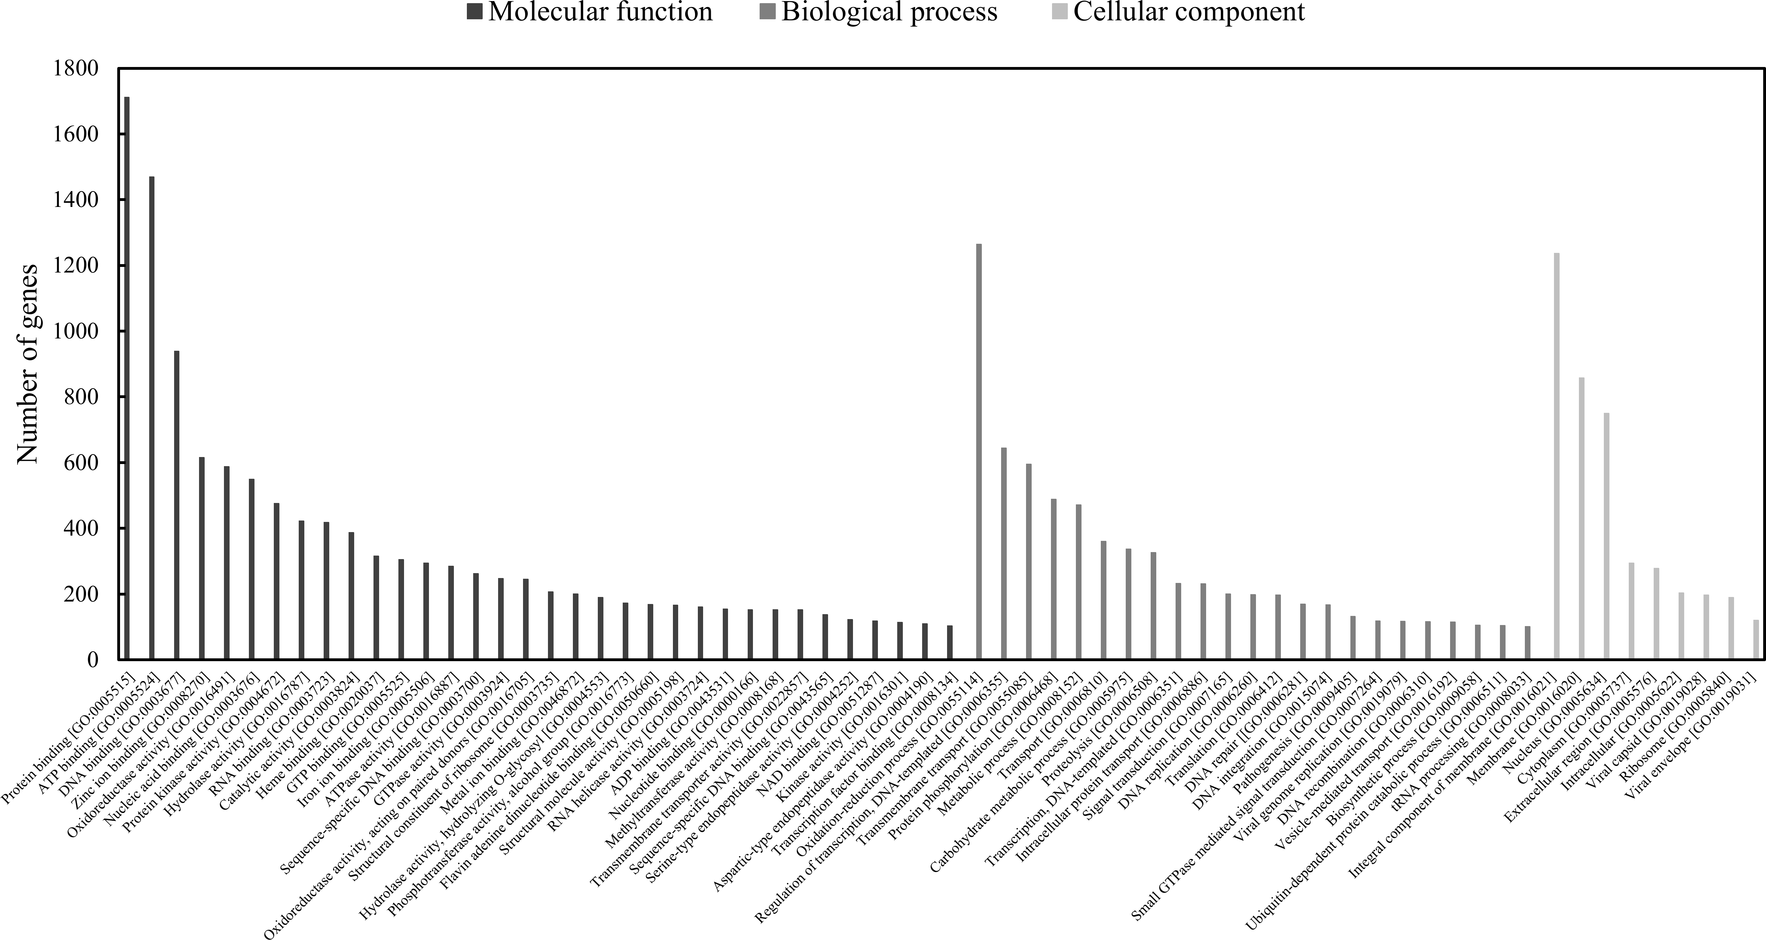

Supplementary Fig. 3. Distribution of I. obliquus genes in different GO terms. GO terms containing more than 100 genes are shown.

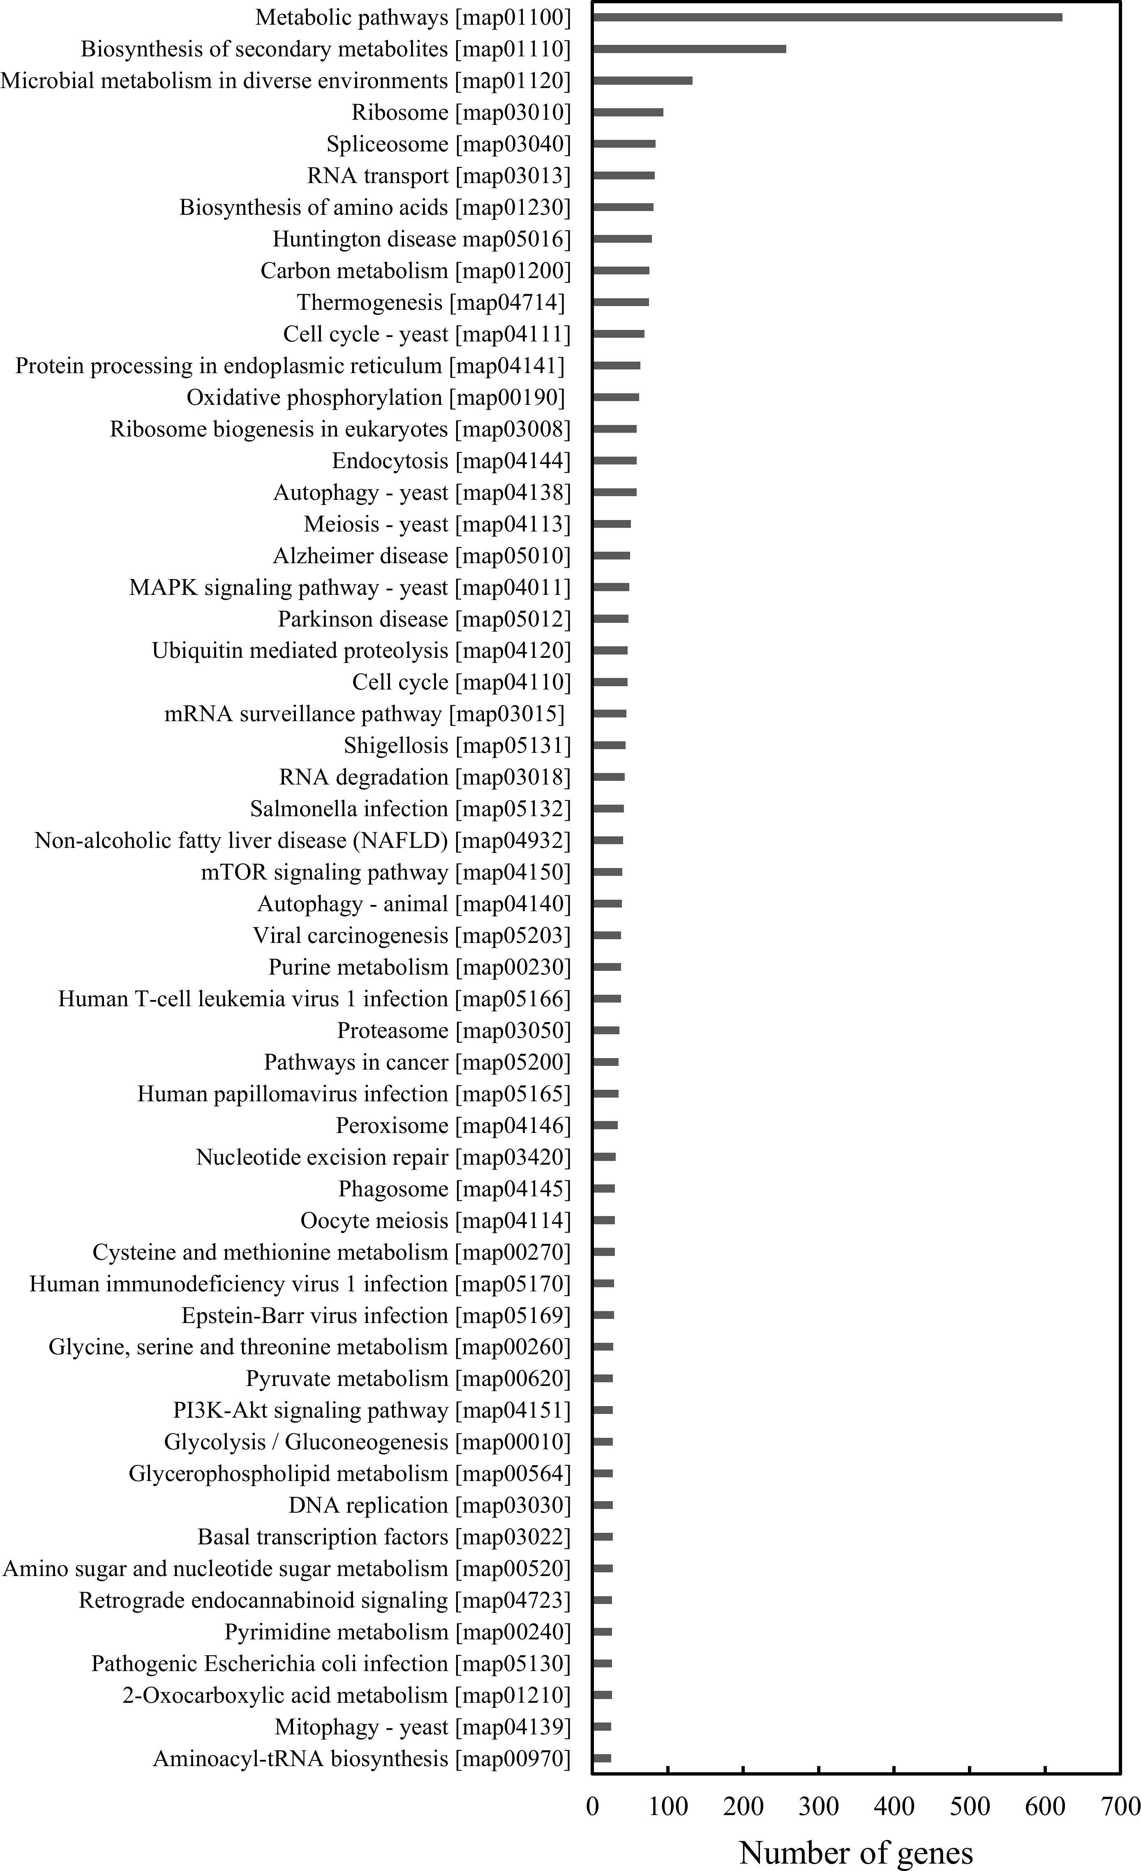

Supplementary Fig. 4. Distribution of I. obliquus genes in different KEGG categories. KEGG categories containing more than 25 genes are shown.

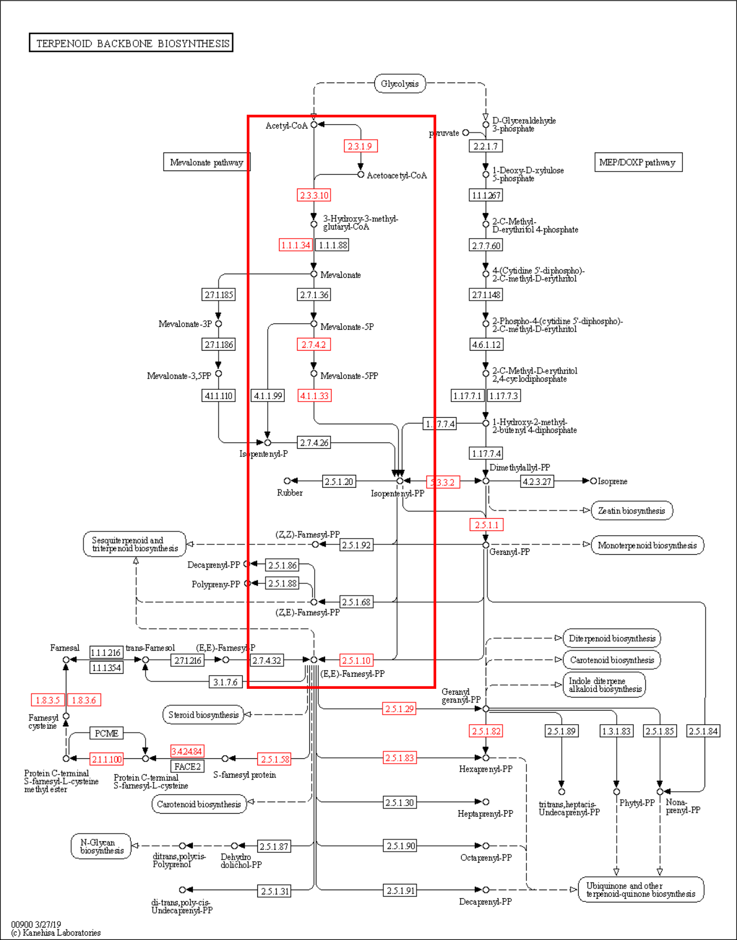  A | 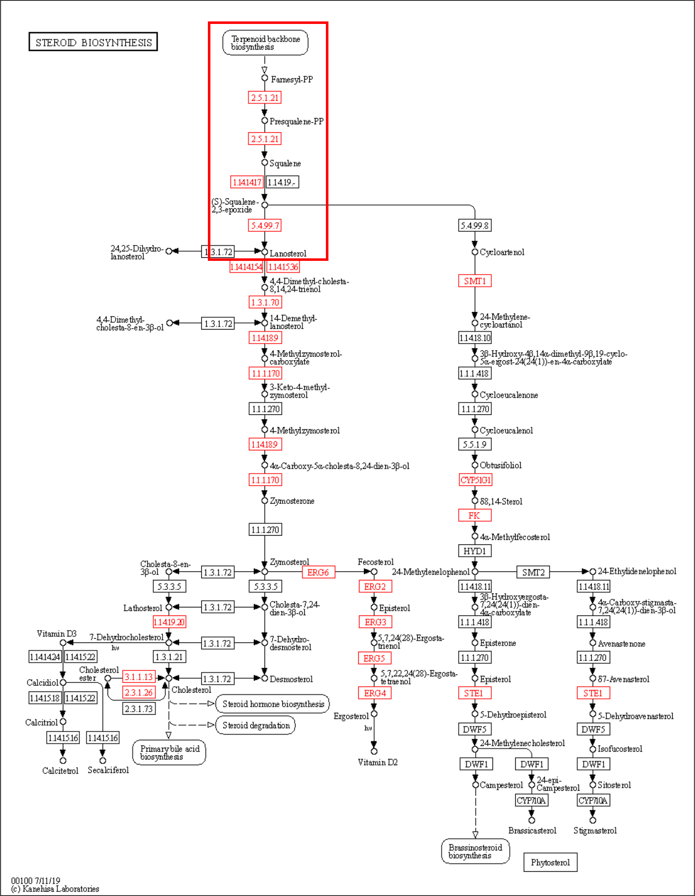  B
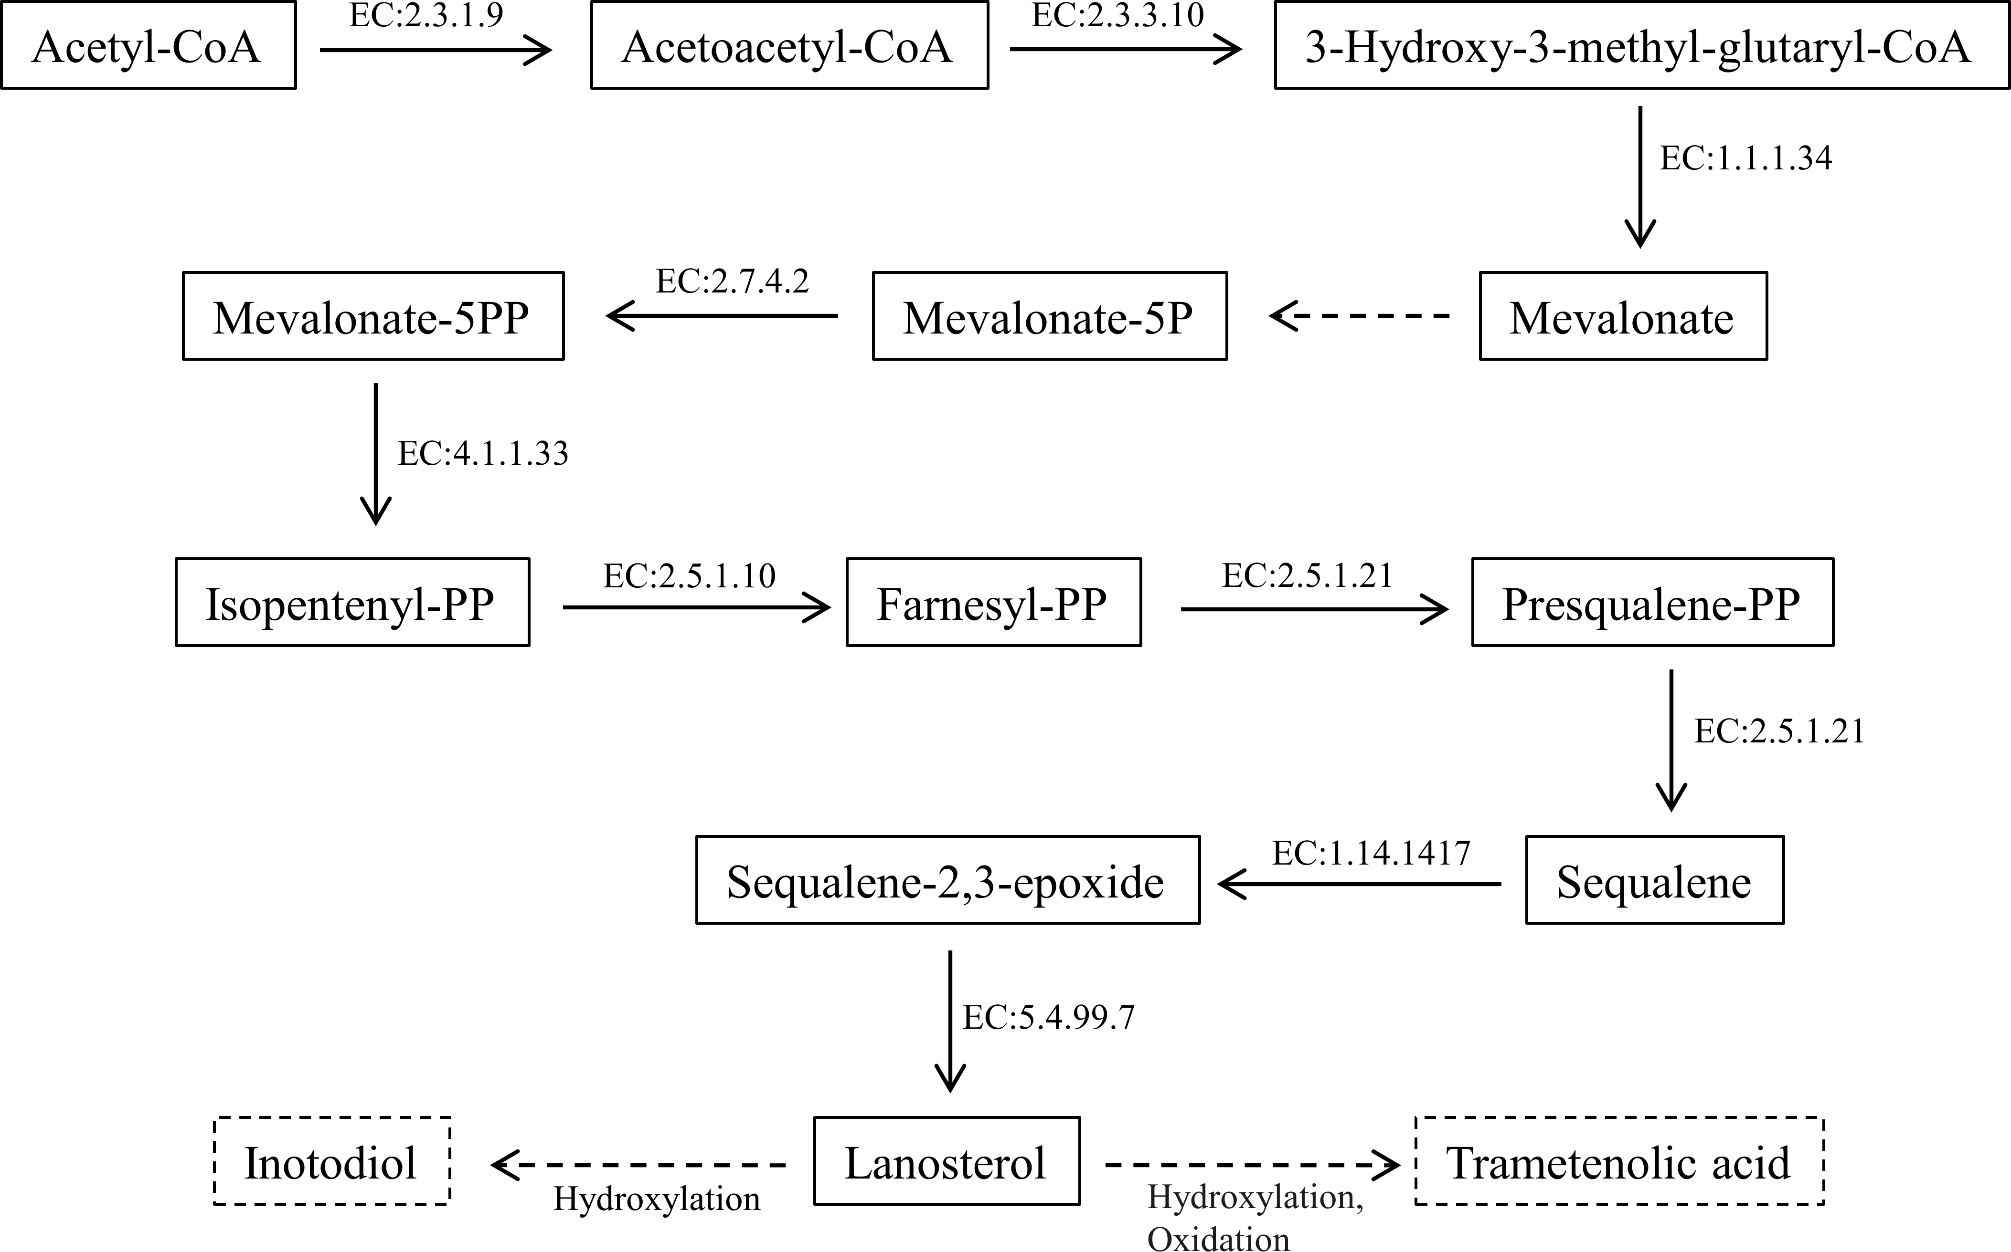
C
Supplementary Fig. 5. Pathways of (A) terpenoid backbone biosynthesis and (B) steroid biosynthesis from the KEGG database. (C) Putative lanosterol biosynthesis pathway in I. obliquus. Red EC number, enzyme encoding genes detected in the I. obliquus genome. Dashed arrow, enzyme encoding gene not detected. Enzyme encoding genes involved in this pathway are as follows: EC:2.3.1.9, acetyl-CoA acetyltransferase; EC:2.3.3.10, hydroxymethylglutaryl-CoA synthase A; EC:1.1.1.34, 3-hydroxy-3-methylglutaryl-coenzyme A reductase; EC:2.7.4.2, phosphomevalonate kinase; EC: 4.1.1.33, diphosphomevalonate decarboxylase; EC:2.5.1.10, farnesyl pyrophosphate synthase; EC: 2.5.1.21, squalene synthase; EC: 1.14.1417, squalene epoxidase; EC: 5.4.99.7, lanosterol synthase.
Supplementary Fig. 6. Multiple alignment of the deduced amino acid sequence of DyPs. AA-DyP, DyP of Auricularia auricula-judae (Accession No. 4W7L_A); IO-DyP.1 and IO-DyP.2, DyPs of Inonotus obliquus with gene IDs. MSTRG.14052.1 and g3844.t1, respectively; SB-DyP, DyP of Sanghuangporus baumii (Accession No. OCB85293.1); HI-DyP, DyP of Heterobasidion irregulare (Accession No. XP_009544629.1).

Supplementary Fig. 7. Multiple alignments of the deduced amino acid sequence of IO-Px. PO, Pleurotus ostreatus; PN, Pyrrhoderma noxium; FM, Fomitiporia mediterranea; SB, Sanghuangporus baumii; IO, Inonotus obliquus; B, Bjerkandera sp.; PE, P. eryngii; PC, Phanerochaete chrysosporium; TCe, Triuncina cervine; MnP, manganese peroxidase; Px, putative versatile peroxidase; VP, versatile peroxidase; LiP, lignin peroxidase. The underlined amino acid sequence indicates the signal peptide.

