Effect of age at Human Papillomavirus (HPV) vaccination on incidence and persistence of vaccine-targeted HPV types: Supplementary figures
Supplementary figure 1
Study flowchart showing enrolment in both vaccination and screening trials respectively as well as the HPV genotyping results visit and stratified by early vaccination at 12-to-15 years old or late vaccination at 18 years old.
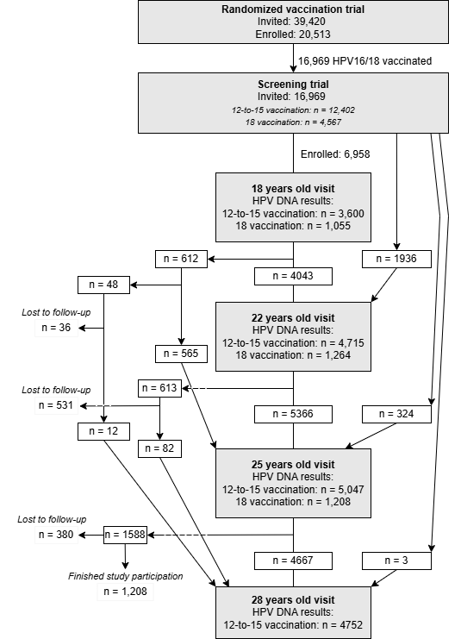
Supplementary figure 2
Type-specific incidence rates for the vaccine-covered HPV types 16/18/31/45 and the reference non-vaccine-covered HPV type 51 between the different study visits (between ages of 18 and 22 years old, 22 and 25 years old, 25 and 28 years old) stratified by age at vaccination.
