Supplementary materials
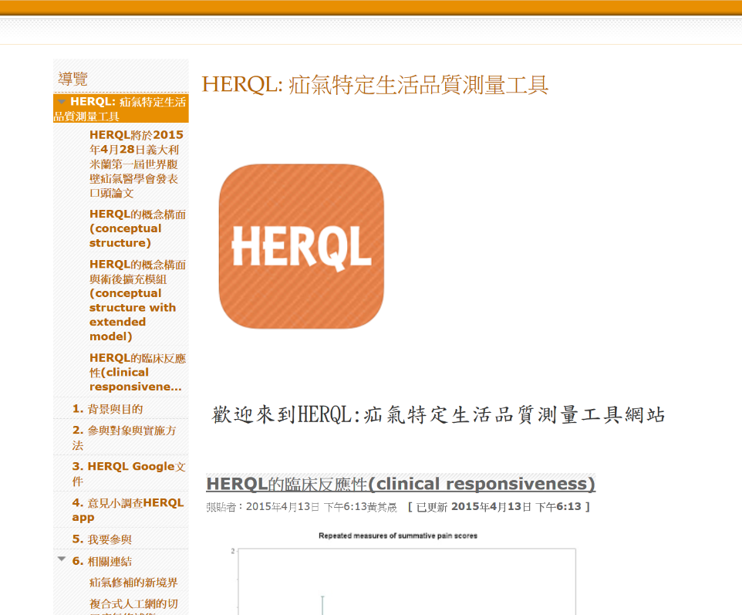

Supplementary Fig 1. Screenshot for HERQL mobile app google site.

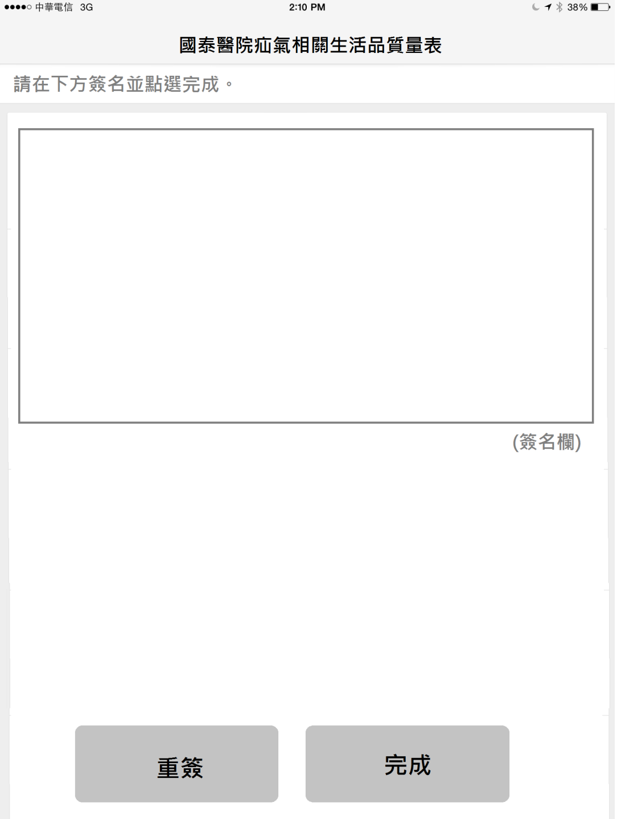
Supplementary Fig 2. Electrical signature module in portrait mode.

