Supplementary information

Enhancement of Electrocatalytic Oxygen Evolution by Chiral Molecular Functionalization of Hybrid 2D Electrodes
Yunchang Liang,^{1,2,*} Karla Banjac,^{1,2} Kévin Martin,³ Nicolas Zigon,³ Seunghwa Lee,⁴ Nicolas Vanthuyne,⁵ Felipe Andrés Garcés,⁶ José R. Galan-Mascaros,^{6,7} Xile Hu,⁴ Narcis Avarvari,^{3,*} Magalí Lingenfelder^{1,2,*}
¹ Max Planck-EPFL Laboratory for Molecular Nanoscience and Technology, École Polytechnique Fédérale de Lausanne (EPFL), 1015 Lausanne, Switzerland
² Institut of Physics (IPHYS), Ecole Polytechnique Fédérale de Lausanne (EPFL),
1015 Lausanne, Switzerland
³ Univ Angers, CNRS, MOLTECH-Anjou, SFR MATRIX, F-49000 Angers, France
⁴ Laboratory of Inorganic Synthesis and Catalysis, Institute of Chemical Sciences and Engineering, École Polytechnique Fédérale de Lausanne (EPFL), 1015 Lausanne, Switzerland
⁵ Aix Marseille Université, CNRS, Centrale Marseille, iSm2, Marseille, France
⁶ Institute of Chemical Research of Catalonia (ICIQ), The Barcelona Institute of Science and Technology (BIST), Av. Països Catalans 16, E-43007 Tarragona, Spain
⁷ Catalan Institution for Research and Advanced Studies (ICREA), Passeig Lluis Com- panys, 23, Barcelona 08010, Spain

*e-mail: yunchang.liang@epfl.ch; narcis.avarvari@univ-angers.fr; magali.lingenfelder@epfl.ch

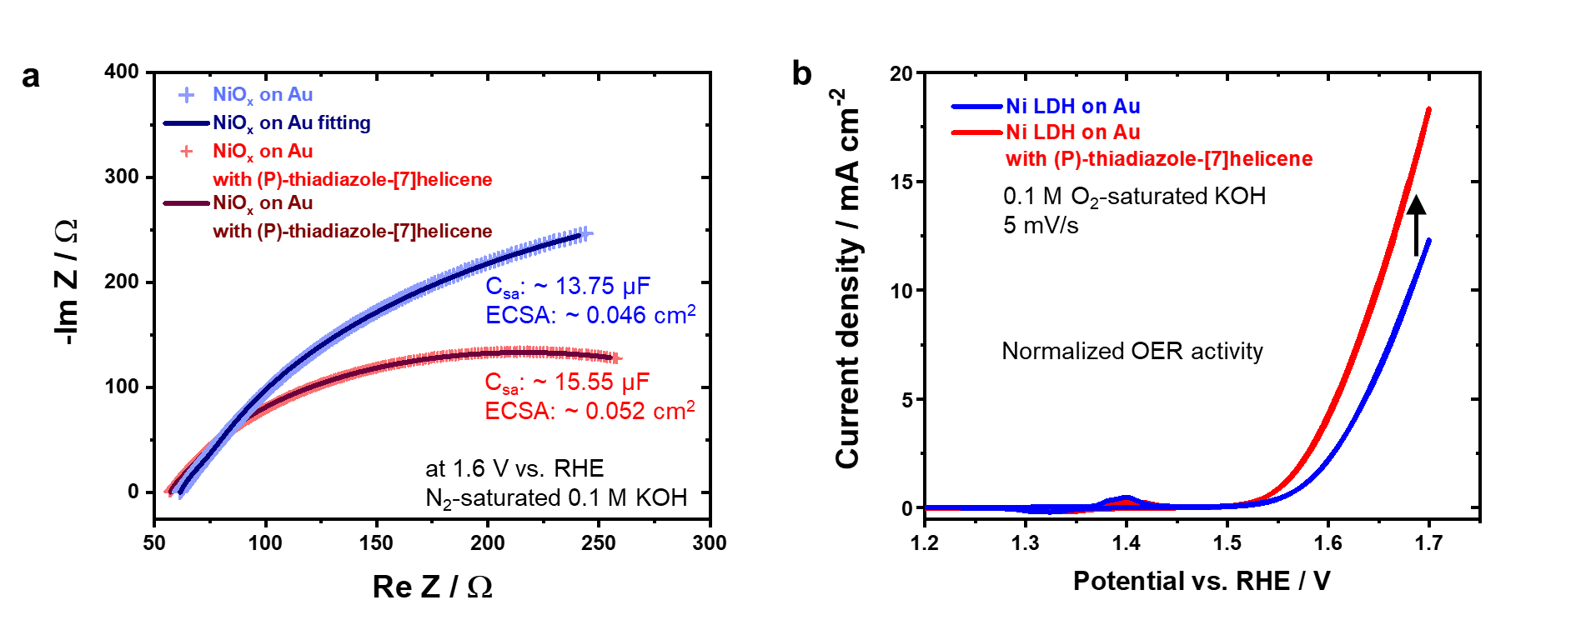
Supplementary Figure 1 | a, impedance spectroscopy of the NiO_{x} on Au surface before and after the deposition of (P)-thiadiazole-[7]helicene and the data-fitting results. b, the activity of the NiO_{x} sample normalized by the ECSA obtained from EIS measurements.

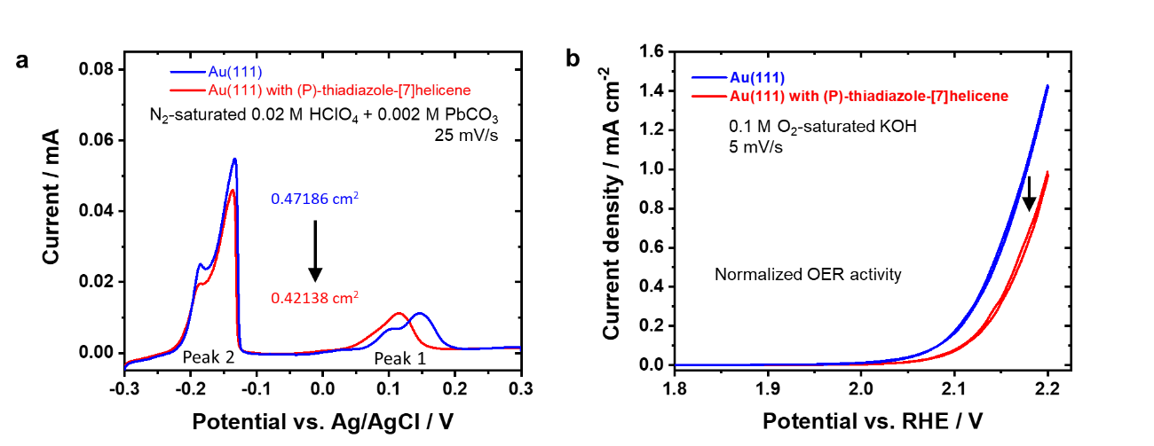
Supplementary Figure 2 | a, Pb stripping on Au surfaces before and after (P)-thiadiazole-[7]helicene deposition and b, normalized OER activity,.

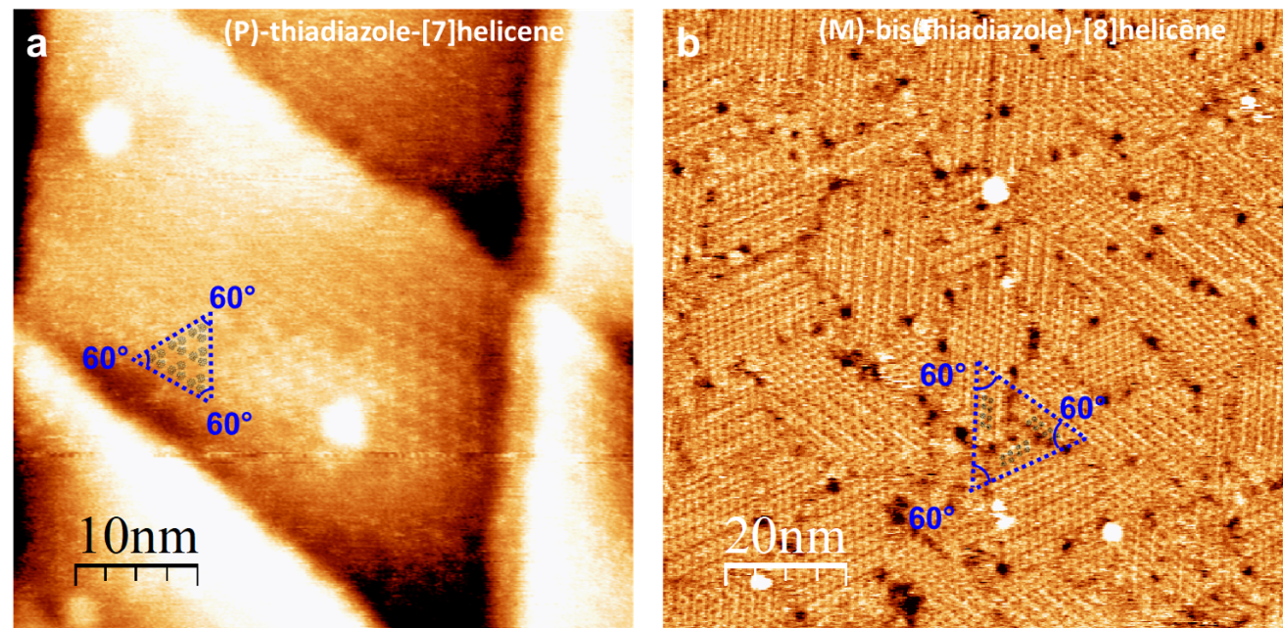
Supplementary Figure 3 | STM images of the SAM of a (P)-thiadiazole-[7]helicene as packed trimers (image size: 50 nm x 50 nm, tunneling current: 15 pA, sample bias: 50 mV) and b (M)-bis(thiadiazole)-[8]helicene with three rotational domains 60° to each other (image size: 100 nm x 100 nm, tunneling current: 20 pA, sample bias: 50 mV).

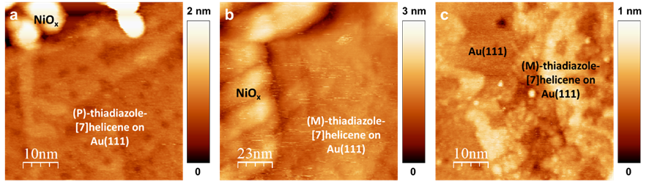
Supplementary Figure 4 | STM images (image size: 50 nm x 50 nm) of a (P)- and b,c (M)-thiadiazole-[7]helicene functionalized electrode surface after the OER measurements. All images were recorded in air. Imaging parameters: a, tunneling current: 40 pA, sample bias: -500 mV; b, tunneling current: 35 pA, sample bias: -316.8 mV; c, tunneling current: 30 pA, sample bias: -316.8 mV.

Experimental Section
All the solvents and precursors for synthesis of the helicenes were commercially available and used without further purification. Infrared (IR) spectra were recorded in the solid state using a Bruker Vertex 70 spectrometer with Platinum ATR in the 400–4000 cm^{–1} range. ¹H and ¹³C spectra were recorded on a Bruker Advance DRX 300 spectrometer operating at 300 MHz for ¹H and 76 MHz for ¹³C. Chemical shifts are given in ppm relative to tetramethylsilane TMS and coupling constants J in Hz. The residual non-deuterated solvent was used as an internal standard. Mass spectra were obtained by the MALDI-TOF techniques by using a Bruker Biflex-IIITM apparatus, equipped with a 337 nm N₂ laser. 2,7-bis((triphenylphosphonium)methyl)naphthalene bromide 1 and [7]helicene-thiadiazole were synthesized according to published literature protocols.,
Supplementary Scheme 1 | Synthesis of (rac)-bis(thiadiazole)-[8]helicene. i) benzothiadiazole-5-carbaldehyde, n-BuLi, THF, -78 °C to RT; ii) I₂ (cat.), hν, toluene, RT.

Crystallography
X-Ray structure determinations, details about data collection and solution refinement are given in Table S2. Data collections were performed on a Rigaku Oxford Diffraction SuperNova diffractometer equipped with an Atlas CCD detector and micro-focus Cu-K_{α} radiation (λ = 1.54184 Å). The structures were solved by intrinsic phasing and refined on F² by full matrix least-squares techniques with SHELX programs (SHELXT 2018/2 and SHELXL 2018/3), using the ShelXle and the Olex2 graphical user interfaces,. All non-H atoms were refined anisotropically, and absorption was corrected by multiscan empirical absorption using spherical harmonics with the CrysAlisPro program. The H atoms were placed at calculated positions and refined using a riding model. Crystallographic data for the three structures have been deposited with the Cambridge Crystallographic Data Centre, deposition numbers CCDC 2109360 for (rac)-, 2109361 for (P)- and 2109362 for (M)-bis(thiadiazole)-[8]helicene. These data can be obtained free of charge from CCDC, 12 Union road, Cambridge CB2 1EZ, UK (e-mail: deposit@ccdc.cam.ac.uk or http://www.ccdc.cam.ac.uk).

Supplementary Table 1 | Crystallographic data, details of data collection and structure refinement parameters for the compounds (rac)-, (P)- and (M)-bis(thiadiazole)-[8]helicene.
 | (rac)-bis(thiadiazole)-[8]helicene | (P)-bis(thiadiazole)-[8]helicene | (M)-bis(thiadiazole)-[8]helicene
Formula sum | C₂₆H₁₂N₄S₂ | C₂₆H₁₂N₄S₂ | C₂₆H₁₂N₄S₂
Formula weight | 444.52 | 444.52 | 444.52
Crystal system | triclinic | monoclinic | monoclinic
Space group | P-1 | P2₁ | P2₁
a/Å | 8.0568(3) | 9.5161(2) | 9.5191(2)
b/Å | 11.0813(5) | 11.7193(2) | 11.7168(2)
c/Å | 11.5581(5) | 9.7503(2) | 9.7410(2)
α/° | 81.947(4) | 90 | 90
β/° | 78.412(3) | 114.570(3) | 114.668(2)
γ/° | 72.829(4) | 90 | 90
V/Å³ | 962.21(7) | 988.92(4) | 987.30(4)
Z | 2 | 2 | 2
D_{c}/g cm⁻³ | 1.534 | 1.493 | 1.495
T/K | 150.00(10) | 150.00(10) | 150.00(10)
μ/mm⁻¹ | 2.697 | 2.625 | 2.629
Reflections collected | 6629 | 19261 | 17010
Independent reflection | 3739 | 4073 | 4024
final R₁ª, wR₂^{b} [I > 2σ(I)] | 0.0548/0.1530 | 0.0293, 0.0792 | 0.0261 , 0.0672
R₁ª,wR₂^{b} (all data) | 0.0554/0.1541 | 0.0297, 0.0797 | 0.0266, 0.0678
goodness-of-fit on F2 | 1.034 | 1.034 | 1.064
Δρ_{min}/Δρ_{max} (e Å⁻³) | -0.355/0.550 | -0.275/0.172 | -0.232/0.168
Completeness (%) | 99.54 | 99.89 | 99.79
Flack parameter | / | 0.017(8) | -0.006(8)
CCDC number | 2109360 | 2109361 | 2109362
ªR₁ = ∑||F_{o}|–|F_{c}||/∑|F_{o}|. ^{b}wR₂ = [∑w(F_{o}² – F_{c}²)²/∑w(F_{o}²)²]^{1/2}; w = 1/[σ²(F₀²)+(aP)²+bP] where P= [max(F₀², 0) + 2F_{c}²]/3.

Supplementary Table 2 | Selected bond distances (Å) and dihedral angle between two terminal helicene planes for compounds (rac)-, (P)- and (M)-bis(thiadiazole)-[8]helicene.
(rac)-bis(thiadiazole)-[8]helicene |  |  | (P)-bis(thiadiazole)-[8]helicene |  |  | (M)-bis(thiadiazole)-[8]helicene
S1 | N2 | 1.6175(16) | S001 | N003 | 1.6140(19) | S001 | N003 | 1.613(2)
S1 | N1 | 1.6200(18) | S001 | N004 | 1.617(2) | S001 | N004 | 1.619(1)
S2 | N3 | 1.6137(15) | S002 | N005 | 1.614(2) | S002 | N005 | 1.617(2)
S2 | N4 | 1.621(2) | S002 | N007 | 1.624(3) | S002 | N006 | 1.623(3)
N2 | C2 | 1.340(2) | N003 | C006 | 1.340(3) | N003 | C007 | 1.341(2)
N3 | C23 | 1.341(2) | N004 | C008 | 1.340(3) | N004 | C008 | 1.339(3)
N1 | C1 | 1.342(3) | N005 | C009 | 1.337(3) | N005 | C009 | 1.338(3)
N4 | C24 | 1.333(3) | C006 | C008 | 1.435(3) | N006 | C00M | 1.337(3)
C2 | C1 | 1.439(3) | C006 | C00E | 1.452(3) | C007 | C008 | 1.435(3)
C2 | C3 | 1.445(3) | N007 | C00O | 1.336(4) | C007 | C00D | 1.447(3)
C23 | C19 | 1.441(3) | C008 | C00K | 1.429(3) | C008 | C00I | 1.432(3)
C23 | C24 | 1.434(3) | C009 | C00B | 1.452(3) | C009 | C00C | 1.449(2)
C1 | C6 | 1.426(3) | C009 | C00O | 1.442(3) | C009 | C00M | 1.441(4)
C3 | C7 | 1.445(3) | C00A | C00C | 1.449(3) | C00A | C00B | 1.451(2)
C3 | C4 | 1.405(3) | C00A | C00D | 1.447(3) | C00A | C00D | 1.439(3)
C15 | C19 | 1.438(3) | C00A | C00J | 1.417(3) | C00A | C00L | 1.417(4)
C15 | C11 | 1.442(3) | C00B | C00C | 1.439(3) | C00B | C00E | 1.447(3)
C15 | C16 | 1.422(3) | C00B | C00N | 1.410(3) | C00B | C00G | 1.414(3)
C7 | C11 | 1.447(3) | C00C | C00I | 1.423(3) | C00C | C00E | 1.440(3)
C7 | C8 | 1.419(3) | C00D | C00E | 1.437(3) | C00C | C00N | 1.410(4)
C19 | C20 | 1.416(3) | C00D | C00F | 1.422(3) | C00D | C00K | 1.411(2)
C24 | C25 | 1.429(3) | C00E | C00G | 1.412(3) | C00E | C00F | 1.422(2)
C4 | C5 | 1.439(3) | C00F | C00S | 1.426(4) | C00F | C00J | 1.426(4)
C4 | C10 | 1.428(3) | C00F | C00T | 1.408(4) | C00F | C00P | 1.419(3)
C11 | C12 | 1.419(3) | C00G | C00R | 1.425(3) | C00G | C00H | 1.430(3)
C6 | C5 | 1.352(3) | C00G | C00W | 1.436(3) | C00G | C00O | 1.423(4)
C16 | C22 | 1.416(4) | C00H | C00I | 1.427(4) | C00H | C00J | 1.343(4)
C16 | C17 | 1.424(4) | C00H | C00L | 1.346(4) | C00I | C00V | 1.349(4)
C20 | C26 | 1.445(4) | C00I | C00M | 1.418(4) | C00K | C00U | 1.424(3)
C20 | C21 | 1.421(3) | C00J | C00L | 1.429(4) | C00K | C00V | 1.437(3)
C8 | C9 | 1.410(4) | C00J | C00Q | 1.420(4) | C00L | C00S | 1.412(3)
C8 | C14 | 1.443(4) | C00K | C00W | 1.347(4) | C00L | C00T | 1.427(4)
C9 | C10 | 1.364(4) | C00M | C00P | 1.355(4) | C00M | C00R | 1.426(5)
C14 | C13 | 1.348(4) | C00N | C00P | 1.417(4) | C00N | C00Q | 1.417(3)
C22 | C21 | 1.336(4) | C00N | C00V | 1.443(4) | C00N | C00W | 1.445(4)
C12 | C18 | 1.425(4) | C00O | C00U | 1.427(4) | C00O | C00T | 1.352(3)
C12 | C13 | 1.414(4) | C00Q | C00S | 1.352(4) | C00P | C00Q | 1.357(4)
C25 | C26 | 1.332(4) | C00R | C00T | 1.355(4) | C00R | C00W | 1.348(3)
C17 | C18 | 1.348(4) | C00U | C00V | 1.342(5) | C00S | C00U | 1.356(4)
Dihedral angle between the planes C1-C2-N2-S1-N1 and C24-C23-N3-S2-N4 |  | 29.37 | Dihedral angle between the planes N003-C006-C008-N004-S001 and N005-S002-N007-C00O-C009 |  | 35.02 | Dihedral angle between the planes C007-C008-N004-S001-N003 and C009-N005-S002-N006-C00M |  | 35.15

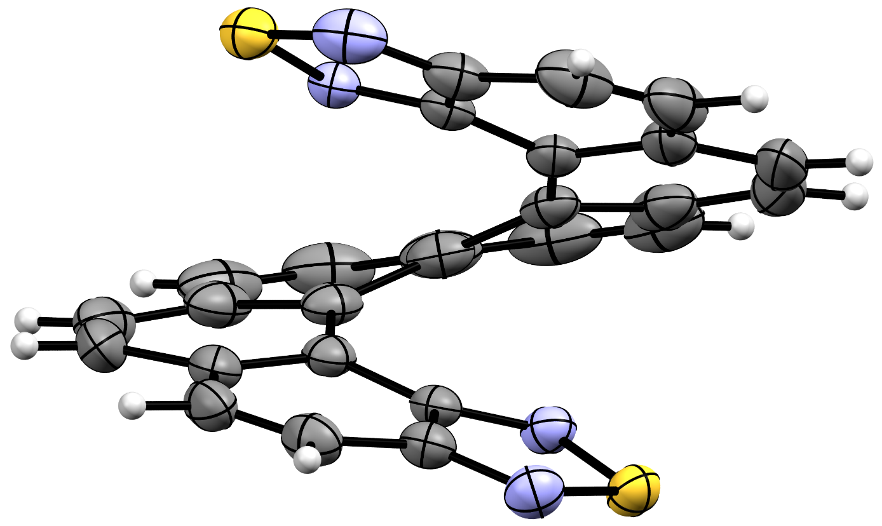
Supplementary Figure 5 | Asymmetric unit of the X-Ray structure of (rac)-bis(thiadiazole)-[8]helicene.
Supplementary Figure 6 | Homochiral M columnar stacks in the structure of (rac)-bis(thiadiazole)-[8]helicene viewed along the c axis. N-S short contacts (3.014(2) Å and 3.103(2) Å) are highlighted in green.
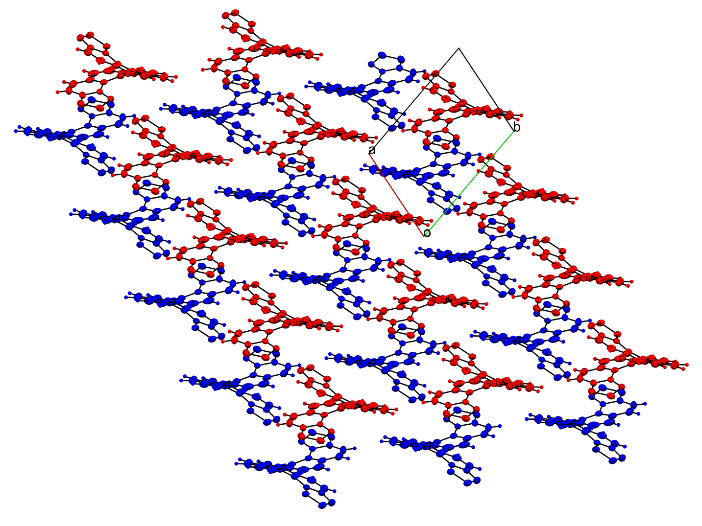
Supplementary Figure 7 | Packing of (rac)-bis(thiadiazole)-[8]helicene viewed along the c axis (blue: P enantiomer; red: M enantiomer).

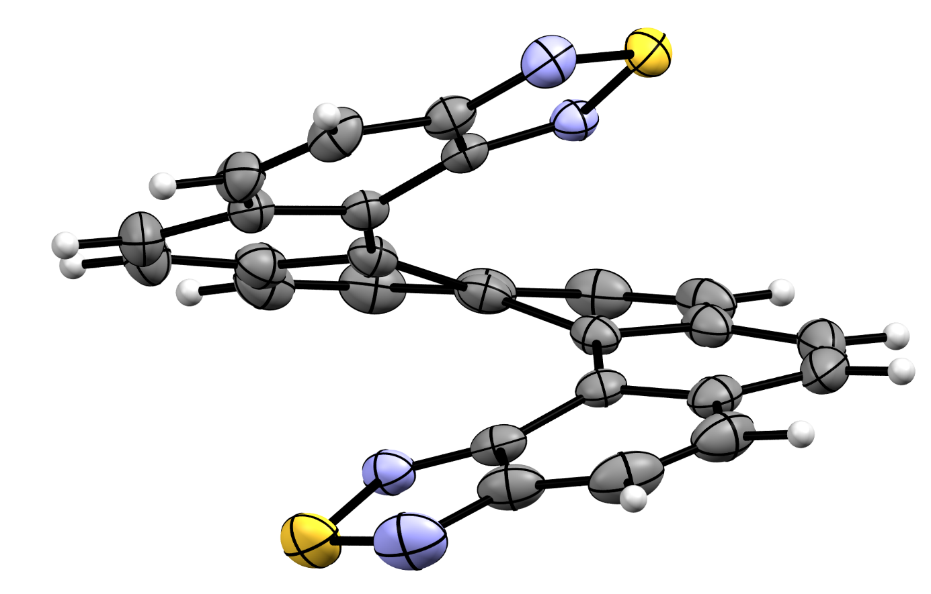
Supplementary Figure 8 | Asymmetric unit of the X-Ray structure of (P)-bis(thiadiazole)-[8]helicene.

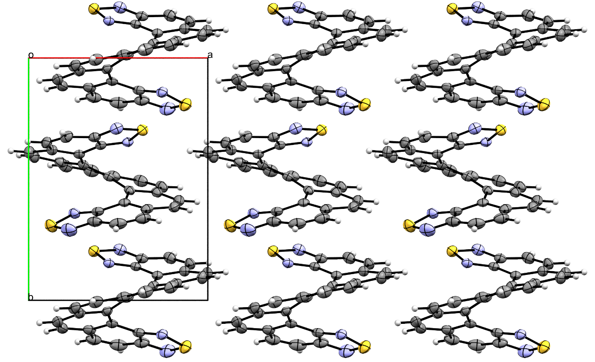
Supplementary Figure 9 | Packing of (P)-bis(thiadiazole)-[8]helicene viewed along the c axis.
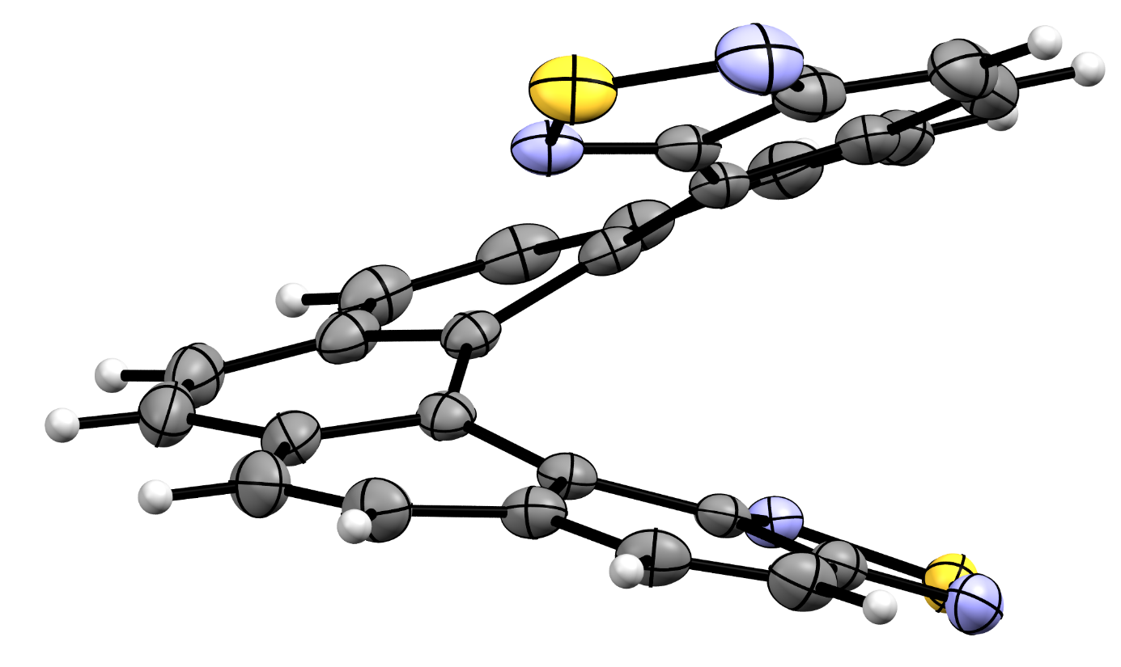
Supplementary Figure 10 | Asymmetric unit of the X-Ray structure of (M)-bis(thiadiazole)-[8]helicene.
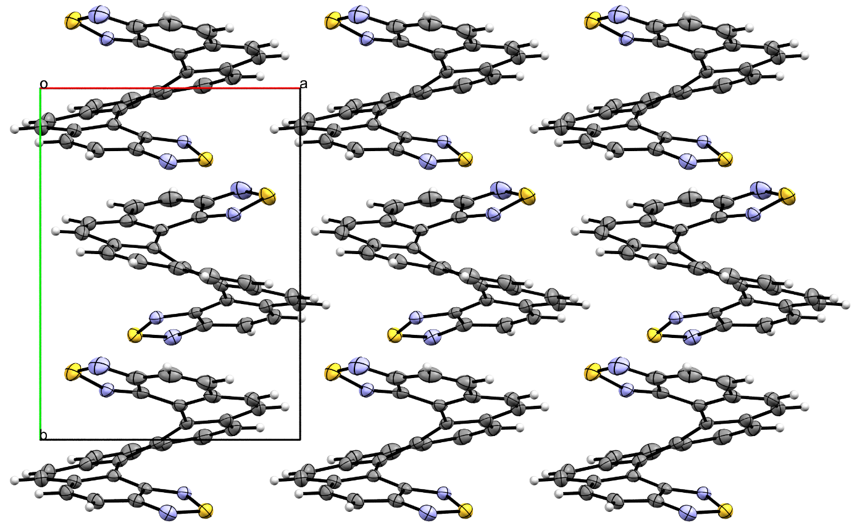
Supplementary Figure 11 | Packing of (M)-bis(thiadiazole)-[8]helicene viewed along the c axis.

Chiral resolution on HPLC
Analytical chiral HPLC separation for (rac)-(bis)thiadiazole-[8]helicene
• The sample was dissolved in a mixture of heptane, dichloromethane and 2-PrOH, injected on the chiral column, and detected with a UV detector at 230 nm and a circular dichroism detector at 254 nm. The flow-rate was 1 mL/min.
Column | Mobile Phase | t₁ | k₁ | t₂ | k₂ | α | Rs
Chiralpak IF | Heptane / 2-PrOH / dichloromethane (80/10/10) | 5.58 (+) | 0.89 | 6.72 (-) | 1.28 | 1.43 | 4.54

Chiralpak IF
Heptane / 2-PrOH / dichloromethane (80/10/10)
RT [min] | Area | Area% | Capacity Factor | Enantioselectivity | Resolution (USP)
5.58 | 4758 | 50.61 | 0.89
6.72 | 4643 | 49.39 | 1.28 | 1.43 | 4.54
Sum | 9402 | 100.00

Preparative separation for (rac)-(bis)thiadiazole-[8]helicene
• Sample preparation: About 28 mg of compound are dissolved in 4 mL of dichloromethane.
• Chromatographic conditions: Chiralpak IF (250 x 10 mm), hexane / 2-PrOH / dichloromethane (80/10/10) as mobile phase, flow-rate = 5 mL/min, UV detection at 230 nm.
• Injections (stacked): 27 times 150 μL, every 8 minutes.
• First fraction: 7 mg of the first eluted with ee > 99.5%
Chiralpak IF
Heptane / 2-PrOH / dichloromethane (80/10/10)

• Second fraction: 6.9 mg of the second eluted with ee > 99.5 %
Chiralpak IF
Heptane / 2-PrOH / dichloromethane (80/10/10)

Optical rotations
Optical rotations were measured on a Jasco P-2000 polarimeter with a halogen lamp (589 nm, 578 nm and 546 nm), in a 10 cm cell, thermostated at 25 °C with a Peltier controlled cell holder.
λ (nm) | P enantiomer, first eluted on Chiralpak IF  [α]_{λ}²⁵ (CH₂Cl₂, c =0.01) | M enantiomer, second eluted on Chiralpak IF  [α]_{λ}²⁵ (CH₂Cl₂, c =0.01)
589 | + 8100 | - 8100
578 | + 8900 | - 8900
546 | + 12600 | - 12600

Electronic Circular Dichroism
ECD and UV spectra were measured on a JASCO J-815 spectrometer equipped with a JASCO Peltier cell holder PTC-423 to maintain the temperature at 25.0 ± 0.2 °C. A CD quartz cell of 1 mm of optical pathlength was used. The CD spectrometer was purged with nitrogen before recording each spectrum, which was baseline subtracted.
The baseline was always measured for the same solvent and in the same cell as the samples. The spectra are presented without smoothing and further data processing. P enantiomer, first eluted on Chiralpak IF: green solid line, concentration = 0.210 mmol.L⁻¹ in acetonitrile. M enantiomer, second eluted on Chiralpak IF: red dotted line, concentration = 0.216 mmol.L⁻¹ in acetonitrile. Acquisition parameters: 0.1 nm as intervals, scanning speed 50 nm/min, band width 2 nm, and 3 accumulations per sample.
Supplementary Figure 12 | ECD spectra for P enantiomer (green solid line) and M enantiomer (red dotted line) in CH₃CN (0.216 mM, 298 K).

Supplementary Figure 13 | UV-visible spectra for P enantiomer (green solid line) and M enantiomer (red dotted line) in CH₃CN (0.216 mM, 298 K).

NMR spectra
¹H NMR of (rac)-(bis)thiadiazole-[8]helicene
¹³C NMR of (rac)-(bis)thiadiazole-[8]helicene

References

Mitchell, C., Fayette, M. & Dimitrov, N. Homo- and hetero-epitaxial deposition of Au by surface limited redox replacement of Pb underpotentially deposited layer in one-cell configuration. Electrochimica Acta 85, 450–458 (2012).
Jeyabharathi, C., Zander, M. & Scholz, F. Underpotential deposition of lead on quasi-spherical and faceted gold nanoparticles. Journal of Electroanalytical Chemistry 819, 159–162 (2018).
Mori, K., Murase T. & Fujita, M. One-Step Synthesis of [16]Helicene. Angew. Chem. Int. Ed. 54, 6847–6851 (2015).
Biet, T., Martin, K., Hankache, J., Hellou, N., Hauser, A., Bürgi, T., Vanthuyne, N., Aharon, T., Caricato, M., Crassous, J. & Avarvari, N. Triggering Emission with the Helical Turn in Thiadiazole-Helicenes. Chem. Eur. J. 23, 437–446 (2017).
Sheldrick, G. M. A short history of SHELX. Acta Crystallogr. Sect. A 64, 112–122 (2008).
Sheldrick, G. M. SHELXT - Integrated space-group and crystal-structure determination. Acta Crystallogr. Sect. A A71, 3–8 (2015).
Hübschle, C. B., Sheldrick, G. M. & Dittrich, B. ShelXle: a Qt graphical user interface for SHELXL. J. Appl. Crystallogr. 44, 1281–1284 (2011).
Dolomanov, O. V., Bourhis, L. J., Gildea, R. J., Howard, J. A. K. & Puschmann, H. OLEX2: a complete structure solution, refinement and analysis program. J. Appl. Crystallogr. 42, 339–341 (2009).

