Supplementary Information

Mapping Current and Future Schistosomiasis Risk in Rwanda under Climate Change
Marcellin Rwibutso^{1,2,*}, Chester Kalinda^{4,6}, Zadoki Tabo^{2,3 ,} ImmaculateTumwebaze¹, and Christian Albrecht^{1,2,5}
¹ Department of Animal Ecology and Systematics, Justus Liebig University Giessen, Germany, Heinrich-Buff-Ring 26 (iFZ), 35392 Giessen, Germany
² Center for International Development and Environmental Research (ZEU), Justus Liebig University Giessen, Senckenbergstrasse 3, 35390 Giessen, Germany
³Department of Landscape Ecology and Resource Management, Justus Liebig University Giessen, Heinrich-Buff-Ring 26 (iFZ), 35392 Giessen, Germany
⁴ School of Global Health, University of Global Health Equity (UGHE), Kigali, Rwanda
⁵ Department of Biology, Mbarara University of Science and Technology, Uganda, P.O. Box 1410, Mbarara, Uganda
⁶ Discipline of Public Health, School of Medicine, College of Health Sciences, University of KwaZulu-Natal, Durban 4041, South Africa.
*Correspondence: rwibutso87@gmail.com
E-mail addresses:
MR: rwibutso87@gmail.com

Fig. S1: Raster layers considered for model input variable selection. Each raster was visually inspected to ensure complete spatial coverage and the absence of data gaps (NoData areas) within the study area. Only continuous layers without missing values were retained to prevent bias and misleading results in the modeling process.
Fig. S2: Pearson correlation matrix (lower triangle) of the environmental predictor variables used in the modeling process. Color intensity indicates the strength and direction of pairwise correlations, ranging from strong negative (blue, −1) to strong positive (red, +1). The matrix was used to identify multicollinearity among variables and to support the selection of non-redundant predictors for model development.
Fig. S3: Projected change in habitat suitability (Δ suitability) relative to current conditions for Bulinus (S3a–S3b) and Biomphalaria (S3c–S3d) under future climate scenarios SSP1-2.6 and SSP5-8.5. Positive values (green) indicate areas with increasing suitability, while negative values (blue) indicate decreasing suitability compared to the present baseline. Maps show spatial patterns of suitability shifts across the study area under moderate (SSP1-2.6) and high-emission (SSP5-8.5) scenarios.
Fig. S4. Projected district-level changes in habitat suitability (Δ suitability) relative to present conditions (baseline) for Bulinus (upper panels) and Biomphalaria (lower panels) under moderate (SSP1–2.6) and high-emission (SSP5–8.5) climate scenarios for 2050. Positive changes (red) represent increased suitability, while negative changes (blue) indicate reduced suitability. The maps reveal species-specific and spatially heterogeneous responses to climate change across districts.

Fig. S1:

Fig. S2:

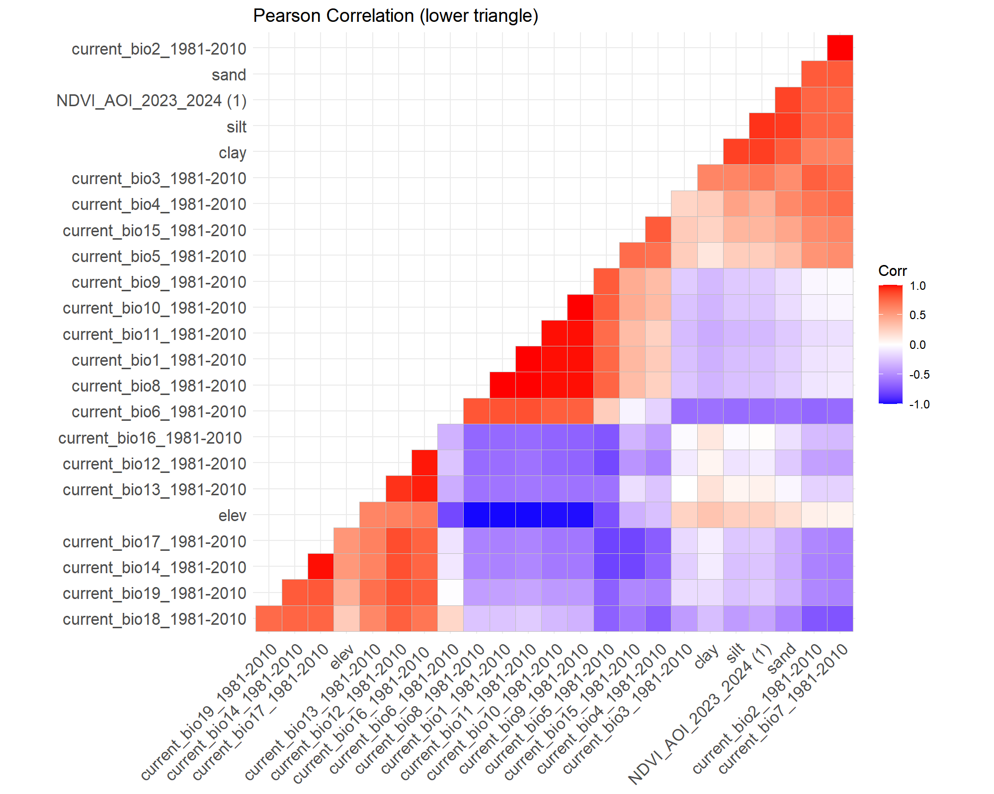

Fig. S3:

Fig. S4:

Table S1: District-level sampling locations and geographic coordinates of Biomphalaria snail occurrences
District | Location(waterbodies) | Species | Latitude | Longitude | Ref
Rutsiro | Pfunda River | Biomphalaria pfeifferi | -1.82026 | 29.35886 | [1]
Rubavu | Sebeya River | Biomphalaria pfeifferi | -1.70939 | 29.30865 | [1]
Rubavu | Nyaburaro River | Biomphalaria pfeifferi | -1.74616 | 29.34263 | [1]
Rutsiro | Kazibaziba River | Biomphalaria pfeifferi | -2.02014 | 29.39096 | [1]
Rutsiro | Ntaruko River | Biomphalaria pfeifferi | -2.03045 | 29.39901 | [1]
Karongi | Gisayo River | Biomphalaria pfeifferi | -2.072 | 29.34411 | [1]
Rusizi | Cyunyu River | Biomphalaria pfeifferi | -2.47425 | 28.92357 | [1]
Rusizi | Kannyogo River | Biomphalaria pfeifferi | -2.44683 | 28.96992 | [1]
Rusizi | Kadasomwa River | Biomphalaria pfeifferi | -2.48265 | 28.90944 | [1]
Nyamasheke | Mutongo River | Biomphalaria pfeifferi | -2.28011 | 29.1955 | [1]
Nyagatare | Rice plantation (Muvumba) | Biomphalaria sp | -1.28675 | 30.31707 | [2]
Gisenyi | Lake Kivu | Biomphalaria sp | -1.69798 | 29.24905 | [1]
Rwamagana | Rice plantation (Rugende) | Biomphalaria sp | -1.89305 | 30.28889 | [2]
Rustiro | Lake Kivu | Biomphalaria choanomphala | -1.81336 | 29.2795 | [1]
Rusizi | Lake Kivu | Biomphalaria choanomphala | -2.47922 | 28.89847 | [1]
Rusizi | Lake Kivu | Biomphalaria choanomphala | -2.48322 | 28.89428 | [1]
Nyamasheke | Lake Kivu | Biomphalaria choanomphala | -2.31239 | 29.13775 | [1]
Nyamasheke | Lake Kivu | Biomphalaria choanomphala | -2.18839 | 29.28014 | [1]
Karongi | Lake Kivu | Biomphalaria choanomphala | -2.07361 | 29.35914 | [1]
Rubavu | Lake Kivu | Biomphalaria choanomphala | -1.73939 | 29.27028 | [1]
Rubavu | Lake Kivu | Biomphalaria choanomphala | -1.74814 | 29.27814 | [1]
Nyagatare | Rice plantation (Muvumba) | Biomphalaria sp | -1.38439 | 30.28913 | [2]
Burera | Rugezi wetland | Biomphalaria sp | -1.42026 | 29.8541 | [2]
Gatsibo | Rice plantation (Kanyonyomba) | Biomphalaria sp | -1.82562 | 30.3614 | [2]
Rwamagana | Lake Mugesera | Biomphalaria sp | -2.07692 | 30.32536 | [2]
Muhanga | Rice plantation (Muhanga ) | Biomphalaria sp | -2.11456 | 29.74404 | [2]
Burera | Rugezi wetland | Biomphalaria sp | -1.4162 | 29.8458 | [2]
Musanze | Lake Ruhondo | Biomphalaria sp | -1.49939 | 29.71595 | [2]
Nyagatare | Rice plantation (Muvumba) | Biomphalaria sp | -1.40864 | 30.27797 | [2]
Burera | Lake Ruhondo | Biomphalaria sp | -1.47449 | 29.7476 | Unpublished
Burera | Rugezi wetland | Biomphalaria sp | -1.41923 | 29.83568 | Unpublished
Gasabo | Lake Muhazi | Biomphalaria sp | -1.80503 | 30.17921 | Unpublished
Nyagatare | Rice plantation (Muvumba) | Biomphalaria sp | -1.28734 | 30.31817 | Unpublished
Gatsibo | Lake Muhazi | Biomphalaria sp | -1.85029 | 30.32547 | Unpublished
Gicumbi | Lake Muhazi | Biomphalaria sp | -1.79313 | 30.14771 | Unpublished
Gicumbi | Lake Muhazi | Biomphalaria sp | -1.84219 | 30.22835 | Unpublished
Musanze | Lake Ruhondo | Biomphalaria sp | -1.51485 | 29.72231 | Unpublished
Musanze | Lake Ruhondo | Biomphalaria sp | -1.51601 | 29.71621 | Unpublished
Musanze | Lake Ruhondo | Biomphalaria sp | -1.50192 | 29.74947 | Unpublished
Musanze | Lake Ruhondo | Biomphalaria sp | -1.502 | 29.74469 | Unpublished
Musanze | Lake Ruhondo | Biomphalaria sp | -1.53555 | 29.75498 | Unpublished
Musanze | Lake Ruhondo | Biomphalaria sp | -1.49978 | 29.71656 | Unpublished
Rutsiro | Kazibaziba River | Biomphalaria sp | -2.02009 | 29.39016 | Unpublished
Huye | Rice plantation (Gahenerezo) | Biomphalaria sp | -2.58196 | 29.73768 | Unpublished
Huye | Rice plantation (Rwasave) | Biomphalaria sp | -2.61113 | 29.76546 | Unpublished
Huye | Rice plantation (Rwasave) | Biomphalaria sp | -2.57567 | 29.75987 | Unpublished
Ngoma | Lake Mugesera | Biomphalaria sp | -2.15454 | 30.32722 | Unpublished
Ngoma | Lake Mugesera | Biomphalaria sp | -2.16252 | 30.33853 | Unpublished
Ngoma | Lake Mugesera | Biomphalaria sp | -2.20059 | 30.38493 | Unpublished
Ngoma | Lake Sake | Biomphalaria sp | -2.25367 | 30.37859 | Unpublished
Kayonza | Lake Muhazi | Biomphalaria sp | -1.83737 | 30.47504 | Unpublished
Rusizi | Rice plantation (Butambamo) | Biomphalaria sp | -2.64273 | 28.9497 | [3]
Rusizi | Lake Kivu | Biomphalaria sp | -2.40989 | 28.9015 | [3]
Rusizi | Lake Kivu | Biomphalaria sp | -2.40631 | 28.9056 | [3]
Nyamasheke | Rice plantation (Rwamatamu) | Biomphalaria sp | -2.21453 | 29.219 | [3]
Nyamasheke | Rice plantation(Kagano) | Biomphalaria sp | -2.34211 | 29.1185 | [3]
Nyamasheke | Lake Kivu | Biomphalaria sp | -2.27604 | 29.192 | [3]
Nyamasheke | Rice plantation (Gatare) | Biomphalaria sp | -2.27744 | 29.2 | [3]
Nyagatare | Rice plantation (Muvumba) | Biomphalaria sp | -1.43325 | 30.2601 | [3]
Nyagatare | Rice plantation (Muvumba) | Biomphalaria sp | -1.33299 | 30.2965 | [3]
Nyagatare | Rice plantation (Muvumba) | Biomphalaria sp | -1.34818 | 30.2932 | [3]
Nyagatare | Rice plantation (Muvumba) | Biomphalaria sp | -1.39505 | 30.2176 | [3]
Nyagatare | Rice plantation (Muvumba) | Biomphalaria sp | -1.40318 | 30.2764 | [3]
Nyagatare | Rice plantation (Muvumba) | Biomphalaria sp | -1.43610 | 30.3078 | [3]
Nyagatare | Rice plantation (Muvumba) | Biomphalaria sp | -1.43924 | 30.3081 | [3]
Gatsibo | Rice plantation (Muvumba) | Biomphalaria sp | -1.82559 | 30.3614 | [3]
Gatsibo | Rice plantation (Muvumba) | Biomphalaria sp | -1.80749 | 30.3725 | [3]
Gatsibo | Rice plantation (Muvumba) | Biomphalaria sp | -1.80670 | 30.3754 | [3]
Gatsibo | Rice plantation (Muvumba) | Biomphalaria sp | -1.81040 | 30.3753 | [3]
Kayonza | Rwabigabiro wetland | Biomphalaria sp | -1.83349 | 30.4924 | [3]
Kayonza | Rwabigabiro wetland | Biomphalaria sp | -1.83511 | 30.485 | [3]
Ngoma | Lake Sake | Biomphalaria sp | -2.25910 | 30.4017 | [3]
Rwamagana | Lake Muhazi | Biomphalaria sp | -1.85929 | 30.4303 | [3]
Rwamagana | Lake Muhazi | Biomphalaria sp | -1.87856 | 30.4339 | [3]
Bugesera | Lake Cyohoha | Biomphalaria sp | -2.35130 | 30.0427 | [3]
Bugesera | Lake Cyohoha | Biomphalaria sp | -2.34895 | 30.0434 | [3]
Nyanza | Rice plantation (Ntyazo) | Biomphalaria sp | -2.42214 | 29.8693 | [3]
Nyanza | Rice plantation (Nyanza) | Biomphalaria sp | -2.39889 | 29.7203 | [3]
Gasabo | Rice plantation (Kigali) | Biomphalaria sp | -1.90404 | 30.1054 | [3]
Gicumbi | Lake Muhazi | Biomphalaria sp | -1.79618 | 30.1738 | [3]
Gicumbi | Giti wetland | Biomphalaria sp | -1.77732 | 30.1376 | [3]

Table S2: Spatial distribution and specimen details of Bulinus species
District | Location | Species | Latitude | Longitude | Prep No | Ref
Rwamagana | Lake Muhazi | Bulinus truncatus | -1.85912 | 30.49039 | 22513 | [4]
Rwamagana | Lake Muhazi | Bulinus truncatus | -1.84843 | 30.47826 | 22549 | [4]
Karongi | Kavungu River | Bulinus forskalii | -2.06699 | 29.41105 | 28720 | [1]
Rubavu | Lake Kivu | Bulinus truncatus | -1.69798 | 29.24905 |  | unpublished
Rwamagana | Rice plantation (Rugende) | Bulinus trancatus | -1.89305 | 30.28889 |  | [2]
Rutsiro | Lake Kivu | Bulinus truncatus | -1.813 | 29.27903 |  | unpublished
Rutsiro | Lake Kivu | Bulinus truncatus | -1.81336 | 29.2795 |  | [1]
Rusizi | Lake Kivu | Bulinus truncatus | -2.47922 | 28.89847 | 28932 | [1]
Nyamasheke | Lake Kivu | Bulinus truncatus | -2.31239 | 29.13775 | 28937 | [1]
Nyamasheke | Lake Kivu | Bulinus truncatus | -2.18839 | 29.28014 |  | [1]
Karongi | Lake Kivu | Bulinus truncatus | -2.07361 | 29.35914 | 28944 | [1]
Rusizi | Lake Kivu | Bulinus truncatus | -2.48436 | 28.89408 |  | [1]
Rubavu | Lake Kivu | Bulinus truncatus | -1.73939 | 29.27028 | 28946 | [1]
Rubavu | Lake Kivu | Bulinus truncatus | -1.73847 | 29.27542 | 28904 | [1]
Nyagatare | Akagera River | Bulinus forskalii | -1.06659 | 30.45412 | 29123 | Unpublished
Nyagatare | Rice plantation (Muvumba) | Bulinus tropicus | -1.3244 | 30.29866 | 29245 | Unpublished
Muhanga | Muhanga Dam | Bulinus truncatus | -2.10692 | 29.75244 | 29249 | Unpublished
Muhanga | Rice plantation (Muhanga) | Bulinus tropicus | -2.11456 | 29.74404 | 29253 | Unpublished
Musanze | Lake Ruhondo | Bulinus truncatus | -1.49939 | 29.71595 |  | Unpublished
Gasabo | Lake Muhazi | Bulinus truncatus | -1.80503 | 30.17921 | 29257 | Unpublished
Musanze | Lake Ruhondo | Bulinus truncatus | -1.51485 | 29.72231 | 29982 | Unpublished
Musanze | Lake Ruhondo | Bulinus truncatus | -1.53555 | 29.75498 |  | Unpublished
Burera | Lake Ruhondo | Bulinus tropicus | -1.48021 | 29.73865 | 29145 | Unpublished
Nyabihu | Karago wetland | Bulinus truncatus | -1.7 | 29.5 |  | Unpublished
Musanze | Lake Ruhondo | Bulinus truncatus | -1.502 | 29.74469 | 29986 | Unpublished
Huye | Rice plantation (Gahenerezo) | Bulinus truncatus | -2.58196 | 29.73768 |  | Unpublished
Huye | Rice plantation (Rwasave) | Bulinus truncatus | -2.61113 | 29.76546 | 30021 | Unpublished
Ngoma | Lake Mugesera | Bulinus ugandae | -2.20059 | 30.38493 | 30022 | Unpublished
Nyagatare | Kazaza Dam | Bulinus truncatus | -1.20139 | 30.3315 | 30016 | Unpublished
Nyagatare | Cyenjojo Dam | Bulinus forskalii | -1.25672 | 30.32676 | 30025 | Unpublished
Musanze | Lake Ruhondo | Bulinus truncatus | -1.50192 | 29.74947 | 29983 | Unpublished
Burera | Lake Burera | Bulinus tropicus | -1.38611 | 29.79686 | 29150 | Unpublished

References
1. Dusabe MC, Kalinda C, Clewing C, Hyangya BL, Van Bocxlaer B, Albrecht C. Environmental perturbations and anthropogenic disturbances determine mollusc biodiversity of Africa’s explosive Lake Kivu. J Great Lakes Res. 2024;50: 102339. doi:10.1016/j.jglr.2024.102339
2. Rwibutso M, Clewing C, Habimana R, Kalinda C, Dusabe MC, Albrecht C. Molecular identification of Radix natalensis as the prevailing fasciolosis vector in Rwanda. Malacologia. 2025;68: 63–80.
3. Kagabo J, Tabo Z, Kalinda C, Nyandwi E, Rujeni N. Schistosomiasis transmission: A machine learning analysis reveals the importance of agrochemicals on snail abundance in Rwanda. PLoS Negl Trop Dis. 2024;18: e0012730. doi:10.1371/journal.pntd.0012730
4. Tumwebaze I, Clewing C, Dusabe MC, Tumusiime J, Kagoro-Rugunda G, Hammoud C, et al. Molecular identification of Bulinus spp. intermediate host snails of Schistosoma spp. In crater lakes of western Uganda with implications for the transmission of the Schistosoma haematobium group parasites. Parasites and Vectors. 2019;12: 1–23. doi:10.1186/s13071-019-3811-2

