Supplementary Information
Table S1: List of the tuned parameters employed with the Grid Search and Randomised Search hyperparameter tuning for decision tree, random forest, KNN, and linear regression models
Model | Tuning methods | Tunned parameters
Decision Tree | Grid Search | 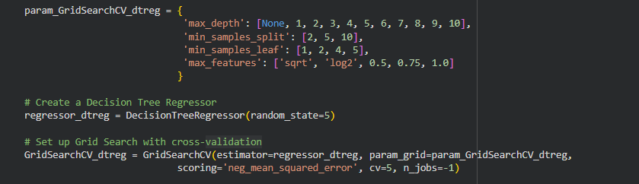
Decision Tree | Randomised Search | 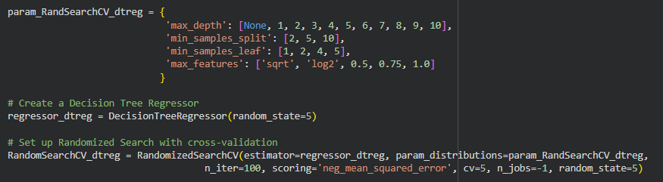
Random Forest | Grid Search | 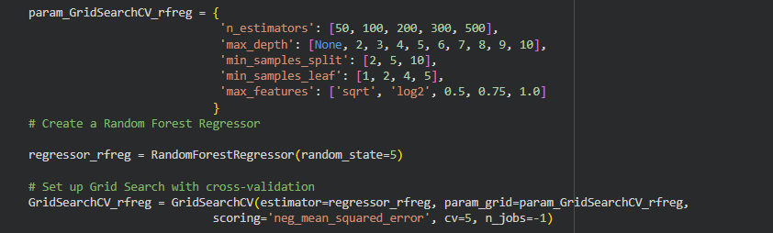
Random Forest | Randomised Search | 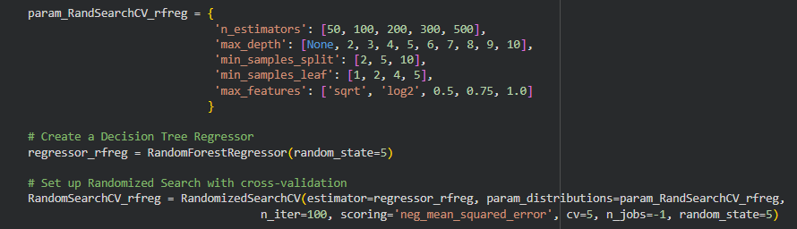
KNN | Grid Search | 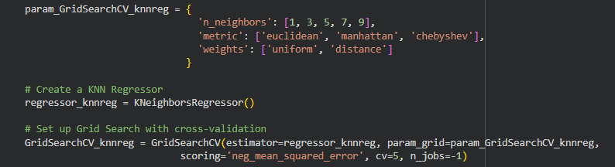
KNN | Randomised Search | 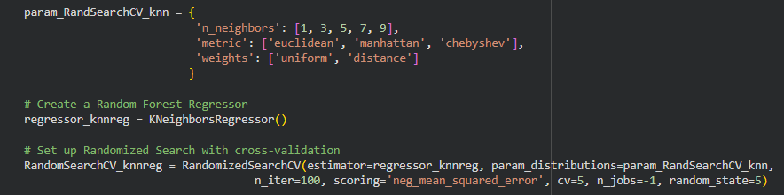
Linear | Grid Search | 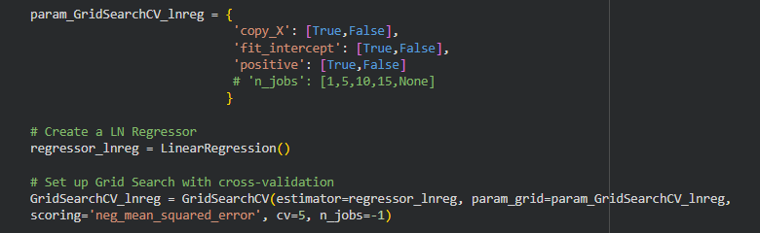
Linear | Randomised Search | 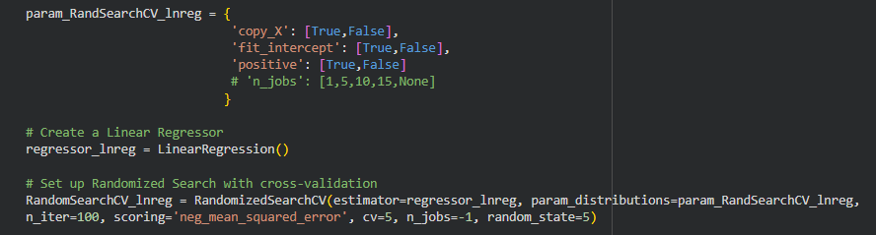

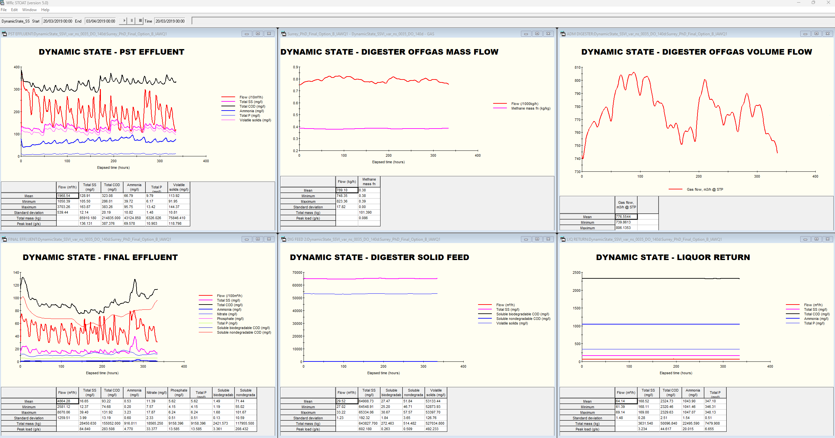
Figure S1: The result of dynamic state simulation from the STOAT modelling environment showing predictions for PST effluent, final effluent, digester performance, and liquor return quality.

