Supplementary Information

Fragment screenings afford inhibitors of SARS-CoV-2 non-structural protein 10

Authors
Hugo Scherer^{1,2,3}, Pietro Vincenzi¹, Natalie M. Köhler⁴, Margarida Saramago⁵, Dominik Kolling^{1,2,3,6}, Alexander Voltz^{1,2,3}, Ravindra P. Jumde¹, Antonia P. Gunesch⁴, Marta V. Cunha⁵, Sebastian Adam¹, Nicolas Frank^{1,2,3}, Christina Grethe⁴, Gwenaëlle Jézéquel¹, Rute G. Matos⁵, Kai Schließmann^{1,2,3}, Rolf Müller^{1,2,3}, Jesko Koehnke⁶, Cecília M. Arraiano⁵, Thomas Pietschmann^{4,7,8,9} and Anna K. H. Hirsch^{1,2,3,}*

Affiliations
¹Helmholtz-Institut für Pharmazeutische Forschung Saarland (HIPS) – Helmholtz-Zentrum für Infektionsforschung (HZI), 66123 Saarbrücken, Germany
²Universität des Saarlandes, Naturwissenschaftlich-Technische Fakultät, Fachrichtung Pharmazie, 66123 Saarbrücken, Germany
³PharmaScienceHub (PSH), Universität des Saarlandes, 66123 Saarbrücken, Germany
⁴TWINCORE, Zentrum für Experimentelle und Klinische Infektionsforschung, Experimentelle Virologie, 30625 Hannover, Germany
⁵ITQB NOVA, Instituto de Tecnologia Química e Biológica António Xavier, Universidade Nova de Lisboa, 2780-157 Oeiras, Portugal
⁶Leibniz Universität Hannover, Institut für Lebensmittelchemie (LCI), 30167 Hannover, Germany
⁷Deutsches Zentrum für Infektionsforschung (DZIF), Hannover–Braunschweig Partner Site, 30625 Hannover, Germany
⁸Deutsches Zentrum für Lungenforschung (DZL), BREATH Faculty, 30625 Hannover, Germany
⁹Exzellenzcluster RESIST (EXC 2155), Medizinische Hochschule Hannover (MHH), 30625 Hannover, Germany
*Corresponding author, email address: anna.hirsch@helmholtz-hips.de

Present addresses
Ravindra P. Jumde: Global Antibiotic Research & Development Partnership (GARDP), 1202 Geneva, Switzerland
Gwenaëlle Jézéquel: Laboratoire de Chimie de Coordination (UPR CNRS 8241), Centre National de la Recherche Scientifique (CNRS), Université Toulouse III–Paul Sabatier (UPS), 31077 Toulouse, France

Table of contents
Supplementary Methods 4
Recombinant expression and purification of severe acute respiratory syndrome coronavirus 2 (SARS-CoV-2) non-structural protein 10 (Nsp10) 4
Amino acid sequence of recombinantly expressed Nsp10 4
Amino acid sequence after tobacco etch virus (TEV) cleavage and His-tag removal 4
Surface plasmon resonance (SPR) 4
Chemistry 4
1. General Procedures 5
1.1. General Procedure A: amide synthesis 5
1.2. General Procedure B: Suzuki–Miyaura cross-coupling 5
1.3. General Procedure C: Suzuki–Miyaura cross-coupling 6
1.4. General Procedure D: amide synthesis 6
1.5. General Procedure E: amide synthesis 6
1.6. General Procedure F: carbamate synthesis 7
1.7. General Procedure G: amide synthesis 7
1.8. General Procedure H: reductive amination 7
2. Compound characterisation 7
Supplementary Figures 81
Supplementary Fig. 1: Preliminary dual-luciferase assay measuring residual infectivity and cell viability in human coronavirus 229E (HCoV-229E)-infected cells. 81
Supplementary Fig. 2: Near-native mass spectrometry (MS) reveals binding of fragment 4 to severe acute respiratory syndrome coronavirus 2 (SARS-CoV-2) non-structural protein 10 (Nsp10). 81
Supplementary Fig. 3: Docking poses of fragments 4 and 9 suggest distinct interaction sites on severe acute respiratory syndrome coronavirus 2 (SARS-CoV-2) non-structural protein 10 (Nsp10). 82
Supplementary Fig. 4: Docking results of the virtual libraries generated with severe acute respiratory syndrome coronavirus 2 (SARS-CoV-2) non-structural protein 10 (Nsp10). 82
Supplementary Fig. 5: Initial screening for evaluation of the inhibition of severe acute respiratory syndrome coronavirus 2 (SARS-CoV-2) non-structural protein 14 (Nsp14) exoribonuclease (ExoN) activity. 83
Supplementary Fig. 6: Screening of compounds for antiviral activity against human coronavirus 229E (HCoV-229E) and cytotoxicity. 83
Supplementary Fig. 7: Near-native mass spectrometry (MS) reveals binding of compound 37 to severe acute respiratory syndrome coronavirus 2 (SARS-CoV-2) non-structural protein 10 (Nsp10). 84
Supplementary Fig. 8: Screening of compounds for antiviral activity against severe acute respiratory syndrome coronavirus 2 (SARS-CoV-2). 85
Supplementary Notes 86
List of Abbreviations 86

Supplementary Methods

Recombinant expression and purification of severe acute respiratory syndrome coronavirus 2 (SARS-CoV-2) non-structural protein 10 (Nsp10)

Amino acid sequence of recombinantly expressed Nsp10
MGSSHHHHHHSSGENLYFQGAGNATEVPANSTVLSFCAFAVDAAKAYKDYLASGGQPITNCVKMLCTHTGTGQAITVTPEANMDQESFGGASCCLYCRCHIDHPNPKGFCDLKGKYVQIPTTCANDPVGFTLKNTVCTVCGMWKGYGCSCDQLREPMLQ*.

Amino acid sequence after tobacco etch virus (TEV) cleavage and His-tag removal
GAGNATEVPANSTVLSFCAFAVDAAKAYKDYLASGGQPITNCVKMLCTHTGTGQAITVTPEANMDQESFGGASCCLYCRCHIDHPNPKGFCDLKGKYVQIPTTCANDPVGFTLKNTVCTVCGMWKGYGCSCDQLREPMLQ*.

Surface plasmon resonance (SPR)
SPR screenings were conducted using 96-well plates including test compounds (C), blank buffer injections (B), and ethylene glycol reference injections (EG). The plate layout was used as described in the table below.
 | 1 | 2 | 3 | 4 | 5 | 6 | 7 | 8 | 9 | 10 | 11 | 12
A | B | C | B | C | B | C | B | C | B | C | B | B
B | B | C | B | C | B | C | B | C | B | C | B | B
C | B | C | B | C | B | C | B | C | B | C | B | B
D | B | C | B | C | B | C | B | C | B | C | B | B
E | B | C | B | C | B | C | B | C | B | C | B | B
F | B | C | B | C | B | C | B | C | B | C | B | B
G | B | C | B | C | B | C | B | C | B | C | B | B
H | B | C | B | C | B | C | B | C | EG | B | B | B

Chemistry
All reagents and solvents were obtained from commercial suppliers and used without further purification unless otherwise stated.
NMR data were collected on a Bruker Avance Neo 500 MHz (¹H at 500 MHz; ¹³C at 126 MHz; ¹⁹F at 470 MHz), equipped with a CryoProbe Prodigy in CDCl₃ or DMSO-d₆ unless otherwise specified. Chemical shifts are given in parts per million (ppm) and referenced against the residual proton or carbon resonances of the > 99% deuterated solvents as internal standard. Coupling constants (J) are given in Hertz (Hz). Data are reported as follows: chemical shift, multiplicity (s = singlet, d = doublet, t = triplet, q = quartet, quint = quintet, sext = sextet, sept = septet, m = multiplet, dd = doublet of doublets, dt = doublet of triplets, ddd = doublet of doublets of doublets, td = triplet of doublets, br = broad and combinations of these), coupling constants and integration. NMR spectra were evaluated using ACD/Labs 2021.2.0 (Advanced Chemistry Development, Toronto, ON, Canada) or TopSpin 5.0.0 (Bruker, Billerica, MA, USA).
Liquid chromatography–mass spectrometry (LC–MS) was performed on an LC–MS system consisting of a Dionex UltiMate 3000 pump, autosampler, column compartment, detector (Thermo Fisher Scientific, Dreieich, Germany) and ESI quadrupole MS (MSQ Plus or ISQ EC, Thermo Fisher Scientific, Dreieich, Germany). The purity of the final compounds was determined by LC–MS using a gradient with A: H₂O + 0.1% formic acid (FA) to B: MeCN + 0.1% FA at a flow rate of 600 μL/min and 45 °C. The column was equilibrated with 5% B for 1.0 min and the gradient was initiated starting at 5% B to 100% B in 4.2 min, followed by a 0.8 min isocratic step at 100% B, to end up with a decrease until 50% B in 0.1 min, before re-equilibration under the initial conditions. The purity of the final compounds was determined by using the area percentage method on the ultraviolet (UV) trace recorded at a wavelength of 254 nm. LC–MS spectra were evaluated using Chromeleon 7.2 (Thermo Fisher Scientific, Dreieich, Germany).
High-resolution mass spectrometry (HRMS) of final products was determined by LC–MS/MS using a Thermo Scientific Q Exactive Focus Orbitrap LC–MS/MS system (Waltham, MA, USA). HRMS spectra were evaluated using XCalibur 3.0.63 (Thermo Fisher Scientific, Dreieich, Germany).

General Procedures

General Procedure A: amide synthesis
To a solution of carboxylic acid (1.1 eq) in DMF (0.2 M) were added DIPEA (3.0 eq), EDC·HCl (2.0 eq), HOBt (2.0 eq), followed by the amine (1.0 eq). The reaction mixture was stirred at room temperature overnight. Upon completion, the reaction mixture was diluted with water (10 mL), extracted with dichloromethane (3 × 10 mL), dried over MgSO₄, and concentrated under reduced pressure. The crude product was purified by normal-phase flash chromatography on silica gel using a gradient of cyclohexane/ethyl acetate or dichloromethane/methanol to afford the desired amide.

General Procedure B: Suzuki–Miyaura cross-coupling
To a microwave vial were added the aryl halide (1.0 eq), boronic acid (1.2 eq), K₂CO₃ (3.0 eq), and Pd(PPh₃)₄ (5 %mol). The vial was sealed, evacuated and backfilled with Ar (three times), then a degassed mixture of 1,4-dioxane/H₂O (3:1, 0.1 M) was added. The resulting mixture was further degassed by sparging with Ar for 30 min, after which the vial was resealed and heated at 120 °C for 30 min under microwave irradiation. The reaction mixture was cooled to room temperature, filtered through a pad of Celite, and washed with dichloromethane (10 mL). The combined filtrate was diluted with water (10 mL), extracted with dichloromethane (3 × 10 mL), dried over MgSO₄, and concentrated under reduced pressure. The crude product was purified by normal-phase flash chromatography on silica gel using a gradient of dichloromethane/methanol + 5% triethylamine to afford the desired product.

General Procedure C: Suzuki–Miyaura cross-coupling
To a microwave vial were added the aryl halide (1.0 eq), boronic acid (2.5 eq), K₂CO₃ (4.0 eq), and Pd(dppf)Cl₂ (5 %mol). The vial was sealed, evacuated and backfilled with N₂ (three times), then a degassed mixture of 1,4-dioxane/H₂O (6:1, 0.5 M) was added. The resulting mixture was further degassed by sparging with N₂ for 30 min, after which the vial was resealed and heated at 80–100 °C for 30–120 min under microwave irradiation. The reaction mixture was cooled to room temperature, filtered through a pad of Celite, and washed with dichloromethane (20 mL). The combined filtrate was diluted with water (20 mL), extracted with dichloromethane (3 × 20 mL), dried over MgSO₄, and concentrated under reduced pressure. The crude product was purified by reversed-phase flash chromatography on C18 silica gel using a gradient of water/acetonitrile + 1% formic acid to afford the desired product as a salt.

General Procedure D: amide synthesis
To a solution of carboxylic acid (1.2 eq) in DMF (0.2 M) were added triethylamine (3.0 eq), EDC·HCl (2.0 eq), HOBt hydrate (2.0 eq), followed by the amine (1.0 eq). The reaction mixture was stirred at room temperature overnight. Upon completion, the reaction mixture was diluted with ethyl acetate (10 mL), washed with a cold mixture of water/brine (1:1, 3 × 10 mL) and brine (10 mL), dried over MgSO₄, and concentrated under reduced pressure. The crude product was purified by reversed-phase preparative HPLC using a gradient of water/acetonitrile + 0.05% formic acid to afford the desired amide.

General Procedure E: amide synthesis
To a solution of carboxylic acid (1.2 eq) in DCM (0.2 M) were added triethylamine (4.0 eq) and the amine (1.0 eq). The reaction mixture was stirred under N₂ in an ice bath for 15 min, then propylphosphonic anhydride (50% in EtOAc, 2.0 eq) was added dropwise to the reaction mixture. Upon completion, the reaction mixture was diluted with ethyl acetate (10 mL), washed with saturated NaHCO₃ (2 × 10 mL) and water (10 mL). The combined aqueous phases were back-extracted with ethyl acetate (2 × 15 mL). All organic phases were combined, dried over MgSO₄, and concentrated under reduced pressure. The crude product was purified by normal-phase flash chromatography on silica gel using a gradient of cyclohexane/ethyl acetate or dichloromethane/methanol to afford the desired amide.

General Procedure F: carbamate synthesis
To a solution of chloroformate (1.5 eq) in DCM (0.2 M) were added triethylamine (3.0 eq) and the amine (1.0 eq). The reaction mixture was stirred at room temperature overnight. Upon completion, the reaction mixture was diluted with DCM (10 mL), washed with 1 M HCl (10 mL) and water (10 mL). The combined aqueous phases were back-extracted with dichloromethane (10 mL). All organic phases were combined, dried over MgSO₄, and concentrated under reduced pressure. The crude product was purified by normal-phase flash chromatography on silica gel using a gradient of cyclohexane/ethyl acetate to afford the desired carbamate.

General Procedure G: amide synthesis
To a solution of acyl chloride (1.5 eq) in DCM (0.2 M) were added triethylamine (3.0 eq) and the amine (1.0 eq). The reaction mixture was stirred at room temperature overnight. Upon completion, the reaction mixture was diluted with DCM (10 mL), washed with 1 M HCl (10 mL) and water (10 mL). The combined aqueous phases were back-extracted with dichloromethane (10 mL). All organic phases were combined, dried over MgSO₄, and concentrated under reduced pressure. The crude product was purified by normal-phase flash chromatography on silica gel using a gradient of dichloromethane/methanol to afford the desired amide.

General Procedure H: reductive amination
To a solution of amine (1.0 eq) in DCM (0.2 M) was added the aldehyde (1.5 eq). The reaction mixture was stirred at room temperature for 15 min, then sodium triacetoxyborohydride (1.8 eq) was added. Upon completion, the reaction mixture was diluted with NaHCO₃ (10 mL) and extracted with dichloromethane (3 × 10 mL). The combined organic phases were washed with a cold mixture of water/brine (1:1, 2 × 15 mL), dried over MgSO₄, and concentrated under reduced pressure. The crude product was purified by normal-phase flash chromatography on silica gel using a gradient of cyclohexane/ethyl acetate or dichloromethane/methanol to afford the desired product.

Compound characterisation

(4-((4-Bromothiophen-2-yl)methyl)piperazin-1-yl)(1H-indol-5-yl)methanone (14)
Compound 14 was synthesized according to the General Procedure A using 1H-indole-5-carboxylic acid and 1-((4-bromothiophen-2-yl)methyl)piperazine dihydrochloride (213.44 µmol) as starting materials and purified using cyclohexane/ethyl acetate (13 to 100% ethyl acetate) to yield a white solid (66.1 mg, 66%).
LC–MS (ESI): t_{R} = 2.41 min; > 99% purity (UV at 254 nm);
¹H NMR (500 MHz, CDCl₃): δ 8.35 (br s, 1H), 7.73 (s, 1H), 7.40 (d, J = 8.4 Hz, 1H), 7.28–7.27 (m, 1H), 7.26–7.26 (m, 1H), 7.15 (s, 1H), 6.85 (s, 1H), 6.60–6.59 (m, 1H), 4.00–3.42 (m, 6H), 2.62–2.44 (m, 4H);
¹³C NMR (126 MHz, CDCl₃): δ 171.7, 143.0, 136.3, 128.4, 127.3, 127.2, 125.3, 122.5, 121.5, 120.3, 110.9, 108.9, 103.3, 56.8, 52.9 (4C);
HRMS (ESI⁺) m/z: [M+H]⁺ calculated for C₁₈H₁₈BrN₃OS, 404.0427; found, 404.0425.

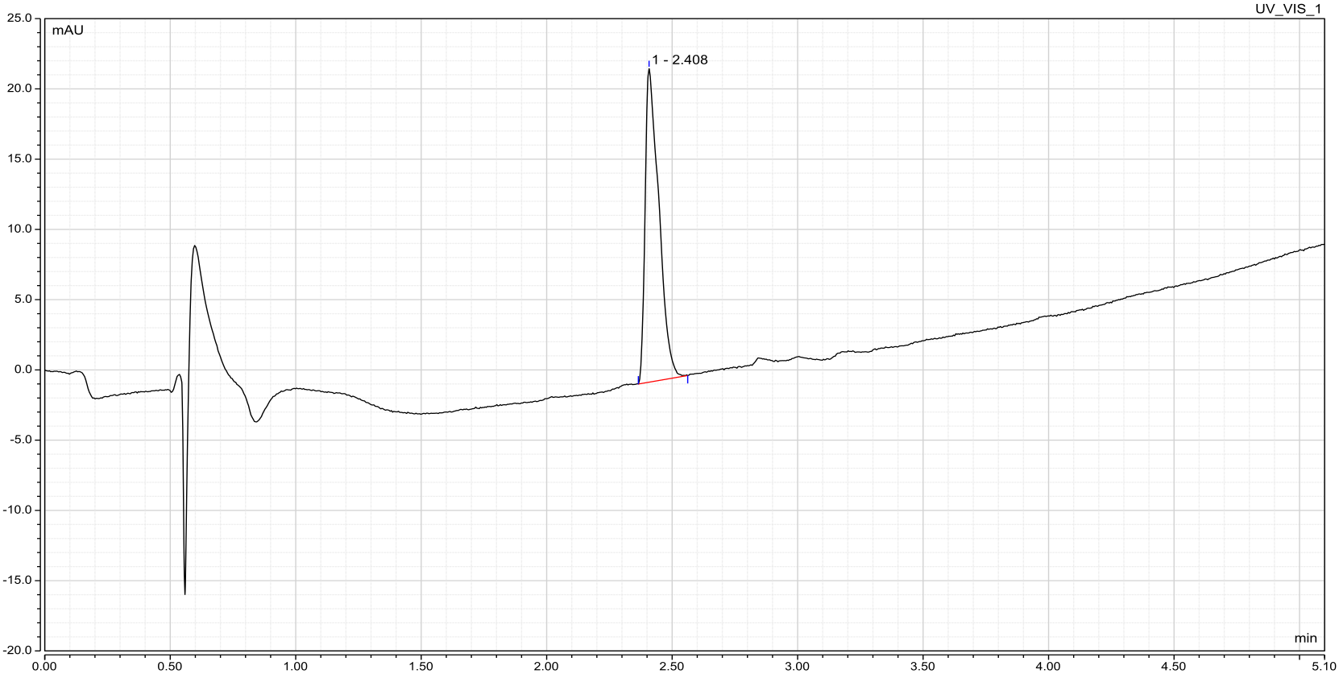

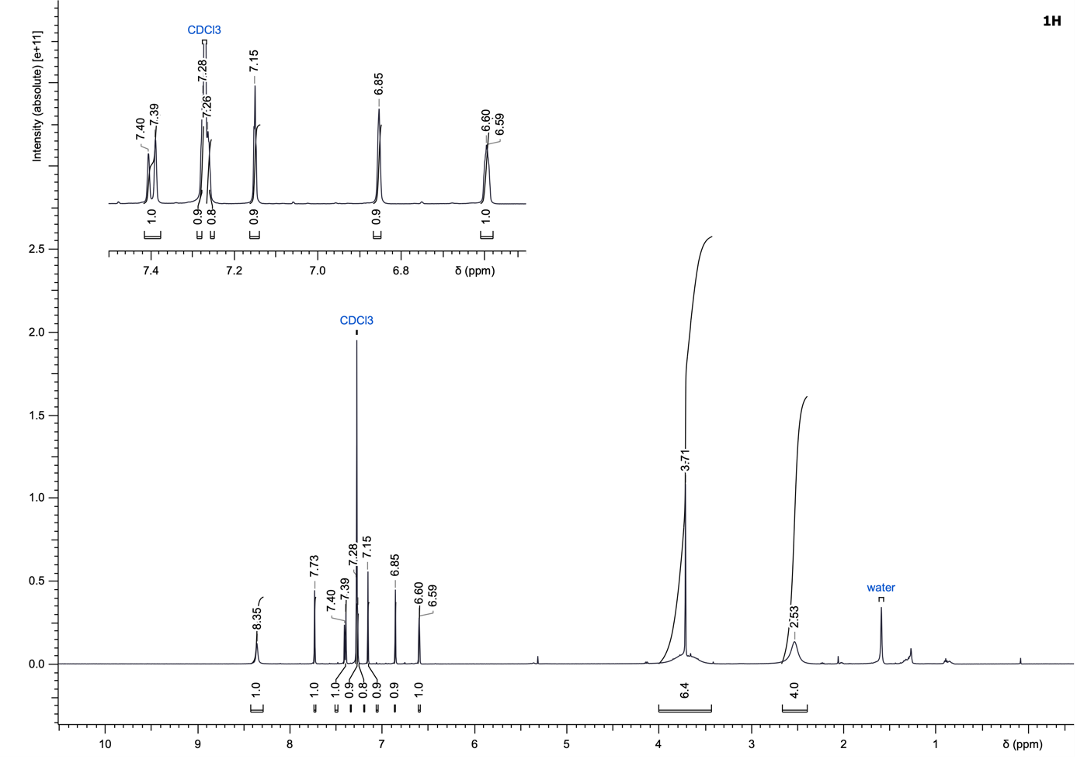
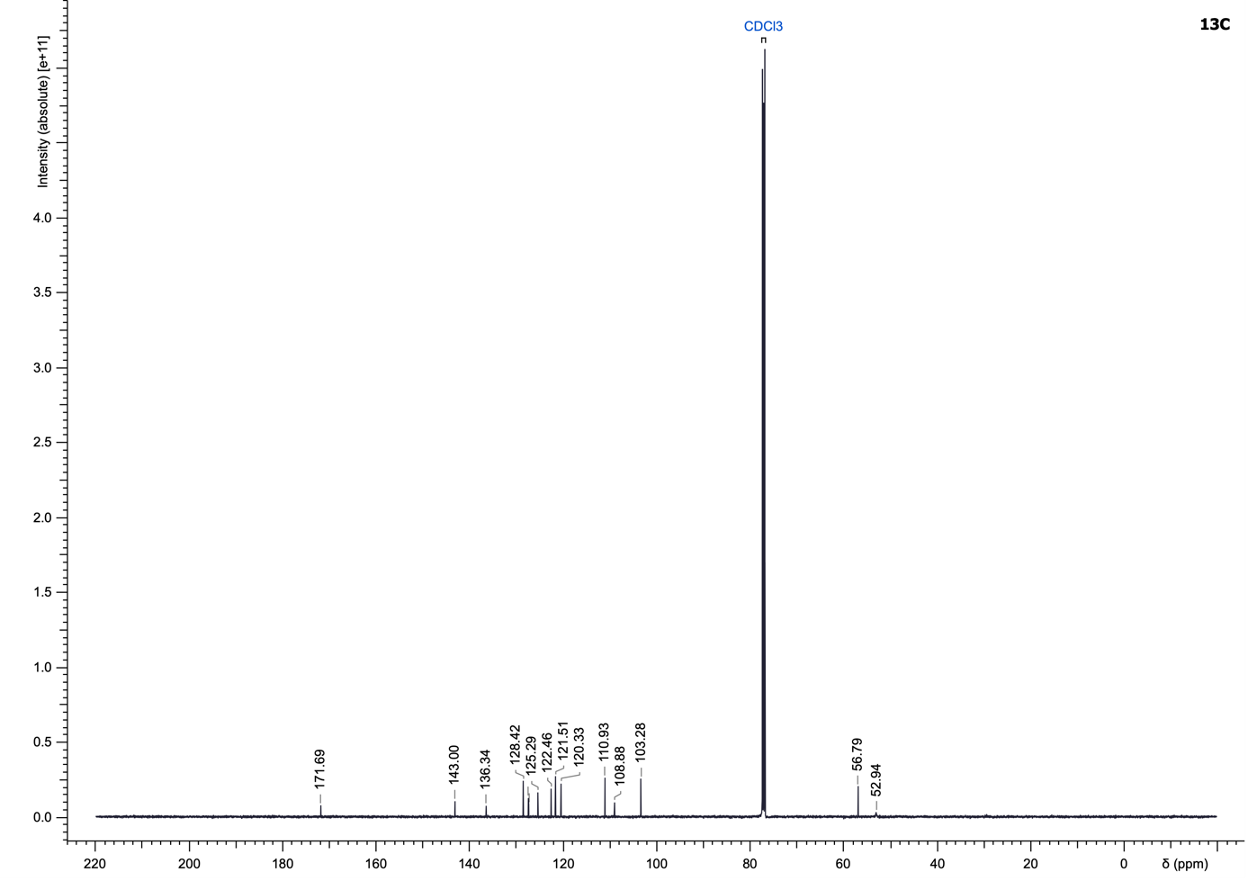

(4-((4-Bromothiophen-2-yl)methyl)piperazin-1-yl)(5-fluoro-1H-indol-2-yl)methanone (15)
Compound 15 was synthesized according to the General Procedure A using 5-fluoro-1H-indole-2-carboxylic acid and 1-((4-bromothiophen-2-yl)methyl)piperazine dihydrochloride (192.01 µmol) as starting materials and purified using cyclohexane/ethyl acetate (13 to 100% ethyl acetate) to yield a yellow solid (34.1 mg, 36%).
LC–MS (ESI): t_{R} = 2.82 min; 98% purity (UV at 254 nm);
¹H NMR (500 MHz, CDCl₃): δ 9.31 (br s, 1H), 7.36 (dd, J = 9.0, 4.3 Hz, 1H), 7.29–7.26 (m, 1H), 7.18 (s, 1H), 7.05 (td, J = 9.1, 2.3 Hz, 1H), 6.88 (s, 1H), 6.72 (s, 1H), 3.96 (br s, 4H), 3.74 (s, 2H), 2.60 (t, J = 4.9 Hz, 4H);
¹³C NMR (126 MHz, CDCl₃): δ 161.9, 158.3 (d), 142.7, 132.2, 130.8, 128.6, 127.6 (d), 122.6, 113.4, 112.6, 109.0, 106.1, 105.1, 56.7, 52.7 (4C);
¹⁹F NMR (470 MHz, DMSO-d₆): δ -123.9;
HRMS (ESI⁺) m/z: [M+H]⁺ calculated for C₁₈H₁₇BrFN₃OS, 422.0333; found, 422.0330.

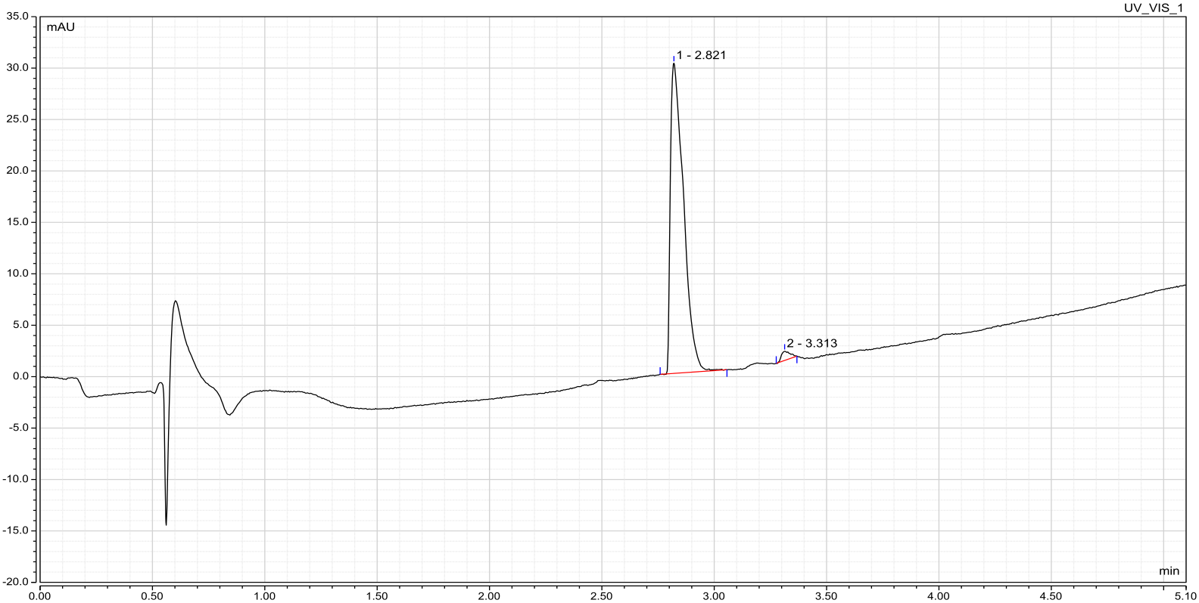

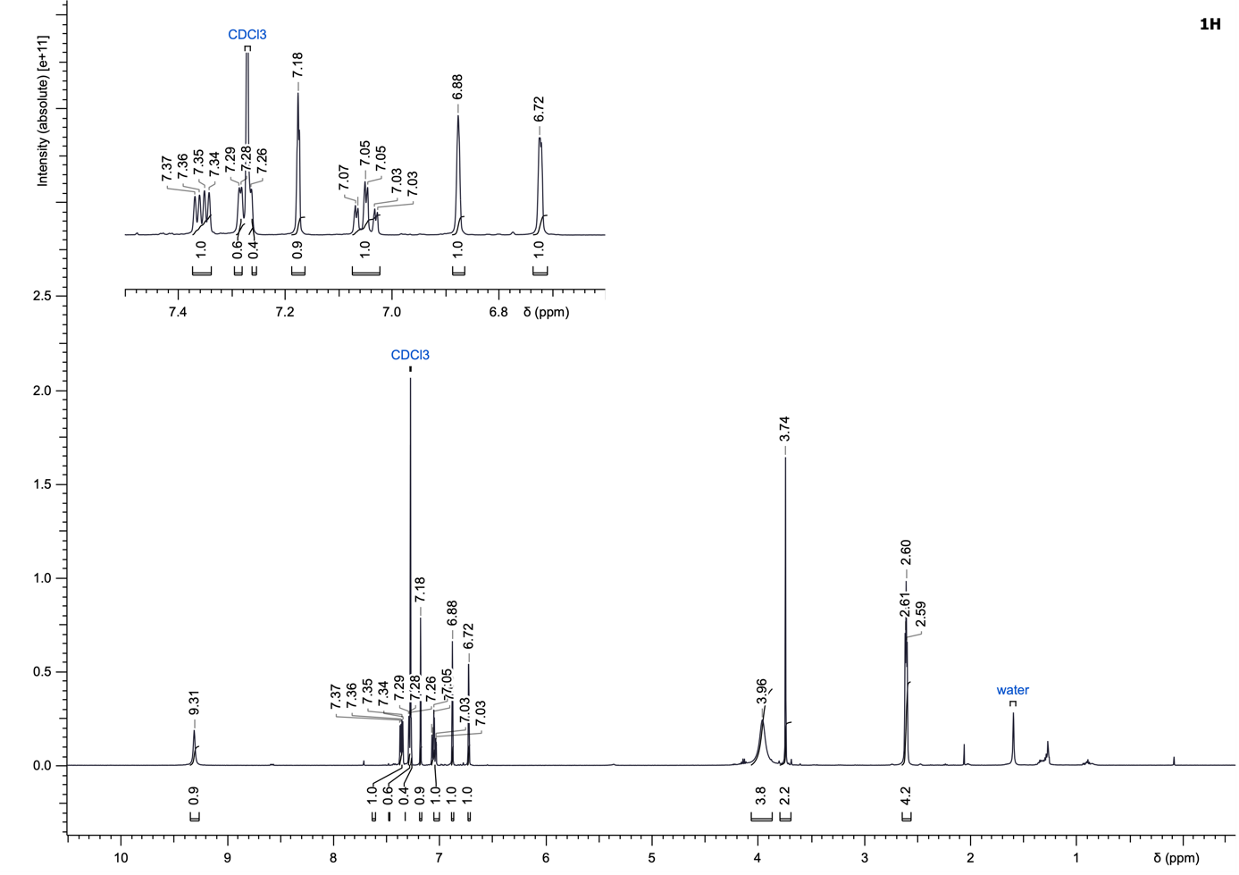
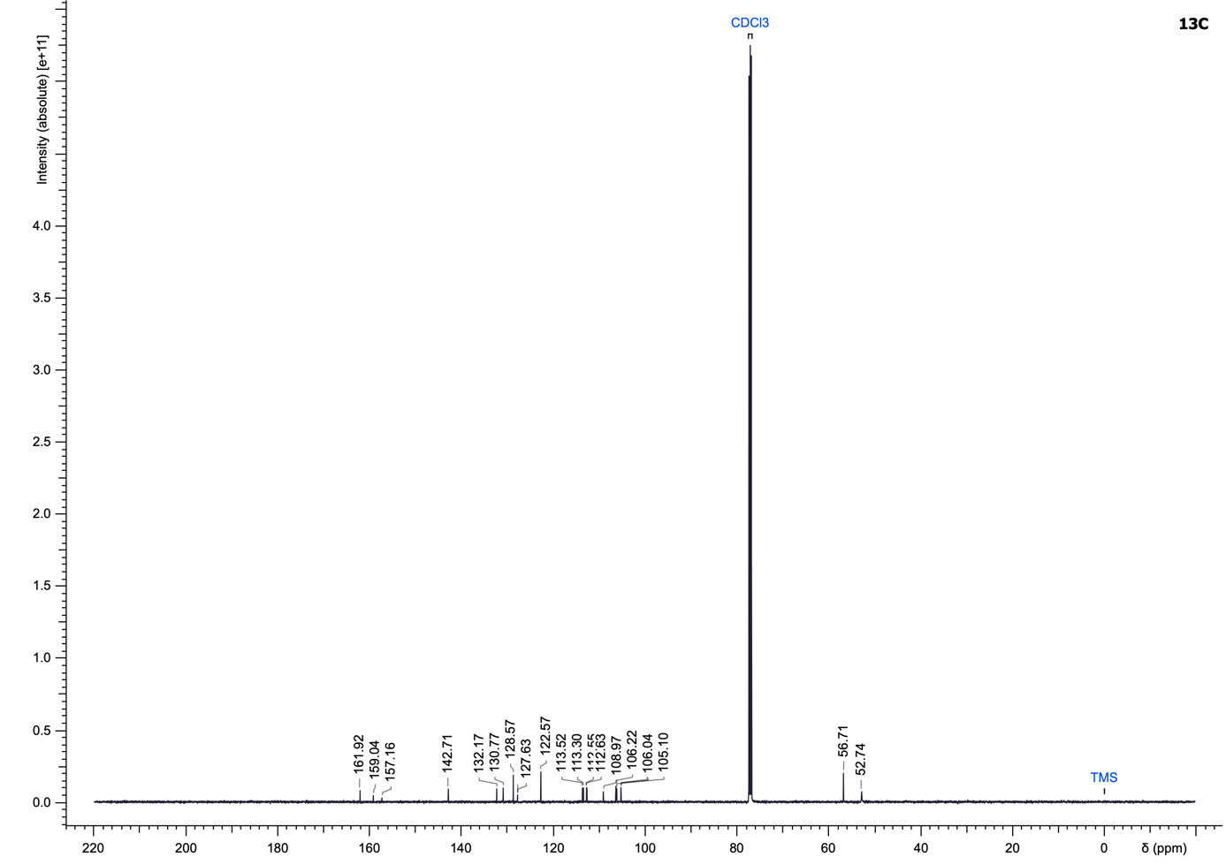
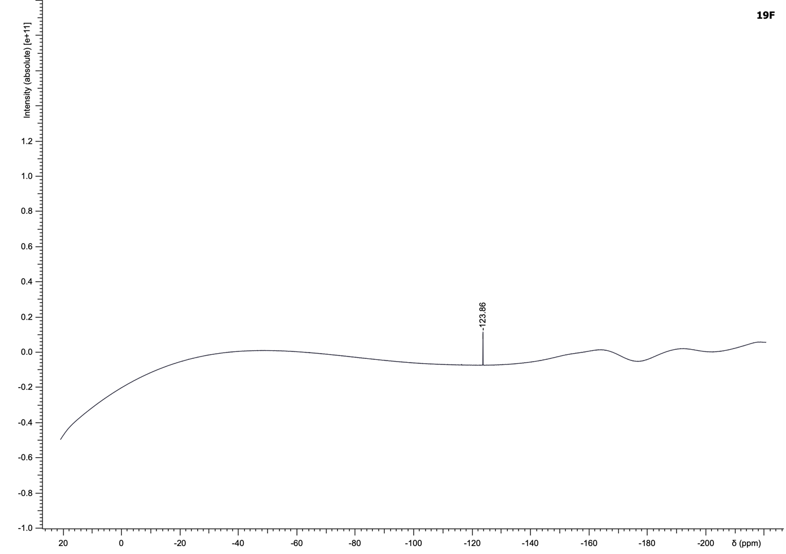

(6-Aminopyridin-3-yl)(4-((4-bromothiophen-2-yl)methyl)piperazin-1-yl)methanone (16)
Compound 16 was synthesized according to the General Procedure A using 6-aminonicotinic acid and 1-((4-bromothiophen-2-yl)methyl)piperazine dihydrochloride (249.03 µmol) as starting materials and purified using dichloromethane/methanol (1 to 8% methanol) to yield a white solid (65.6 mg, 59%).
LC–MS (ESI): t_{R} = 1.63 min; 97% purity (UV at 254 nm);
¹H NMR (500 MHz, CDCl₃): δ 8.19 (s, 1H), 7.56 (dt, J = 8.4, 2.4 Hz, 1H), 7.16 (s, 1H), 6.85 (s, 1H), 6.50 (dd, J = 8.5, 1.4 Hz, 1H), 3.77–3.54 (m, 6H), 2.52 (br s, 4H);
¹³C NMR (126 MHz, CDCl₃): δ 168.6, 159.1, 147.9, 142.8, 137.8, 128.5, 122.5, 121.2, 108.9, 107.8, 56.7, 52.7 (4C);
HRMS (ESI⁺) m/z: [M+H]⁺ calculated for C₁₅H₁₇BrN₄OS, 381.0379; found, 381.0376.

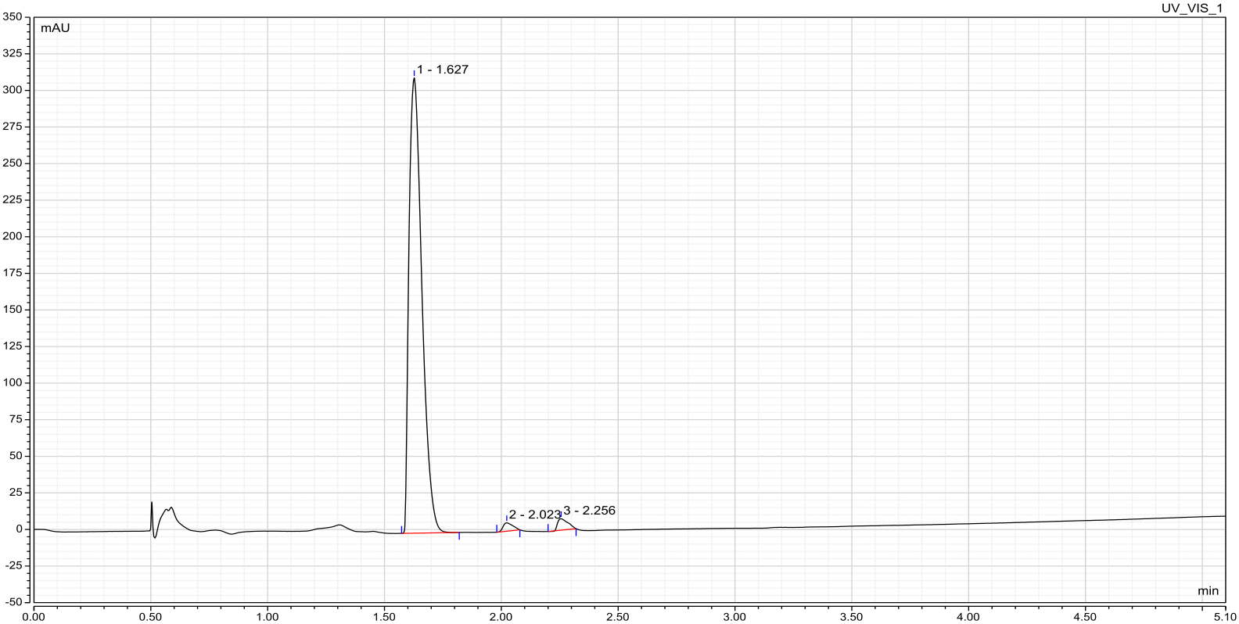

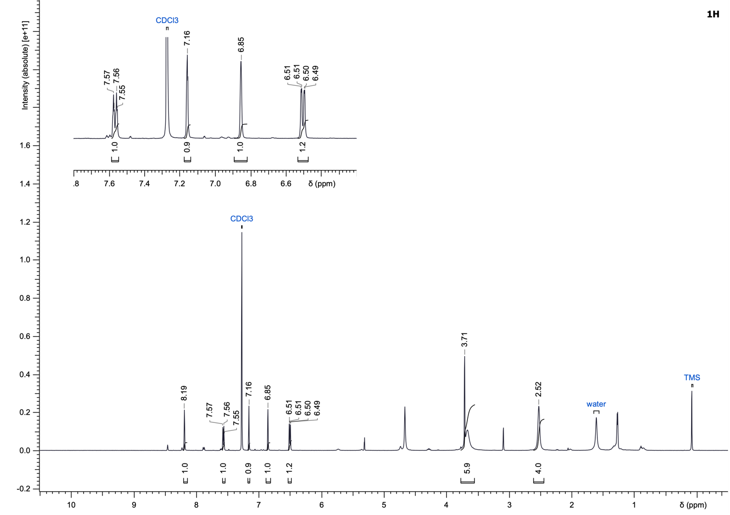
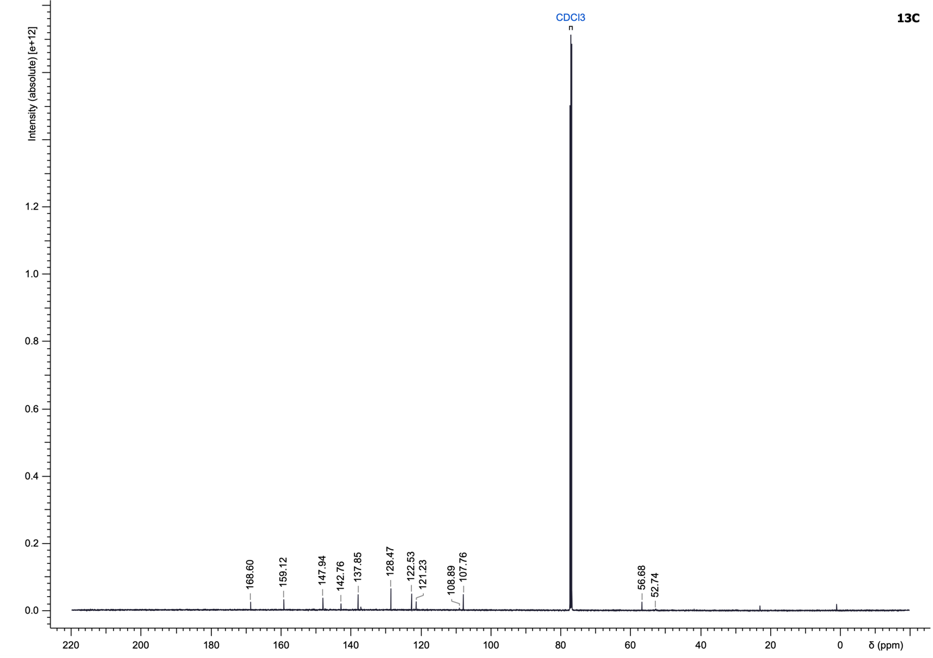

(4-((4-Bromothiophen-2-yl)methyl)piperazin-1-yl)(5-(4-methoxyphenyl)-1H-pyrazol-3-yl)methanone (17)
Compound 17 was synthesized according to the General Procedure A using 5-(4-methoxyphenyl)-1H-pyrazole-3-carboxylic acid and 1-((4-bromothiophen-2-yl)methyl)piperazine dihydrochloride (157.62 µmol) as starting materials and purified using cyclohexane/ethyl acetate (13 to 100% ethyl acetate) to yield a white solid (10.9 mg, 13%).
LC–MS (ESI): t_{R} = 2.61 min; > 99% purity (UV at 254 nm);
¹H NMR (500 MHz, CDCl₃): δ 10.64 (br s, 1H), 7.61 (d, J = 7.8 Hz, 2H), 7.16 (s, 1H), 6.97 (d, J = 6.9 Hz, 2H), 6.86 (s, 1H), 6.76 (s, 1H), 3.99 (br s, 2H), 3.90–3.80 (m, 5H), 3.72 (s, 2H), 2.57 (br s, 4H);
¹³C NMR (126 MHz, CDCl₃): δ 160.0, 142.8, 137.8, 128.5, 127.0 (2C), 123.3, 122.5, 114.4 (2C), 108.9, 103.8, 56.7, 55.4, 52.9 (4C), 46.9, 42.5;
HRMS (ESI⁺) m/z: [M+H]⁺ calculated for C₂₀H₂₁BrN₄O₂S, 461.0641; found, 461.0639.

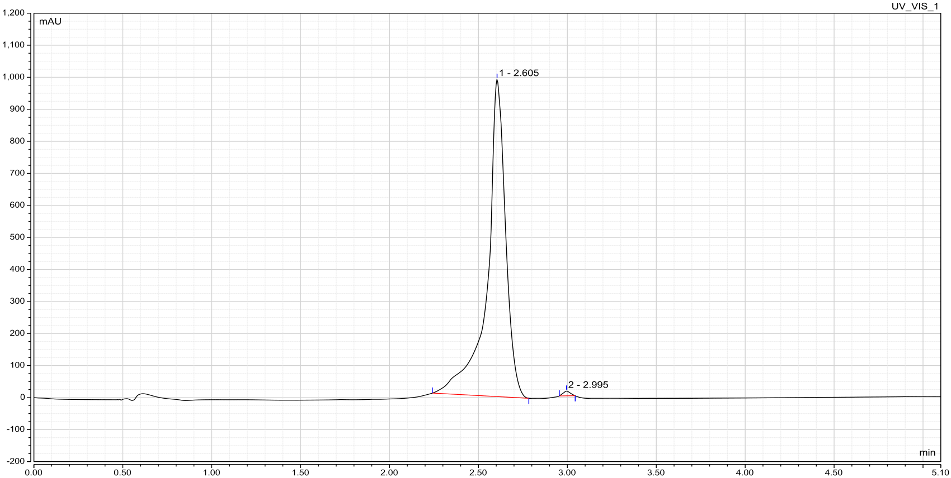

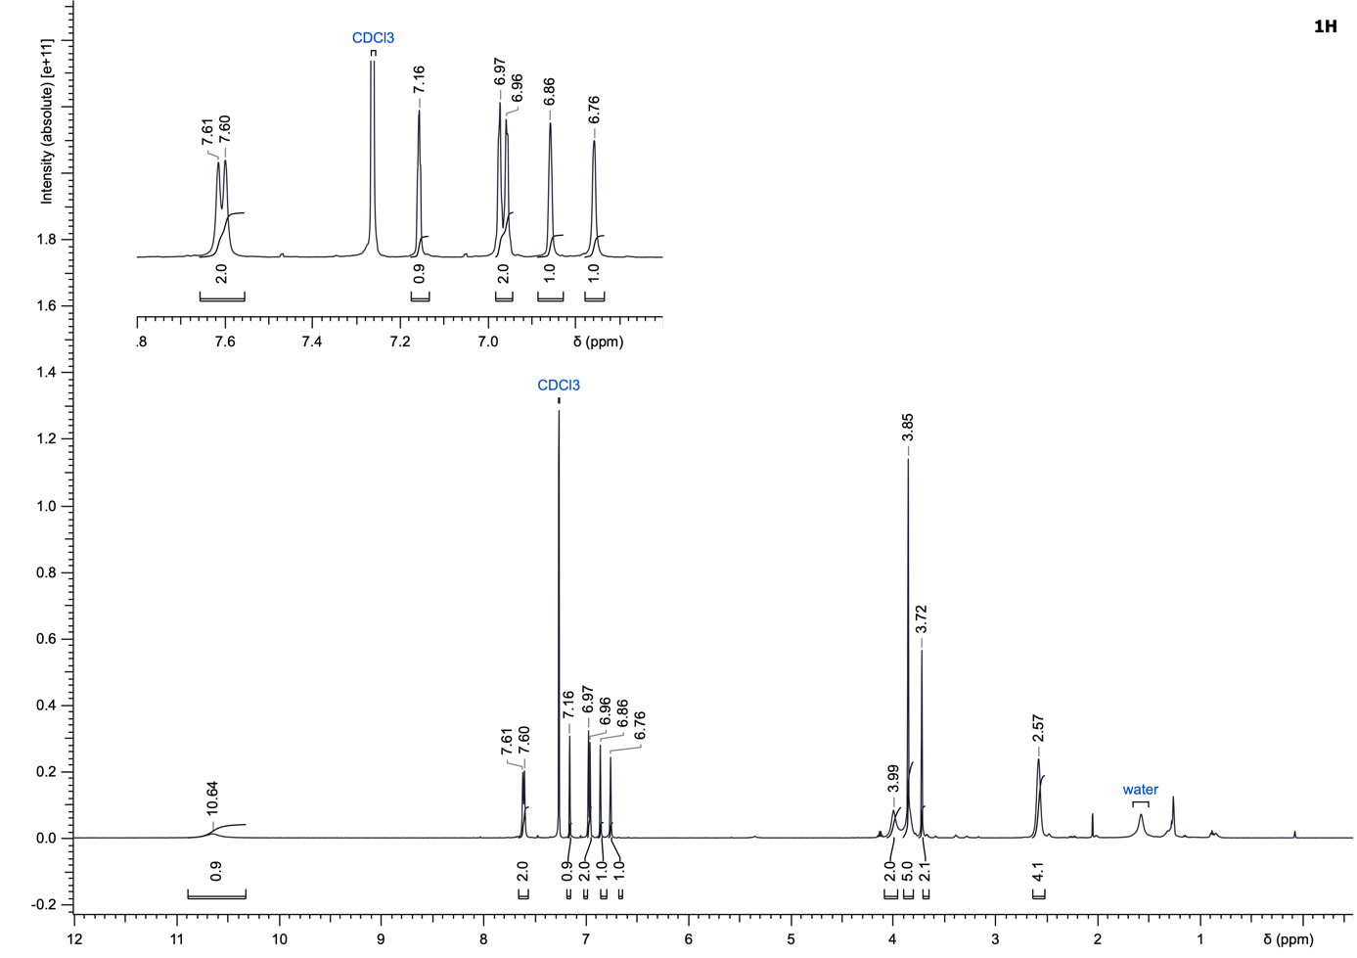
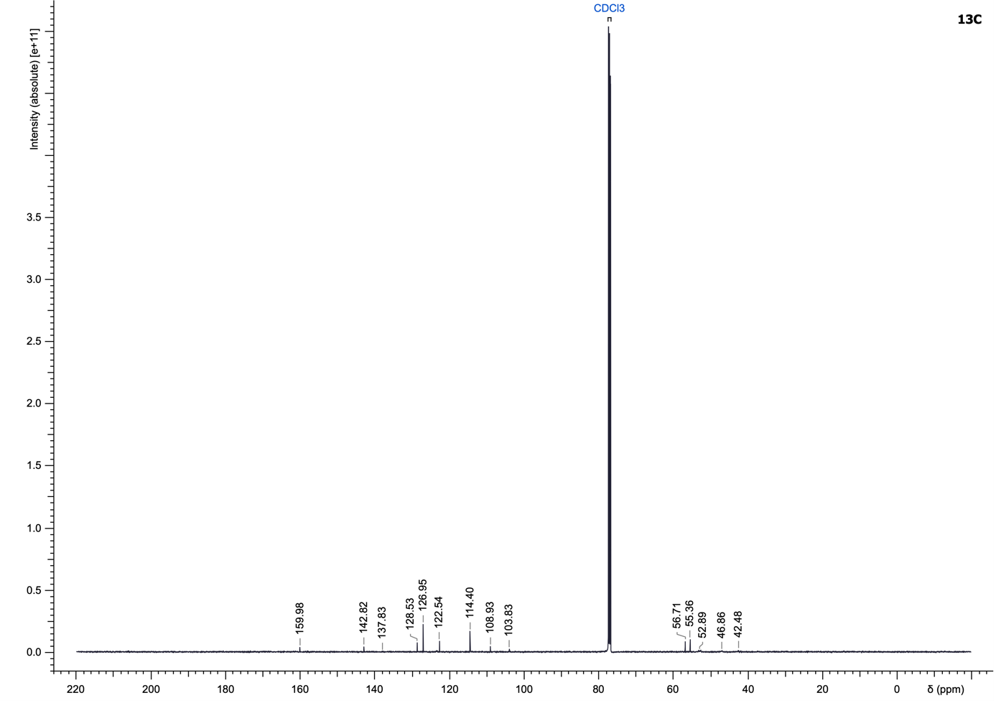

(1H-Benzo[d]imidazol-2-yl)(4-((4-bromothiophen-2-yl)methyl)piperazin-1-yl)methanone (18)
Compound 18 was synthesized according to the General Procedure A using 1H-benzo[d]imidazole-2-carboxylic acid and 1-((4-bromothiophen-2-yl)methyl)piperazine dihydrochloride (299.31 µmol) as starting materials and purified using cyclohexane/ethyl acetate (10 to 100% ethyl acetate) to yield a yellow solid (50.3 mg, 41%).
LC–MS (ESI): t_{R} = 2.53 min; 97% purity (UV at 254 nm);
¹H NMR (500 MHz, DMSO-d₆): δ 13.13 (s, 1H), 7.73 (d, J = 8.1 Hz, 1H), 7.59 (d, J = 1.5 Hz, 1H), 7.52 (d, J = 8.1 Hz, 1H), 7.31 (td, J = 7.5, 1.0 Hz, 1H), 7.25 (td, J = 7.6, 0.9 Hz, 1H), 7.02 (s, 1H), 4.52–4.39 (m, 2H), 3.74 (s, 2H), 3.73–3.70 (m, 2H), 2.56 (br t, J = 4.8 Hz, 2H), 2.53–2.51 (m, 2H);
¹³C NMR (126 MHz, DMSO-d₆): δ 158.1, 145.5, 143.7, 142.4, 133.3, 128.3, 124.2, 123.3, 122.5, 120.2, 112.3, 107.8, 55.6, 52.9, 52.0, 46.1, 42.4;
HRMS (ESI⁺) m/z: [M+H]⁺ calculated for C₁₇H₁₇N₄OBrS, 405.0379; found, 405.0381.

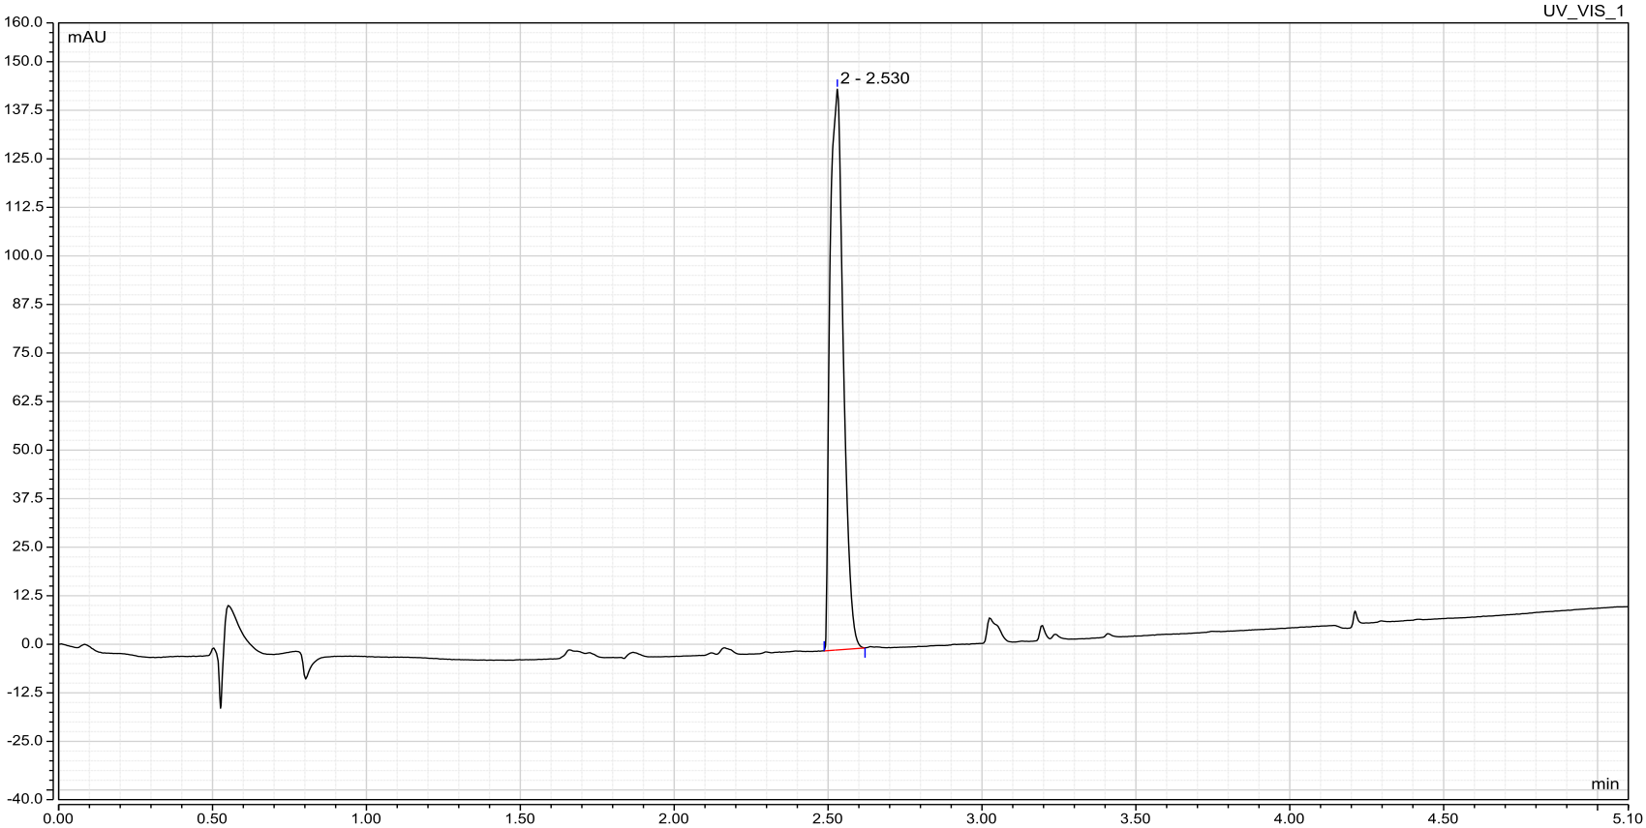

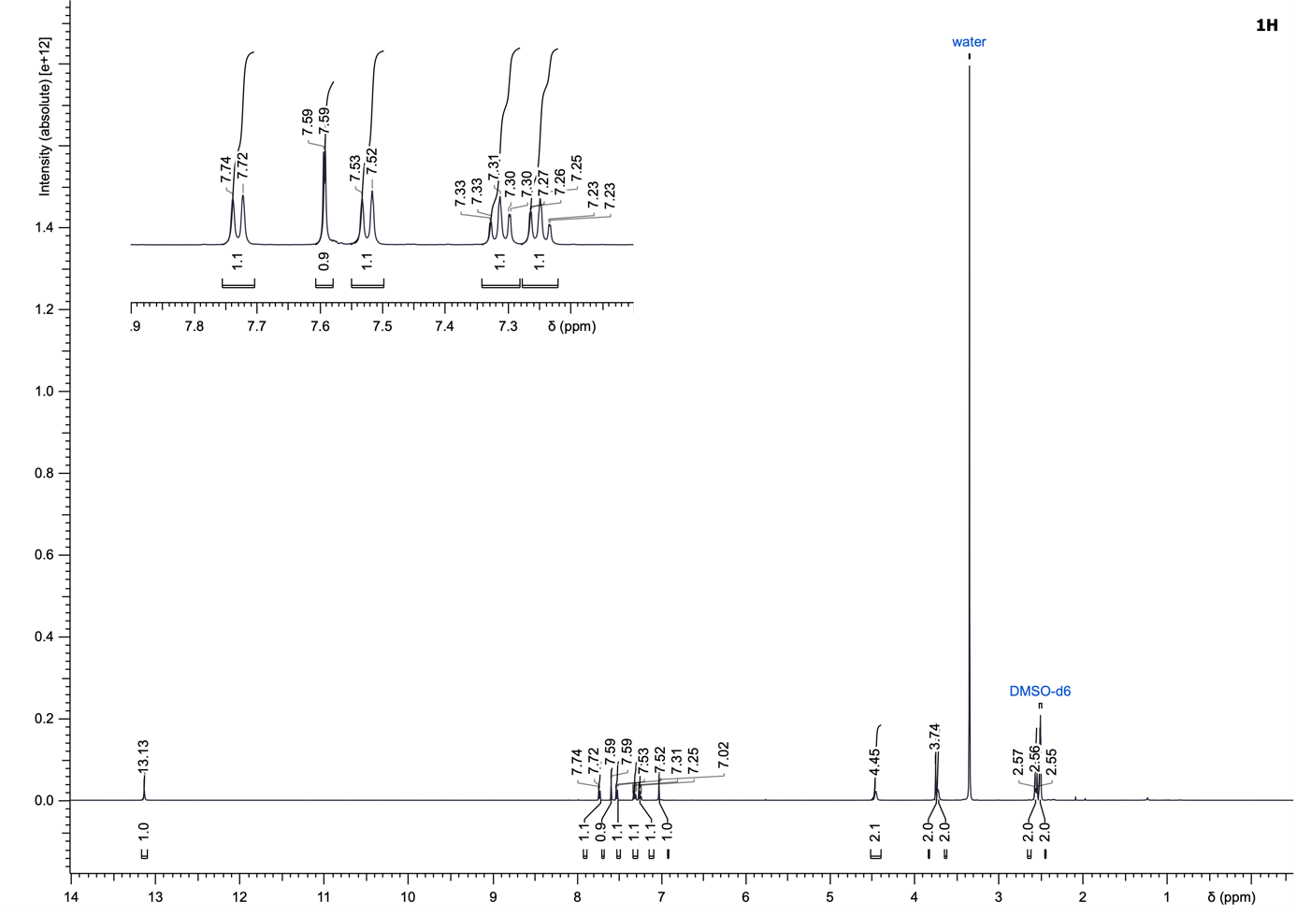
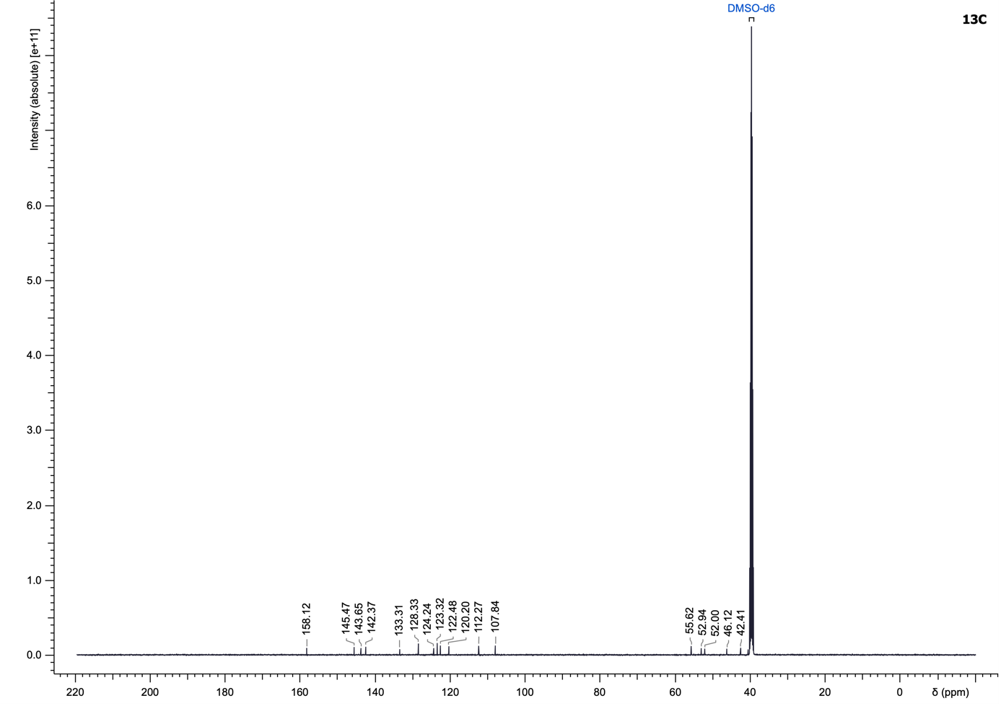

(4-((4-Bromothiophen-2-yl)methyl)piperazin-1-yl)(5-chlorobenzofuran-2-yl)methanone (19)
Compound 19 was synthesized according to the General Procedure A using 5-chlorobenzofuran-2-carboxylic acid and 1-((4-bromothiophen-2-yl)methyl)piperazine dihydrochloride (299.31 µmol) as starting materials and purified using cyclohexane/ethyl acetate (10 to 100% ethyl acetate) to yield a yellow solid (97.6 mg, 74%).
LC–MS (ESI): t_{R} = 3.14 min; 96% purity (UV at 254 nm);
¹H NMR (500 MHz, CDCl₃): δ 7.62 (d, J = 2.0 Hz, 1H), 7.43 (d, J = 8.9 Hz, 1H), 7.35 (dd, J = 8.8, 2.1 Hz, 1H), 7.23 (s, 1H), 7.16 (s, 1H), 6.87 (s, 1H), 3.87 (br s, 4H), 3.74 (br s, 2H), 2.60 (br s, 4H);
¹³C NMR (126 MHz, CDCl₃): δ 159.4, 153.1, 150.4, 129.4, 128.9, 128.4, 127.0, 122.8, 122.0, 121.9, 113.1, 111.6, 109.2, 56.7, 53.1, 52.7, 46.7, 42.9;
HRMS (ESI⁺) m/z: [M+H]⁺ calculated for C₁₈H₁₆N₂O₂BrClS, 438.9877; found, 438.9866.

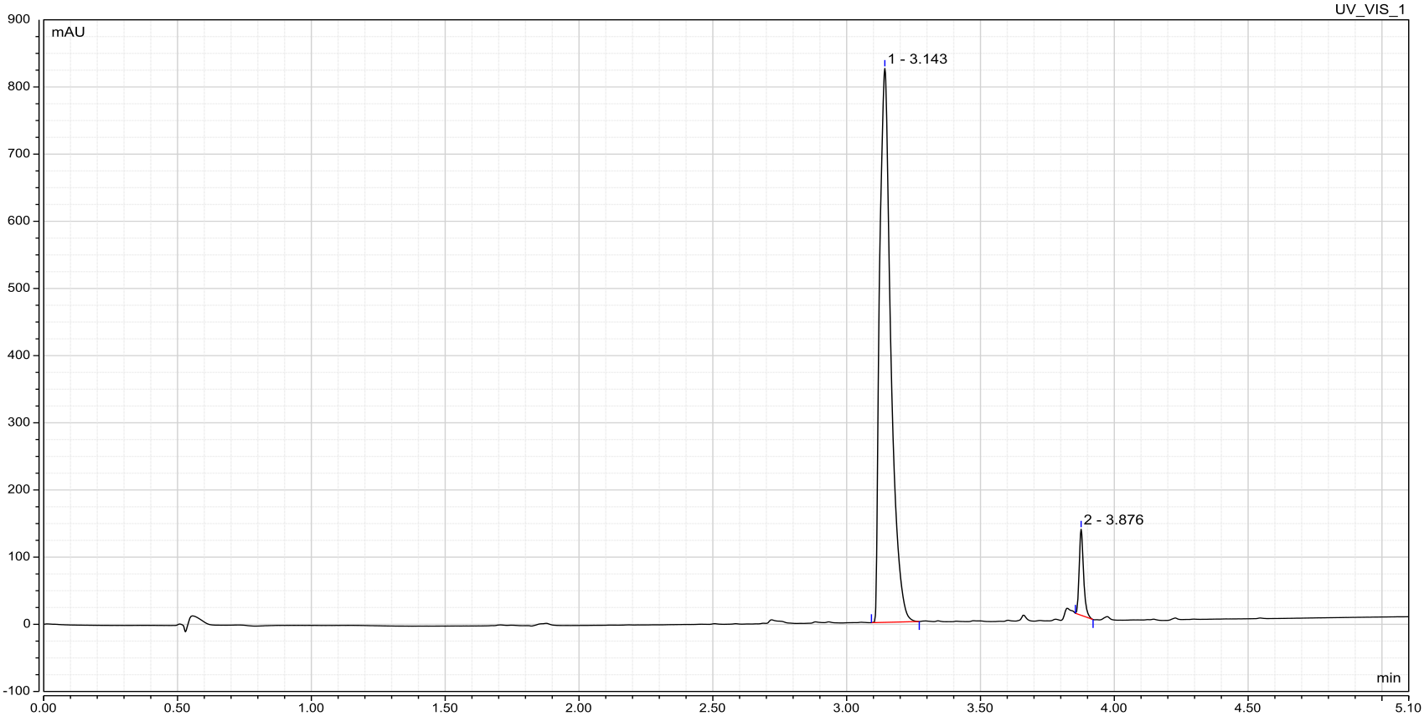

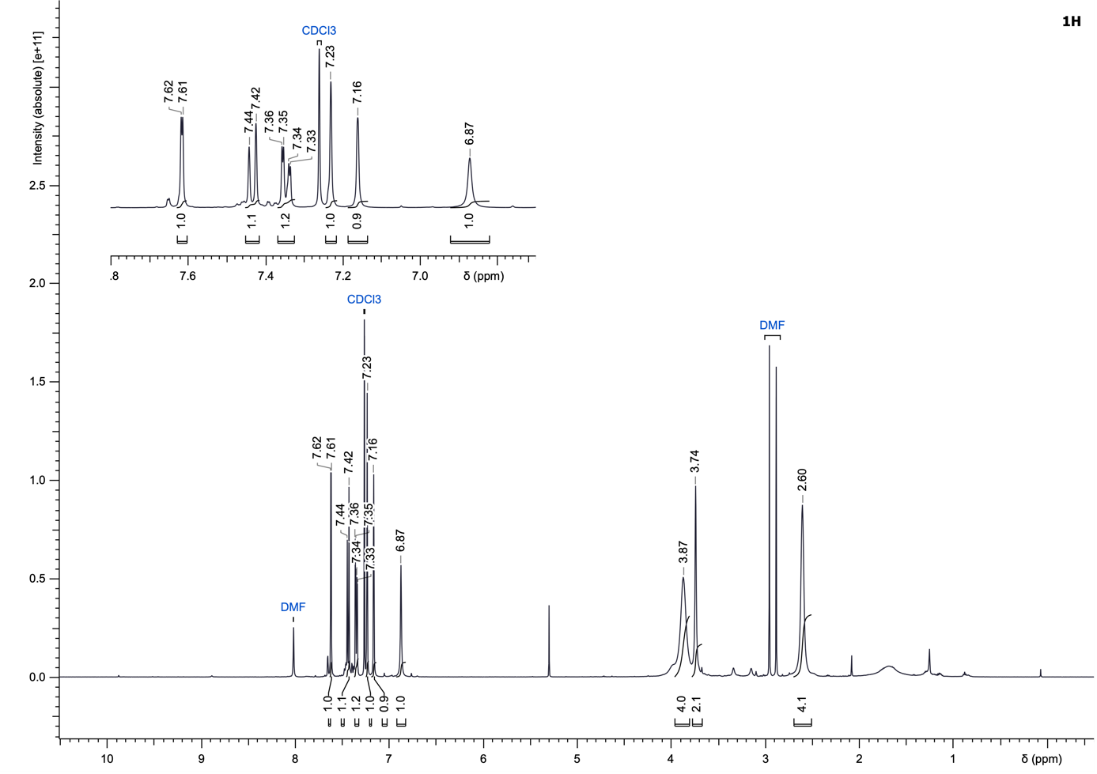
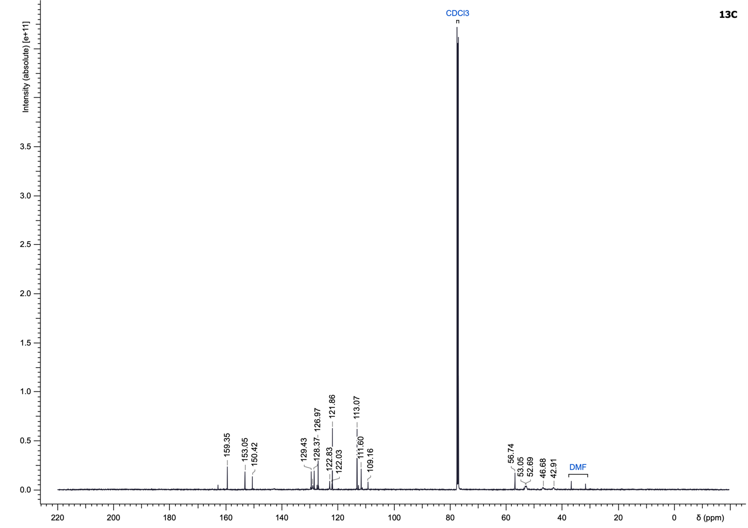

(4-((4-Bromothiophen-2-yl)methyl)piperazin-1-yl)(4,5,6,7-tetrahydrobenzo[b]thiophen-2-yl)methanone (20)
Compound 20 was synthesized according to the General Procedure A using 4,5,6,7-tetrahydrobenzo[b]thiophene-2-carboxylic acid and 1-((4-bromothiophen-2-yl)methyl)piperazine dihydrochloride (299.31 µmol) as starting materials and purified using cyclohexane/ethyl acetate (10 to 100% ethyl acetate) to yield a yellow solid (102.5 mg, 81%).
LC–MS (ESI): t_{R} = 3.07 min; > 99% purity (UV at 254 nm);
¹H NMR (500 MHz, CDCl₃): δ 7.15 (s, 1H), 6.94 (s, 1H), 6.86 (br s, 1H), 3.78 (br s, 4H), 3.71 (br s, 2H), 2.75 (br t, J = 6.0 Hz, 2H), 2.58 (br t, J = 6.0 Hz, 2H), 2.53 (br s, 4H), 1.88–1.75 (m, 4H);
¹³C NMR (126 MHz, CDCl₃): δ 164.1, 143.1, 140.0, 135.3, 132.7, 130.2, 128.8, 122.8, 109.1, 56.8, 52.9 (4C), 25.6, 25.1, 23.5, 22.8;
HRMS (ESI⁺) m/z: [M+H]⁺ calculated for C₁₈H₂₁N₂OBrS₂, 425.0351; found, 425.0344.

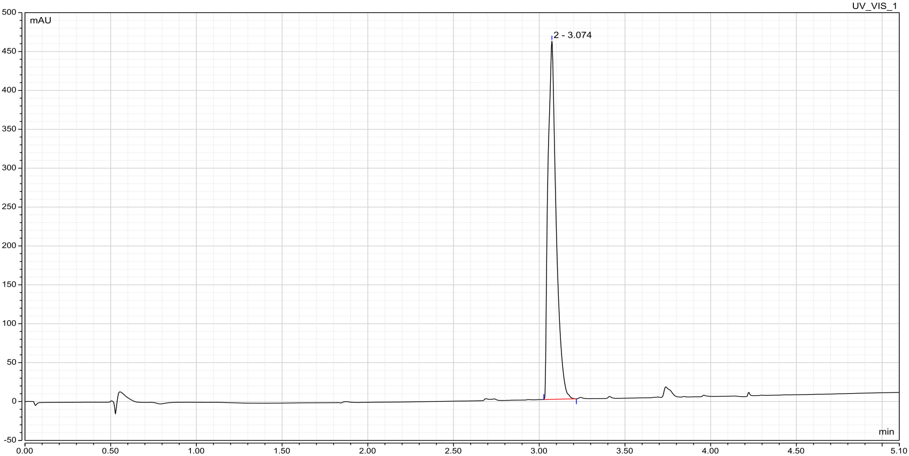

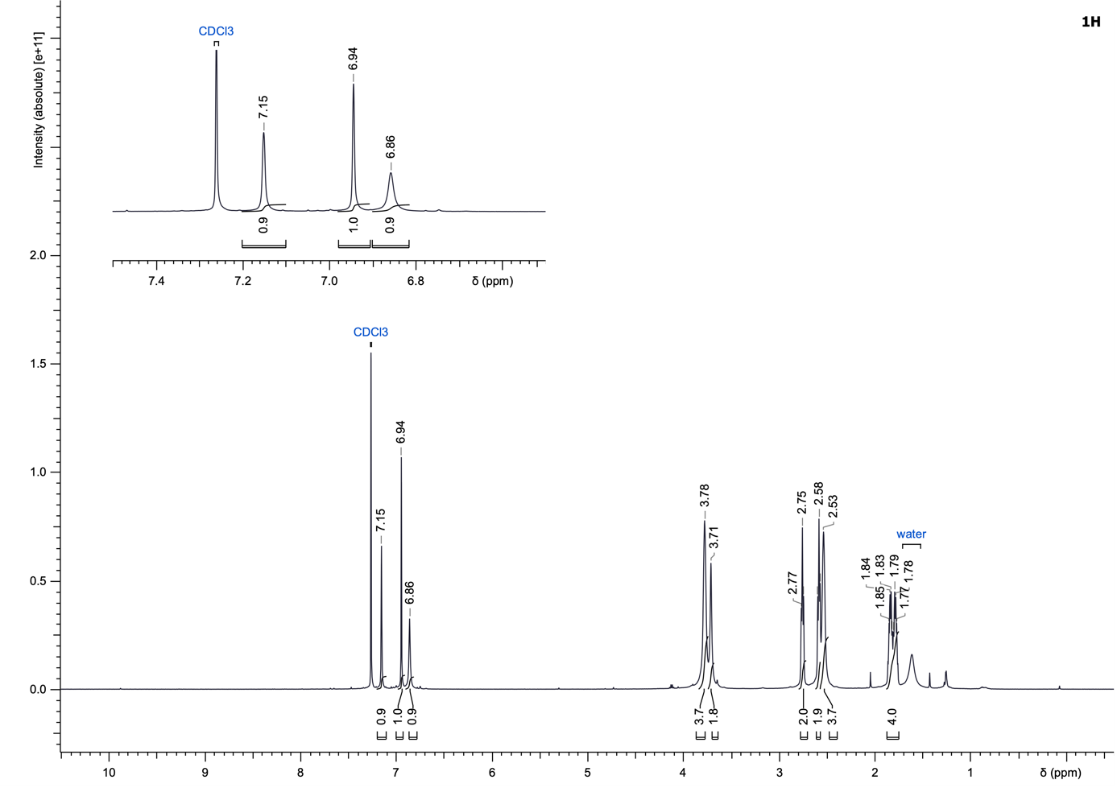
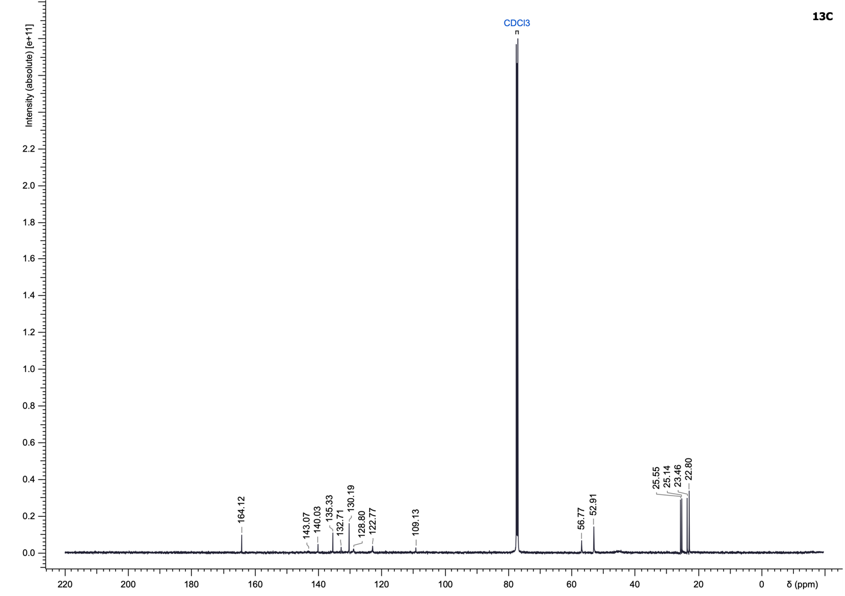

1-((4-(4-Isopropoxyphenyl)thiophen-2-yl)methyl)piperazine (21)
Compound 21 was synthesized according to the General Procedure B using 1-((4-bromothiophen-2-yl)methyl)piperazine dihydrochloride (149.66 µmol) and (4-isopropoxyphenyl)boronic acid as starting materials and purified using dichloromethane/methanol + 5% triethylamine (0.5 to 4% methanol) to yield a light green solid (39.9 mg, 84%).
LC–MS (ESI): t_{R} = 2.68 min; > 99% purity (UV at 254 nm);
¹H NMR (500 MHz, CDCl₃): δ 7.46 (d, J = 8.4 Hz, 2H), 7.23 (s, 1H), 7.15 (s, 1H), 6.90 (d, J = 8.4 Hz, 2H), 4.56 (sept, J = 6.0 Hz, 1H), 3.91–3.71 (m, 3H), 3.01 (t, J = 4.7 Hz, 4H), 2.60 (br s, 4H), 1.35 (d, J = 6.0 Hz, 6H);
¹³C NMR (126 MHz, CDCl₃): δ 157.3, 141.9, 141.5, 128.7, 127.5 (2C), 125.6, 118.7, 116.3 (2C), 70.1, 57.7, 52.66, 52.71, 45.4, 45.3, 22.2 (2C);
HRMS (ESI⁺) m/z: [M+H]⁺ calculated for C₁₈H₂₄N₂OS, 317.1682; found, 317.1682.

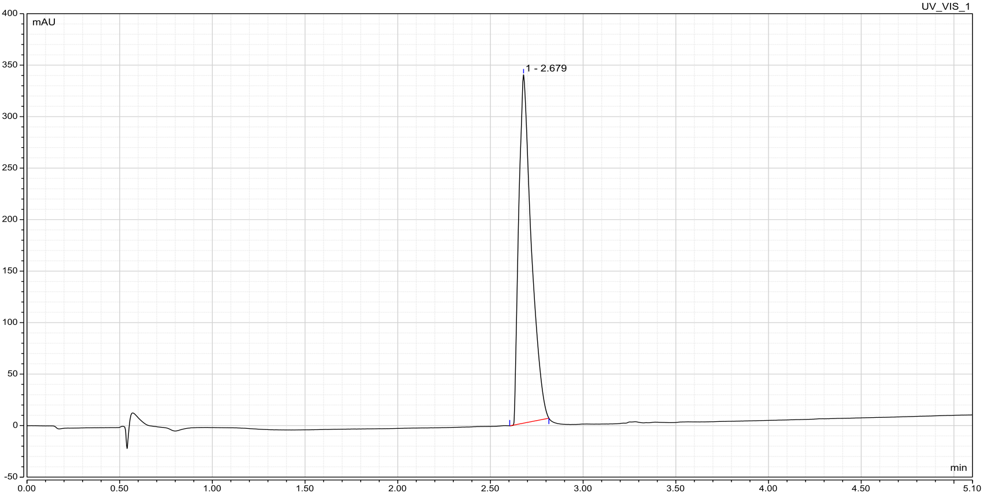

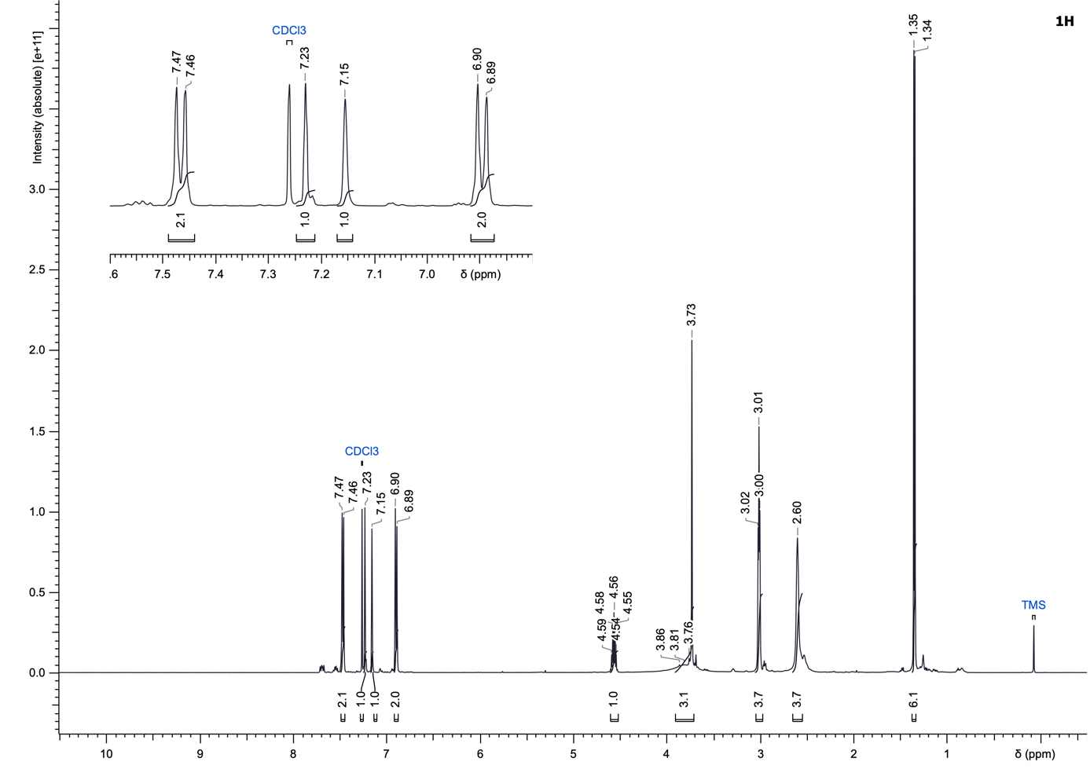
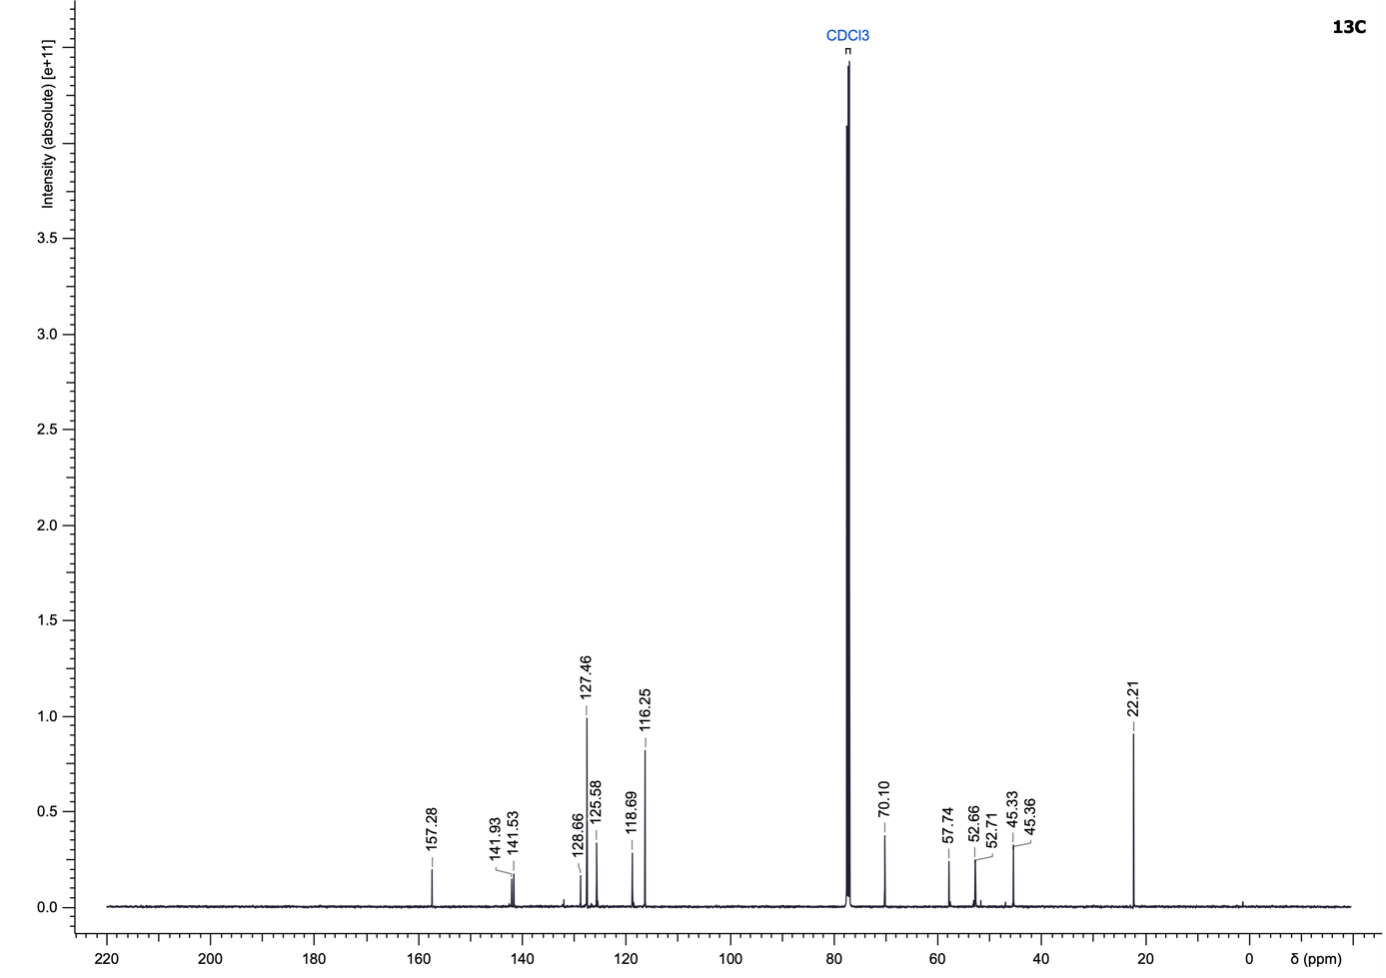

1-((4-(2-Ethoxyphenyl)thiophen-2-yl)methyl)piperazine (22)
Compound 22 was synthesized according to the General Procedure B using 1-((4-bromothiophen-2-yl)methyl)piperazine dihydrochloride (149.66 µmol) and (2-ethoxyphenyl)boronic acid as starting materials and purified using dichloromethane/methanol + 5% triethylamine (0.5 to 4% methanol) to yield a colourless solid (38.3 mg, 85%).
LC–MS (ESI): t_{R} = 2.48 min; > 99% purity (UV at 254 nm);
¹H NMR (500 MHz, CDCl₃): δ 7.57 (s, 1H), 7.46 (d, J = 7.6 Hz, 1H), 7.28 (s, 1H), 7.23 (br t, J = 7.2 Hz, 1H), 6.99–6.91 (m, 2H), 6.39 (br s, 1H), 4.08 (q, J = 6.9 Hz, 2H), 3.75 (s, 2H), 3.11 (br s, 4H), 2.71 (br s, 4H), 1.44 (t, J = 6.9 Hz, 3H);
¹³C NMR (126 MHz, CDCl₃): δ 55.9, 139.5, 137.9, 129.5, 128.3, 128.1, 125.0, 123.3, 120.8, 112.5, 64.0, 57.4, 51.2 (2C), 44.6 (2C), 15.0;
HRMS (ESI⁺) m/z: [M+H]⁺ calculated for C₁₇H₂₂N₂OS, 303.1526; found, 303.1528.

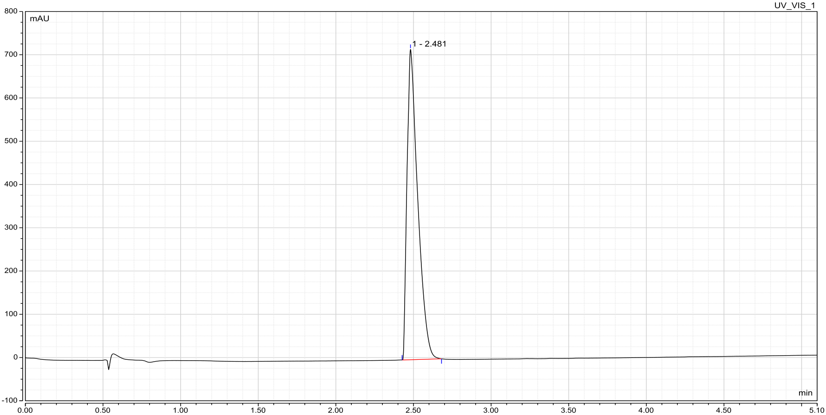

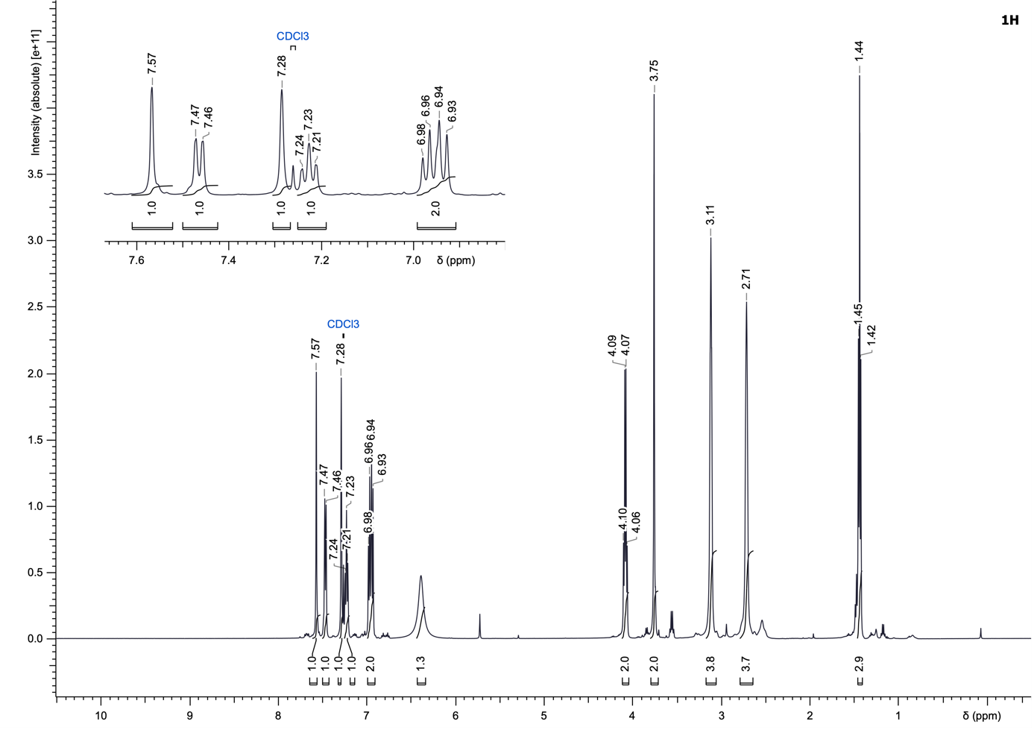
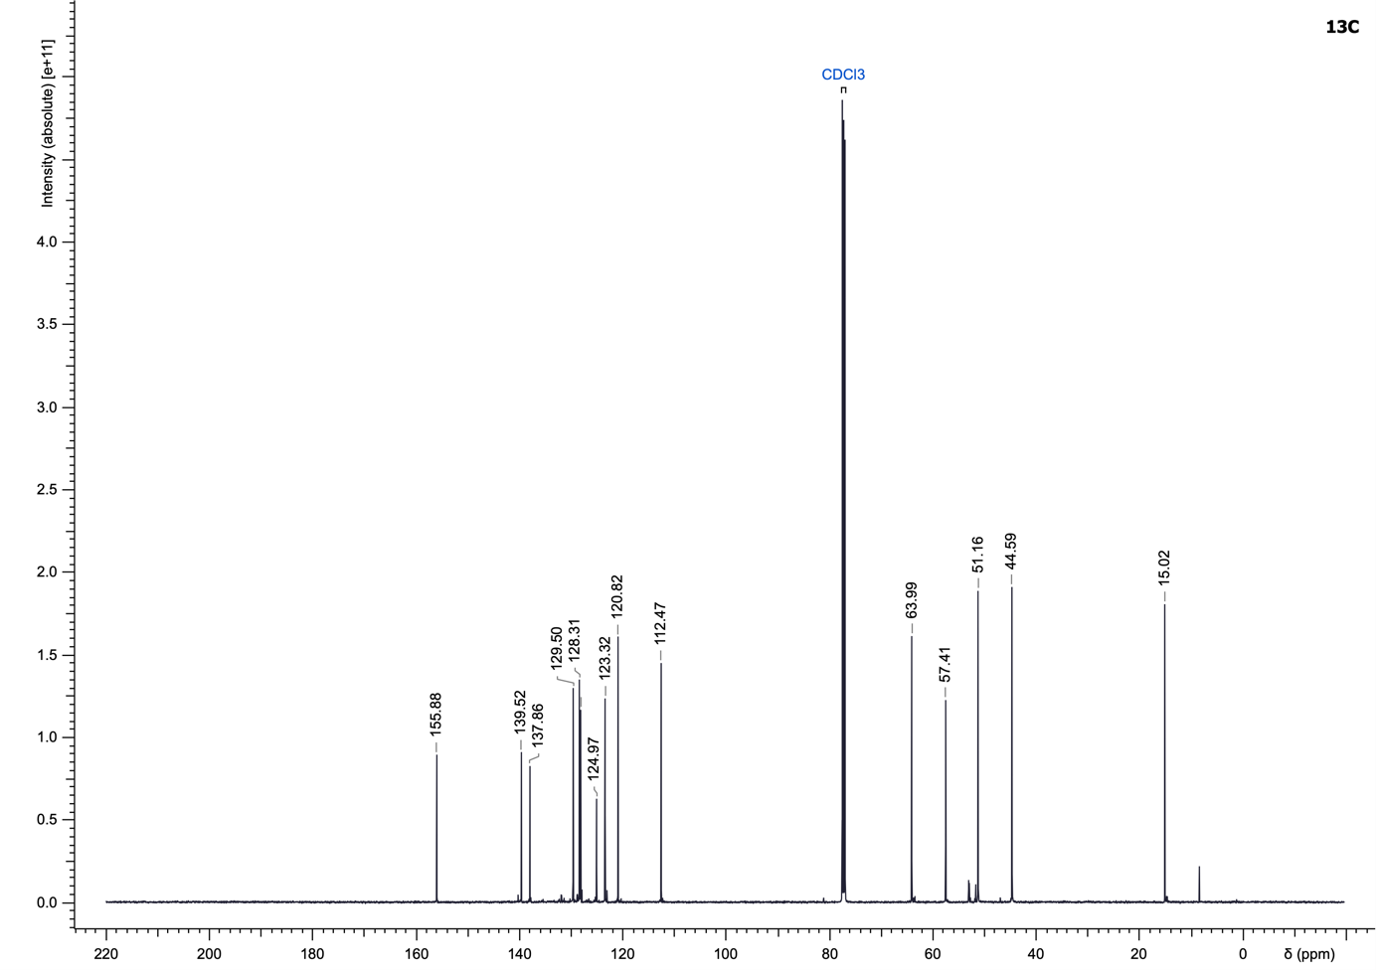

4-((4-(3-Ethoxyphenyl)thiophen-2-yl)methyl)piperazin-1-ium formate (23)
Compound 23 was synthesized according to the General Procedure C using 1-((4-bromothiophen-2-yl)methyl)piperazine dihydrochloride (897.94 µmol) and (3-ethoxyphenyl)boronic acid as starting materials. The reaction mixture was heated at 100 °C for 30 min and the compound was purified using water/acetonitrile + 1% formic acid (5 to 60% acetonitrile) to yield a dark orange oil (134.6 mg, 43%).
LC–MS (ESI): t_{R} = 2.57 min; > 99% purity (UV at 254 nm);
¹H NMR (500 MHz, DMSO-d₆): δ 7.77 (s, 1H), 7.42 (s, 1H), 7.31–7.25 (m, 1H), 7.24–7.19 (m, 2H), 6.83 (dd, J = 8.0, 1.9 Hz, 1H), 6.36 (br s, 2H), 4.06 (q, J = 6.9 Hz, 2H), 3.72 (s, 2H), 2.95 (br s, 4H), 2.66–2.49 (m, 4H), 1.33 (t, J = 7.0 Hz, 3H);
¹³C NMR (126 MHz, DMSO-d₆): δ 159.5, 142.3, 141.0, 137.0, 130.4, 126.0, 121.4, 118.6, 113.5, 112.4, 63.5, 56.8, 50.7 (2C), 43.7 (2C), 15.2;
HRMS (ESI⁺) m/z: [M+H]⁺ calculated for C₁₇H₂₂N₂OS, 303.1526; found, 303.1524.
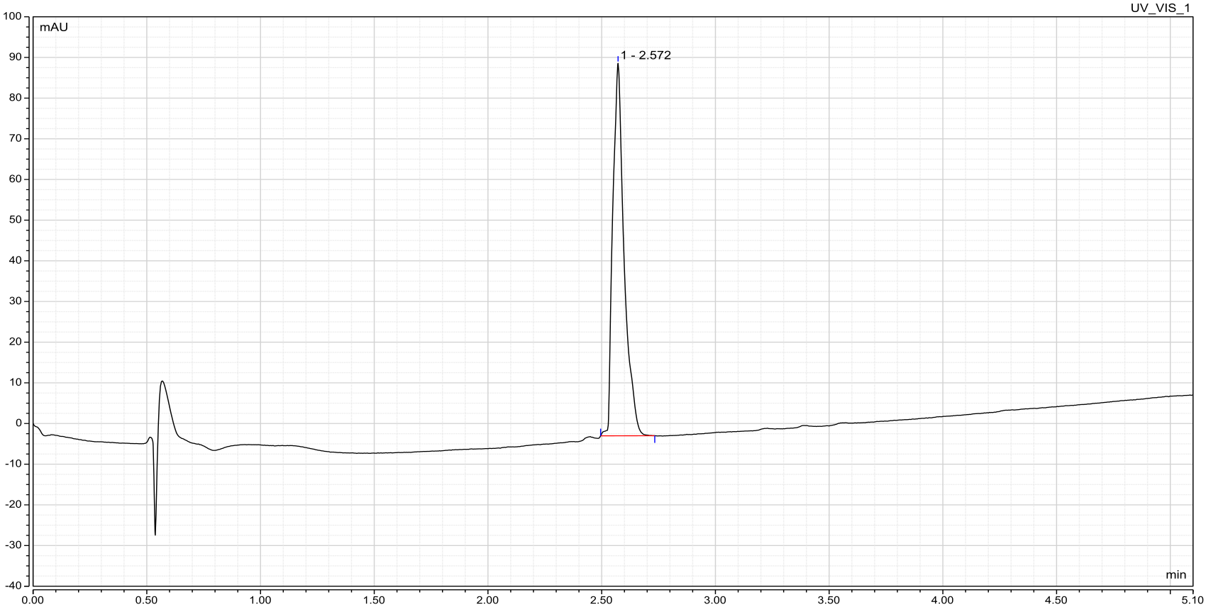

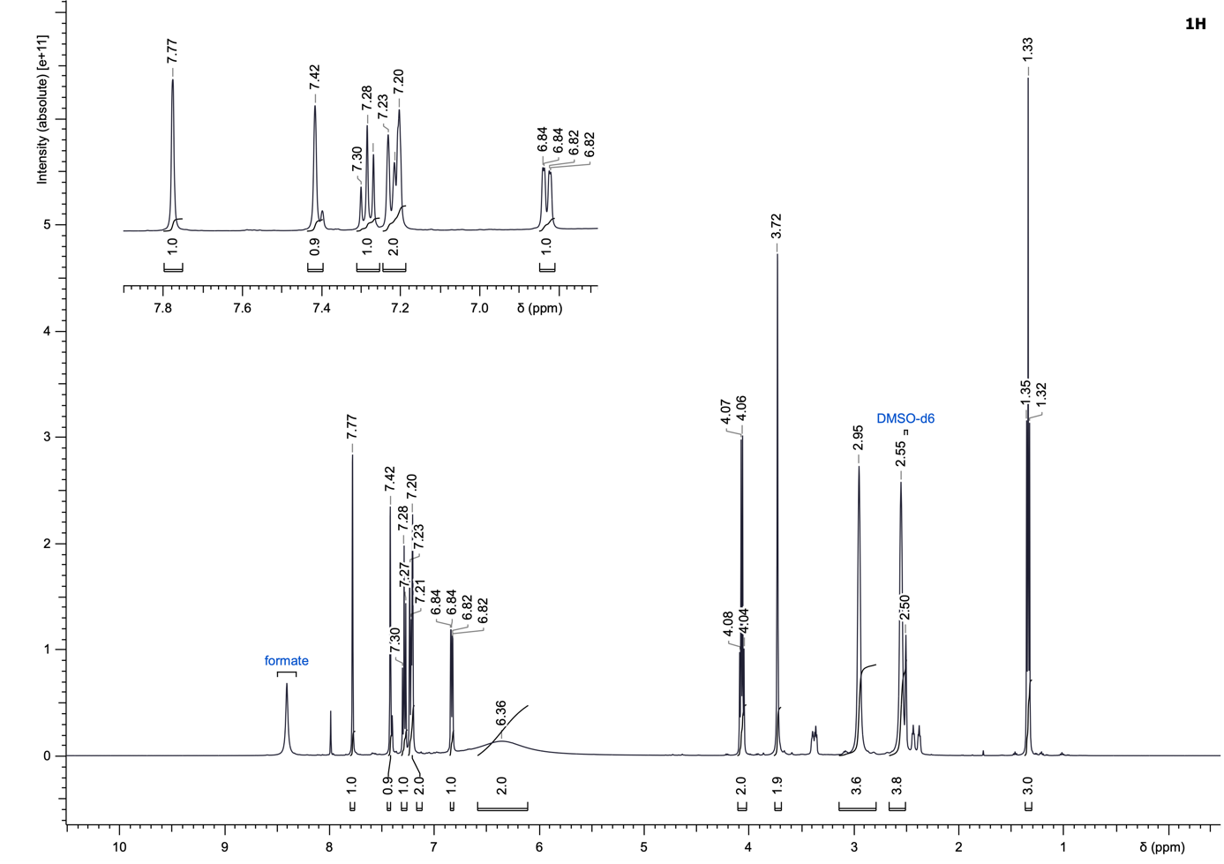
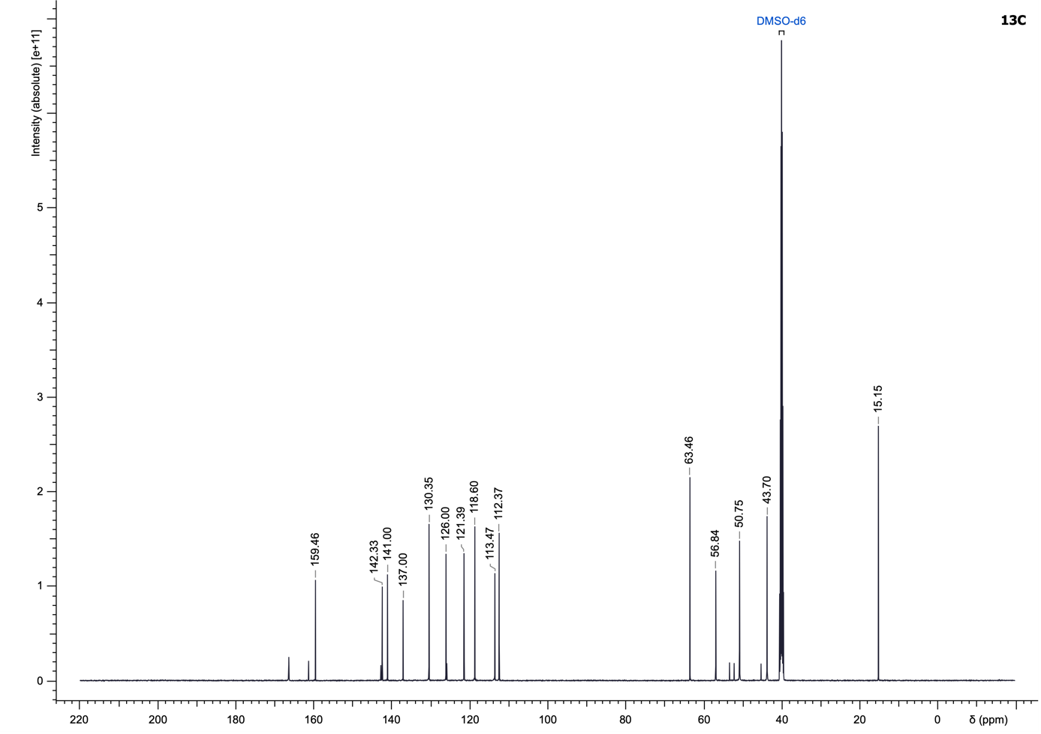

4-((4-(4-Ethoxyphenyl)thiophen-2-yl)methyl)piperazin-1-ium formate (24)
Compound 24 was synthesized according to the General Procedure C using 1-((4-bromothiophen-2-yl)methyl)piperazine dihydrochloride (897.94 µmol) and (4-ethoxyphenyl)boronic acid as starting materials. The reaction mixture was heated at 80 °C for 90 min and the compound was purified using water/acetonitrile + 1% formic acid (5 to 35% acetonitrile) to yield an off-white solid (157.1 mg, 50%).
LC–MS (ESI): t_{R} = 2.51 min; > 99% purity (UV at 254 nm);
¹H NMR (500 MHz, DMSO-d₆): δ 7.60 (s, 1H), 7.58 (d, J = 8.7 Hz, 2H), 7.34 (s, 1H), 6.93 (d, J = 8.5 Hz, 2H), 5.24–4.64 (m, 2H), 4.04 (q, J = 6.9 Hz, 2H), 3.70 (s, 2H), 2.89 (br s, 4H), 2.51–2.49 (m, 4H), 1.33 (t, J = 6.9 Hz, 3H);
¹³C NMR (126 MHz, DMSO-d₆): δ 157.7, 141.9, 140.4, 127.8, 127.0 (2C), 125.2, 118.8, 114.6 (2C), 63.0, 56.6, 51.0 (2C), 43.8 (2C), 14.7;
HRMS (ESI⁺) m/z: [M+H]⁺ calculated for C₁₇H₂₂N₂OS, 303.1526; found, 303.1529.

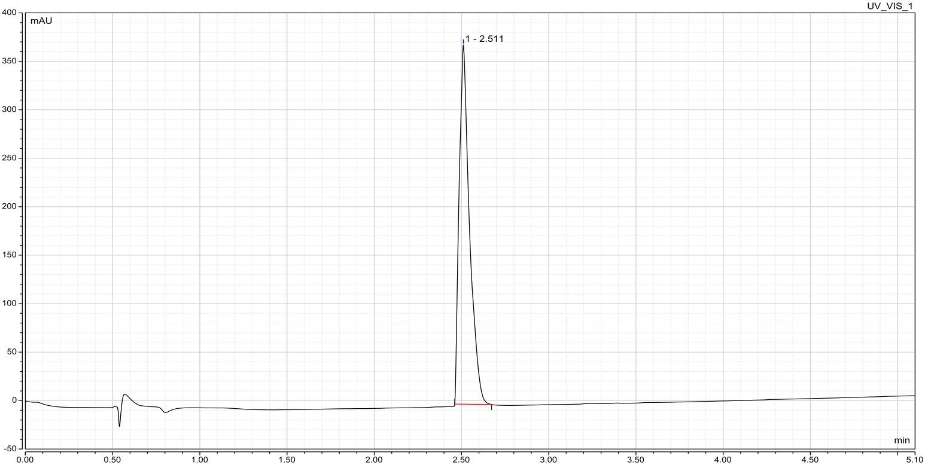

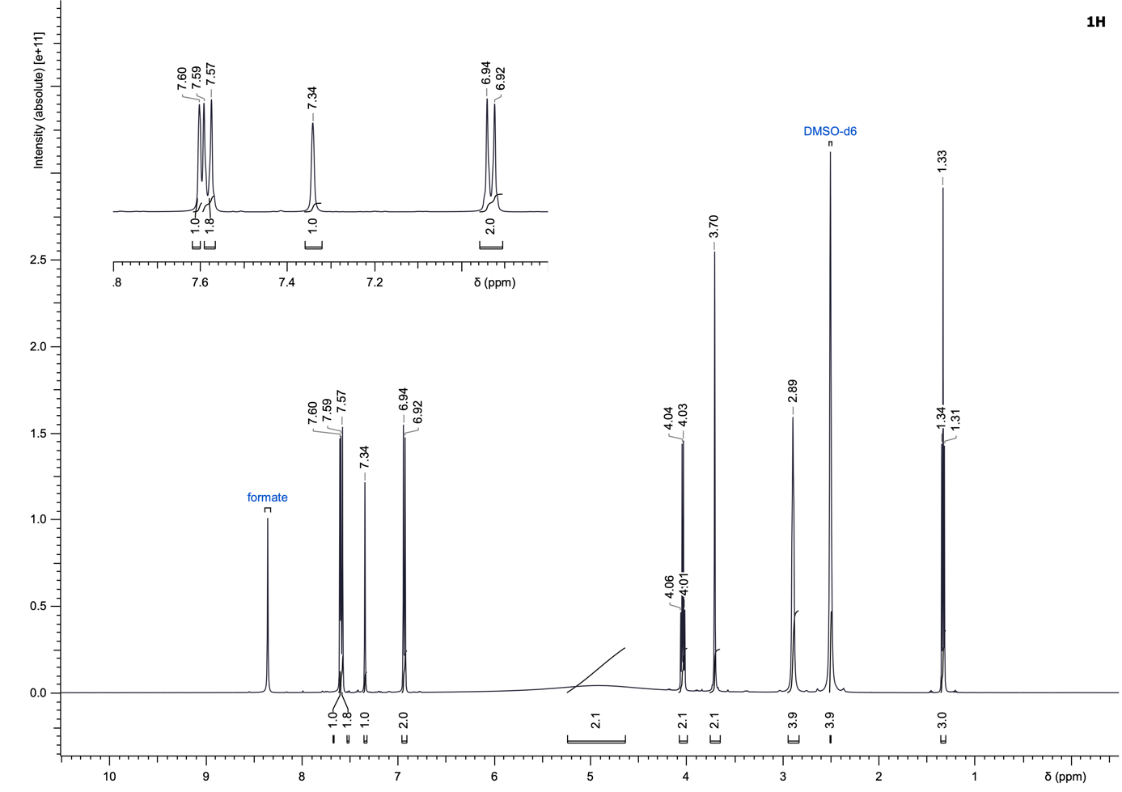
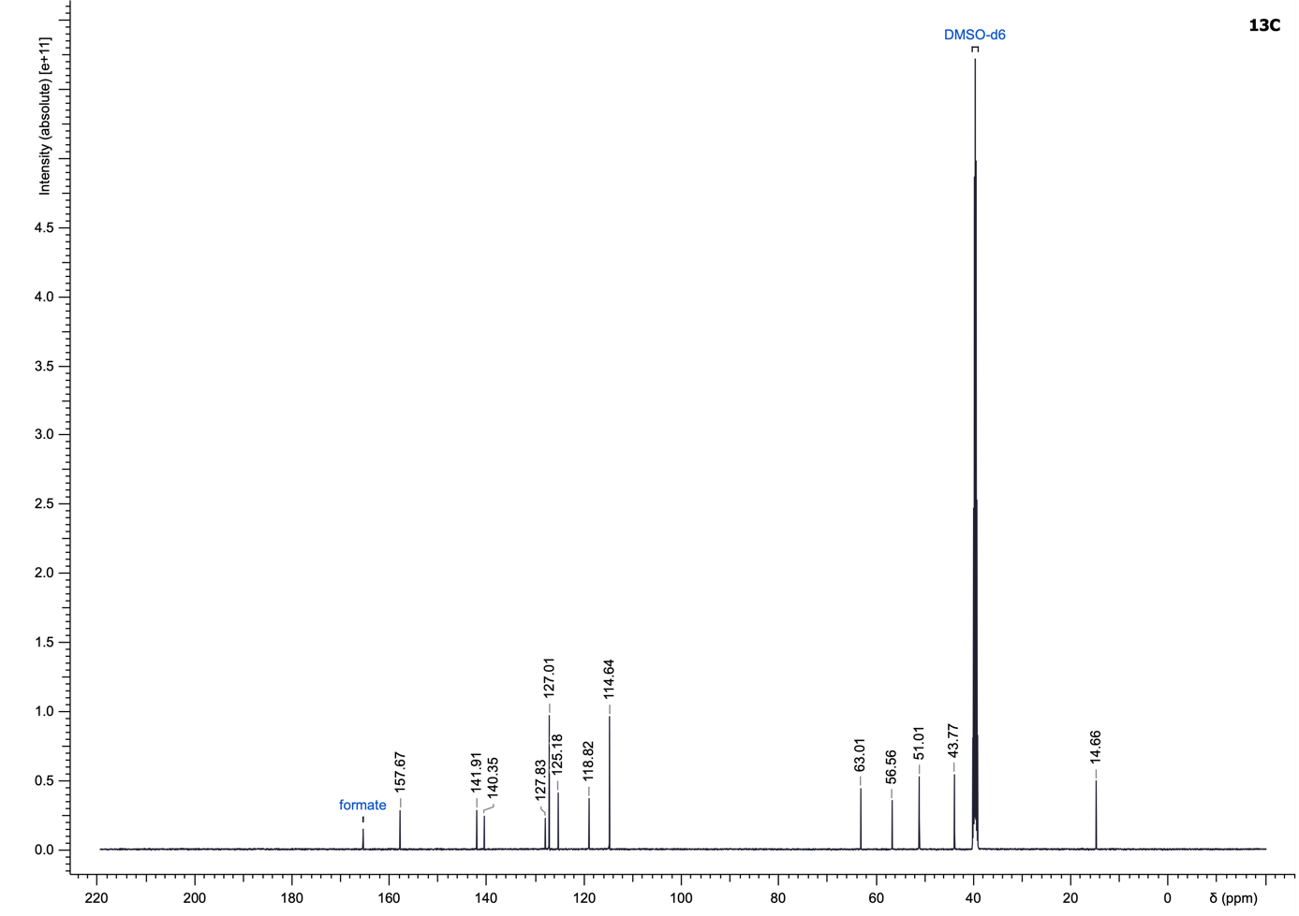

4-((4-(2-Isopropoxyphenyl)thiophen-2-yl)methyl)piperazin-1-ium formate (25)
Compound 25 was synthesized according to the General Procedure C using 1-((4-bromothiophen-2-yl)methyl)piperazine dihydrochloride (897.94 µmol) and (2-isopropoxyphenyl)boronic acid as starting materials. The reaction mixture was heated at 80 °C for 90 min. Then (2-isopropoxyphenyl)boronic acid (1.0 eq) was added, the vial was sealed, evacuated and backfilled with N₂ (three times) and the resulting mixture was further degassed by sparging with N₂ for 30 min, after which the vial was resealed and heated at 80 °C for 60 min. This sequence of boronic acid addition and heating was repeated twice. The compound was purified using water/acetonitrile + 1% formic acid (5 to 45% acetonitrile) to yield a dark orange solid (207.3 mg, 64%).
LC–MS (ESI): t_{R} = 2.69 min; > 99% purity (UV at 254 nm);
¹H NMR (500 MHz, DMSO-d₆): δ 7.68 (s, 1H), 7.50 (br d, J = 7.5 Hz, 1H), 7.36 (s, 1H), 7.23 (t, J = 7.8 Hz, 1H), 7.06 (d, J = 8.2 Hz, 1H), 6.94 (t, J = 7.4 Hz, 1H), 6.01 (br s, 2H), 4.63 (sept, J = 5.9 Hz, 1H), 3.72 (s, 2H), 2.93 (br s, 4H), 2.61–2.50 (m, 4H), 1.27 (d, J = 6.0 Hz, 6H);
¹³C NMR (126 MHz, DMSO-d₆): δ 154.2, 139.5, 137.4, 129.4, 128.2, 127.8, 125.1, 122.9, 120.6, 114.3, 69.7, 56.4, 50.4 (2C), 43.4 (2C), 21.8 (2C);
HRMS (ESI⁺) m/z: [M+H]⁺ calculated for C₁₈H₂₄N₂OS, 317.1682; found, 317.1682.

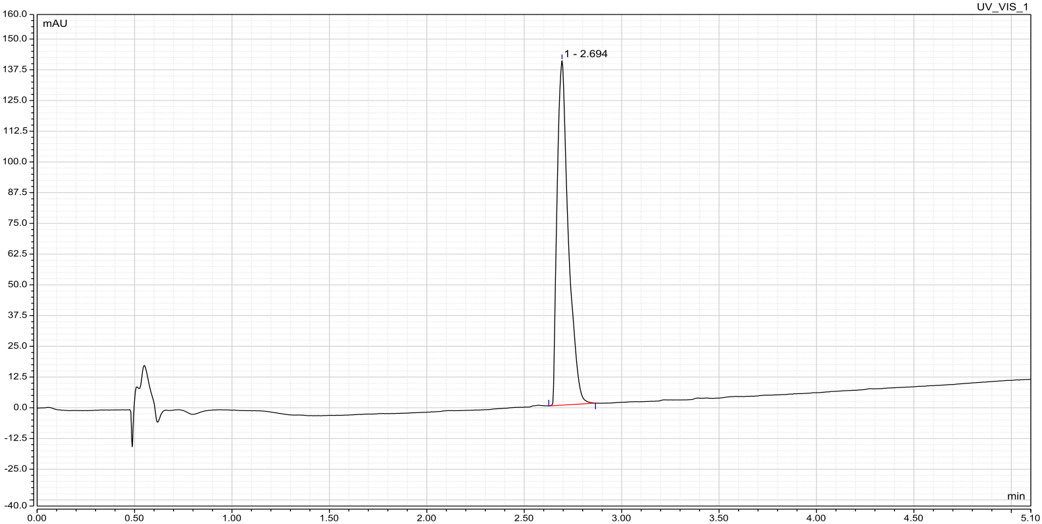

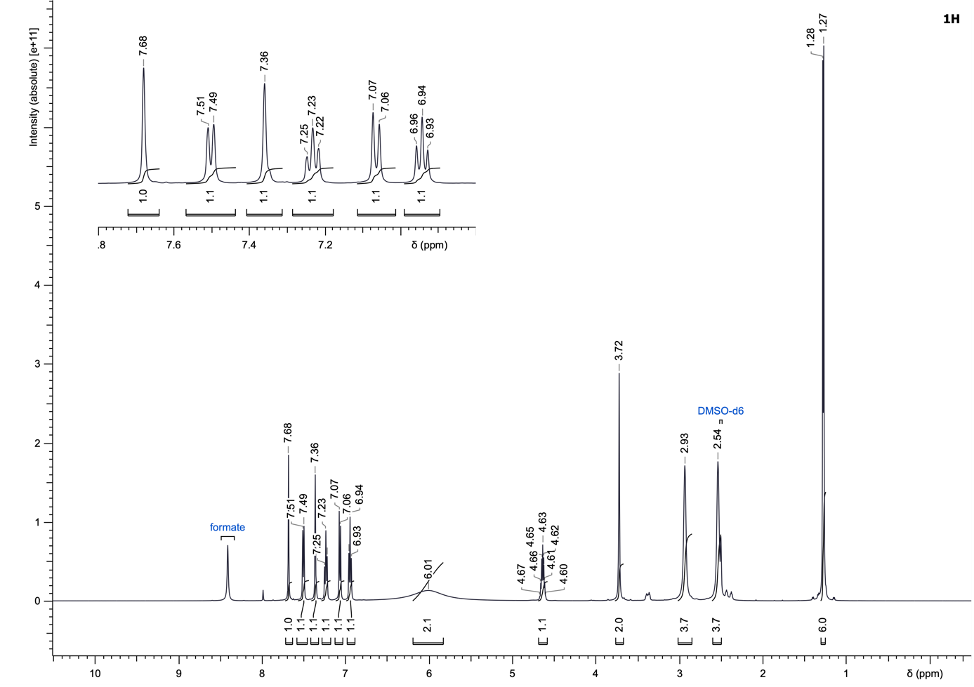
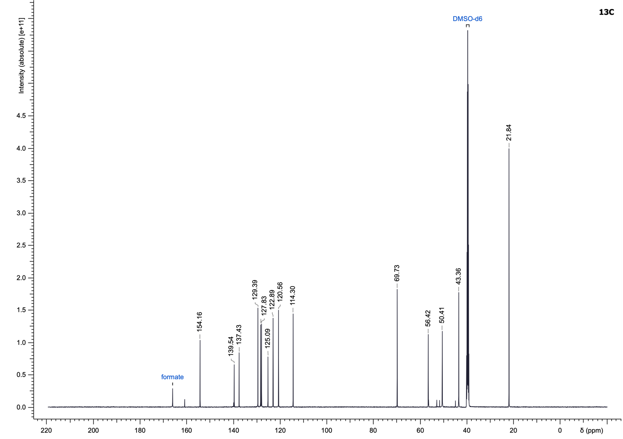

4-((4-(3-Isopropoxyphenyl)thiophen-2-yl)methyl)piperazin-1-ium formate (26)
Compound 26 was synthesized according to the General Procedure C using 1-((4-bromothiophen-2-yl)methyl)piperazine dihydrochloride (897.94 µmol) and (3-isopropoxyphenyl)boronic acid as starting materials. The reaction mixture was heated at 80 °C for 120 min. Then (3-isopropoxyphenyl)boronic acid (1.0 eq) was added, the vial was sealed, evacuated and backfilled with N₂ (three times) and the resulting mixture was further degassed by sparging with N₂ for 30 min, after which the vial was resealed and heated at 80 °C for 30 min. The compound was purified using water/acetonitrile + 1% formic acid (5 to 45% acetonitrile) to yield a dark orange solid (263.0 mg, 81%).
LC–MS (ESI): t_{R} = 2.70 min; > 99% purity (UV at 254 nm);
¹H NMR (500 MHz, DMSO-d₆): δ 7.78 (s, 1H), 7.42 (s, 1H), 7.28 (t, J = 8.0 Hz, 1H), 7.20 (br d, J = 7.9 Hz, 1H), 7.18 (s, 1H), 6.82 (br d, J = 8.1 Hz, 1H), 5.59 (br s, 2H), 4.68 (sept, J = 6.1 Hz, 1H), 3.75 (s, 2H), 3.04 (br s, 4H), 2.60 (br s, 4H), 1.27 (d, J = 6.1 Hz, 6H);
¹³C NMR (126 MHz, DMSO-d₆): δ 158.4, 141.9, 141.0, 137.0, 130.4, 126.2, 121.4, 118.5, 114.6, 113.7, 69.5, 56.5, 49.7 (2C), 43.3 (2C), 22.3 (2C);
HRMS (ESI⁺) m/z: [M+H]⁺ calculated for C₁₈H₂₄N₂OS, 317.1682; found, 317.1682.

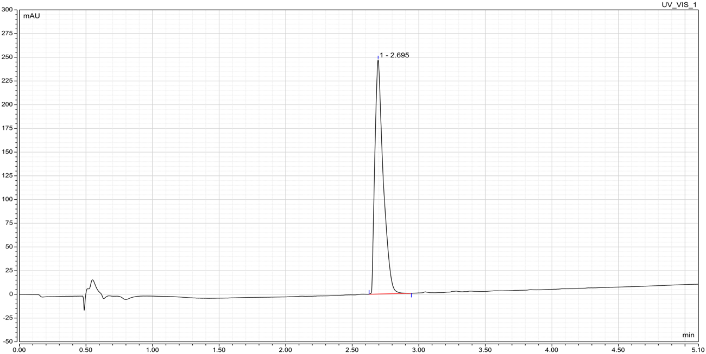

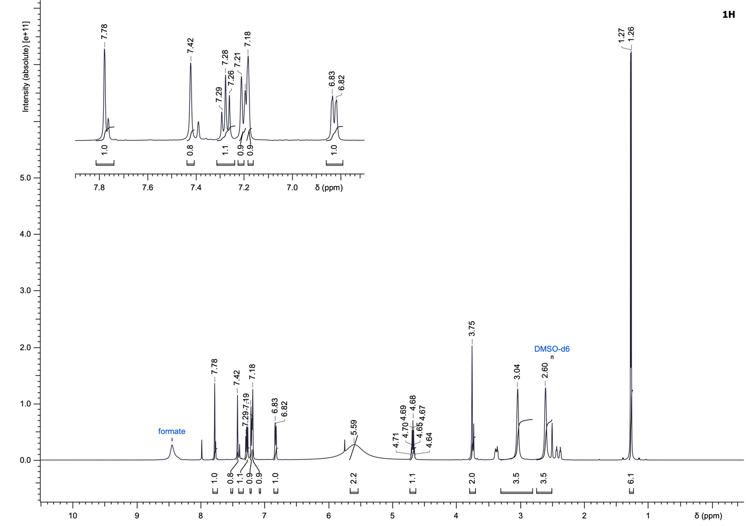
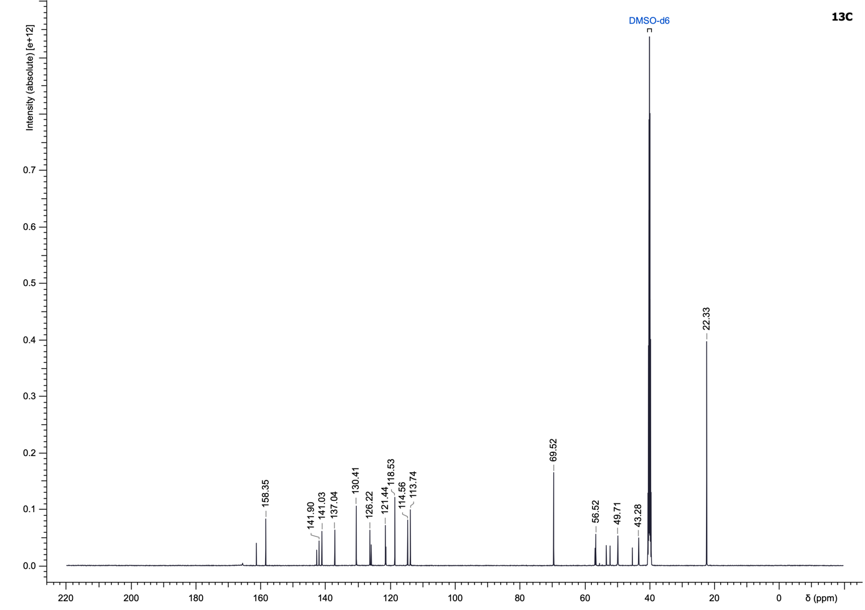

(R)-1-(4-(4-Chlorobenzoyl)piperazin-1-yl)-2,3-diphenylpropan-1-one (27)
Compound 27 was synthesized according to the General Procedure D using (R)-2,3-diphenylpropanoic acid and (4-chlorophenyl)(piperazin-1-yl)methanone (356.05 µmol) as starting materials and purified using water/acetonitrile + 0.05% formic acid (5 to 100% acetonitrile) to yield a white solid (15.8 mg, 10%).
LC–MS (ESI): t_{R} = 3.83 min; 97% purity (UV at 254 nm);
¹H NMR (500 MHz, CDCl₃): δ 7.36 (br d, J = 8.1 Hz, 2H), 7.31–7.16 (m, 10H), 7.08 (br d, J = 7.2 Hz, 2H), 4.09–3.54 (m, 3H), 3.50 (dd, J = 13.5, 8.0 Hz, 1H), 3.41 (br s, 5H), 2.96 (br dd, J = 13.4, 6.4 Hz, 2H);
¹³C NMR (126 MHz, CDCl₃): δ 171.4, 169.5, 139.8, 139.4, 136.3, 133.6, 129.4 (2C), 129.1 (2C), 129.0 (2C), 128.7 (2C), 128.4 (2C), 128.0 (2C), 127.5, 126.5, 51.3, 47.5, 45.6, 42.1 (2C), 41.1;
HRMS (ESI⁺) m/z: [M+H]⁺ calculated for C₂₆H₂₅ClN₂O₂, 433.1678; found, 433.1683.

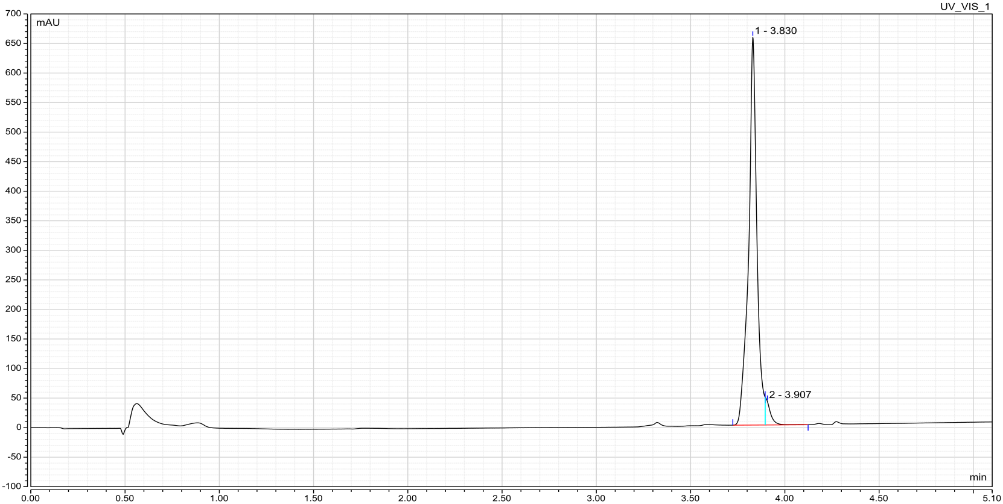

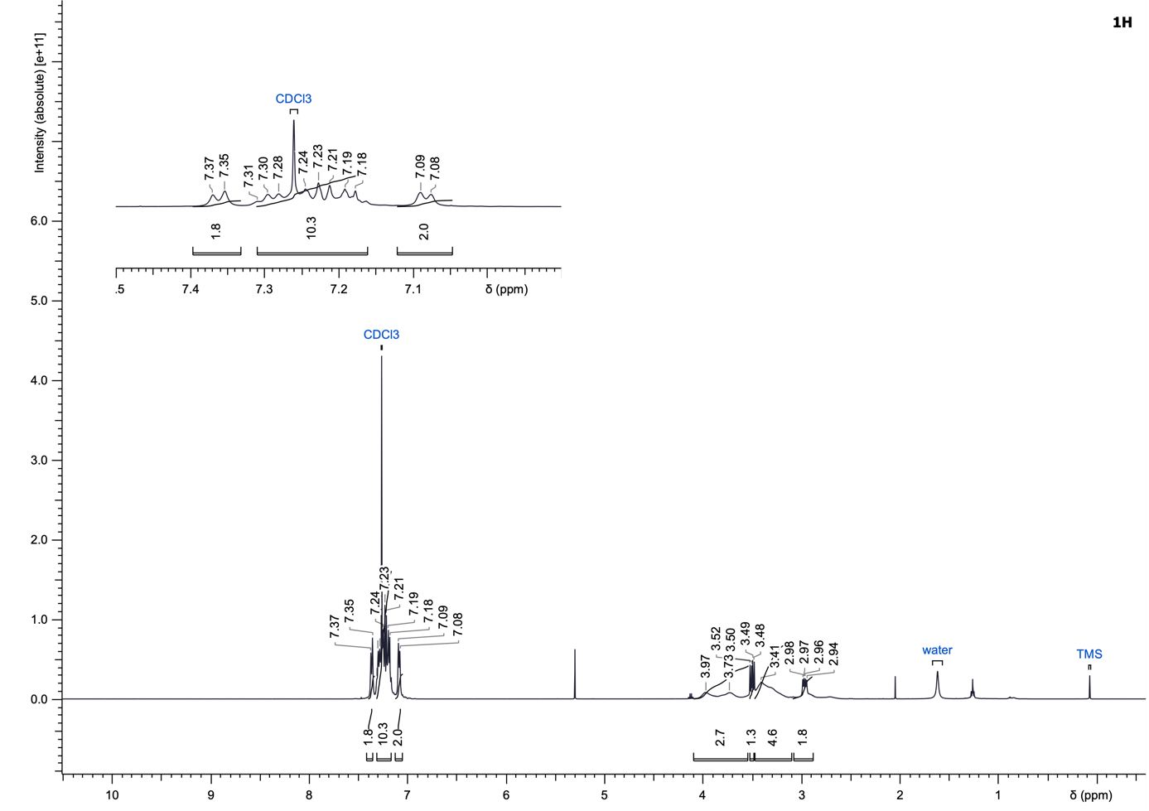
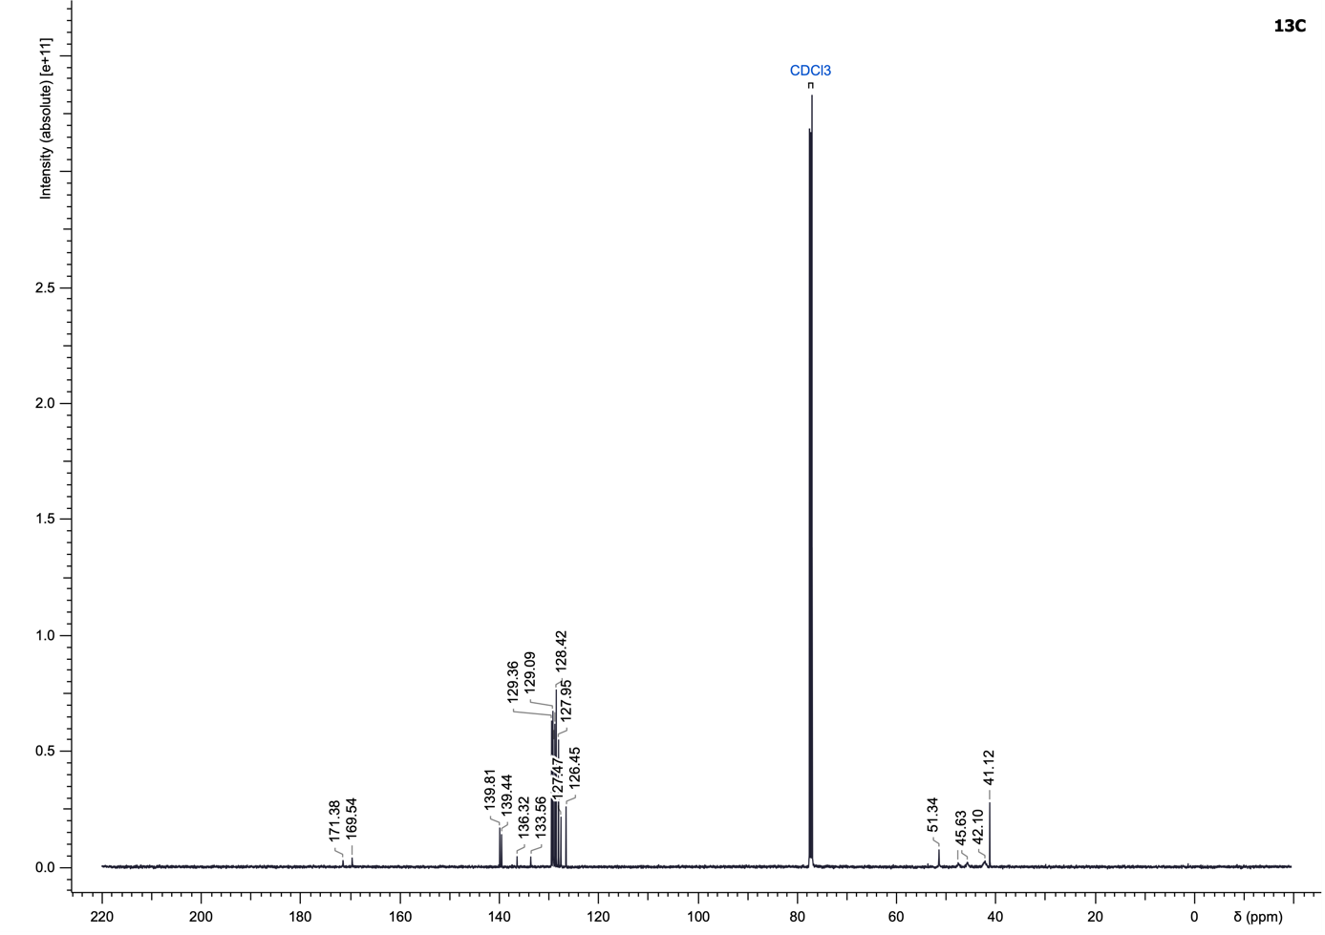

1-(4-(4-Chlorobenzoyl)piperazin-1-yl)-2-(3-(trifluoromethyl)phenyl)ethan-1-one (28)
Compound 28 was synthesized according to the General Procedure D using 2-(3-(trifluoromethyl)phenyl)acetic acid and (4-chlorophenyl)(piperazin-1-yl)methanone (222.53 µmol) as starting materials and purified using water/acetonitrile + 0.05% formic acid (5 to 100% acetonitrile) to yield a white solid (22.1 mg, 24%).
LC–MS (ESI): t_{R} = 3.51 min; 98% purity (UV at 254 nm);
¹H NMR (500 MHz, CDCl₃): δ 7.58–7.47 (m, 2H), 7.47–7.42 (m, 2H), 7.42–7.38 (m, 2H), 7.36–7.32 (m, 2H), 3.81 (br s, 2H), 3.77–3.15 (m, 8H);
¹³C NMR (126 MHz, CDCl₃): δ 169.7, 169.0, 136.5, 135.6, 133.4, 132.4, 131.3 (q, J = 32.4 Hz), 129.4, 129.1 (2C), 128.8 (2C), 125.7, 124.2 (q, J = 3.7 Hz), 47.5 (2C), 46.0, 42.1 (2C), 40.5;
¹⁹F NMR (470 MHz, DMSO-d₆): δ -61.0;
HRMS (ESI⁺) m/z: [M+H]⁺ calculated for C₂₀H₁₈ClF₃N₂O₂, 411.1082; found, 411.1085.

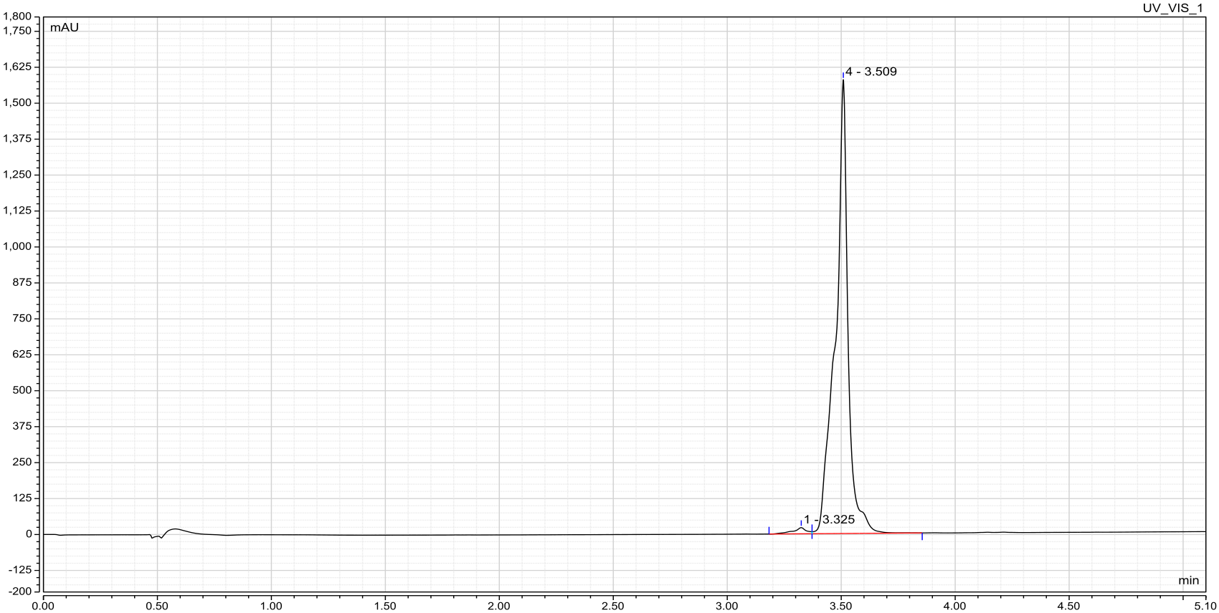

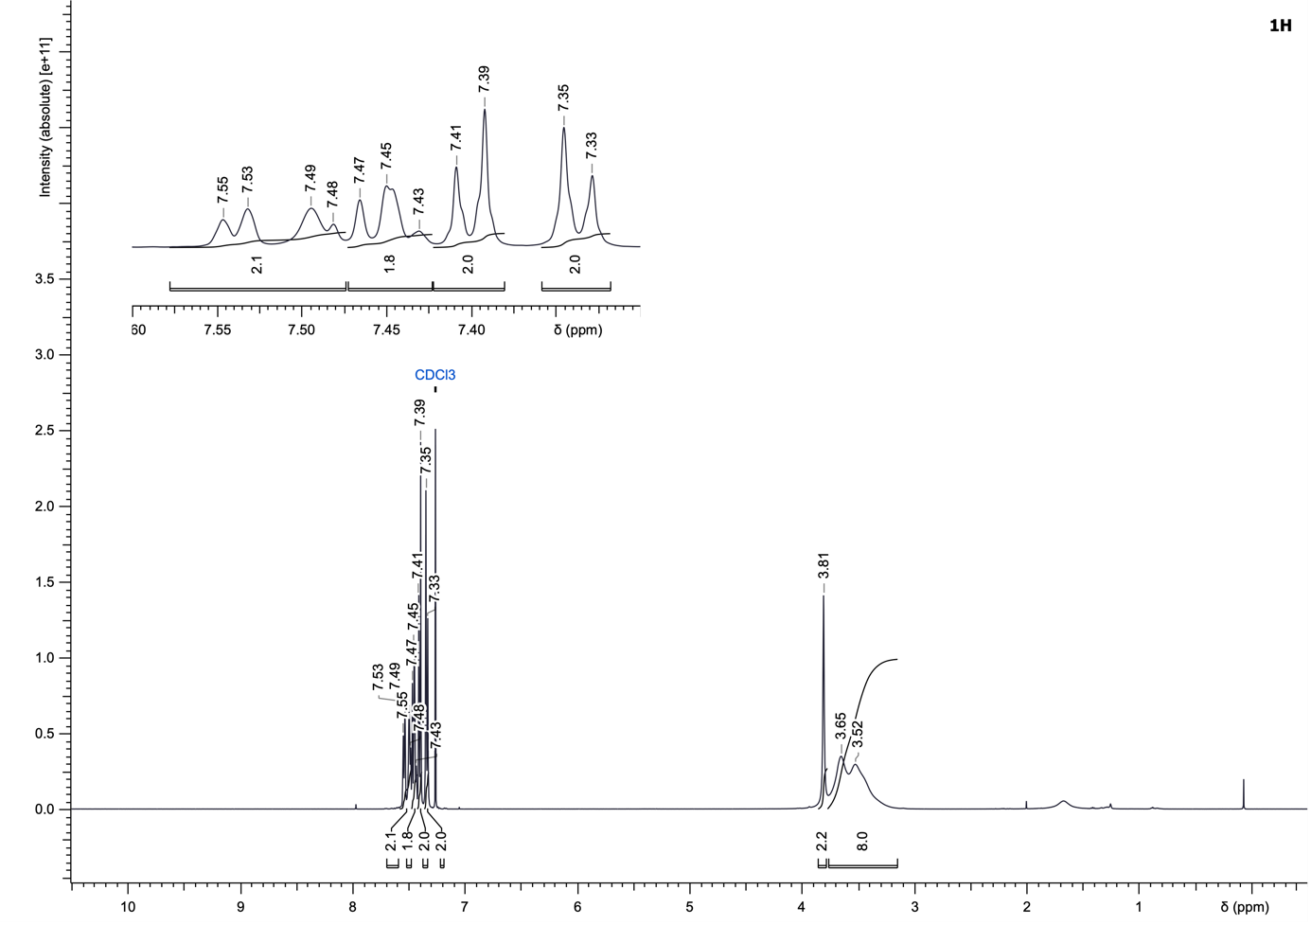
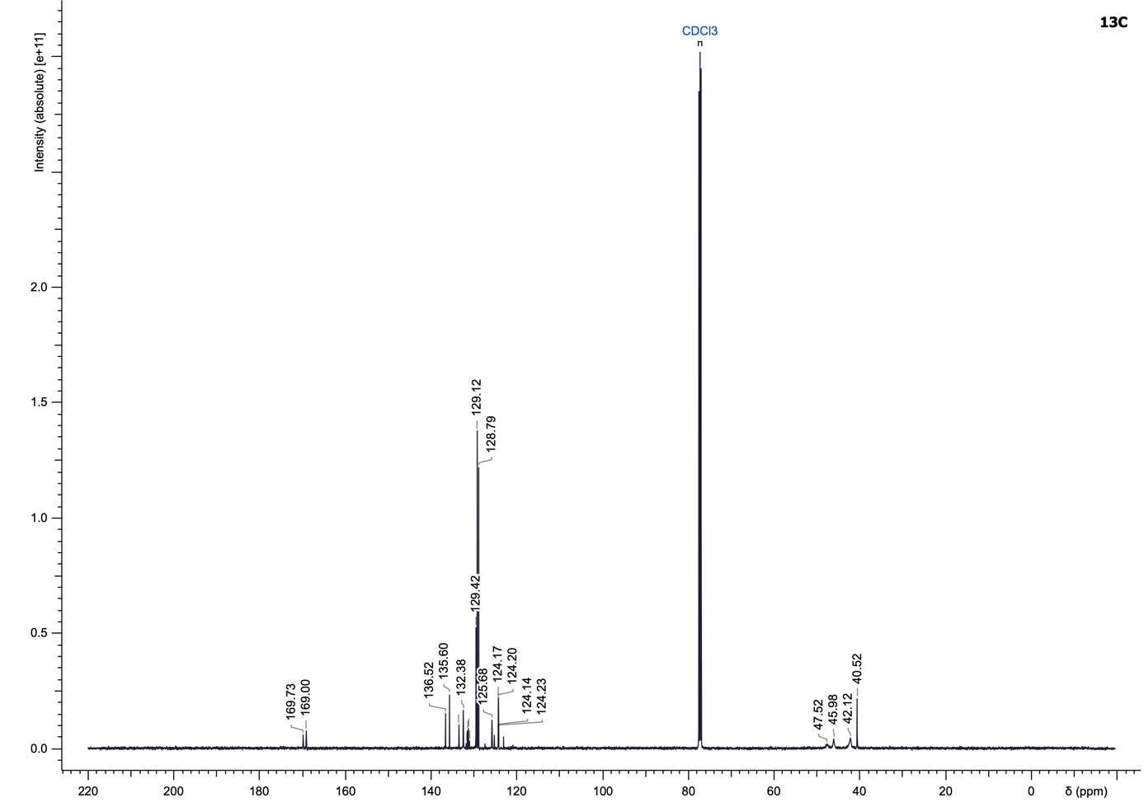
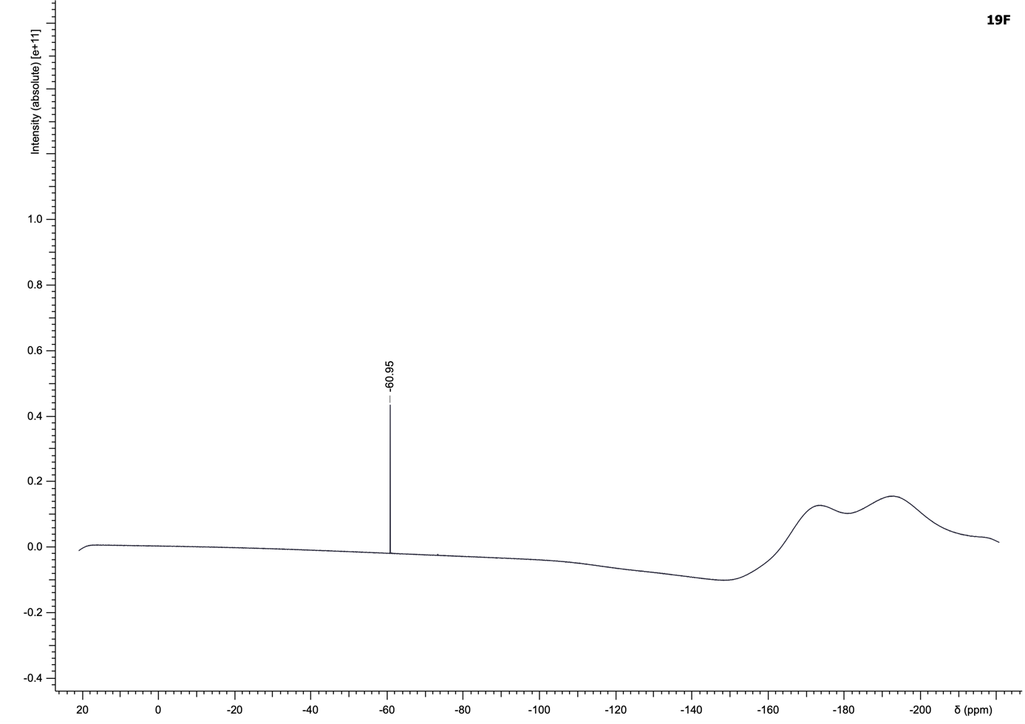

(4-(4-Chlorobenzoyl)piperazin-1-yl)(3,5-dichloropyridin-4-yl)methanone (29)
To a solution of 3,5-dichloroisonicotinic acid (1.2 eq) in DMF (0.2 M) were added triethylamine (3.0 eq), EDC·HCl (2.0 eq), HOBt hydrate (2.0 eq), followed by (4-chlorophenyl)(piperazin-1-yl)methanone (240.33 µmol, 1.0 eq). The reaction mixture was stirred at room temperature overnight. Upon completion, the reaction mixture was diluted with ethyl acetate (10 mL), washed with a cold mixture of water/brine (1:1, 3 × 15 mL) and brine (15 mL), dried over MgSO₄ and concentrated under reduced pressure. The crude product was purified by normal-phase flash chromatography on silica gel using a gradient of cyclohexane/ethyl acetate (25 to 100% ethyl acetate) to yield the desired amide 29 as a white solid (23.9 mg, 25%).
LC–MS (ESI): t_{R} = 3.08 min; > 99% purity (UV at 254 nm);
¹H NMR (500 MHz, CDCl₃): δ 8.56 (s, 2H), 7.41 (br d, J = 7.6 Hz, 2H), 7.37 (br d, J = 8.1 Hz, 2H), 3.97–3.40 (m, 6H), 3.27 (br s, 2H);
¹³C NMR (126 MHz, CDCl₃): δ 169.8, 161.7, 148.0 (2C), 141.5, 136.7, 133.2, 129.2 (2C), 128.8 (2C), 128.7 (2C), 46.2 (2C), 41.8 (2C);
HRMS (ESI⁺) m/z: [M+H]⁺ calculated for C₁₇H₁₄Cl₃N₃O₂, 398.0225; found, 398.0228.

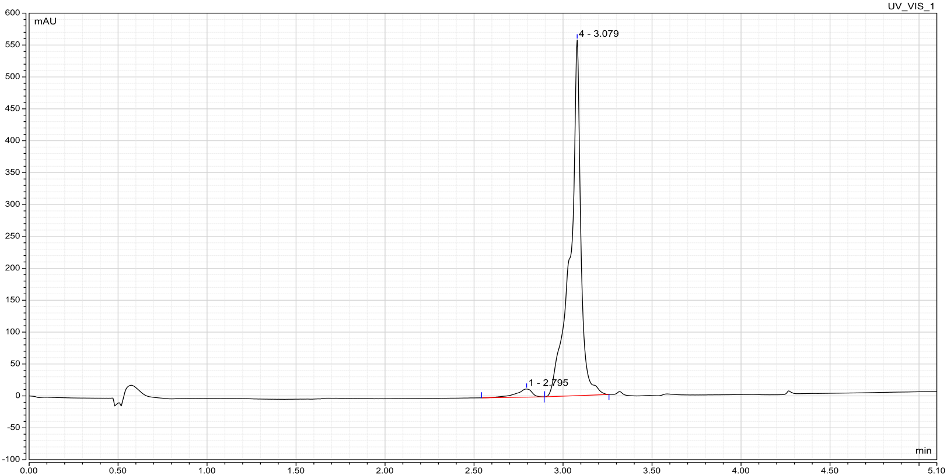

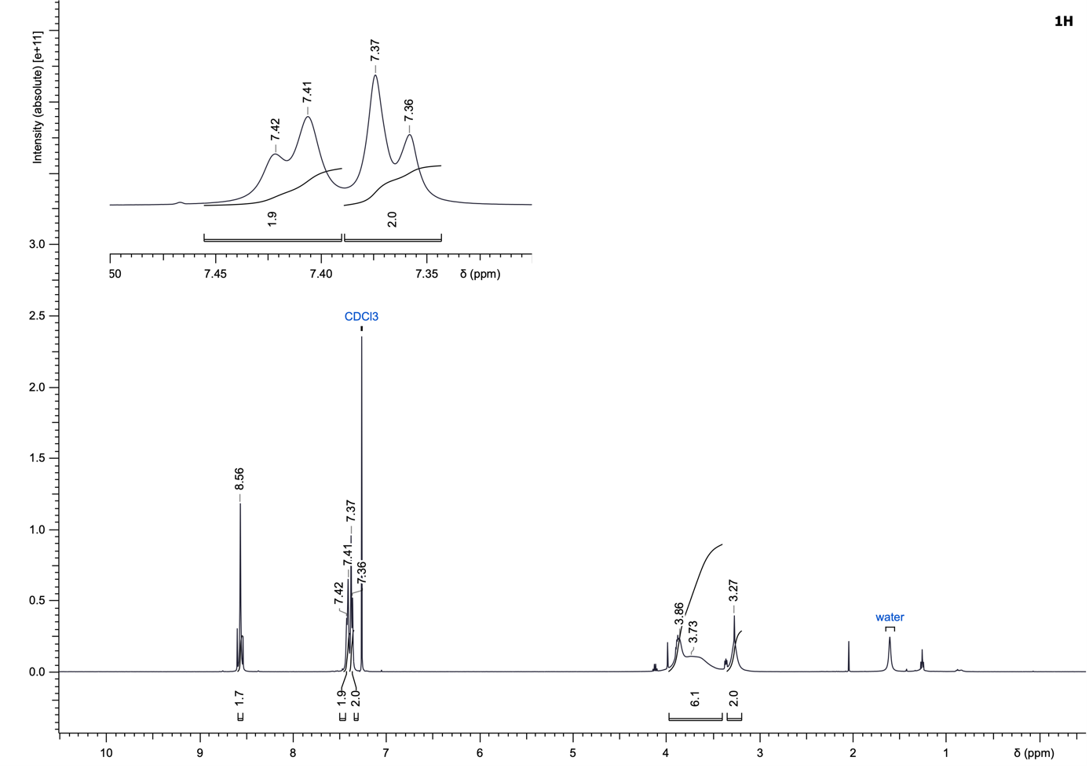
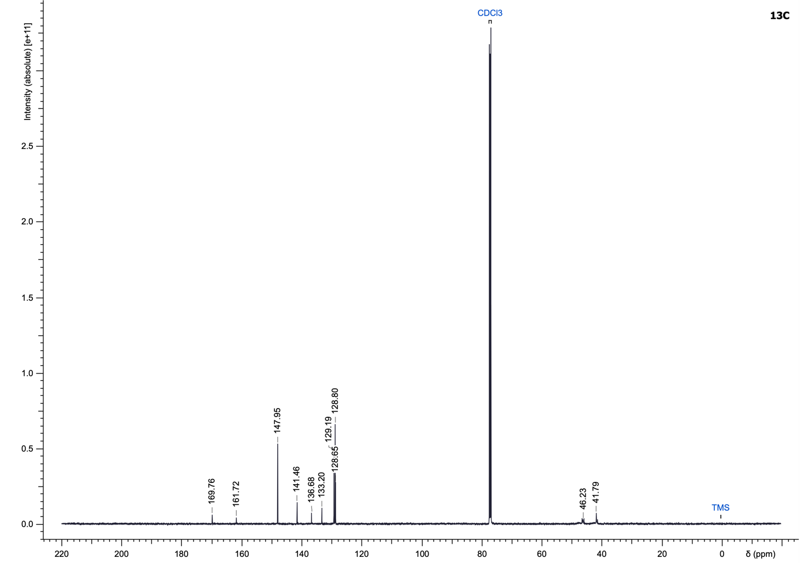

1-(4-(4-Chlorobenzoyl)piperazin-1-yl)-3-phenylpropan-1-one (30)
Compound 30 was synthesized according to the General Procedure E using 3-phenylpropanoic acid and (4-chlorophenyl)(piperazin-1-yl)methanone (267.04 µmol) as starting materials and purified using cyclohexane/ethyl acetate (25 to 100% ethyl acetate) to yield a white solid (33.6 mg, 35%).
LC–MS (ESI): t_{R} = 3.29 min; > 99% purity (UV at 254 nm);
¹H NMR (500 MHz, CDCl₃): δ 7.43–7.37 (m, 2H), 7.35–7.27 (m, 4H), 7.25–7.19 (m, 3H), 3.60 (br s, 4H), 3.41 (br s, 4H), 2.99 (t, J = 7.7 Hz, 2H), 2.65 (br s, 2H);
¹³C NMR (126 MHz, CDCl₃): δ 171.1, 169.7, 141.0, 136.4, 133.5, 129.1 (2C), 128.8 (2C), 128.7 (2C), 128.6 (2C), 126.5, 47.5, 45.5, 42.3, 41.8, 35.1, 31.7;
HRMS (ESI⁺) m/z: [M+H]⁺ calculated for C₂₀H₂₁ClN₂O₂, 357.1365; found, 357.1464.

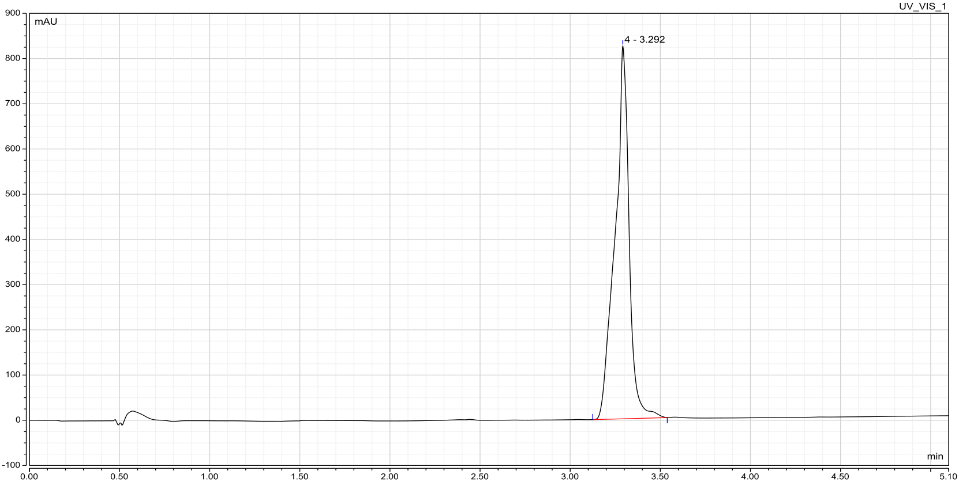

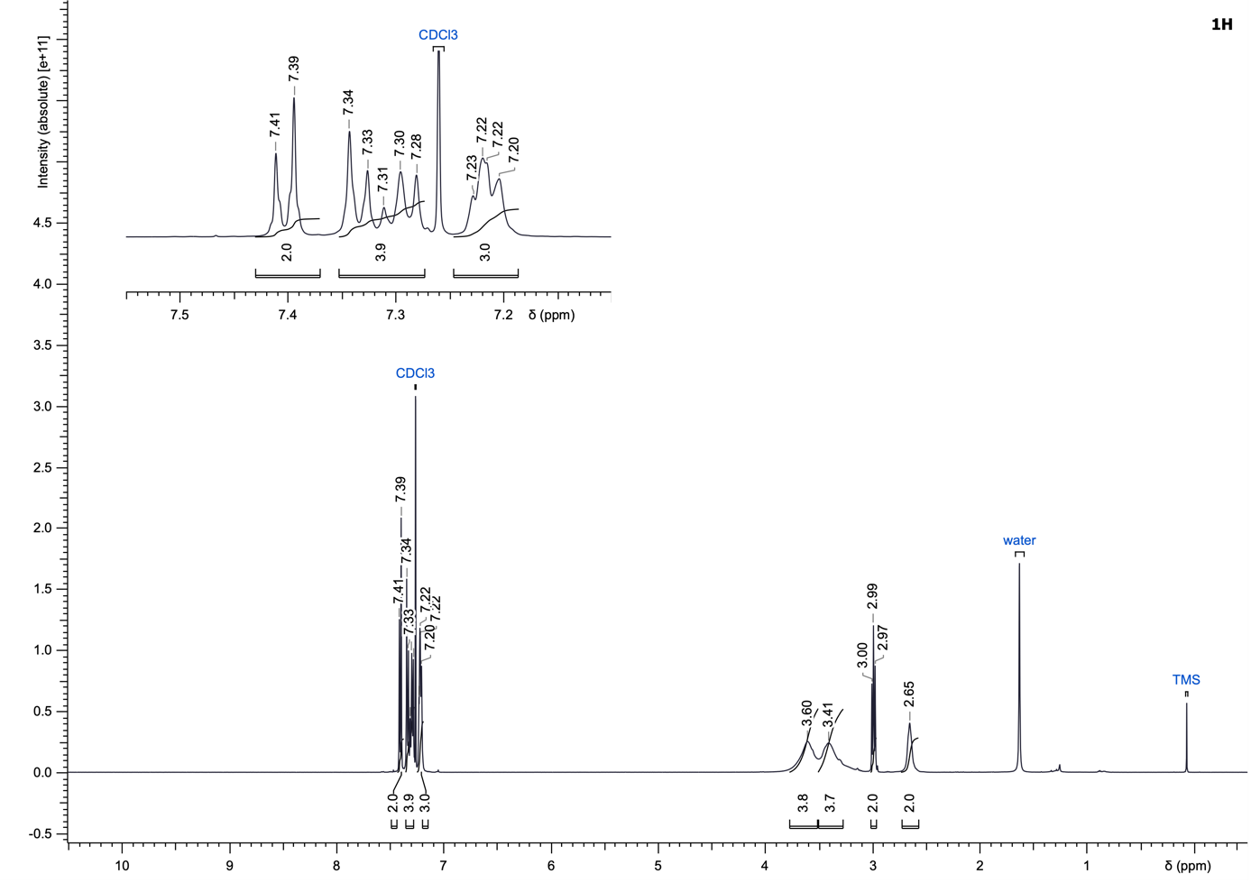
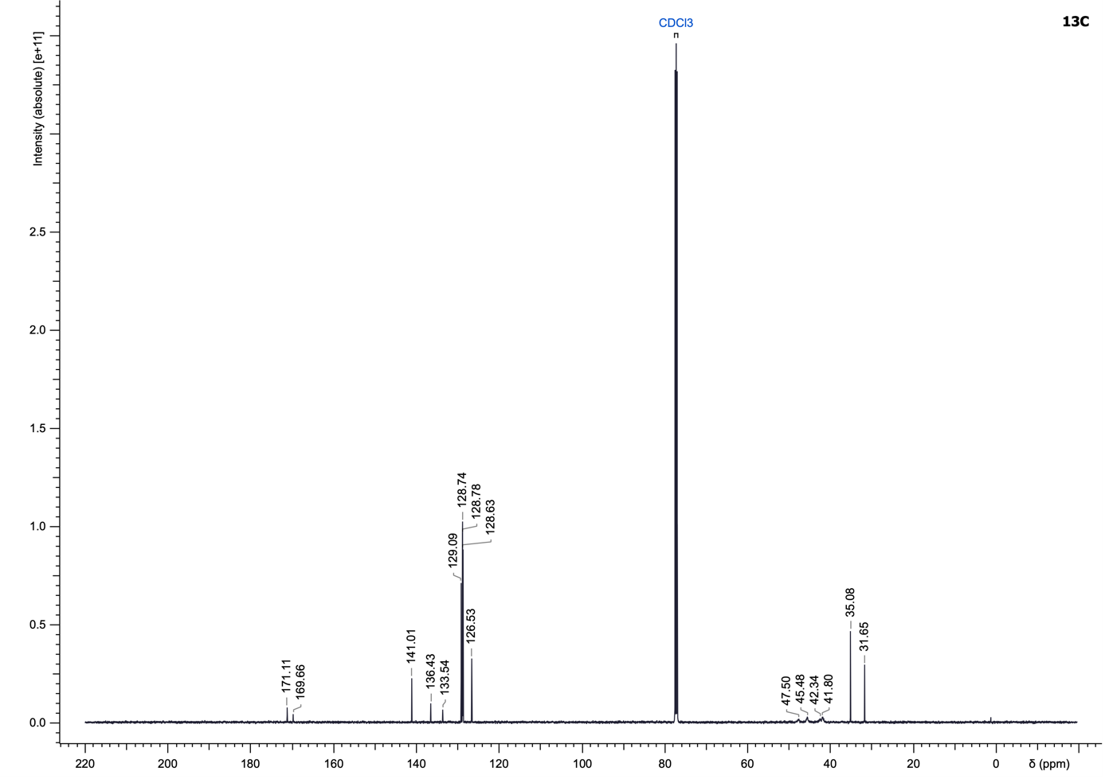

(4-(4-Chlorobenzoyl)piperazin-1-yl)(3-isopropylphenyl)methanone (31)
To a solution of 3-isopropylbenzoic acid (1.2 eq) in DCM (0.2 M) were added triethylamine (4.0 eq) and (4-chlorophenyl)(piperazin-1-yl)methanone (267.04 µmol, 1.0 eq). The reaction mixture was stirred under N₂ in an ice bath for 15 min, then propylphosphonic anhydride (50% in EtOAc, 2.0 eq) was added dropwise to the reaction mixture. Upon completion, the reaction mixture was diluted with ethyl acetate (10 mL), washed with saturated NaHCO₃ (2 × 10 mL) and water (10 mL). The combined aqueous phases were back-extracted with ethyl acetate (2 × 15 mL). All organic phases were combined, dried over MgSO₄ and concentrated under reduced pressure. The crude product was purified by reversed-phase preparative HPLC using a gradient of water/acetonitrile + 0.05% formic acid (5 to 100% acetonitrile) to yield the desired amide 31 as a white solid (54.4 mg, 55%).
LC–MS (ESI): t_{R} = 3.60 min; > 99% purity (UV at 254 nm);
¹H NMR (500 MHz, CDCl₃): δ 7.41 (br d, J = 7.9 Hz, 2H), 7.36 (br d, J = 8.2 Hz, 2H), 7.34–7.28 (m, 2H), 7.27 (s, 1H), 7.23–7.16 (m, 1H), 3.73 (br s, 4H), 3.53 (br s, 4H), 2.93 (sept, J = 6.9 Hz, 1H), 1.25 (d, J = 6.9 Hz, 6H);
¹³C NMR (126 MHz, CDCl₃): δ 171.2, 169.8, 149.7, 136.4, 135.1, 133.6, 129.1 (2C), 128.8 (2C), 128.7, 128.5, 125.3, 124.5, 47.8 (2C), 42.6 (2C), 34.2, 24.0 (2C);
HRMS (ESI⁺) m/z: [M+H]⁺ calculated for C₂₁H₂₃ClN₂O₂, 371.1521; found, 371.1523.

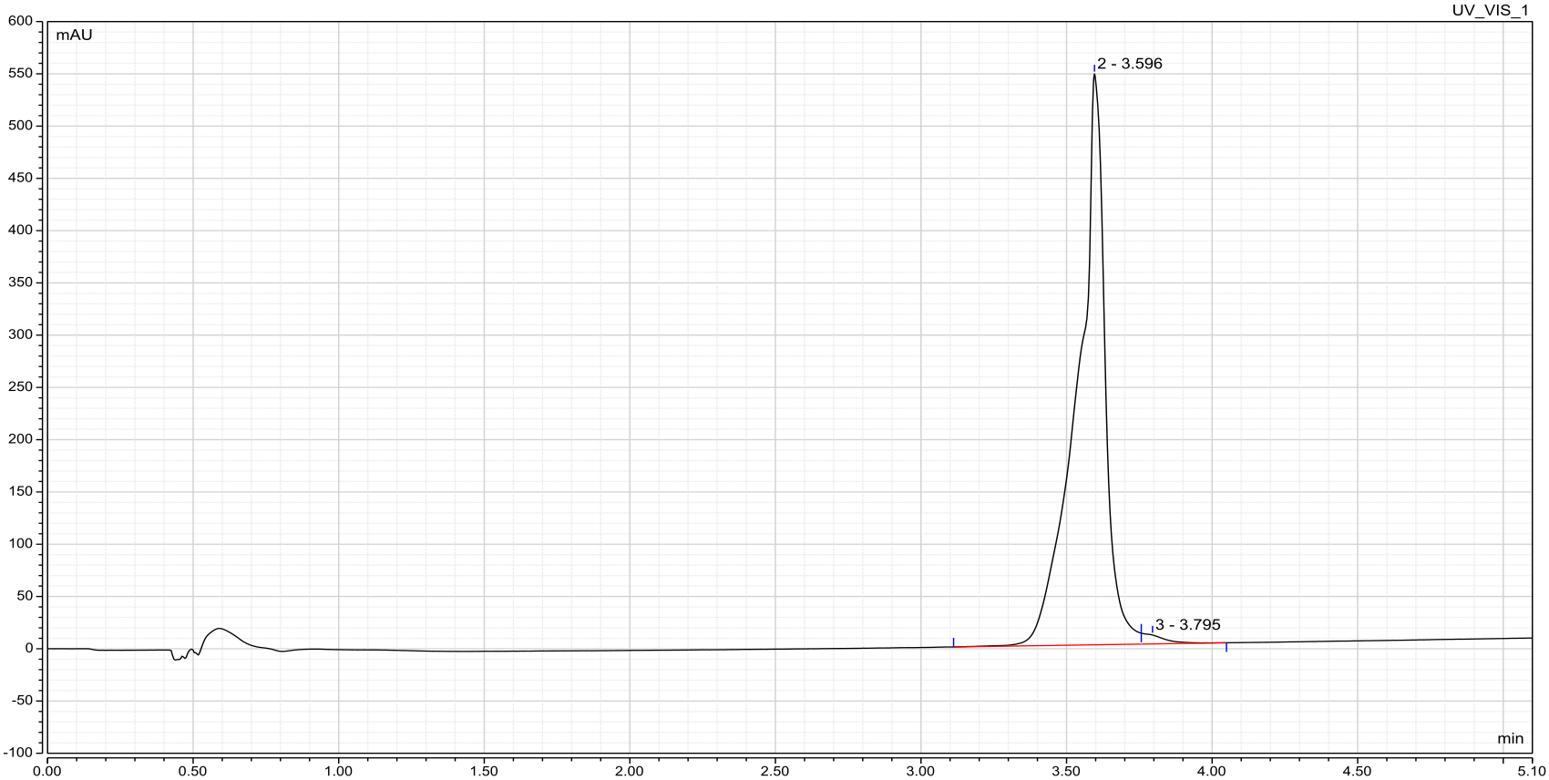

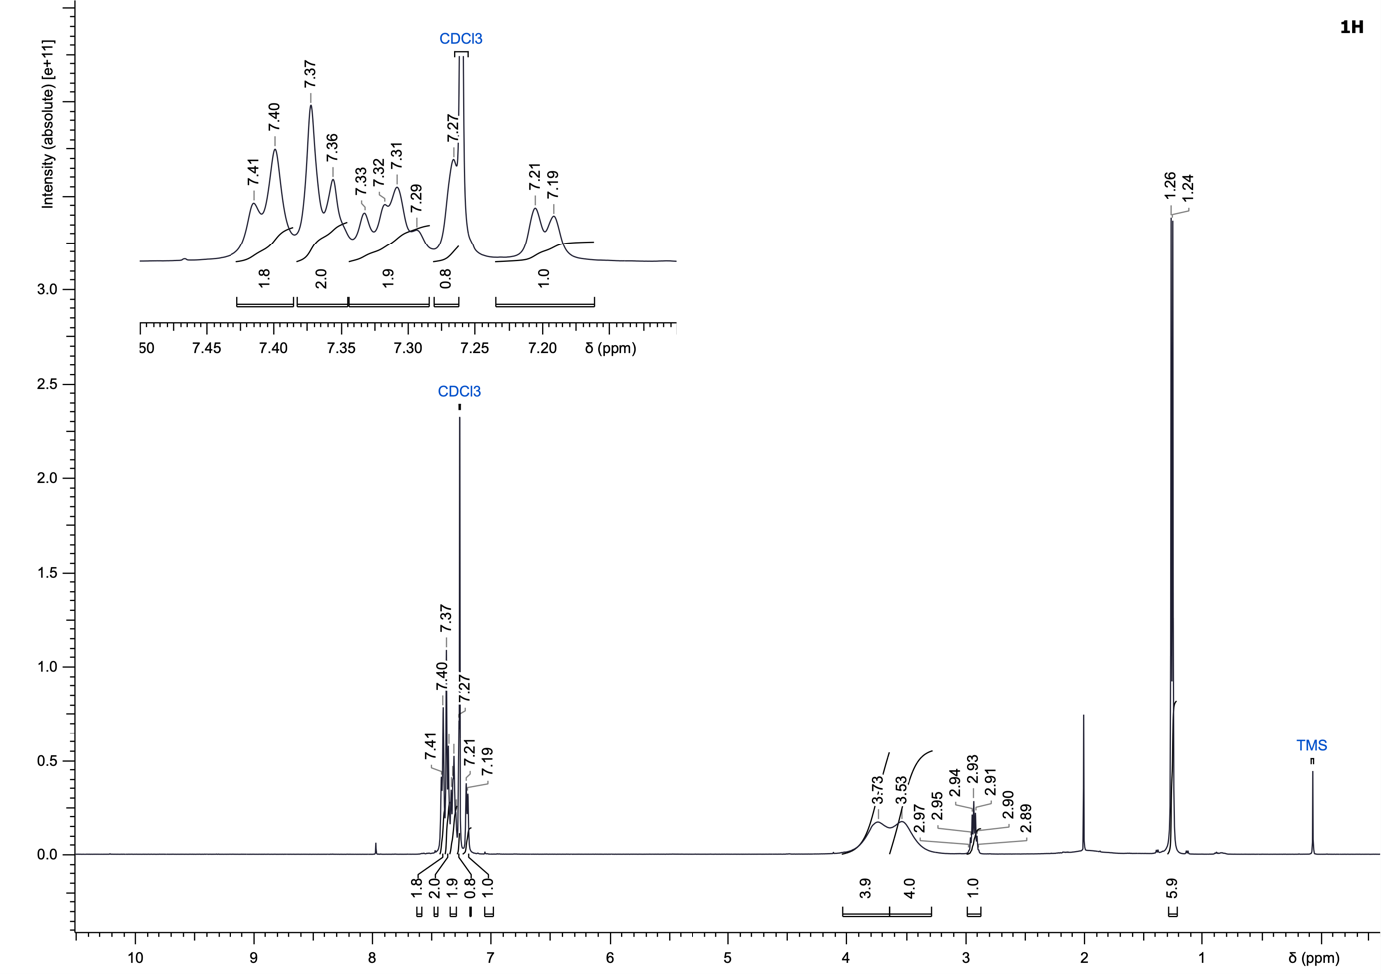
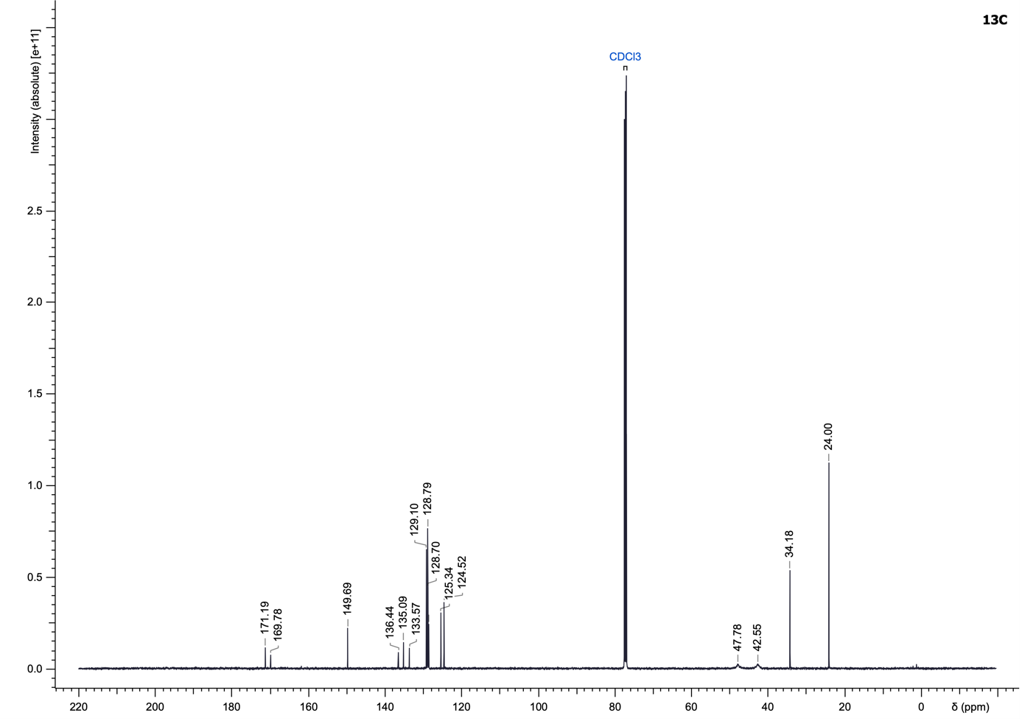

1-(4-(4-Chlorobenzoyl)piperazin-1-yl)-4-phenylbutan-1-one (32)
Compound 32 was synthesized according to the General Procedure E using 4-phenylbutanoic acid and (4-chlorophenyl)(piperazin-1-yl)methanone (267.04 µmol) as starting materials and purified using cyclohexane/ethyl acetate (25 to 100% ethyl acetate) to yield a colourless gel (35.7 mg, 36%).
LC–MS (ESI): t_{R} = 3.45 min; 96% purity (UV at 254 nm);
¹H NMR (500 MHz, CDCl₃): δ 7.43–7.39 (m, 2H), 7.37–7.33 (m, 2H), 7.30–7.27 (m, 2H), 7.22–7.16 (m, 3H), 3.61 (br s, 4H), 3.43 (br s, 4H), 2.69 (t, J = 7.4 Hz, 2H), 2.34 (br s, 2H), 1.99 (quint, J = 7.5 Hz, 2H);
¹³C NMR (126 MHz, CDCl₃): δ 171.6, 169.7, 141.6, 136.4, 133.6, 129.1 (2C), 128.8 (2C), 128.61 (2C), 128.58 (2C), 126.2, 47.8, 45.4, 42.6, 41.8, 35.3, 32.4, 26.6;
HRMS (ESI⁺) m/z: [M+H]⁺ calculated for C₂₁H₂₃ClN₂O₂, 371.1521; found, 371.1522.

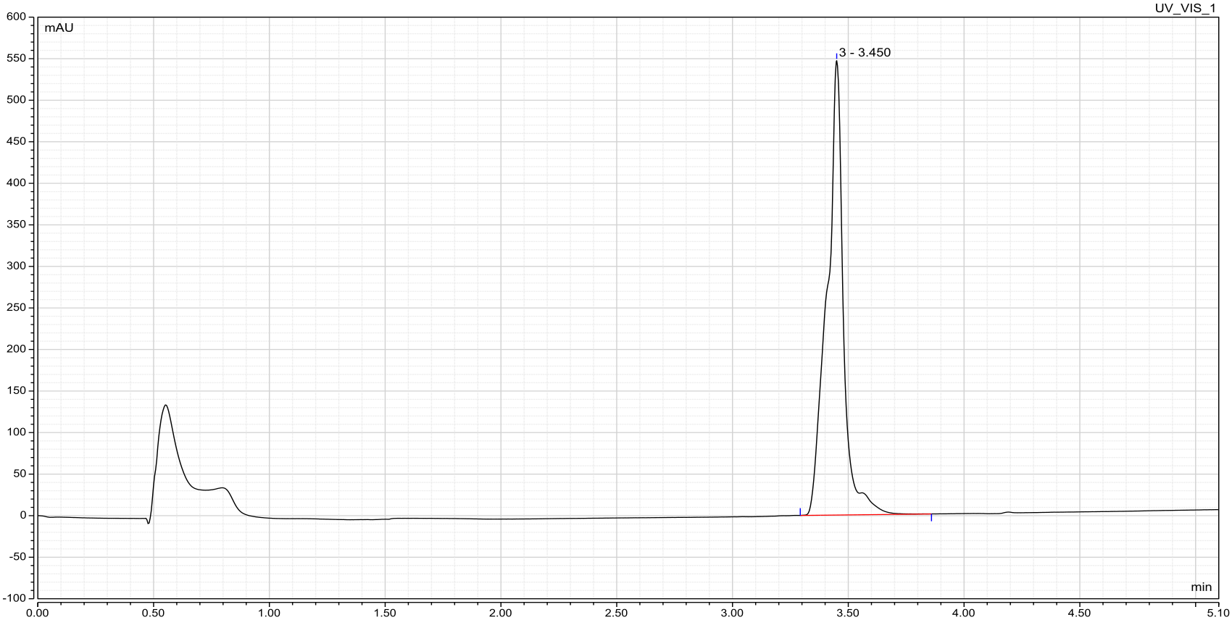

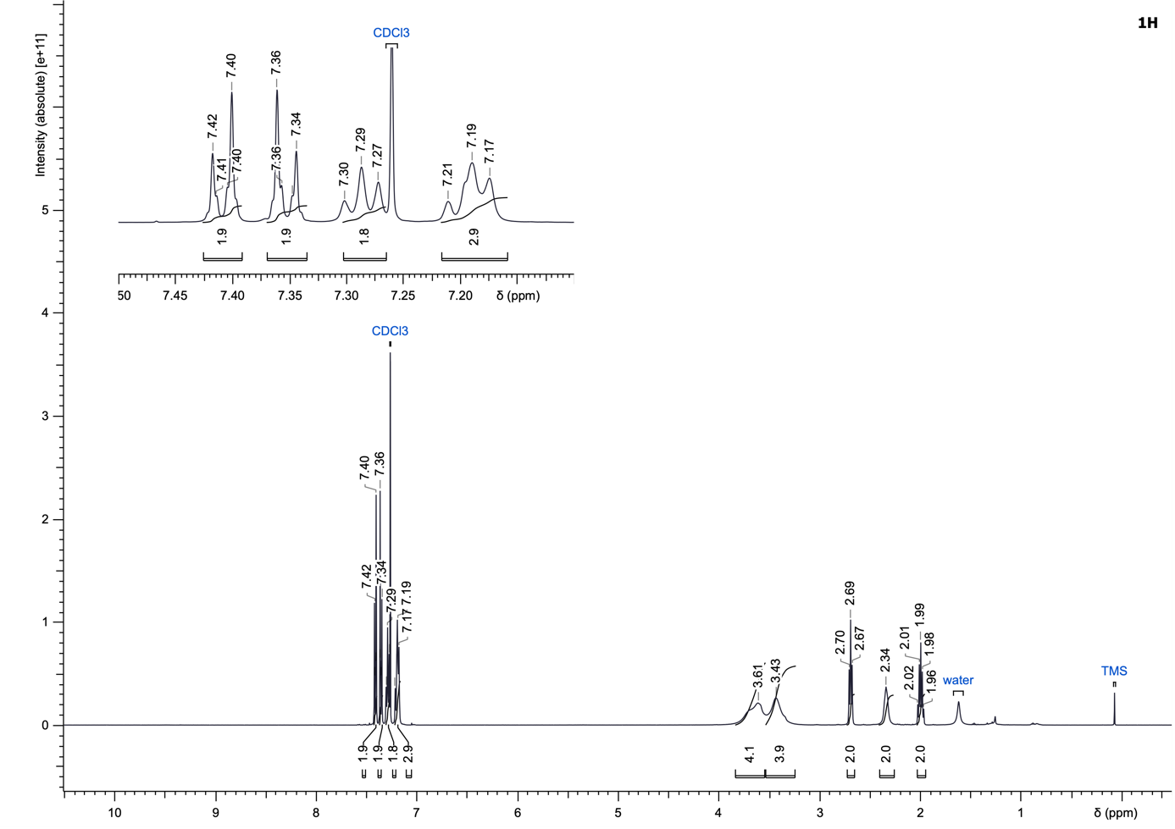
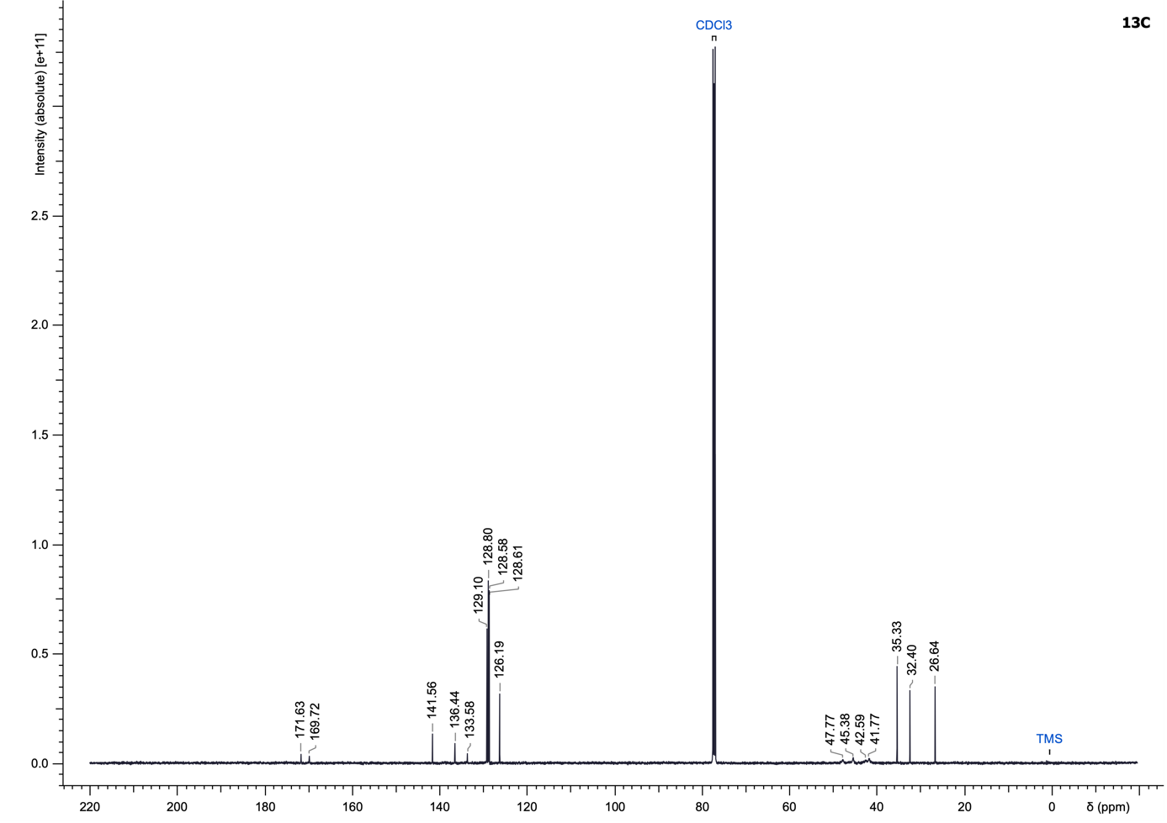

(E)-1-(4-(4-Chlorobenzoyl)piperazin-1-yl)-3-(3-hydroxyphenyl)prop-2-en-1-one (33)
Compound 33 was synthesized according to the General Procedure E using (E)-3-(3-hydroxyphenyl)acrylic acid and (4-chlorophenyl)(piperazin-1-yl)methanone (356.05 µmol) as starting materials and purified using dichloromethane/methanol (2 to 10% methanol) to yield a white gel (13.0 mg, 10%).
LC–MS (ESI): t_{R} = 2.94 min; > 99% purity (UV at 254 nm);
¹H NMR (500 MHz, DMSO-d₆): δ 9.53 (s, 1H), 7.56–7.51 (m, 2H), 7.51–7.39 (m, 3H), 7.26–7.16 (m, 2H), 7.13 (br s, 1H), 7.06 (br s, 1H), 6.79 (d, J = 7.5 Hz, 1H), 3.94–3.35 (m, 8H);
¹³C NMR (126 MHz, DMSO-d₆): δ 168.2, 164.7, 157.3, 142.1, 136.4, 134.5, 134.4, 129.7, 129.1 (2C), 128.6 (2C), 119.0, 117.8, 116.8, 114.5, 47.4, 47.0, 44.9, 41.7;
HRMS (ESI⁺) m/z: [M+H]⁺ calculated for C₂₀H₁₉ClN₂O₃, 371.1157; found, 371.1158.

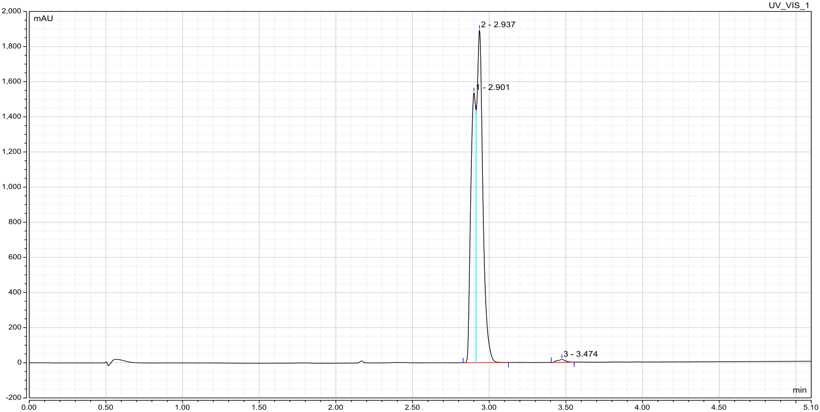

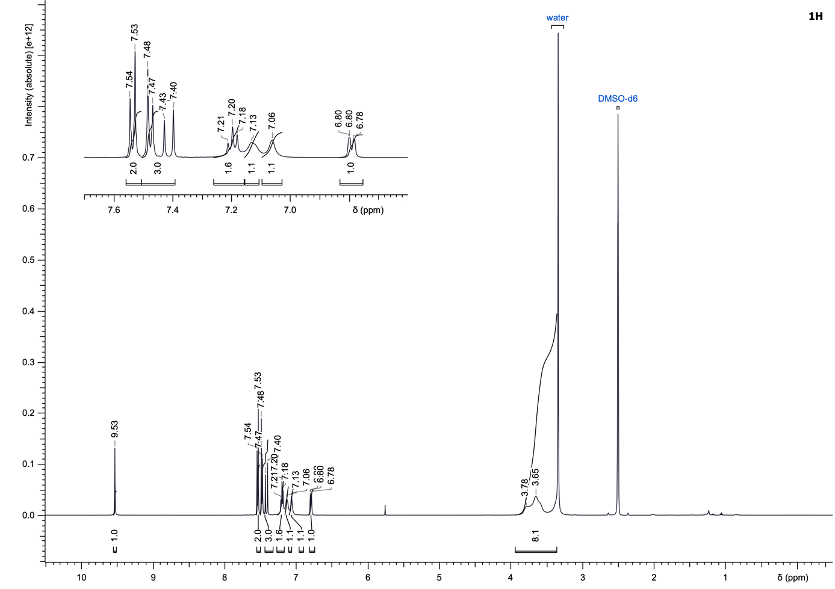
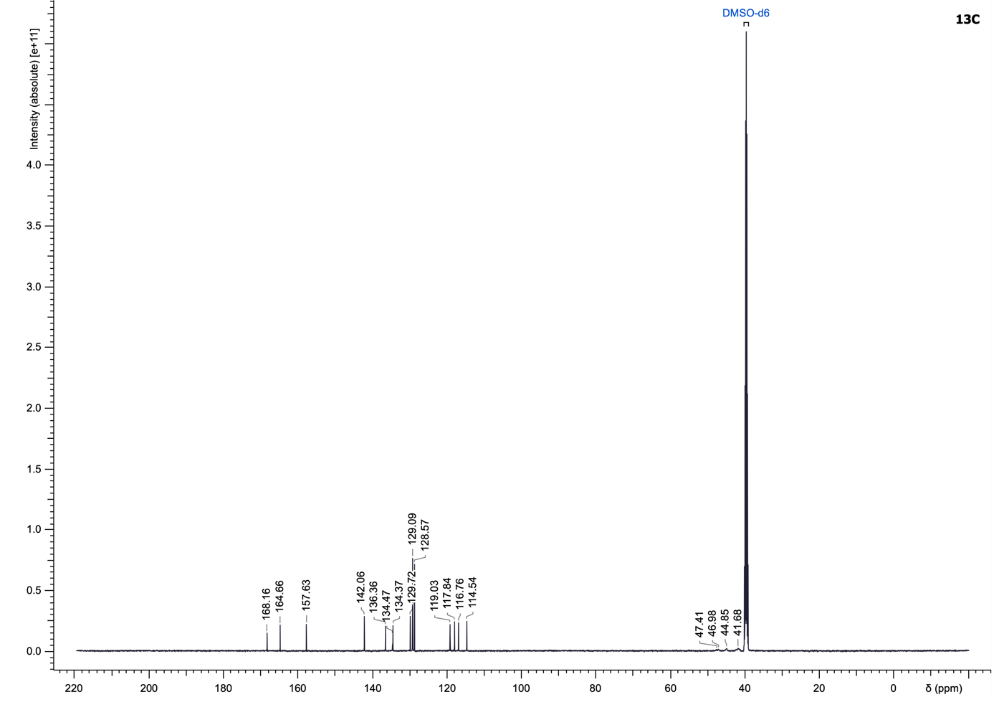

N-(2-(4-(4-Chlorobenzoyl)piperazin-1-yl)-2-oxoethyl)benzamide (34)
Compound 34 was synthesized according to the General Procedure E using benzoylglycine and (4-chlorophenyl)(piperazin-1-yl)methanone (311.54 µmol) as starting materials and purified using dichloromethane/methanol (1 to 6% methanol) to yield a colourless gel (77.0 mg, 64%).
LC–MS (ESI): t_{R} = 2.80 min; > 99% purity (UV at 254 nm);
¹H NMR (500 MHz, CDCl₃): δ 7.83 (d, J = 7.5 Hz, 2H), 7.55–7.49 (m, 1H), 7.47–7.41 (m, 4H), 7.39–7.37 (m, 2H), 4.29 (br s, 2H), 3.70 (br s, 4H), 3.53 (br s, 4H);
¹³C NMR (126 MHz, CDCl₃): δ 169.8, 167.4, 167.1, 136.7, 133.9, 133.3, 132.0, 129.2 (2C), 128.83 (2C), 128.77 (2C), 127.2 (2C), 44.6 (2C), 42.2 (2C), 41.9;
HRMS (ESI⁺) m/z: [M+H]⁺ calculated for C₂₀H₂₀ClN₃O₃, 386.1266; found, 386.1266.

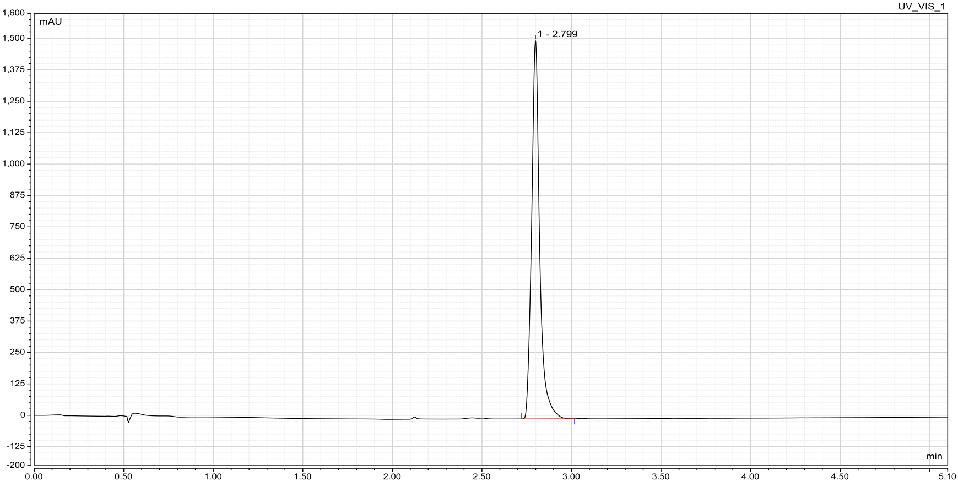

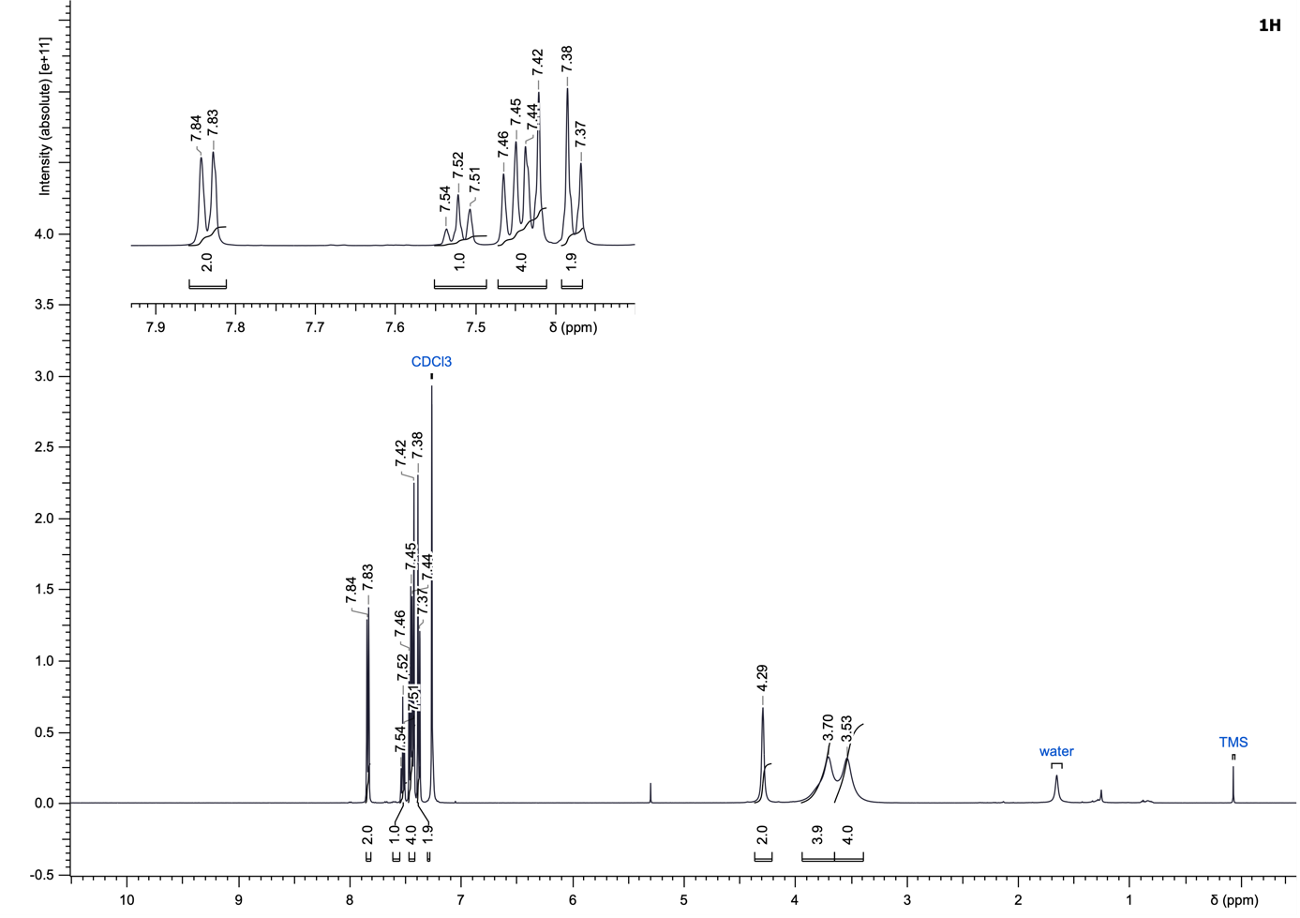
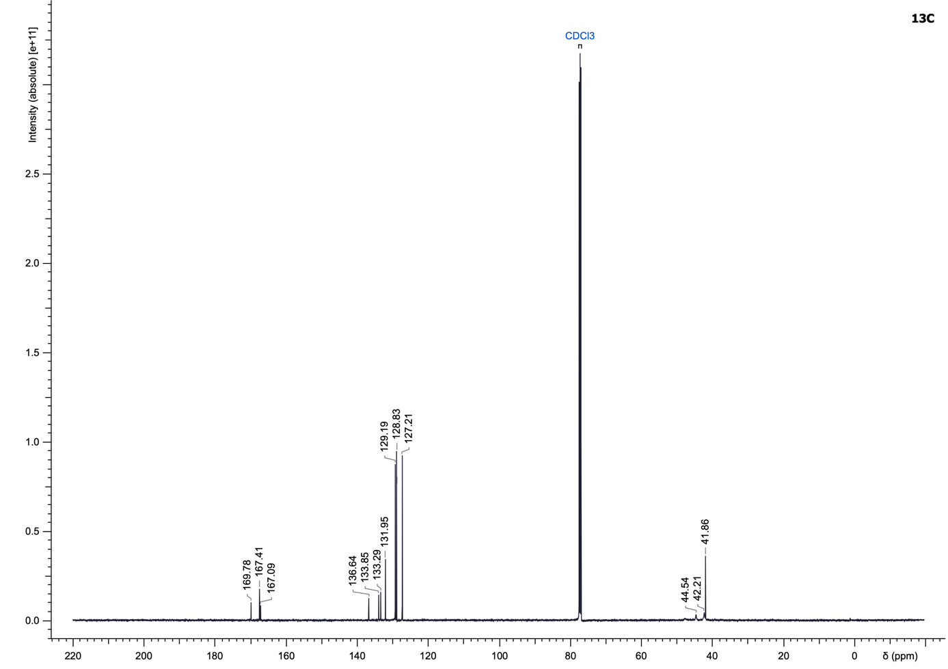

tert-Butyl (S)-(1-(4-(4-chlorobenzoyl)piperazin-1-yl)-1-oxo-4-phenylbutan-2-yl)carbamate (35)
Compound 35 was synthesized according to the General Procedure E using (S)-2-((tert-butoxycarbonyl)amino)-4-phenylbutanoic acid and (4-chlorophenyl)(piperazin-1-yl)methanone (351.60 µmol) as starting materials and purified using cyclohexane/ethyl acetate + 1% triethylamine (10 to 80% ethyl acetate) to yield a white solid (130.1 mg, 76%).
LC–MS (ESI): t_{R} = 3.79 min; > 99% purity (UV at 254 nm);
¹H NMR (500 MHz, CDCl₃): δ 7.44–7.38 (m, 2H), 7.37–7.27 (m, 4H), 7.24–7.16 (m, 3H), 5.36 (br d, J = 8.7 Hz, 1H), 4.58 (br s, 1H), 4.06–2.98 (m, 8H), 2.69 (br s, 2H), 2.00–1.81 (m, 2H), 1.45 (s, 9H);
¹³C NMR (126 MHz, CDCl₃): δ 171.2, 169.7, 155.7, 140.9, 136.5, 133.4, 129.1 (2C), 128.8 (2C), 128.66 (2C), 128.73 (2C), 126.5, 80.1, 49.4, 45.4 (2C), 42.0 (2C), 35.6, 31.6, 28.5 (3C);
HRMS (ESI⁺) m/z: [M+H]⁺ calculated for C₂₆H₃₂ClN₃O₄, 486.2154 found, 486.2151.

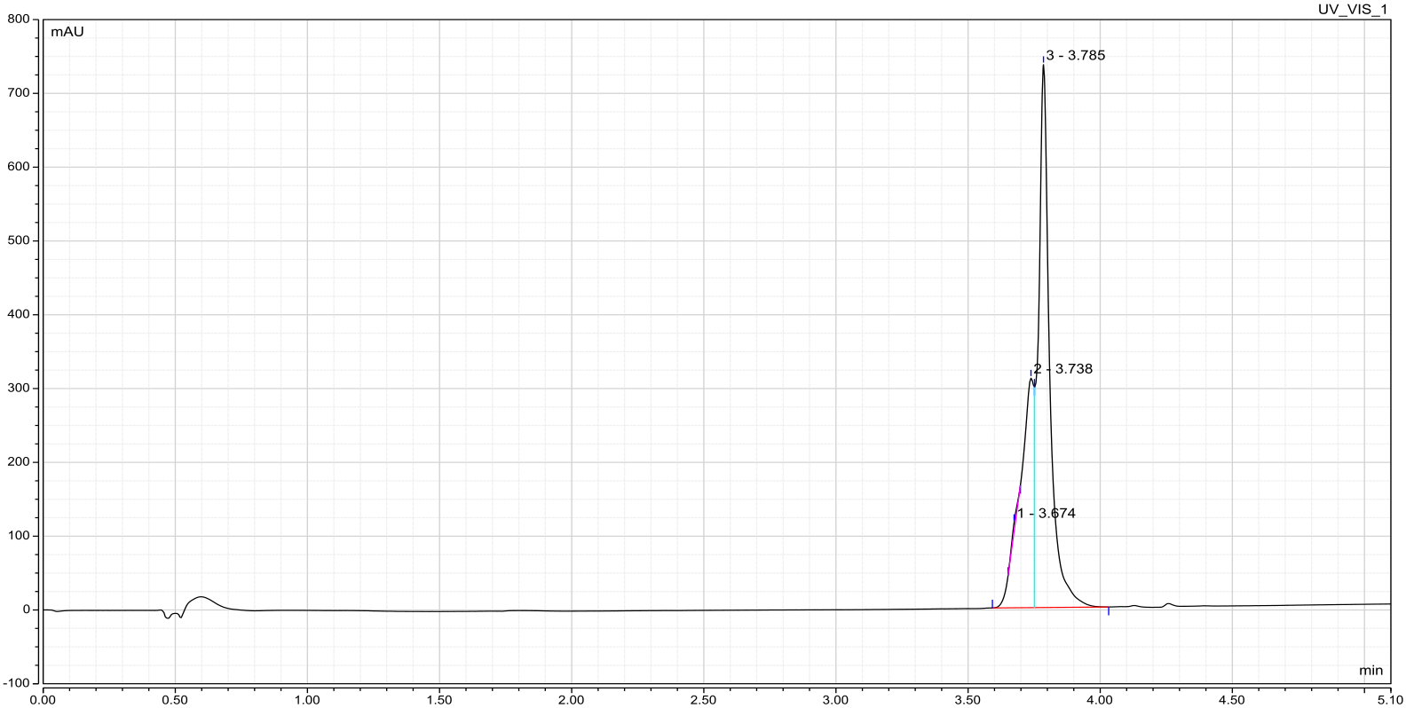

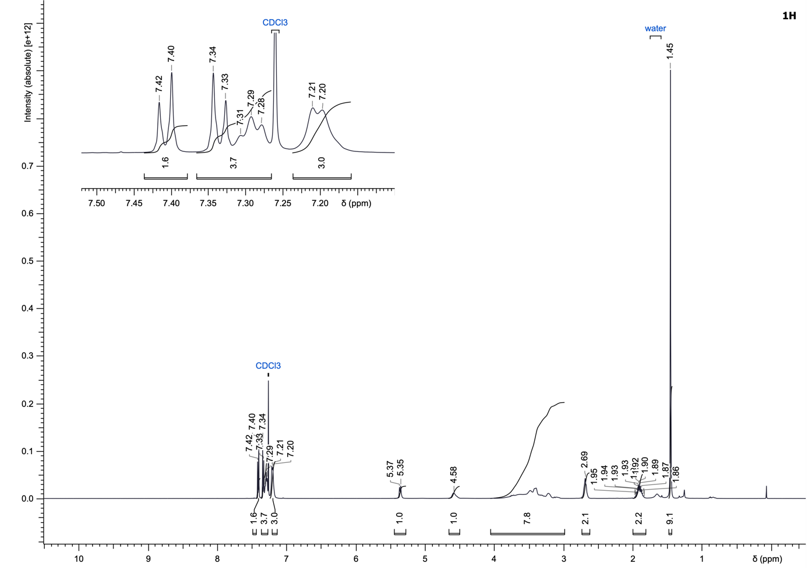
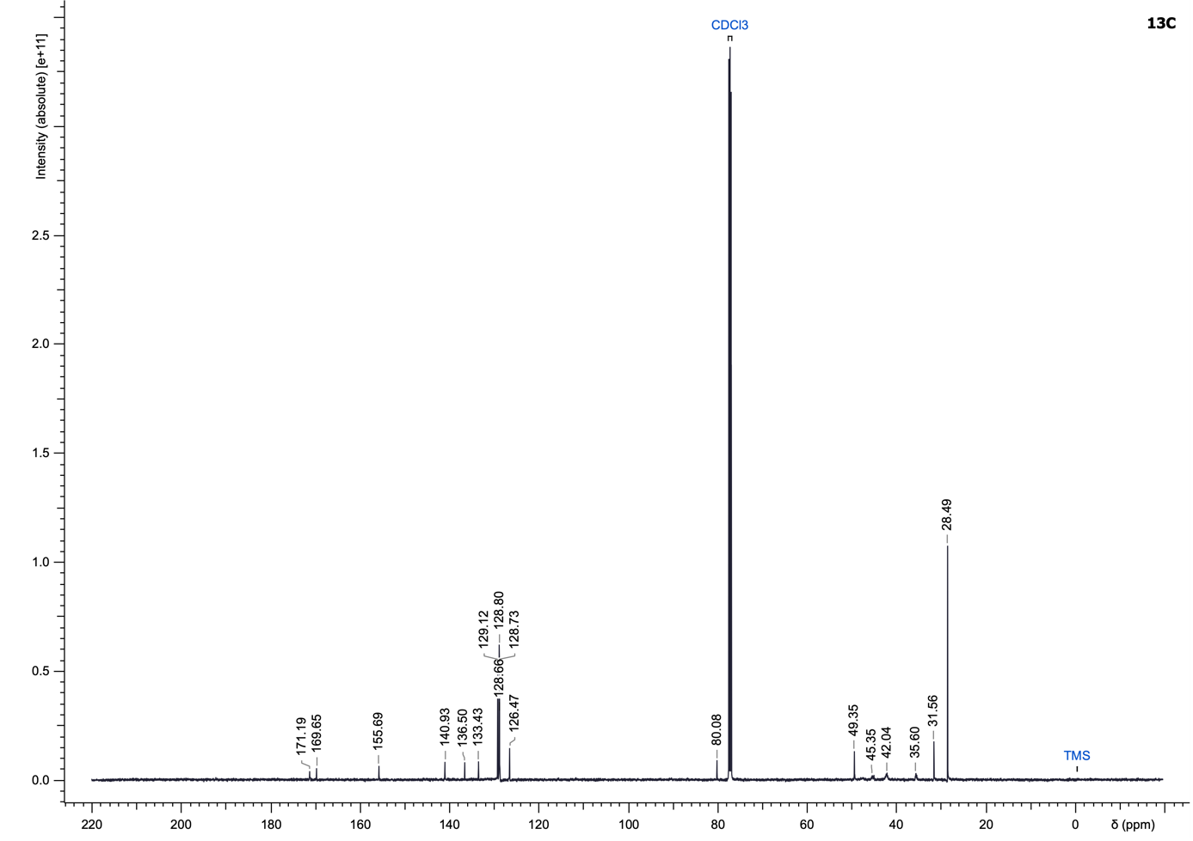

(S)-2-Amino-1-(4-(4-chlorobenzoyl)piperazin-1-yl)-4-phenylbutan-1-one (36)
To a solution of (S)-(1-(4-(4-chlorobenzoyl)piperazin-1-yl)-1-oxo-4-phenylbutan-2-yl)carbamate (205.80 µmol, 1.0 eq) in DCM (0.2 M) at 0 °C was added 2,2,2-trifluoroacetic acid (2.0 eq). The reaction mixture was allowed to warm to room temperature and stirred overnight. Upon completion, the reaction mixture was diluted with dichloromethane (10 mL), washed with saturated NaOH (3 × 15 mL), dried over MgSO₄ and concentrated under reduced pressure. The crude product was purified by normal-phase flash chromatography on silica gel using a gradient of dichloromethane/methanol (1 to 8% methanol) to yield the desired amide 36 as a white solid (45.9 mg, 64%).
LC–MS (ESI): t_{R} = 2.48 min; > 99% purity (UV at 254 nm);
¹H NMR (500 MHz, CDCl₃): δ (d, J = 8.8 Hz, 2H), 7.32 (d, J = 8.7 Hz, 2H), 7.30–7.27 (m, 1H), 7.26–7.23 (m, 1H), 7.23–7.15 (m, 3H), 4.85 (br s, 2H), 4.03 (br dd, J = 7.5, 4.4 Hz, 1H), 3.81–3.02 (m, 8H), 2.78 (br d, J = 6.0 Hz, 2H), 2.07–1.91 (m, 2H);
¹³C NMR (126 MHz, CDCl₃): δ 170.7, 169.7, 140.2, 136.6, 133.3, 129.1 (2C), 128.9 (2C), 128.8 (2C), 128.6 (2C), 126.8, 50.1, 45.0 (2C), 42.4 (2C), 35.0, 31.2;
HRMS (ESI⁺) m/z: [M+H]⁺ calculated for C₂₁H₂₄ClN₃O₂, 386.1630 found, 386.1632.

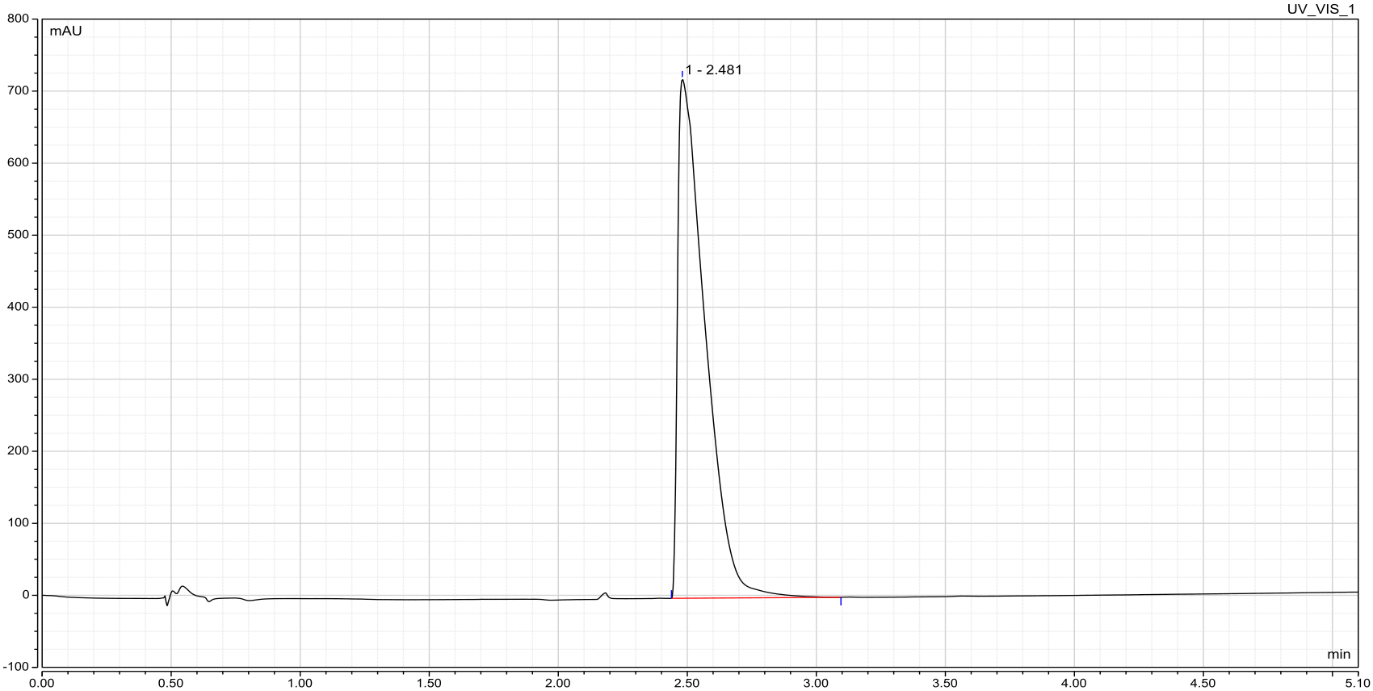

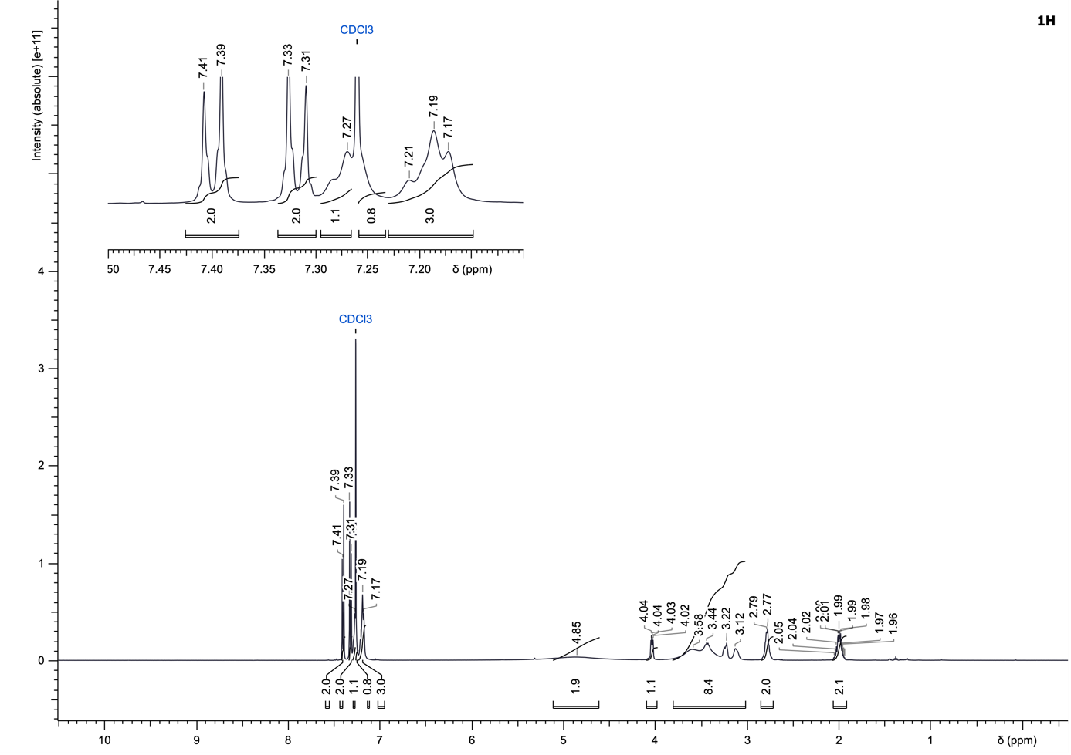
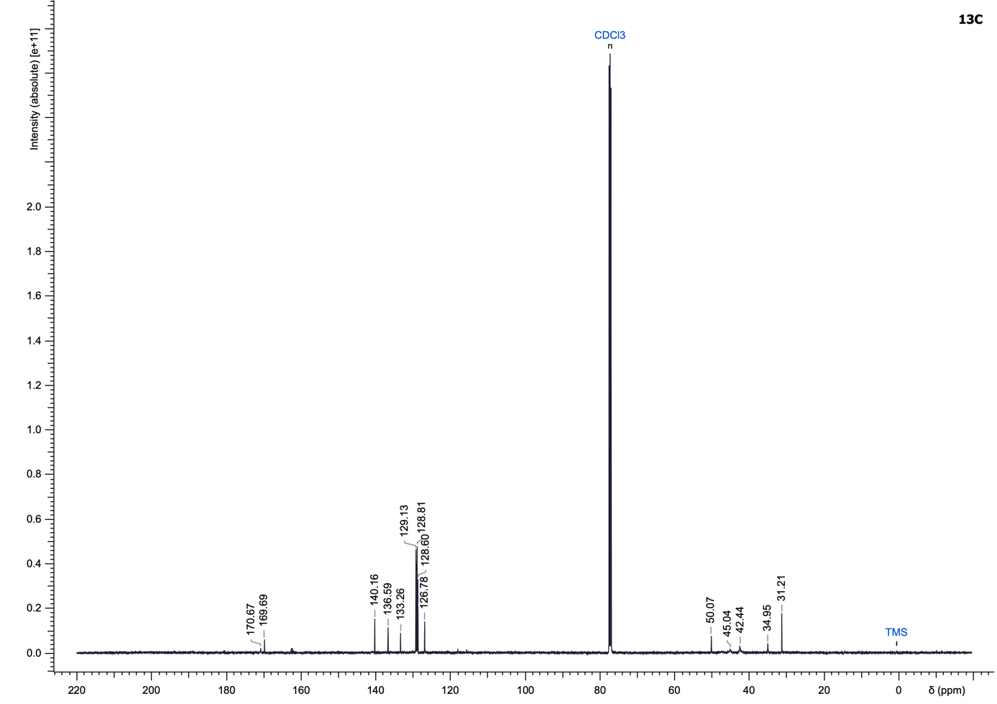

Benzyl 4-(4-chlorobenzoyl)piperazine-1-carboxylate (37)
Compound 37 was synthesized according to the General Procedure F using benzyl carbonochloridate and (4-chlorophenyl)(piperazin-1-yl)methanone (140.19 µmol) as starting materials and purified using cyclohexane/ethyl acetate (5 to 80% ethyl acetate) to yield a white solid (31.6 mg, 63%).
LC–MS (ESI): t_{R} = 3.53 min; > 99% purity (UV at 254 nm);
¹H NMR (500 MHz, CDCl₃): δ 7.42–7.38 (m, 2H), 7.38–7.31 (m, 7H), 5.15 (s, 2H), 3.91–3.36 (m, 8H);
¹³C NMR (126 MHz, CDCl₃): δ 169.7, 155.2, 136.4, 136.3, 133.7, 129.1 (2C), 128.8 (2C), 128.7 (2C), 128.4, 128.2 (2C), 67.7, 47.6, 44.0 (2C), 42.4;
HRMS (ESI⁺) m/z: [M+H]⁺ calculated for C₁₉H₁₉ClN₂O₃, 359.1157 found, 359.1160.

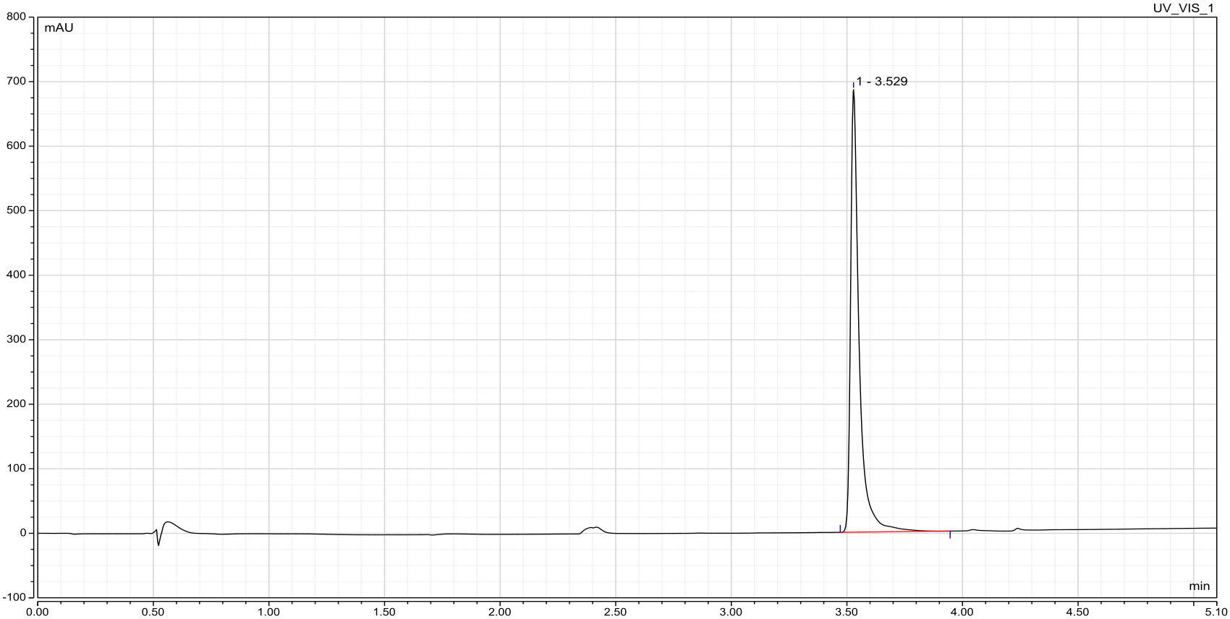

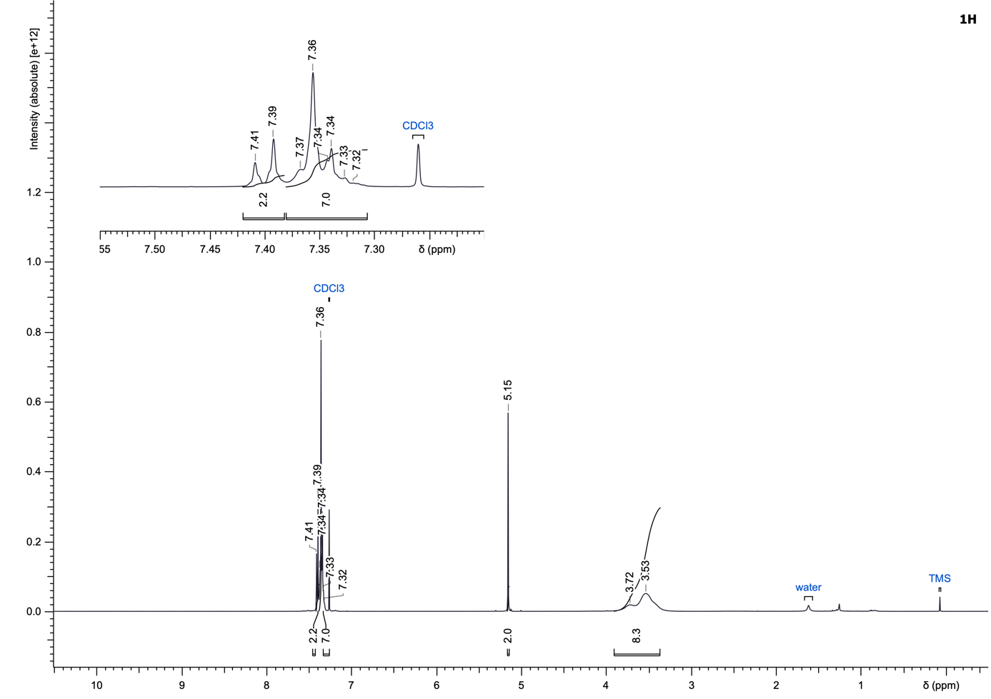
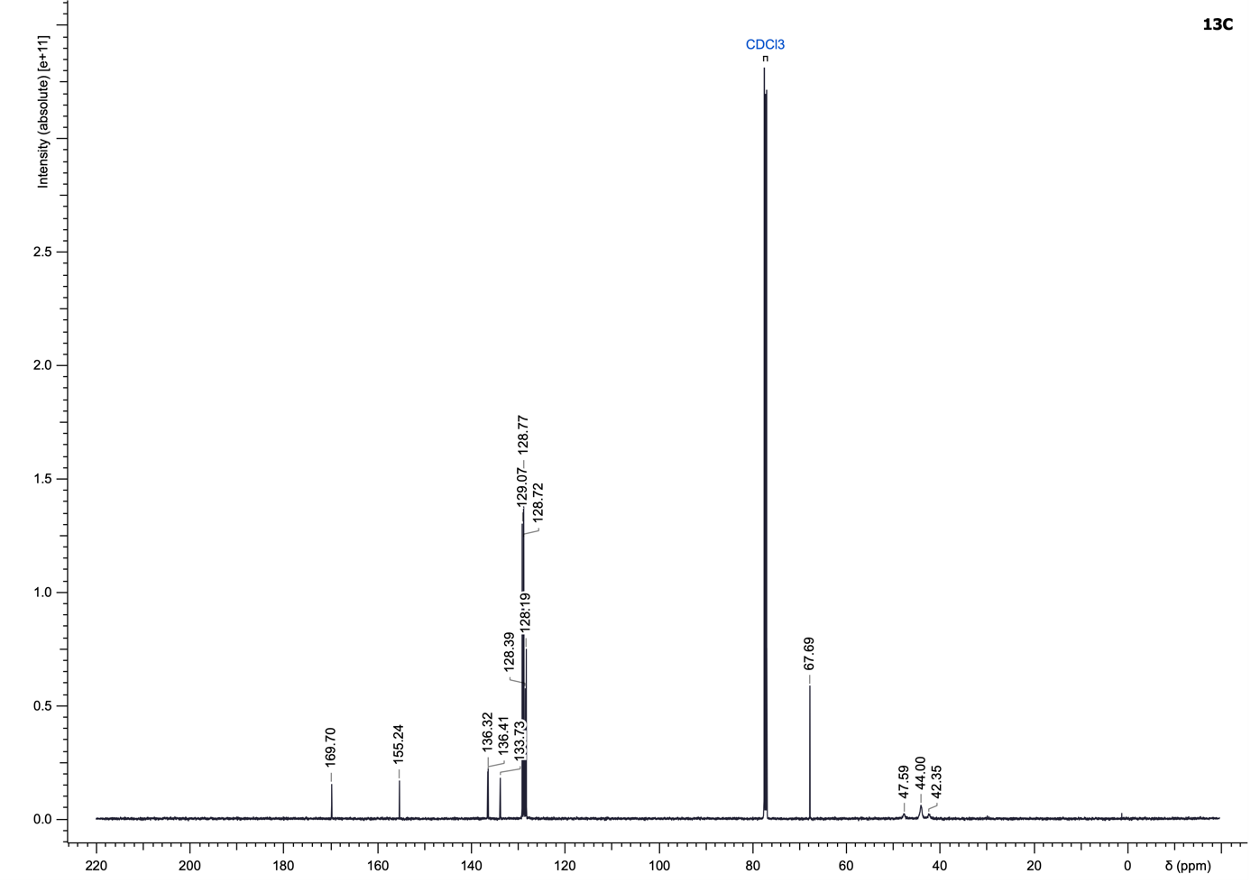

(9H-Fluoren-9-yl)methyl 4-(4-chlorobenzoyl)piperazine-1-carboxylate (38)
Compound 38 was synthesized according to the General Procedure F using (9H-fluoren-9-yl)methyl carbonochloridate and (4-chlorophenyl)(piperazin-1-yl)methanone (311.54 µmol) as starting materials and purified using cyclohexane/ethyl acetate (5 to 70% ethyl acetate) to yield a white solid (43.5 mg, 31%).
LC–MS (ESI): t_{R} = 3.99 min; > 99% purity (UV at 254 nm);
¹H NMR (500 MHz, CDCl₃): δ 7.77 (br d, J = 7.5 Hz, 2H), 7.55 (br d, J = 7.5 Hz, 2H), 7.43–7.38 (m, 4H), 7.36–7.30 (m, 4H), 4.52 (d, J = 6.3 Hz, 2H), 4.24 (br t, J = 6.0 Hz, 1H), 3.77–3.23 (m, 8H);
¹³C NMR (126 MHz, CDCl₃): δ 169.7, 155.1, 143.9 (2C), 141.5 (2C), 136.4, 133.7, 129.1 (2C), 128.8 (2C), 127.9 (2C), 127.2 (2C), 125.0 (2C), 120.2 (2C), 67.5, 47.5, 44.0 (2C), 42.2 (2C);
HRMS (ESI⁺) m/z: [M+H]⁺ calculated for C₂₆H₂₃ClN₂O₃, 447.1470 found, 447.1471.

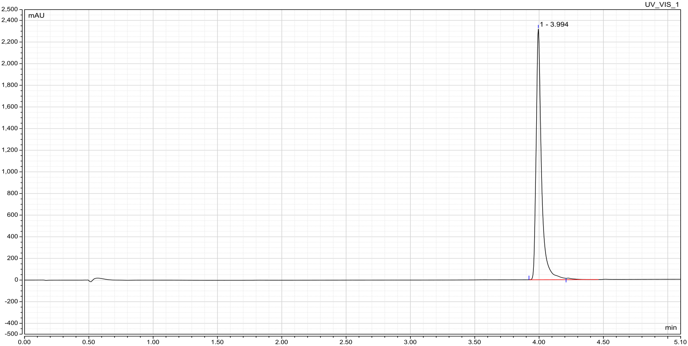

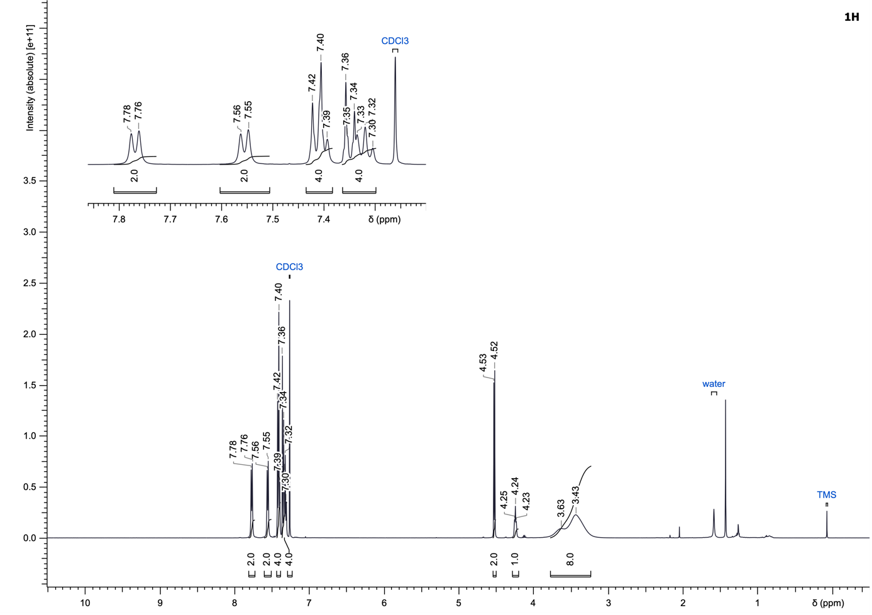
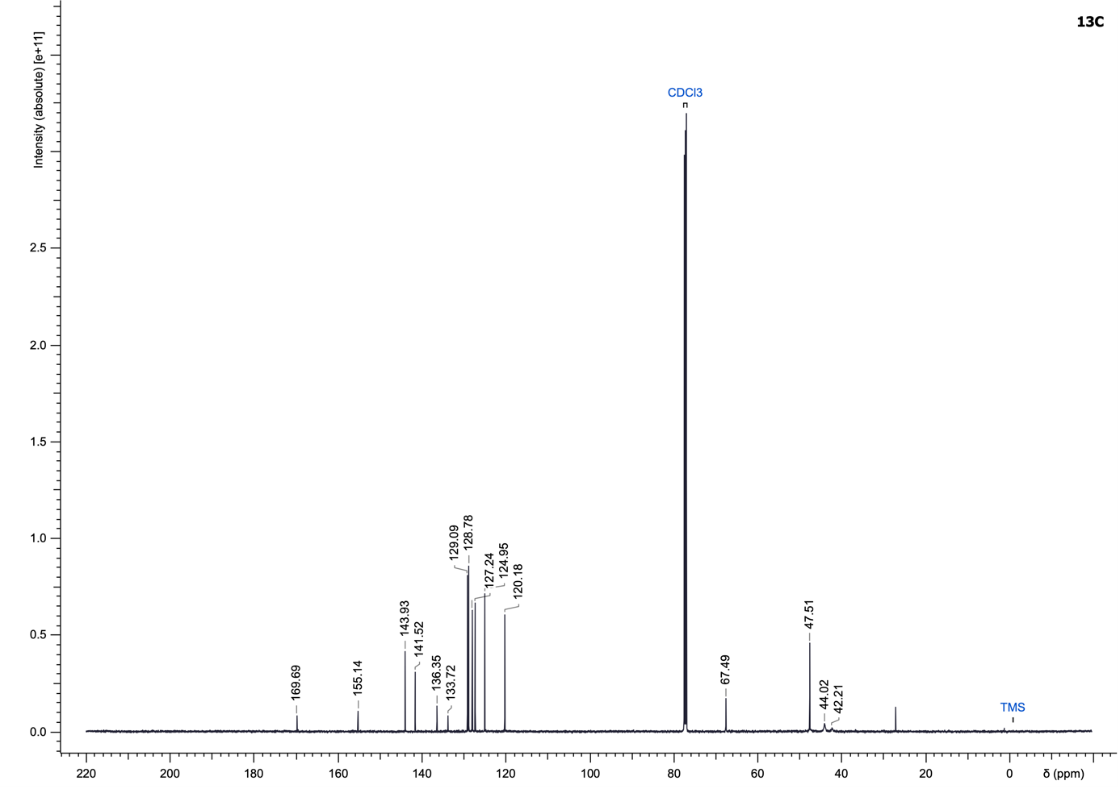

(4-(4-Chlorobenzoyl)piperazin-1-yl)(2,4-difluoro-3-methoxyphenyl)methanone (39)
Compound 39 was synthesized according to the General Procedure G using 2,4-difluoro-3-methoxybenzoyl chloride and (4-chlorophenyl)(piperazin-1-yl)methanone (311.54 µmol) as starting materials and purified using dichloromethane/methanol (0 to 6% methanol) to yield a colourless gel (104.2 mg, 85%).
LC–MS (ESI): t_{R} = 3.27 min; 97% purity (UV at 254 nm);
¹H NMR (500 MHz, CDCl₃): δ 7.46–7.33 (m, 4H), 7.06–6.95 (m, 2H), 4.01 (s, 3H), 3.98–3.07 (m, 8H);
¹³C NMR (126 MHz, CDCl₃): δ 169.8, 164.6, 156.80 (d, J = 252.8 Hz), 156.77 (d, J = 251.9 Hz), 136.5, 133.4, 129.2 (2C), 128.8 (2C), 126.3, 122.3 (dd, J = 9.7, 4.1 Hz), 120.6 (dd, J = 16.5, 3.7 Hz), 113.4 (dd, J = 19.8, 3.2 Hz), 62.2 (t, J = 3.2 Hz), 47.2 (2C), 42.4 (2C);
¹⁹F NMR (470 MHz, CDCl₃): δ -124.7 (br d, J = 5.2 Hz), -129.8 (br t, J = 8.7 Hz);
HRMS (ESI⁺) m/z: [M+H]⁺ calculated for C₁₉H₁₇ClF₂N₂O₃, 395.0969 found, 395.0969.

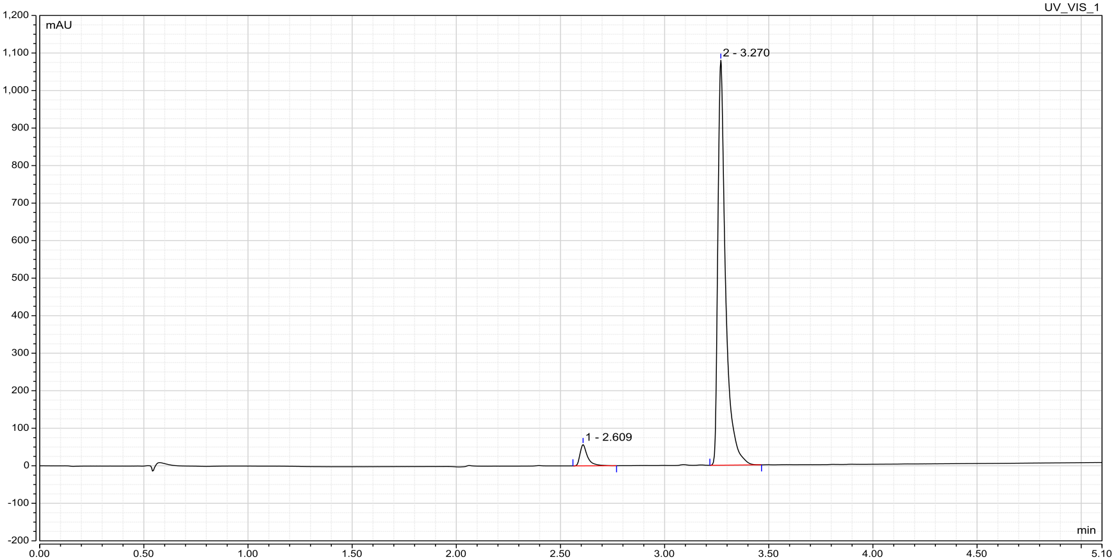

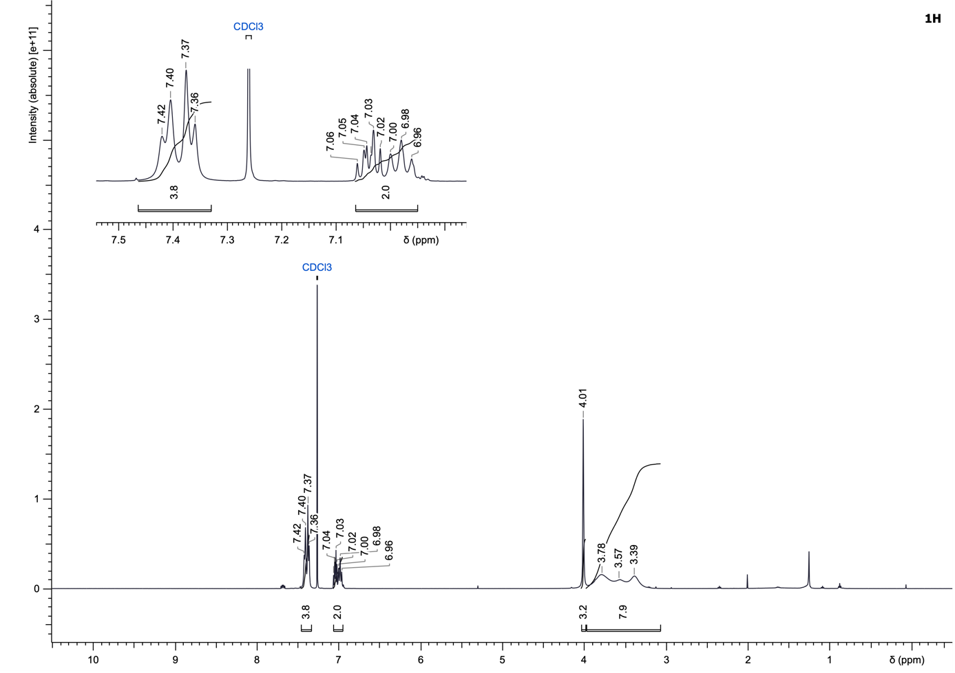
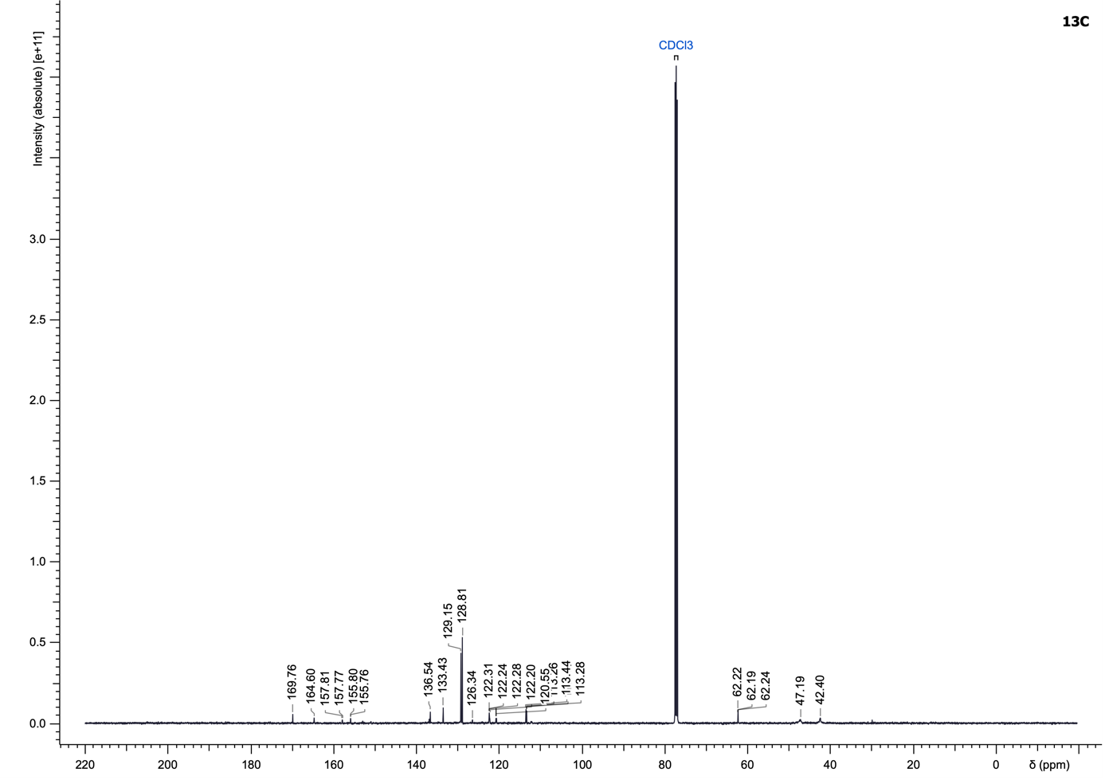
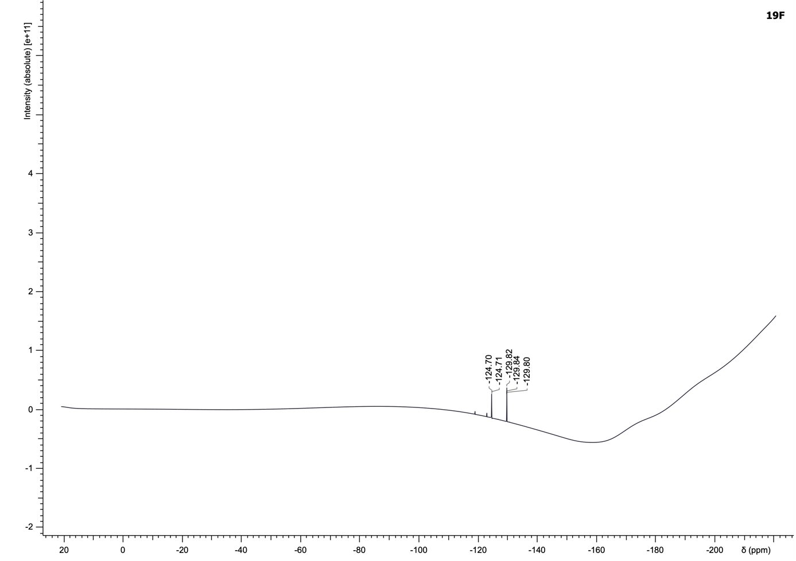

(4-(4-Chlorobenzoyl)piperazin-1-yl)(2,4,5-trifluoro-3-methoxyphenyl)methanone (40)
Compound 40 was synthesized according to the General Procedure G using 2,4,5-trifluoro-3-methoxybenzoyl chloride and (4-chlorophenyl)(piperazin-1-yl)methanone (311.54 µmol) as starting materials and purified using dichloromethane/methanol (0 to 8% methanol) to yield a colourless gel (125.7 mg, 99%).
LC–MS (ESI): t_{R} = 3.40 min; > 99% purity (UV at 254 nm);
¹H NMR (500 MHz, DMSO-d₆): δ 7.52 (br d, J = 7.5 Hz, 2H), 7.47 (br d, J = 7.7 Hz, 2H), 7.39–7.28 (m, 1H), 4.01 (br s, 3H), 3.83–3.51 (m, 4H), 3.51–3.34 (m, 2H), 3.32–3.18 (m, 2H);
¹³C NMR (126 MHz, DMSO-d₆): δ 168.2, 162.0, 147.1 (d, J = 244.4 Hz), 146.9 (br dd, J = 244.8, 11.2 Hz), 144.1 (br ddd, J = 250.7, 15.4, 5.6 Hz), 137.4 (br t, J = 13.3 Hz), 134.4, 134.3, 129.1 (2C), 128.6 (2C), 120.0–119.8 (m), 109.1 (dd, J = 20.7, 4.1 Hz), 62.2 (t, J = 3.2 Hz), 46.2 (2C), 41.6 (2C);
¹⁹F NMR (470 MHz, DMSO-d₆): δ -135.6 (br d, J = 53.8 Hz), -139.9–-139.9 (m), -150.1 (dt, J = 22.1, 7.2 Hz);
HRMS (ESI⁺) m/z: [M+H]⁺ calculated for C₁₉H₁₆ClF₃N₂O₃, 413.0875 found, 413.0877.

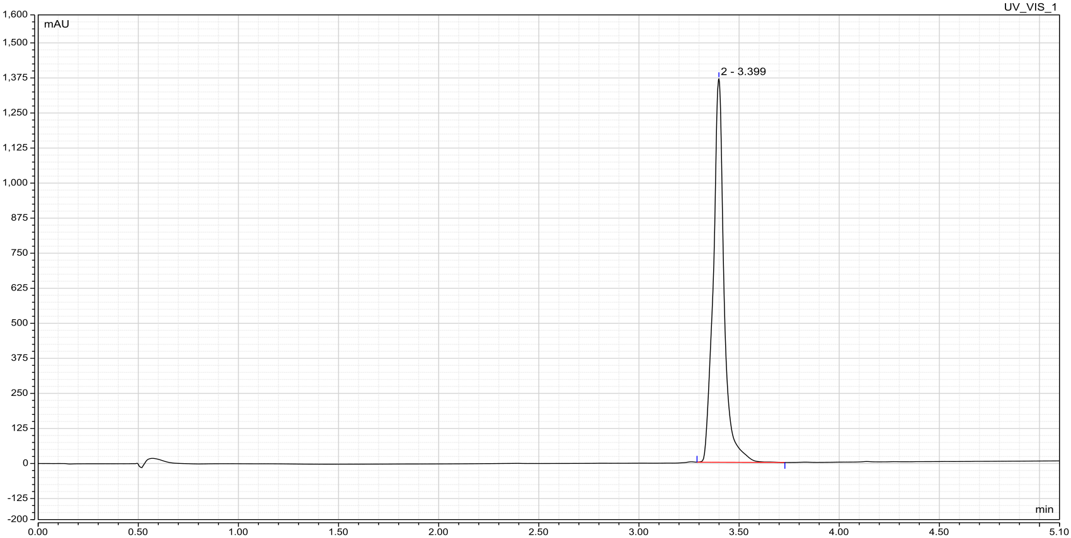

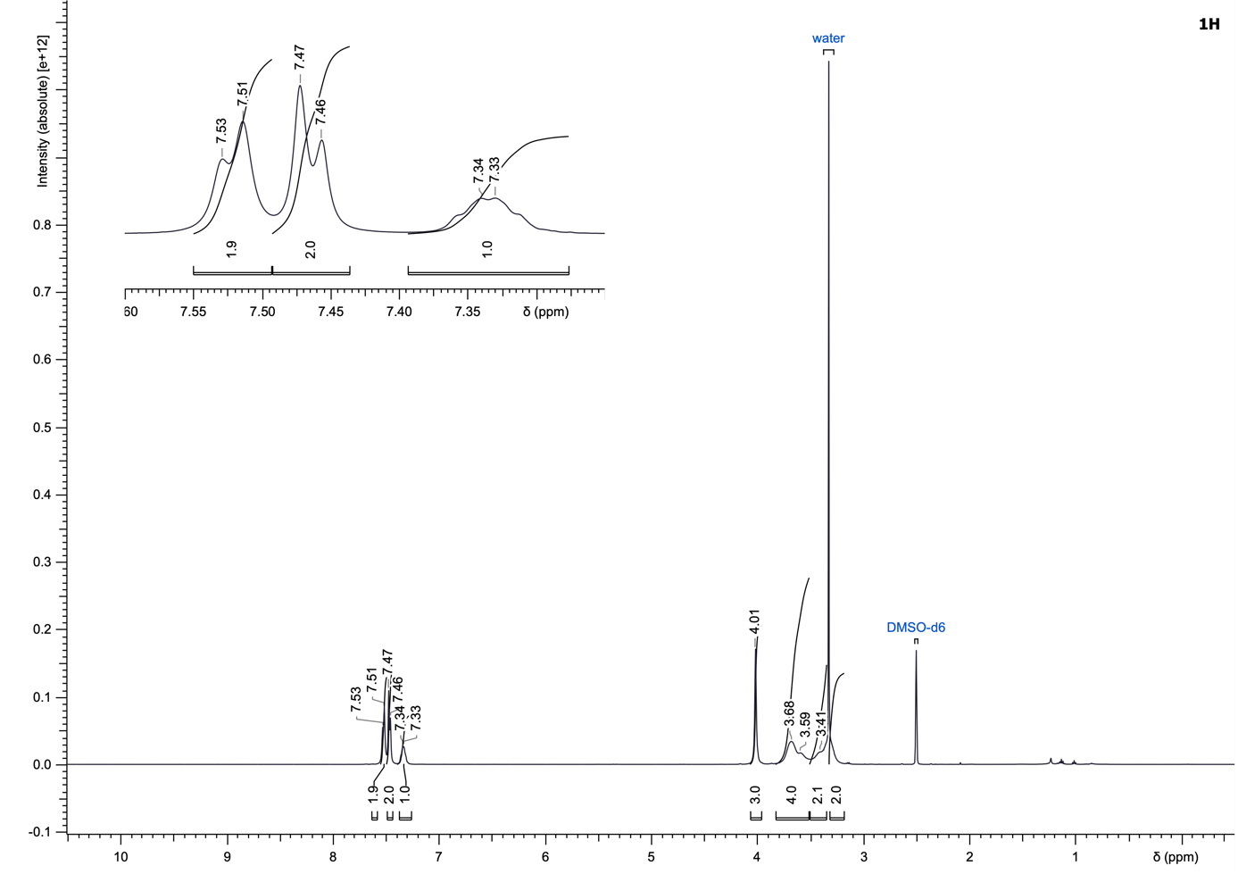
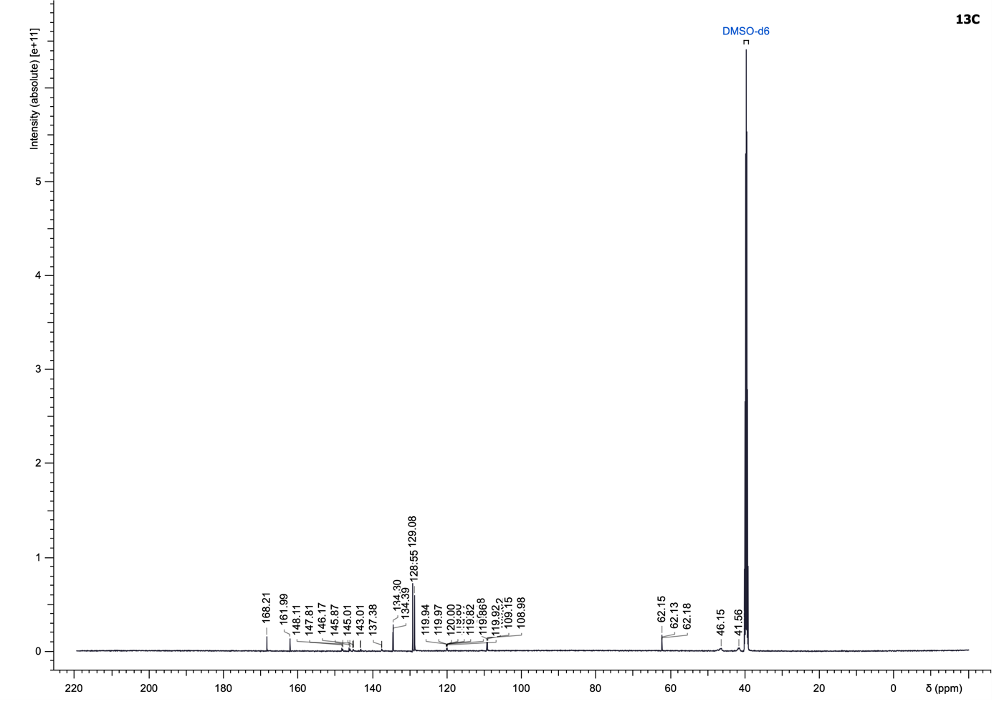
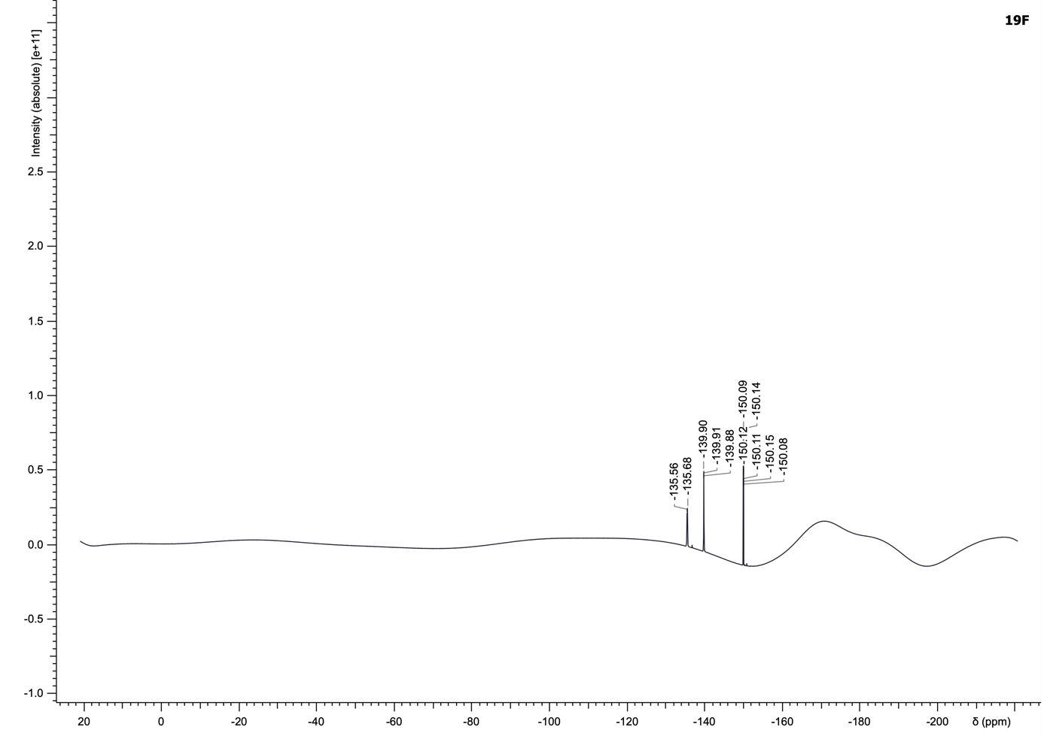

4-(4-Chlorobenzoyl)-N,N-diphenylpiperazine-1-carboxamide (41)
To a solution of diphenylcarbamic chloride (1.5 eq) in DCM (0.2 M) were added triethylamine (3.0 eq) and (4-chlorophenyl)(piperazin-1-yl)methanone (734.35 µmol, 1.0 eq). The reaction mixture was stirred at room temperature overnight. Upon completion, the reaction mixture was diluted with DCM (10 mL), washed with 1 M HCl (10 mL) and water (10 mL). The combined aqueous phases were back-extracted with dichloromethane (10 mL). All organic phases were combined, dried over MgSO₄, and concentrated under reduced pressure. The crude product was purified by normal-phase flash chromatography on silica gel using a gradient of dichloromethane/methanol (0 to 10% methanol) to yield the desired carbamide 41 as a colourless gel (107.6 mg, 35%).
LC–MS (ESI): t_{R} = 3.69 min; > 99% purity (UV at 254 nm);
¹H NMR (500 MHz, DMSO-d₆): δ 7.49 (d, J = 8.4 Hz, 2H), 7.40 (m, J = 8.4 Hz, 2H), 7.34 (t, J = 7.8 Hz, 4H), 7.15 (t, J = 7.3 Hz, 2H), 7.00 (d, J = 7.8 Hz, 4H), 3.61–3.33 (m, 4H), 3.31–3.09 (m, 4H);
¹³C NMR (126 MHz, DMSO-d₆): δ 168.2, 158.7, 144.6 (2C), 134.4, 134.3, 129.3 (4C), 129.0 (2C), 128.5 (2C), 124.9 (4C), 124.6 (2C), 46.5, 44.9 (2C), 41.1;
HRMS (ESI⁺) m/z: [M+H]⁺ calculated for C₂₄H₂₂ClN₃O₂, 420.1474 found, 420.1475.

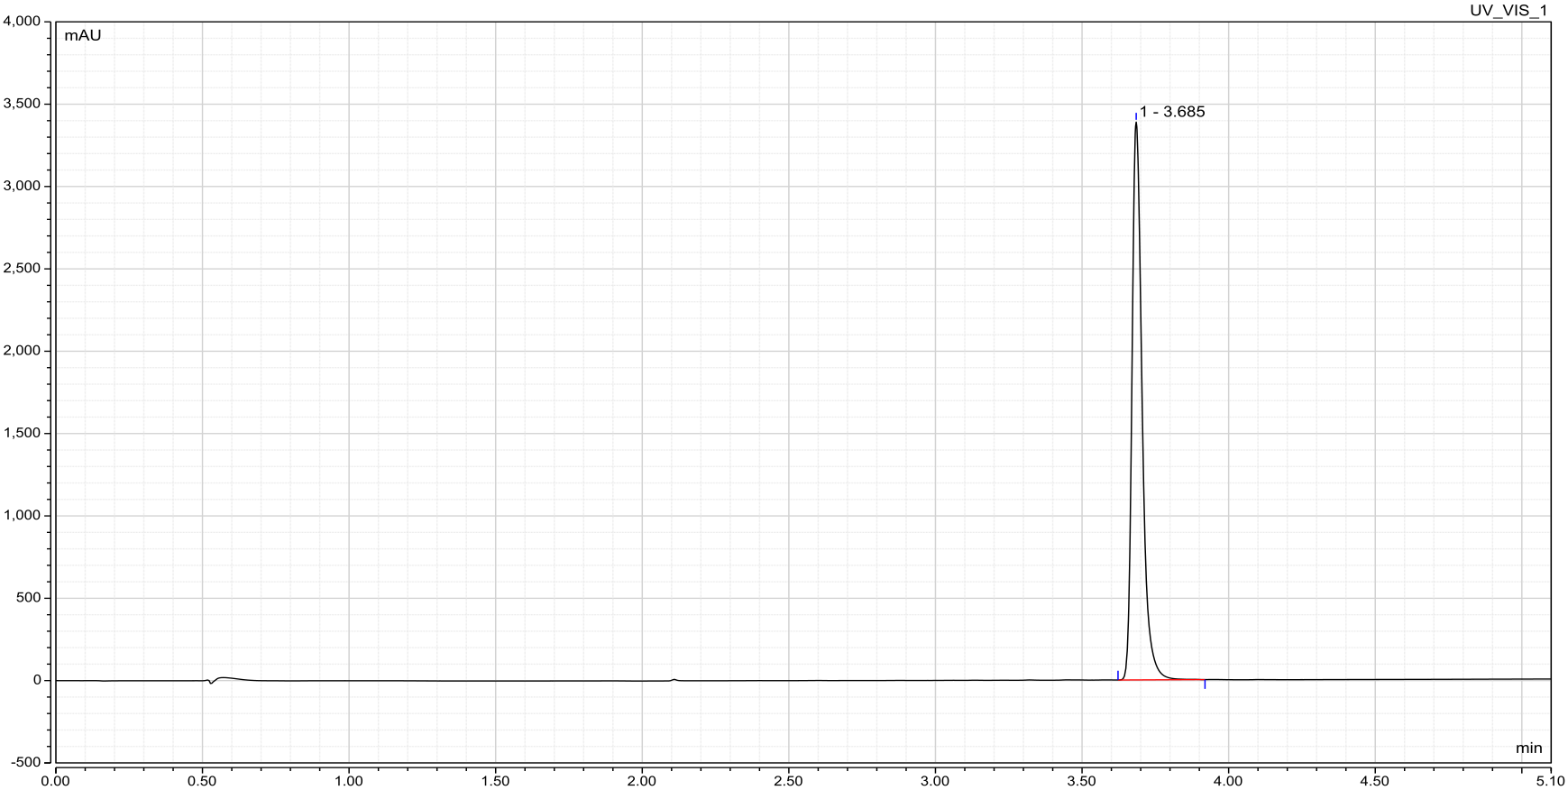

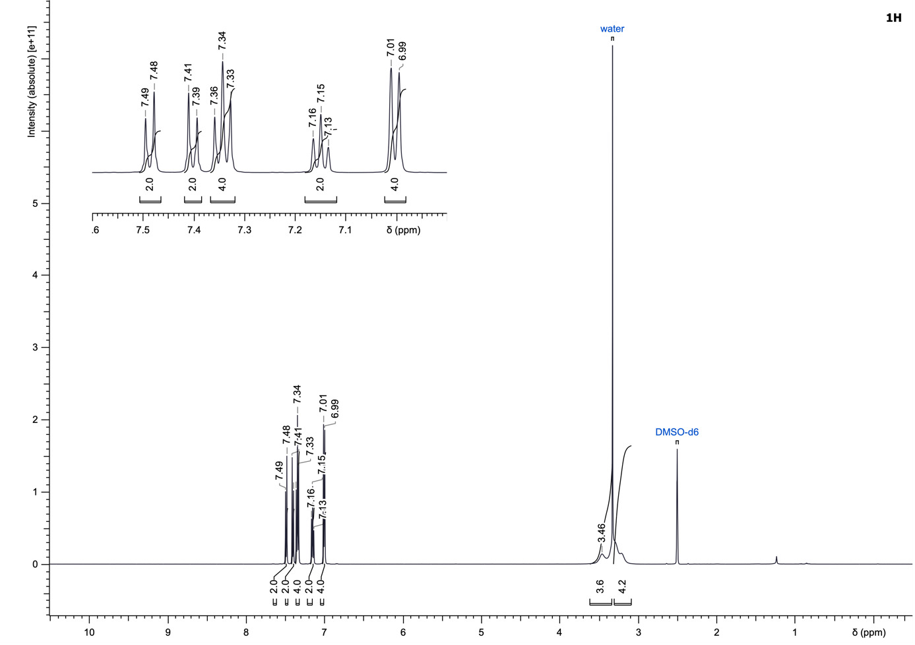
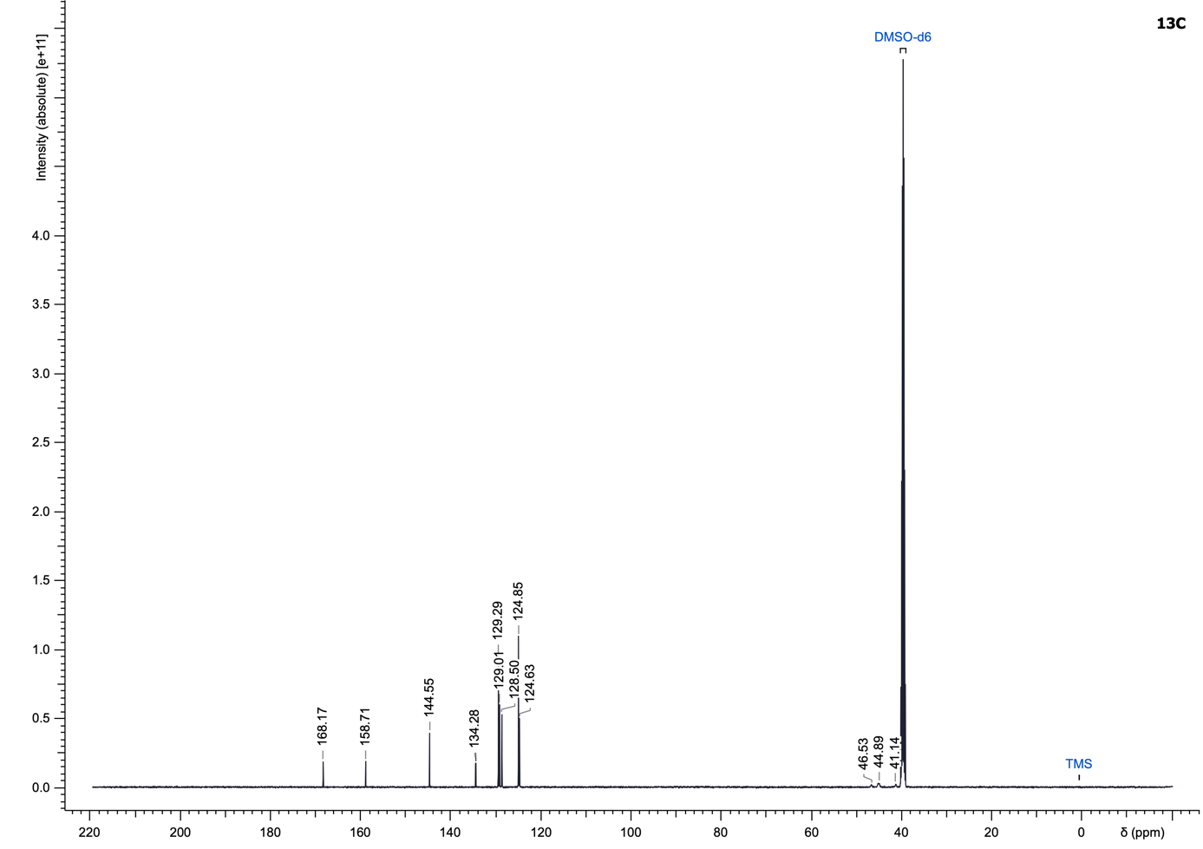

(4-((6-(Benzyloxy)-1H-indol-3-yl)methyl)piperazin-1-yl)(4-chlorophenyl)methanone (42)
Compound 42 was synthesized according to the General Procedure H using (4-chlorophenyl)(piperazin-1-yl)methanone (267.04 µmol) and 6-(benzyloxy)-1H-indole-3-carbaldehyde as starting materials and purified using dichloromethane/methanol (0 to 10% methanol) to yield an orange gel (97.7 mg, 80%).
LC–MS (ESI): t_{R} = 2.97 min; > 99% purity (UV at 254 nm);
¹H NMR (500 MHz, DMSO-d₆): δ 10.73 (s, 1H), 7.52–7.45 (m, 5H), 7.41–7.37 (m, 4H), 7.35–7.28 (m, 1H), 7.08 (d, J = 2.0 Hz, 1H), 6.91 (d, J = 2.3 Hz, 1H), 6.72 (dd, J = 8.5, 2.1 Hz, 1H), 5.10 (s, 2H), 3.60 (s, 2H), 3.60–3.47 (m, 2H), 3.32–3.22 (m, 2H), 2.48–2.28 (m, 4H);
¹³C NMR (126 MHz, DMSO-d₆): δ 167.8, 154.5, 137.7, 136.9, 134.8, 134.1, 128.9 (2C), 128.5 (2C), 128.4 (2C), 127.6, 127.5 (2C), 123.5, 122.1, 119.7, 110.3, 109.3, 95.9, 69.5, 53.1, 52.6, 52.1, 47.3, 41.7;
HRMS (ESI⁺) m/z: [M+H]⁺ calculated for C₂₇H₂₆ClN₃O₂, 470.1787; found, 417.1786.

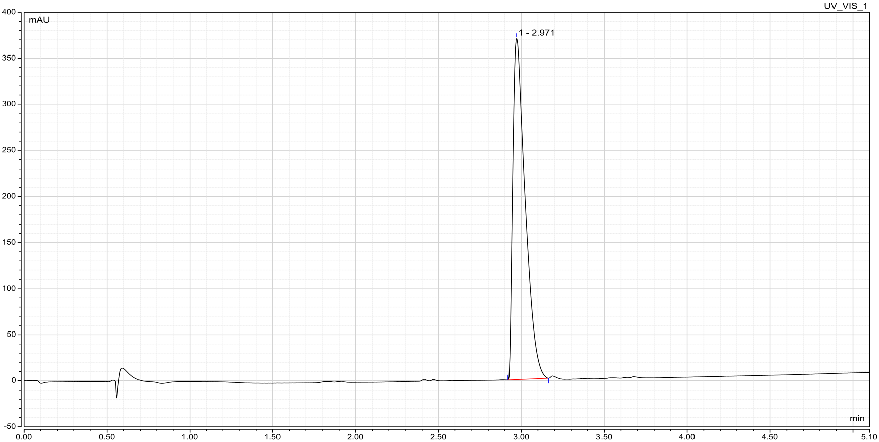

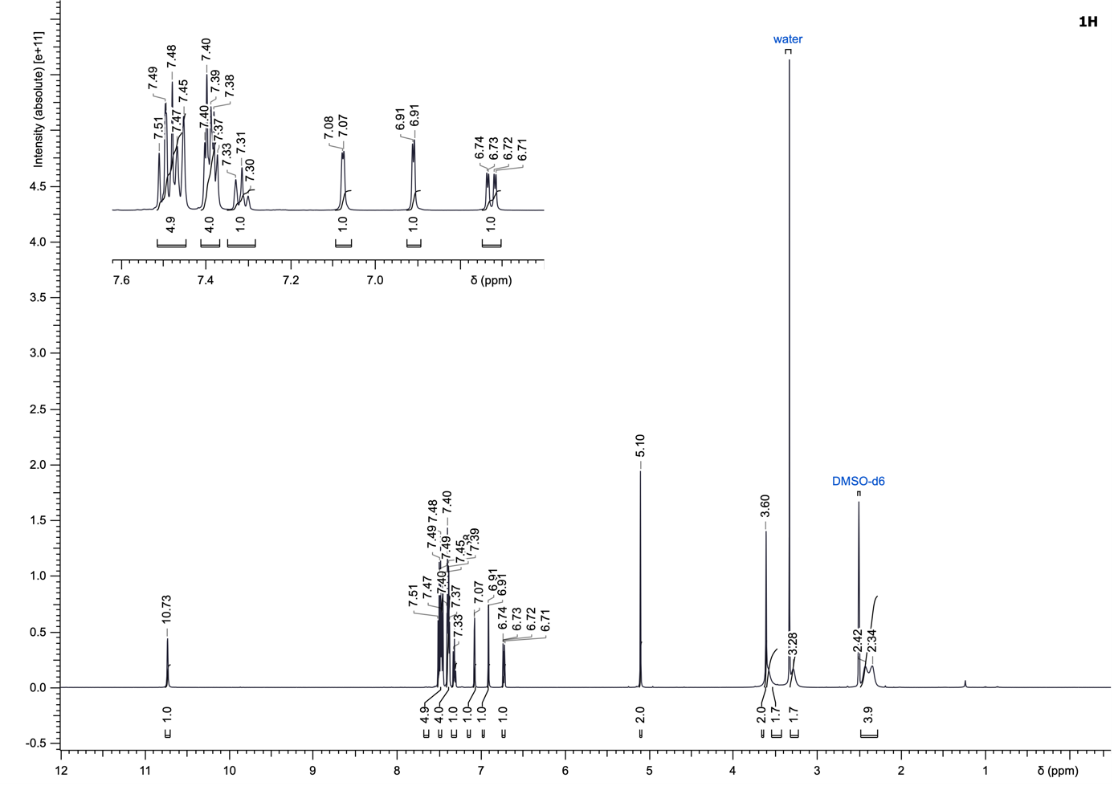
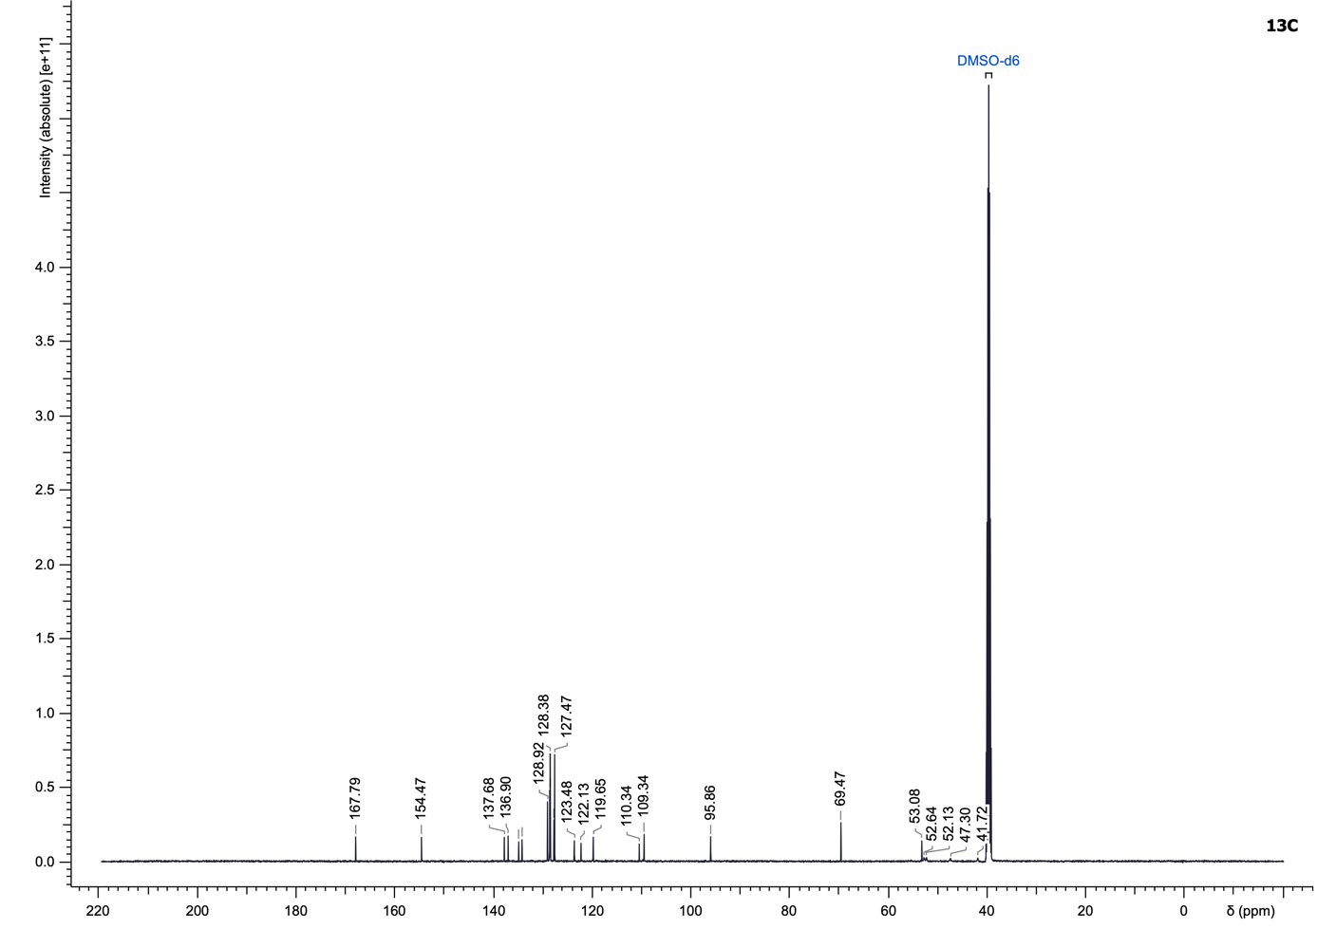

Ethyl 2-(4-(4-chlorobenzoyl)piperazin-1-yl)acetate (43)
Compound 43 was synthesized according to the General Procedure H (4-chlorophenyl)(piperazin-1-yl)methanone (267.04 µmol) and ethyl 2-oxoacetate as starting materials and purified using dichloromethane/methanol (0 to 14% methanol) to yield an orange gel (15.2 mg, 18%).
LC–MS (ESI): t_{R} = 2.31 min; > 99% purity (UV at 254 nm);
¹H NMR (500 MHz, DMSO-d₆): δ 7.51 (d, J = 8.3 Hz, 2H), 7.41 (d, J = 8.3 Hz, 2H), 4.08 (q, J = 7.2 Hz, 2H), 3.61 (br s, 2H), 3.32 (br s, 2H), 3.28 (br s, 2H), 2.64–2.50 (m, 3H), 2.49–2.41 (m, 1H), 1.19 (t, J = 7.1 Hz, 3H);
¹³C NMR (126 MHz, DMSO-d₆): δ 169.8, 167.9, 134.6, 134.2, 128.9 (2C), 128.5 (2C), 59.9, 58.0, 51.9, 51.5, 47.1, 41.5, 14.1;
HRMS (ESI⁺) m/z: [M+H]⁺ calculated for C₁₅H₁₉ClN₂O₃, 311.1157; found, 311.1158.

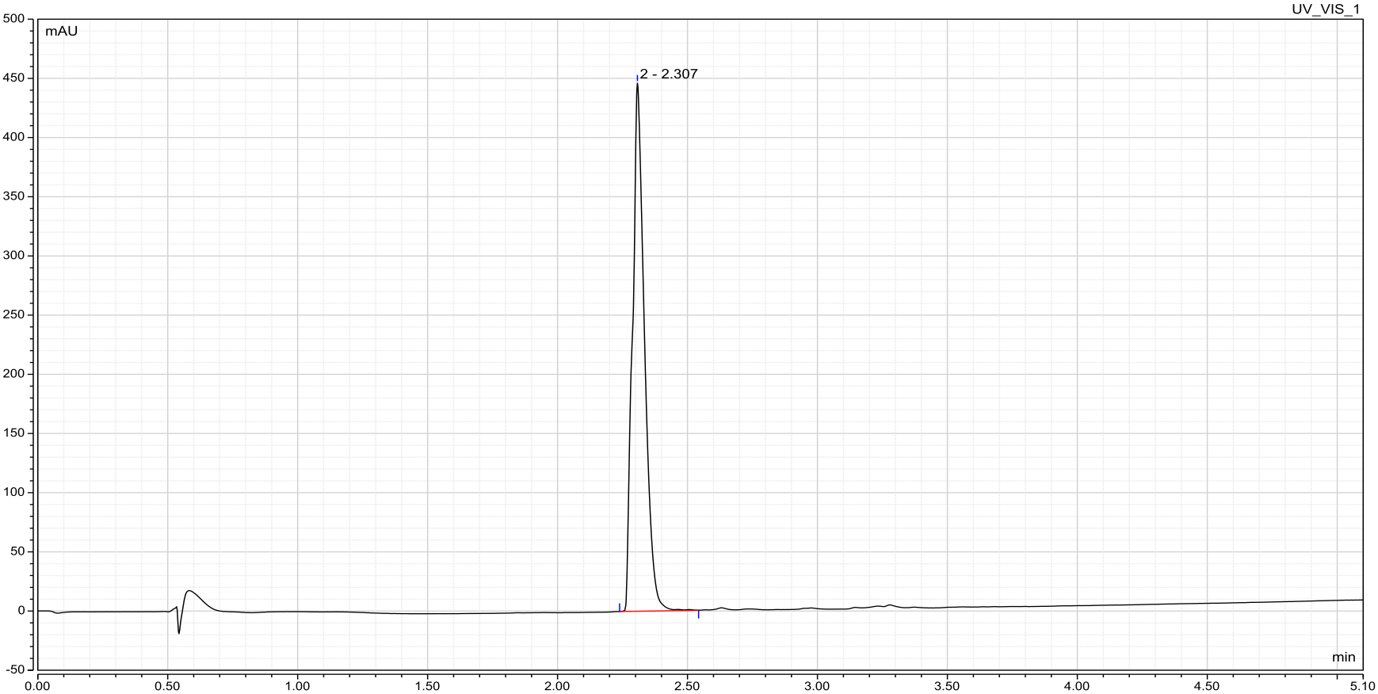

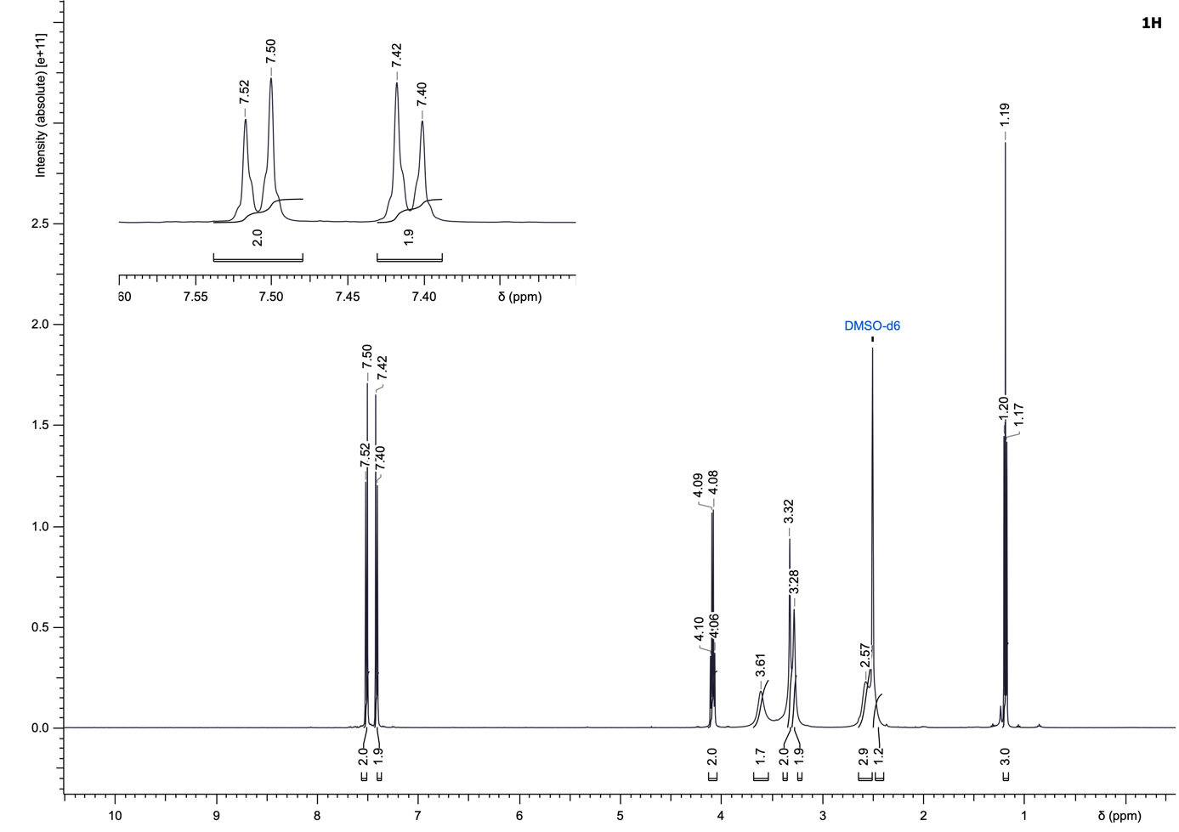
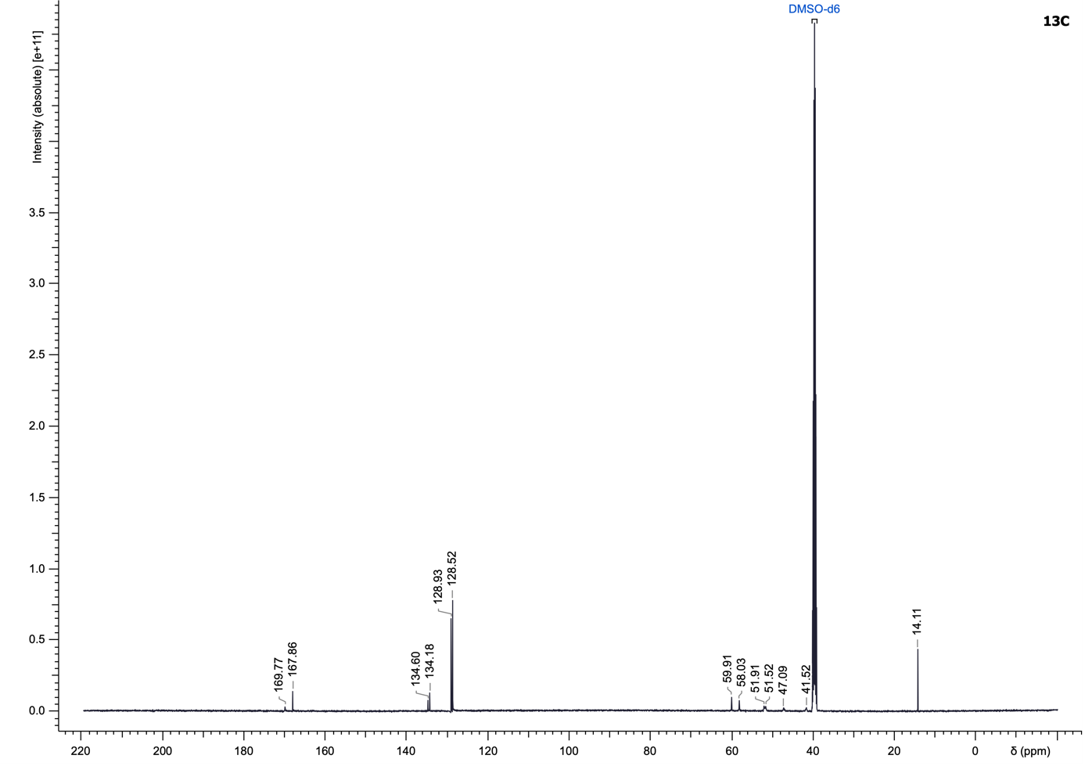

(4-Chlorophenyl)(4-(4-fluoro-3,5-dimethylbenzyl)piperazin-1-yl)methanone (44)
Compound 44 was synthesized according to the General Procedure H using (4-chlorophenyl)(piperazin-1-yl)methanone (267.04 µmol) and 4-fluoro-3,5-dimethylbenzaldehyde as starting materials and purified using cyclohexane/ethyl acetate (25 to 100% ethyl acetate) to yield an orange gel (94.9 mg, 98%).
LC–MS (ESI): t_{R} = 2.66 min; > 99% purity (UV at 254 nm);
¹H NMR (500 MHz, DMSO-d₆): δ 7.50 (d, J = 8.2 Hz, 2H), 7.40 (d, J = 8.4 Hz, 2H), 7.00 (d, J = 7.2 Hz, 2H), 3.68–3.48 (m, 2H), 3.38 (s, 2H), 3.30 (br s, 2H), 2.39 (br s, 2H), 2.32 (br s, 2H), 2.21–2.17 (m, 6H);
¹³C NMR (126 MHz, DMSO-d₆): δ 167.8, 158.3 (d, J = 240.8 Hz), 134.7, 134.2, 132.9 (d, J = 4.6 Hz), 129.4 (d, J = 4.6 Hz, 2C), 129.0 (2C), 128.5 (2C), 123.4 (d, J = 17.5 Hz, 2C), 61.1, 52.7, 52.2, 47.1, 41.6, 14.3 (d, J = 3.7 Hz, 2C);
¹⁹F NMR (470 MHz, CDCl₃): δ -123.9;
HRMS (ESI⁺) m/z: [M+H]⁺ calculated for C₂₀H₂₂ClFN₂O, 361.1478; found, 361.1479.

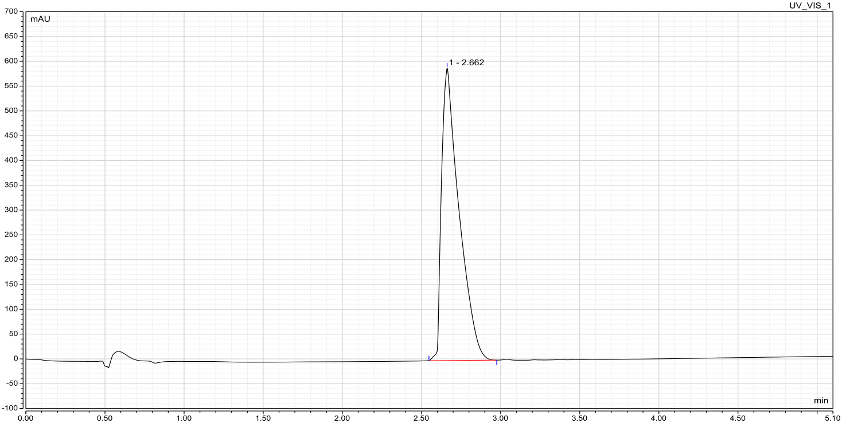

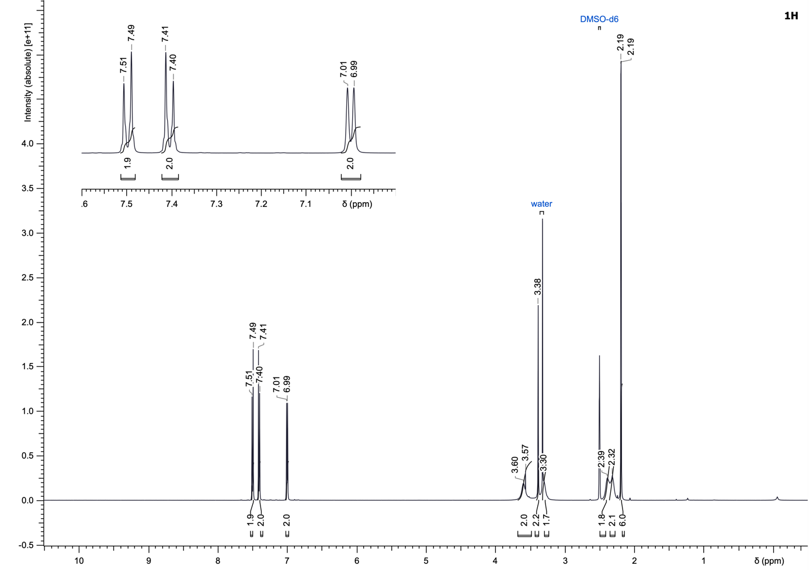
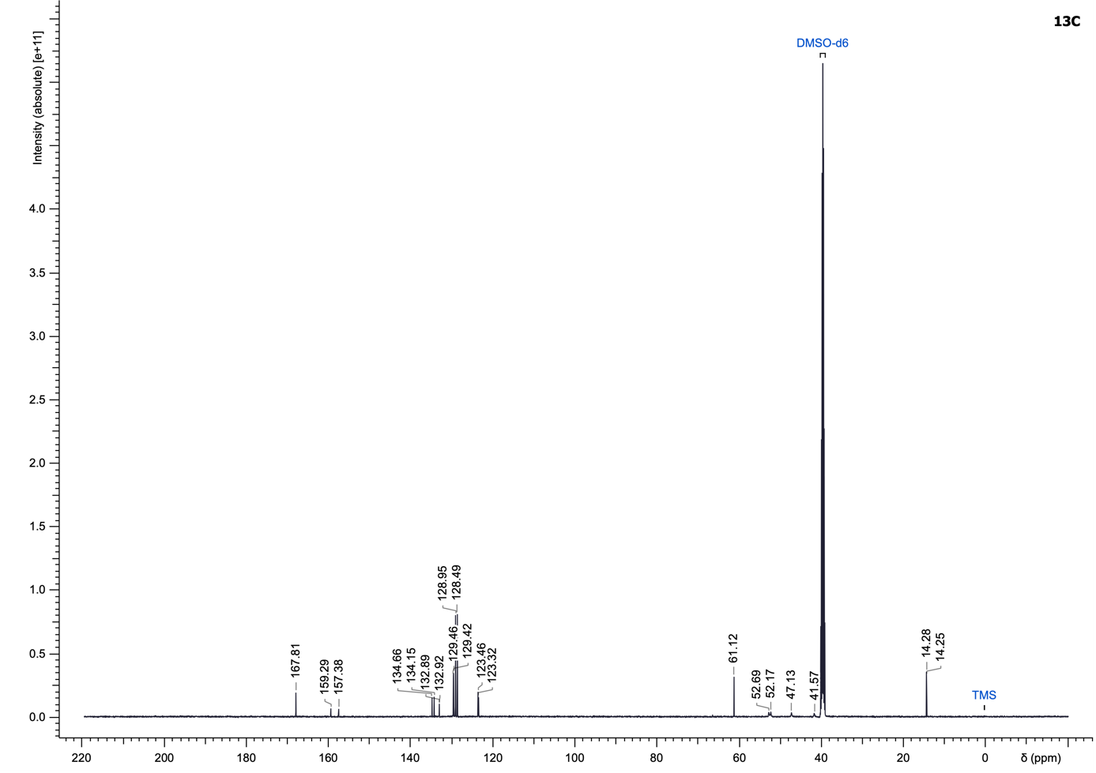
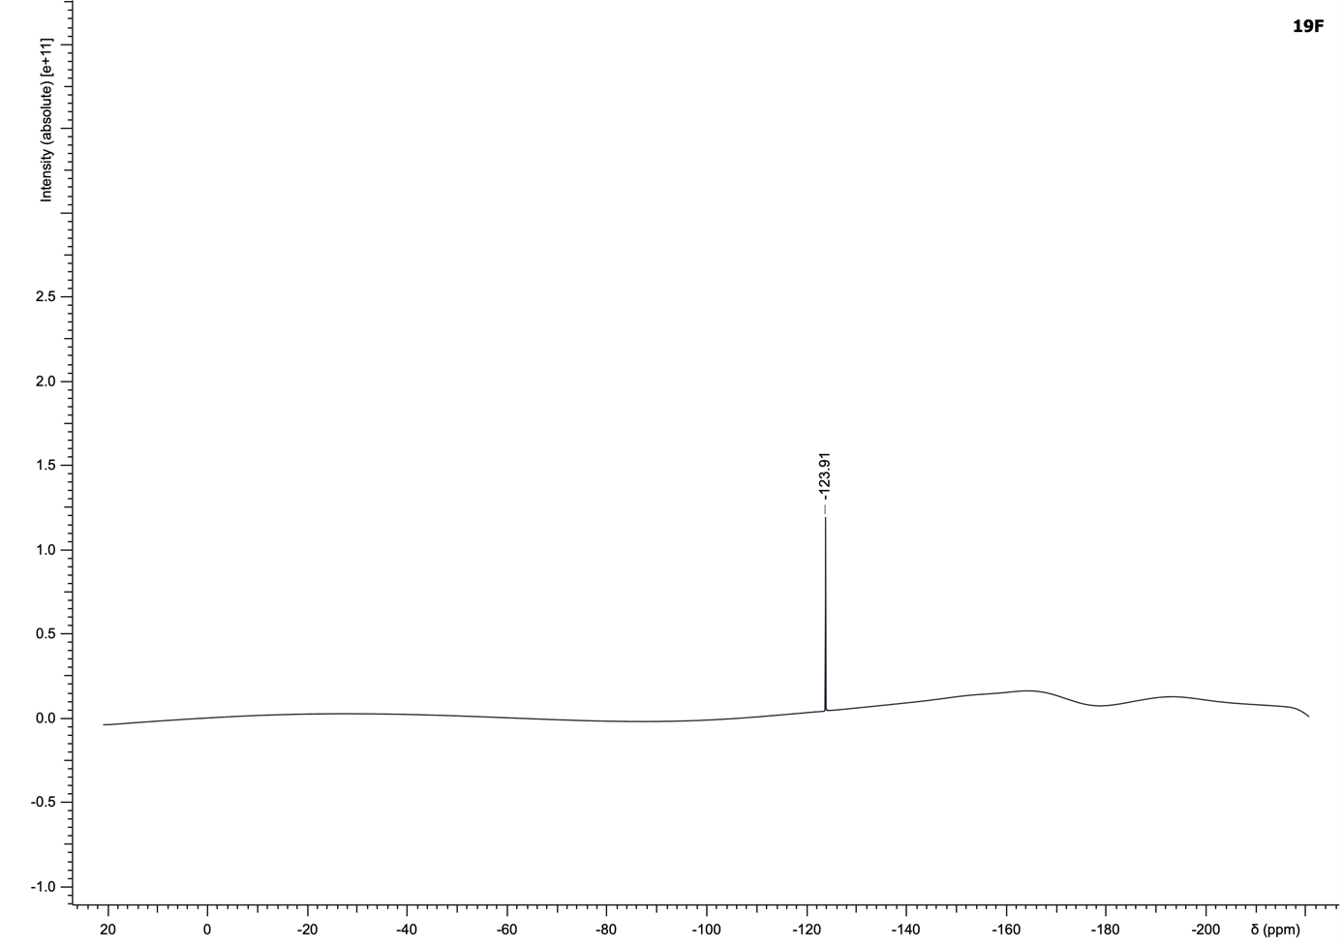

(4-Chlorophenyl)(4-(3,5-dimethylbenzyl)piperazin-1-yl)methanone (45)
Compound 45 was synthesized according to the General Procedure H using (4-chlorophenyl)(piperazin-1-yl)methanone (222.53 µmol) and 3,5-dimethylbenzaldehyde as starting materials and purified using cyclohexane/ethyl acetate (10 to 100% ethyl acetate) to yield an orange gel (73.3 mg, 96%).
LC–MS (ESI): t_{R} = 2.67 min; > 99% purity (UV at 254 nm);
¹H NMR (500 MHz, DMSO-d₆): δ 7.50 (d, J = 8.4 Hz, 2H), 7.40 (d, J = 8.4 Hz, 2H), 6.89 (s, 2H), 6.87 (s, 1H), 3.60 (br s, 2H), 3.43–3.37 (m, 2H), 3.32–3.22 (m, 2H), 2.39 (br s, 2H), 2.32 (br s, 2H), 2.24 (s, 6H);
¹³C NMR (126 MHz, DMSO-d₆): δ 167.8, 137.6 (2C), 137.1 (2C), 134.7, 134.1, 129.0 (2C), 128.5 (2C), 126.7 (2C), 61.9, 52.8, 52.3, 47.2, 41.6, 20.9 (2C);
HRMS (ESI⁺) m/z: [M+H]⁺ calculated for C₂₀H₂₃ClN₂O, 343.1571; found, 343.1573.

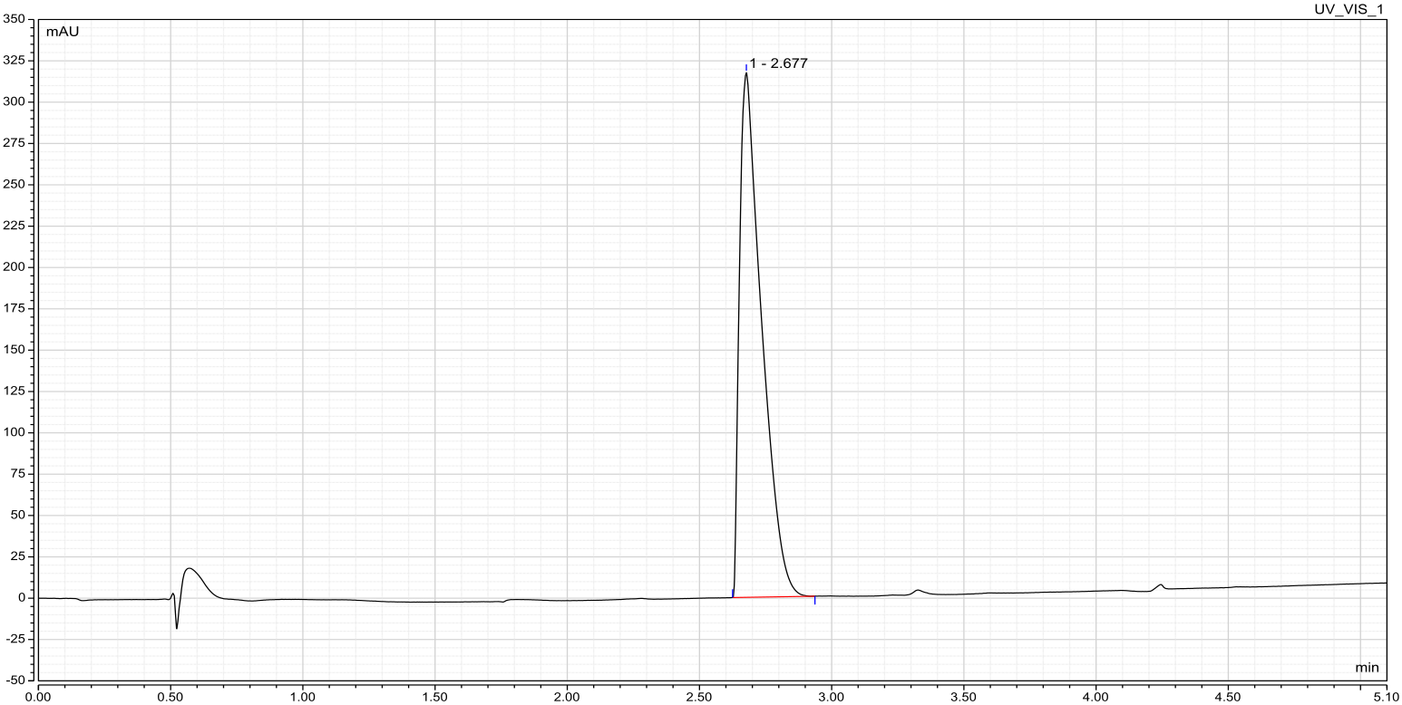

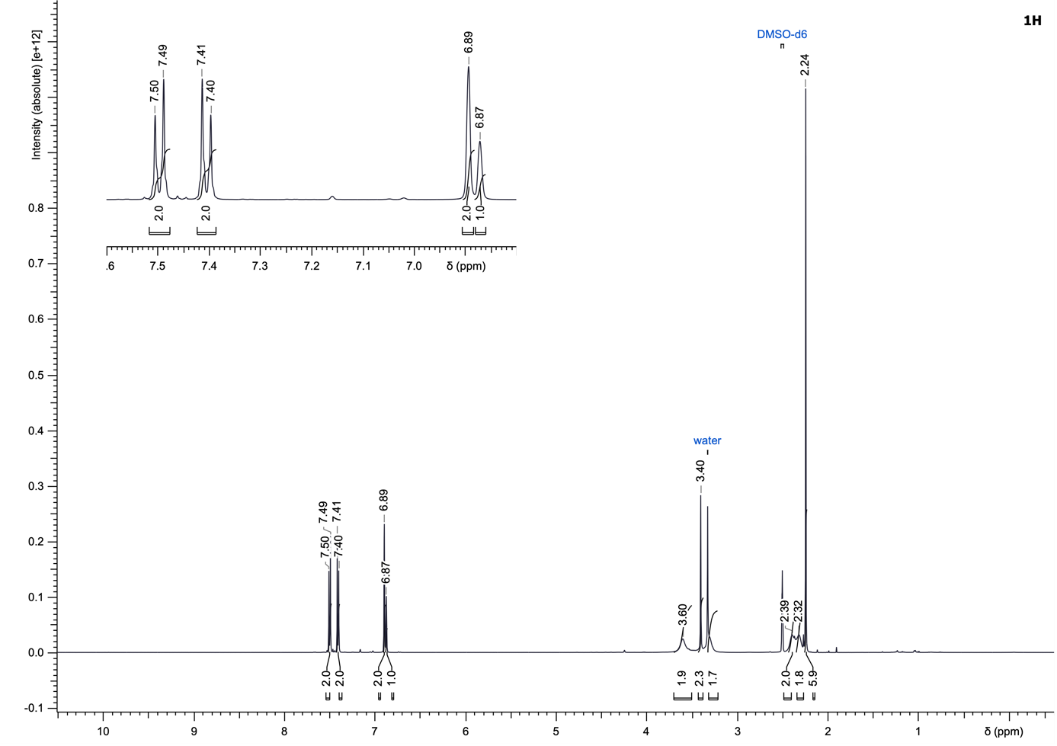
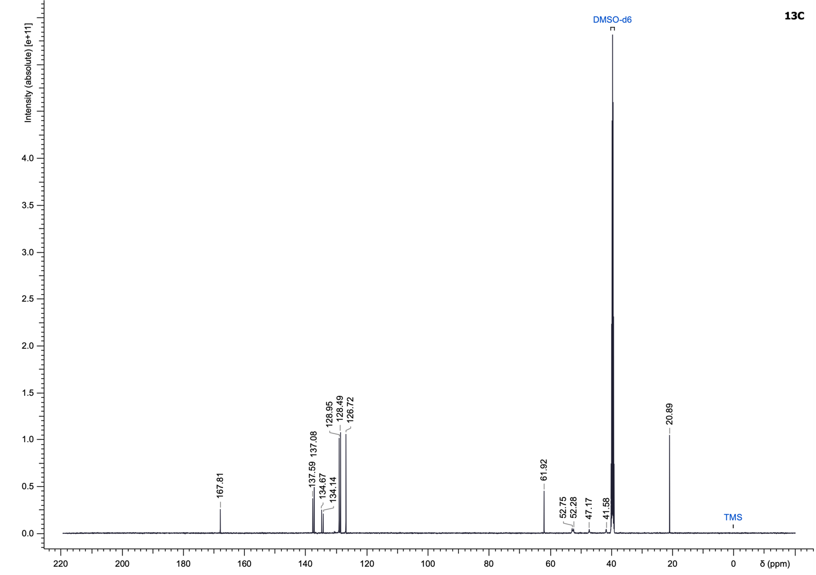

(4-Chlorophenyl)(4-((5-(3-chlorophenyl)furan-2-yl)methyl)piperazin-1-yl)methanone (46)
Compound 46 was synthesized according to the General Procedure H using (4-chlorophenyl)(piperazin-1-yl)methanone (173.57 µmol) and 5-(3-chlorophenyl)furan-2-carbaldehyde as starting materials and purified using cyclohexane/ethyl acetate (25 to 100% ethyl acetate) to yield a white solid (63.5 mg, 88%).
LC–MS (ESI): t_{R} = 3.09 min; > 99% purity (UV at 254 nm);
¹H NMR (500 MHz, DMSO-d₆): δ 7.71 (s, 1H), 7.63 (d, J = 7.8 Hz, 1H), 7.49 (d, J = 8.4 Hz, 2H), 7.46–7.38 (m, 3H), 7.32 (d, J = 8.1 Hz, 1H), 7.03 (d, J = 3.4 Hz, 1H), 6.45 (d, J = 3.4 Hz, 1H), 3.61 (s, 4H), 3.38–3.33 (m, 1H), 3.32–3.27 (m, 1H), 2.54–2.51 (m, 1H), 2.41 (br s, 3H);
¹³C NMR (126 MHz, DMSO-d₆): δ 167.9, 152.1, 150.9, 134.6, 134.2, 133.7, 132.3, 130.8, 128.9 (2C), 128.5 (2C), 127.0, 122.7, 121.8, 111.5, 108.1, 53.7, 52.2, 51.9, 47.1, 41.6;
HRMS (ESI⁺) m/z: [M+H]⁺ calculated for C₂₂H₂₀Cl₂N₂O₂, 415.0975; found, 415.0975.

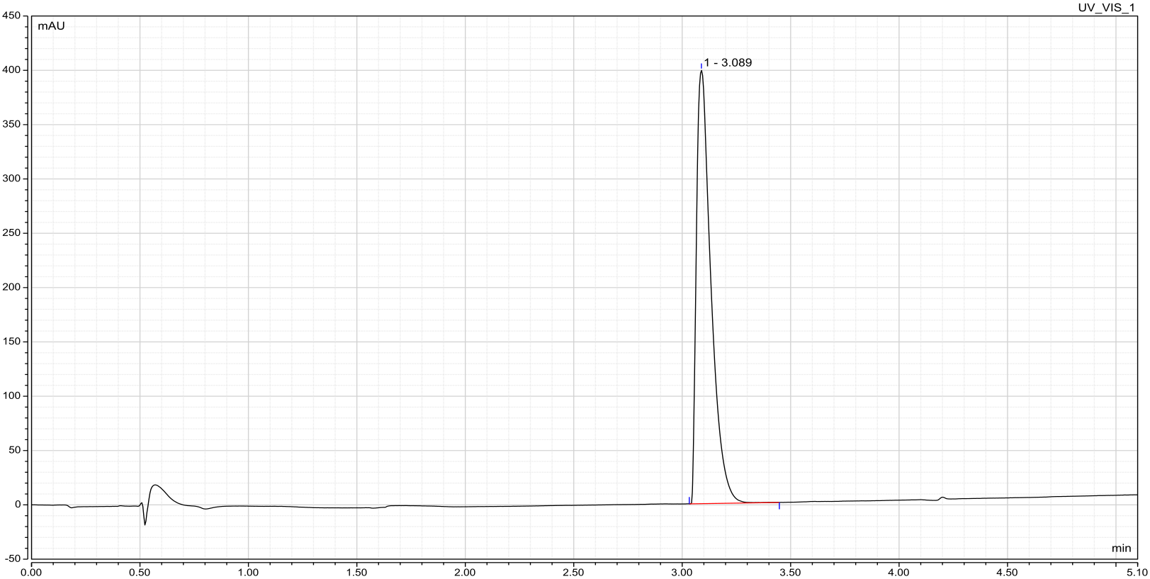

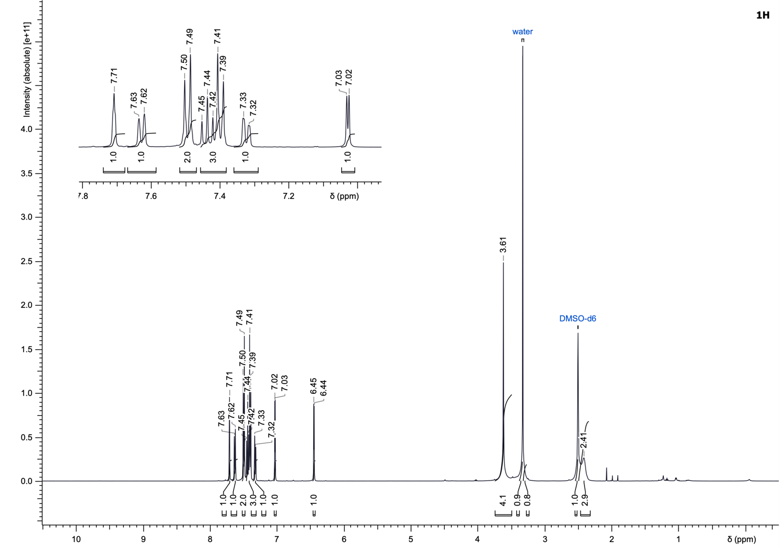
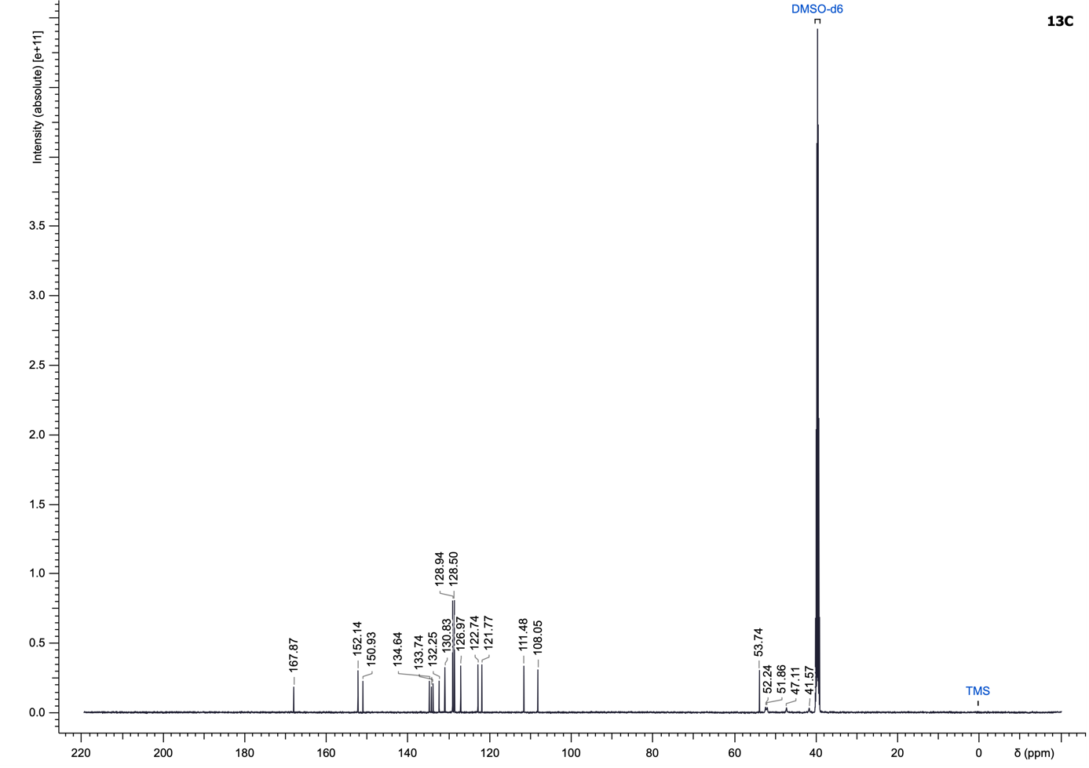

(4-Chlorophenyl)(4-(2-fluoro-4-iodobenzyl)piperazin-1-yl)methanone (47)
Compound 47 was synthesized according to the General Procedure H using (4-chlorophenyl)(piperazin-1-yl)methanone (356.05 µmol) and 2-fluoro-4-iodobenzaldehyde as starting materials and purified using cyclohexane/ethyl acetate (10 to 100% ethyl acetate) to yield a white solid (146.2 mg, 90%).
LC–MS (ESI): t_{R} = 2.86 min; > 99% purity (UV at 254 nm);
¹H NMR (500 MHz, DMSO-d₆): δ 7.61 (d, J = 9.5 Hz, 1H), 7.56 (d, J = 8.1 Hz, 1H), 7.50 (d, J = 8.4 Hz, 2H), 7.40 (d, J = 8.4 Hz, 2H), 7.20 (t, J = 7.9 Hz, 1H), 3.59 (br s, 2H), 3.52 (s, 2H), 3.32–3.23 (m, 2H), 2.42 (br s, 2H), 2.40–2.31 (m, 2H);
¹³C NMR (126 MHz, DMSO-d₆): δ 167.8, 161.5, 159.5, 134.6, 134.2, 133.3 (dd, J = 8.7, 4.1 Hz), 129.0 (2C), 128.5 (2C), 124.2 (d, J = 14.4 Hz), 124.0 (d, J = 23.7 Hz), 93.1 (d, J = 8.3 Hz), 54.0, 52.4, 52.0, 47.1, 41.5;
¹⁹F NMR (470 MHz, CDCl₃): δ -115.3;
HRMS (ESI⁺) m/z: [M+H]⁺ calculated for C₁₈H₁₇ClFIN₂O, 459.0131; found, 459.0134.

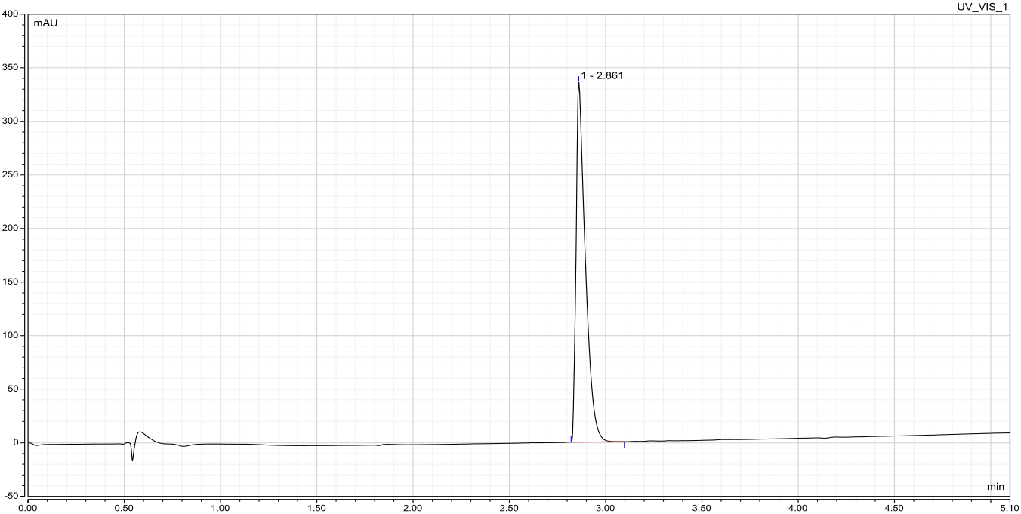

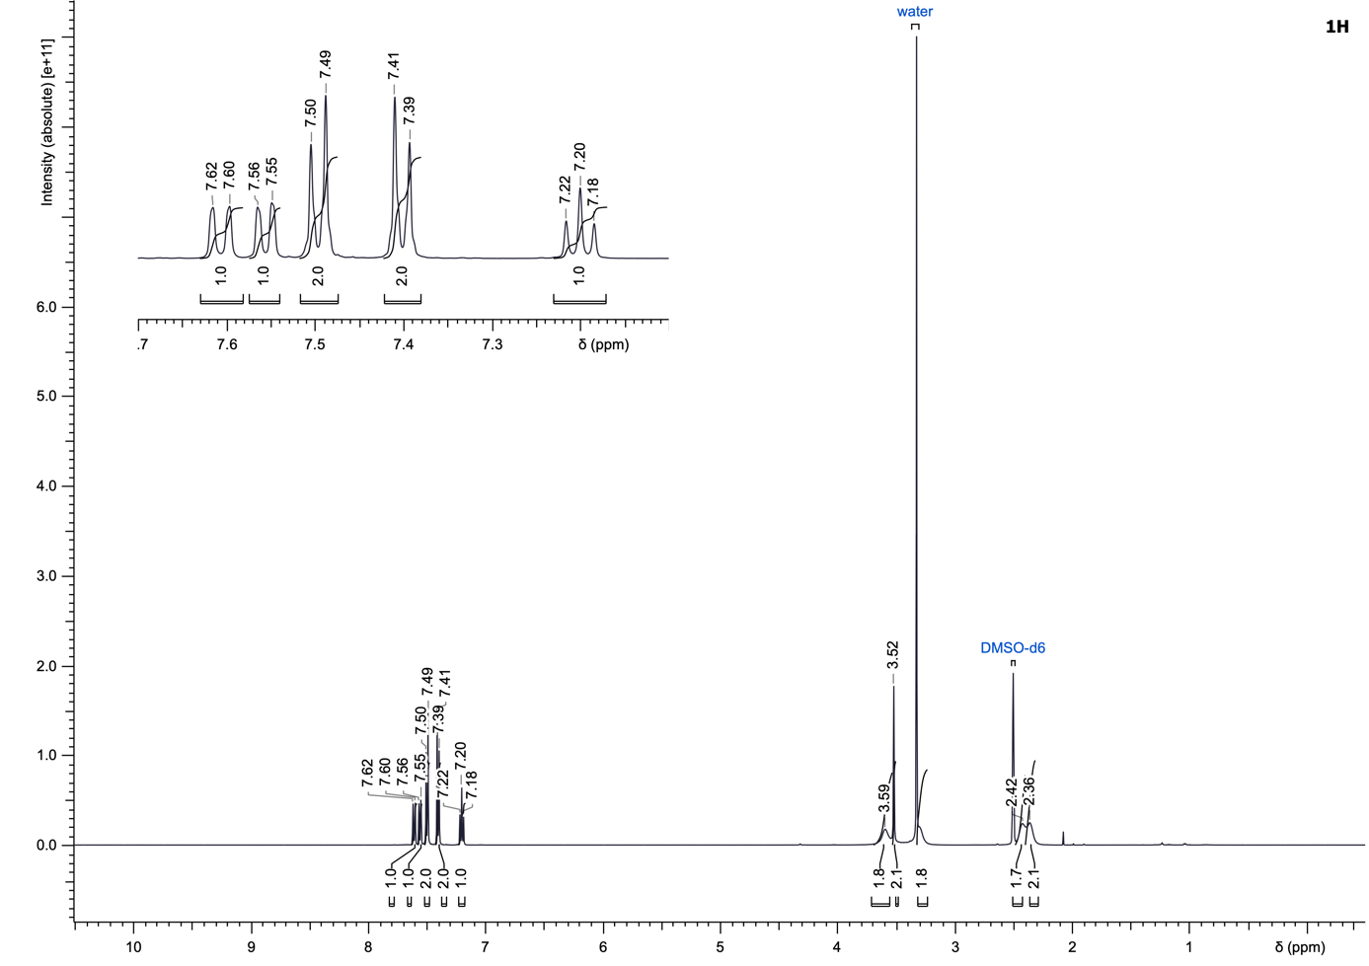
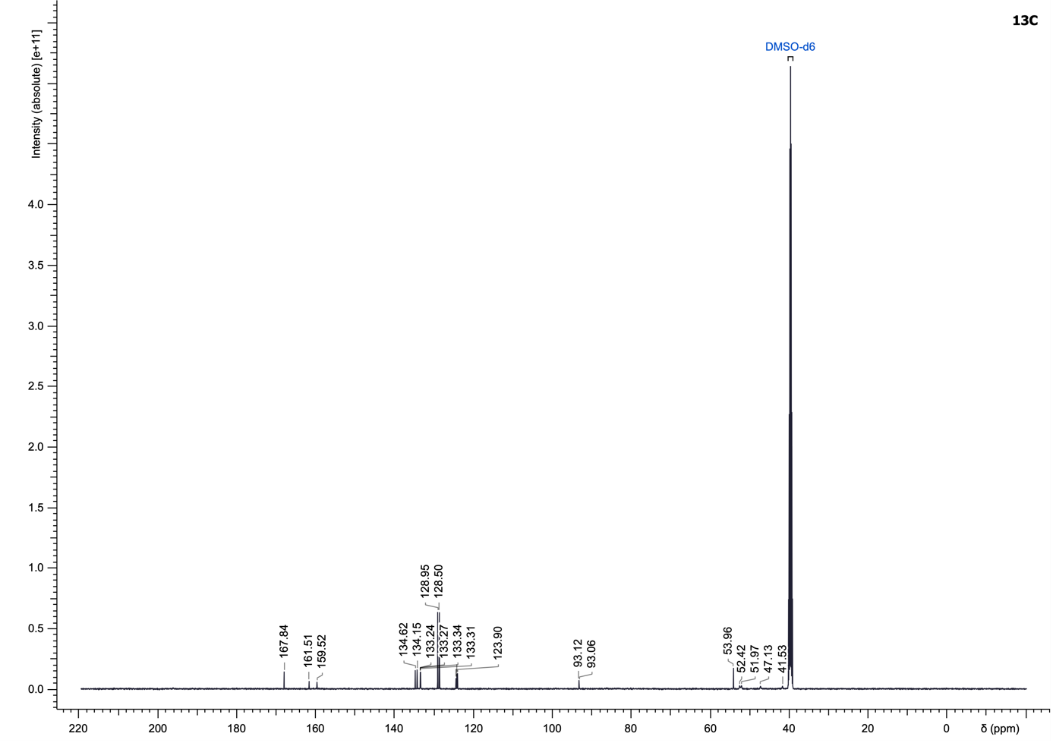
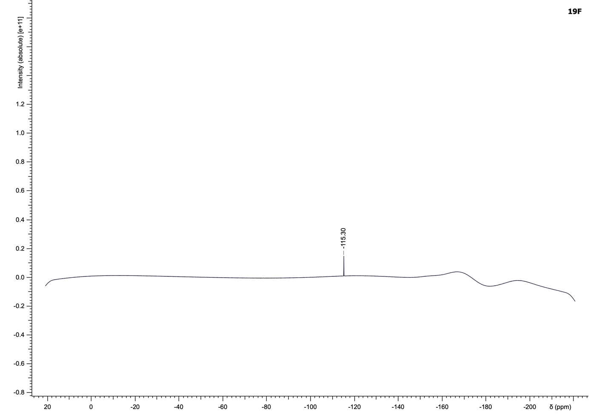

(4-Chlorophenyl)(4-(4-(2-morpholinoethoxy)phenyl)piperazin-1-yl)methanone (48)
To an oven-dried screw-cap tube were added 4-(2-(4-chlorophenoxy)ethyl)morpholine (64.13 µmol, 1.0 eq), RuPhos Pd G3 (1 %mol), potassium tert-butoxide (2.0 eq) and (4-chlorophenyl)(piperazin-1-yl)methanone (1.5 eq). The tube was evacuated and backfilled with Ar (three times), then 1,4-dioxane (0.1 M) was added, after which the tube was sealed and heated at 110 °C overnight. Upon completion, the reaction mixture was cooled to room temperature, diluted with water (5 mL), extracted with dichloromethane (3 × 5 mL), dried over MgSO₄ and concentrated under reduced pressure. The crude product was purified by normal-phase flash chromatography on silica gel using a gradient of dichloromethane/methanol (1 to 8% methanol) to yield the desired product 48 as a white solid (7.8 mg, 28%).
LC–MS (ESI): t_{R} = 2.49 min; > 99% purity (UV at 254 nm);
¹H NMR (500 MHz, DMSO-d₆): δ 7.53 (d, J = 8.4 Hz, 2H), 7.46 (d, J = 8.4 Hz, 2H), 6.90 (d, J = 9.1 Hz, 2H), 6.84 (d, J = 9.1 Hz, 2H), 4.00 (t, J = 5.8 Hz, 2H), 3.74 (br s, 2H), 3.57 (t, J = 4.6 Hz, 4H), 3.53–3.39 (m, 2H), 3.05 (br s, 2H), 2.99 (br s, 2H), 2.64 (t, J = 5.7 Hz, 2H), 2.49–2.41 (m, 4H);
¹³C NMR (126 MHz, DMSO-d₆): δ 167.9, 152.5, 145.1, 134.6, 134.2, 129.0 (2C), 128.5 (2C), 118.1 (2C), 115.0 (2C), 66.2 (2C), 65.6, 57.1, 53.7 (2C), 50.0 (2C), 47.1, 41.6;
HRMS (ESI⁺) m/z: [M+H]⁺ calculated for C₂₃H₂₈ClN₃O₃, 430.1892; found, 430.1896.

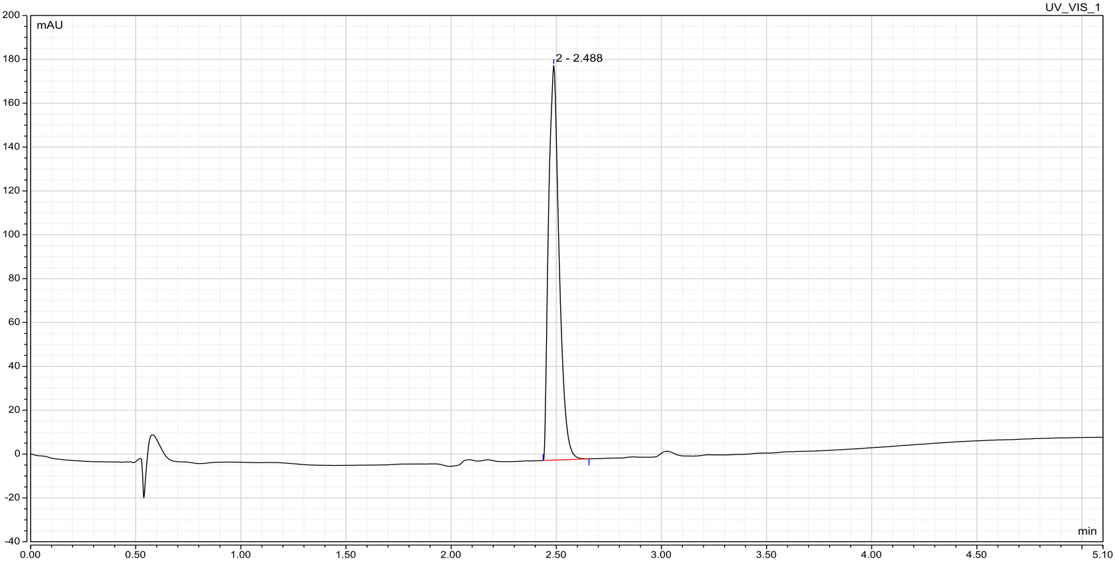

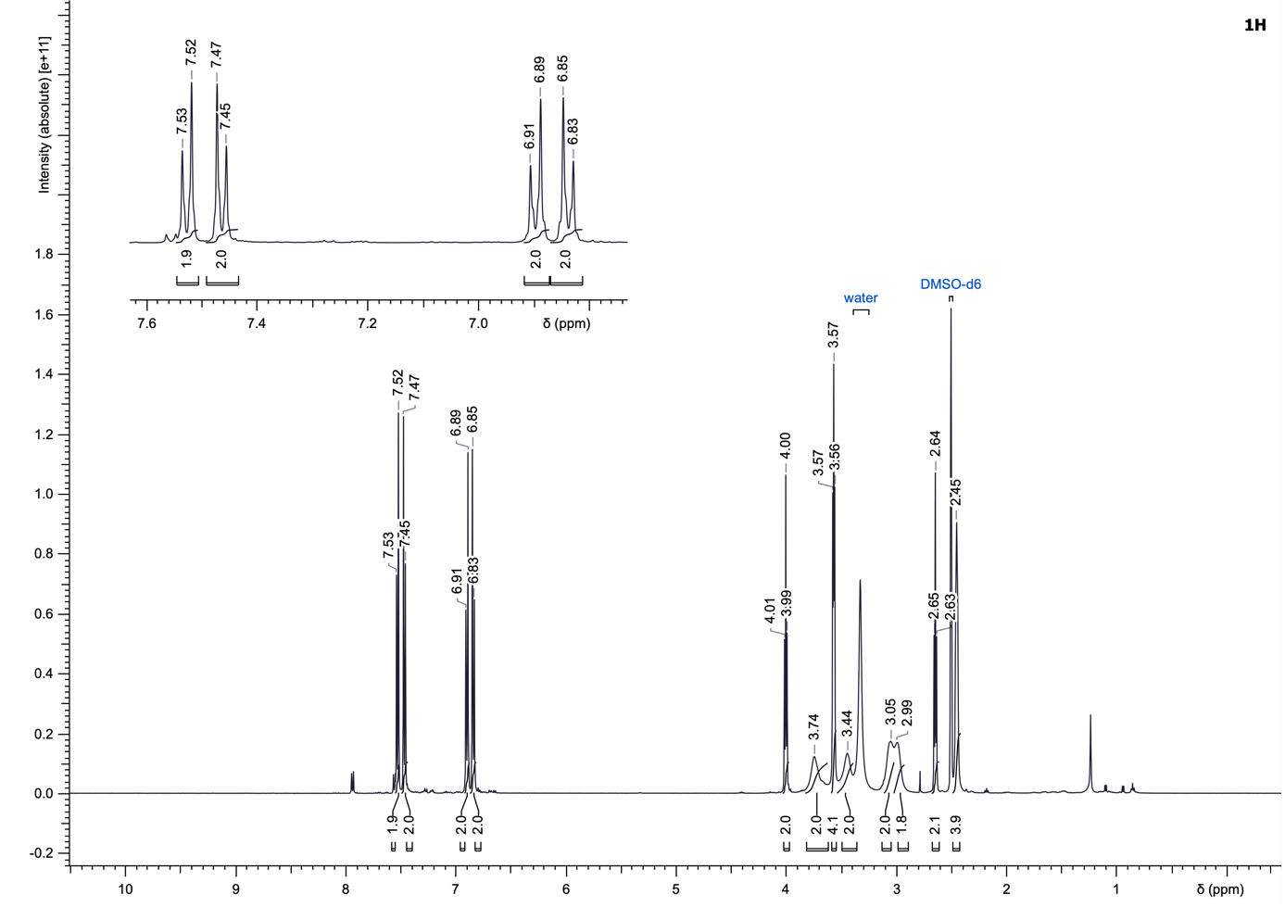
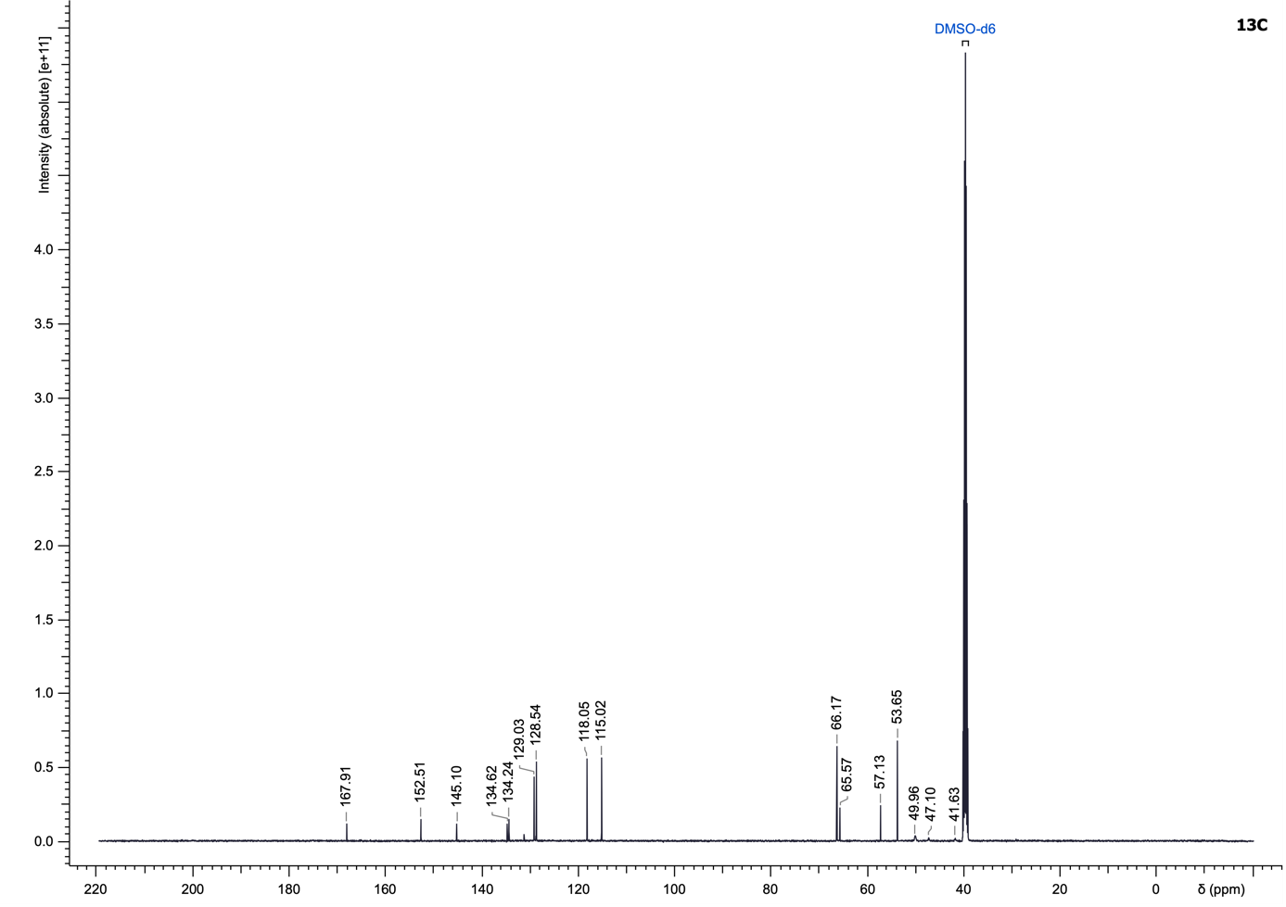

Supplementary Figures
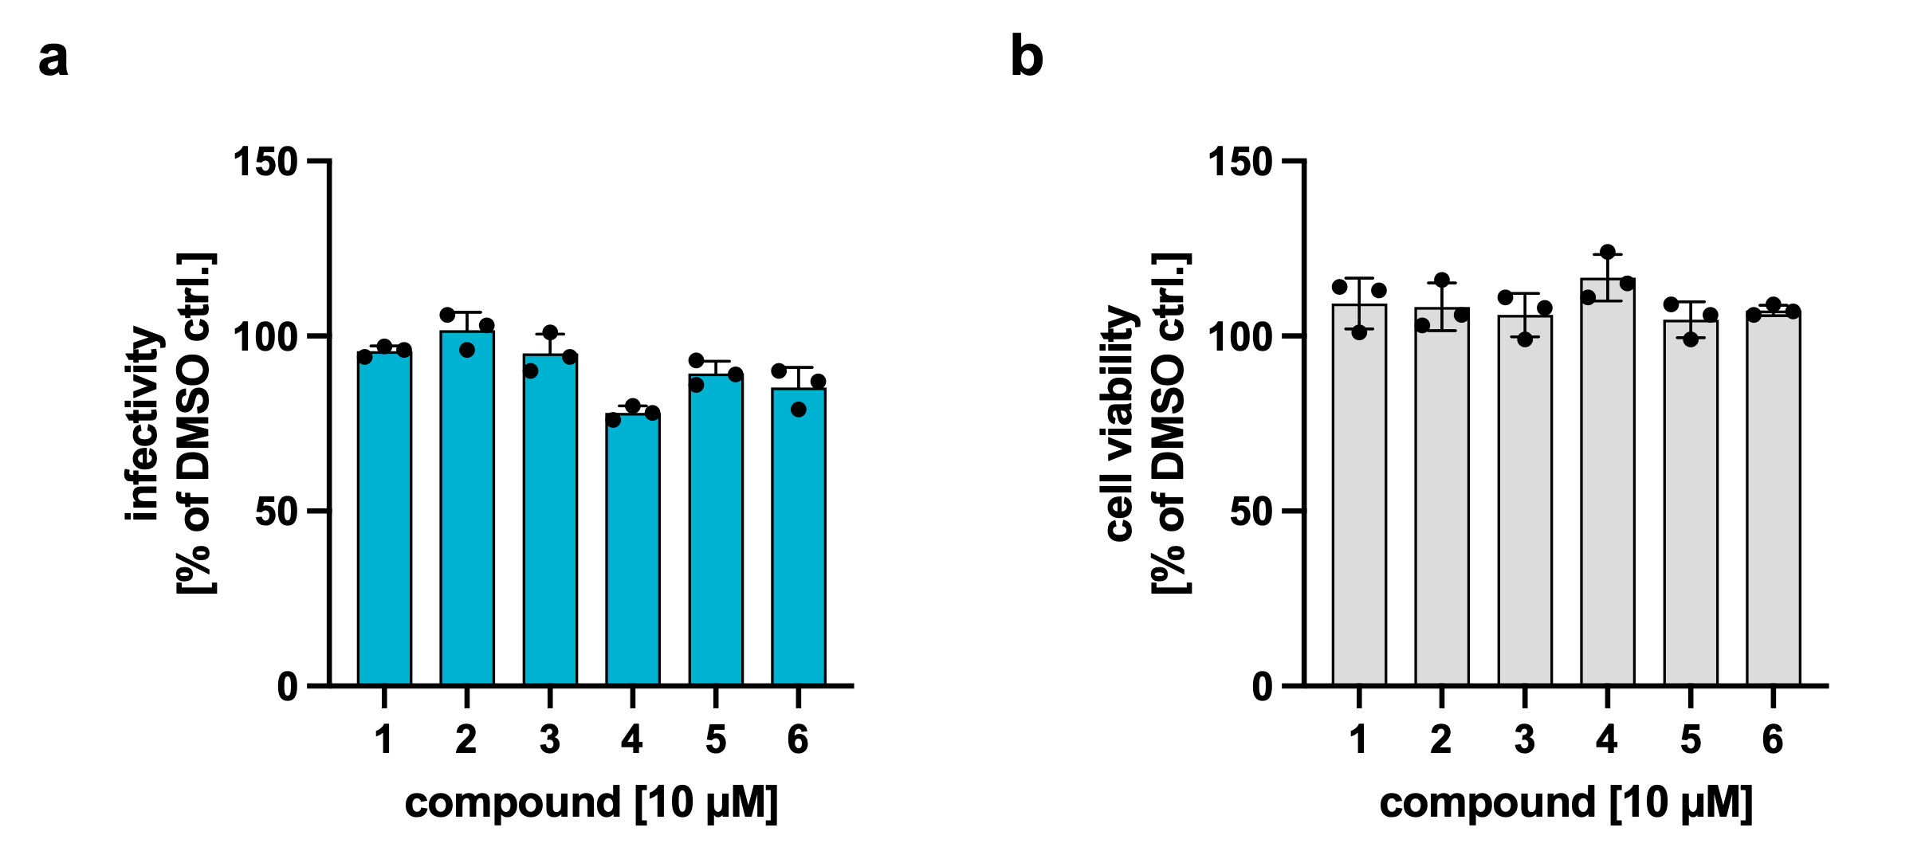

Supplementary Fig. 1: Preliminary dual-luciferase assay measuring residual infectivity and cell viability in human coronavirus 229E (HCoV-229E)-infected cells. Human hepatocellular carcinoma cell lines (Huh-7.5) stably expressing firefly luciferase (FLuc) were infected with HCoV-229E carrying a renilla luciferase (RLuc) reporter. a After compound treatment at 10 µM, residual infectivity was quantified by measuring RLuc activity relative to the dimethyl sulfoxide (DMSO)-treated control. b FLuc signal was measured in parallel to assess cell viability. The error bars indicate the standard deviation based on three independent measurements.

Supplementary Fig. 2: Near-native mass spectrometry (MS) reveals binding of fragment 4 to severe acute respiratory syndrome coronavirus 2 (SARS-CoV-2) non-structural protein 10 (Nsp10). The mass spectrum shows two prominent peak clusters corresponding to multiple charged ions of apo Nsp10. Additional peaks of lower intensity represent the protein–ligand complex, suggesting weak binding under the experimental conditions. The difference in m/z values between the apo and complex species, when multiplied by the charge state, matches the exact mass of the free base form of fragment 4 (exact mass = 259.99828 Da), thus confirming complex formation under near-native conditions.

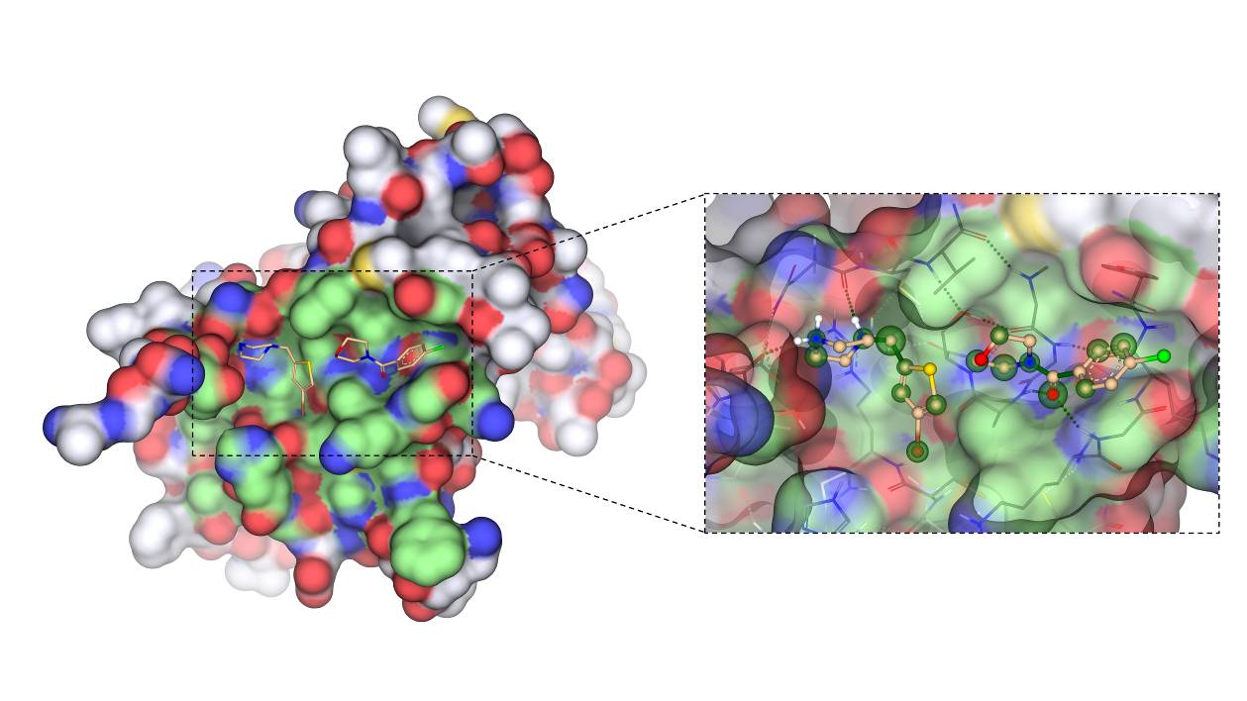
Thr5
Gly94
Ala71
Asn40

Supplementary Fig. 3: Docking poses of fragments 4 and 9 suggest distinct interaction sites on severe acute respiratory syndrome coronavirus 2 (SARS-CoV-2) non-structural protein 10 (Nsp10). Fragments 4 (left) and 9 (right) were docked into Nsp10 after defining the binding pocket (in green). The two fragments occupy distinct regions within the binding surface, supporting the potential for a fragment linking or merging strategy to enhance binding affinity through simultaneous engagement of multiple sites.

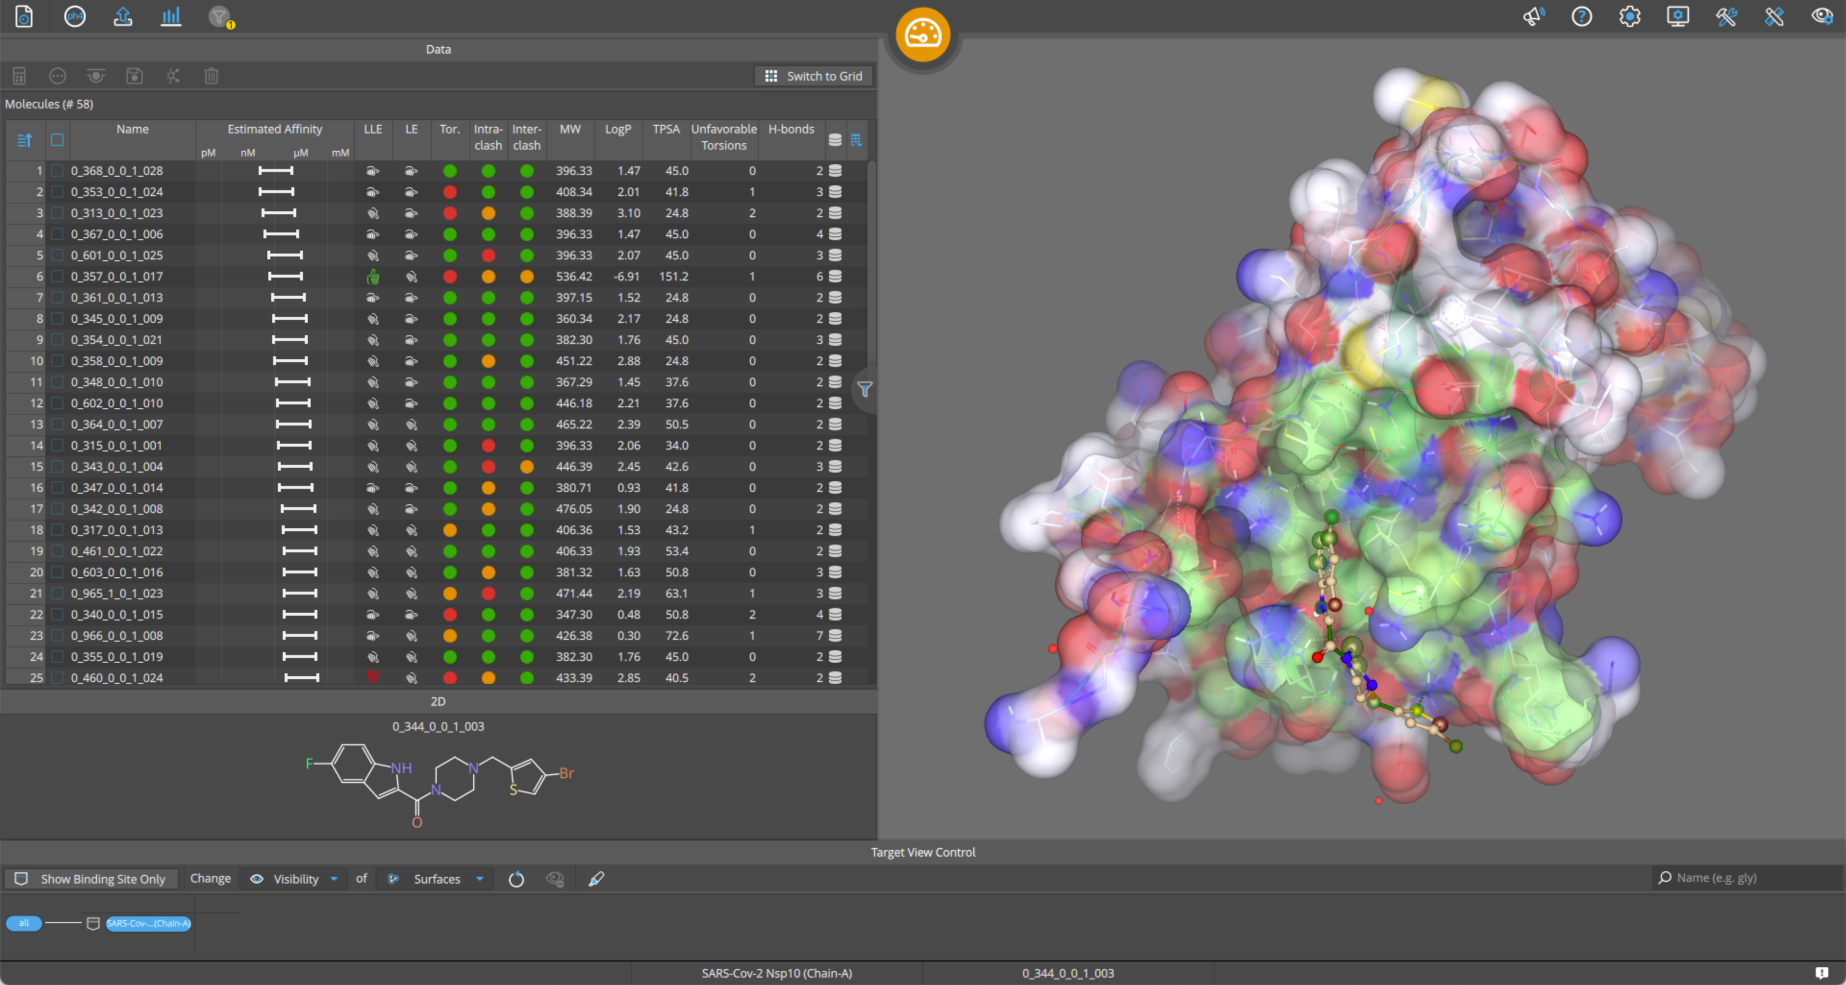

Supplementary Fig. 4: Docking results of the virtual libraries generated with severe acute respiratory syndrome coronavirus 2 (SARS-CoV-2) non-structural protein 10 (Nsp10). Molecular docking using SeeSAR 12.1 was performed on the in silico libraries targeting Nsp10. The binding pocket was defined using residues involved in Nsp14 interaction and additional ligand-binding residues reported in the literature. Compounds were ranked according to their estimated binding affinity, torsional strain and key intermolecular interactions. The top-ranked candidates were selected for synthesis and further experimental validation.

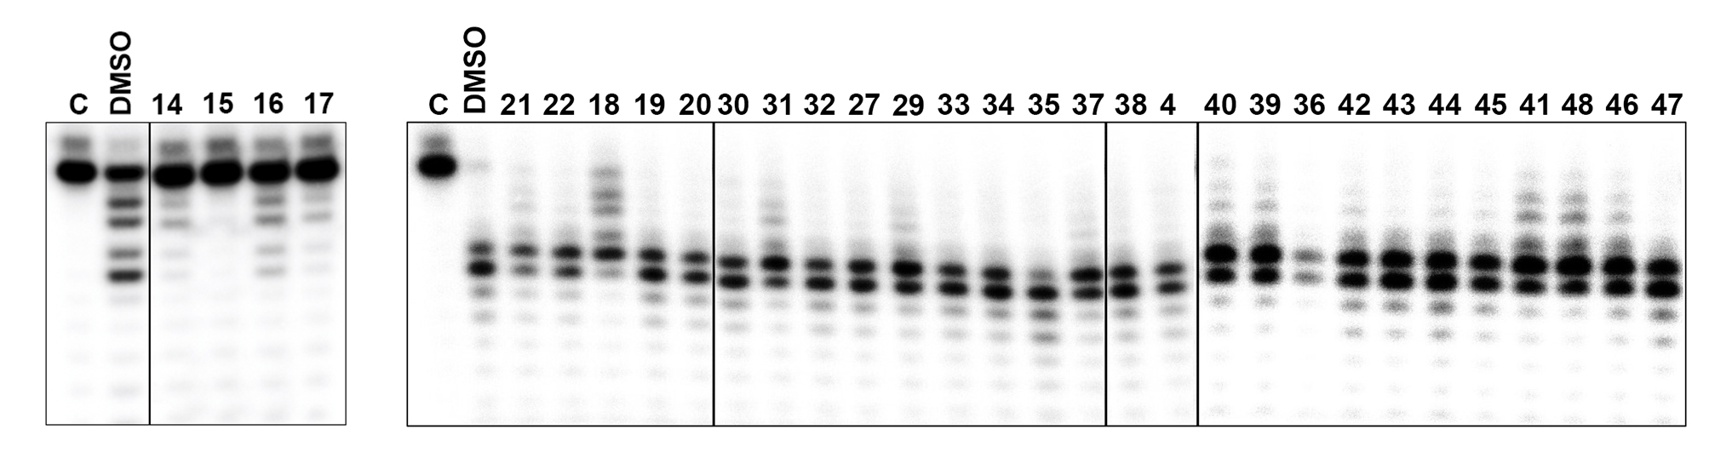

Supplementary Fig. 5: Initial screening for evaluation of the inhibition of severe acute respiratory syndrome coronavirus 2 (SARS-CoV-2) non-structural protein 14 (Nsp14) exoribonuclease (ExoN) activity. The ExoN activity of Nsp14 (500 nM) was measured in the presence of SARS-CoV-2 Nsp10 (2,000 nM) and 2,000 μM of each compound. Compounds were pre-incubated with Nsp10 to promote complex formation before initiating the enzyme reaction with Nsp14 and a ribonucleic acid (RNA) substrate. The absence of RNA degradation served as the functional readout for ExoN inhibition. “C” represents the negative control reaction without enzymes, where the full-length RNA substrate remains intact. “DMSO” represents the positive control reaction carried out with the compound solvent, showing RNA degradation and the formation of small products, used to asses any effect of DMSO on protein activity. Reactions were analysed on a 20% denaturing polyacrylamide gel. DMSO: dimethyl sulfoxide.

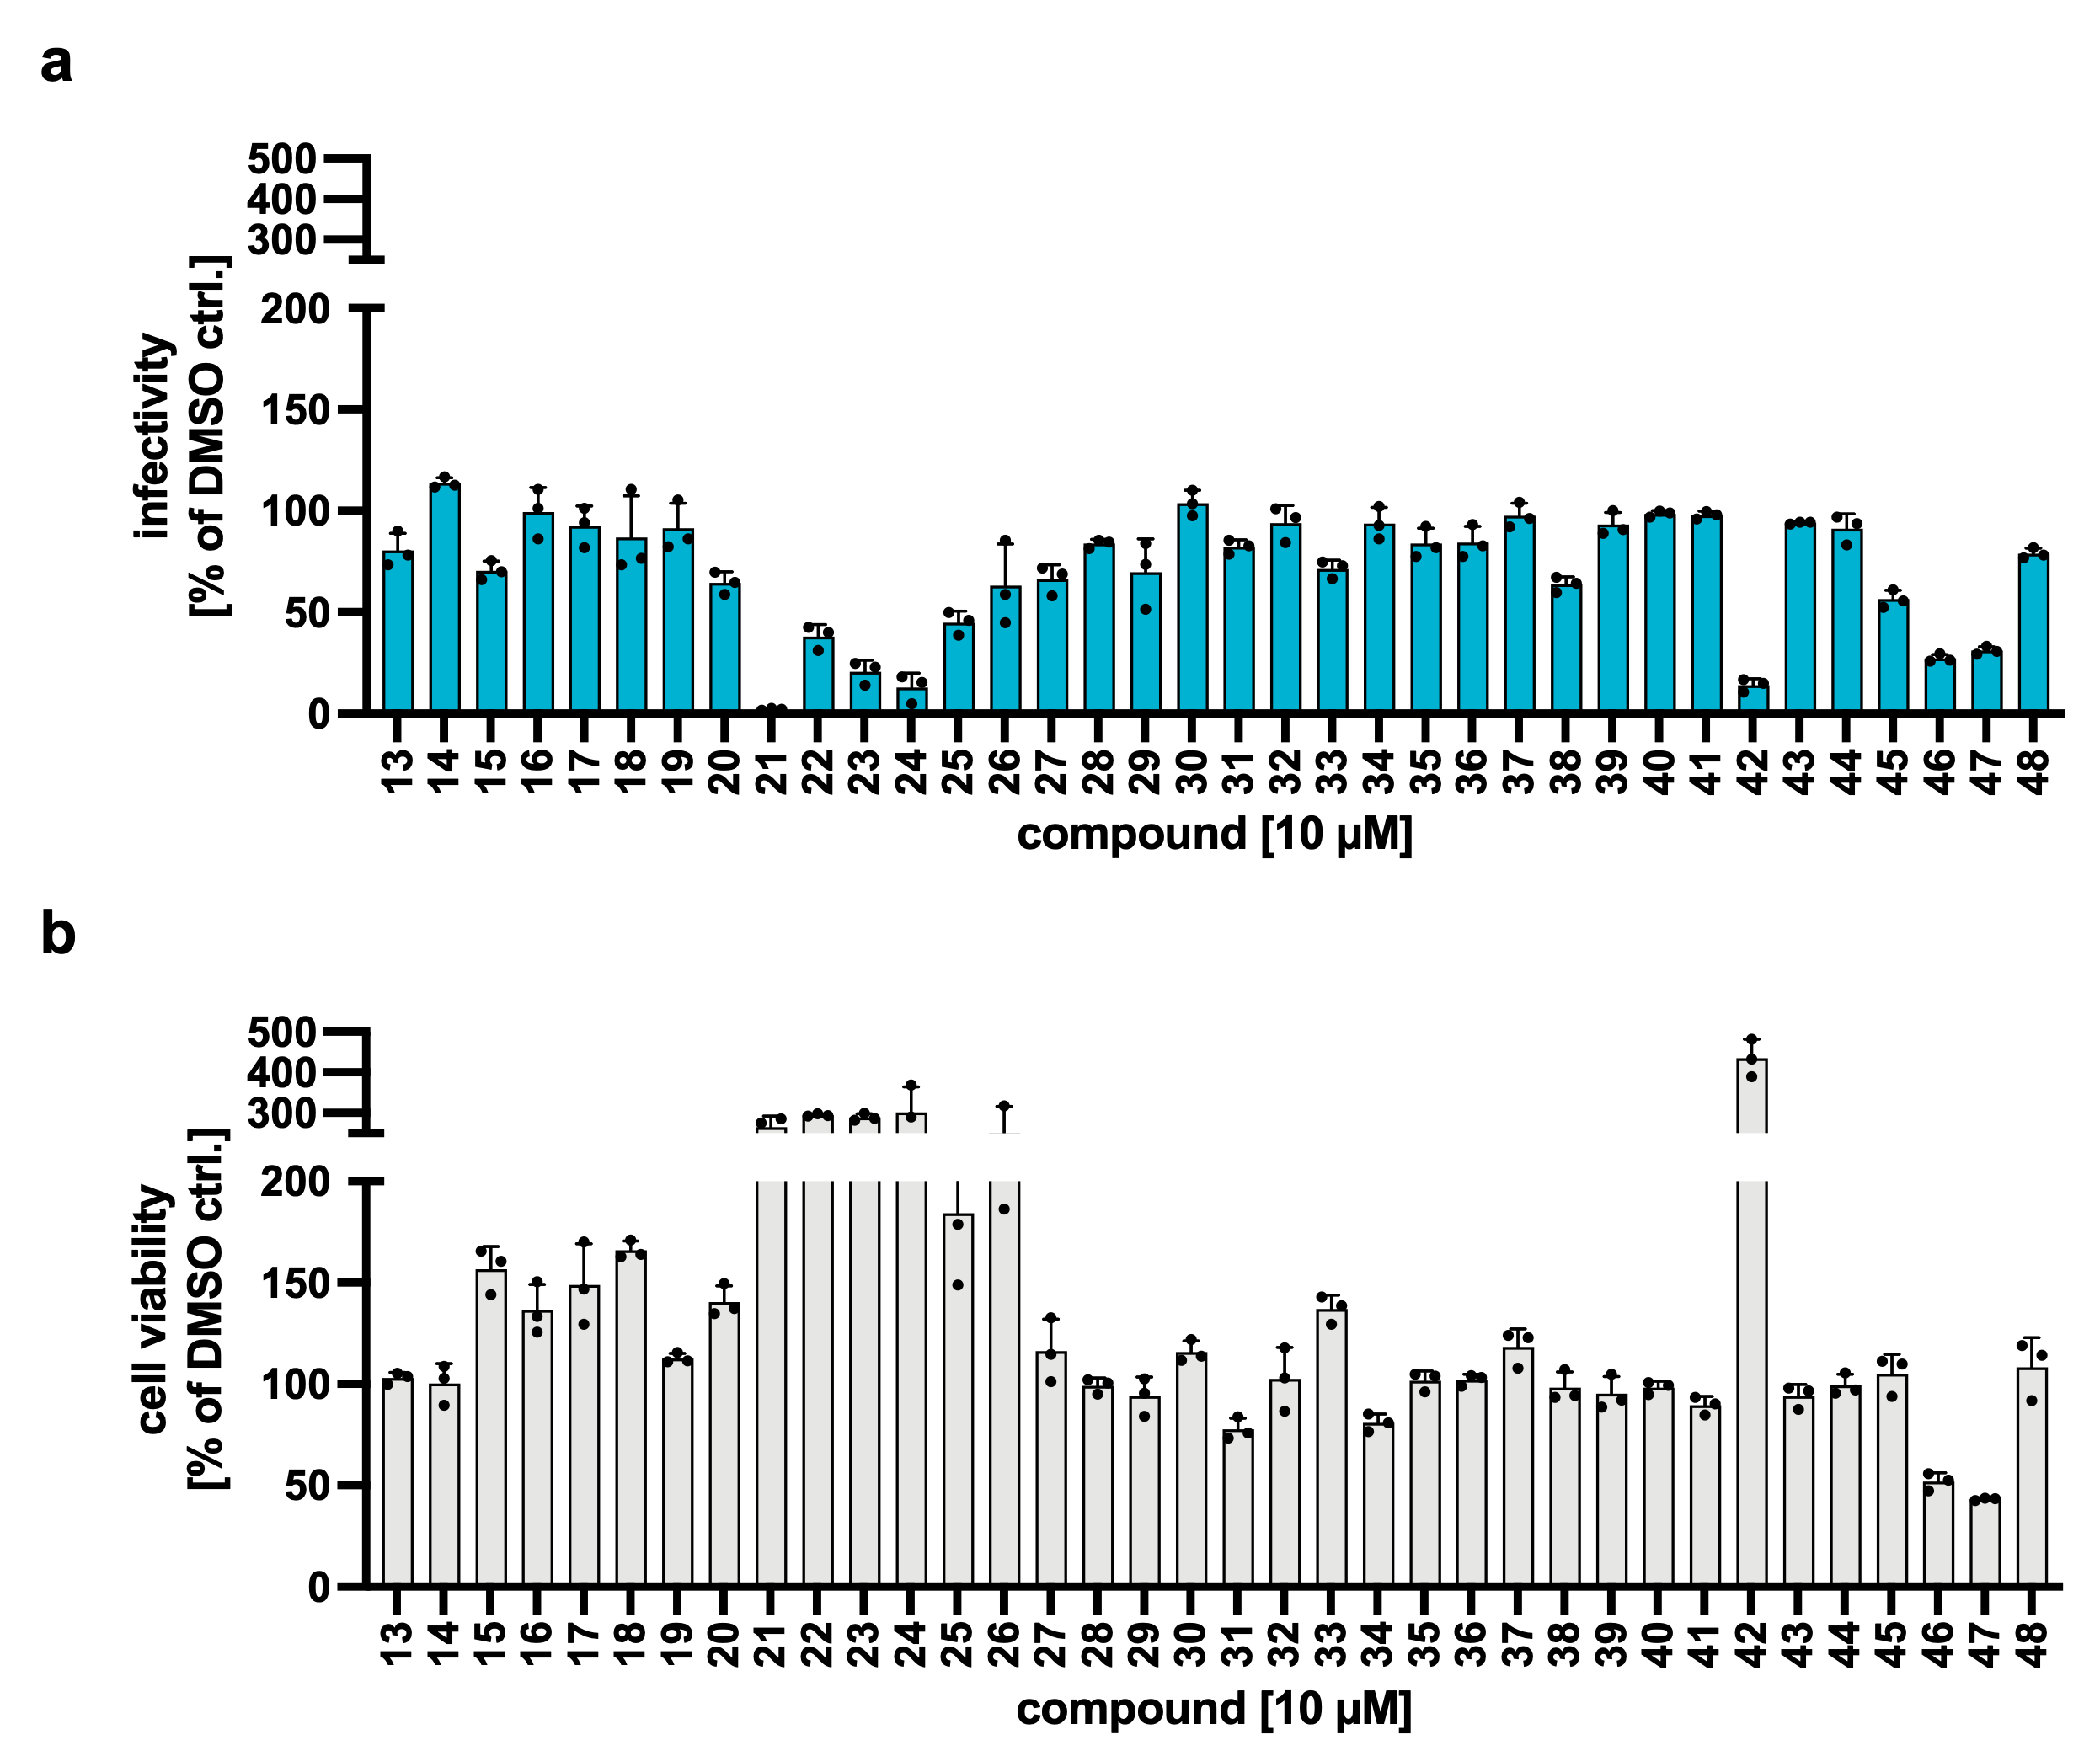

Supplementary Fig. 6: Screening of compounds for antiviral activity against human coronavirus 229E (HCoV-229E) and cytotoxicity. Residual infectivity and cell viability of HCoV-229E carrying a renilla luciferase (RLuc) reporter in human hepatocellular carcinoma cell lines stably expressing firefly luciferase (Huh-7.5 FLuc) treated with compounds at 10 µM were measured using a dual-luciferase assay. a Viral infectivity was monitored in Huh-7.5 FLuc cells infected with an HCoV-229E RLuc reporter virus. b Cell viability was assessed in Huh-7.5 FLuc. The values were normalised to the dimethyl sulfoxide (DMSO) solvent control. Compounds exhibiting antiviral activity protected cells from HCoV-229E-induced cell death, resulting in enhanced cell viability relative to the DMSO control. The error bars indicate the standard deviation of three biological replicates.

Supplementary Fig. 7: Near-native mass spectrometry (MS) reveals binding of compound 37 to severe acute respiratory syndrome coronavirus 2 (SARS-CoV-2) non-structural protein 10 (Nsp10). a The mass spectrum shows two prominent peak clusters corresponding to multiple charged ions of apo Nsp10. Additional peaks of lower intensity represent the protein–ligand complex, suggesting binding under the experimental conditions. The difference in m/z values between the apo and complex species, when multiplied by the charge state, matches the mass of compound 37 (exact mass = 358.10842 Da), thus confirming complex formation under near-native conditions. b The deconvoluted mass spectrum shows one peak corresponding to apo Nsp10 and another peak of lower intensity representing the protein–ligand complex, suggesting binding under the experimental conditions. The difference in m/z values between the apo and complex species, matches the mass of compound 37, thus confirming complex formation under near-native conditions.

Supplementary Fig. 8: Screening of compounds for antiviral activity against severe acute respiratory syndrome coronavirus 2 (SARS-CoV-2). Residual infectivity of SARS-CoV-2 in Calu-3 cells treated with compounds at 10 µM was measured by SARS-CoV-2 specific quantitative reverse-transcription polymerase chain reaction (qRT-PCR). Ribonucleic acid (RNA) was extracted from the supernatants. Infectivity is expressed as a percentage relative to dimethyl sulfoxide (DMSO)-treated infected controls (N = 2–4 technical replicates; N = 1–2 biological replicates).

Supplementary Notes

List of Abbreviations
2′-O-MTase | 2′-O-methyltransferase
A₂₈₀ | absorption at 280 nm
ACE2 | angiotensin-converting enzyme 2
ACL | Academia das Ciências de Lisboa
ATP | adenosine triphosphate
B | blank
br | broad
C | compound
Cap-1 | viral mRNA cap structure with methylation of the 2′-O position of the first nucleotide
CC₅₀ | 50% cytotoxic concentration
cLogP | calculated logarithm of the n-octanol/water partition coefficient
CNRS | Centre National de la Recherche Scientifique
COVID-19 | coronavirus disease 2019
CV | column volume
d | doublet
DCM | dichloromethane
dd | doublet of doublets
ddd | doublet of doublets of doublets
DFG | Deutsche Forschungsgemeinschaft
DIPEA | N,N-diisopropylethylamine
DMF | dimethylformamide
DMSO | dimethyl sulfoxide
dt | doublet of triplets
DTT | dithiothreitol
DZIF | Deutsches Zentrum für Infektionsforschung
DZL | Deutsches Zentrum für Lungenforschung
E | envelope
EDC·HCl | N-ethyl-N′-(3-dimethylaminopropyl)carbodiimide hydrochloride
EDTA | ethylenediaminetetraacetic acid
EG | ethylene glycol
EMA | European Medicines Agency
ESI | electrospray ionisation
EVA-GLOBAL | European Virus Archive GLOBAL
EXC | Cluster of Excellence
ExoN | exoribonuclease
FA | formic acid
FBDD | fragment-based drug discovery
FCT | Fundação para a Ciência e a Tecnologia I.P.
FLuc | firefly luciferase
FT-ICR | Fourier-transform ion cyclotron resonance
GARDP | Global Antibiotic Research & Development Partnership
HCoV-229E | human coronavirus 229E
HEFL | halogen-enriched fragment library
HEPES | 2-[4-(2-hydroxyethyl)piperazin-1-yl]ethane-1-sulfonic acid
HIPS | Helmholtz-Institut für Pharmazeutische Forschung Saarland
HOBt | N-Hydroxybenzotriazole
HP | high performance
HPLC | high-performance liquid chromatography
HRMS | high-resolution mass spectrometry
Huh-7.5 FLuc | human hepatocellular carcinoma cell lines stably expressing firefly luciferase
HZI | Helmholtz-Zentrum für Infektionsforschung
IC₅₀ | half-maximal inhibitory concentration
IPTG | isopropyl-β-D-thiogalactoside
J | coupling constant
K_{D} | dissociation constant
LB | lysogeny broth
LC–MS | liquid chromatography–mass spectrometry
LCI | Institut für Lebensmittelchemie
LDH | lactate dehydrogenase
LLE | ligand-lipophilicity efficiency
M | membrane
m | multiplet
MHH | Medizinische Hochschule Hannover
M^{pro} | main protease
MS | mass spectrometry
MW | microwave
N | nucleocapsid
N.C. | not calculable
N.T. | not tested
N7-MTase | N7-methyltransferase
NHS | N-hydroxysuccinimide
NMR | nuclear magnetic resonance
Nsp | non-structural protein
OD₆₀₀ | optical density at 600 nm
ORF | open reading frame
PBS | phosphate-buffered saline
Pd(dppf)Cl₂ | dichloro[1,1′-bis(diphenylphosphino)ferrocene]palladium(II)
Pd(PPh₃)₄ | tetrakis(triphenylphosphine)palladium(0)
PDB | protein data bank
PMSF | phenylmethylsulfonyl fluoride
pp1a | polyprotein 1a
pp1ab | polyprotein 1ab
PPI | protein–protein interaction
ppm | parts per million
pRSF-Duet-1-Amp | pRSF-Duet-1 carrying an ampicillin resistance gene
PSH | PharmaScienceHub
q | quartet
qRT-PCR | quantitative reverse-transcription polymerase chain reaction
quint | quintet
RdRp | RNA-dependent RNA polymerase
RIU | refractive index unit
RIU | refractive index unit
RLuc | renilla luciferase
RNA | ribonucleic acid
RT | room temperature
RU | response unit
S | spike
s | singlet
SAM | S-adenosylmethionine
SAR | structure–activity relationship
SARS-CoV-2 | severe acute respiratory syndrome coronavirus 2
SDF | structure-data file
SDS-PAGE | sodium dodecyl sulfate-polyacrylamide gel electrophoresis
sept | septet
sext | sextet
SMILES | simplified molecular input line entry system
SPR | surface plasmon resonance
STD | saturation-transfer difference
t | triplet
T3P | propylphosphonic anhydride
TB | terrific broth
td | triplet of doublets
tdDCC | target-directed dynamic combinatorial chemistry
TEA | triethylamine
TEV | tobacco etch virus
TFA | trifluoroacetic acid
TMS | tetramethylsilane
UHPLC | ultra-high-performance liquid chromatography
UPS | Université Toulouse III–Paul Sabatier
UV | ultraviolet

