Supplementary Material: Global economic costs of herpetofauna invasions

Ismael Soto¹; Ross N. Cuthbert^{2,3}; Antonín Kouba¹; César Capinha⁴; Anna Turbelin⁵; Emma J. Hudgins⁶; Christophe Diagne⁵; Franck Courchamp⁵ & Phillip J. Haubrock^{1,7}

¹ University of South Bohemia in České Budějovice, Faculty of Fisheries and Protection of Waters, South Bohemian Research Center of Aquaculture and Biodiversity of Hydrocenoses, Zátiší 728/II, 389 25 Vodňany, Czech Republic
² GEOMAR Helmholtz-Zentrum für Ozeanforschung Kiel, 24105 Kiel, Germany
³ School of Biological Sciences, Queen’s University Belfast, BT9 5DL Belfast, UK
⁴ Centro de Estudos Geográficos, Instituto de Geografia e Ordenamento do Território - IGOT, Universidade de Lisboa, Rua Branca Edmée Marques, 1600-276 Lisboa, Portugal
⁵ Université Paris-Saclay, CNRS, AgroParisTech, Ecologie Systématique Evolution, 91405, Orsay, France
⁶ Department of Biology, Carleton University, Ottawa, Canada
⁷ Senckenberg Research Institute and Natural History Museum Frankfurt, Department of River Ecology and Conservation, Gelnhausen, Germany.

Correspondence: isotoalmena@frov.jcu.cz

Appendix A. Supplementary material
A Web of Science search was performed in July 2021 which included the following string: latin name of species name AND (non-native OR nonnative OR non-indigenous OR nonindigenous OR alien OR exotic OR introduced OR colonizing OR invasive), thus combining each species’ name with a synonym of alien. Studies that reported an economic cost (i.e. overlap with Invacost) were removed from the total number for the corresponding species to reduce potential overestimation in the total number of studies.

Appendix B. Supplementary material
Table S1: Summary of species without costs found at the order and family levels for herpetofauna invasions in InvaCost compared to known aliens from Capinha et al. (2017).
Order | Class | Species without costs | Percentage without costs | Observed costs^{ϴ} | Total costs^{ϕ}
Anura | Amphibia | 62/68 | 91.17 | 1.97 | 36.95
Caudata | Amphibia | 13/13 | 100 | NR | NR
Squamata | Reptilia | 155/163 | 95.09 | 97.7 | 61.05
Testudines | Reptilia | 32/35 | 91.42 | 0.07 | 0.01
Crocodilia | Reptilia | 1/1 | 100 | NR | NR
Diverse | Amphibia/Reptilia | 0/0 | 0 | 0.25 | 1.97
Family
Bufonidae | Amphibia | 6/7 | 88.7 | 1.21 | 0.45
Eleutherodactylidae | Amphibia | 4/6 | 66.66 | 0.63 | 0.92
Rhacophoridae | Amphibia | 1/2 | 50 | 0.004 | 0.001
Pipidae | Amphibia | 0/1 | 0 | 0.002 | 0.0004
Ranidae | Amphibia | 23/24 | 95.83 | 0.11 | 35.6
Alytae | Amphibia | 2/2 | 100 | NR | NR
Ambystomatidae | Amphibia | 1/1 | 100 | NR | NR
Bombinatoridae | Amphibia | 1/1 | 100 | NR | NR
Cryptobranchidae | Amphibia | 1/1 | 100 | NR | NR
Dendrobatidae | Amphibia | 1/1 | 100 | NR | NR
Dicroglossidae | Amphibia | 4/4 | 100 | NR | NR
Hylidae | Amphibia | 10/10 | 100 | NR | NR
Leptodactylidae | Amphibia | 1/1 | 100 | NR | NR
Microhylidae | Amphibia | 3/3 | 100 | NR | NR
Pelodryadidae | Amphibia | 4/4 | 100 | NR | NR
Plethodontidae | Amphibia | 4/4 | 100 | NR | NR
Proteidae | Amphibia | 2/2 | 100 | NR | NR
Ptychadenidae | Amphibia | 1/1 | 100 | NR | NR
Pyxicephalidae | Amphibia | 1/1 | 100 | NR | NR
Salamandridae | Amphibia | 5/5 | 100 | NR | NR
Chelydridae | Reptilia | 1/2 | 50 | 0.002 | 0.0005
Colubridae | Reptilia | 17/20 | 85 | 97.05 | 60.9
Dactyloidae | Reptilia | 17/19 | 89.47 | 0.63 | 0.13
Emydidae | Reptilia | 10/12 | 83.33 | 0.06 | 0.01
Iguanidae | Reptilia | 5/6 | 83.33 | 0.004 | 0.0008
Lacertidae | Reptilia | 9/10 | 90 | 0.001 | 0.0002
Teiidae | Reptilia | 6/7 | 85.71 | NR | 0.00006
Pythonidae | Reptilia | 3/3 | 100 | NR | NR
Viperidae | Reptilia | 2/2 | 100 | NR | NR
Agamidae | Reptilia | 6/6 | 100 | NR | NR
Acrochordidae | Reptilia | 1/1 | 100 | NR | NR
Alligatoridae | Reptilia | 1/1 | 100 | NR | NR
Amphisbaenidae | Reptilia | 1/1 | 100 | NR | NR
Anguidae | Reptilia | 1/1 | 100 | NR | NR
Blanidae | Reptilia | 1/1 | 100 | NR | NR
Boidae | Reptilia | 2/2 | 100 | NR | NR
Chamaeleonidae | Reptilia | 7/7 | 100 | NR | NR
Chelidae | Reptilia | 1/1 | 100 | NR | NR
Corytophanidae | Reptilia | 1/1 | 100 | NR | NR
Crotaphytidae | Reptilia | 1/1 | 100 | NR | NR
Gekkonidae | Reptilia | 34/34 | 100 | NR | NR
Geoemydidae | Reptilia | 6/6 | 100 | NR | NR
Gymnophthalmidae | Reptilia | 1/1 | 100 | NR | NR
Lamprophiidae | Reptilia | 2/2 | 100 | NR | NR
Leiocephalidae | Reptilia | 2/2 | 100 | NR | NR
Leptotyphlopidae | Reptilia | 1/1 | 100 | NR | NR
Liolaemidae | Reptilia | 1/1 | 100 | NR | NR
Pareidae | Reptilia | 1/1 | 100 | NR | NR
Pelomedusidae | Reptilia | 2/2 | 100 | NR | NR
Phrynosomatidae | Reptilia | 2/2 | 100 | NR | NR
Phyllodactylidae | Reptilia | 4/4 | 100 | NR | NR
Scincidae | Reptilia | 18/18 | 100 | NR | NR
Sphaerodactylidae | Reptilia | 6/6 | 100 | NR | NR
Testudinidae | Reptilia | 7/7 | 100 | NR | NR
Trionychidae | Reptilia | 5/5 | 100 | NR | NR
Typhlopidae | Reptilia | 1/1 | 100 | NR | NR
Varanidae | Reptilia | 2/2 | 100 | NR | NR
Diverse | Amphibia/Reptilia | 0/0 | 0 | 0.26 | 1.98
NR*: Not recorded
ϴ: Percentage of total observed costs
Φ: Percentage of total costs

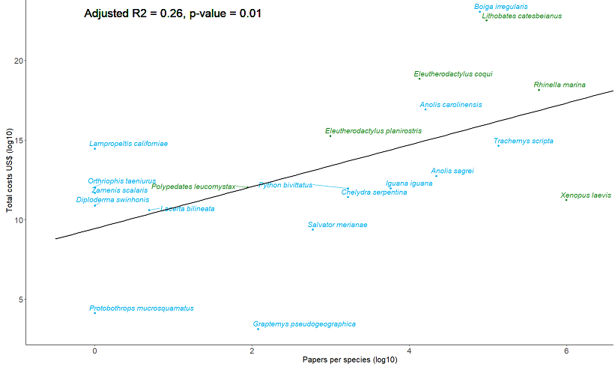
Figure S1: Linear regression between the total costs of invasive herpetofauna (y-axis) vs. the number of research documents mentioning each species (x-axis) returned by our search (see main text). Green color represents alien amphibians and blue color represents alien reptiles.

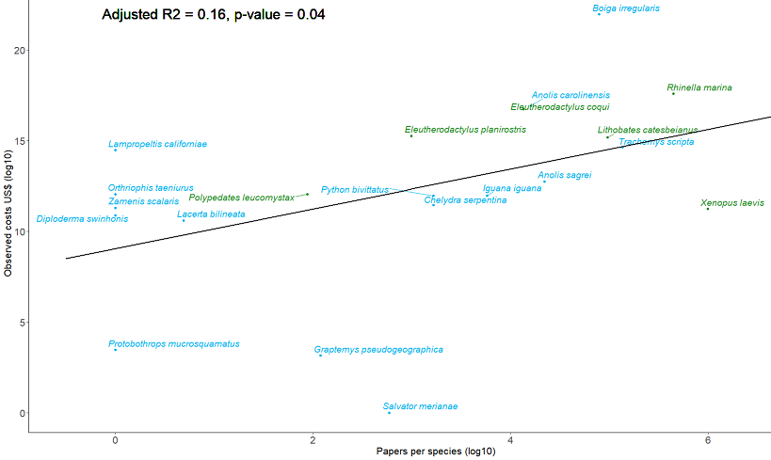
Figure S2: Linear regression between the observed costs of invasive herpetofauna (log-transformed, y-axis) vs. the number of research documents mentioning each species (log-transformed, x-axis) returned by our search (see main text). Green color represents alien amphibians and blue color represents alien reptiles.

Figure legends
Figure S1: Linear regression between the total costs of invasive herpetofauna (y-axis) vs. the number of research documents mentioning each species (x-axis) returned by our search (see main text). Green color represents alien amphibians and blue color represents alien reptiles.

Figure S2: Linear regression between the observed costs of invasive herpetofauna (log-transformed, y-axis) vs. the number of research documents mentioning each species (log-transformed, x-axis) returned by our search (see main text). Green color represents alien amphibians and blue color represents alien reptiles.

