Supplementary File 1. Full-length original gel and blot images
Manuscript: Novel compound-heterozygous variants in PYCR1 broaden the mutation spectrum of autosomal-recessive cutis laxa

Notes for editorial assessment
- For each gel/blot, the original available imaging frame is shown together with an annotated copy for clarity.
- For the Western blot experiments shown in Figure 4B, after transfer, the PVDF/NC membrane was physically cut to the required size according to the number of loaded lanes before antibody incubation and immunodetection. Therefore, no larger intact membrane image exists for these blots.
- The Western blot images provided here represent the complete membrane pieces/strips that were actually used for antibody incubation, immunodetection, and imaging, rather than digitally cropped portions from a larger blot image.
- In the annotated copies, the blue outline marks the physical edge of the complete gel image or membrane piece/strip used in the experiment. The red outline marks the cropped region used in the corresponding manuscript figure panel.
- The original images shown in the left panels are presented without annotations. The annotated copies are provided only to indicate the gel/membrane edge and the manuscript figure crop region.
- Images were resized only for document layout. No digital splicing, selective enhancement, or manipulation was applied to the original images shown in the left panels.
- Figure 3B: agarose gel electrophoresis of RT-PCR products. Lanes: M, Control, Patient. Band a and Band b are indicated in the manuscript figure.
- Figure 4B: Western blot analysis of Flag-PYCR1 expression. Lanes: wt = wild-type PYCR1; mut = c.724_725del mutant PYCR1. Anti-Flag was used to detect Flag-PYCR1 fusion protein. Beta-actin was used as the loading control. GFP was used as the transfection/vector expression control. Replicates 1, 2, and 3 correspond to the left, middle, and right Western blot panels shown in Figure 4B, respectively.

Manuscript panel | Original image included | Descriptor | Replicate information
Figure 3B | Full-length agarose gel image | RT-PCR products; lanes M, Control, Patient; bands a and b | Original gel image used for Figure 3B
Figure 4B | Full-length anti-Flag blots | Flag-PYCR1 fusion protein | Replicates 1-3 shown as the three panels in Figure 4B
Figure 4B | Full-length beta-actin blots | Loading control | Replicates 1-3 shown as the three panels in Figure 4B
Figure 4B | Full-length GFP blots | Transfection/vector expression control | Replicates 1-3 shown as the three panels in Figure 4B

Figure 3B. Original full agarose gel image used for Figure 3B
Original unprocessed full gel image and annotated copy. The red outline marks the cropped region used in Figure 3B. The blue outline marks the full gel image edge.

Original unprocessed full-length image | Annotated copy
Control
M
Patient
Band b
Band a
Blue: physical edge of the complete membrane piece/strip used for this blot

Red: cropped region used in Fig. 3B

Corresponding figure: Figure 3B

Agarose gel electrophoresis of RT-PCR products

Lanes:M,ControlPatient

nding figure: Figure 3B
Agarose gel electrophoresis of RT-PcR products
Lanes: M, Control, Patient

Figure 4B. Original Western blot images of the complete membrane pieces/strips: anti-Flag / Flag-PYCR1
anti-Flag detection of Flag-PYCR1 fusion protein. The red outline marks the cropped band region used in Figure 4B. Blue outlines mark the full blot/membrane edge. Replicates 1-3 correspond to the left, middle,and right Western blot panels in Figure 4B.

Replicate | Original unprocessed full-length image | Annotated copy
Replicate 1  (left panel in Figure 4B) |  | Blue: physical edge of the complete membrane piece/strip used for this blot  Red: cropped region used in Fig. 4B  Corresponding figure: Figure 4B  Replicate 1 (left panel in Figure 4B)  anti-Flag /Flag-PYCR1  Lanes: wt= wild type; mut = C.724_725del mutant  nding figure: Figure 3B  Agarose gel electrophoresis of RT-PcR products  Lanes: M, Control, Patient
Replicate 2  (middle panel in Figure 4B) | 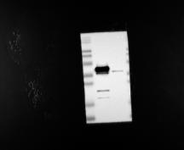 | Blue: physical edge of the complete membrane piece/strip used for this blot  Red: cropped region used in Fig. 4B  Corresponding figure: Figure 4B  Replicate 2 (middle panel in Figure 4B)  anti-Flag /Flag-PYCR1  Lanes: wt= wild type; mut = C.724_725del mutant  nding figure: Figure 3B  Agarose gel electrophoresis of RT-PcR products  Lanes: M, Control, Patient
Replicate 3  (right panel in Figure 4B) | 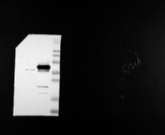 | Blue: physical edge of the complete membrane piece/strip used for this blot  Red: cropped region used in Fig. 4B  Corresponding figure: Figure 4B  Replicate 3 (right panel in Figure 4B)  anti-Flag /Flag-PYCR1  Lanes: wt= wild type; mut = C.724_725del mutant  nding figure: Figure 3B  Agarose gel electrophoresis of RT-PcR products  Lanes: M, Control, Patient

Figure 4B. Original Western blot images of the complete membrane pieces/strips: beta-actin loading control
beta-actin loading control. The red outline marks the cropped band region used in Figure 4B. Blue outlines mark the full blot/membrane edge. Replicates 1-3 correspond to the left, middle, and right Western blot panels in Figure 4B.

Replicate | Original unprocessed full-length image | Annotated copy
Replicate 1  (left panel in Figure 4B) | 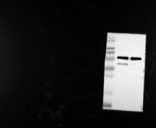 | Red: cropped region used in Fig. 4B  Blue: physical edge of the complete membrane piece/strip used for this blot  Corresponding figure: Figure 4B  Replicate 1 (left panel in Figure 4B)  beta-actin loading control  Lanes: wt= wild type; mut = C.724_725del mutant  nding figure: Figure 3B  Agarose gel electrophoresis of RT-PcR products  Lanes: M, Control, Patient
Replicate 2  (middle panel in Figure 4B) | 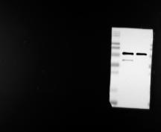 | Red: cropped region used in Fig. 4B  Blue: physical edge of the complete membrane piece/strip used for this blot  Corresponding figure: Figure 4B  Replicate 2 (middle panel in Figure 4B)  beta-actin loading control  Lanes: wt= wild type; mut = C.724_725del mutant  nding figure: Figure 3B  Agarose gel electrophoresis of RT-PcR products  Lanes: M, Control, Patient
Replicate 3  (right panel in Figure 4B) | 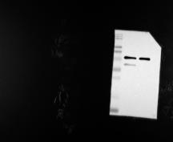 | Blue: physical edge of the complete membrane piece/strip used for this blot  Red: cropped region used in Fig. 4B  Corresponding figure: Figure 4B  Replicate 3 (right panel in Figure 4B)  beta-actin loading control  Lanes: wt= wild type; mut = C.724_725del mutant  nding figure: Figure 3B  Agarose gel electrophoresis of RT-PcR products  Lanes: M, Control, Patient

Figure 4B. Original Western blot images of the complete membrane pieces/strips: GFP transfection/vector expression control
GFP transfection/vector expression control. The red outline marks the cropped band region used in Figure 4B. Blue outlines mark the full blot/membrane edge. Replicates 1-3 correspond to the left, middle, and right Western blot panels in Figure 4B.

Replicate | Original unprocessed full-length image | Annotated copy
Replicate 1  (left panel in Figure 4B) | 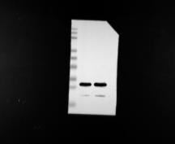 | Blue: physical edge of the complete membrane piece/strip used for this blot  Red: cropped region used in Fig. 4B  Corresponding figure: Figure 4B  Replicate 1 (left panel in Figure 4B)  GFP transfection/vector expression control  Lanes: wt= wild type; mut = C.724_725del mutant  nding figure: Figure 3B  Agarose gel electrophoresis of RT-PcR products  Lanes: M, Control, Patient
Replicate 2  (middle panel in Figure 4B) | 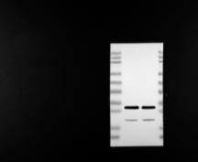 | Blue: physical edge of the complete membrane piece/strip used for this blot  Red: cropped region used in Fig. 4B  Corresponding figure: Figure 4B  Replicate 2 (middle panel in Figure 4B)  GFP transfection/vector expression control  Lanes: wt= wild type; mut = C.724_725del mutant  nding figure: Figure 3B  Agarose gel electrophoresis of RT-PcR products  Lanes: M, Control, Patient
Replicate 3  (right panel in Figure 4B) | 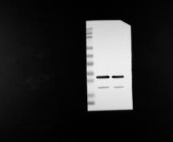 | Blue: physical edge of the complete membrane piece/strip used for this blot  Red: cropped region used in Fig. 4B  Corresponding figure: Figure 4B  Replicate 3 (right panel in Figure 4B)  GFP transfection/vector expression control  Lanes: wt= wild type; mut = C.724_725del mutant  nding figure: Figure 3B  Agarose gel electrophoresis of RT-PcR products  Lanes: M, Control, Patient

