A Comprehensive Psychometric Assessment of Spider Fear Scales in a Chinese Sample

Supplementary Material
Table S1 ….SPQ-18, SPQ-13 and SPQ-12 in English and Chinese
Table S2 …. FSQ in English and Chinese
Table S3 …. Data normality and item statistics of sample groups
Fig. S1 …. Scree Plot with Parallel Analysis of SPQ-31 and SPQ-15
Table S4 …. Results of the scree test and parallel analysis
Table S5 …. Factor loading of SPQ-18, SPQ-13, and FSQ-13
Table S6 …. Measurement invariance from multigroup CFA analysis across gender and age
Table S7 …. Scale descriptives and internal consistency reliability
Table S8 …. Item-to-item correlations of SPQ-18
Table S9 …. Item-to-item correlations of SPQ-13
Table S10 …. Item-to-item correlations of SPQ-12
Table S11 …. Item-to-item correlations of FSQ-13
Table S12 …. Test-retest reliability of the three SPQ and the FSQ scales
Table S13 …. Correlations between SPQ-18, SPQ-13, SPQ-12 and FSQ-13 scales
Table S14 …. Floor and ceiling effect of SPQ-18, SPQ-13, SPQ-12 and FSQ-13 scales
Table S15 …. Statistical results and central tendencies on all SPQ and FSQ scales divided by gender and age group

Table S1 SPQ-18, SPQ-13 and SPQ-12 in English and Chinese
Item  Code | English | Chinese | SPQ-18 | SPQ-13 | SPQ-12
1 | I avoid going to parts or on camping trips because there may be spiders about. | 我避免去公園或露營，因為那裡可能會有蜘蛛出現 | ✓ |  | ✓
2 | I would feel some anxiety holding a toy spider in my hand. | 我拿著玩具蜘蛛在手上，會感到有點焦慮 |  | ✓
3 | If a picture of a spider crawling on a person appears on the screen during a motion picture, I turn my head away. | 如果在電影中出現蜘蛛在人身上爬行的畫面，我會轉過頭來避開 | ✓ |  | ✓
4 | I dislike looking at pictures of spiders in a magazine. | 我不喜歡在雜誌上看到蜘蛛的照片 |  | ✓ | ✓
5 | If there is a spider on the ceiling over my bed, I cannot go to sleep unless someone kills it for me. | 如果我在床上看到蜘蛛在天花板上，我會無法入睡，直至有人將牠殺死 | ✓ | ✓ | ✓
6 | I enjoy watching spiders build their webs. | 我享受觀看蜘蛛織網 | ✓
7 | I am terrified by the thought of touching a harmless spider. | 一想到要觸摸一隻無害的蜘蛛，我就感到十分恐懼 | ✓ | ✓ | ✓
8 | If someone says that there are spiders anywhere about, I become alert and edgy. | 如果有人說附近某些地方有蜘蛛，我會變得警惕和緊張不安 | ✓ | ✓
9 | I would not go down to the basement to get something if I thought there might be spiders down there. | 如果我認為地下室可能有蜘蛛，我就不會到那裡去拿東西 |  | ✓ | ✓
10 | I would feel uncomfortable if a spider crawled out of my shoe as I took it out of the closet to put it on. | 如果我把鞋子從櫃子中拿出來穿時，一隻蜘蛛從我的鞋裡爬出來，我會感到不自在 | ✓ | ✓ | ✓
11 | When I see a spider, I feel tense and restless. | 當我見到蜘蛛時，我會感到緊張及坐立不安 | ✓ | ✓
12 | I enjoy reading articles about spiders. | 我享受閱讀有關蜘蛛的文章 | ✓
13 | I feel sick when I see a spider. | 當我見到蜘蛛時，我感到噁心 |  | ✓ | ✓
14 | Spiders are sometimes useful. | 蜘蛛有時候是有用的 | ✓
15 | I shudder when I think of spiders | 當我想到蜘蛛的時候，我會發抖 |  | ✓
16 | I don’t mind being near a harmless spider if there is someone there in whom I have confidence. | 如果我在信任的人陪同下，我不介意在一隻無害的蜘蛛附近 | ✓
17 | Some spiders are very attractive to look at. | 有些蜘蛛是十分吸引人觀賞的 | ✓
18 | I don’t believe anyone could hold a spider without some fear. | 我不相信任何人能夠毫無恐懼地捧著一隻蜘蛛 | ✓
19 | The way spiders move is repulsive. | 蜘蛛移動的方式令人反感 |  | ✓
20 | It would not bother me to touch a dead spider with a long stick. | 我不介意用長棍觸碰一隻死了的蜘蛛 | ✓
21 | If I came upon a spider while cleaning the attic I would probably run. | 如果我在打掃時遇到一隻蜘蛛，我應該會跑走 |  | ✓ | ✓
22 | I am probably more afraid of spiders than of any other animals. | 比起其他動物，我更怕蜘蛛 | ✓
23 | I would not want to travel to Mexico or Central America because of the greater prevalence of tarantulas. | 因為狼蛛在墨西哥或中美洲很常見，所以我不想到當地旅遊 | ✓
24 | I am cautious when buying fruit because bananas may attract spiders. | 我在購買生果時會特別小心，因為香蕉會吸引蜘蛛
25 | I have no fear of non-poisonous spiders. | 我不懼怕無毒的蜘蛛
26 | I would not take a course in biology if I thought I might have to handle live spiders. | 如果我認為有機會要處理活蜘蛛，我就不會選讀生物課 |  |  | ✓
27 | Spider webs are very artistic. | 蜘蛛網是很有藝術感的 | ✓
28 | I think that I am no more afraid of spiders than the average person. | 我認為我比其他人不會更害怕蜘蛛
29 | I would prefer not to finish a story if something about spiders was introduced in the plot. | 如果故事情節中引入了有關蜘蛛的內容，我會選擇不繼續閱讀整個故事 |  |  | ✓
30 | Not only am I afraid of spiders but millipedes and caterpillars make me feel anxious. | 我不僅害怕蜘蛛，千足蟲和毛蟲也讓我感到焦慮 | ✓ |  | ✓
31 | Even if I was late for a very important appointment, the thought of spiders would stop me from taking a shortcut through an underpass. | 即使我已經在一個非常重要的約會中遲到，一想到蜘蛛就會阻止我走一條要經過行人隧道的捷徑 |  | ✓

Table S2 FSQ in English and Chinese
Item  Code | English | Chinese | FSQ-13
1 | If I came across a spider now, I would get help from someone else to remove it. | 如果我遇到一隻蜘蛛，我會找人幫忙拿走牠 | ✓
2 | Currently, I am sometimes on the look out for spiders. | 我現在有時會留意有沒有蜘蛛出沒 | ✓
3 | If I saw a spider now, I would think it will harm me. | 如果我現在看到一隻蜘蛛，我會認為牠會傷害我
4 | I now think a lot about spiders. | 我正在想很多關於蜘蛛的事 | ✓
5 | I would be somewhat afraid to enter a room now, where I have seen a spider before. | 我現在有點害怕進入一個我曾經見過蜘蛛的房間
6 | I now would do anything to try to avoid a spider. | 我現在會做任何事情來避開蜘蛛
7 | Currently, I sometimes think about getting bit by a spider. | 我現在有時會想到被蜘蛛咬 | ✓
8 | If I encountered a spider now, I wouldn't be able to deal effectively with it. | 如果我現在遇上一隻蜘蛛，我不能夠有效地應付牠 | ✓
9 | If I encountered a spider now, it would take a long time to get it out of my mind. | 如果我現在遇上一隻蜘蛛，我需要花很多時間去忘記牠
10 | If I came across a spider now, I would leave the room. | 如果我現在遇上一隻蜘蛛，我會離開該房間 | ✓
11 | If I saw a spider now, I would think it will try to jump on me. | 如果我現在見到一隻蜘蛛，我會想到牠可能會跳上我身上 | ✓
12 | If I saw a spider now, 1 would ask someone else to kill it. | 如果我現在見到一隻蜘蛛，我會請別人殺死牠 | ✓
13 | If I encountered a spider now, I would have images of it trying to get me. | 如果我現在遇上一隻蜘蛛，我腦海中會有牠嘗試傷害我的畫面
14 | If I saw a spider now I would be afraid of it. | 如果我現在見到一隻蜘蛛，我會害怕牠 | ✓
15 | If I saw a spider now, I would feel very panicky. | 如果我現在見到一隻蜘蛛，我會感到驚慌失措 | ✓
16 | Spiders are one of my worst fears. | 蜘蛛是我最懼怕的東西之一 | ✓
17 | I would feel very nervous if I saw a spider now. | 如果我現在見到一隻蜘蛛，我會感到十分緊張 | ✓
18 | If I saw a spider now I would probably break out in a sweat and my heart would beat faster. | 如果我現在見到一隻蜘蛛，我應該會冒汗和心跳加速 | ✓

Table S3 Data normality and item statistics of sample groups
Item | Sample 1 (n₁ = 478)  for SPQ-31 Validation |  |  |  | Sample 2 (n₂ = 476)  for SPQ-15 Validation |  |  |  | Total sample (N = 1,430)  For FSQ Validation
Item | M | SD | Skewness  -2 to +2 | Kurtosis  -7 to +7 | M | SD | Skewness  -2 to +2 | Kurtosis  -7 to +7 | M | SD | Skewness  -2 to +2 | Kurtosis  -7 to +7
1 | 0.15 | 0.36 | 1.91 | 1.67 | 0.13 | 0.33 | 2.26 | 3.123 | 4.23 | 2.044 | -0.146 | -1.224
2 | 0.32 | 0.47 | 0.78 | -1.39 | 0.34 | 0.47 | 0.68 | -1.55 | 3.07 | 1.788 | 0.546 | -0.732
3 | 0.2 | 0.4 | 1.52 | 0.3 |  |  |  |  | 3.00 | 1.72 | 0.622 | -0.46
4 | 0.35 | 0.48 | 0.62 | -1.63 | 0.34 | 0.47 | 0.69 | -1.54 | 2.67 | 1.725 | 0.847 | -0.244
5 | 0.64 | 0.48 | -0.61 | -1.64 | 0.64 | 0.48 | -0.6 | -1.65 | 2.71 | 1.716 | 0.818 | -0.295
6 | 0.69 | 0.46 | -0.83 | -1.32 |  |  |  |  | 2.70 | 1.691 | 0.849 | -0.106
7 | 0.64 | 0.48 | -0.57 | -1.69 | 0.6 | 0.49 | -0.41 | -1.84 | 1.98 | 1.398 | 1.607 | 2.07
8 | 0.53 | 0.5 | -0.13 | -1.99 | 0.48 | 0.5 | 0.67 | -2 | 3.51 | 1.942 | 0.307 | -1.079
9 | 0.46 | 0.5 | 0.18 | -1.98 | 0.41 | 0.49 | 0.38 | -1.87 | 2.65 | 1.724 | 0.913 | -0.13
10 | 0.85 | 0.36 | -1.94 | 1.76 | 0.79 | 0.41 | -1.46 | 0.13 | 3.60 | 2.065 | 0.222 | -1.257
11 | 0.54 | 0.5 | -0.16 | -1.98 | 0.5 | 0.5 | 0 | -2.01 | 3.72 | 1.945 | 0.146 | -1.156
12 | 0.8 | 0.4 | -1.48 | 0.2 |  |  |  |  | 3.71 | 2.147 | 0.186 | -1.335
13 | 0.46 | 0.5 | 0.17 | -1.98 | 0.44 | 0.5 | 0.25 | -1.95 | 2.69 | 1.753 | 0.891 | -0.229
14 | 0.23 | 0.42 | 1.3 | -0.31 |  |  |  |  | 3.89 | 2.064 | 0.041 | -1.285
15 | 0.17 | 0.38 | 1.75 | 1.06 | 0.15 | 0.36 | 1.95 | 1.82 | 3.63 | 2.068 | 0.24 | -1.245
16 | 0.32 | 0.47 | 0.75 | -1.44 |  |  |  |  | 3.18 | 2.002 | 0.501 | -1.011
17 | 0.51 | 0.5 | -0.06 | -2.01 |  |  |  |  | 3.58 | 2.01 | 0.233 | -1.202
18 | 0.2 | 0.4 | 1.52 | 0.3 |  |  |  |  | 2.92 | 1.89 | 0.686 | -0.692
19 | 0.35 | 0.48 | 0.65 | -1.58 | 0.36 | 0.48 | 0.58 | -1.67
20 | 0.27 | 0.45 | 1.02 | -0.97
21 | 0.4 | 0.49 | 0.41 | -1.84 | 0.34 | 0.48 | 0.66 | -1.56
22 | 0.19 | 0.39 | 1.6 | 0.56
23 | 0.2 | 0.4 | 1.52 | 0.3
24 | 0.09 | 0.29 | 2.79 | 5.8
25 | 0.58 | 0.49 | -0.32 | -1.9
26 | 0.28 | 0.45 | 0.96 | -1.09
27 | 0.41 | 0.49 | 0.35 | -1.89
28 | 0.56 | 0.5 | -0.23 | -1.96
29 | 0.1 | 0.3 | 2.71 | 5.35 | 0.07 | 0.25 | 3.47 | 10.07
30 | 0.6 | 0.49 | -0.4 | -1.85
31 | 0.22 | 0.42 | 1.33 | -0.23 | 0.17 | 0.37 | 1.8 | 1.25

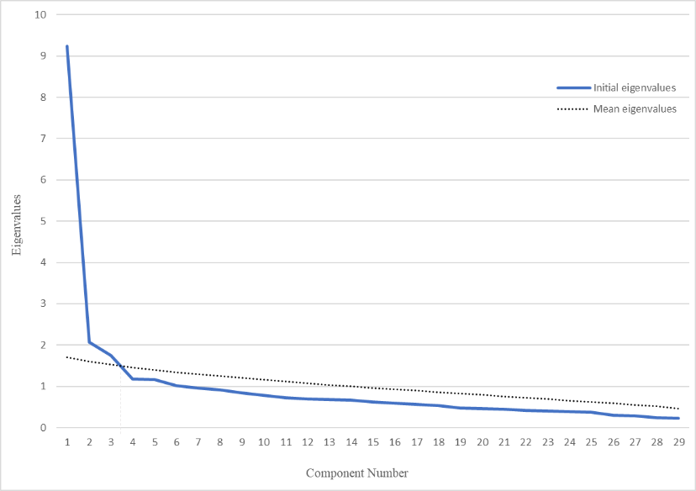
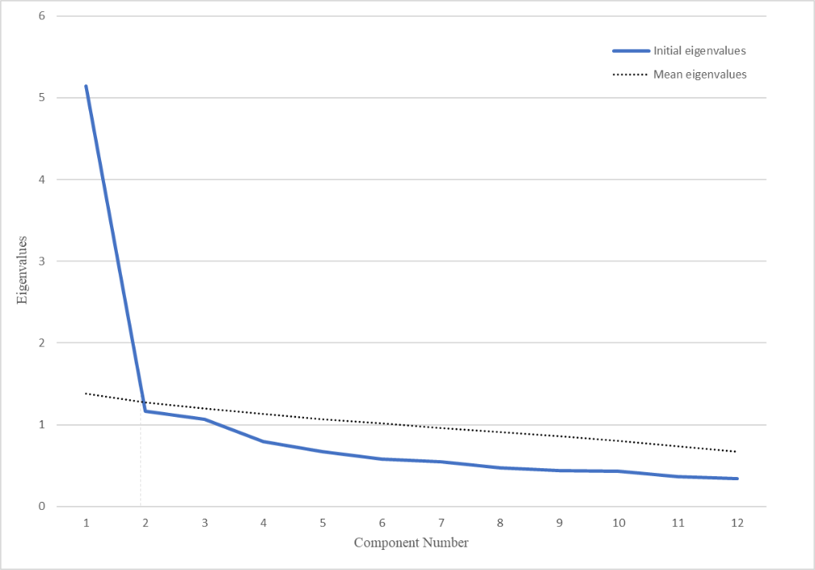
Fig. S1 Scree Plot with Parallel Analysis of SPQ-31 (top) and SPQ-15 (bottom)

Table S4 Results of the scree test and parallel analysis (n_{1a} = 239, n_{2a} = 238)
Component Number | SPQ-31 (n_{1a} = 239) |  |  |  | SPQ-15 (n_{2a} = 238) |  |  |  | FSQ (n_{4a} = 715)
Component Number | Scree test |  | Parallel Analysis |  | Scree test |  | Parallel Analysis |  | Scree test |  | Parallel Analysis
Component Number | Initial Eigenvalues | % of variance | Mean Eigenvalues | Percentile eigenvalues | Initial Eigenvalues | % of variance | Mean Eigenvalues | Percentile eigenvalues | Initial Eigenvalues | % of variance | Mean Eigenvalues | Percentile eigenvalues
1 | 9.241 | 31.867 | 1.703 | 1.791 | 5.695 | 43.807 | 1.453 | 1.544 | 10.553 | 58.826 | 1.286 | 1.343
2 | 2.068 | 7.133 | 1.597 | 1.667 | 1.177 | 9.052 | 1.343 | 1.408 | 1.590 | 8.832 | 1.228 | 1.261
3 | 1.754 | 6.047 | 1.527 | 1.581 | 1.069 | 8.222 | 1.269 | 1.319 | 0.804 | 4.466 | 1.189 | 1.219
4 | 1.178 | 4.064 | 1.458 | 1.511 | 0.804 | 6.182 | 1.199 | 1.247 | 0.712 | 3.953 | 1.153 | 1.180
5 | 1.156 | 3.985 | 1.404 | 1.456 | 0.688 | 5.296 | 1.143 | 1.188 | 0.593 | 3.295 | 1.124 | 1.151
6 | 1.020 | 3.518 | 1.344 | 1.389 | 0.579 | 4.455 | 1.088 | 1.066 | 0.521 | 2.896 | 1.091 | 1.114

Table S5 Factor loading of SPQ-18, SPQ-13, and FSQ-13
SPQ-18 |  |  |  | SPQ-13 |  | FSQ-13
Item code  (from SPQ-31) | Component 1 | Component 2 | Component 3 | Item code  (from SPQ-31) | Factor loading | Item code  (from FSQ-18) | Component 1 | Component 2
30 | .776 |  |  | 8 | .780 | 15 | .916
5 | .730 |  |  | 11 | .775 | 14 | .915
7 | .711 |  |  | 9 | .769 | 17 | .893
11 | .707 |  | .311 | 13 | .765 | 10 | .863
8 | .678 |  | .328 | 21 | .671 | 12 | .834
10 | .650 |  |  | 4 | .656 | 8 | .824
17 |  | .732 |  | 15 | .644 | 18 | .802 | .305
6 |  | .689 |  | 5 | .633 | 16 | .791
27 |  | .670 |  | 19 | .624 | 1 | .778
14 |  | .614 |  | 7 | .611 | 11 | .730
16 |  | .580 |  | 31 | .578 | 4 |  | .769
12 |  | .554 |  | 2 | .516 | 7 |  | .731
23 |  |  | .705 | 10 | .500 | 2 | .318 | .654
1 |  |  | .638 | / | / | / | / | /
3 |  |  | .611 | / | / | / | / | /
18 |  |  | .557 | / | / | / | / | /
20 |  |  | .457 | / | / | / | / | /
22 |  |  | .428 | / | / | / | / | /

Table S6 Measurement invariance from multigroup CFA analysis across gender and age
 | SPQ-18  (n_{1b} = 239) |  |  | SPQ-13  (n_{2b} = 238) |  |  | SPQ-12  (n₃ = 476) |  |  | FSQ-13  (n_{4b} = 715)
 | Configural invariance | Metric invariance | Scalar invariance | Configural invariance | Metric invariance | Scalar invariance | Configural invariance | Metric invariance | Scalar invariance | Configural invariance | Metric invariance | Scalar invariance
Gender
SRMR | 0.1051 | 0.1064 | 0.1082 | 0.0745 | 0.0985 | 0.101 | 0.0760 | 0.0867 | 0.0832 | 0.0608 | 0.0630 | 0.0735
|ΔSRMR| | / | 0.0013 | 0.0049 | / | 0.024 | 0.0265 | / | 0.0107 | 0.0072 |  | 0.0022 | 0.0127
RMSEA | 0.046 | 0.046 | 0.049 | 0.062 | 0.063 | 0.059 | 0.053 | 0.051 | 0.062 | 0.063 | 0.061 | 0.060
|ΔRMSEA| | / | 0 | 0.003 | / | 0.001 | 0.003 | / | 0.002 | 0.009 |  | 0.002 | 0.003
CFI | 0.865 | 0.863 | 0.828 | 0.891 | 0.880 | 0.881 | 0.906 | 0.906 | 0.844 | 0.952 | 0.952 | 0.949
|ΔCFI| | / | 0.002 | 0.037 | / | 0.011 | 0.001 | / | 0 | 0.062 |  | 0 | 0.003
Age group
SRMR | 0.1140 | 0.1140 | 0.1193 | 0.0835 | 0.0815 | 0.0796 | 0.0684 | 0.0808 | 0.0756 | 0.0513 | 0.0545 | 0.0482
|ΔSRMR| | / | 0 | 0.0053 | / | 0.002 | 0.0039 | / | 0.0124 | 0.0072 |  | 0.0032 | 0.0031
RMSEA | 0.044 | 0.043 | 0.041 | 0.049 | 0.047 | 0.044 | 0.048 | 0.046 | 0.046 | 0.050 | 0.048 | 0.047
|ΔRMSEA| | / | 0.001 | 0.003 | / | 0.002 | 0.005 | / | 0.002 | 0.002 |  | 0.002 | 0.003
CFI | 0.814 | 0.819 | 0.821 | 0.887 | 0.890 | 0.897 | 0.878 | 0.877 | 0.863 | 0.949 | 0.950 | 0.950
|ΔCFI| | / | 0.005 | 0.007 | / | 0.003 | 0.010 | / | 0.001 | 0.015 |  | 0.001 | 0.001
Note: Gender as male and female; age groups as 18 to 20, 21 to 30, 30 or above
Table S7 Scale descriptives and internal consistency reliability
Scales | Subsample (n) | M | SD | Cronbach’s α | McDonald’s ω
SPQ-18 | 1 (n₁ = 478) | 7.98 | 4.08 | 0.832 | 0.831
SPQ-13 | 2 (n₂ = 476) | 5.57 | 3.96 | 0.890 | 0.892
SPQ-12 | 3 (n₃ = 476) | 5.25 | 3.12 | 0.837 | 0.846
FSQ-13 | Total sample | 43.68 | 19.27 | 0.941 | 0.947

Table S8 Item-to-item correlations of SPQ-18 (n = 478)
 | 1 | 2 | 3 | 4 | 5 | 6 | 7 | 8 | 9 | 10 | 11 | 12 | 13 | 14 | 15 | 16 | 17 | 18
1 | -
3 | .27 | -
5 | .22 | .23 | -
6 | .16 | .11 | .24 | -
7 | .17 | .21 | .30 | .22 | -
8 | .32 | .31 | .53 | .30 | .47 | -
10 | .12 | .15 | .38 | .18 | .32 | .36 | -
11 | .31 | .31 | .50 | .36 | .45 | .66 | .36 | -
12 | .07 | .13 | .14 | .41 | .19 | .15 | .18 | .15 | -
14 | .15 | .05 | .14 | .28 | .04 | .12 | .04 | .14 | .23 | -
16 | .14 | .13 | .18 | .24 | .20 | .28 | .05 | .30 | .21 | .27 | -
17 | .13 | .16 | .21 | .43 | .28 | .23 | .14 | .30 | .35 | .30 | .32 | -
18 | .21 | .05 | .05 | -.05 | .01 | .05 | .04 | .05 | -.05 | .09 | .03 | -.05 | -
20 | .19 | .21 | .11 | .11 | .14 | .21 | .05 | .21 | .05 | .12 | .22 | .10 | .05 | -
22 | .21 | .31 | .28 | .14 | .19 | .29 | .14 | .33 | .08 | .12 | .17 | .19 | .15 | .14 | -
23 | .38 | .28 | .28 | .13 | .15 | .29 | .04 | .27 | .04 | .08 | .22 | .12 | .17 | .19 | .28 | -
27 | .17 | .14 | .15 | .42 | .22 | .19 | .00 | .27 | .25 | .26 | .31 | .49 | .02 | .17 | .20 | .14 | -
31 | .41 | .30 | .34 | .18 | .30 | .42 | .12 | .55 | .20 | .07 | .21 | .31 | .06 | .08 | .30 | .22 | .19 | -
Note: The first column shows the original number code of SPQ-18 from SPQ-31; the first row shows the new number code of SPQ-18
Table S9 Item-to-item correlations of SPQ-13 (n = 476)
 | 1 | 2 | 3 | 4 | 5 | 6 | 7 | 8 | 9 | 10 | 11 | 12 | 13
2 | -
4 | .45 | -
5 | .23 | .32 | -
7 | .27 | .43 | .45 | -
8 | .28 | .41 | .48 | .48 | -
9 | .29 | .44 | .43 | .40 | .52 | -
10 | .19 | .27 | .43 | .38 | .43 | .35 | -
11 | .35 | .40 | .47 | .45 | .68 | .55 | .41 | -
13 | .38 | .45 | .41 | .40 | .49 | .47 | .35 | .56 | -
15 | .30 | .35 | .22 | .24 | .37 | .39 | .14 | .36 | .43 | -
19 | .35 | .40 | .31 | .33 | .40 | .36 | .25 | .39 | .55 | .39 | -
21 | .26 | .34 | .40 | .34 | .51 | .51 | .32 | .54 | .43 | .38 | .36 | -
31 | .28 | .29 | .26 | .27 | .38 | .45 | .16 | .41 | .35 | .43 | .29 | .42 | -
Note: The first column shows the original number code of SPQ-13 from SPQ-31; the first row shows the new number code of SPQ-13
Table S10 Item-to-item correlations of SPQ-12 (n = 476)
 | 1 | 2 | 3 | 4 | 5 | 6 | 7 | 8 | 9 | 10 | 11 | 12
1 | -
3 | .21 | -
4 | .26 | .42 | -
5 | .24 | .27 | .37 | -
7 | .24 | .25 | .40 | .37 | -
9 | .30 | .30 | .43 | .45 | .45 | -
10 | .14 | .19 | .24 | .36 | .37 | .34 | -
13 | .32 | .33 | .56 | .47 | .45 | .48 | .31 | -
21 | .30 | .34 | .39 | .43 | .38 | .60 | .31 | .47 | -
26 | .26 | .35 | .43 | .26 | .35 | .38 | .22 | .38 | .40 | -
29 | .21 | .21 | .13 | .14 | .15 | .16 | .06 | .19 | .18 | .24 | -
30 | .24 | .25 | .35 | .48 | .46 | .44 | .38 | .48 | .43 | .29 | .10 | -
Note: The first column of each table shows the original number code of SPQ-18, SPQ-13, and SPQ-12 from SPQ-31, respectively; the first row shows the new number code of SPQ-18, SPQ-13 and SPQ-12

Table S11 Item-to-item correlations of FSQ-13 (N = 1,430)
 | 1 | 2 | 3 | 4 | 5 | 6 | 7 | 8 | 9 | 10 | 11 | 12 | 13
1 | -
2 | .28 | -
4 | .14 | .35 | -
7 | .21 | .40 | .37 | -
8 | .64 | .35 | .19 | .29 | -
10 | .66 | .37 | .15 | .30 | .73 | -
11 | .53 | .38 | .21 | .38 | .59 | .66 | -
12 | .70 | .36 | .15 | .26 | .65 | .71 | .61 | -
14 | .68 | .38 | .18 | .30 | .72 | .77 | .68 | .74 | -
15 | .68 | .42 | .20 | .32 | .73 | .78 | .68 | .74 | .90 | -
16 | .60 | .44 | .21 | .36 | .63 | .68 | .61 | .65 | .77 | .78 | -
17 | .66 | .41 | .21 | .32 | .70 | .78 | .68 | .72 | .86 | .88 | .81 | -
18 | .58 | .43 | .23 | .38 | .64 | .69 | .61 | .63 | .73 | .78 | .74 | .83 | -
Note: The first column shows the original number code of FSQ; the first row shows the number code of SPQ-18
Table S12 Test-retest reliability of the three SPQ and the FSQ scales (N = 64, M_{age} = 26.12, SD = 9.29, %_{female} = 76.6%)
 | Test  Mean (SD) | Retest  Mean (SD) | Pearson Correlation  between  Test & Retest | Intraclass Correlation  (Average measures)
SPQ-18 | 8.72 (4.75) | 8.83 (4.69) | 0.90** | 0.95
Component 1: Aggravating visualization | 3.95 (2.04) | 4.02 (2.10) | 0.75** | 0.86
Component 2: Appreciating | 3.39 (2.17) | 3.20 (2.06) | 0.79** | 0.88
Component 3: Avoiding interaction | 1.38 (1.61) | 1.61 (1.65) | 0.77** | 0.87
SPQ-13 | 6.55 (4.37) | 6.81 (4.35) | 0.84** | 0.91
SPQ-12 | 5.61 (3.65) | 5.97 (3.59) | 0.87** | 0.93
FSQ-13 | 47.42 (20.10) | 49.95 (16.31) | 0.77** | 0.97
Component 1: avoidance/help seeking behaviors | 39.16 (17.98) | 41.22 (14.59) | 0.77** | 0.98
Component 2:  Fear of harms | 8.27 (3.69) | 8.73 (3.55) | 0.71** | 0.81
Note: ** p < 0.01
Table S13 Correlations between SPQ-18, SPQ-13, SPQ-12 and FSQ-13 scales
 |  | SPQ-18  (n₁ = 478) |  |  | SPQ-13  (n₂ = 476) | SPQ-12  (n₃ = 476) | FSQ-13  (N = 1,430)
 | Total | Aggravating visualisation | Appreciating | Avoiding interaction | SPQ-13  (n₂ = 476) | SPQ-12  (n₃ = 476) | FSQ-13  (N = 1,430)
SPQ-18 | - | - | - | - | - | - | -
SPQ18-AgV | .84 | - | - | - | - | - | -
SPQ18-Apr | .75 | .41 | - | - | - | - | -
SPQ18-AvI | .69 | .44 | .29 | - | - | - | -
FSQ-13 | .76 | .72 | .47 | .53 | .80 | .77 | -
FSQ-13 Factor 1 | .76 | .74 | .47 | .51 | .80 | .78 | .99
FSQ-13 Factor 2 | .44 | .34 | .26 | .43 | .36 | .32 | .60
FSS-ANI | .58 | .56 | .42 | .30 | .59 | .59 | .59
FSS-INJ | .28 | .27 | .20 | .16 | .31 | .33 | .32
SNAQ-30 | .53 | .38 | .50 | .32 | .48 | .50 | .39
INS | -.24 | -.23 | -.19 | -.10 | -.22 | -.18 | -.19
Note: all coefficients in the table were significant (p < 0.01)
Table S14 Floor and ceiling effect of SPQ-18, SPQ-13, SPQ-12 and FSQ-13 scales
Version | N | M | Median | Lowest score | Highest score | Floor Effect (%) | Ceiling Effect (%)
SPQ-18 | 478 | 7.98 | 8.00 | 0 | 17 | 0.4 | 1.5
SPQ-13 | 476 | 5.57 | 5.00 | 0 | 13 | 11.8 | 4.2
SPQ-12 | 476 | 4.55 | 5.00 | 0 | 12 | 10.1 | 0.6
FSQ-13 | 1,430 | 43.68 | 19.27 | 13 | 91 | 2.6 | 0.2

Table S15 Statistical results and central tendencies on all SPQ and FSQ scales divided by gender and age group
Gender | N | Male |  |  |  | Female |  | t
Gender | N | M |  | SD |  | M | SD | t
SPQ18 | 478 | 7.08 |  | 4.11 |  | 8.32 | 4.01 | -2.99**
SPQ18 - AgV | 478 | 3.17 |  | 2.20 |  | 4.04 | 1.98 | -4.16**
SPQ18 - Apr | 478 | 2.82 |  | 1.88 |  | 3.03 | 1.78 | -1.12
SPQ18 - AvI | 478 | 1.10 |  | 1.32 |  | 1.26 | 1.41 | -1.12
SPQ-13 | 476 | 4.43 |  | 3.89 |  | 6.03 | 3.90 | -4.05**
SPQ-12 | 476 | 3.38 |  | 2.96 |  | 5.00 | 3.18 | -5.07**
FSQ-13 | 1,430 | 37.14 |  | 17.51 |  | 46.23 | 19.32 | -8.19**
FSQ-13 factor 1 | 1,430 | 29.57 |  | 15.70 |  | 38.45 | 17.22 | -8.98**
FSQ-13 factor 2 | 1,430 | 7.58 |  | 3.82 |  | 7.78 | 3.73 | -0.89
Age Group | N | Age  20 or below |  | Age  21 - 30 |  | Age  31 or above |  | F
Age Group | N | M | SD | M | SD | M | SD | F
SPQ18 | 478 | 8.35 | 3.84 | 8.20 | 4.28 | 7.10 | 3.87 | 3.61*
SPQ18 - AgV | 478 | 4.12 | 2.01 | 3.84 | 2.07 | 3.30 | 2.13 | 5.20**
SPQ18 - Apr | 478 | 2.99 | 1.72 | 3.00 | 1.90 | 2.88 | 1.77 | 0.19
SPQ18 - AvI | 478 | 1.23 | 1.37 | 1.36 | 1.46 | 0.92 | 1.22 | 3.73*
SPQ-13 | 476 | 6.01 | 3.85 | 5.76 | 4.07 | 4.51 | 3.63 | 4.632*
SPQ-12 | 476 | 4.81 | 3.37 | 4.71 | 3.12 | 3.88 | 3.05 | 3.202*
FSQ-13 | 1,430 | 47.48 | 18.94 | 44.24 | 19.09 | 37.54 | 18.63 | 25.63**
FSQ-13 factor 1 | 1,430 | 39.53 | 17.02 | 36.28 | 17.00 | 30.62 | 16.92 | 25.31**
FSQ-13 factor 2 | 1,430 | 7.95 | 3.71 | 7.95 | 3.81 | 6.93 | 3.58 | 9.44**
Note: *p < 0.05; ** p < 0.01

