Supplementary material: “The industrialisation of the seabed: Estimating century-scale impacts of bottom trawling on shelf sea sediments”
- Supplementary Tables
- Supplementary Figures
- Supplementary References

- Supplementary Tables
Table S1: (A) Total number of bottom trawlers (1825–1916) and (B) total bottom trawling hours in 1925 used in Swept Area Ratio (SAR) calculations. Part (A) is presented by fleet associated region and Part (B) by ICES Fishing Regions. Hyphens (–) indicate missing data. Icelandic fleet data from 1895 and 1910 were combined with 1900 and 1916, respectively, to maintain temporal consistency with other regions. Superscript numerals indicate the literature source and correspond to the Supplementary Tables S1–S5 reference list provided below.

(A)
Fleet | Region | Year | Sail | Steam | Motor | Dredger
England and Wales | Northeast | 1825 | 2 ³⁰ | 0 | 0 | 0
England and Wales | Northeast | 1850 | 32 ^{30,32,38} | 0 | 0 | 0
England and Wales | Northeast | 1875 | 904 ^{2,3,15,32,38} | 35 ³² | 0 | 0
England and Wales | Northeast | 1900 | 367 ^{12,15,16,32,38} | 753 ^{12,16,32,38} | 5 ³¹ | 0
England and Wales | South | 1825 | 235 ^{15,18,36,37} | 0 | 0 | 29 ³⁷
England and Wales |  | 1850 | 339 ^{30, 37} | 0 | 0 | 323 ³⁷
England and Wales |  | 1875 | 272 ^{1, 15,30} | 1 ³² | 0 | 323 ³⁰
England and Wales |  | 1900 | 423 ^{12,32,38} | 13 ^{12,38} | 7 ³¹ | 323 ³⁰
England and Wales | Southeast | 1825 | 160 ^{30, 37} | 0 | 0 | 0
England and Wales |  | 1850 | 222 ^{30, 37} | 0 | 0 | 0
England and Wales |  | 1875 | 609 ^{15,30,32,38} | 0 | 0 | 0
England and Wales |  | 1900 | 960 ^{12,16,32,38} | 11 ¹⁶ | 8 ³¹ | 18 ³¹
England and Wales | West | 1825 | 61 ^{4,30} | 0 | 0 | 0
England and Wales |  | 1850 | 88 ^{4,30} | 0 | 0 | 0
England and Wales |  | 1875 | 108 ^{15,30} | 0 | 0 | 0
England and Wales |  | 1900 | 151 ^{12,14,38} | 76 ^{12,14} | 1 ³¹ | 0
England and Wales | Eng. & Wal. | 1916 | 453 ²⁵ | 231 ²⁵ | 33 ²⁵ | -
Distant Water | Iceland / Faroe | 1895 (1990) | 0 | 20 ³⁹ | 0 | 0
Distant Water | Iceland / Faroe | 1910 (1916) | 0 | 151 ³⁹ | 0 | 0
Scotland | Scotland | 1825 | 15 ⁴ | 0 | 0 | 3 ⁴
Scotland |  | 1850 | 27 ³² | 0 | 0 | 0
Scotland |  | 1875 | 36 ³² | 1 | 0 | 0
Scotland |  | 1900 | 97 ^{12,32,38} | 173 ^{12,32,38} | 13 ⁹ | 4 ⁹
Scotland |  | 1916 | 34 ⁹ | 90 ⁹ | 0 | -
Ireland | Connacht | 1825 | 0 | 0 | 0 | 10 ⁴
Ireland |  | 1850 | 11 ^{4,30} | 0 | 0 | 99 ⁴
Ireland |  | 1875 | 22 ^{10,15,30} | 0 | 0 | 159 ⁴
Ireland |  | 1900 | 117 ^{17,29,38} | 10 ^{17,38} | 8 ³⁴ | 159 ⁴
Ireland | Leinster | 1825 | 35 ⁴ | 0 | 0 | 150 ^{4,11}
Ireland |  | 1850 | 45 ⁴ | 0 | 0 | 150 ^{4,11}
Ireland |  | 1875 | 70 ^{10,15,30} | 0 | 0 | 150 ^{4,11}
Ireland |  | 1900 | 116 ^{17,29} | 4 ¹⁷ | 10 ³⁴ | 150 ^{4,11}
Ireland | Munster | 1825 | 38 ^{4,27} | 0 | 0 | 125 ⁴
Ireland |  | 1850 | 60 ⁴ | 0 | 0 | 400 ⁴
Ireland |  | 1875 | 172 ^{4,10,15,29,30} | 3 ¹⁰ | 0 | 400 ⁴
Ireland |  | 1900 | 72 ^{17,29} | 2 ^{17,29} | 1 ³⁴ | 400 ⁴
Ireland | Ulster | 1825 | 14 ⁴ | 0 | 0 | 140 ⁴
Ireland |  | 1850 | 38 ⁴ | 0 | 0 | 227 ⁴
Ireland |  | 1875 | 50 ^{10,15} | 0 | 0 | 227 ⁴
Ireland |  | 1900 | 151 ^{17,29} | 1 ¹⁷ | 7 ³⁴ | 227 ⁴
Ireland | Ireland | 1916 | 311 ³⁵ | 12 ³⁵ | 15 ³⁵ | -
(B) Total fishing hours by British first-class bottom trawlers ²⁵
 |  | Year | Sail | Steam | Motor | Dredger
Bristol Channel (VII f) |  | 1925 | 7,469 | 38,967 | 1,321 | -
English Channel (Vii d / e) |  | 1925 | 124,130 | 32,610 | 23,898 | -
Faroe (V b) |  | 1925 | 0 | 181,901 | 0 | -
Iceland (V a) |  | 1925 | 0 | 209,192 | 0 | -
Irish Sea (VII a) |  | 1925 | 7,981 | 156,598 | 7,756 | -
North Sea (IV) |  | 1925 | 390,669 | 1,950,881 | 17,977 | -
Rockall (VI b) |  | 1925 | 0 | 3,814 | 0 | -
South of Ireland (VII g / k) |  | 1925 | 5,586 | 334,388 | 0 | -
West of Ireland (VII b / c) |  | 1925 | 0 | 99,508 | 0 | -
West of Scotland (VI a) |  | 1925 | 0 | 213,556 | 0 | -
Note: Data represents fishing hours for British first-class vessels in 1925 ²⁵. To account for the Irish fleet, British effort was scaled using the 1925 ratio of total Irish to British trawlers ³⁵.

Table S2: Gear and effort parameters used in Swept Area Ratio (SAR) calculations by trawler type and fleet (1825–1925). Values provided are based on representative observations from historical records. For 1925, effort was calculated using total fishing hours rather than fishing days and tow parameters. Beam width is defined as the width of the wooden beam, while otter trawl width refers to distance between doors. Superscript numerals indicate the literature source and correspond to the Supplementary Tables S1–S5 reference list provided below.
Vessel Type | Fleet | Period | Beam Width (m) | Otter trawl width (m) | Fishing Days | Tows (day⁻¹) | Tow Duration (h) | Tow Speed (km/h)
Sail | Eng. & Wal. | 1825 - 1850 | 8.7 ^{37,38} | - | 214 ³⁷ | 1.8 ^{15,22,38} | 4.8 ^{30,38} | 2.8 ³²
Sail | Eng. & Wal. | 1875 | 8.7 ^{37,38} | - | 233 ^{15,30} | 1.8 ^{15,22,38} | 4.8 ^{30,38} | 2.8 ³²
Sail | Eng. & Wal. | 1900 - 1916 | 13.3 ^{32,38} | 26.2 ^{6,21} | 235 ^{32,38} | 1.8 ^{15,22,38} | 4.8 ^{30,38} | 2.8 ³²
Sail | Eng. & Wal. | 1925 |  | 26.2 ^{6,21} | - | - | - | 2.8 ³²
Sail | Scotland | 1825 - 1916 | 13.3 * | 26.2 * | 223 ³² | 1.8 * | 4.8 * | 2.8 ³²
Sail | Scotland | 1925 | - | 26.2 * | - | - | - | 2.8 ³²
Sail | Ireland | <1850 | 10.1 ^{4,30} | - | 228 ⁴ | 1.8 * | 4.8 * | 2.8 *
Sail | Ireland | 1850 - 1916 | 10.9 ¹⁵ | 26.2 * | 228 ⁴ | 1.8 * | 4.8 * | 2.8 *
Sail | Ireland | 1925 | - | 26.2 * | - | - | - | 2.8 *
Steam | Eng. & Wal. | 1875 - 1916 | 15.5 ³² | 26.2 ^{6,21} | 235 * | 3 ³⁸ | 5 ³⁸ | 3.7 ²⁴
Steam | Eng. & Wal. | 1925 | - | 26.2 ^{6,21} | - | - | - | 3.7 ²⁴
Steam | Scotland | 1875 - 1916 | 14.1 ³² | 26.2 * | 223 * | 3 * | 5 * | 3.7 *
Steam | Eng. & Wal. | 1925 | - | 26.2 ^{6,21} | - | - | - | 3.7 ²⁴
Steam | Ireland | 1875 - 1916 | 15.5 * | 26.2 * | 228 * | 3 * | 5 * | 3.7 *
Steam | Eng. & Wal. | 1925 | - | 26.2 ^{6,21} | - | - | - | 3.7 ²⁴
Steam | Iceland | 1900 - 1916 | 15.5 * | 26.2 * | 196 ³⁹ | 3 * | 5 * | 3.7 *
Steam | Eng. & Wal. | 1925 | - | 26.2 ^{6,21} | - | - | - | 3.7 *
Motor | All Regions | 1916 | - | 26.2 * | 229 * | 3 * | 5 * | 4.6 ^{21,23}
Motor | All Regions | 1925 | - | 26.2 * | - | - | - | 4.6 *
Dredger | Eng. & Wal. | 1825 - 1900 | 2.4 * | - | 193 ³⁰ | 1.8 * | 4.8 * | 2.8 *
Dredger | Scotland | 1825 - 1900 | 2.4 * | - | 200 * | 1.8 * | 4.8 * | 2.8 *
Dredger | Ireland | 1825 - 1900 | 2.4 ⁴ | - | 205 ⁴ | 1.8 * | 4.8 * | 2.8 *
* assumed based on similar data

Table S3. Historical beam trawl gear dimensions and estimated hydrodynamic drag for the period 1825 - 1925. Hydrodynamic drag was calculated by summing contributions from the beam, shoes, netting, warp, and ground rope, with component surfaces scaled from beam width. Historical beam trawls used only a ground rope, lacking the tickler chains characteristic of modern gear. Values are reported as total drag (kN) and normalized per meter of trawl width (N/m). The final row shows the mean and range across the four vessel types. Superscript numerals indicate the literature source and correspond to the Supplementary Tables S1–S5 reference list provided below.
Parameter (m) | Beam trawler type
Parameter (m) | Smack ³ | Schokker ⁸ | Schuit ⁴¹ | Bomschuit ²⁶
Vessel length | 24 | 12.2 | 13.7 | 12.2
Beam trawl | 14 | 8 | 8.6 | 8
Diameter beam | 0.20 | - | 0.15 | -
Trawl head (2x) | 1.22 | 0.8 | 0.9 | -
Foot rope | 29.9 | 10-12 | 10.3 | -
Head rope diameter | 0.06 | 0.06 | - | -
Net length | 25.6 | 12 | 15.3 | -
Mesh size | 0.076 – 0.20 | 0.07 – 0.05 | - | -
Cod-end length | 3.65 | 2 | 5.1 | -
Cod-end mesh | 0.076 | 0.05 | - | -
Netting | 31.7 | 7.0 | 13.4 | -
Unit | Overall gear hydrodynamic drag
kN | 5.19 | 2.18 | 2.26 | 1.76
N/m | 317 | 272 | 262 | 219
Mean N/m [range] | 268 [219-317]

Table S4. Historical otter trawl gear dimensions and hydrodynamic drag estimates for associated components. Hydrodynamic drag per meter of dredge width (N/m) was calculated by summing contributions from doors and ground gear. Values were based on reported ranges of historic gear in relevant years. In some cases, values were scaled to reflect the emergence and rapid evolvement of fishing gears (e.g. Rijnsdorp et al., 2008) around the turn of the 20th century and are reported as total and range values for the periods indicate. In addition to the sources listed in the table, other literature consulted included Cunningham, (1895) and Kerby et al., (2012). Superscript numerals indicate the literature source and correspond to the Supplementary Tables S1–S5 reference list provided below.
Trawler type (gear) | Year | Door length (m) | Door height (m) | Ground gear length (m) | Towing speed (km/h) | Overall hydrodynamic drag (N/m)*
Steam (otter) | 1875 | 2.5 ⁷ | 1.3 ⁷ | 38 ⁷ | 2.88 ²¹ | 420 [399-441]
Steam (otter) | 1900 | 2.5 ⁷ | 1.3 ⁷ | 38 ⁷ | 3.24 † | 512 [486-537]
Steam (otter) | 1916 | 3.35 ¹³ | 1.4 ¹³ | 42 ¹³ | 3.6 † | 701 [666-736]
Steam (otter) | 1925 | 3.35 ¹³ | 1.4 ¹³ | 42 ¹³ | 3.96 † | 821 [780-862]
Motor (otter) | 1900 | 2.5 ⁷ | 1.3 ⁷ | 38 ⁷ | 3.96 † | 713 [677-749]
Motor (otter) | 1916 | 3.35 ¹³ | 1.4 ¹³ | 42 ¹³ | 4.32 † | 948 [901-996]
Motor (otter) | 1925 | 3.35 ¹³ | 1.4 ¹³ | 42 ¹³ | 4.68 ^{21, 23} | 1081 [1027-1135]
*Otter boards were assumed to have a 20° attack angle ⁷, ground gear was modelled as a continuous 8 cm rope, and netting was parameterized with 85 mm mesh size, 4 mm twine thickness, and a 22.5° mesh opening angle ¹³. Otter trawls used within the study timeline lacked sweeps, the extended cables between the otter boards and the net used to herd fish, and were thus not considered in the drag area.
† Scaled based on available data

Table S5. Penetration depths, silt fractions, and sediment porosity parameters used in sediment mobilisation estimates. As historical beam trawls used only a ground rope, lacking the tickler chains characteristic of modern gear, penetration depth was assumed to be analogous to that of an otter trawl given the similarity of ground rope. Superscript numerals indicate the literature source and correspond to the Supplementary Tables S1–S5 reference list provided below.
Sediment | Penetration depth (cm) |  |  | Silt frac (%) | Sed. Por  [mean ± SD]
Sediment | OT | BT | DR | Silt frac (%) | Sed. Por  [mean ± SD]
Mud | 0.3 – 5.3 ²⁸ | 0.3 – 5.3 * | 1.7 – 13.9 ²⁸ | 30-80 ⁴⁰ | 0.8 ± 0.05 ²⁰
Sand | 0.0 - 3.7 ²⁸ | 0.0 - 3.7 * | 1.2 – 8.3 ²⁸ | 5-30 ⁴⁰ | 0.4 ± 0.05 ²⁰
Gravel | 0.2 – 5.8 ²⁸ | 0.2 – 5.8 * | 1.7 – 13.7 ²⁸ | 1-5 ⁴⁰ | 0.3 ± 0.05 *
* assumed based on similar data

Supplementary Tables S1 – S5 References:
- Alward, G. L. (1932) The sea fisheries of Great Britain and Ireland: A record of the development of the fishing industry and its world-wide ramifications. Grimsby: Albert Gait.
- Ansell, A.W. (1883) On Trawling (No. 12). W. Clowes and Sons, Limited.
- Collins, J. W. (1889) The beam-trawl fishery of Great Britain: With notes on beam-trawling in other European countries. US Government Printing Office.
- Commissioners of Inquiry (1836) First Report of the Commissioners of Inquiry into the state of the Irish Fisheries, with the Minutes of Evidence and Appendix. Alexander Thom & Co., Dublin.
- Cunningham, J.T. (1895) North Sea investigations. Journal of the Marine Biological Association of the United Kingdom, 4(1), pp.10-47.
- Cunningham, J.T. (1896) Observations at Sea and in the Markets. Journal of the Marine Biological Association of the United Kingdom, 4(2), 108-112. doi:10.1017/S0025315400060331.
- Currie, J.C., Sink, K.J., Attwood, C.G., Atkinson, L.J., & Engelhard, G.H. (2019) Reconstructing the past: design and function of Granton otter trawl gear at the turn of the twentieth century, as used in South Africa’s first trawl surveys (1897–1904). Maritime Studies 18:1-16.
- de Veen, J. (2024) De trawlvisserij en haar ontwikkeling. Een ongepubliceerd manuscript geschreven in de periode 1941-1945. Wageningen Marine Research, Wageningen Marine Research rapport 24.003. 114 pp.
- Fishery Board for Scotland (1922) Sea fisheries statistical tables. H.M. Stationery Office, Edinburgh.
- Fishery Commissioners (1865) Report of the Deep Sea and Coast Fishery Commissioners Ireland for 1864 to His Excellency the Lord Lieutenant of Ireland. Alexander Thom & Co., Dublin.
- Fraser, R. (1818) A review of the domestic fisheries of Great Britain and Ireland.
- Garstang, W. (1900) The impoverishment of the sea. Journal of the Marine Biological Association of the United Kingdom, 6, 1–69.
- Gibbs, W.E. (1922) The fishing industry. Sir I. Pitman & sons, Limited.
- Herdman, W.A. & Dawson, R.A. (1902) Fishes and fisheries of the Irish Sea: And especially of the Lancashire and western sea-fisheries district (No. 2). George Philip & Son.
- Holdsworth, E. W. H. (1874) Deep-sea fishing and fishing boats. E. Stanford, London.
- Holt, E. W. (1895) An examination of the present state of the Grimsby trawl fishery, with especial reference to the destruction of immature fish. Journal of the Marine Biological Association of the United Kingdom, 3(5), 339–446.
- Inspectors of Irish Fisheries (1892) Report of the Inspector of Irish Fisheries on the Sea and Inland Fisheries of Ireland for 1891. Alexander Thom & Co., Dublin.
- Jones, P. (2018) The spread of bottom trawling in the British Isles, c. 1700–1860. International Journal of Maritime History, 30(4), 681–700.
- Kerby, T.K., Cheung, W.W., & Engelhard, G.H. (2012) The United Kingdom’s role in North Sea demersal fisheries: a hundred year perspective. Reviews in Fish Biology and Fisheries, 22(3), pp.621-634.
- Khedri, P., Gourgue, O., Depestele, J., Arndt, S., & van de Velde, S.J. (2025) Reconciling the impact of mobile bottom-contact fishing on marine organic carbon sequestration. ICES journal of marine science, 82(9), p.fsaf154.
- Kyle, H.M. (1903) Fishing nets, with special reference to the otter-trawl. Journal of the Marine Biological Association of the United Kingdom, 6(4), pp.562-586.
- March, E.J. (1953) Sailing trawlers. The story of deep-sea fishing with long line and trawl. Percival Marshall and Company Ltd, London.
- Masterman, A. T. (1914) Report on the plaice fisheries of the North Sea (Parts I and II). Fishery Investigations, Series II, Vol II:120.
- Meek, Alexander (1901) Report on the Scientific Investigations for the year 1901. Northumberland Sea Fisheries Committee.
- Sea Fisheries (1925). Sea fisheries statistical tables 1925. Fisheries – England & Wales. Ministry of Agriculture, Fisheries and Food. H.M. Stationery Office, London.
- Petrejus, E.W. (1954) De bomschuit, een verdwenen scheepstype. Publicaties van het Museum van Land- en Volkenkunde en het Maritiem Museum "Prins Hendrik" Book 1954. No 2. M.M.1, Rotterdam.
- Walsh, J., XLVI. (1774). Of torpedos found on the Coast of England. In a letter from John Walsh, Esq; FRS to Thomas Pennant, Esq; FR S. Philosophical Transactions of the Royal Society of London, (64), pp.464-473.
- Pitcher, C.R., Hiddink, J.G., Jennings, S., Collie, J., Parma, A.M., Amoroso, R., Mazor, T., Sciberras, M., McConnaughey, R.A., Rijnsdorp, A.D., & Kaiser, M.J. (2022) Trawl impacts on the relative status of biotic communities of seabed sedimentary habitats in 24 regions worldwide. Proceedings of the National Academy of Sciences, 119(2), p.e2109449119.
- Report on Fish Decreases (1889) Report on Inquired held by the Inspectors of Irish Fisheries into an Alleged Decrease in the Supply of Fish off Certain Parts of the Coast of Ireland and the Alleged Effects Thereon by Trawling and Other Modes of Fishing to His Excellency the Lord Lieutenant of Ireland. Alexander Thom & Co., Dublin.
- Report on Sea Fisheries (1866) Report from the Commissioners Appointed to Enquire into the Sea Fisheries of the United Kingdom with Appendix and Minutes of Evidence. Eyre and Spottiswoode, London.
- Report on Sea Fisheries (1914) Annual report on sea fisheries for the year 1914 Part I and II. H.M. Stationery Office, London.
- Report on Trawl Net and Beam Trawl Fishing (1885) Report of the Commissioners Appointed to Inquire and Report upon … the use of the Trawl Net and Beam Trawl, with Minutes of Evidence and Appendix. Eyre and Spottiswoode, London.
- Rijnsdorp, A.D., Poos, J.J., Quirijns, F.J., HilleRisLambers, R., De Wilde, J.W., & Den Heijer, W.M. (2008) The arms race between fishers. Journal of sea Research, 60(1-2), pp.126-138.
- Sea and Inland Fisheries of Ireland (1908) Report on the sea and inland fisheries of Ireland and appendix. The Stationery Office, Dublin.
- Sea and Inland Fisheries of Ireland (1919) Report on the sea and inland fisheries of Ireland and appendix. The Stationery Office, Dublin.
- Select Committee (1817) Report from Select Committee on South Devon Fisheries, with the Minutes of Evidence taken before them, 1817. Parliamentary Papers Online.
- Select Committee (1833) Report from the Select Committee on British Channel Fisheries, with Minutes of Evidence and Appendix, 1833. Parliamentary Papers Online.
- Select Committee (1893) Report from the Select Committee on Sea Fisheries, together with Proceedings of the Committee, Minutes of Evidence, Appendix and Index. Eyre and Spottiswoode, London.
- Thor, J.T. (1992) British trawlers in Icelandic waters: History of British steam trawling off Iceland 1889-1916 and the Anglo-Icelandic fisheries dispute 1896-1897.
- van der Reijden, K.J., Eigaard, O.R., Bastardie, F., van Denderen, P.D. and O’Neill, F.G., (2025). A gear component approach to trawling impact and sediment mobilization assessments. ICES Journal of Marine Science, 82(7), p.fsaf106
- Venema, G.A. (1869) De visscherij in de provincie Groningen. In: Bijdragen tot de kennis van den tegenwoordigen staat der provincie Groningen. Gebr. Hoitsema, Groningen: 83-271.

Table S6. Pre-1900 mapped trawling grounds with associated number shown in Figure S4.
Number | Trawling ground | Number | Trawling ground
1 | Aberdeen Bay | 164 | Inchkeith (east)
2 | Achill Head | 165 | India Bank
3 | Achill Sound | 166 | Inner Dowsing
4 | Adalvik | 167 | Inner Gabbard
5 | Alward ground #1 | 168 | Ireland’s Eye
6 | Alward ground #2 | 169 | Irish Sea grounds
7 | Alward ground #3 | 170 | Isle of Man (west)
8 | Alward ground #4 | 171 | Isle of May
9 | Alward ground #5 | 172 | Johnshaven to Bervie
10 | Alward ground #6 | 173 | Kenmare Bay
11 | Alward ground #7 | 174 | Kentish Knock
12 | Alward ground #8 | 175 | Kilcogan Bank
13 | Alward ground #9 | 176 | Kilcummin Bay
14 | Alward ground #10 | 177 | Kiliney Bay
15 | Annalong ground | 178 | Killala Bay
16 | Ardglass Bank | 179 | Killary Harbour
17 | Ardmore | 180 | Kilmore
18 | Arklow | 181 | Kinsale
19 | Arnafjord 1 | 182 | Kinsale Harbour
20 | Arnafjord 2 | 183 | Kish Bank 1
21 | Arnafjord (northwest) | 184 | Kish Bank 2
22 | Arran islands (north) | 185 | Lacken Bay
23 | Arran islands (outer) | 186 | Lambay / Rockabill
24 | Arran islands (west) | 187 | Langston & Emsworth
25 | Arthurstown | 188 | Larne Lough
26 | Axarfjord | 189 | Latrabjarg
27 | Baginbun Bay | 190 | Laxey
28 | Bakkafjord 1 | 191 | Leestone
29 | Bakkafjord 2 | 192 | Leman Bank
30 | Balbriggan | 193 | Lemon Bank
31 | Balbriggan grounds | 194 | Little Fisher Bank
32 | Ballantrae Bank | 195 | Liverpool grounds 1
33 | Ballinacourty | 196 | Liverpool grounds 2
34 | Ballinskelligs | 197 | Londmundarfjord
35 | Ballinskelligs Bay | 198 | Lonsvik
36 | Ballycotton Bay | 199 | Looe Bay
37 | Ballycroy Bay | 200 | Loch Foyle
38 | Ballyhalbert Bay | 201 | Loch Ryan
39 | Ballyheigue Bay | 202 | Loch Swilly
40 | Ballyshannon | 203 | Lundy and Carmarthen
41 | Ballyteige Bay | 204 | Madam Piper’s Bay
42 | Baltimore | 205 | Magilligan Strand
43 | Bantry Bay | 206 | Maguire’s Bank
44 | Basurelle Bank | 207 | Malahide
45 | Belfast Lough 1 | 208 | Mannin Bay
46 | Belfast Lough 2 | 209 | Mar Bank
47 | Bell Rock and Firth of the Tay | 210 | Marino
48 | Bengore Head to Sheep Island | 211 | May Island grounds
49 | Bertrahgboy Bay | 212 | Mevagissey Bay
50 | Berwick grounds | 213 | Milford Haven
51 | Between Cromer and Texel | 214 | Minard
52 | Bideford Bay | 215 | Mine Head to Coninbeg rock
53 | Bigbury Bay | 216 | Montrose Bank
54 | Black Bank | 217 | Moray Firth
55 | Blackpool to Liverpool | 218 | Morecambe Bay
56 | Blacksod Bay | 219 | Mountain Foot ground
57 | Blackwater Bank | 220 | Mounts Bay
58 | Blackwater Estuary | 221 | Mullaghmore
59 | Boppep Bay to Rye | 222 | Mulroy Bay
60 | Botany Gut | 223 | Newburgh to Stonehaven
61 | Bouy of the Tay and Bell Rock | 224 | North Foreland & Margate
62 | Boyne (mouth) | 225 | Nymph Bank
63 | Brandon Bay | 226 | Olafsvik
64 | Bray Head | 227 | Old Hake
65 | Breidifjord | 228 | Old Head to Dunworley
66 | Brewing Scar | 229 | Old Head to Hake Head
67 | Bridlington Bay | 230 | Outer Dowsing
68 | Brighton | 231 | Outer Gabbard
69 | Brixham | 232 | Outer Thames grounds
70 | Brixham winter grounds | 233 | Patreksfjord
71 | Broad fourteens | 234 | Pittenweem Fluke Hole
72 | Broadhaven Bay | 235 | Plymouth
73 | Brown Bank | 236 | Plymouth grounds
74 | Buchaness to Stonehaven | 237 | Plymouth Sound
75 | Buchaness to Girdle Ness | 238 | Poole Harbour
76 | Buchaness (south) | 239 | Porter’s Rock to Arklow Rock
77 | Buckhaven | 240 | Portland Bay
78 | Bundoran | 241 | Portrush 1
79 | Burbo Bank | 242 | Portrush 2
80 | Burghead and Findorn | 243 | Raghley
81 | Burnmouth to Buchaness | 244 | Ramsgate grounds
82 | Burnt Island | 245 | Reykjanes (northwest)
83 | Burr Point | 246 | Ridge Bank
84 | Caernarfon Bay 1 | 247 | River Colne
85 | Caernarfon Bay 2 | 248 | River Tay
86 | Cahore point and Kilmicheal point | 249 | Rock Bank
87 | Cambeltown | 250 | Ross Bay
88 | Cape Clear & Stags | 251 | Rossmore to West Cove
89 | Cardigan Bay | 252 | Roundstone
90 | Carlingford Loch | 253 | Rush grounds
91 | Carmarthen Bay | 254 | Rye Bay
92 | Carrickfergus | 255 | Saltees to Helvick Head
93 | Carrigholt Bay | 256 | Sandiette Bank
94 | Castletownsend 1 | 257 | Scarborough
95 | Castletownsend 2 | 258 | Scarborough (SE 40-50 miles)
96 | Cheek Point to Dunmore East | 259 | Schull
97 | Clew Bay | 260 | Seareach / Nore
98 | Clonakilty Bay | 261 | Shields & Coquet isle
99 | Clougherhead | 262 | Shipwash
100 | Cloughey | 263 | Silver Pit (Inner)
101 | Constaple Bank | 264 | Skagafjord
102 | Cork Harbour | 265 | Skerries
103 | Costello Bay | 266 | Skerries Bay
104 | Courtmacsherry | 267 | Skerries Sound
105 | Courtown | 268 | Skjalfandafloi
106 | Cove | 269 | Smith’s Knoll
107 | Craster grounds | 270 | Sole Pit
108 | Cromarty Firth | 271 | South Foreland to Wintertonness
109 | Cromer Knoll | 272 | South Papey
110 | Crookhaven | 273 | South Reykjanes peninsula
111 | Cullercoats (north) | 274 | Sowe Bank
112 | Cummen Bay | 275 | Spurn Point
113 | Cushendall | 276 | St. Abbs
114 | Cushenden Bay | 277 | St. Andrews 1
115 | Dingle Bay | 278 | St. Andrews 2
116 | Dogger and Heliogland | 279 | St. Finians
117 | Dogger Bank (east) | 280 | St. Johns to Carlingford
118 | Dogger Bank (west) | 281 | Start Bay to Portland
119 | Donegal Bay | 282 | Start to Portland
120 | Donegal Bay (northeast) | 283 | Stonehaven sand bed
122 | Dublin Bay | 284 | Strangford Loch
123 | Dundrum Bay | 285 | Suna grounds
124 | Dungarvan Bay | 286 | Svortuloft
125 | Dunkerron to Dunmore | 287 | Swansea Bay
126 | Dunmanus Bay | 288 | Swarte Bank
127 | East of Galloper | 289 | Talknafjord
128 | Eddystone (southeast) | 290 | Templenoe to Westcove
129 | Eldejarbanki | 291 | Texel & Tershelling
130 | Essex coast | 292 | Texel to Schelling
131 | Fairlight to Dungeness | 293 | The Garden
132 | Falmouth Bay | 294 | The Lizard & Black Head
133 | Falmouth Harbour | 295 | The Reefs
134 | Faxa Bay | 296 | The Ridge
135 | Finnafjord & Langness | 297 | The Varne
136 | Firth of the Forth grounds | 298 | The Wash
137 | Galway Bay | 299 | Thistlefjord
138 | Girdle Ness to Bell Rock | 300 | Torbay
139 | Glandore Head to Galley Head | 301 | Tralee Bay
140 | Glenarm Bay | 302 | Trevose Head to Hartland Point
141 | Golspie | 303 | Unionhall
142 | Great Burbo Bank | 304 | Upper Cover
143 | Great Fisher Bank | 305 | Vestrahorn
310 | Great Silver Pit (Outer) | 306 | Vopnafjord
145 | Greencastle | 307 | Waterford Harbour
146 | Greenore | 309 | Well Bank 1 (Inner)
147 | Halamid | 308 | Well Bank 2 (Outer)
148 | Hali grounds | 311 | West Cove
149 | Hartlepool and coquet | 312 | West Hoyle Bank
150 | Hartlepool to Berwick | 313 | West Reykjanes peninsula
151 | Harwich / Orford | 314 | Westernmost Rough
152 | Heligoland (north) | 315 | Westman Islands
153 | Helvick Head to Mine Head | 316 | Westport Bay
154 | Hemptons Turbot Bank | 317 | Wexford Bay 1
155 | High Whitby | 318 | Wexford Bay 2
156 | Holman ground | 319 | Weymouth Bay
157 | Hook Light | 320 | Whitesand Bay
158 | Hook of Holland | 321 | Whiting Bay
159 | Hornbjarg | 322 | Wolf Rock
160 | Hornvik | 323 | Yellow Bank
161 | Hraunamid | 324 | Yorkshire Hole / Sole Pit
162 | Hunafloi | 325 | Youghal Bay
163 | Hythe Bay

Table S7: Cumulative bottom trawling by ground area size category between 1825 and 1900.
Trawling ground area | Number of trawling grounds | Range of cumulative SAR | Median cumulative SAR | Mean cumulative SAR (95% confidence interval)
0 - 10 km² | 37 | 3.1– 1626.1 | 288.8 | 372.0 (220.0, 524.0)
10 - 50 km² | 89 | 0.5 – 2399.1 | 56.6 | 333.2 (215.6, 450.9)
50 - 200 km² | 77 | 0.1 – 1704.7 | 47.6 | 180.9 (107.1, 254.6)
200 - 1000 km² | 76 | 0.1 – 888.5 | 19.3 | 108.5 (66.8, 150.3)
1000 - 10000 km² | 36 | 0.1 – 271.6 | 19.5 | 37.5 (19.2, 55.9)
>10000 km² | 10 | 0.3 – 28 | 5.4 | 8.2 (1.9, 14.4)
All grounds | 324 | 0.07 – 2399.1 | 39.2 | 206.5 (163.4, 249.6)

Table S8: Estimated total swept area, sediment resuspension rates, and total mass of sediment resuspended and mixed in 1825, 1850, 1875, 1900, 1916, and 1925. Total across trawler type are also provided. Sediment and resuspension rates represent the average of 1000 runs, with values in parentheses showing 95% quantiles. SA = sail, ST = steam, MT = motor, DR = dredger.
Trawler type | Year | Swept area (km²) | Resuspension rate (kg m⁻²) | Total sediment resuspended (Mt) | Total sediment mixed (Mt)
SA | 1825 | 18,300 | 1.51 (0.80, 2.25) | 27.57 (14.53, 41.04) | 651 (250, 1100)
SA | 1850 | 34,200 | 1.58 (0.85, 2.33) | 54.11 (29.16, 79.84) | 1225 (463, 2082)
SA | 1875 | 102,000 | 1.43 (0.74, 2.14) | 145.94 (75.58, 218.78) | 3692 (1424, 6221)
SA | 1900 | 156,000 | 1.43 (0.75, 2.14) | 223.80 (116.88, 334.16) | 5689 (2108, 9640)
SA | 1916 | 55,800 | 1.75 (1.20, 2.52) | 97.51 (55.72, 140.85) | 715 (354, 654)
SA | 1925 | 44,200 | 1.14 (0.60, 1.69) | 50.30 (26.64, 74.81) | 912 (692, 3249)
ST | 1875 | 6,350 | 2.06 (1.13, 2.99) | 13.06 (7.16, 18.96) | 203 (15, 480)
ST | 1900 | 124,000 | 2.71 (1.52, 3.89) | 336.52 (189.18, 484.06) | 3721 (282, 7512)
ST | 1916 | 146,000 | 3.43 (2.06, 4.80) | 499.54 (299.93, 699.71) | 4905 (456, 9816)
ST | 1925 | 262,000 | 3.62 (2.11, 5.13) | 949.27 (554.35, 1345.4) | 8726 (1740, 13000)
MT | 1900 | 12,200 | 3.58 (2.04, 5.12) | 43.65 (24.86, 62.48) | 361 (27, 729)
MT | 1916 | 19,700 | 4,65 (2.83, 6.48) | 91.84 (55.81, 127.99) | 648 (61, 1300)
MT | 1925 | 3,150 | 3.36 (2.09, 4.63) | 10.56 (6.57, 14.58) | 129 (12, 255)
DR | 1825 | 6,040 | 1.02 (0.51, 1.52) | 6.14 (3.09, 9.92) | 451 (124, 823)
DR | 1850 | 12,700 | 0.91 (0.46, 1.36) | 11.54 (5.78, 17.29) | 1037 (283, 1881)
DR | 1875 | 13,400 | 0.89 (0.43, 1.35) | 11.91 (5.75, 18.07) | 1060 (294, 1916)
DR | 1900 | 9,590 | 0.95 (0.48, 1.41) | 9.08 (4.60, 13.55) | 773 (211, 1460)
All trawlers | 1825 | 24,320 | n/a | 33.72 (17.63, 50.24) | 1100 (374, 1923)
All trawlers | 1850 | 46,910 | n/a | 65.64 (34.94, 97.13) | 2600 (746, 3963)
All trawlers | 1875 | 122,050 | n/a | 170.9 (88.05, 255.08) | 4960 (1733, 8617)
All trawlers | 1900 | 302,310 | n/a | 613.05 (335.53, 894.26) | 10540 (2628, 19341)
All trawlers | 1916 | 221,320 | n/a | 688.94 (411.45, 968.55) | 7670 (871, 11770)
All trawlers | 1925 | 309,540 | n/a | 1010.14 (587.56, 1434.74) | 10740 (2444, 20920)

- Supplementary Figures
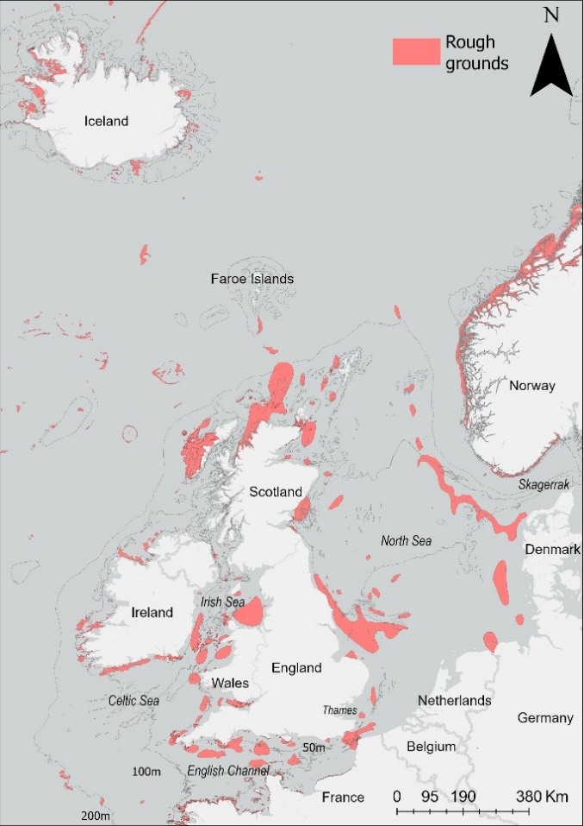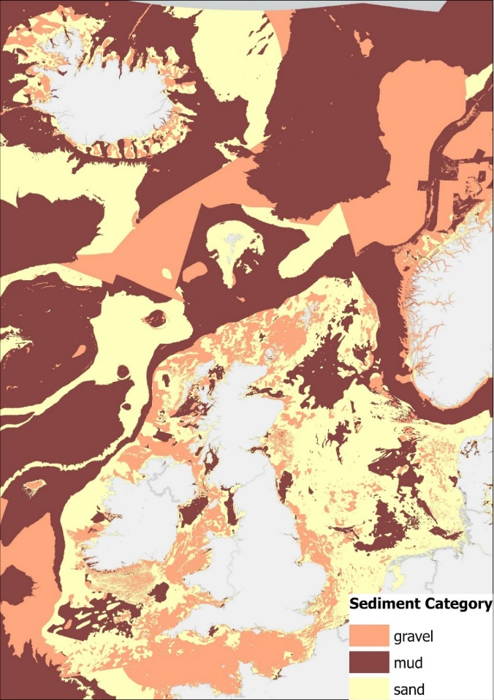
Figure S1: (A) Study area showing countries, sea areas (italics), and the location of rough grounds (red polygons). Rough grounds are a composite of areas classified as ‘rock’ in EMODnet (https://emodnet.ec.europa.eu/en) and SHOM (https://www.services.data.shom.fr), and as ‘rocks and stones’ in Olsen (1883). (B) Distribution of the main sediment categories (gravels, muds, and sands) in the study area, reclassified from benthic broadscale habitat types by EMODnet.

Figure S2: Estimated trawling capacity of regional fleets in terms of bottom trawlers (±95% confidence intervals) and associated gross tonnage (brown dotted lines). Fleets are categorized by region: (A–D) England and Wales, (E–H) Ireland, (I) Distant Water, and (J) Scotland. Raw values are overlaid for trawlers (circles) and gross tonnage (triangles).

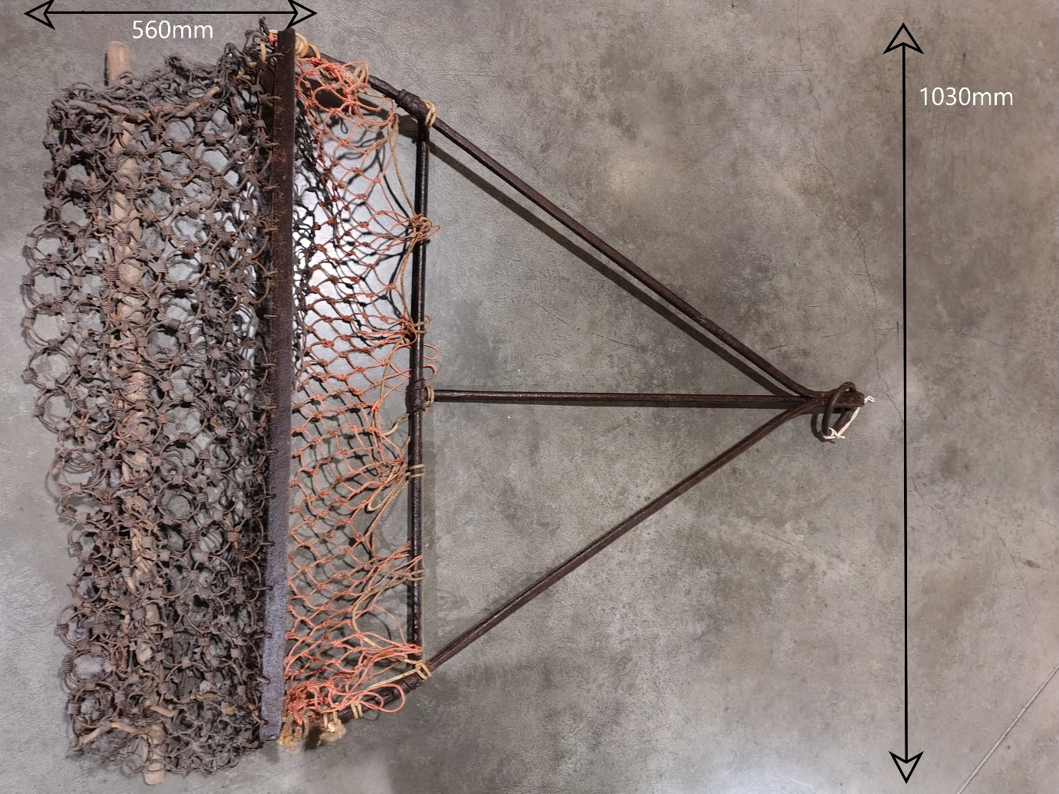
Figure S3. 19th century Falmouth oyster dredge held at UK National Maritime Museum (visited February 19th, 2026). The image shows the dredge with measurements indicating total gear width measured from cutting bar (1030mm) and the length of the seabed-contacting bag (560 mm).
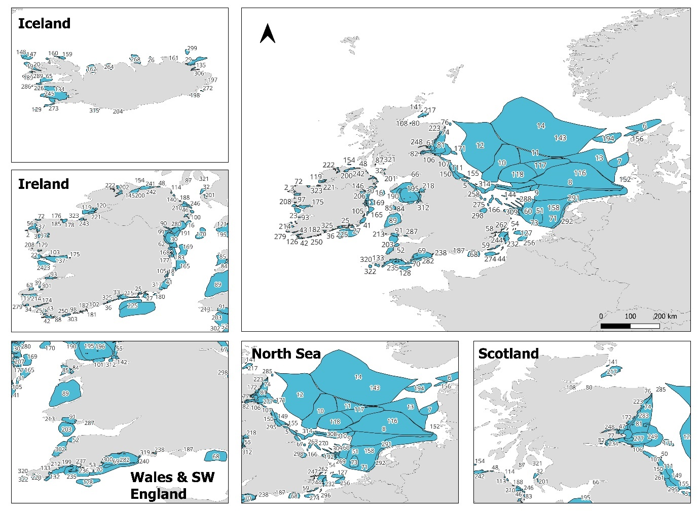
Figure S4: Distribution of northeast Atlantic trawling grounds pre-1900 based on archival records. The full list of trawling ground names and corresponding numbers is provided in Table S6.

Figure S5: Cumulative Swept Area Ratio between 1825 and 1900 at trawling grounds described in the study, categorized by ground size: (A) 0–10 km², (B) 10–50 km², (C) 50–200 km², (D) 200–1,000 km², (E) 1,000–10,000 km², and (F) >10,000 km².
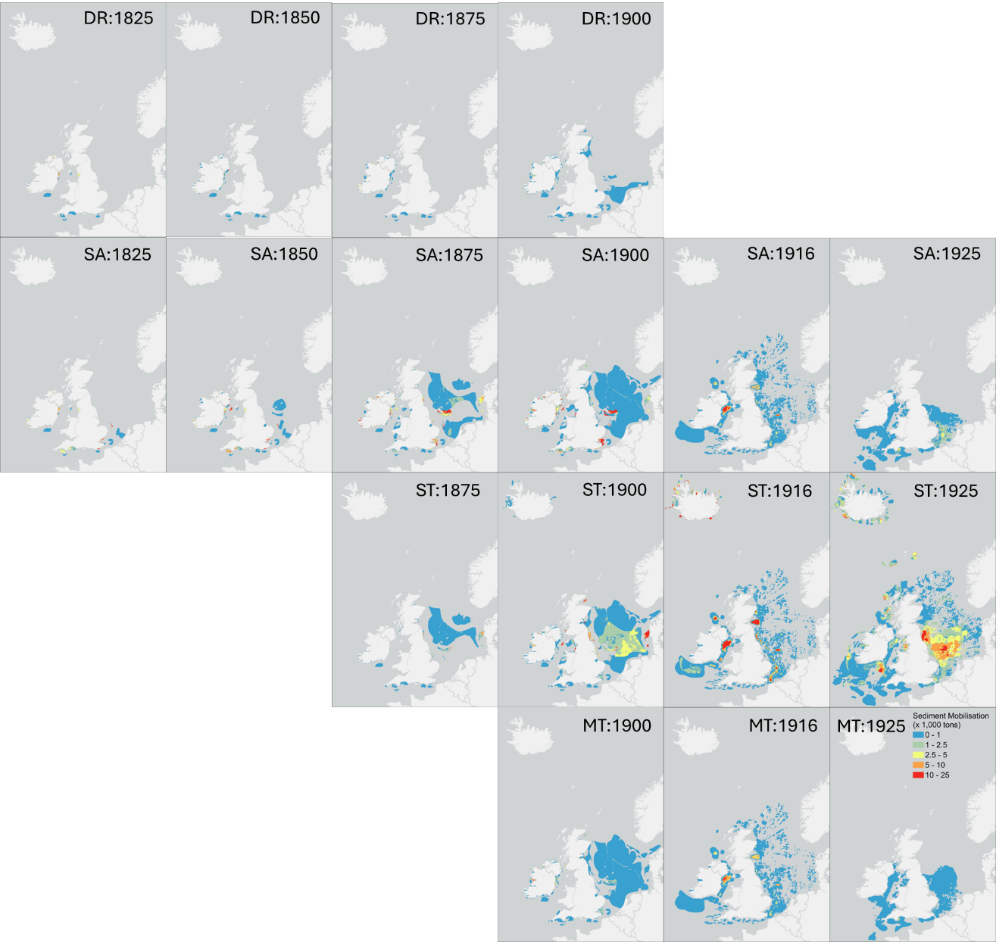
Figure S6: Estimated annual sediment resuspended by dredging (DR), sail (SA), steam (ST), and motor (MT) fleets for the years 1825, 1850, 1875, 1900, 1916, and 1925

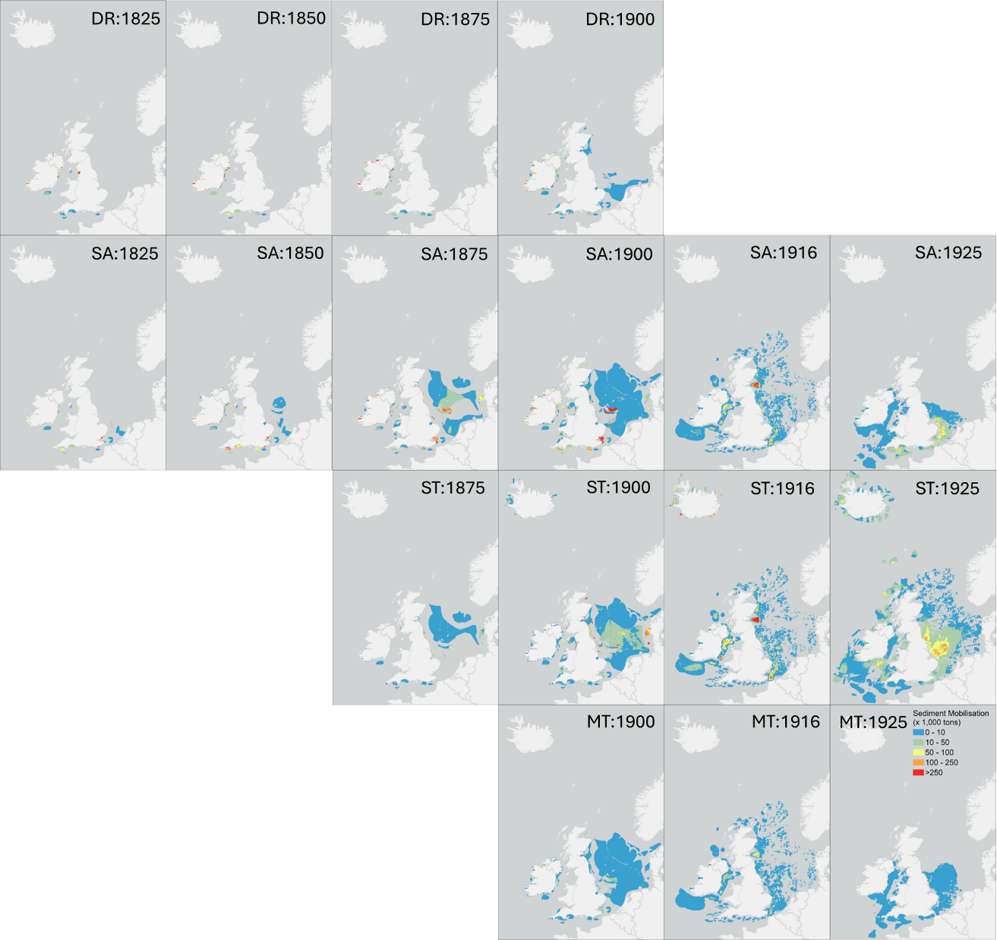
Figure S7: Estimated annual sediment mixing by dredging (DR), sail (SA), steam (ST), and motor (MT) fleets for the years 1825, 1850, 1875, 1900, 1916, and 1925
- Supplementary references
Full bibliographic details of sources cited in Table 1, including books and scientific articles (Part A), state papers (Part B), government inquiries (Part C), other reports (Part D), statistical tables (Part E), and nautical charts (Part F).
Part A - Books and Scientific Articles:
Aikin, J. (1790). England delineated, or, a geographical description of every county in England and Wales: With a concise account of its most important products, natural and artificial, for the use of young persons. T. Bensley.
Alward, G. L. (1911). The development of the British sea fisheries during the 19th century, with special reference to the North Sea. Grimsby News Co., Grimsby.
Berkenhout, J. (1789). Synopsis of the natural history of Great Britain and Ireland: Comprehending the animal and fossil kingdoms. T. Cadell.
Calderwood, W. L. (1894). British sea fisheries and fishing areas, in view of recent national advance. Scottish Geographical Magazine, 10(2), 69–81.
Collins, J. W. (1889). The beam-trawl fishery of Great Britain: With notes on beam-trawling in other European countries. US Government Printing Office.
Cox, T., Hall, A., & Morden, R. (1738). Staffordshire – Warwickshire.
Davies, D. C. (1885). The fisheries of Wales. In Transactions of the Liverpool National Eisteddfod (Vol. 1884, pp. 285–320). Liverpool FC.
Ellis, J. (1755). An essay towards a natural history of the corallines, and other marine productions of the like kind, commonly found on the coasts of Great Britain.
Galloway, J. A. (2021). Fishing the Thames estuary in the later Middle Ages: Environment, technology and the metropolitan market for fish c. 1250–1550. Imago temporis: Medium Aevum, 243–271.
Garstang, W. (1900). The impoverishment of the sea. Journal of the Marine Biological Association of the United Kingdom, 6, 1–69.
Holdsworth, E. W. H. (1874). Deep-sea fishing and fishing boats. E. Stanford, London.
Holt, E. W. (1895). An examination of the present state of the Grimsby trawl fishery, with especial reference to the destruction of immature fish. Journal of the Marine Biological Association of the United Kingdom, 3(5), 339–446.
Jones, P. (2018a). The long “lost” history of bottom trawling in England, c. 1350–1650. International Journal of Maritime History, 30(2), 201–217.
Jones, P. (2018b). The spread of bottom trawling in the British Isles, c. 1700–1860. International Journal of Maritime History, 30(4), 681–700.
Llwyd, A., (1833). History of the Island of Mona, Or Anglesey... R. Jones.
McIntosh, W. C. (1895). Remarks on trawling. Journal of the Marine Biological Association of the United Kingdom, 3, 307–334.
Walsh, J., (1774). XLVI. Of torpedos found on the Coast of England. In a letter from John Walsh, Esq; FRS to Thomas Pennant, Esq; FR S. Philosophical Transactions of the Royal Society of London, (64), pp.464-473.
Russell, E. S. (1943). Trawling and the stocks of fish. Journal of the Royal Society of Arts, 91(4635), 198–214.
Thor, J.T., (1992). British trawlers in Icelandic waters: History of British steam trawling off Iceland 1889-1916 and the Anglo-Icelandic fisheries dispute 1896-1897.
Thor, J.T., (1995). British Trawlers and Iceland, 1919-1976. Department of Economic History of the University of Göteborg, 1995.
Part B - State Papers:
State Papers (1547). State papers published under the authority of His Majesty’s Commission: King Henry the Eighth (Vol. 1, Part II, Entry no. 110). Crown copyright.
State Papers (1570). Acts of the Privy Council of England, volume 7, pp. 326–351. British History Online.
State Papers (1618). Calendar of state papers, domestic series, of the reign of James I. Longman, Brown, Green, Longmans and Roberts.
State Papers (1631). Calendar of state papers, domestic series, of the reign of Charles I (Vol. 4, Entry no. 39). Longman, Green, Longmans and Roberts.
State Papers (1634). Calendar of state papers, domestic series, of the reign of Charles I (Vol. 6, Entry no. 26). Longman, Green, Longman, Roberts and Green.
State Papers (1638). Calendar of state papers, domestic series, of the reign of Charles I (Vol. 12, Entry no. 23). Longmans, Green and Co.
State Papers (1644). Calendar of state papers, domestic series, of the reign of Charles I (Vol. 19, Entry no. 82). H.M. Stationery Office.
State Papers (1655). Calendar of state papers, domestic series, Commonwealth (Vol. 8, Entry no. 1.452). Longman & Co.; Trübner & Co.; Parker & Co.; Macmillan & Co.; A. & C. Black; A. Thom.
State Papers (1664). Calendar of state papers, domestic series, of the reign of Charles II (Vol. 3, Entry no. 146). Longman, Green, Longman and Roberts.
State Papers (1670). Calendar of state papers, domestic series, Charles II, with addenda 1660–1670 (Vol. 10, Entry no. 111). H.M. Stationery Office.
Part C - Government Inquires:
Commissioners of Inquiry (1836). First Report of the Commissioners of Inquiry into the state of the Irish Fisheries, with the Minutes of Evidence and Appendix. Alexander Thom & Co., Dublin.
Fishery Commissioners (1865). Report of the Deep Sea and Coast Fishery Commissioners Ireland for 1864 to His Excellency the Lord Lieutenant of Ireland. Alexander Thom & Co., Dublin.
Inspectors of Irish Fisheries (1892). Report of the Inspector of Irish Fisheries on the Sea and Inland Fisheries of Ireland for 1891. Alexander Thom & Co., Dublin.
Report on Fish Decreases (1889). Report on Inquired held by the Inspectors of Irish Fisheries into an Alleged Decrease in the Supply of Fish off Certain Parts of the Coast of Ireland and the Alleged Effects Thereon by Trawling and Other Modes of Fishing to His Excellency the Lord Lieutenant of Ireland. Alexander Thom & Co., Dublin.
Report on Sea Fisheries (1866). Report from the Commissioners Appointed to Enquire into the Sea Fisheries of the United Kingdom with Appendix and Minutes of Evidence. Eyre and Spottiswoode, London.
Report on Trawl Net and Beam Trawl Fishing (1885). Report of the Commissioners Appointed to Inquire and Report upon … the use of the Trawl Net and Beam Trawl, with Minutes of Evidence and Appendix. Eyre and Spottiswoode, London.
Select Committee (1817). Report from Select Committee on South Devon Fisheries, with the Minutes of Evidence taken before them, 1817. Parliamentary Papers Online
Select Committee (1833). Report from the Select Committee on British Channel Fisheries, with Minutes of Evidence and Appendix, 1833. Parliamentary Papers Online
Select Committee (1893). Report from the Select Committee on Sea Fisheries, together with Proceedings of the Committee, Minutes of Evidence, Appendix and Index. Eyre and Spottiswoode, London
Select Committee (1904). Report from the Select Committee of the House of Lords on the Sea Fisheries Bill, Together with Proceedings of the Committee, Minutes of Evidence, and Appendix [and Index]. Wyman.
Part D - Other reports:
House of Commons. (1800). Report respecting the British herring fisheries.
Lee, R. M. (1911). Report on the Grimsby steam trawler records 1904–1907. Marine Biological Association.
Report on Sea Fisheries (1914). Annual report on sea fisheries for the year 1914 Part I and II. H.M. Stationery Office, London
Report on Sea Fisheries (1925). Report on Sea Fisheries for the Years 1919, 1920, 1921, 1922, and 1923. H.M. Stationery Office, London
Sea and Inland Fisheries of Ireland (1908). Report on the sea and inland fisheries of Ireland and appendix. The Stationery Office, Dublin.
Sea and Inland Fisheries of Ireland (1912). Report on the sea and inland fisheries of Ireland and appendix. The Stationery Office, Dublin.
Sea and Inland Fisheries of Ireland (1919). Report on the sea and inland fisheries of Ireland and appendix. The Stationery Office, Dublin.
Part E - Statistical tables:
Fishery Board for Scotland (1922). Sea fisheries statistical tables. H.M. Stationery Office, Edinburgh.
Sea Fisheries (1908). Sea fisheries statistical tables 1908. Fisheries – England & Wales. Ministry of Agriculture, Fisheries and Food. H.M. Stationery Office, London.
Sea Fisheries (1919). Sea fisheries statistical tables 1919. Fisheries – England & Wales. Ministry of Agriculture, Fisheries and Food. H.M. Stationery Office, London.
Sea Fisheries (1920). Sea fisheries statistical tables 1920. Fisheries – England & Wales. Ministry of Agriculture, Fisheries and Food. H.M. Stationery Office, London.
Sea Fisheries (1921). Sea fisheries statistical tables 1921. Fisheries – England & Wales. Ministry of Agriculture, Fisheries and Food. H.M. Stationery Office, London.
Sea Fisheries (1922). Sea fisheries statistical tables 1922. Fisheries – England & Wales. Ministry of Agriculture, Fisheries and Food. H.M. Stationery Office, London.
Sea Fisheries (1923). Sea fisheries statistical tables 1923. Fisheries – England & Wales. Ministry of Agriculture, Fisheries and Food. H.M. Stationery Office, London.
Sea Fisheries (1925). Sea fisheries statistical tables 1925. Fisheries – England & Wales. Ministry of Agriculture, Fisheries and Food. H.M. Stationery Office, London.
Sea Fisheries (1929). Sea fisheries statistical tables 1929. Fisheries – England & Wales. Ministry of Agriculture, Fisheries and Food. H.M. Stationery Office, London.
Part F – Nautical charts:
Close, A.W. (1914). Close’s fisherman’s chart of Scotland, north & western sheets.
Close, A.W. (1919). Close’s fisherman’s chart of Iceland.
Close, A.W. (1921a). Close’s fisherman’s chart of the English Channel.
Close, A.W. (1921b). Close’s fisherman’s chart of the North Sea.
Close, A.W. (1922). Close’s fisherman’s chart of Ireland, eastern & western sheets.
ICES (1925). Demersal landings by ICES rectangle, from ICES statistical charts.
Royal Navy (1916). Monthly fishing charts, compiled by the hydrographer for the Royal Navy, January–December.
Royal Navy (1924). Monthly fishing charts, compiled by the hydrographer for the Royal Navy, January–December.

