Table. Mass Spectrometry Analysis of Saponin Compounds in Ginseng.
No. | t_{R}/min | Identification | Formula | Ionic mode | Predicted | Fragmented ion | Content (%) | formula
1 | 8.85 | Ginsenoside Rg1* | C₄₂H₇₂O₁₄ | [M-H]- | 800.4928 | 799.4865,637.4331,475.3806 | 3.00% | 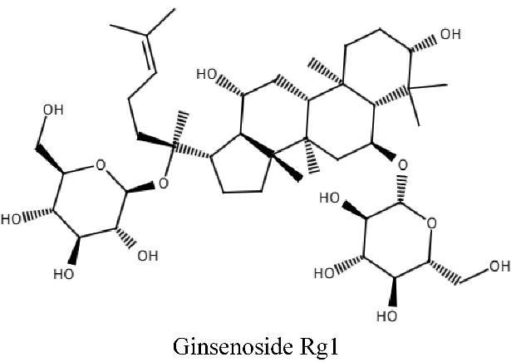
2 | 9.50 | Ginsenoside Re* | C₄₈H₈₂O₁₈ | [M-H]- | 946.5507 | 945.5466,783.4926,637.4343,475.3815 | 11.78% | 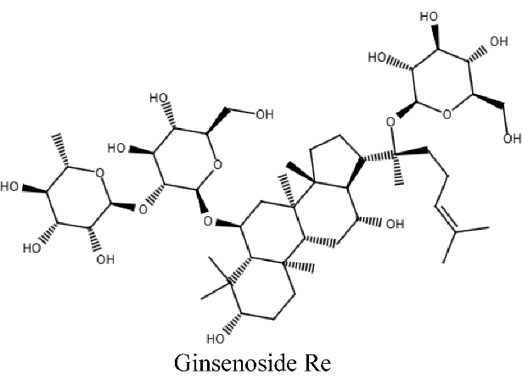
3 | 18.43 | Ginsenoside Rf | C₄₂H₇₂O₁₄ | [M-H]- | 800.4928 | 799.4885,637.4359,475.3836,304.9168 | 2.34% | 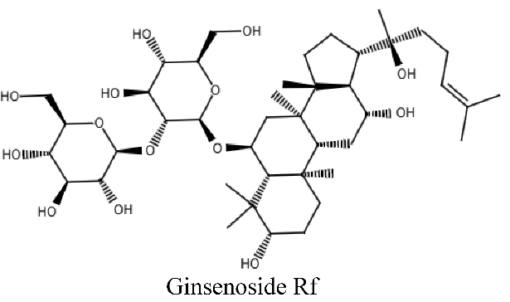
4 | 19.05 | Noto-ginsenoside R2 | C₄₁H₇₀O₁₃ | [M+HCOO]- | 815.4830 | 769.4772、637.4348、475.3817 |  | 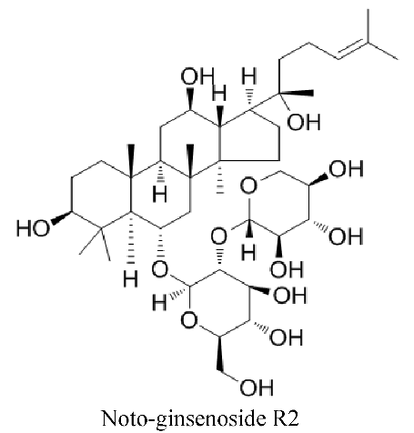
5 | 20.00 | Ginsenoside Rh1 | C₃₆H₆₂O₉ | [M+HCOO]- | 683.4393 | 475.3802 |  | 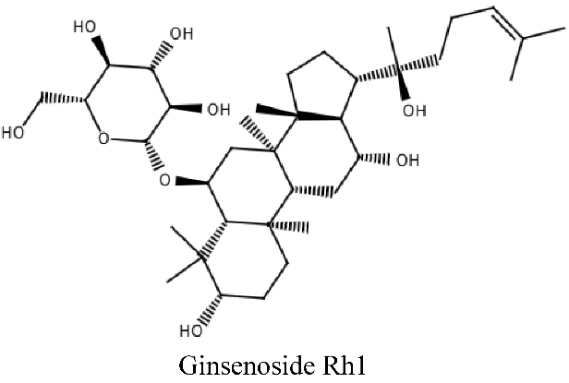
6 | 20.03 | Ginsenoside Rg2* | C₄₂H₇₂O₁₃ | [M-H]- | 784.4978 | 783.4932,677.4998,637.4354,5888.9855 | 0.98% | 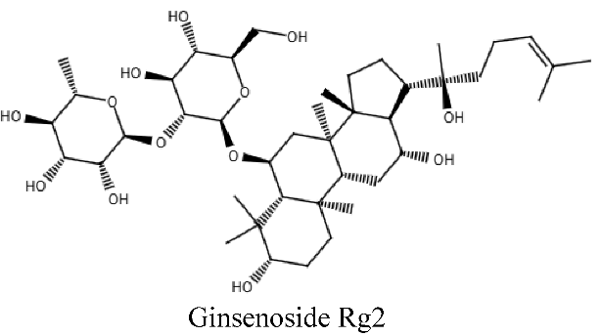
7 | 21.11 | Ginsenoside Rb1* | C₅₄H₉₂O₂₃ | [M-H]- | 1108.6035 | 1107.6005,945.5458,621.4399,459.3867 | 21.28% | 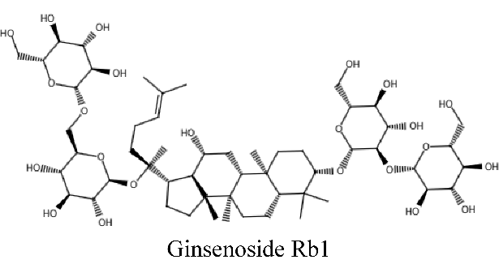
8 | 22.15 | Ginsenoside Ro* | C₄₈H₇₆O₁₉ | [M-H]- | 956.4986 | 955.4946,793.4407,731.4437,523.3806 | 11.41% | 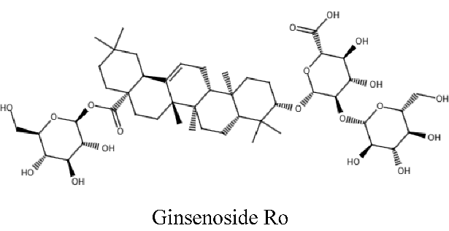
9 | 23.56 | Ginsenoside Rb2* | C₅₃H₉₀O₂₂ | [M-H]- | 1078.5929 | 1077.5890,945.5439,915.5344,783.4934 | 10.73% | 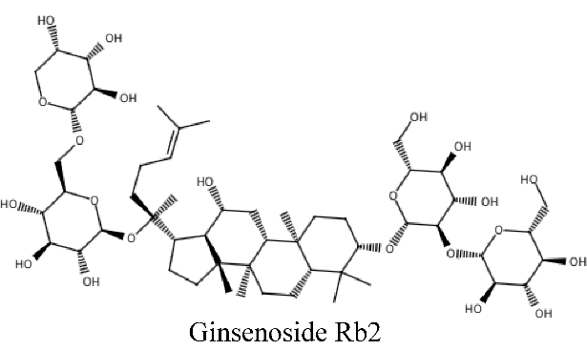
10 | 23.94 | Ginsenoside Rc | C₅₃H₉₀O₂₂ | [M-H]- | 1078.5929 | 1077.5894,945.5475,621.4399,434.8747 | 0.17% | 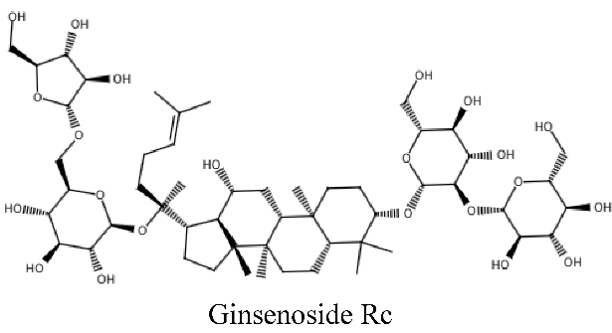
11 | 26.59 | Ginsenoside Rd* | C₄₈H₈₂O₁₈ | [M-H]- | 946.5507 | 945.5474,783.4929,677.5012,621.4410 | 8.74% | 