Supplementary Figure 1. The growth curve and Ct values of the Hr-HPV assay. The results shown (Ct 42.2 in the “other” channel) exceeds its clinical cutoff 40.0, resulting in a negative call despite HSIL.

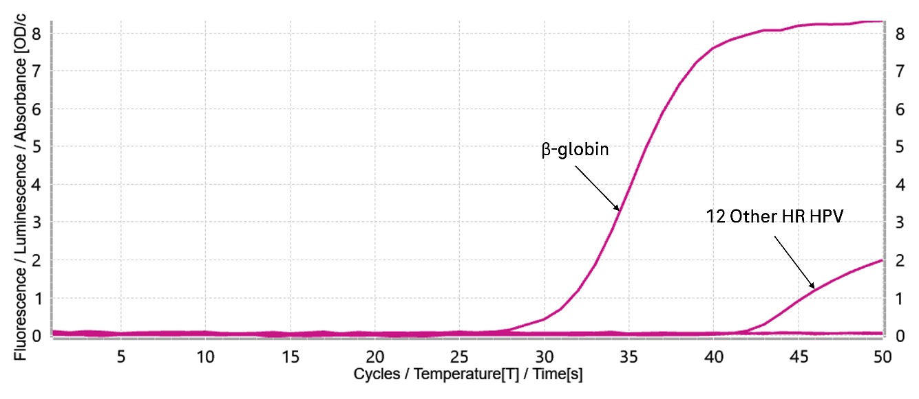

Supplementary Table 1. Histopathologic outcomes at year 2 and years 3~5
 | Second year |  |  | 3~5 year
 | Follow up numbers | CIN2+/  cumulative CIN2+ | CIN3+/  cumulative CIN3+ | Follow up numbers | CIN2+/  cumulative CIN2+ | CIN3+/  cumulative CIN3+
ASC-US | 34 | 6/32 | 5/13 | 39 | 4/36 | 4/17
LSIL | 8 | 2/39 | 1/8 | 20 | 4/43 | 0/8
ASC-H | 3 | 1/16 | 1/9 | 4 | 0/16 | 0/9

