Supplementary Table 1. Antibodies used for immunoblotting analysis
Name | Cat. No. | Company
Phospho-Rpb1 CTD (Ser2) | 13499 | Cell Signaling Technology
Phospho-Rpb1 CTD (Ser5) | 13523 | Cell Signaling Technology
Phospho-Rpb1 CTD (Ser7) | 13780 | Cell Signaling Technology
XIAP |  | Cell Signaling Technology
PARP | 9542 | Cell Signaling Technology
Caspase-9 | 9502 | Cell Signaling Technology
Cleaved Caspase-3 | 9661 | Cell Signaling Technology
DNMT1 | AF6110 | R&D
DNMT3a | 3598 | Cell Signaling Technology
DNMT3b | 67259 | Cell Signaling Technology
CDK2 | SC-163 | Santa Cruz
CDK4 | SC-23896 | Santa Cruz
CDK7 | 2916s | Cell Signaling Technology
CDK9 | 2316 | Cell Signaling Technology
c-ABL | 2862 | Cell Signaling Technology
Phospho-JNK (Thr183,Tyr185) | 905-662 | Stressgen
JNK | 9252 | Cell Signaling Technology
Phopho-PI3K (Tyr458, Tyr199) | 42228 | Cell Signaling Technology
PI3K | ADI-KAM-PI200 | ENZO
Phopho-AKT (Ser473) | 9271 | Cell Signaling Technology
AKT | 9272 | Cell Signaling Technology
Phopho-ERK (Thr202/Tyr204) | 9101l | Cell Signaling Technology
ERK | 9102l | Cell Signaling Technology
Phospho-S6 (Ser240, Ser244) | 2215 | Cell Signaling Technology
S6 | 2217 | Cell Signaling Technology
BCL-xL | 2762 | Cell Signaling Technology
BCL-2 | 15071s | Cell Signaling Technology
BAX | SC-20067 | Santa Cruz
MCL1 | 4572 | Cell Signaling Technology
c-MYC | 5605 | Cell Signaling Technology
ATG3 | 2630 | Cell Signaling Technology
ATG5 | 2552 | Cell Signaling Technology
P53 | SC-126 | Santa Cruz
β-actin | A5441 | Sigma-Aldrich

Supplementary Figure. 1. Validation of apoptosis-related genes identified by RT² Profiler PCR Array at the protein expression level. Western blot analysis of apoptosis-associated proteins in MOLM-13, MOLM/AZA-1, and MOLM/DEC-5 cells following CDK7 inhibition. Cells were treated with YPN-005 for 24 h, and whole cell lysates were subjected to Western blotting for targets identified as differentially regulated in the RT² Profiler PCR Array (Fig. 4A). β-actin was used as a loading control.
Abbreviations: CDK7, cyclin-dependent kinase 7; PCR, polymerase chain reaction; RT², reverse transcription quantitative.


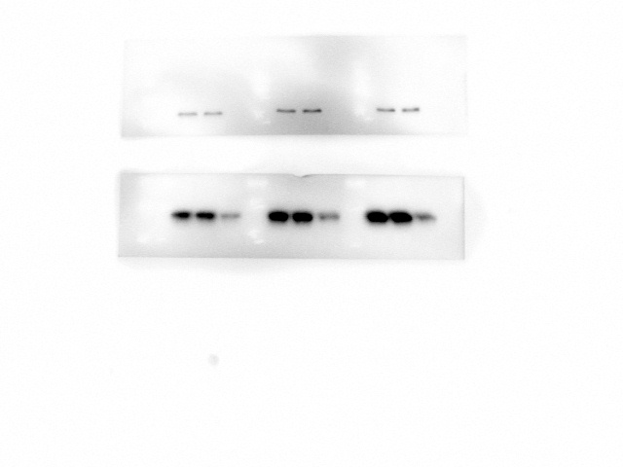
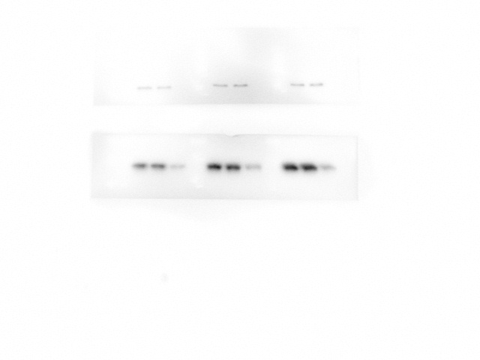




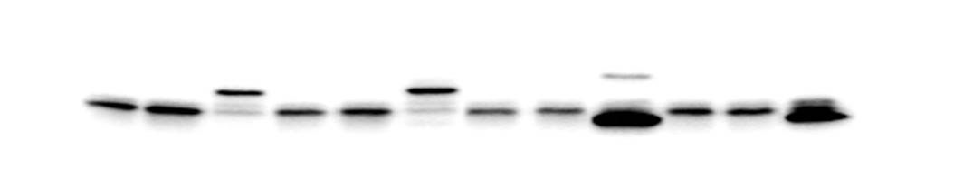
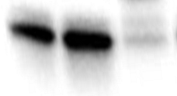




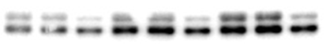

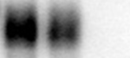
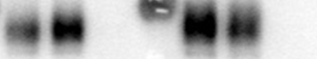

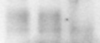
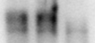
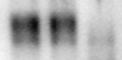



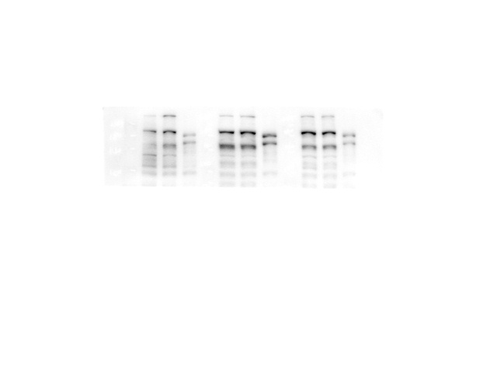
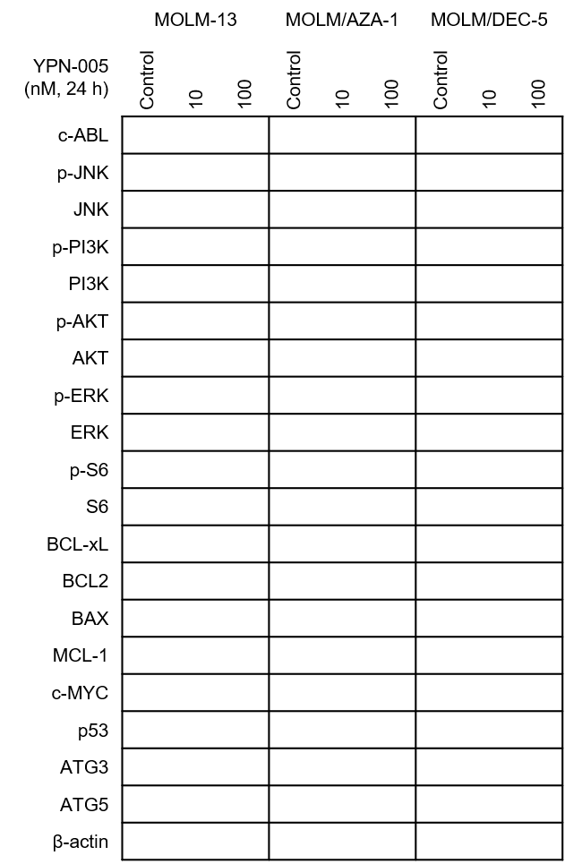

Supplementary Figure. 2. Heatmap visualization of cell death pathway gene expression changes in MOLM-13 cells treated with 20 nM YPN-005 for 24 h. Gene map corresponding to each well position of the RT² Profiler PCR array plate. Cells were treated with 20 nM YPN-005 for 24 h, and mRNA expression was analyzed using the Human Signal Transduction PathwayFinder RT² Profiler PCR Array. Differentially regulated genes are shown as a color-coded matrix, where downregulated transcripts are represented in green and upregulated transcripts in red, relative to DMSO control. The table lists the specific genes assigned to wells A01-G12, corresponding to the heatmap grid shown above.
Abbreviations: DMSO, dimethyl sulfoxide; PCR, polymerase chain reaction; RT², reverse transcription quantitative

Layout | 1 | 2 |  | 3 |  | 4 |  | 5 |  | 6 |  | 7 |  |  | 8 | 9 |  |  | 10 |  | 11 |  | 12
A | ABL1 |  | AKT1 |  | APAF1 |  | APP |  | ATG12 |  | ATG16L1 |  | ATG3 | ATG5 |  |  | ATG7 | ATP6V1G2 |  | BAX |  | BCL2
B | BCL2A1 |  | BCL2L1 |  | BCL2L11 |  | BECN1 |  | BIRC2 |  | BIRC3 |  | BMF | C1orf159 |  |  | CASP1 | CASP2 |  | CASP3 |  | CASP6
C | CASP7 |  | CASP9 |  | CCDC103 |  | CD40 |  | CD40LG |  | CFLAR |  | COMMD4 | CTSB |  |  | CTSS | CYLD |  | DEFB1 |  | DENND4
D | DFFA |  | DPYSL4 |  | EIF5B |  | ESR1 |  | FAS |  | FASLG |  | FOXI1 | GAA |  |  | GADD45A | GALNT5 |  | GRB2 |  | HSPBAP1
E | HTT |  | IFNG |  | IGF1 |  | IGF1R |  | INS |  | IRGM |  | JPH3 | KCNIP1 |  |  | MAG | MAP1LC3A |  | MAPK8 |  | MCL1
F | NFKB1 |  | NOL3 |  | OR10J3 |  | PARP1 |  | PARP2 |  | PIK3C3 |  | PVR | RAB25 |  |  | RPS6KB1 | S100A7A |  | SNCA |  | SPATA2
G | SQSTM1 |  | SYCP2 |  | TMEM57 |  | TNF |  | TNFRSF10A |  | TNFRSF11B |  | TNFRSF1A | TP53 |  |  | TRAF2 | TXNL4B |  | ULK1 |  | XIAP

