Table S1. Mapping of Semantic Features to Expert Language and Physical Interpretations.
Feature Name | Corresponding Phrase (LLM Output) | Physical Meaning / Expert Interpretation
num_peaks | "The spectrum contains N prominent peaks" | Overall signal complexity; reflects molecular vibrational diversity
main_peak_pos | "The main peak appears at X" | Dominant vibrational mode of the polymer; highly discriminative for polymer type
main_peak_intensity | "With an intensity of Y" | Signal strength at main vibrational mode; relates to composition, crystallinity
other_peaks_count | "Other peaks are located at [...]" | Secondary vibrational signatures; helpful for detailed polymer discrimination
other_peak_avg_pos | "Other peaks are located at [positions]" | Mean position of subpeaks; can reveal additive-related features or branching structures
other_peak_avg_intensity | "With respective intensities [...]" | Average strength of secondary modes; contributes to material fingerprint
width_avg | "The peak widths are [...]" | Average spectral peak width; relates to crystallinity, homogeneity
width_max | "The peak widths are [...]" | Broadest observed peak; may indicate material disorder or fluorescence interference
is_symmetric | "The peaks are symmetric/asymmetric" | Peak shape; relates to molecular environment or instrument response
shoulder_peaks | "Shoulder peaks are present" | Shoulder features often indicate overlapping vibrational modes or impurities
baseline_flat | "The baseline trend is flat" | Ideal condition; baseline stability implies minimal fluorescence or drift
baseline_decreasing | "The baseline trend is decreasing" | Potential baseline distortion or instrument drift
global_slope_flat | "Global slope is flat" | Overall intensity trend; often flat in high-quality acquisitions
global_slope_decreasing | "Global slope is left-to-right decrease" | May indicate fluorescence quenching or sample degradation
noise_high | "Noise level is high" | Low signal-to-noise ratio; may affect classification reliability
saturation | "Saturation: True" | Detector saturation; may distort intensities and require exclusion
anomalies | "Anomalies detected: True" | Spectral outliers due to contamination, preprocessing failure, or sample damage
sharp_peaks | "Peak sharpness: sharp" | Well-defined peaks; common in crystalline, pure polymers
sharp_mixed | "Peak sharpness: mixed" | Mixture of sharp and broad peaks; indicates heterogeneity or additives

Table S2. Performance of Raw Spectral Features on Dataset 1
Model | ACC | AUC | PRE | SE | SP
LR | 83.67 | 96.12 | 81.94 | 77.38 | 94.66
SVM (Linear) | 83.67 | 94.17 | 83.36 | 78.72 | 94.60
SVM (RBF) | 46.94 | 79.83 | 28.21 | 39.40 | 80.95
KNN | 67.35 | 86.06 | 60.88 | 61.34 | 88.97
Naive Bayes | 48.98 | 69.20 | 61.06 | 47.50 | 83.21
RF | 65.31 | 91.84 | 60.00 | 59.02 | 88.43
GBDT | 67.35 | 85.09 | 64.14 | 62.77 | 89.35
XGBoost | 69.39 | 91.61 | 64.66 | 62.65 | 89.58

Table S3. Performance of LLM-Derived Semantic Features on Dataset 1
Model | ACC | AUC | PRE | SE | SP
LR | 52.00 | 78.45 | 49.70 | 50.40 | 84.04
SVM (Linear) | 56.00 | 81.65 | 54.38 | 53.97 | 85.60
SVM (RBF) | 52.00 | 75.22 | 51.39 | 49.80 | 84.39
KNN | 48.00 | 81.66 | 52.92 | 46.83 | 83.47
Naive Bayes | 56.00 | 78.72 | 56.99 | 59.52 | 85.78
RF | 52.00 | 79.63 | 48.17 | 45.63 | 84.39
GBDT | 56.00 | 79.36 | 54.42 | 53.97 | 85.53
XGBoost | 56.00 | 83.23 | 54.42 | 53.97 | 85.53

Table S4. Performance of Raw Spectral Features on Dataset 2
Model | ACC | AUC | PRE | SE | SP
Logistic Regression | 98.40 | 99.81 | 95.94 | 95.48 | 99.89
SVM (Linear) | 98.73 | 99.80 | 96.82 | 97.20 | 99.91
SVM (RBF) | 96.18 | 99.64 | 86.94 | 87.31 | 99.72
KNN | 94.36 | 99.38 | 89.49 | 91.75 | 99.59
Naive Bayes | 55.53 | 88.65 | 54.16 | 60.62 | 96.78
Random Forest | 95.63 | 99.77 | 89.36 | 87.10 | 99.68
Gradient Boosting | 94.03 | 99.26 | 85.21 | 81.83 | 99.57
XGBoost | 95.24 | 99.65 | 91.46 | 87.97 | 99.65

Table S5. Performance of LLM-Derived Semantic Features on Dataset 2
Model | ACC | AUC | PRE | SE | SP
LR | 74.56 | 96.30 | 52.93 | 50.65 | 98.10
SVM (Linear) | 79.42 | 97.70 | 59.86 | 54.85 | 98.48
SVM (RBF) | 76.11 | 96.91 | 55.80 | 51.33 | 98.22
KNN | 79.42 | 92.24 | 62.91 | 60.46 | 98.50
Naive Bayes | 22.46 | 85.17 | 15.40 | 25.72 | 94.74
RF | 89.27 | 98.78 | 76.45 | 74.13 | 99.23
GBDT | 89.60 | 99.25 | 79.17 | 76.88 | 99.24
XGBoost | 89.38 | 99.28 | 76.94 | 75.63 | 99.24

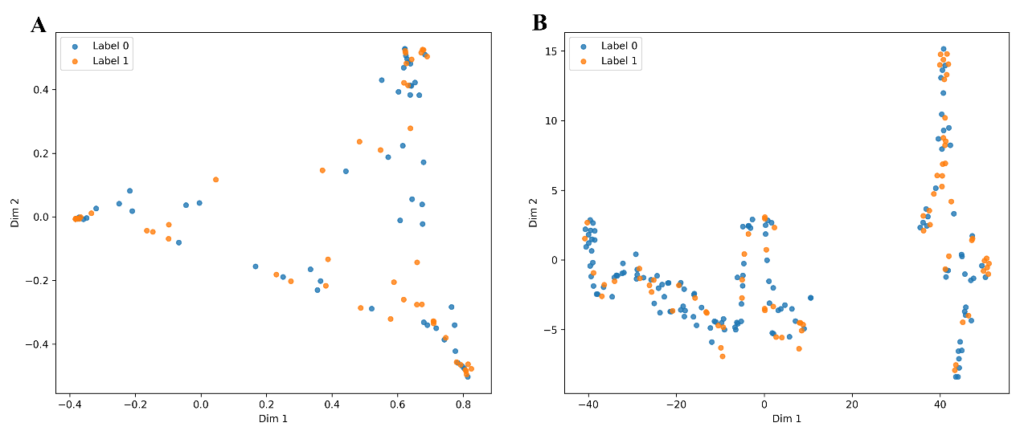
Fig. S1. Two-dimensional visualization of transferred probabilistic representations for external plastic screening. (A) PCA projection; (B) t-SNE projection.

