Supplementary Information to

Genomic Identification of Cobalamin-Dependent O-Demethylase Genes in Human Gut Bacterium Blautia sp. MRG-PMF1

Santipap Chaiyasarn^{1ǂ}, Niels Krabbe Johnsen^{2ǂ}, Intira Khumthong¹, Bekir Engin Eser², Jaehong Han¹*

Figure S1. AlphaFold3 and I-TASSER simulated structures of CP proteins. Cofactors of methylcobalamin (CP1, CP3, CP5 and CP6) and 5-methoxybenzimidazolylcobamide (CP2 and CP4) are shown in ball-and-stick model in the I-TASSER simulated structures.
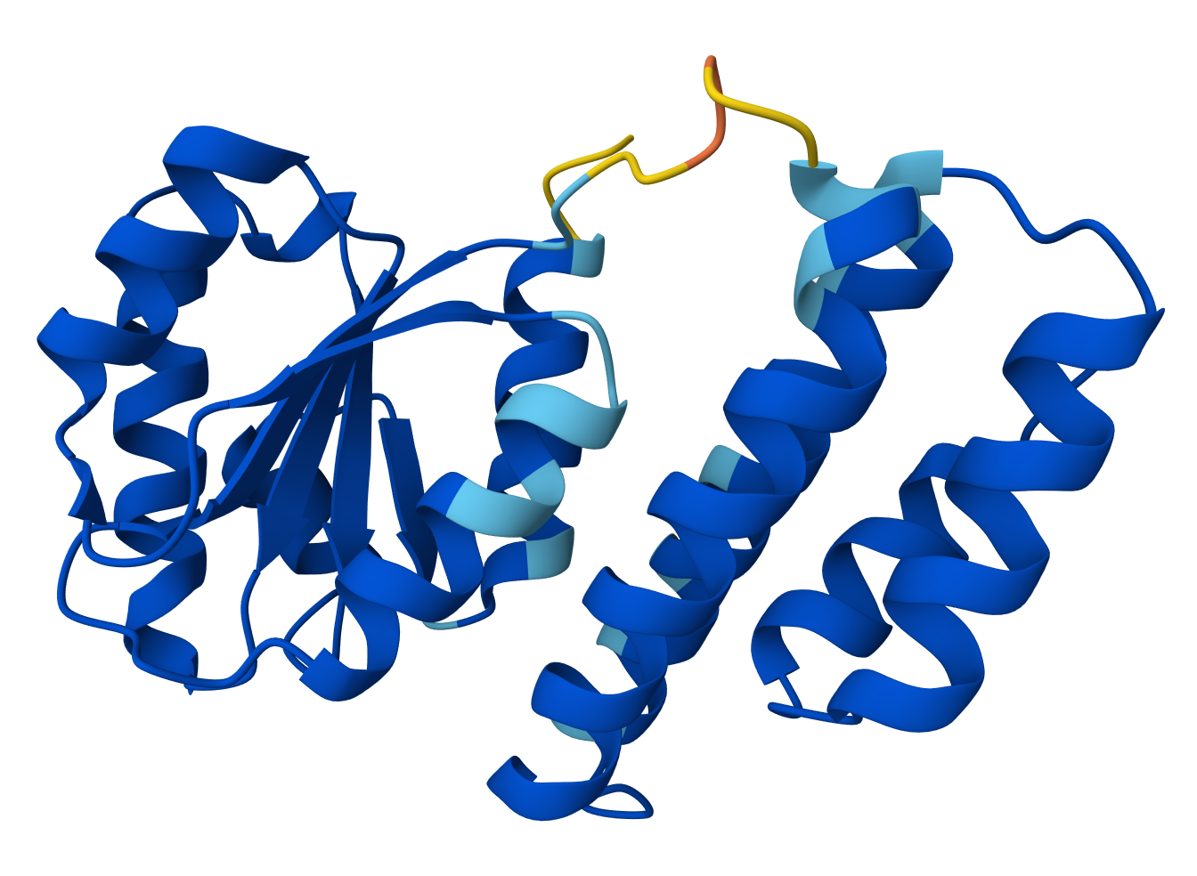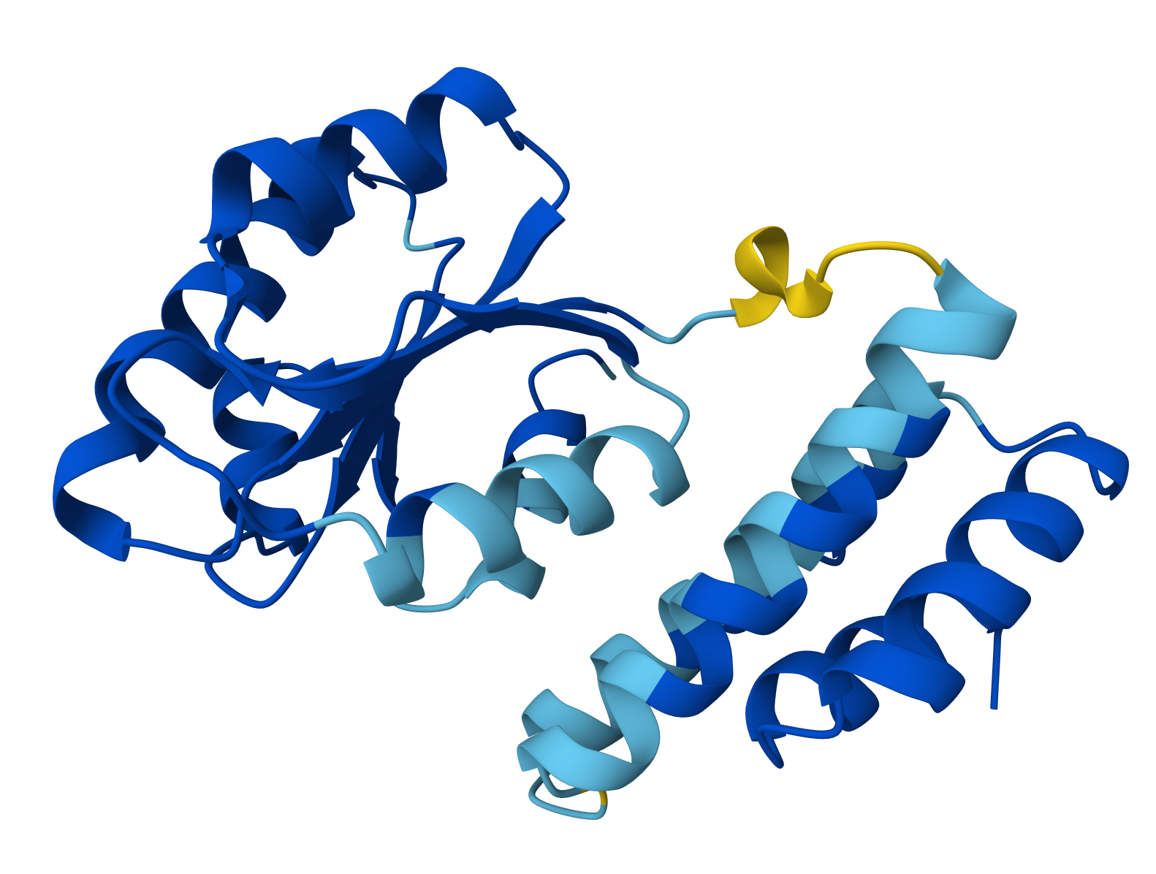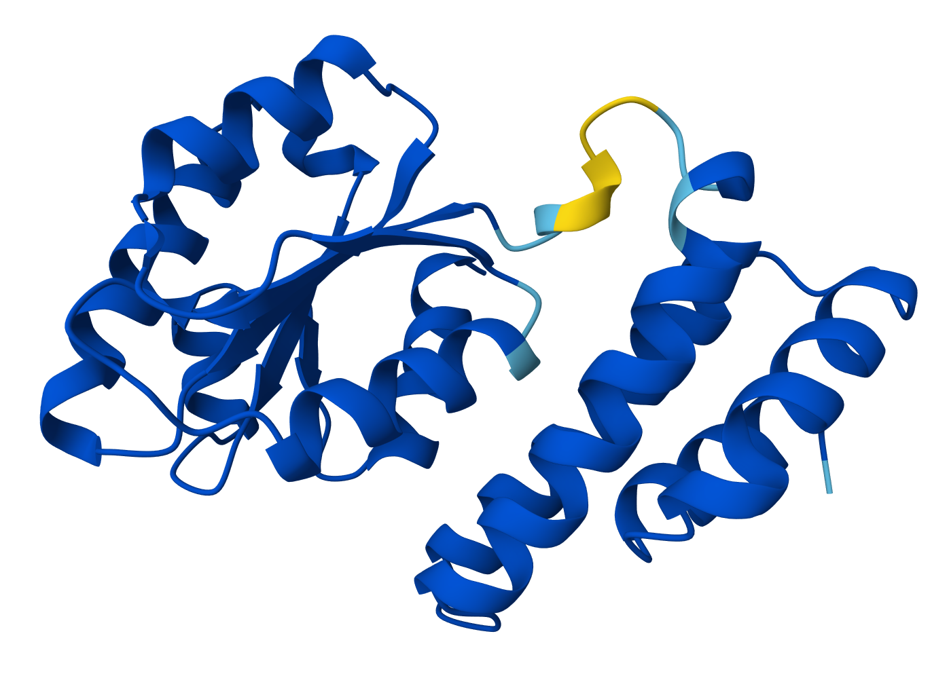
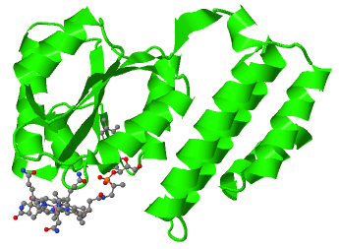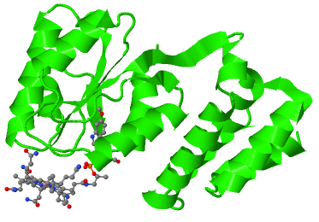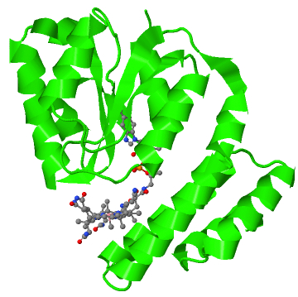
CP1 CP2 CP3
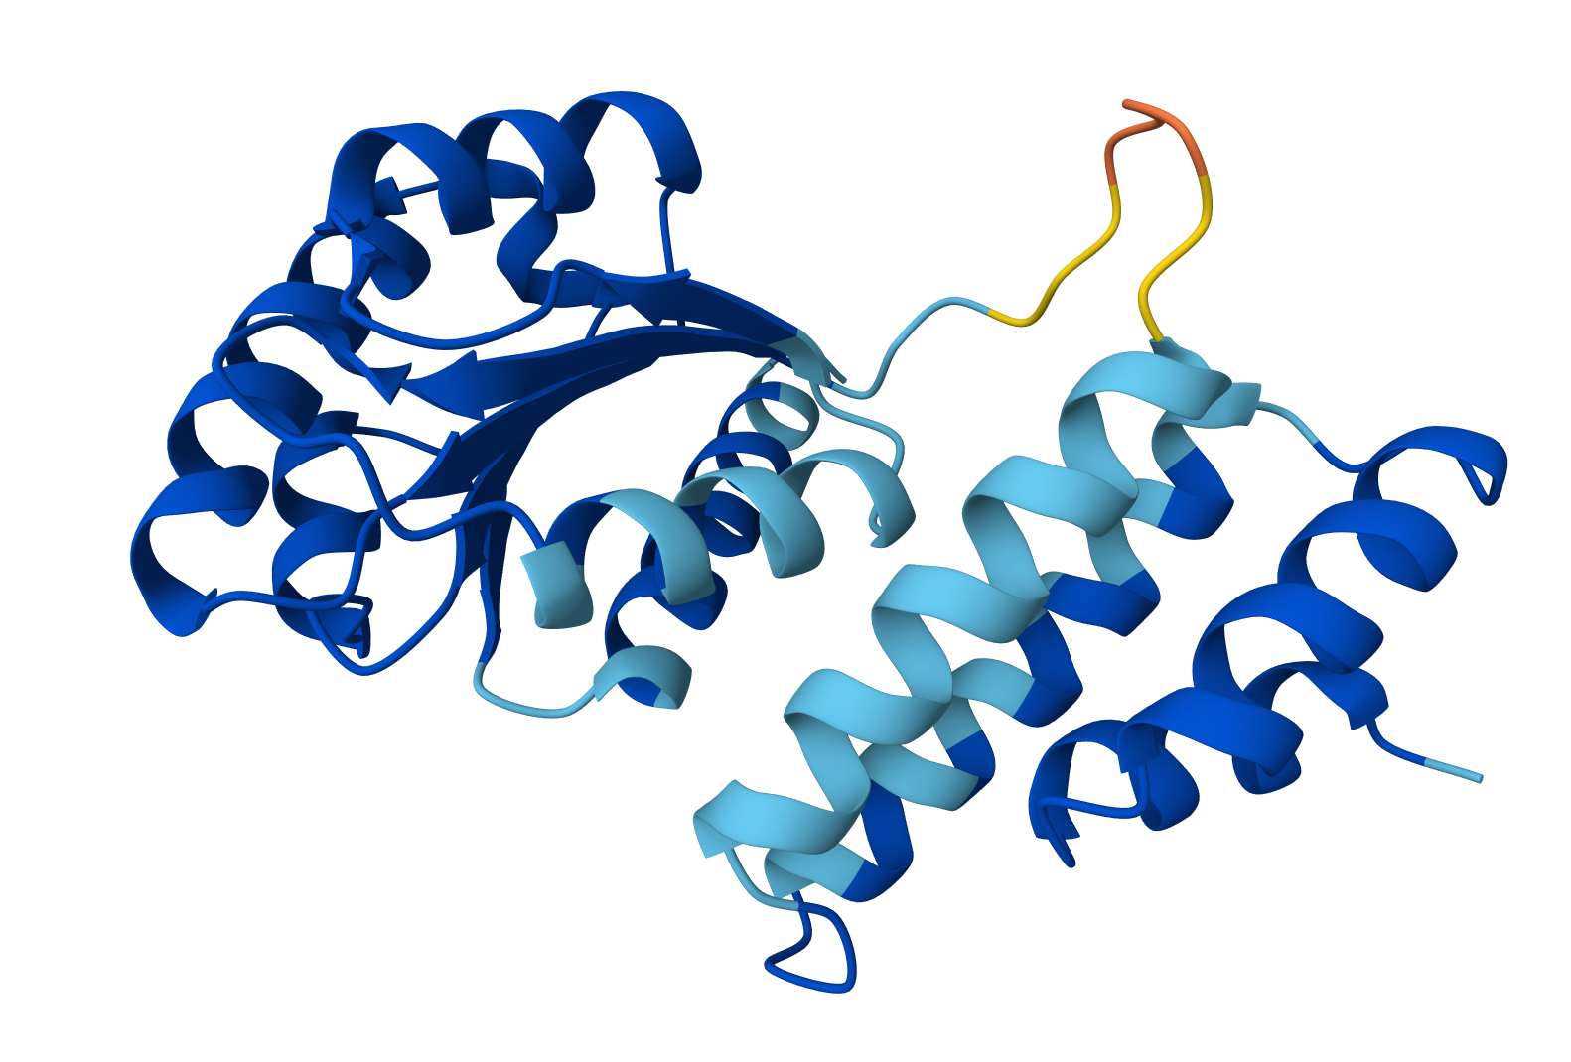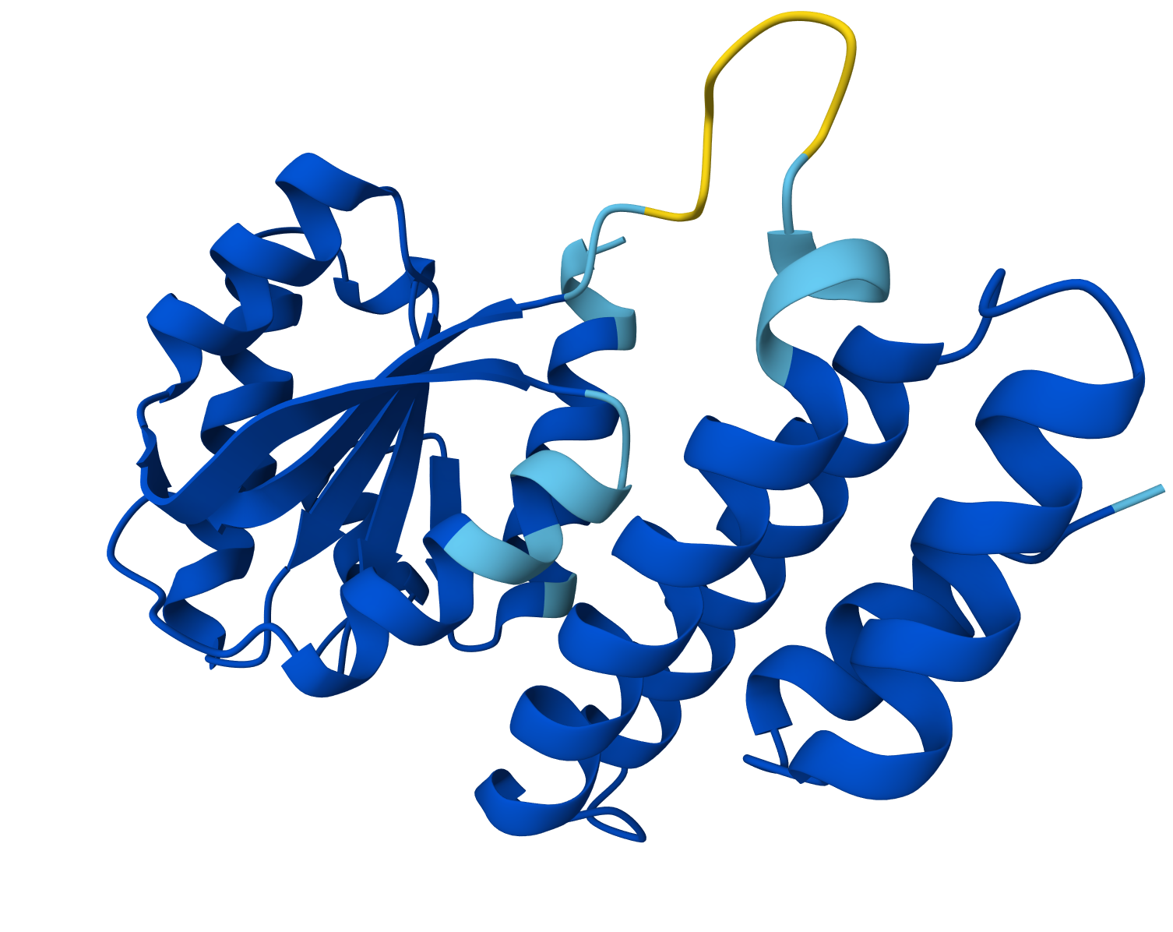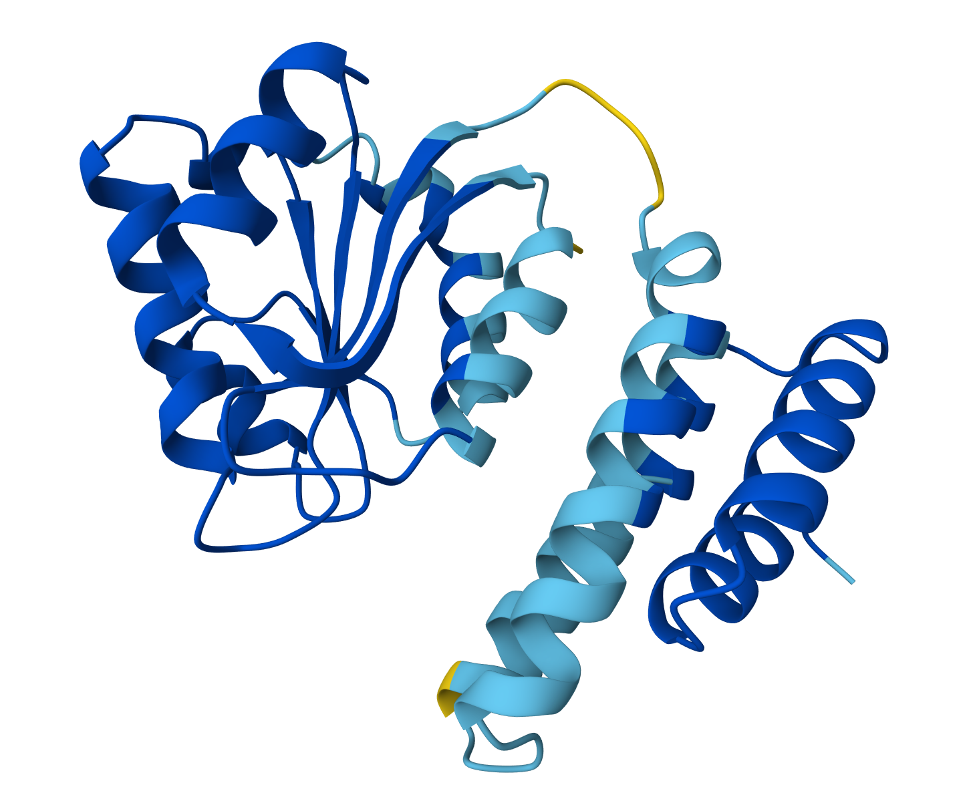
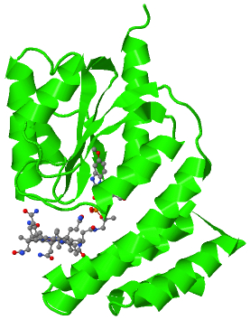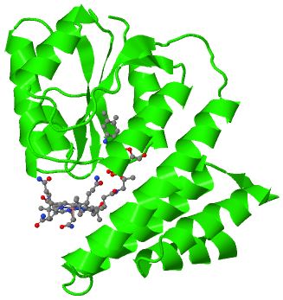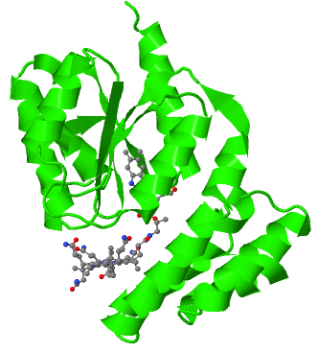
CP4 CP5 CP6

Figure S2. AlphaFold3 simulated structures of MT1 proteins.

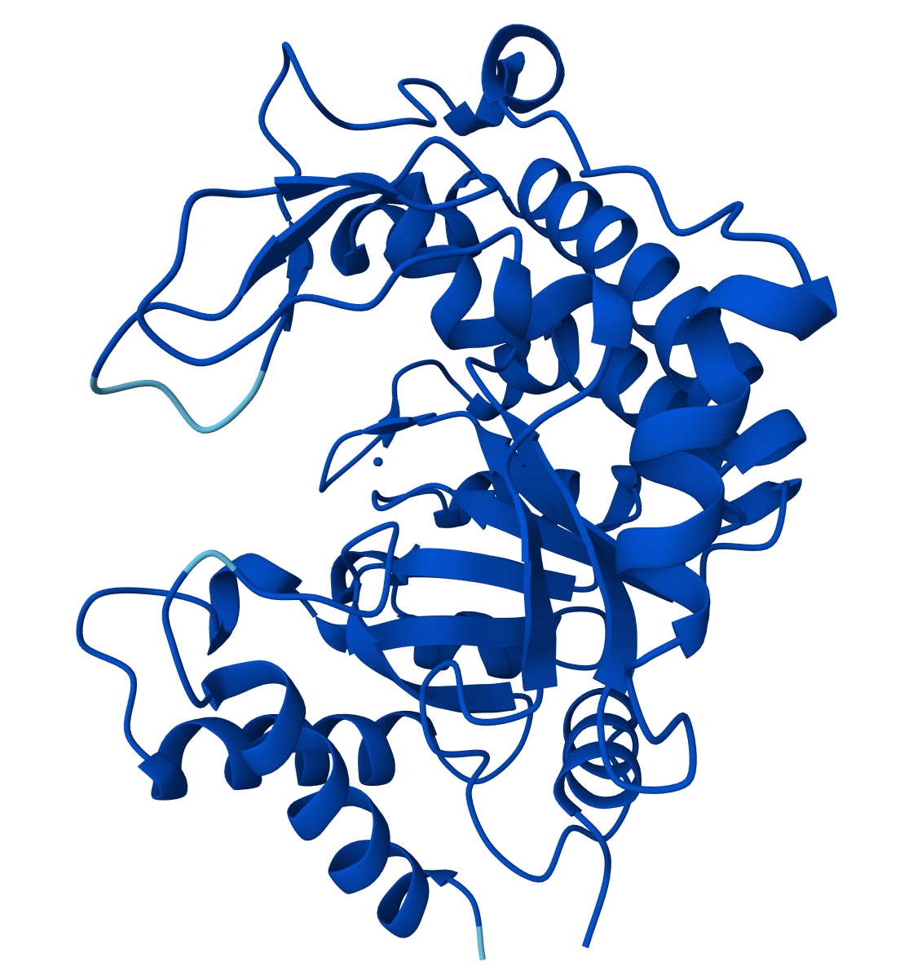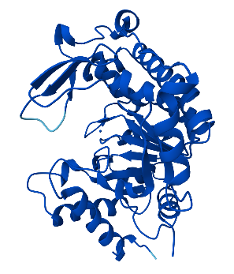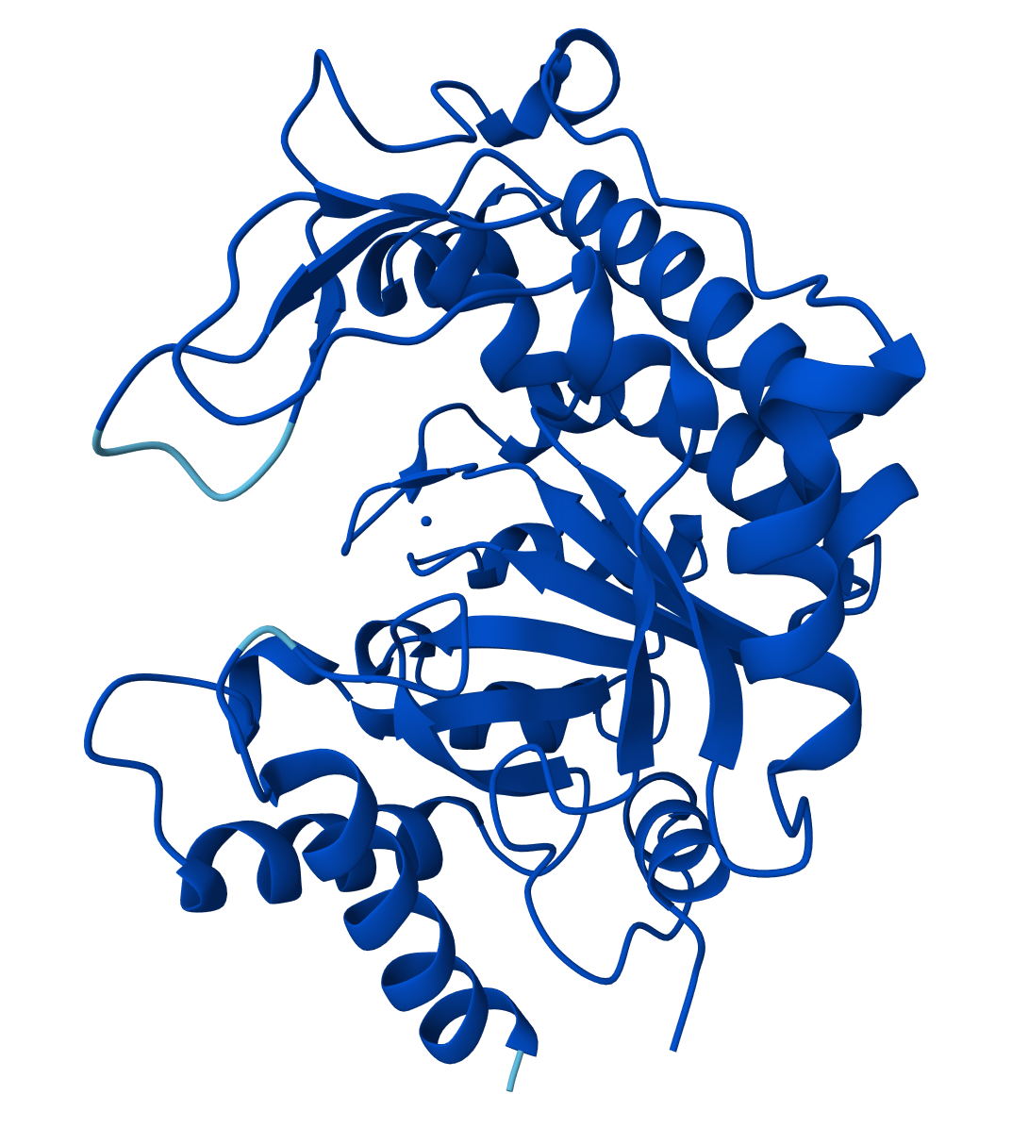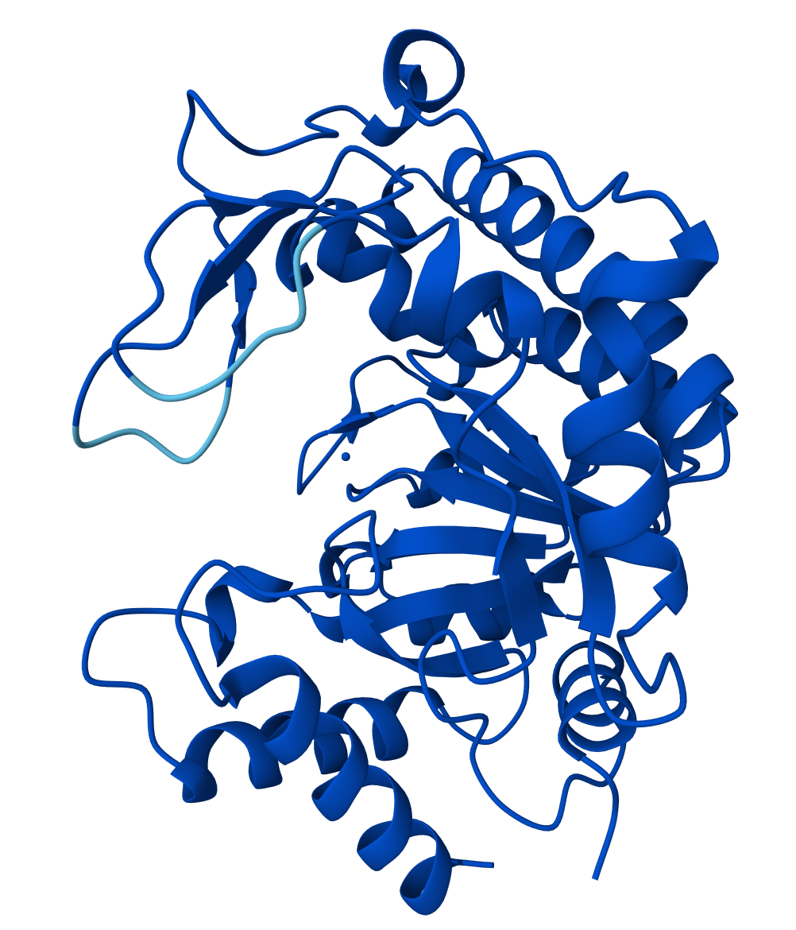
MT1_1 MT1_2 MT1_3 MT1_4
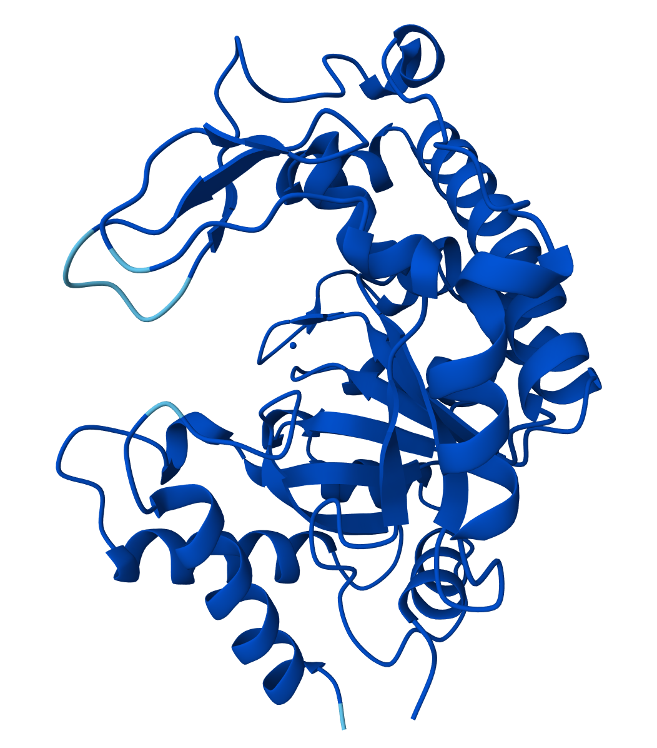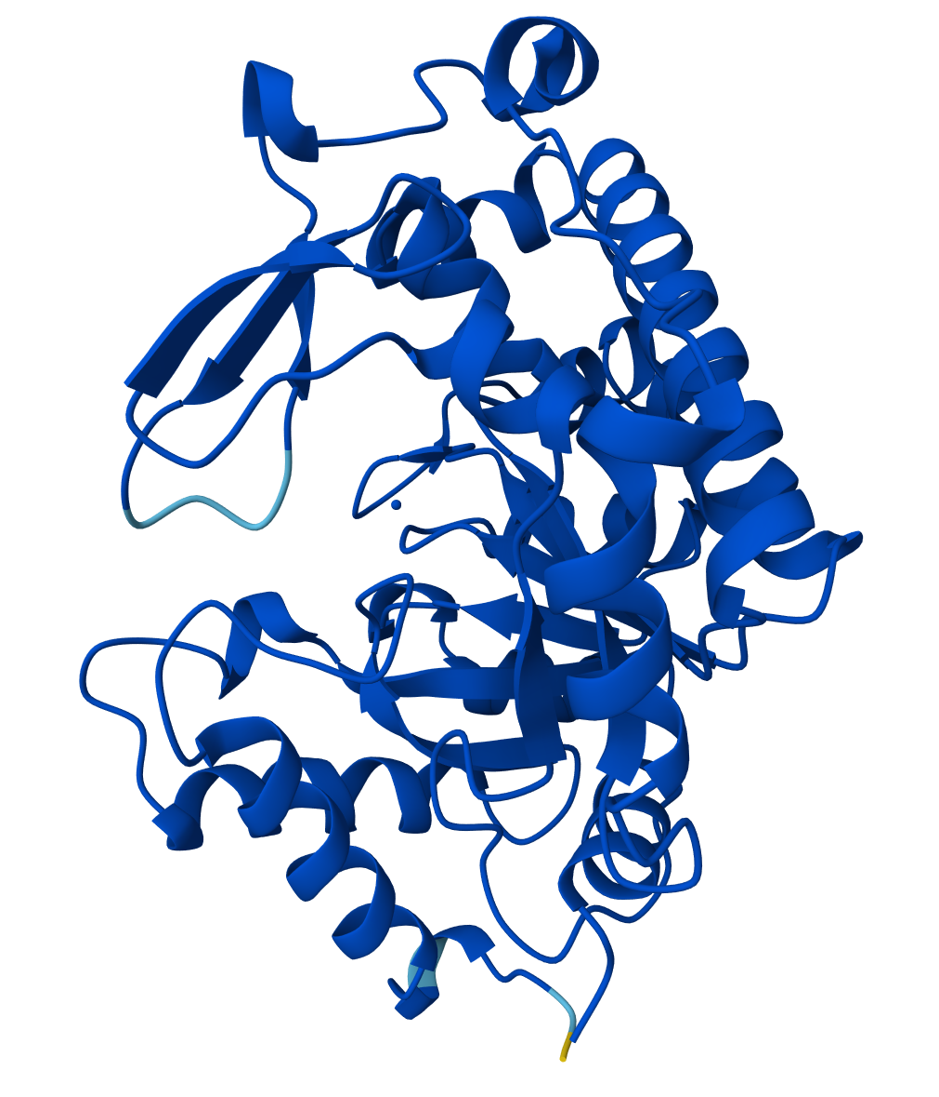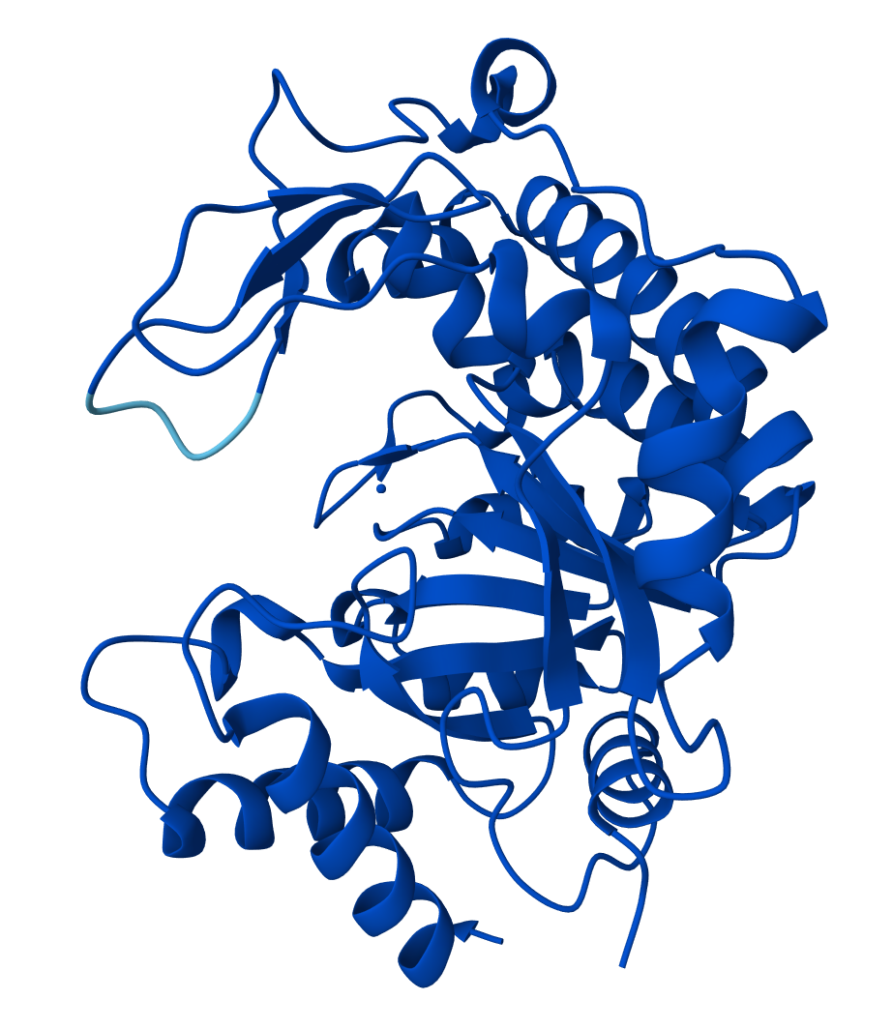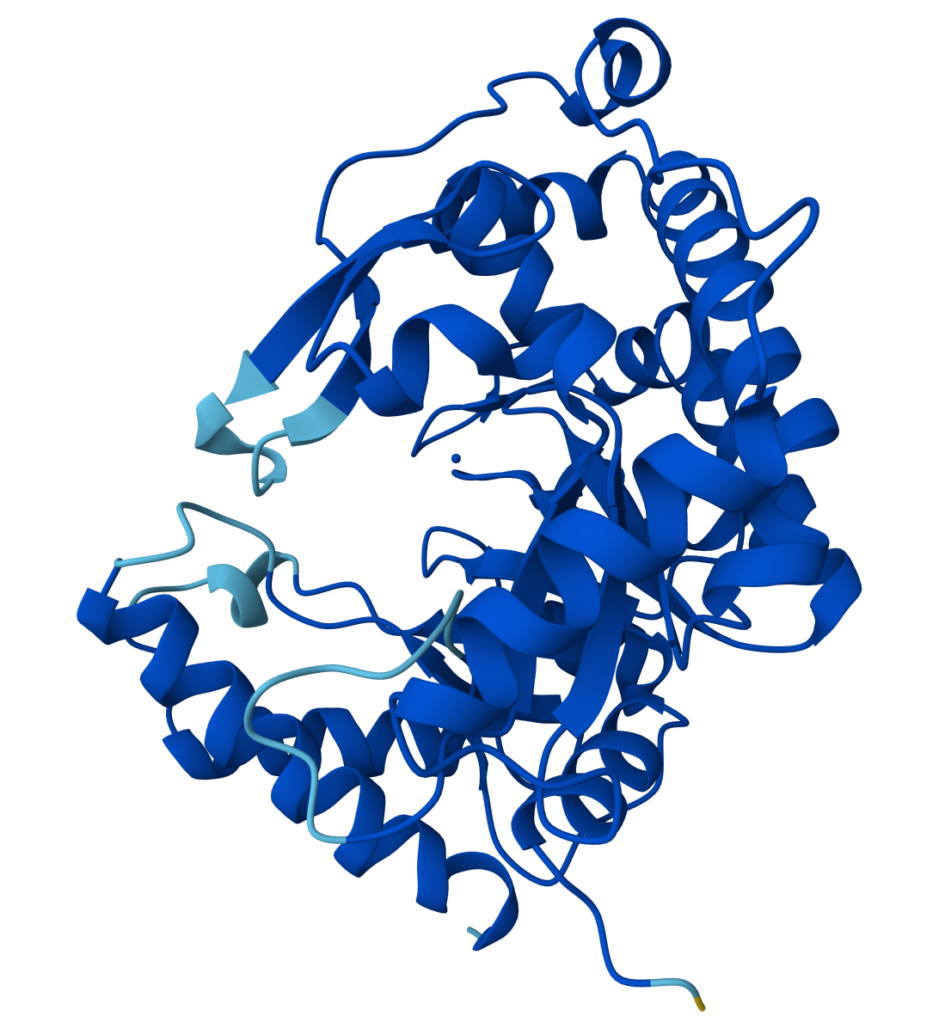
MT1_5 MT1_6 MT1_7 MT1_a
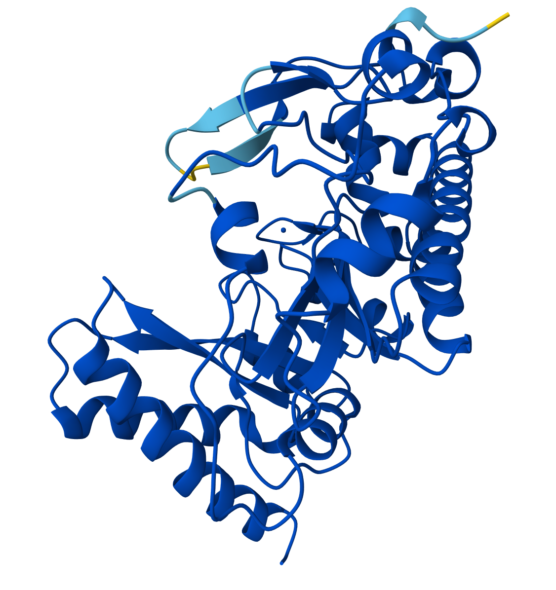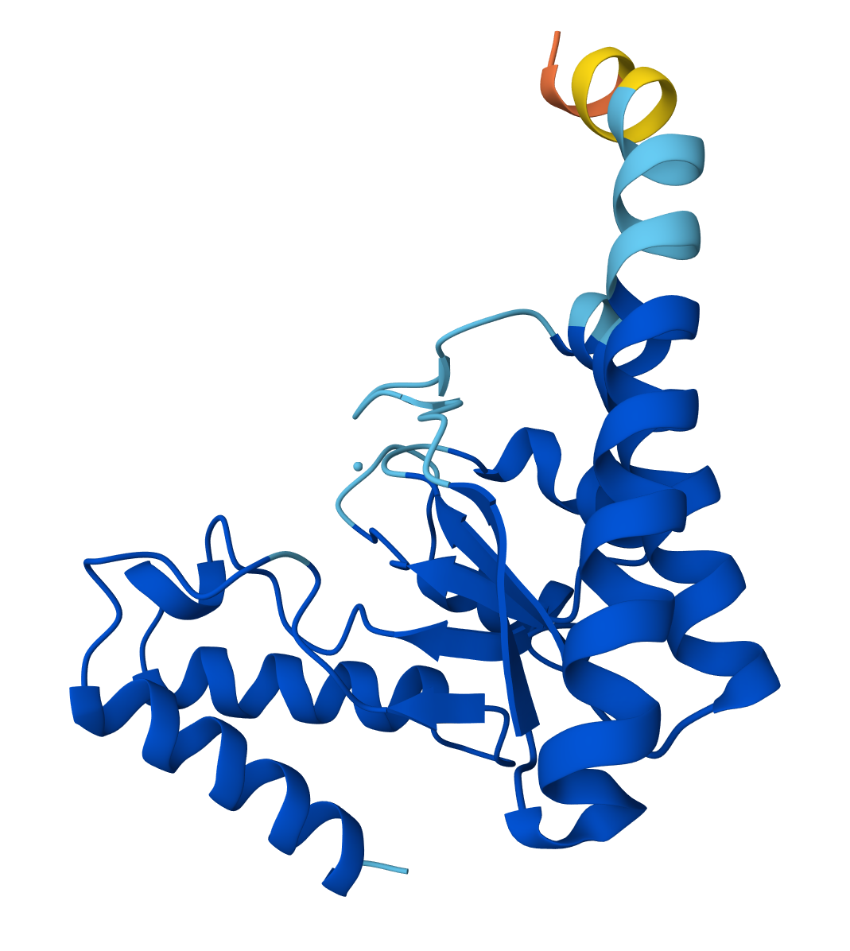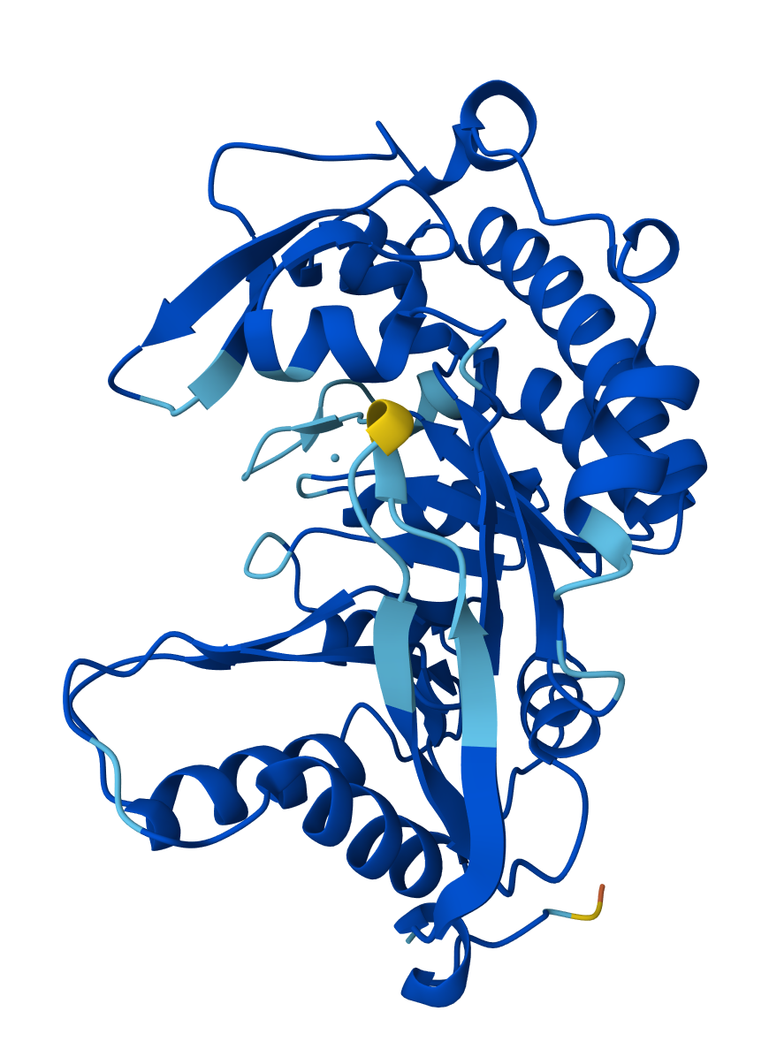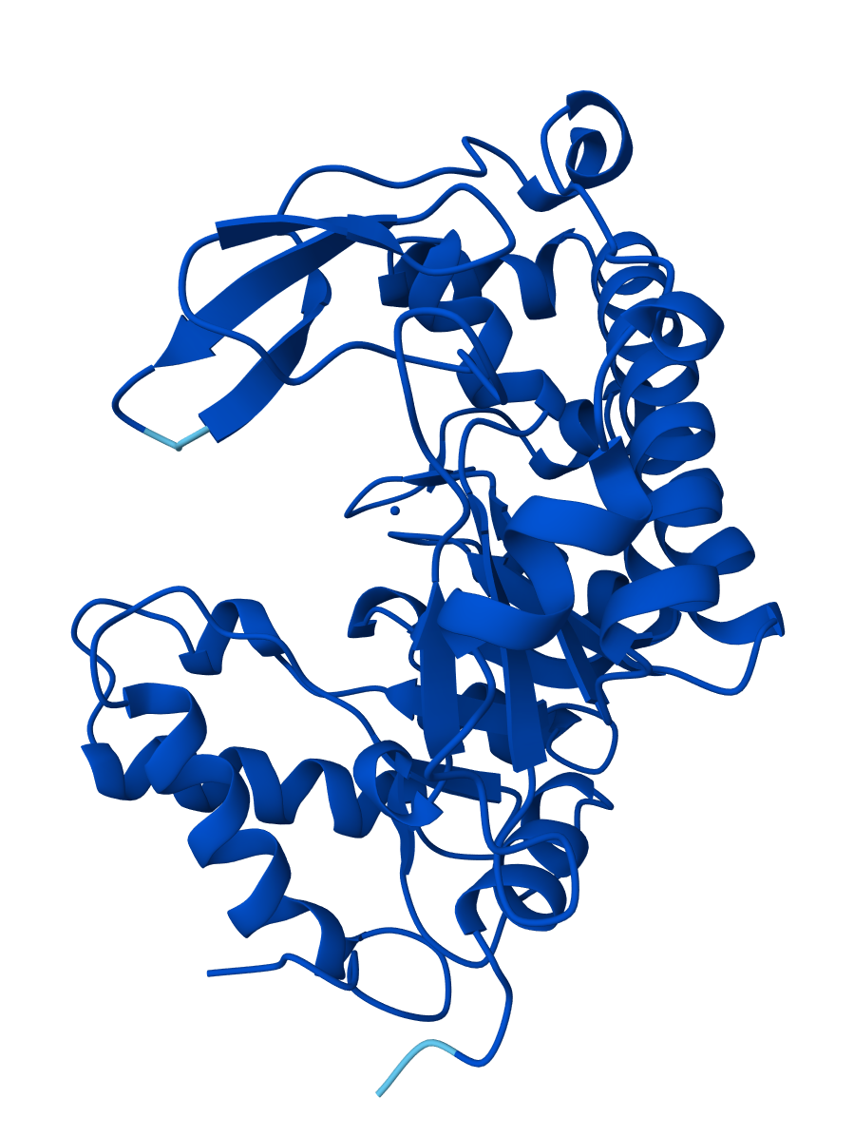
MT1_b MT1_c MT1_d MT1_e
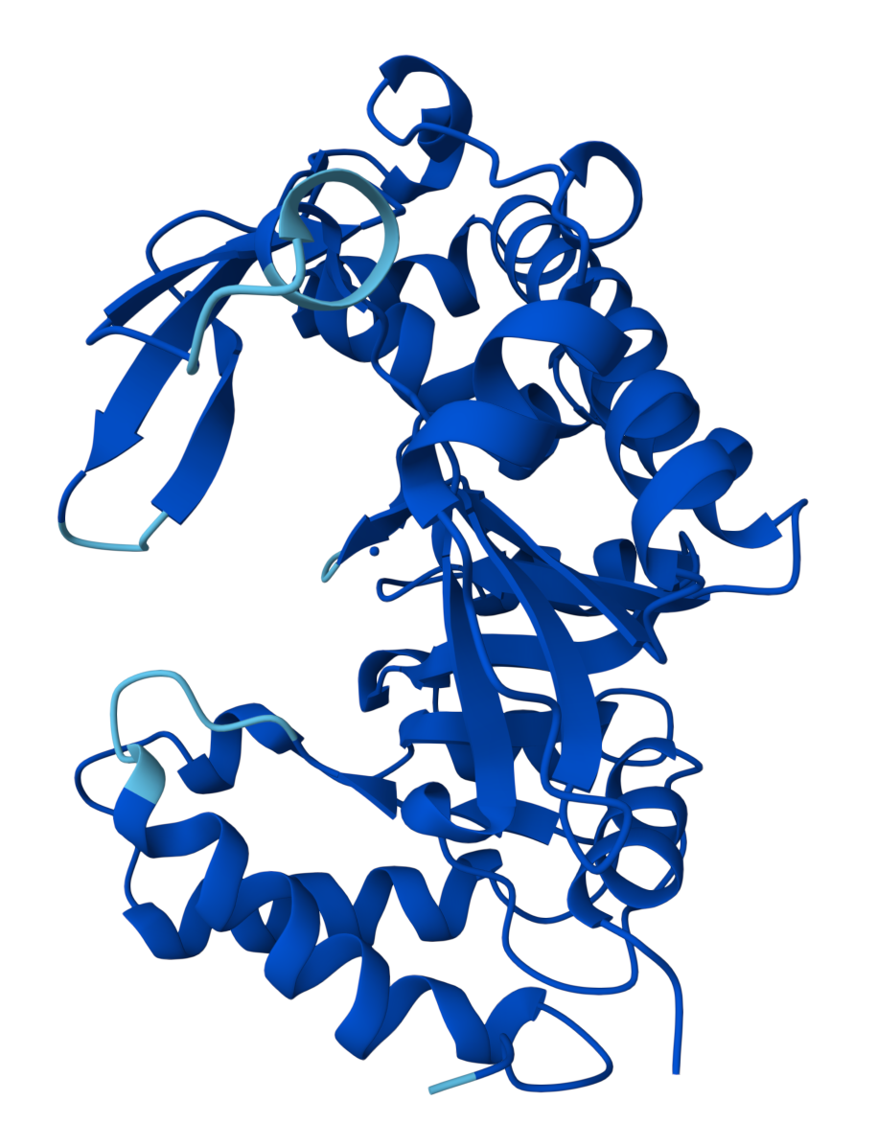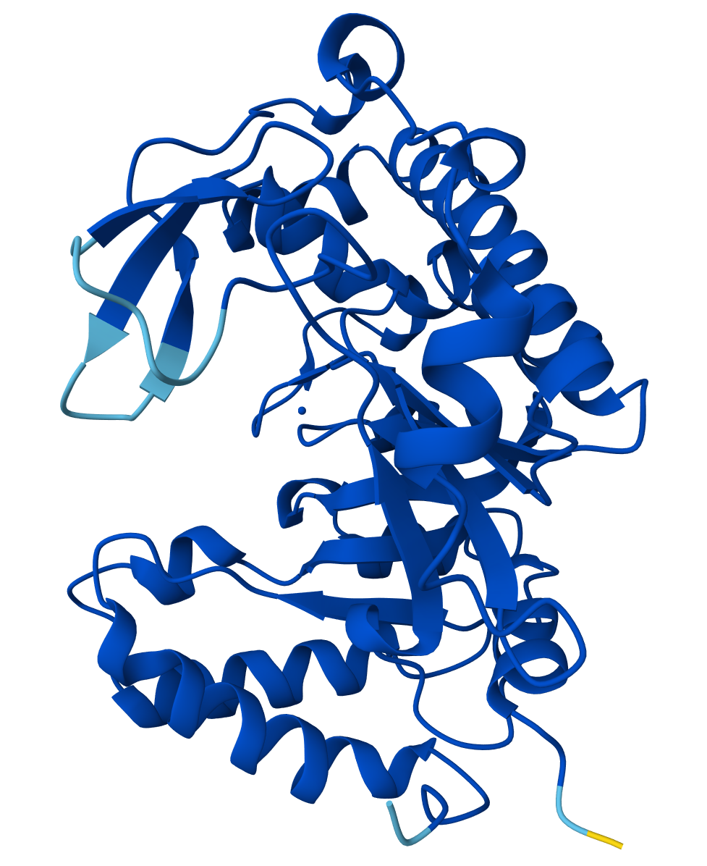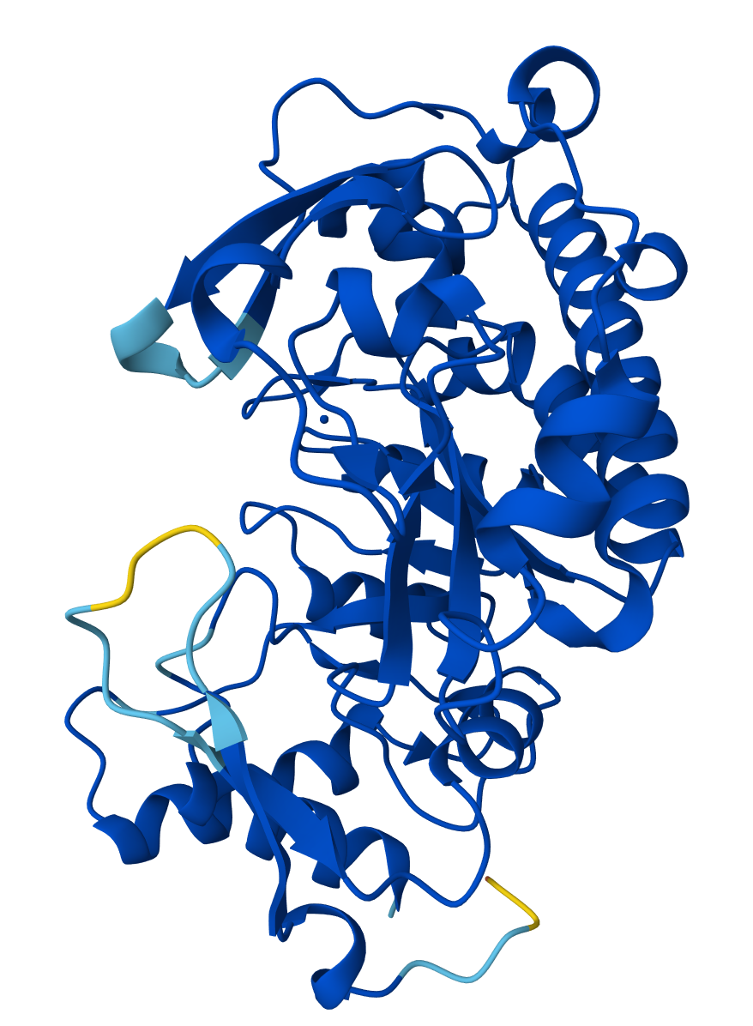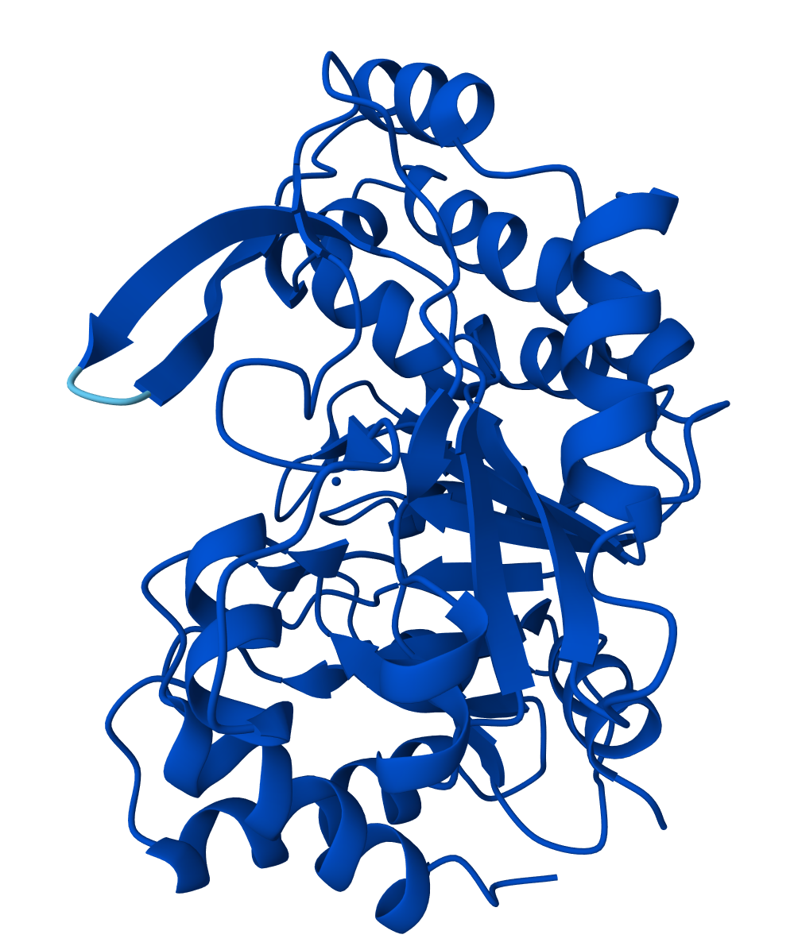
MT1_f MT1_g MT1_h MT1_i
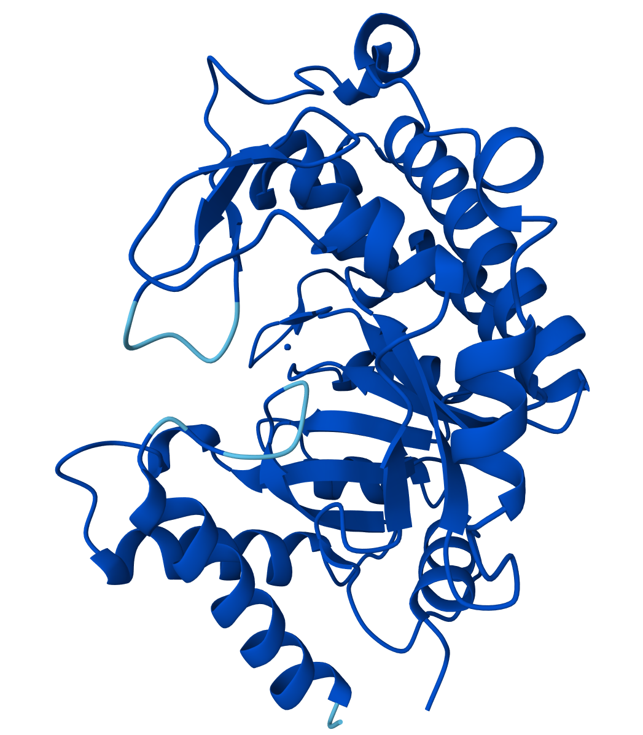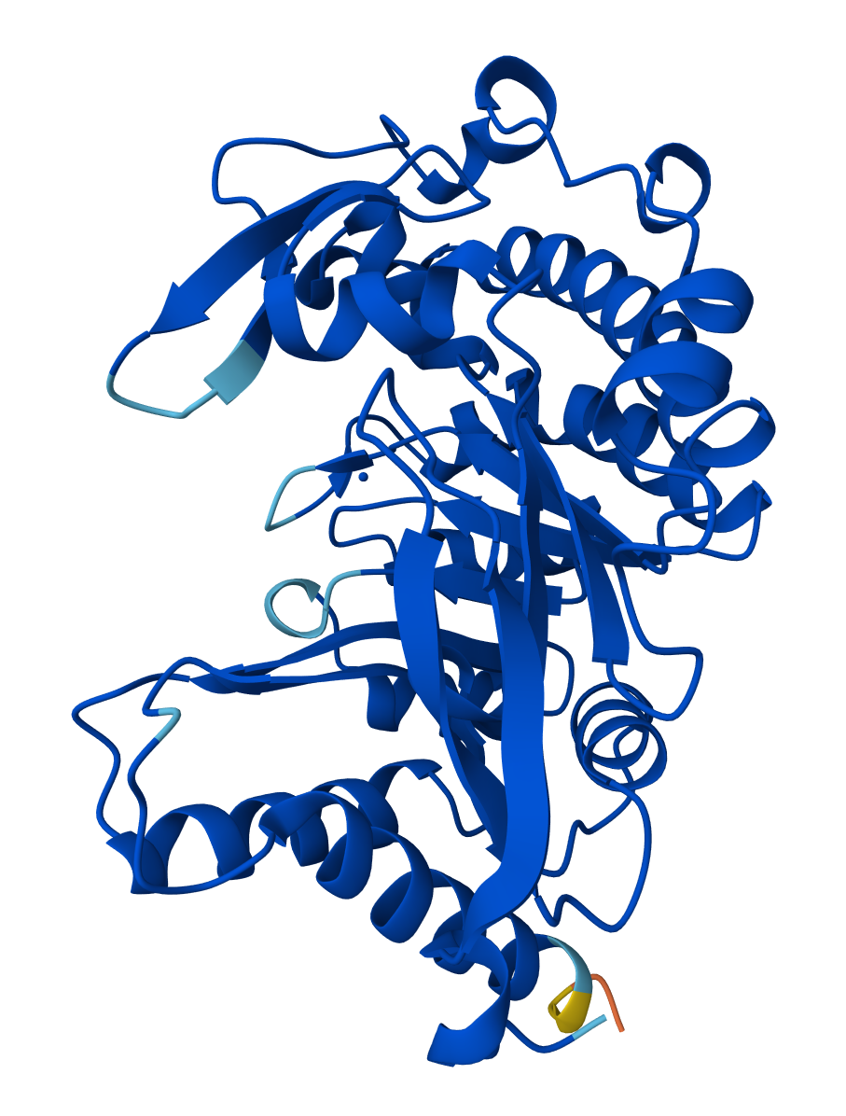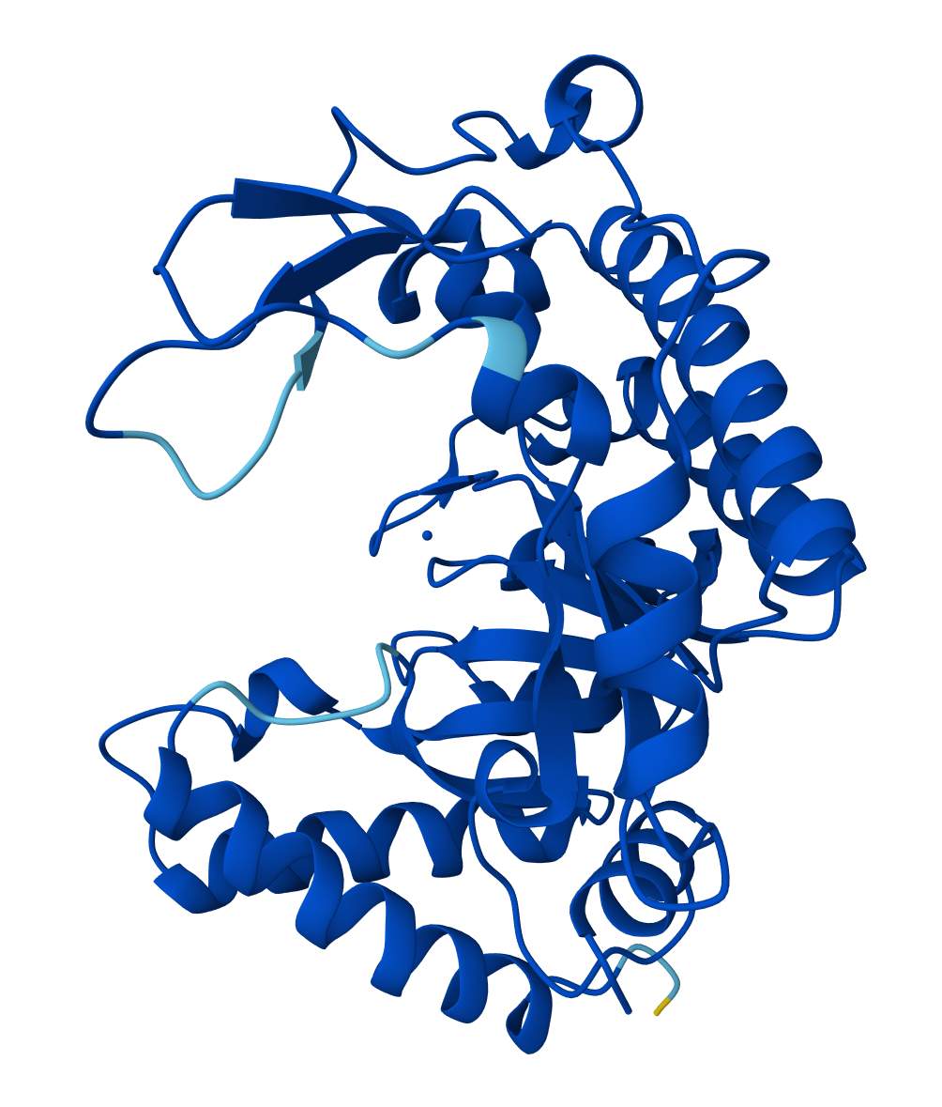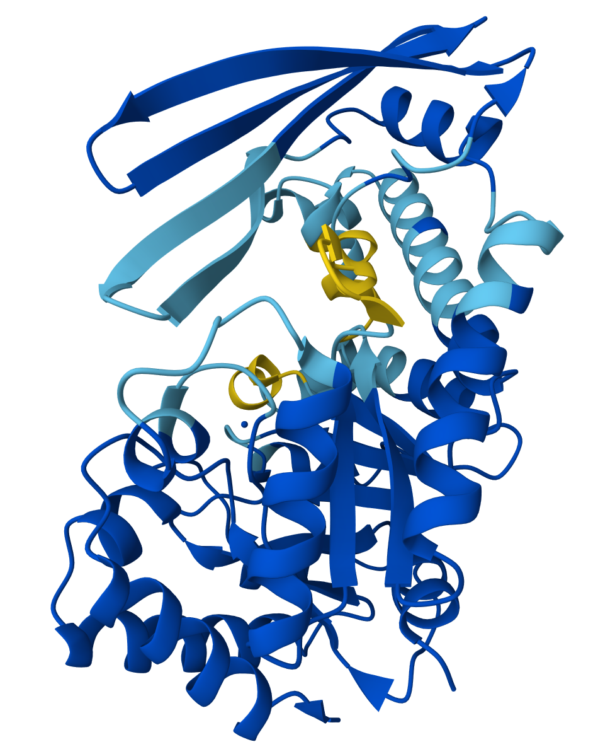
MT1_k MT1_l MT1_m MT1_p
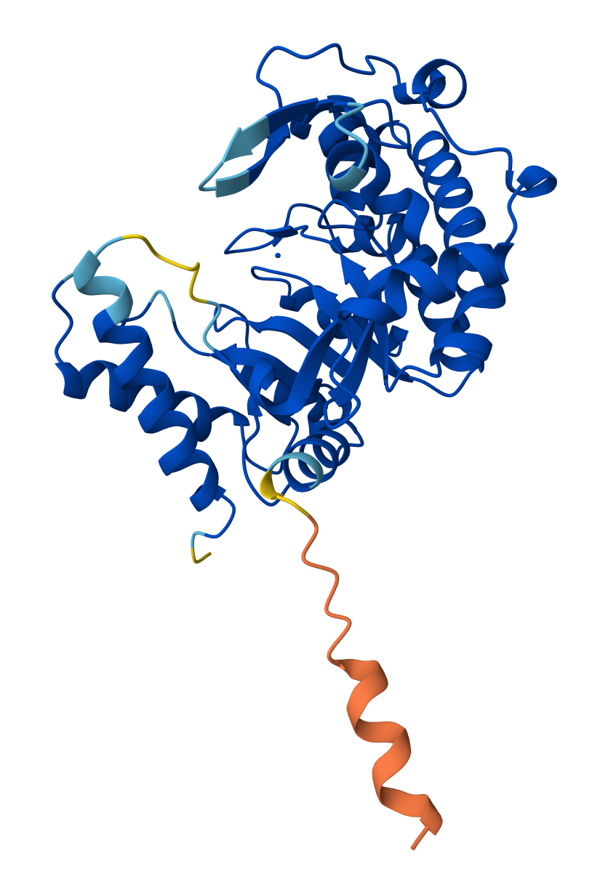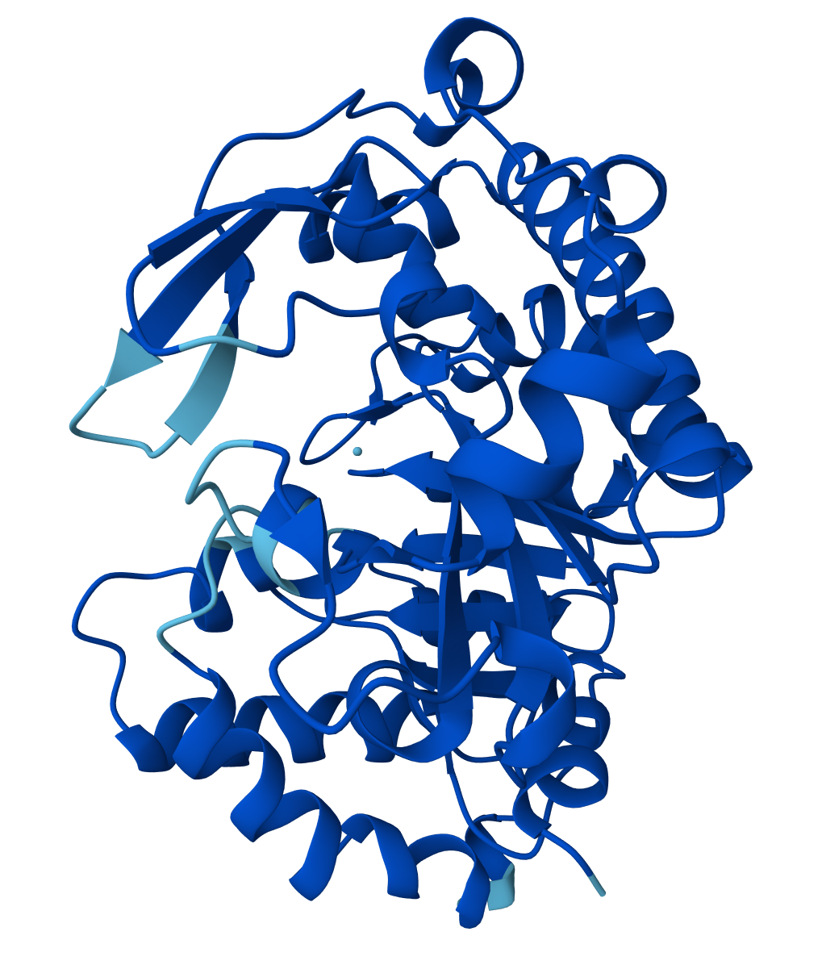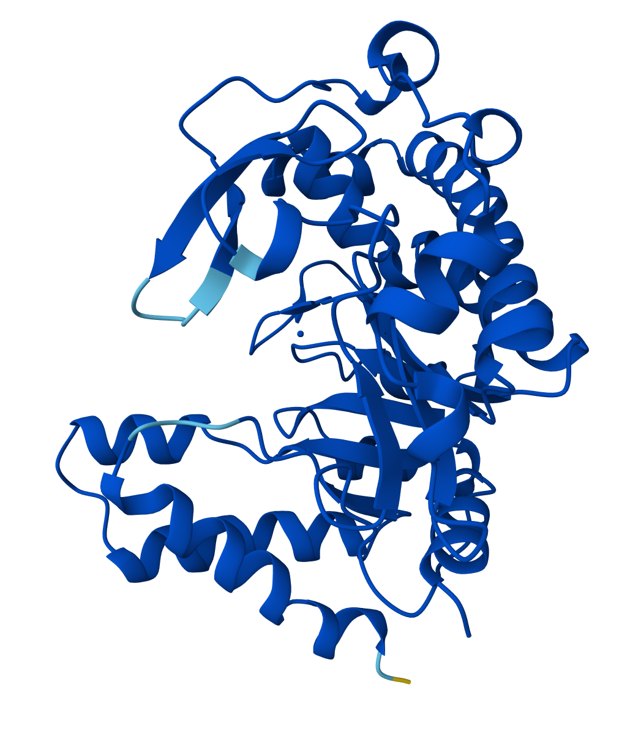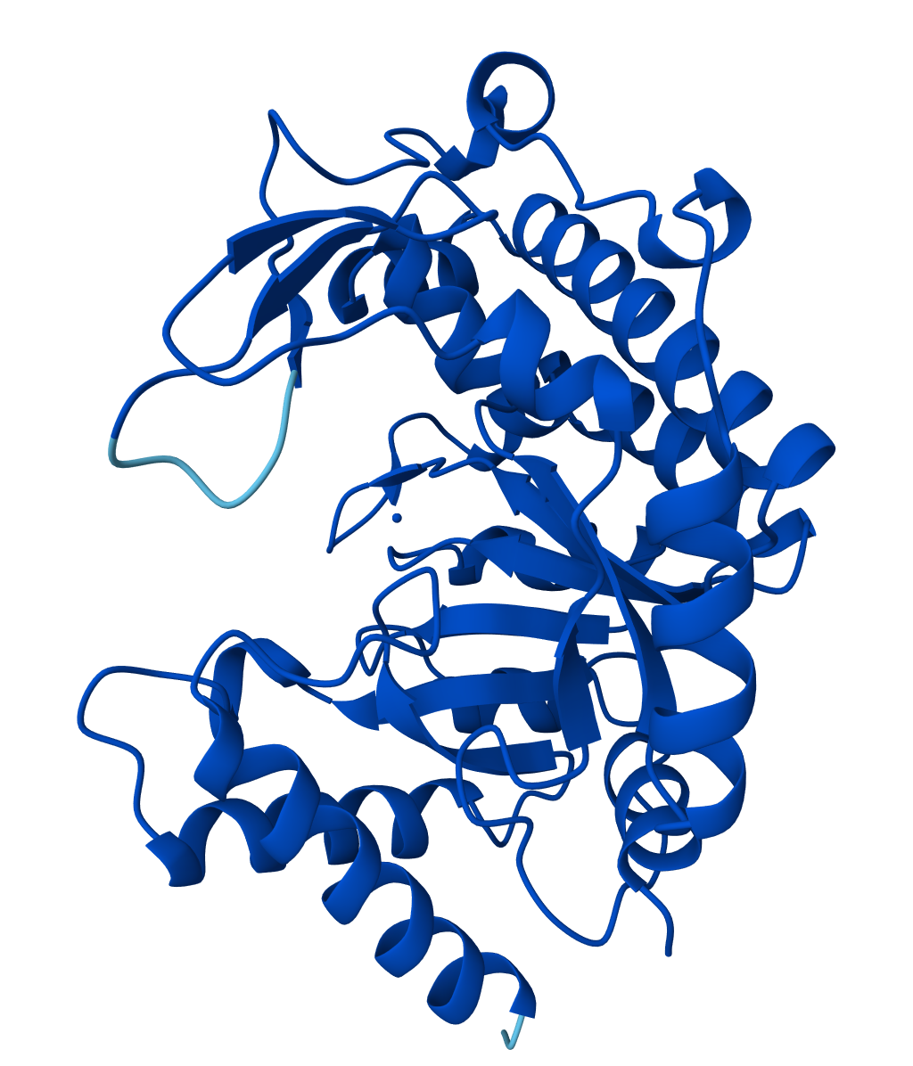
MT1_q MT1_r MT1_s MT1_t
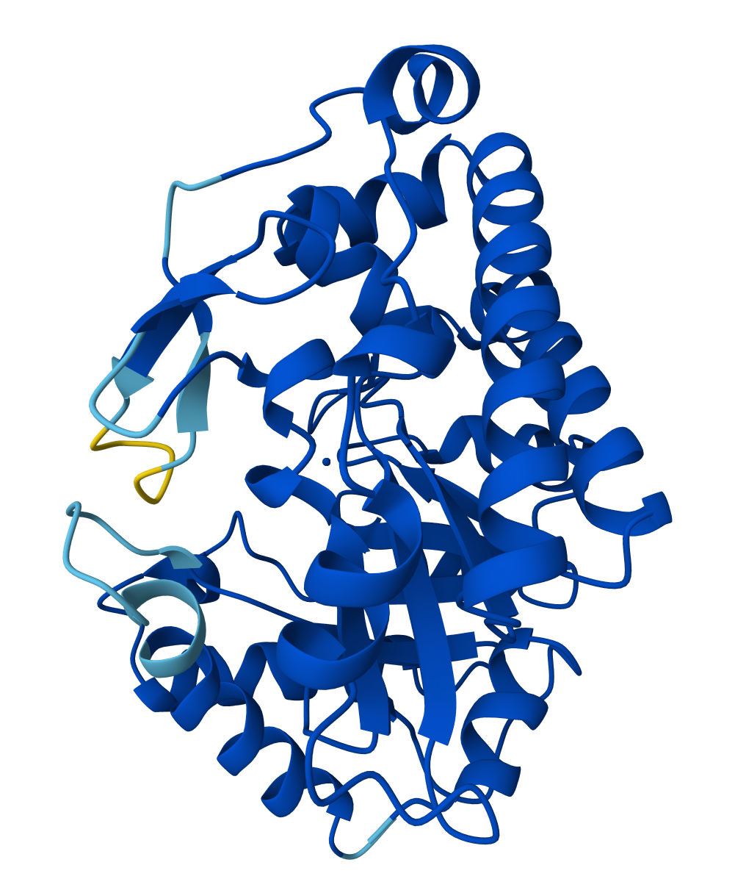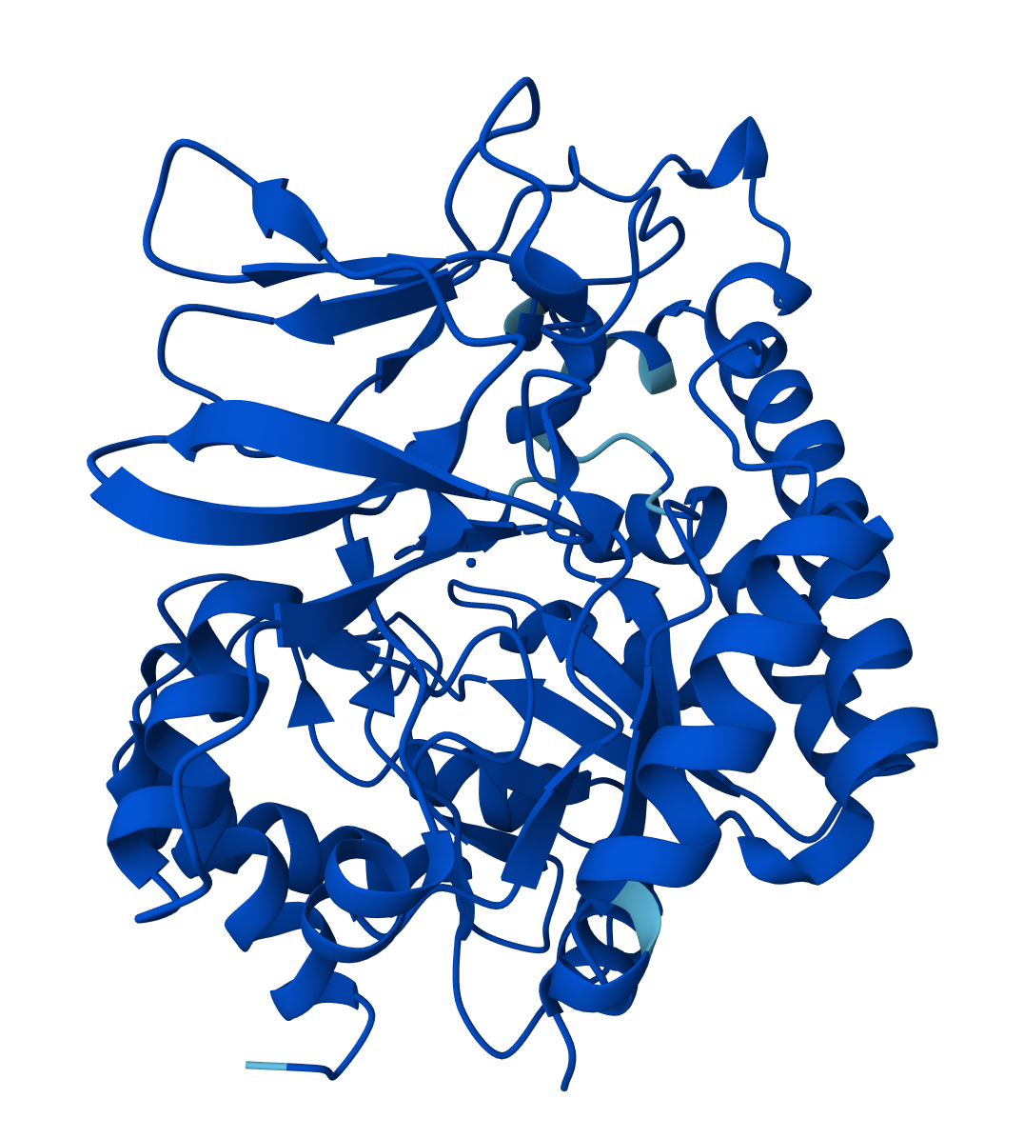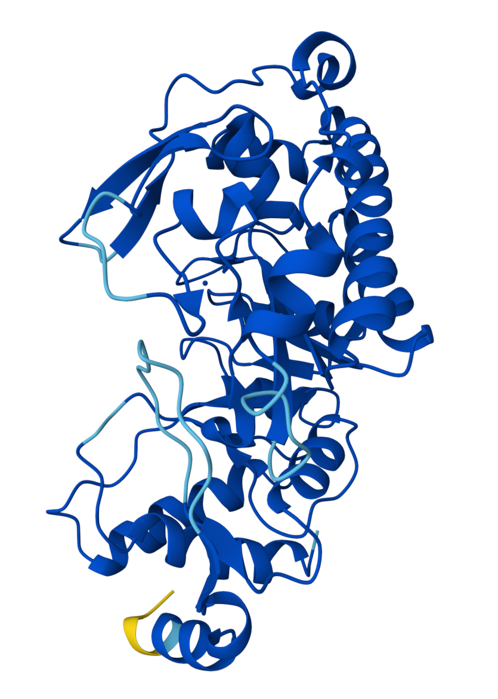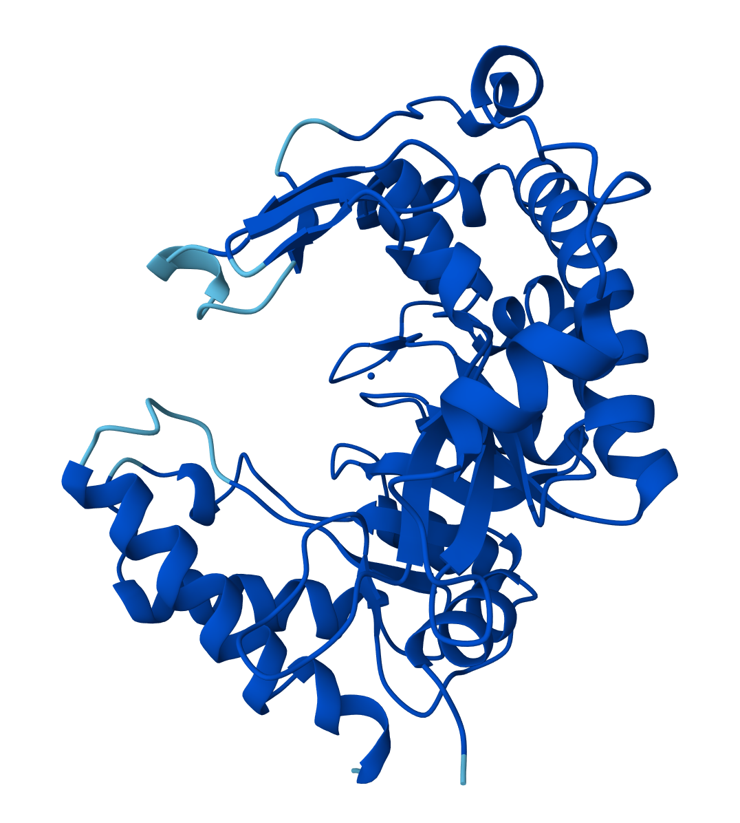
MT1_u MT1_v MT1_w MT1_z
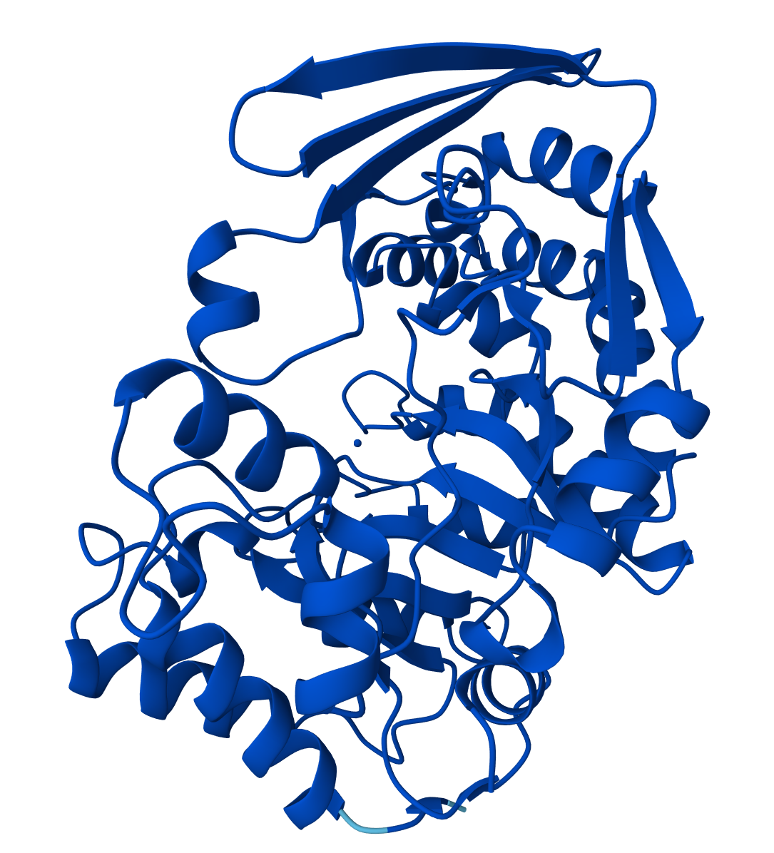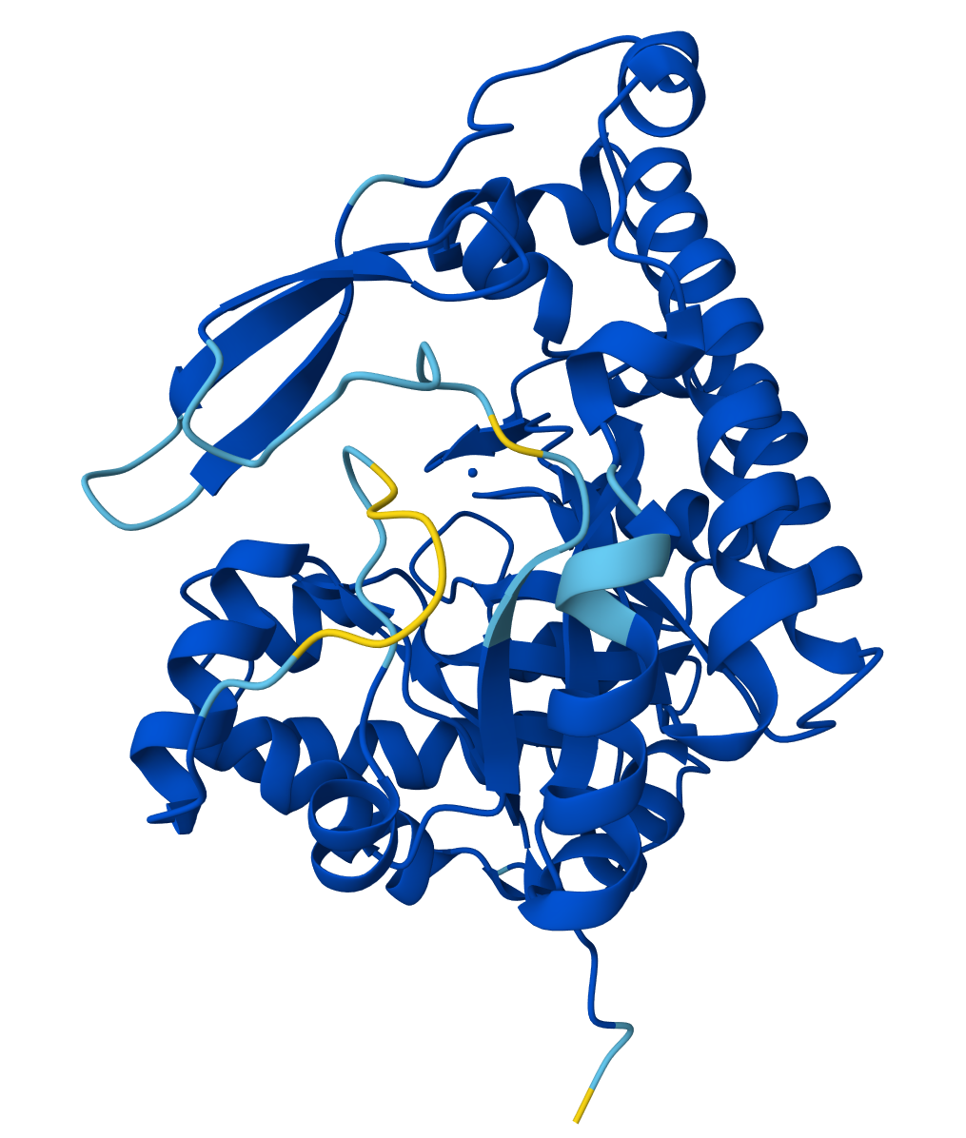
MT1_ae MT1_ag

Figure S3. Zn-binding residues in the AlphaFold3 simulated MT1 proteins.

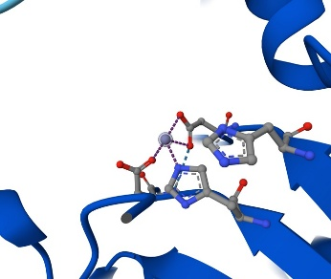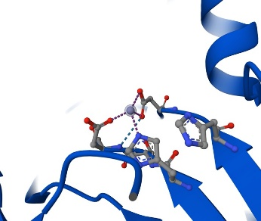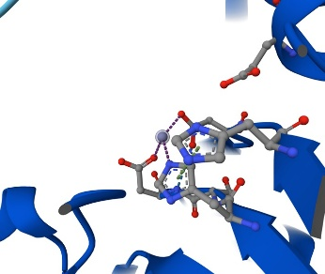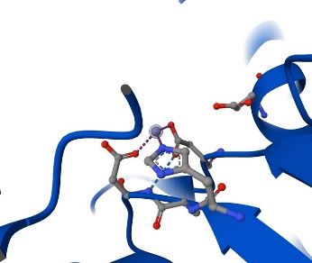
MT1_1 MT1_2 MT1_3 MT1_4
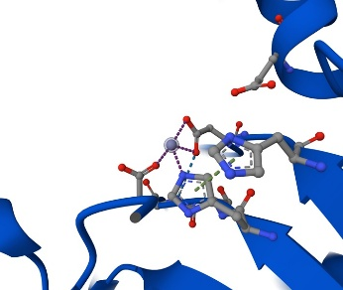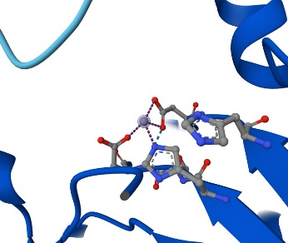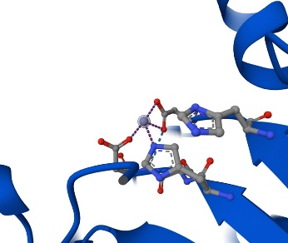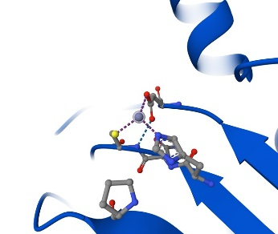
MT1_5 MT1_6 MT1_7 MT1_a
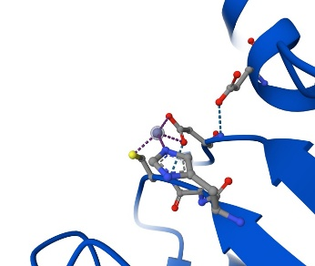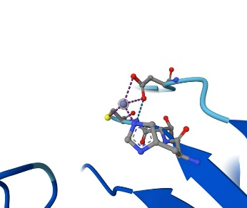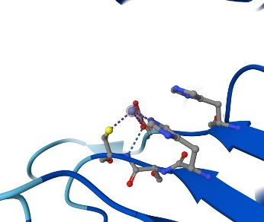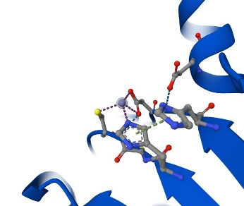
MT1_b MT1_c MT1_d MT1_e
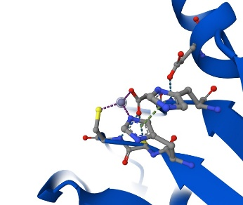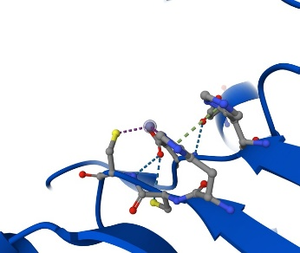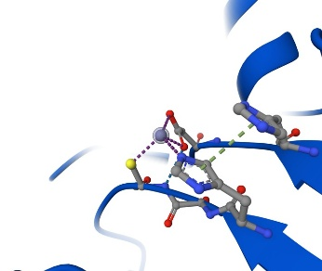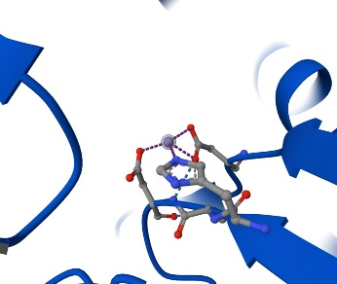
MT1_f MT1_g MT1_h MT1_i
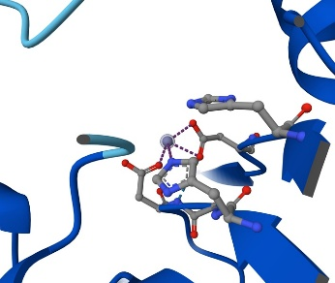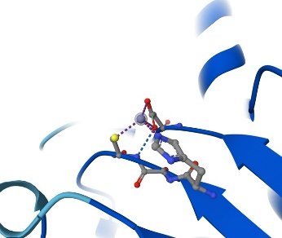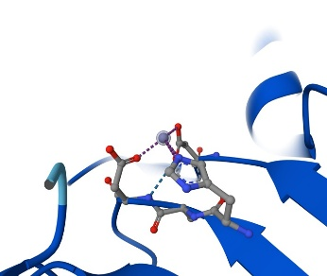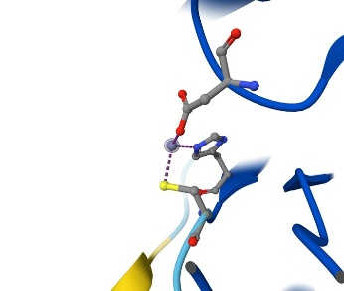
MT1_k MT1_l MT1_m MT1_p
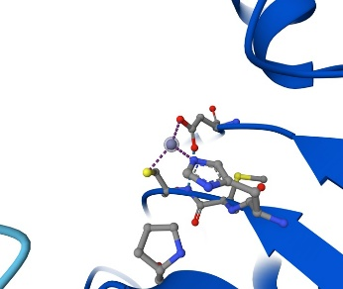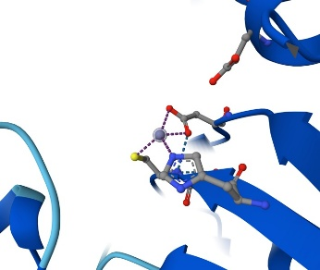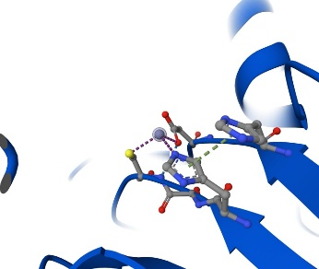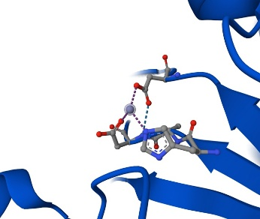
MT1_q MT1_r MT1_s MT1_t
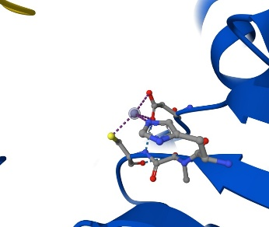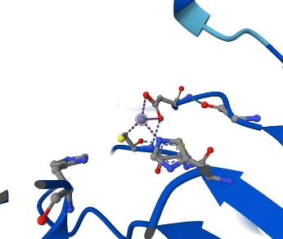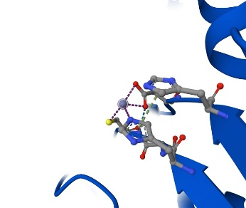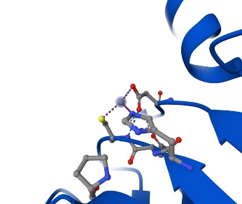
MT1_u MT1_v MT1_w MT1_z
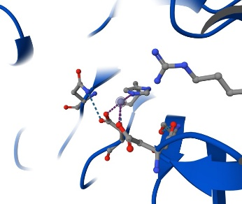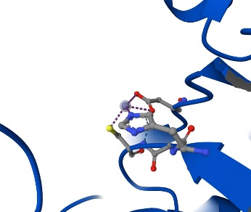
MT1_ae MT1_ag

Figure S4. AlphaFold3 and I-TASSER simulated structures of MT2 proteins.
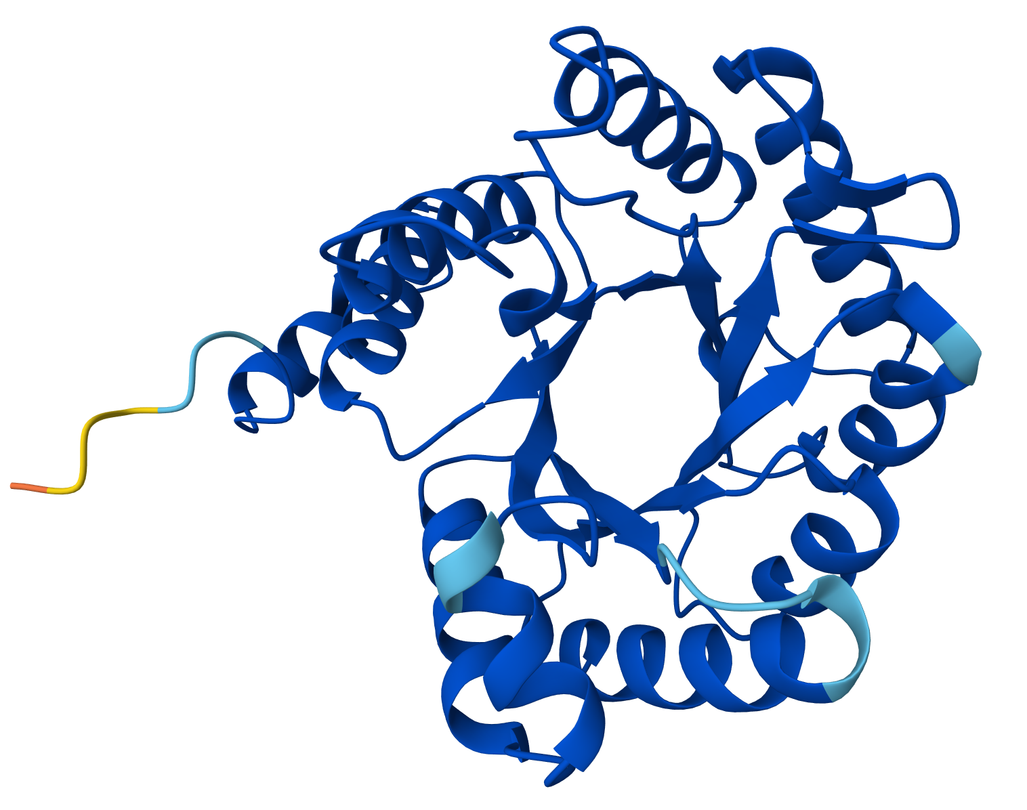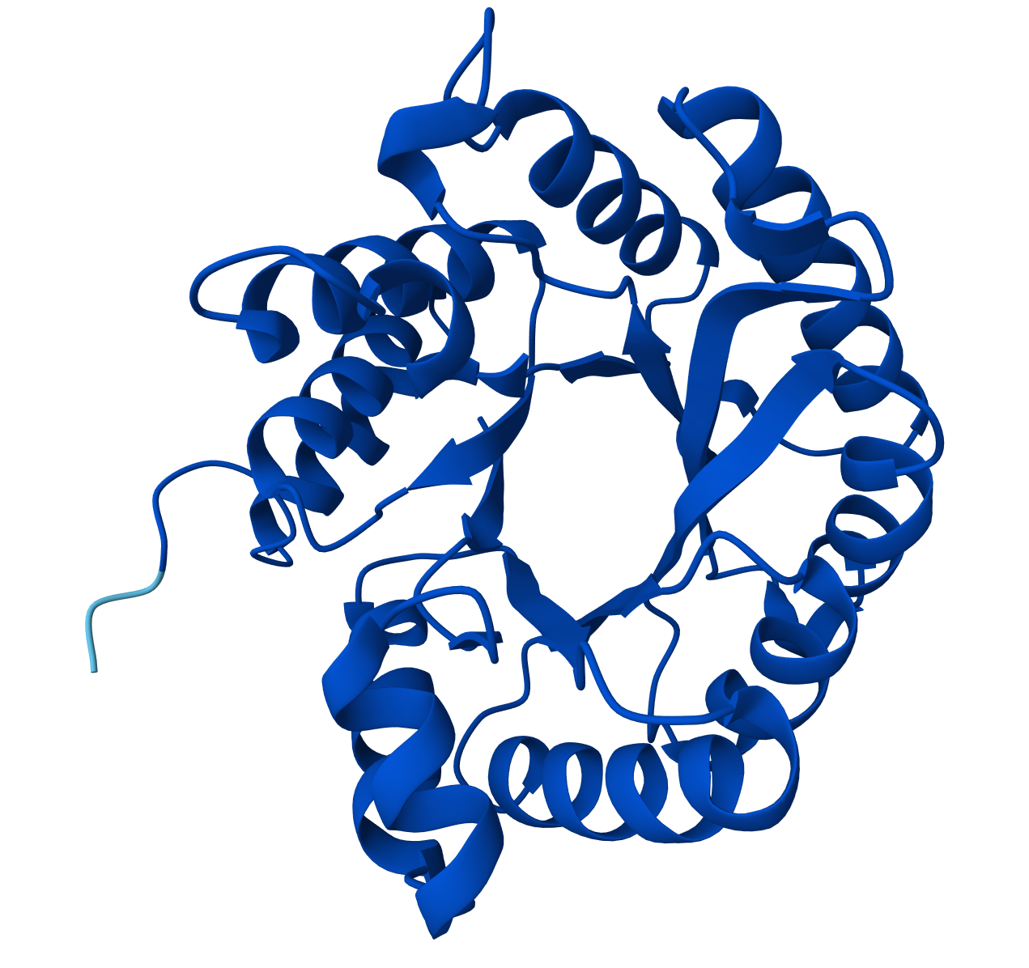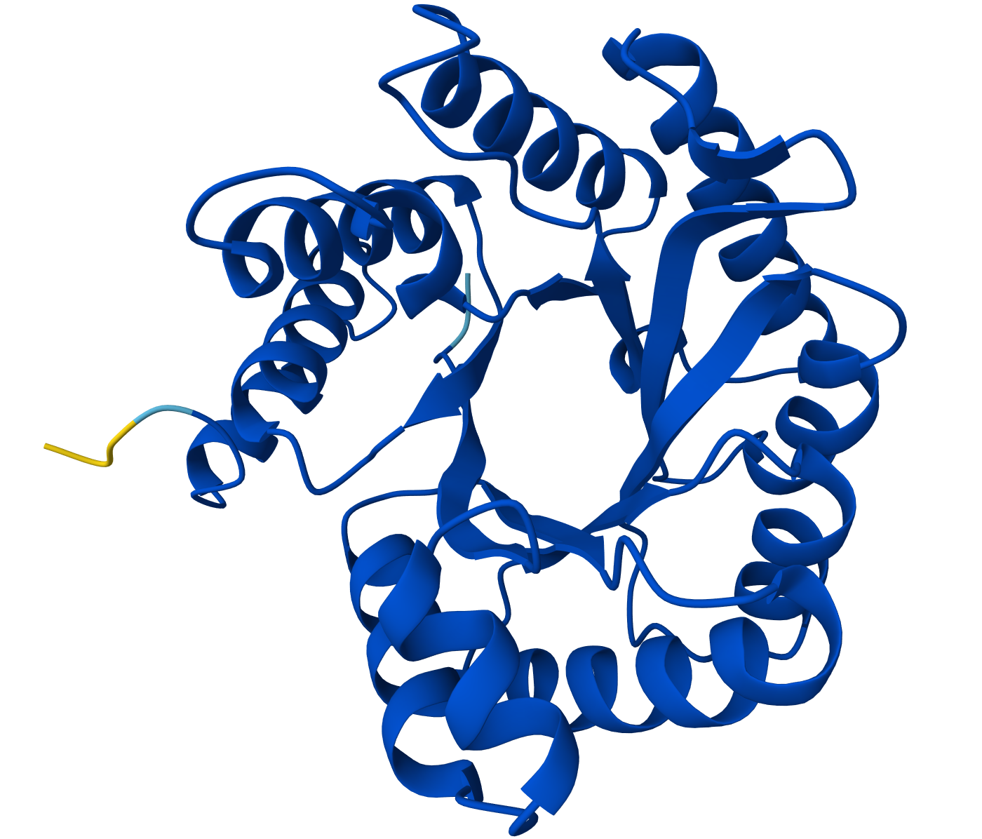
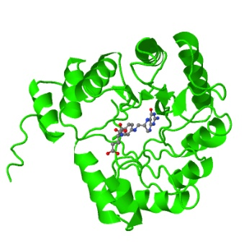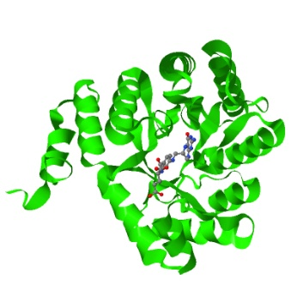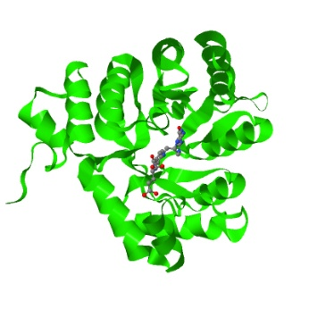
MT2_1 MT2_2 MT2_3

O-demethylase proteins in Blautia sp.
1. CP

WP_033139956.1 CP1
MIDLTSLTSAVGELDEKKVMSMLQEFVAGAPETEEAAQAITACQKGMEKVGQRFETGEYFVGDLIFAGEL
LTEAMEVLKPIIGSAARQKVGKIVLGTVQGDLHNIGKNIFKSMAEAAGFTVYDLGINVSPEAFLDKIKEV
QPDILGLSGVLTMAVESMKETVDLVKEAGLRDHIKITIGGACASYEAMQVSGADAWSTNAAETVNVCLGW
VGQHQE

WP_018597197.1 CP2
MTTLEELRQAIENGHPRDAQFLVSRALEEHIKPSLIVDQAMVPAMKTVGEYYKQNDADIPRILAAARSVR
KGFDILEEKCGAMEEQSIGTVILGTVEGDLHDVGKNIVAIMFRSAGFKVIDLGVDISEKQFLKAVRDNPE
VSIVCISSLLTTSIPEMQQVVKSLRRHDKEHRLKIMVGGGAVTQEFADTIGADAYTESAVDAAEKAKTFI
I

WP_018597193.1 CP3
MSKIQAVADAVAAGKAKLVGGLVQEALDDGCQAVDVLNAMIDAMGVVGERFKNNEIFVPEMLVAARAMKK
GVEVLKPHLASGSAGVCGKMVIGTVAGDLHDIGKNLVAMMIESAGFEVIDLGVDVPTEKFVETIKANPDV
KIVGCSALLTTTMPALKATVEALNAQDFRGNIKVMVGGAPITQEFADEIGADAYTADAASAAQKAKELVA

WP_165392515.1 CP4
MNYQEELIKSMAQLDEENVLKYIQLMLTSGFSREAIRKYLTEGSEEVGYYFANGEYFIADLIVSGMIYQH
ALSLLTPPLESGDPKPIGRAVIGVVEGDIHDIGKDIVVSLLRSERFEVIDLGIDVRPQRFVYALRSYNPD
IVLLSGLLASSSLSVARTMKELNADPCRKETRIFIGGQCASSQLCSQTGADGWAYDTIVTIDFCKKVIKE
HHAKNK

WP_130181735.1 CP5
MIDFNVLAEAMGDLDEDNVVENLTQVMDEGGSDAQKALDACQKGMDIVGNLFEDGEYYVGDLIYAGELMT
KAVEILKDGLVTEDGSGGEKTKMILCTVKDDLHDIGKNIVRSMLEASGFDVLDLGIDVPADVIVETAKKE
DIHIIGLSGVLTLAIDSMKNTIDAFQEAGMRDQVKVIIGGAPVNQEVCDQTGANAWASSPQTTISYCKEW
EQALA

WP_130182660.1 CP6
MDIYEEIRRNLLGGKADEVVNLIKKAIAVCYPPESVLKEGLILGVDTLAYKFRNSEVCVPEALRVARALN
AGLRCLTPYLDQGGARQCTAVIGTVEGDVHDIGKNLVKIYLSTLNIDMVDLGVDVTKEEFVEAAVENEAK
LVMASALLPTTVCELRGIIEELERAGIRDKVIVFVGGLSVSREYADEIGADYYTRDAIELRDFLNKNLSK
ILKEI

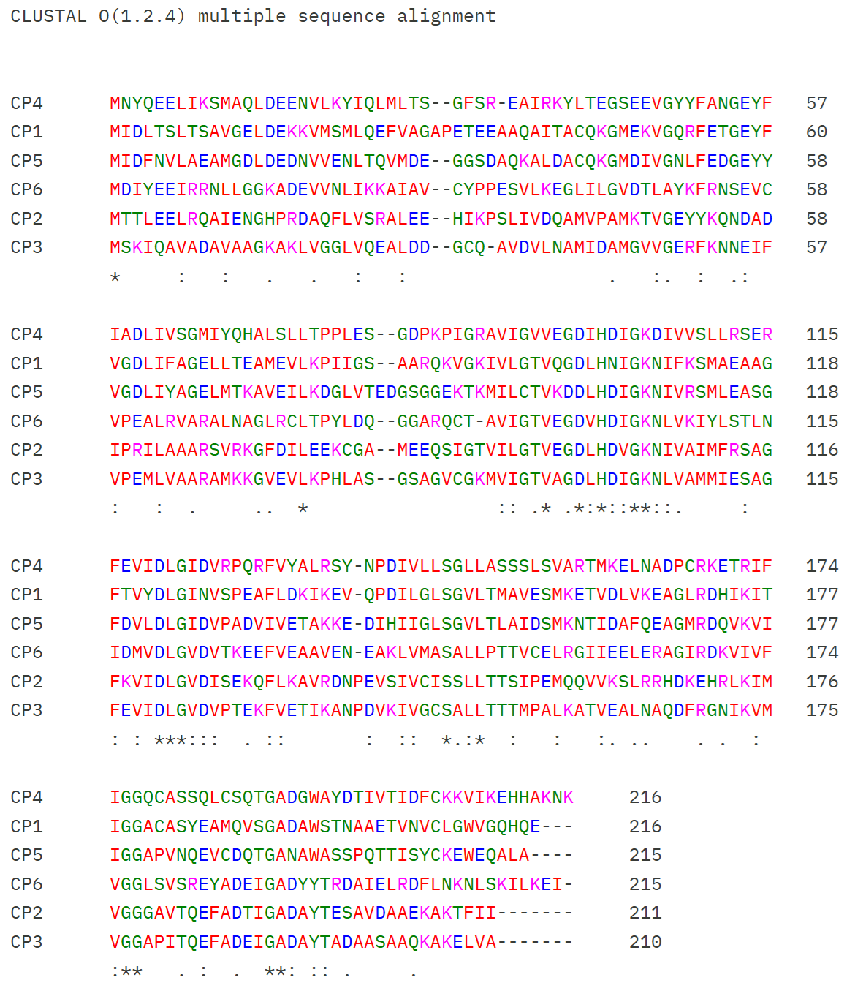

# Percent Identity Matrix - created by Clustal2.1
#
#

1: CP4 100.00 32.39 31.60 27.57 24.40 28.85
2: CP1 32.39 100.00 45.54 21.13 24.76 35.41
3: CP5 31.60 45.54 100.00 23.11 24.29 37.32
4: CP6 27.57 21.13 23.11 100.00 28.23 37.98
5: CP2 24.40 24.76 24.29 28.23 100.00 42.86
6: CP3 28.85 35.41 37.32 37.98 42.86 100.00
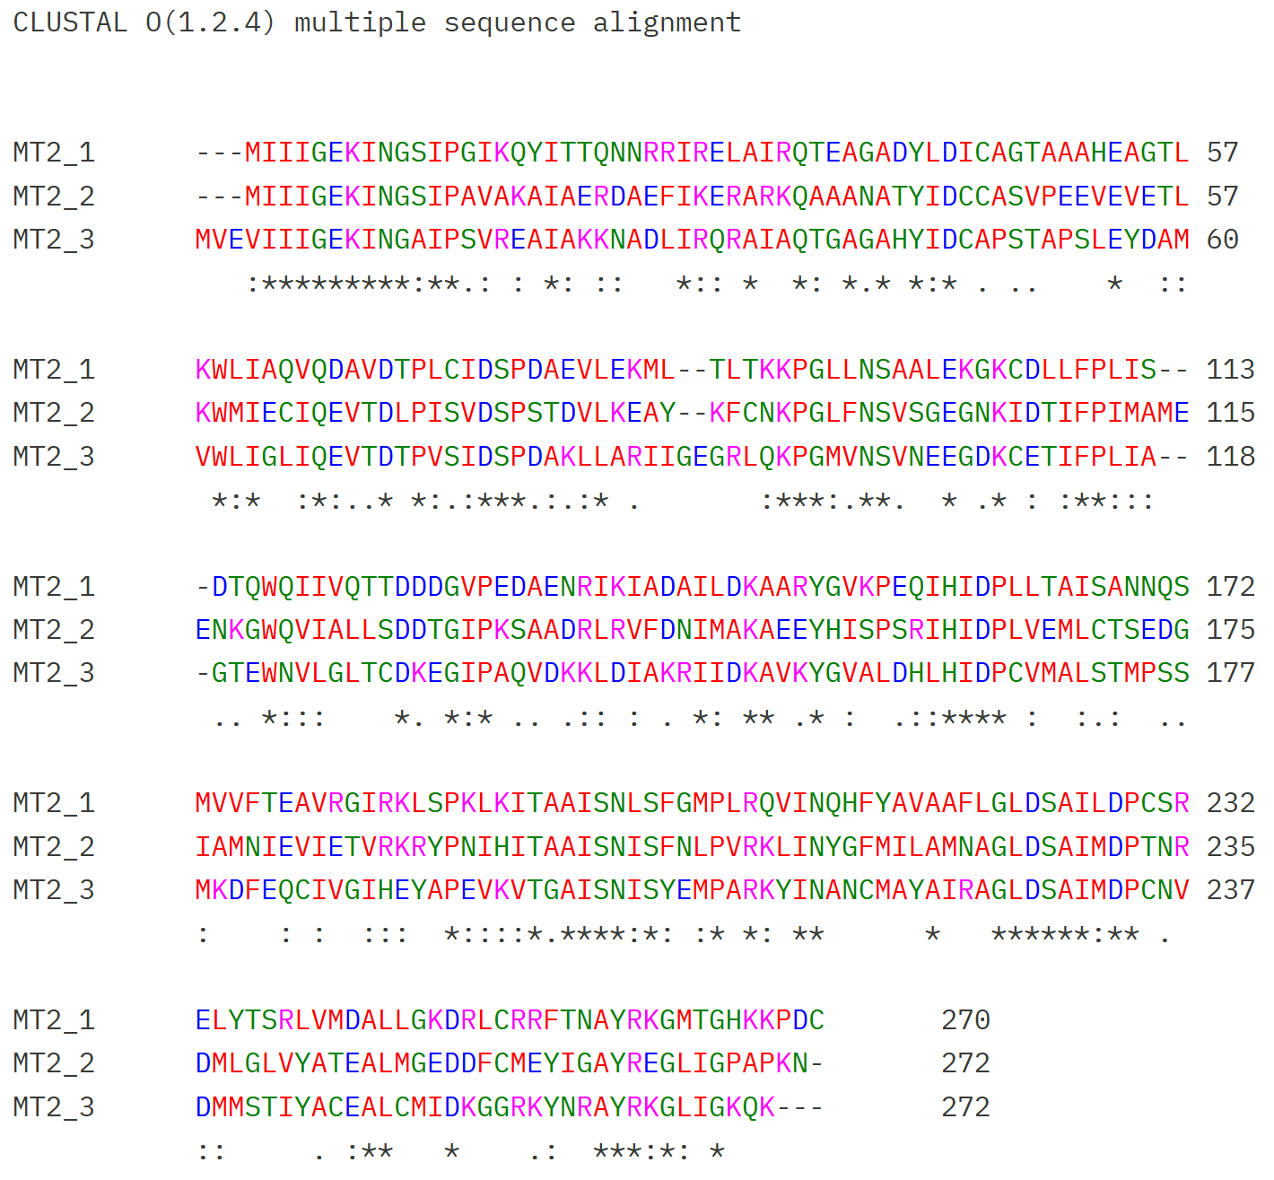
#

# Percent Identity Matrix - created by Clustal2.1
#
ELI 00.00 12.92 12.50 12.08 11.52 10.45 13.33 12.69 12.31 11.90 13.33 13.01 13.77 13.04 11.54 14.44 15.33 15.38 12.31 11.55 12.68 12.64 15.48 14.13 14.07 14.56 15.21 13.64 15.49 15.71 11.11 11.04 13.14
MT1_2 12.92 100.00 78.01 56.66 50.46 56.40 54.27 53.35 54.57 29.41 39.33 37.42 17.97 22.26 27.01 22.40 23.70 22.98 25.72 23.79 23.22 23.44 21.78 24.59 24.35 23.23 20.90 17.44 19.64 19.12 16.55 16.39 18.18
MT1_6 12.50 78.01 100.00 58.20 54.41 60.67 53.66 54.88 54.88 30.25 38.11 37.73 18.95 24.19 23.40 23.70 21.68 23.30 25.40 20.90 23.22 23.75 22.44 24.51 23.95 23.15 20.19 17.08 20.71 18.38 16.84 16.94 18.51
OdmB 12.08 56.66 58.20 100.00 60.19 62.96 59.20 57.28 56.66 31.01 37.27 38.94 19.74 23.28 24.59 23.76 24.17 24.43 24.84 23.28 23.51 24.05 24.67 23.76 24.50 24.34 22.62 18.28 18.93 18.15 17.89 19.67 20.26
MT1_1 11.52 50.46 54.41 60.19 100.00 69.30 66.87 64.74 67.48 30.94 38.53 39.38 18.57 25.89 23.62 23.13 23.86 24.84 27.01 24.92 24.46 26.56 22.44 24.83 24.51 24.03 21.04 16.31 20.64 19.41 19.10 24.59 19.74
MT1_7 10.45 56.40 60.67 62.96 69.30 100.00 62.01 65.55 65.85 30.72 37.42 38.27 16.61 21.43 24.35 22.55 21.31 24.19 25.72 21.43 24.22 22.26 19.14 25.58 23.28 23.13 20.13 16.31 19.57 17.95 16.72 20.22 18.77
MT1_4 13.33 54.27 53.66 59.20 66.87 62.01 100.00 68.60 67.99 29.37 37.00 39.69 17.15 23.87 25.16 24.68 27.04 22.12 24.12 22.58 25.31 25.55 22.95 26.73 23.45 22.33 20.65 17.25 19.79 18.55 18.69 20.77 19.29
MT1_3 12.69 53.35 54.88 57.28 64.74 65.55 68.60 100.00 75.08 29.47 37.12 37.96 17.65 23.05 22.08 22.88 23.28 25.16 23.47 21.36 23.60 24.76 21.12 23.51 24.18 24.03 21.36 15.60 17.50 16.18 19.86 22.40 17.86
MT1_5 12.31 54.57 54.88 56.66 67.48 65.85 67.99 75.08 100.00 31.66 36.50 38.58 16.67 23.38 25.00 22.88 24.26 24.19 25.08 23.62 22.98 23.20 22.44 23.51 23.53 23.38 23.62 17.02 19.64 18.75 18.47 22.95 20.78
MT1_m 11.90 29.41 30.25 31.01 30.94 30.72 29.37 29.47 31.66 100.00 40.68 35.40 18.69 24.92 24.04 23.78 25.16 26.62 26.95 23.95 23.12 25.16 27.15 29.55 25.81 29.90 29.71 15.96 15.36 19.26 20.55 18.48 18.18
MT1_k 13.33 39.33 38.11 37.27 38.53 37.42 37.00 37.12 36.50 40.68 100.00 49.24 18.51 21.54 21.86 22.01 24.68 24.84 24.44 25.16 22.84 27.10 25.33 29.28 28.01 26.21 25.48 15.25 14.95 19.41 20.07 19.67 15.86
MT1_t 13.01 37.42 37.73 38.94 39.38 38.27 39.69 37.96 38.58 35.40 49.24 100.00 17.32 21.36 21.68 21.17 23.20 21.86 22.76 24.52 23.22 26.79 24.84 24.18 25.41 24.92 23.55 12.72 16.01 19.78 18.62 20.00 14.24
MT1_h 13.77 17.97 18.95 19.74 18.57 16.61 17.15 17.65 16.67 18.69 18.51 17.32 100.00 38.15 24.62 30.93 29.79 22.44 24.51 24.13 20.25 22.04 26.40 23.26 21.97 19.54 22.01 13.99 14.08 13.01 16.55 19.78 18.01
MT1_w 13.04 22.26 24.19 23.28 25.89 21.43 23.87 23.05 23.38 24.92 21.54 21.36 38.15 100.00 27.76 35.12 34.04 26.25 25.25 27.27 25.08 26.35 29.90 30.26 25.24 22.26 21.47 11.62 17.44 19.10 18.03 21.79 21.68
MT1_b 11.54 27.01 23.40 24.59 23.62 24.35 25.16 22.08 25.00 24.04 21.86 21.68 24.62 27.76 100.00 31.61 34.20 20.60 22.67 25.23 26.27 24.36 27.21 30.00 26.95 26.14 25.00 14.08 16.55 17.78 17.35 16.94 20.59
MT1_d 14.44 22.40 23.70 23.76 23.13 22.55 24.68 22.88 22.88 23.78 22.01 21.17 30.93 35.12 31.61 100.00 57.64 25.42 28.43 26.65 25.71 25.40 33.45 30.74 26.97 24.50 29.61 15.52 14.39 18.22 20.34 17.03 19.67
MT1_l 15.33 23.70 21.68 24.17 23.86 21.31 27.04 23.28 24.26 25.16 24.68 23.20 29.79 34.04 34.20 57.64 100.00 23.08 28.43 25.00 25.71 25.08 32.42 31.67 30.00 25.49 27.51 18.84 14.80 18.66 19.05 15.47 18.75
VdmB 15.38 22.98 23.30 24.43 24.84 24.19 22.12 25.16 24.19 26.62 24.84 21.86 22.44 26.25 20.60 25.42 23.08 100.00 36.83 29.62 26.96 30.72 24.60 31.58 28.01 25.24 28.71 16.08 18.05 20.30 21.68 22.34 18.15
MT1_u 12.31 25.72 25.40 24.84 27.01 25.72 24.12 23.47 25.08 26.95 24.44 22.76 24.51 25.25 22.67 28.43 28.43 36.83 100.00 32.28 31.27 34.69 25.88 29.26 29.26 25.56 28.98 18.21 13.78 22.59 20.00 21.16 20.78
MT1_q 11.55 23.79 20.90 23.28 24.92 21.43 22.58 21.36 23.62 23.95 25.16 24.52 24.13 27.27 25.23 26.65 25.00 29.62 32.28 100.00 34.86 42.55 23.78 26.05 27.07 26.43 28.48 11.81 18.05 23.97 20.27 24.60 22.04
MT1_a 12.68 23.22 23.22 23.51 24.46 24.22 25.31 23.60 22.98 23.12 22.84 23.22 20.25 25.08 26.27 25.71 25.71 26.96 31.27 34.86 100.00 52.10 26.43 29.87 30.41 25.39 28.04 13.90 16.72 19.93 19.87 20.74 19.38
MT1_z 12.64 23.44 23.75 24.05 26.56 22.26 25.55 24.76 23.20 25.16 27.10 26.79 22.04 26.35 24.36 25.40 25.08 30.72 34.69 42.55 52.10 100.00 26.52 28.21 27.85 27.36 29.47 13.75 15.38 21.09 22.37 23.94 19.49
MT1_s 15.48 21.78 22.44 24.67 22.44 19.14 22.95 21.12 22.44 27.15 25.33 24.84 26.40 29.90 27.21 33.45 32.42 24.60 25.88 23.78 26.43 26.52 100.00 33.12 31.27 27.65 27.56 13.68 14.75 14.89 19.86 19.13 18.75
MT1_r 14.13 24.59 24.51 23.76 24.83 25.58 26.73 23.51 23.51 29.55 29.28 24.18 23.26 30.26 30.00 30.74 31.67 31.58 29.26 26.05 29.87 28.21 33.12 100.00 40.06 31.46 33.54 14.93 14.59 21.21 21.21 21.74 24.76
MT1_e 14.07 24.35 23.95 24.50 24.51 23.28 23.45 24.18 23.53 25.81 28.01 25.41 21.97 25.24 26.95 26.97 30.00 28.01 29.26 27.07 30.41 27.85 31.27 40.06 100.00 46.30 54.43 12.63 13.41 19.25 18.12 22.40 19.08
MT1_f 14.56 23.23 23.15 24.34 24.03 23.13 22.33 24.03 23.38 29.90 26.21 24.92 19.54 22.26 26.14 24.50 25.49 25.24 25.56 26.43 25.39 27.36 27.65 31.46 46.30 100.00 53.50 15.28 15.77 15.47 17.17 23.37 19.87
MT1_g 15.21 20.90 20.19 22.62 21.04 20.13 20.65 21.36 23.62 29.71 25.48 23.55 22.01 21.47 25.00 29.61 27.51 28.71 28.98 28.48 28.04 29.47 27.56 33.54 54.43 53.50 100.00 14.19 11.79 16.92 18.00 18.48 20.78
MT1ae 13.64 17.44 17.08 18.28 16.31 16.31 17.25 15.60 17.02 15.96 15.25 12.72 13.99 11.62 14.08 15.52 18.84 16.08 18.21 11.81 13.90 13.75 13.68 14.93 12.63 15.28 14.19 100.00 19.72 16.84 16.10 17.93 19.20
MT1_p 15.49 19.64 20.71 18.93 20.64 19.57 19.79 17.50 19.64 15.36 14.95 16.01 14.08 17.44 16.55 14.39 14.80 18.05 13.78 18.05 16.72 15.38 14.75 14.59 13.41 15.77 11.79 19.72 100.00 17.55 22.50 18.58 19.83
MT1_i 15.71 19.12 18.38 18.15 19.41 17.95 18.55 16.18 18.75 19.26 19.41 19.78 13.01 19.10 17.78 18.22 18.66 20.30 22.59 23.97 19.93 21.09 14.89 21.21 19.25 15.47 16.92 16.84 17.55 100.00 22.30 24.44 25.60
MT1ag 11.11 16.55 16.84 17.89 19.10 16.72 18.69 19.86 18.47 20.55 20.07 18.62 16.55 18.03 17.35 20.34 19.05 21.68 20.00 20.27 19.87 22.37 19.86 21.21 18.12 17.17 18.00 16.10 22.50 22.30 100.00 31.47 27.27
MT1_c 11.04 16.39 16.94 19.67 24.59 20.22 20.77 22.40 22.95 18.48 19.67 20.00 19.78 21.79 16.94 17.03 15.47 22.34 21.16 24.60 20.74 23.94 19.13 21.74 22.40 23.37 18.48 17.93 18.58 24.44 31.47 100.00 47.50
MT1_v 13.14 18.18 18.51 20.26 19.74 18.77 19.29 17.86 20.78 18.18 15.86 14.24 18.01 21.68 20.59 19.67 18.75 18.15 20.78 22.04 19.38 19.49 18.75 24.76 19.08 19.87 20.78 19.20 19.83 25.60 27.27 47.50 100.00

2. MT1
WP_018597200.1 MT1_1
MLTRRQNLLETIRGGHPDRYVNQYEALGMLFGNPYTAASPNAEYGKPPVKNAWGVTMVWPEGTPGGFPIH
DEEHIVCKDITHWRDYVKAPRLDYSDAEWEPFIAEAEKVDRNEYFVTQFIAPGLFEQCHHLQEIQNALIN
FYEEPECTHELIEYLTEWELQYAEKICKYIKPDAIFHHDDWGSQTSTFISPDMFEEFFLPSYKKIYGYYK
EHGVDVVIHHADSYAATLVPFMIEMGIDIWQGCMTSNNIADLIAKYGEKITFMGGIDSASVDRPDWTPEL
VEKEVRRACEEYGTKYYIPCITQGLGISTFPGVYETASEAIDKVSKEMFK

WP_130180465.1 MT1_2
MLTIKQNLLETIHGGEPDRFVNQFEYLAMVSNPALMASMGSCPQGSTSRNGWGVTIAYPLNVPGPFPMTK
GDLVVVKDVARWRDYVKAPPTRFPEEAWKPFVEMADSIDREEQFVAAFEAPGIFEKLHYLMGMEEALINF
YEEPGAMHELIDFLADYEIESAKEVIPHLHPDAVFHHDDWGSHISSFLSPEMFDEFLLPAYKRIYGFWRE
NGVELIVHHSDSYAANLVPSMIKMGVDIWQGPVTTNNIPELIKTYGGQISFHGGIDNGVVDRENWSKENI
MKYARQICQECGRHYFIPGGTVGGPGSTYPGVYEAIAEVIDELSREEQFHFR

WP_130180486.1 MT1_3
MLTKRQNLMETIRGGSPDRFVNQYEAFRLIQNPLGGHNPNPKYGEMNVKNAWGITRSWPKGTPGAFPVHT
PEKVVIKDICHWRDYVHAPSVKFSDAEWEPFIKQAEETDRSEYFVMPFVAPGLFEQCHHLGEIQTTLINL
YEEPEAMHELIDYLTEFELQLAEEICTHLKPDGLFHHDDWGSQTSTFMSPAMFEEFYLPGYKKIYGYYKS
HGVELIVHHSDSYAATFVPYMIDMGVDIWQGVMTTNRIPELIGKYGGKISFMGGIDSAKVDYEGWSRNVI
AREVKRACDENGKYYFIPNASIGLPTSTYDGVYNVITEEIDKYSKEVFG

WP_018595041.1 MT1_4
MLTKRQNLLETIRGGHPDRFVNQYEFLHLVYGNPFFDLHNGPVLEEGVINAVNGWGITFSWPKGTPGDFP
VHDDEHLVLKDVTRWREFVHAPSLDYPDSEWEPYIKEVESVDRNEYFVSAVMYPGLFEQCHHLMDIPQTM
MNFIEEPEAMHELIDYLTDWELEYADKVCKYLKPDALFHHDDWGTQTSTFISPAMFEEFFLPAYKKIYKR
YRDNGVELIVHHSDSYAATLVPYMIEMGIDIWQGVMTTNNIPELIKKYGGQISFMGGIDSAKVDFPGWSR
DVIKKEVRRACDENGKLYFIPCASQGLDISTFPGVYETLSEEIAAYSKEVF

WP_130181550.1 MT1_5
MLTKRENFLETIRGGRPDRFVNQFEAFRILYNPIMMHSPMPGPGDLDVVNDWGVVNSWPAGTPGPFPVHR
PDTIVIKDITHWRDYVHAPNTRYSDAEWEPFIRQAEETDRKEYFVTPFAAPGLFEQCHHLGEIQNTLINF
YEEPEYMHELIDYLTEYELFLGEEVCRRLKPDALFHHDDWGSQTSTFISPEMFEEFYLPSYKKIYGLYRS
MGVDVIVHHSDSYAATLVPYMIEMGIDVWQGVMCSNNIPDLITKYGGKISFMGGIDSAKVDYEGWSREVI
AKEVRRACDENGRLYFIPNTSQGLPMSTFPGVYETVTEEIKKYSNVVFD

WP_130182555.1 MT1_6
MLSKRQNLLETIHGGNPDRFVNQYEYMAMIQNPVILASMGNCPQGSIAKNGWGVTISFPEYTPGPFPLTK
GDLLVVKDITRWKDYVKAPPTKFTEDDWAPFVEMAKNIDRKEQFVTCTEAPGIFEKLHYLMGMEEAMINF
YEEPDSMHELIDYLTDYEIESAKESIAHLHPDALFHHDDWGSHISSFLSPDMFDEFILPSYQKIYGYWRE
HGVELIIHHSDSYAANLVPSMIKMGVDIWQGPVTTNNLPELIEKYGGQISFHGGIDNGVVDRADWTEENI
MKYTRQICEACGKLYFIPGGTMGGPGSTYPGVYETISKCIDKLSQDEQFHFHK

WP_130182683.1 MT1_7
MLSKRQNLLETIRGGHPDRYVNQYEAIAMLYGTPYSMRNAMPTKGGPNVKNAWGVTISFPEGMPGMFPVH
DEEHIVCKDITHWRDYVKAPNVKFSAEEWAPFVAEAEKIDRDEYFVAPFVAPGIFEQCHYLLEIQNCLIQ
FYEEPDYMHELIDYITDWELAYAEEICKYLKPDALFHHDDWGSRNSSFISPQMFKEFYEPAYKKVYGYYK
EHGVEVIIHHSDSYAANLVPSMIEMGIDIWQGVMSTNNIPELIEKYGGQITFMGGIDSGEVDREDWSREH
IAQEVERVCKENGTKFFIPCNTMGGPESIFPGVYETITEEIAKVSDKIF

>WP_130179455.1 uroporphyrinogen decarboxylase family protein [Blautia producta] MT1a
MKKLTEKTNYLMTLRGEQPEWVPTYSFGPMPNMTRPCTSCMLEPEIVAYFRFQGGGKDCWGVTYVPTRET
GNALLPKPGEFILDDITKWRDVIKAPSLEGIDWEAMAKKQLEGFYRQGVNREDTAIALNMHVGYFQNLMA
FMGFTEGLCAMAEEPEEVYAMFDYMCDFYTEITRQIIGYVKPDVLTLMDDTAAWRAPFISQQMYHDLVLP
FHDRQAKFGRDLGIPITMHNCGKAEPFIDDWLSIGVNAWDPAQTCNDLTGIKEKYGNKLVIMGGFDPRDH
LADPNVTEEEIRQAVRDTMDLLAPGGGFCWCGGYLGAVDDPEVIRKNAVLFDEVFRYGDEFYKK

>WP_018594661.1 uroporphyrinogen decarboxylase family protein [Blautia producta] MT1b
MVSKFMQTAANRDYSKHWQAEGSFPWIFQQPKPPIEERPISVRENYIRCVKGEEPYWMPAYFYESNTVWP
DAMEEHPVPEVDGYDWWGVDWFMVDGINGMITRPGTRTISDFAKWKEELPWPDLSVVDFKADGEKLQKAM
DPDRPHIYECVEGIFERLHELIPFDESLVAFYEEPELLEEFFQKMADYKIESTEQIFKYYGRVDGVLYHD
DWGTQRSGFFSNEMFREQLMPATSRYLKFIKDQGKFIELHSCGRNMQYVPEMLEMGIDMWTPQANANDPD
FLHNTYGKQMTFCFPVNIGNDWDEKQIRTAIRDYVDHFGENGRMMAWIMTEVPDPVKEEIARDELYHYSL
EYYNKLYHR

>WP_243126051.1 uroporphyrinogen decarboxylase family protein [Blautia producta] MT1c
MESRVCILLRPYLSLLFEMQVETGLKNAELIRQACGDKIQVVYISGTDFGTQNGPFMSLDSFREFYKPYY
KRINDWVHKNTNWKTFYHTCGAVMAFLQDFYEAGMDILNPVQLSAKGMDGKILKEKWGDKFVFWGGGIDT
QHTLPFGTPDDVYREVRERLELFARGGGFVFNTTHNIQSPTSAENLMAMFQAIEDFKNAK

>WP_130180584.1 uroporphyrinogen decarboxylase family protein [Blautia producta] MT1d
MSIVKFSESEMKRIGSYKIPGSYGSASVEQPRLSTPITPRENALRVFRGEKPLWLPNMNRDMNLICPDMM
PDAAARAFGGIDWFGVEWQYEPLTKAAMVKPGTRRLSDIVNWENELVFPDLNELDWEKDAEELYSMLPND
RFTYFVVYNGIFERTADLTNFEDTFCYLLEEPDALTAFFDRLIDWYIQLIKIAKKYYHADMILFHDDMGS
QRAPFFSGEIYQELFIPQYKKLTQAVHEEGMYIALHSCGDVRMHIPNFIEAGFDAWEGQEGATDKDEIME
LYGDSLIQLGNFNISGDITDEQAVQIIRKMIETRGKKGRCAYRIRDMRPVRGDVNLDDEMYRYSRMFYSG
Q

>WP_115624571.1 MULTISPECIES: uroporphyrinogen decarboxylase family protein [Blautia] MT1e
MAVLSYKENTLLALQHKEPEFLPMITDVQTYTPLGMDFVCEYTNVPGVAKDWFGQSWTYEPKIKAANPTP
GIHLVPDITVWKDYMKFPDLSRLDWEGHAAADTKDWDRVHKLTRINDVFGPWERMFSVMDFQEALCALIE
EPEACYDFFGAVADHKIRMYEYIIKYYKPDILCMHDDYGHGKGMFMSPDTWRVLLKPHLQRIIDMVTSMG
VLYEHHCCGYFAPILDEIADMGCTASNTMHISNHPAELKKKNGHKMCYIGGFDTQYMDGLTVSEENIRAS
VRKTLDEMAPGGSYIALFALKTQGRNEIAADEIRRYSSRFYSSPRPDAL

>WP_029470198.1 uroporphyrinogen decarboxylase family protein [Blautia producta] MT1f
MLTLRENMLLVYQHKIPEYLPLLGDIQRIRSVEPGFKNVLFHGKRAGKKETDWFGQDWVYEPMVNAFNPD
ASHYIVADIADWRDYVEIPDVDSIDWKAKFDEDAVEIDKNRLLEIKDATGLWERAFSMVPIDELLCGLLL
EPEACEDLFRTVADHKIKLHNQYIKYYHPDVICMHDDYGHGNGLFMSPDTWRELIKPHLQRVIDNITSQG
VLYEHHCCGYMAPLAQEIADMGASSWNMVHVVNDVCACKQKLGHKLAFVGGVCDGQLFDMDSTTEEQMRS
HVREMSDKMLPGVGTVMAVGCICHPERNQIFQDELLSYGQQYFKYRRPE

>WP_130180690.1 uroporphyrinogen decarboxylase family protein [Blautia producta] MT1g
MAVTFKENMLLVYHHQEPEFMPLMEDVDICKPMGLDFVNEVPDGGLTELINEDWFGQKWQFEPTIKASNP
APGCHLLDDITRWEDMLEFPDLNRLDWNAHAAADTAGWNREQKLCKIVDRLGLWERMFSIMPFTDALCAL
LEEPDACEAFFSAMADHKIRLHNCYIRYYKPDIINMHDDYGSGSGMFMSPEIWRSLIKPHLQRVIDNITS
QGVIYEHHCCGIMAPIAEEIADMGASSWATVHISNDPASCKAKFGGKLAMIGGVCDTQFMDLESTGPEQI
REHVRKTADQMFHGPGTVISCQFAAHPKRKMIWDEEILRYGQQYFKCSRPEV

>WP_130180803.1 uroporphyrinogen decarboxylase/cobalamine-independent methonine synthase family protein [Blautia producta] MT1h
MSKIPFNENEMNIAYTVPNLFDPTVPESPAWTYPQSEKDAIQELYAGTPTWCPSGLETGLFAPSVIPDNI
ARGFVIEGIPYDMAKYGGPDMFGVEWEYVPVAGGSMVRPGAPLLEDVNDWRKILKFPNIDEWDWDASGRE
NYKFLQNGKANMLWFLNGCWYERLVSFMDFEGAVVALIDDEQKDALKELFAETTELYCRLVDRCAETYGD
GISGFTVHDDWGSQRAPFFSPAVGEEMIVPYMRQLTDHIKSKGLIADLHSCGSLEMQLPNFIKAGWQSWC
PMPMNPTQKMYEEYGDKILLHVEPDLPEGASEEEQEKAGEEFVRNYFKPGKYCFPNTTYFPKKVTPAFRK
GMYRASRQ

>WP_130180987.1 uroporphyrinogen decarboxylase family protein [Blautia producta] MT1i
MNKKERFLTAIKGGTPDKVPYALISLYQNVQEAIIGHEITLPVYNGLNNAGWLGSPTEEAKVEPVFCCIP
ETAEKLNLDAMTIQVIPPMFVKKEIRGNDACVAGGIIDSGKVLRQCEEAMPDPDDSKLLEEIKNMVDMCR
DYEFAVGAKIRLGASPTLLSLGMDNIAMMIAEEDDTFERCIEMYTNWTHRFNKNLMELGFDYFWTADDIA
YTKSMLISPVMFREYFKDRMKYAMEPIKKPFIYHSDGNYSLVLDDLIEIGVDAIHPIERGSIDQDWLLKN
YKGKLAMVGNIDINHILFDASVEEVYEDVRTRIETFGPGGGYVLADSNSVPGWCSPRNVMAMSEAVEKYR
YIY

>WP_130181231.1 uroporphyrinogen decarboxylase family protein [Blautia producta] MT1k
MLTPKENFLETLKKDGTPDRLVNQYQPFVPIMNDPLQKFTRGNRVRGKTSVDRWGTEILFPQDAPGPMPH
VTESNKVCPDVTQWQESVKVPDLIANCSDGWEEALSSAAQVDRSQKLVLGFMGTGIFEQSHFLMGFEDAL
MNLLLEPESMQELVDAIAEYRFQYAKLLVDNLHPDIILSHDDWGSKTSLFMQPDIWRQFFKEHYRRIYGY
MHDHGVLVMHHADSFLEPIVEDMVEIGVDVWQGVLPENDIVKLQKQLDGRMTLMGGIDATIDREDAQEEE
IRADVRRACSTYGPAGHFIPCMTYGLAGTIYPKTDEIIADEIESYNREIYHI

>WP_130181232.1 uroporphyrinogen decarboxylase family protein [Blautia producta] MT1l
MKFDEKELEIIGEYNMPGIYGAPDSIVPKYNRPITPKENMLRMLEGKMPLWVPNQTLDNNAIQPPVMPDA
RARNFGGTDWFGIEWEYEPNTKAAMVKPGTQRLSDITKWREELEFPDLSAIDWKKDYEENYKGRIAPDRF
SYFVIVNGFFERTADLISFEDAFCALIEEPDELTAFYDKLADWHIELIKTAHEVYHADMILFHDDMGTQI
STFFSPSTYEELFVPQYKKITKAAHDMGMYICLHSCGCIKTLMPLIIEAGFDAWEGQDSANDKAAIMKEY
GKDLAQCTLYIIPADMSDEDAVADIHKKVDELAMTGRFACRLKDEKPDRAVNLADELYRYSRIKYAELEG
SIC

>WP_115625312.1 uroporphyrinogen decarboxylase family protein [Blautia producta] MT1m
MNLRENAMAIYNREQPDFYGDLMDAIVLVPDPVLMGDMCPQDGLEHKDSWGTVYIFKPGAPGPHPRVNKE
NAVIKDIEKWEEQLTVPDLEHLDWTLVKEEAAKVDRKEKFVGFMCAGGLFERSHHLMGMEEALVNYLEYP
DEMAGLLRVIADYKMKYIKMVAEQIHPDIIFYHDDWGSKQNVFLPPRVWREIIKPLQKEIADTIHACGMI
YMHHADCICQPIVTDMVEIGVDIWQGAIAQNDIVEIQRVTEGKLAMVGGIDGPKVDIENITEEEIRAEVR
RAIDTYCPGGRFYPSIPNGICFREWNNSIVMDELHSYGRKYAQEHPVVK

>WP_130181416.1 uroporphyrinogen decarboxylase family protein [Blautia producta] MT1p
MNSRERLLKALKGEKTDRVPVTLFIQSQGHFVTQLEPSADPWDFDAAQKRIIDFQRRLGLDVHVRMLFFN
SHEPVFAHWDLLNFQNETEDWKVKITKETAGCTTKYHHLISTPEGDLSQVFCVNEERPGIFMFGSAEPPI
KTPEDLKIAMKYEPGYSEETKQKMKESVTSVREYLGDDGIISAWTNGGLFSNAAGLIDQTELYSLFLEDE
EYYDDLMKFAKKRVFDYTDAVLDTGVDAICVRGNAAGGFIGSRCFEEYVLPYEREYIEHCQRRGNPVIYH
NCGKAMVLVPSYLKLGAMNIEPWSPSPLGDGNLDKLYEELHGEFSVTSGVDQVNVIQNGSAEDVRNTTLE
VMEKGKKFDSFIMQNVDFLEFGTPIENVEEYAKTALENCMY

>WP_115622369.1 uroporphyrinogen decarboxylase family protein [Blautia producta] MT1q
MAENMVLDWMKFSSSVSGEAAEKENYLKVIRGEEPDWVPLYFDACDWVFTGFMLDYVNKERKFDIFNVEW
EIHEAGKMPKPNRRLLEDVTKWRDFVNFPDTSKIDWEQMAAEALKIHDPNKAMGYRTDGCGGNFFIPLMN
MMGFEEGLCALLEEPEAVDELFEAVTVLTEEAMRHLIPIYKPDVVIIDDDMASATNLFISLETFRARFRP
FYQRLIDVAKEFELPVELHMCGCCEKVIPDFVEMGVNIWQPAQVMNDLKGIKARYGNRLVLNGGWDSQGK
AGMPGASQETVRQSARTAIDQFAEGGGYVFWDLSPVGQSEDMQKKIAWLEDEARTYGRKYYHKEK

>WP_130181612.1 uroporphyrinogen decarboxylase family protein [Blautia producta] MT1r
MTNRENCLLAYQHKTPAYIPCFFTDIALIQACPQMERYTGLSRGEDYWGCEWIYEDNIHACITTPGKYLF
TDIADWKENMKFPDLEAIDWEKQADIDVHSDFLAFVMGYGLHPRADGKSIYDDDRARVCMVLNGMFERMH
ACMGFENALMALIEDPDSCREYFHAMADWKIEYFKKIGKYYDMDILNAHDDYGSNDRMFMSPDLWRSLIK
PELARMVEACHDAGMLYQHHSCGFIEPIVPDLVEIGCDAIDTFQACNKNTAELKKKYGDKITFCGGFNNM
NVLDVPGVSPEAIKKEYRRVIDSLAPGGSYVIYPIGGTFEFVEPFLEEHFSYGMQFYGNLQNR

>WP_165392512.1 uroporphyrinogen decarboxylase family protein [Blautia producta] MT1s
MTPKENFRKFFQHERGEWFPSFFTDANLAVFITGMDERAPRNQSGKDFFGCTWVFDPVGNAAVPDTSLPP
ILDDICDWREKVVFPDLDAVDWEESAKADKVDQYDPDKFNYTMLLEGPFERLHTLMGFENALCAMLTDPE
EVGAFFDRLTDLKCKELEILKKYYHTEAVCFHDDWGTQKNMFFSPDIWRSLIKPQIKKITAHCHSLGMFF
DMHSCGKMDQIIAEFPEIGIDSFQGQGINDIVGAMKKTGRSLSYNITPKYQDLEAAAAAETLTEEEVRSR
IREEVLSCAKNGIYTTAFVPVKTWWFPIAMQEAKACEKEIFTM

>WP_243125951.1 uroporphyrinogen decarboxylase family protein [Blautia producta] MT1t
MKVKENLWETIRYGRPDALINEWEAFSFISDPITAYMSVAERGKTKVNPWGVTVYWGEDEPGSMPLINDE
TKVCKDICRWKEYVKVPDICKVPMDWKKAEEDTRRIHEEGKLTMAMMASGLFEQSHALMGFEDVFIAMLE
EPEAMHQLLDLIMEFKLTWCRMLVENCKPDAVLFHDDWGSKKSLFVSRDTWVEFFKERYRKIYGYLRENG
VLVVHHADCYCETIAEDMAEIGVDVWQGVTPENNIPMMQKHLRGKMAFMGGLDAAVIDVPDFKEDIIRGE
VRRACEEYVPGGGFIPCLTYGGDDGSIYPAVDEIVKDEIAKWSRAYFHK

>WP_130181933.1 uroporphyrinogen decarboxylase family protein [Blautia producta] MT1u
MFTKEDYLAAVVGHEKPQHLPSAMSGMVVMAGGSLETFENGPFGGGPDGFGVVWEASRSAGGQAVPAPGH
IVLDDITDWEDVVKFPDLDAYDWKGQAEIQLSGTDRDRQLIEYGAWNAQFLRVTHLMGFMDGLCAFAEEP
EACRGLIEAITDYKIRLAERVAHYFKPDFFTSYDDVATQQSLFLSPQTYRDLIKPSHKRLNDAVKAYGMM
PIMHTCGHCEPLIPDFIDEGAVAWSSAQPVNDIAGILQKYGKQIAVIGGYDSNGPAGREDAPDAVIEEEV
KRCIDSYSPYGSYVFMGFRVMSGTEPDLFFKGLLPINQAFDKLTRDM

>WP_130182285.1 uroporphyrinogen decarboxylase family protein [Blautia producta] MT1v
MTSRERVRAAFEHRQPDKVPVDFGGMCCSMINAIVLKDLRAYYGLEYRPPKINDMSTMTAFVEPDLADCL
GCDVQQLYNYGDTYGHLNTDWKEWRYRGETVLIPSNAVVKDDGKGGYFVYPEGDDSLPPSGHMPANGFYF
DNLTRTPEFDEDEADPDDNVEDYTRVTDEQIAYHKKVLADVKGSQRAIQVGPGYFGLGDANNIPGPNLKD
PRGIRSIQEWYMAPLLYPDYVEEVFEKGTDIAIESFKKYWDAFGSDIDILFICGTDFGTQRGPFMSPEVF
RDMYMPYYKKMNDWVHEHTTWKTLKHCCGGIFPILPYMIEGGFDAINPVQCSAEGMDPRTLKDTYGKDIV
FWGGGVDTQQVLPFGRPEEVRRQVLERLEIFSKDGGYVFNTIHNIQANTPIENIAAMIEAVKEFNGDK

>WP_130182626.1 uroporphyrinogen decarboxylase family protein [Blautia producta] MT1w
MTGKNIEKLLDKYKEELKIIKKAKLPKVCMWPPMPIRNTPISARENYLRMARREKPLFMPLDIDEMMLSP
AIFPDAVARAFVVDNNEPNPDMAGGKDMFGVEWVYVKEAGGSMVRPGNPMLKDIEKWDETIVFPDISRWD
WEGSSRLNQNLISKDHAMNCWIMNGLFERLISFMDFENAAVALIDEEQQEFVHSLFKKLTELYVDMIDHI
KKYYDVDVIYFHDDWGAQRAPFFSADVCREMLAPYLKQIVEAVHERGMLFNFHSCGKIELLVPVMIECGV
DIWCGQPMNDFDILYEKYGTKIALGIYFEPPTPLASQEEVISVCQQFIDTYTKNGCAFPVIYSENIHPEF
YEIMYVLSREAFLHI

>WP_130182865.1 uroporphyrinogen decarboxylase family protein [Blautia producta] MT1z
MLTEKDNYLMTLRGETPEWIPRLLIPSPGHAPATAWIGPGFLNARKTPMGGFDVWGVEYVATKETGYMSL
PKPGRFILDDICRWRDVIKAPDISHIDWETMAKKDLAQVDRTQTSVTATIHVGYFQQLMNFMGFTEGLCA
MLEEPEEVMALFEYMNQFYLQICSKVRDHYKPDVWAITDDTATATNPFISVDMYREMIKPFHASEAKFAQ
EAGIPIDMHDCGRCEDFIEDWLDFGVCAWNPAQTMNDLAGIKKKYGNRLVLEGCWDSSGPAGWPDTPEEI
IRAEVRKCIDSFAPGGGFVFWASTYGSPDDEAIKAKARWITEEYDSYGRNFYKK

>WP_130180979.1 uroporphyrinogen decarboxylase family protein [Blautia producta] MT1_ae
MTPKERILAALNGQPTDTLPFIPRLDIWYNANAGNGTLPAPYQHATLREMVDDLGLGYHAIIPDFKDFTD
PEQGDLDVGLGIYHLKKHPYRIKLHNVKRTYERSGDGILKVKYETPKGDITTTVVHSQDMKRNGITLYVI
KEHAIKSKDDYPAMKYIFDNMEVIPDYDNYTHFQQDFIGDRGVAVALSAMWASPGHYLIKELMAFDTYYY
EQYDNPDEMNEFIEQITPFCSKLFDAALNSPAEVILSGANYDTSFTAPSMFEEYIMPALKEQSDRAHARG
KFLATHTDGENTGLMELYLKSGFDIADSICPAPMTKISLEDTRRMFGHTCTVWGGIPSISVLEDSMNDLT
FKRFVEEKFENLGRGDHLILSVADTVPPAAKFDRILYLQKKAMEFGPVK

>WP_165392495.1 uroporphyrinogen decarboxylase family protein [Blautia producta] MT1_ag
MGKVYSRRERVETALNHREPDRVPCDLTIAPPAYMELCEYLHVPFEPYWWDDCNHAFASVEVLEKLDVDI
MHFSANAFVPRDFSIERDEFRDQWGVLRKKIWDTDTDFMYINGDAPLAGIEDVADVYAYHWPEPEELYNP
DLAVPLVKSLYRETDFALTCQVGGHLFEMGQFLLGFEDYLAYLYTEPEIVEAIMDKTMEIQMKVETMVMD
TIGEYLTYVRLNGEDVGTQNGPLINPAYYVQVVKSRHETEWSHVKKEFRKYNPQGKLSIHTCGGVYPFIP
HFIDAGADILNPIQPSAAGMDTELIGREFGGRLCFHGGIDSVNVLALGNEQDVRNEVKKRIHDLGQGGGY
LCAPSHNIQGGVPMENVIAMYEAIHEYGKYPLY

Other related MT1
>AAC83696.2 vanillate:corrinoid protein methyltransferase [Acetobacterium malicum subsp. dehalogenans] OdmB
MLTKRQNLVEVMKGGNPDRFVKQYEAFALMMKTPITRLKPPVGGSIVNEWGVTLSWPEGQLGSFPIHDKE
HIVIKDITKWRDYVKAPNLDYPDEAWATAVADANAVDRNDQYVTVFVAPGLFEHVHYLMSMEEALMAYYE
EPEAMHELIDYLVDFELRLAKEFIKHLHPDAVFHHDDWGSQINSFISPAMFEEFFEPAYKKIYGYYKENG
VELIIHHSDSYAANLVPSMIEMGIDIWQGVMNTNNIPELIKQYGEKITFMGGIHSGLVDFPTWTPEIVAE
YVEKTCQENGKLHFIPSQTSGLPIDSFPGVYETINKEIDKMSEKLF
>AAQ89566.1 veratrol:corrinoid protein metyltransferase [Acetobacterium malicum subsp. dehalogenans] VdmB
MNQRENFFAMIEGKKPEFIPNSMEVYKTCVMATSIIDSPFQGGLDAYGVNWIATKEGSIPEPNKFMFNDI
TDWKDHVKFPNVDTLGIEEAAKMELADVKRDEMVINVFSACGLFERMAAFMGFENTLCSLVEDPDASREF
FEAFADFRIDCHNRIIDAYQPDVITYFDDLATANGLFMSPKVYREVIKPAHQRIAEAVTSRGVIFSQHTC
GKCEEIVGDFVEMGAKIWHSAQISNDLEGIMDRYKGKLIIEGGWDSSGPVSYIGASIEDLIEEAKRCVRV
YGPKGNYIFMPVLMNENGNSLLVGDPRLEPMLKAFNEINKL
>ANI69960.1 methyltransferase-I [Eubacterium limosum] ELI
MAKKFDKLAINNLDDFIYGSCPNPVTTKSGMVIGGGTIYPEINFTLPGMDVNDATIDKALGIYSNIIDGV
LKRAAELYAPGVLVEFETVPDFTEHPKYGIDANRILINGIKEAADKYGLKASLRTTPNDLREMSRPPVMR
GGKYWDTMLELYEQCAKDGSDFLSIESTGGKEINDEALVKADIRKAIFAMGVLGCRDMEYLWGNLVKLSD
ENGCFAAGDSACGFANTAMVLAEKGFIPHVFAAVMRVVAVPRALVAFEQGAVGPSKDCAYEGPYLKAITG
SPIAMEGKSAAGAHLSPIGNIAAAVADTWSNESIQQVKLLSEMAPVVGMEQLVYDCRLMNVAKEKGQGLI
MRDLLTESDAPLDVQAWVLRPDVVLKIAGELVKEQDNFLRTKLAAKLTINELRDAIKAEKVKADRRDMKW
LDKMEKAVDTIPDDPEQFYAEIKPELDMDKWHPEGYGLKA

3. MT2
>WP_130179603.1 dihydropteroate synthase [Blautia producta] MT2_1
MIIIGEKINGSIPGIKQYITTQNNRRIRELAIRQTEAGADYLDICAGTAAAHEAGTLKWLIAQVQDAVDT
PLCIDSPDAEVLEKMLTLTKKPGLLNSAALEKGKCDLLFPLISDTQWQIIVQTTDDDGVPEDAENRIKIA
DAILDKAARYGVKPEQIHIDPLLTAISANNQSMVVFTEAVRGIRKLSPKLKITAAISNLSFGMPLRQVIN
QHFYAVAAFLGLDSAILDPCSRELYTSRLVMDALLGKDRLCRRFTNAYRKGMTGHKKPDC

>WP_130180415.1 methyltetrahydrofolate cobalamin methyltransferase [Blautia producta] MT2_2
MIIIGEKINGSIPAVAKAIAERDAEFIKERARKQAAANATYIDCCASVPEEVEVETLKWMIECIQEVTDL
PISVDSPSTDVLKEAYKFCNKPGLFNSVSGEGNKIDTIFPIMAMEENKGWQVIALLSDDTGIPKSAADRL
RVFDNIMAKAEEYHISPSRIHIDPLVEMLCTSEDGIAMNIEVIETVRKRYPNIHITAAISNISFNLPVRK
LINYGFMILAMNAGLDSAIMDPTNRDMLGLVYATEALMGEDDFCMEYIGAYREGLIGPAPKN

>WP_243125940.1 dihydropteroate synthase [Blautia producta] MT2_3
MVEVIIIGEKINGAIPSVREAIAKKNADLIRQRAIAQTGAGAHYIDCAPSTAPSLEYDAMVWLIGLIQEV
TDTPVSIDSPDAKLLARIIGEGRLQKPGMVNSVNEEGDKCETIFPLIAGTEWNVLGLTCDKEGIPAQVDK
KLDIAKRIIDKAVKYGVALDHLHIDPCVMALSTMPSSMKDFEQCIVGIHEYAPEVKVTGAISNISYEMPA
RKYINANCMAYAIRAGLDSAIMDPCNVDMMSTIYACEALCMIDKGGRKYNRAYRKGLIGKQK

4. AE
>WP_130180413.1 ASKHA domain-containing protein [Blautia producta] AE1
MKTHEVTFIREGKSILAEEGTTVLQAQRQAGLDPDAPCGGQGTCGKCMVHVTKGPVTGVLKACQTKITGD
MTVDTLVREKEHAILAEGFSRPVPLHPLLRFGRIHIRKIKPGDNLSDWDRLKLALEESFGESMEHLRPDL
QTASGLYEMLKETDTWYAAVSGDTLLDLQKEPIKGYLAAFDIGTTTVVGYLMDARTGRVLAVESSMNPQA
QYGADVIMRANYALENGTENLSSCIRQTVQTILDTLAEKSGISTDCIYQTCIVGNTCMHHLFLGISPGAL
VHAPYNPAISQLLFLKASEYDLHIHPKGQLILLPDVAGFVGADTMGCLLCIRPDQQEEISLMIDIGTNGE
MVLGNKDRLAACSTAAGPAFEGAKIECGMRGASGAVDHVEYREGTWNYTTVGSEKAIGICGSGLIDLIAC
LRKAGIIDESGKLLTEDGTASFTLVAAEESGNGSPVYLSQKDVREVQLAKAAIAAGIQLLQKELGITTDQ
IAHVYIAGAFGNYMNPKSACDIGLIPICLKERIVPVGNAAGEGSKIALINREELFYSDILAKEISFVELA
ASPEFQDCFVDELEFPELL

