Supplementary material to:

Visible-light responsive Cu-MOF-NH₂ for highly efficient
aerobic photocatalytic oxidation of benzyl alcohol

Samira Abdel-Azim¹,Delvin Aman^{*b,c}, , Eric Van Steen^{**d}, HowaidaAbd El Salam^{e}

ª Process development division, Egyptian Petroleum Research Institute (EPRI), Nasr city, 11727, Cairo, Egypt.
^{b} Catalysis laboratory, refining department, Egyptian Petroleum Research Institute (EPRI), Nasr city, 11727, Cairo, Egypt
^{c} EPRI-Nanotechnology Center, Egyptian Petroleum Research Institute (EPRI), Nasr City, 11727, Cairo, Egypt, E-mail: delvin.aman@epri.sci.
^{d} Catalysis Institute, Department of Chemical Engineering, Univerity of Cape Town, Private Bag X3, Rondebosch 7701, South Africa, E-mail: eric.vansteen@uct.ac.za.
^{e}Analysis and Evaluation Division, Egyptian Petroleum Research Institute, Nasr City, 11727, Cairo, Egypt.

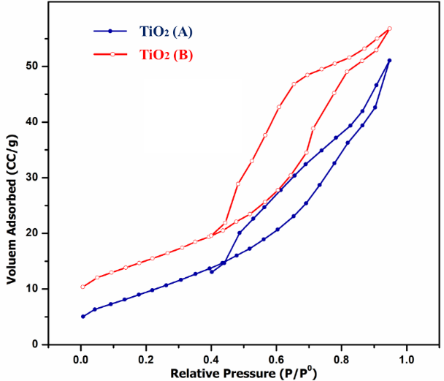
Figure S1: N₂ adsorption/desorption isotherms (left) and BJH pore size distribution (right) for TiO₂(A) and TiO₂(B).

Figure S2: N₂ adsorption/desorption isotherms (left) and BJH pore size distribution (right) for (a) pristine Cu-MOF and (b) Cu-MOF -NH₂.

