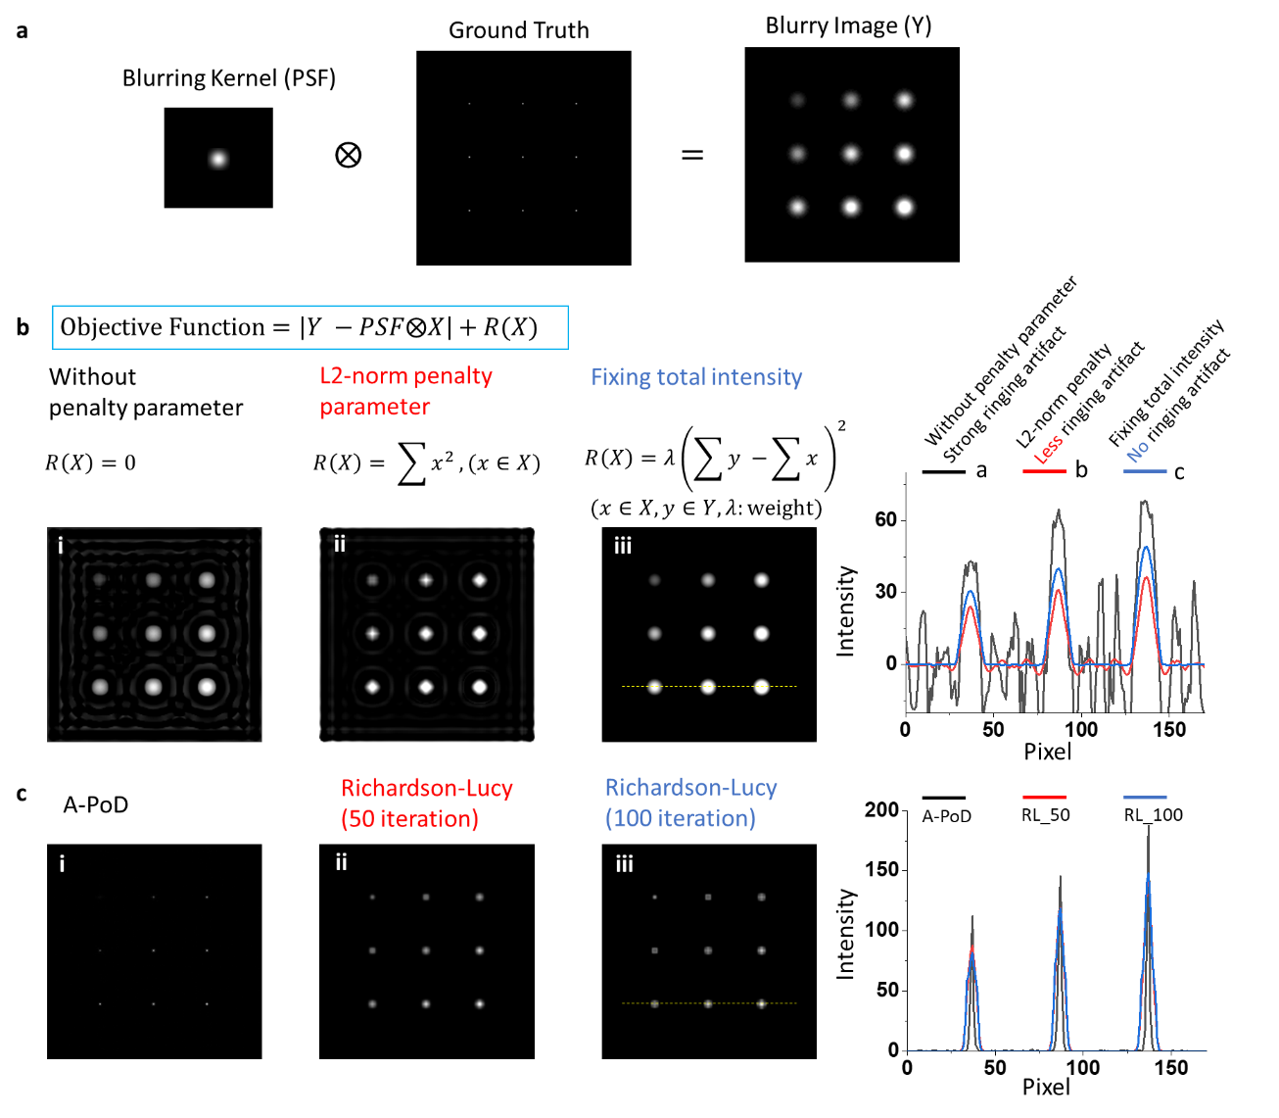
Extended Data Fig. 1 Comparison of A-PoD with Richardson-Lucy method using simulation data. a. To compare different deconvolution methods, we generated an artificial image composed of single pixel sized 9 dots. The dots in the image have different intensity values. By convolution with an artificial PSF, a blurry image (Y) was generated. The image (Y) was deconvolved using a penalized regression method. b. When we minimize the objective function in panel b, the images, X results. Depending on the penalty parameter, R(X), X has various forms. The optimization result without any penalty parameter has strong ringing artifact as shown in panel b(i), and the result with L2-norm penalty parameter has reduced ringing artifact as shown in panel b(ii). By limiting summation of total intensity, we can reduce the ringing artifact as shown in panel b(iii). The penalty parameter limiting the total intensity as a fixed value makes the values in empty space to zeros. Accordingly, one of the main characteristics of A-PoD, the fixed total intensity of X, can increase sparsity of resulting images. c. Comparison of A-PoD with Richardson-lucy method. When we apply another characteristic of A-PoD, quantization of intensity value, together, the resulting image of A-PoD has higher resolution than that obtained using Richardson-Lucy method. The signal intensity profile shows the difference in resolutions. The dots in the A-PoD image have narrower width than Richardon-Lucy images. The calculation time of A-PoD was 1.9 s, and Deconvolutionlab2 using Richardson-Lucy algorithm calculated the image for 1.1 s (50 iteration) and 2.2 s (100 iteration).
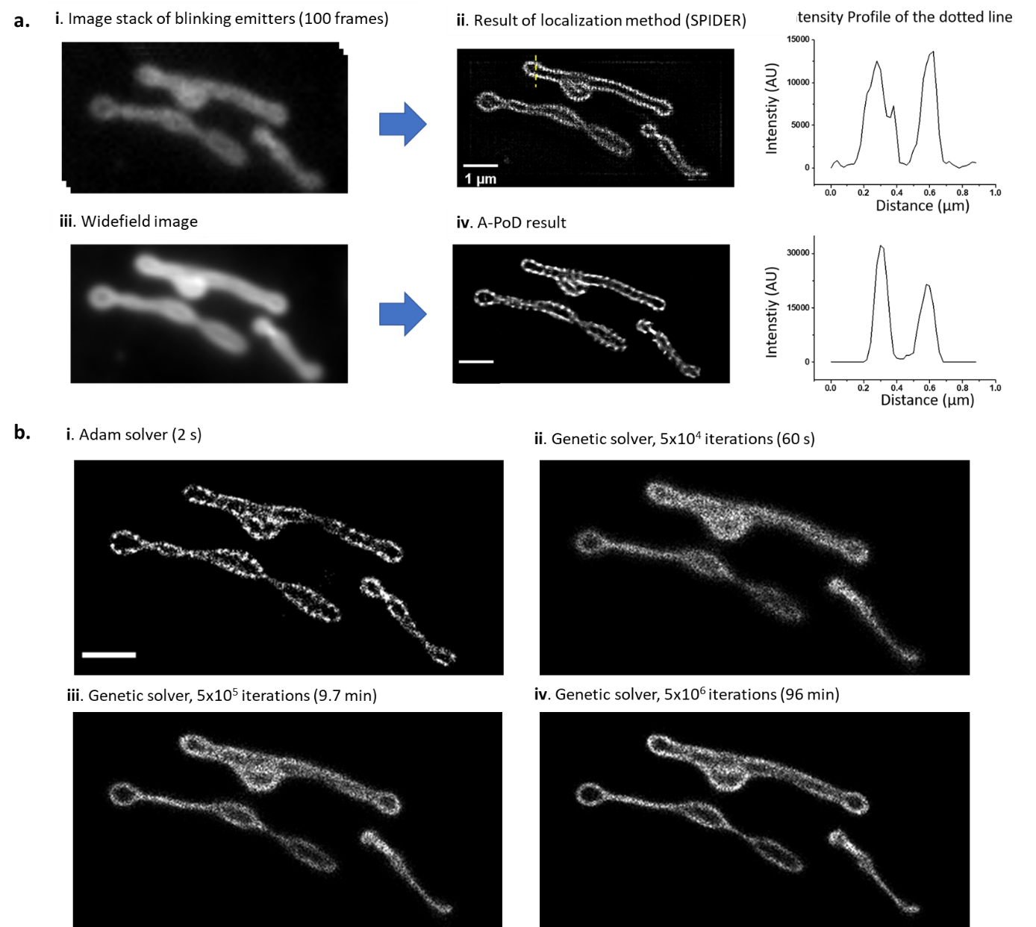
Extended Data Fig. 2 Precision and speed of A-PoD in comparison with SPIDER. a. To compare the localization microscopy image with A-PoD result, we deconvolved a mitochondrial image. The image stack is composed of 100 frames. Each image frame contains information about blinking emitters. The emitters were localized using SPIDER deconvolution algorithm. By averaging the image stack, we generated a widefield image, and the widefield image was deconvolved using A-PoD. The intensity profiles of the cross-section in the deconvolved images show the similarity between the two results. b. Two optimization methods for the deconvolution process were compared. An image composed of 100000 virtual emitters was deconvolved using the two different optimizers. The results of Adam solver (i) finished calculation within 2 s. By increasing the iteration number, the deconvolution results using genetic solver (ii, iii, and iv with different iteration numbers) were compared with the result of Adam solver. The deconvolution result with a high iteration number shows more precise image. However, to generate an image having same quality as that obtained with the Adam solver, we need to increase the iteration number further beyond 5x 10⁶ more.
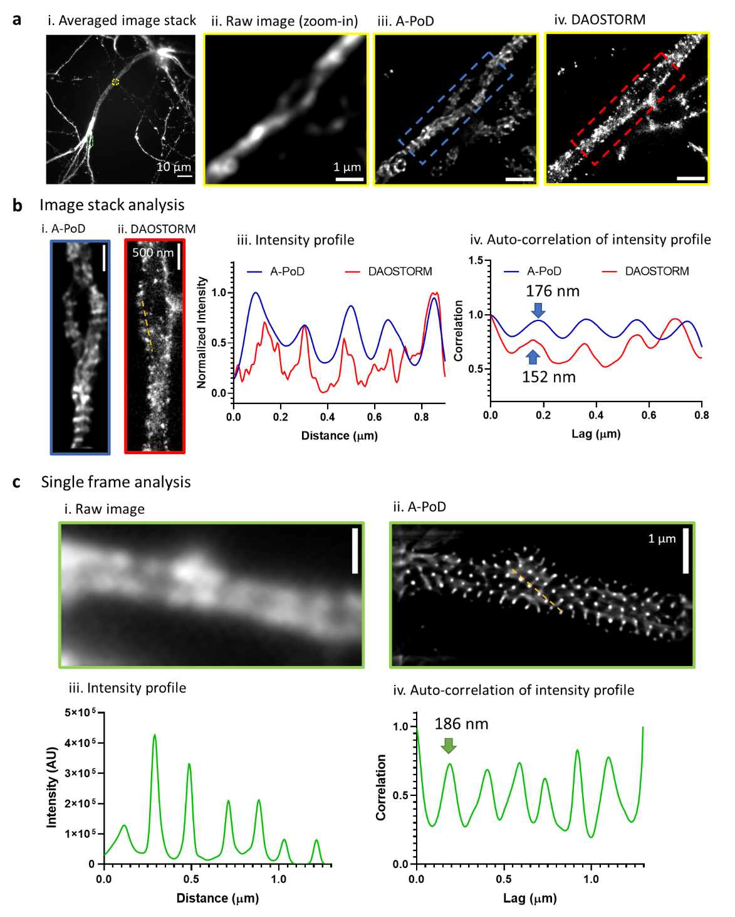
Extended Data Fig. 3 Comparison of the deconvolution results on STORM images using DAO STORM(26) versus A-PoD. a. (i) A single “epifluorescence”-like image was calculated by averaging the STORM-stack. (ii) We selected an area with low emitter density (yellow rectangle region in (i)) than other areas. (iii) The averaged image stack of the chosen area was deconvolved using A-PoD. (iv) From the whole stack of the selected area, the individual single emitters were localized using DAOSTORM. b. The two areas marked by the blue and red rectangle areas in (a. i and b. ii) were selected. (iii and iv) The intensity profiles and auto-correlation data shows the periodicity of the structure of the membrane-associated periodic skeleton (MPS) in neurons. c. Another bright area with high emitter density (green rectangle area in a.i) where we cannot localize the individual molecules using DAOSTORM was selected. (i) From the image stack of the selected area, we chose a single frame. (ii) Using A-PoD, we deconvolved the chosen frame. (iii and iv) The intensity profile and the auto-correlation result show the periodicity. Due to the strong intensity, the periodic structure was clearly revealed, and the interval in the MPS is also close to the previous published result, 190 nm (64).
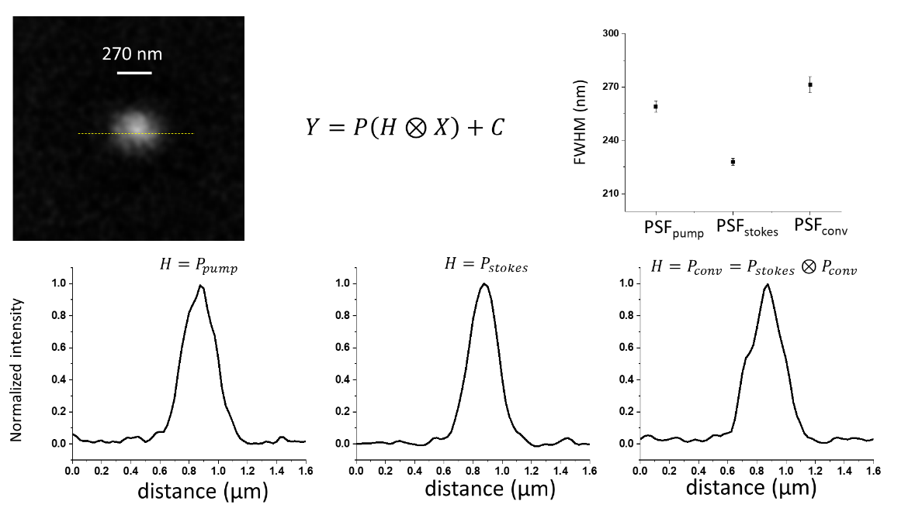
Extended Data Fig.4 Comparison of three PSF models. The bead image of 270 nm size was deconvolved using different PSF models. To compare the accuracy of the results, we compared the FWHM of the fitted Gaussian functions. When we used PSF_{conv}, FWHM was almost same with the bead size.

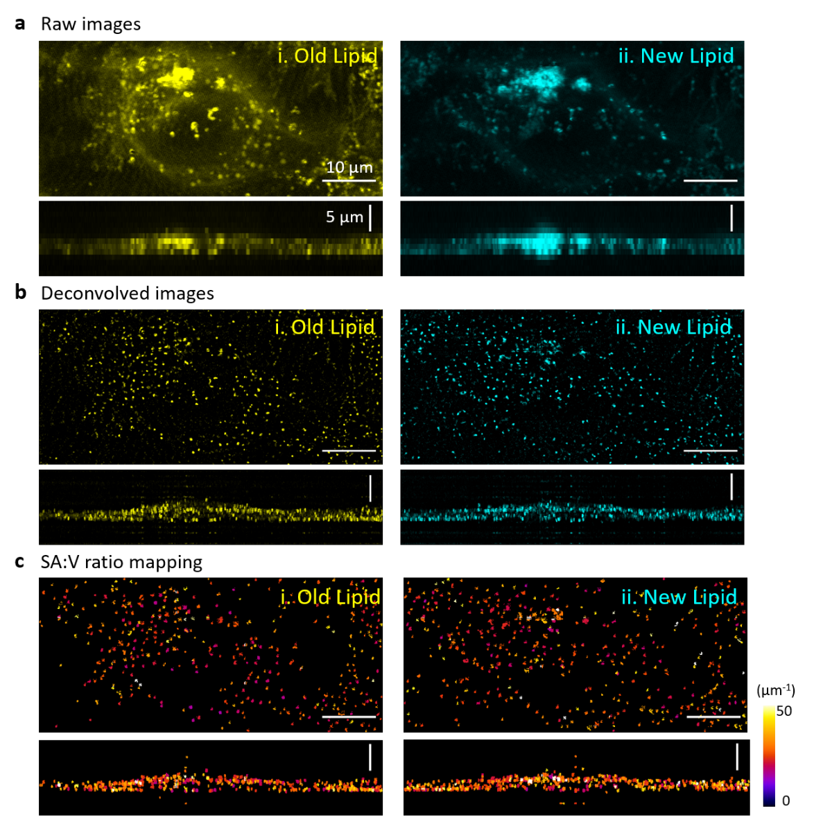

Extended Data Fig.5 SRS images of a HeLa cell cultured in the standard medium. a. Raw DO-SRS images of the HeLa cell. b. Deconvolution results of the images. The images show the shape and distribution of the lipid droplets in sub-micron scale. c. After measuring the surface area and volume of individual lipid droplets, the surface area to volume ratio of individual LDs was mapped.

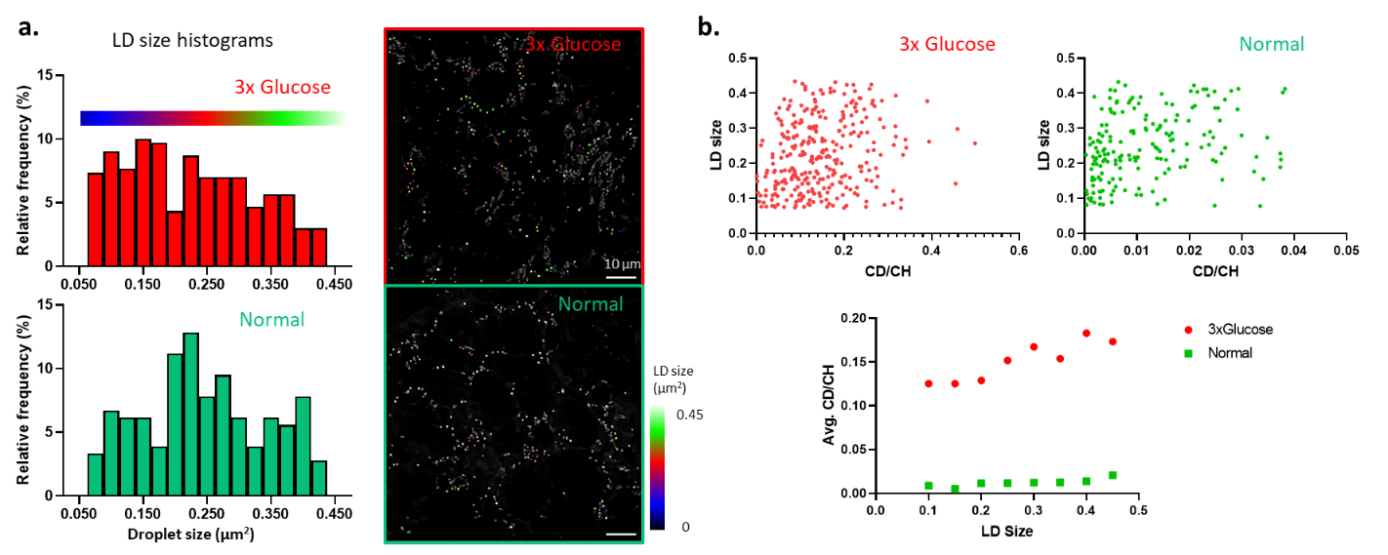

Extended Data Fig. 6 LD size and lipid turnover rate distribution. a. In flies fed on different diets, LDs have different size distribution. In high glucose group, the LD size was widely distributed, and the number of LDs in 0.1~0.2 µm² range was higher than the other size. In control dietary condition, the control group with standard diet, the number of LDs in 0.2~0.3 µm² range was high. LDs were labeled on the images with three colors according to the size (Blue, 0.05~0.2 µm²; Red, 0.2~0.3 µm²; Green, 0.3~0.45 µm²). b. To compare the LD size and lipid turnover rate, the two parameters of individual LDs were plotted. Under both conditions, LD size and lipid turnover rate show positive correlation. Correlation coefficient: 0.40 (3x glucose), 0.44 (control).
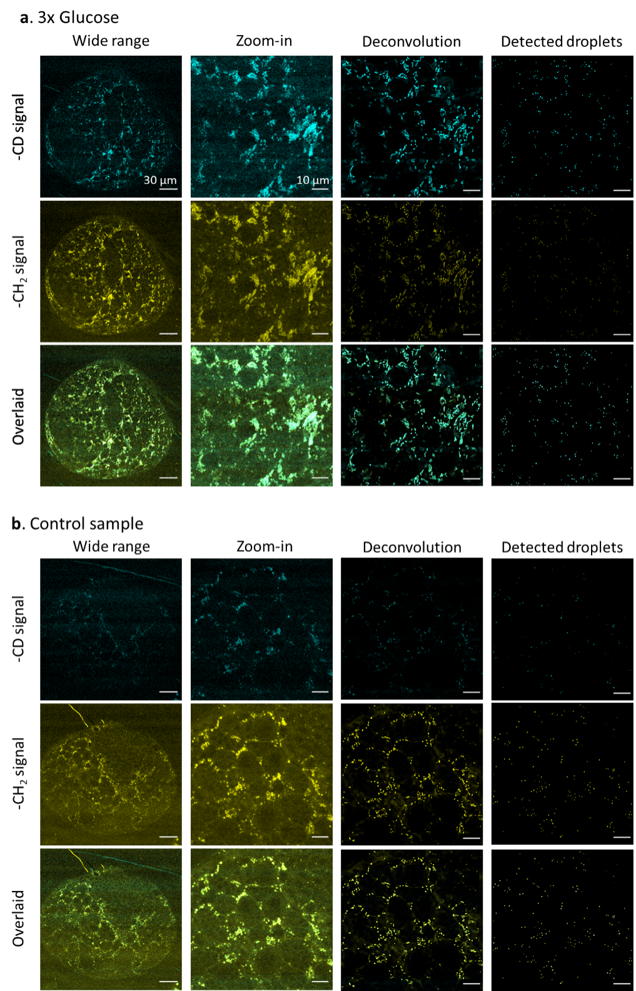
Extended Data Fig. 7 SRS images of larvae brain samples from flies fed on different diets. a. DO-SRS images of a drosophila larvae brain in 3x glucose group. The wide range new lipid (CD) and old lipid (CH₂) signal show the distribution of newly synthesized lipids and old lipids in whole sample, respectively. In the zoomed-in images, the microscopic distribution of two different lipid components is clearly shown. After deconvolution, the nanoscopic distribution and shape of lipid droplets are getting clearer. By using the particle analysis method, we can remove the background and focus on the areas of lipid droplets. b. SRS images of a drosophila larvae brain in the control group were processed with the same manner in a. These images were analyzed, and the analysis result is explained in Fig. 6.
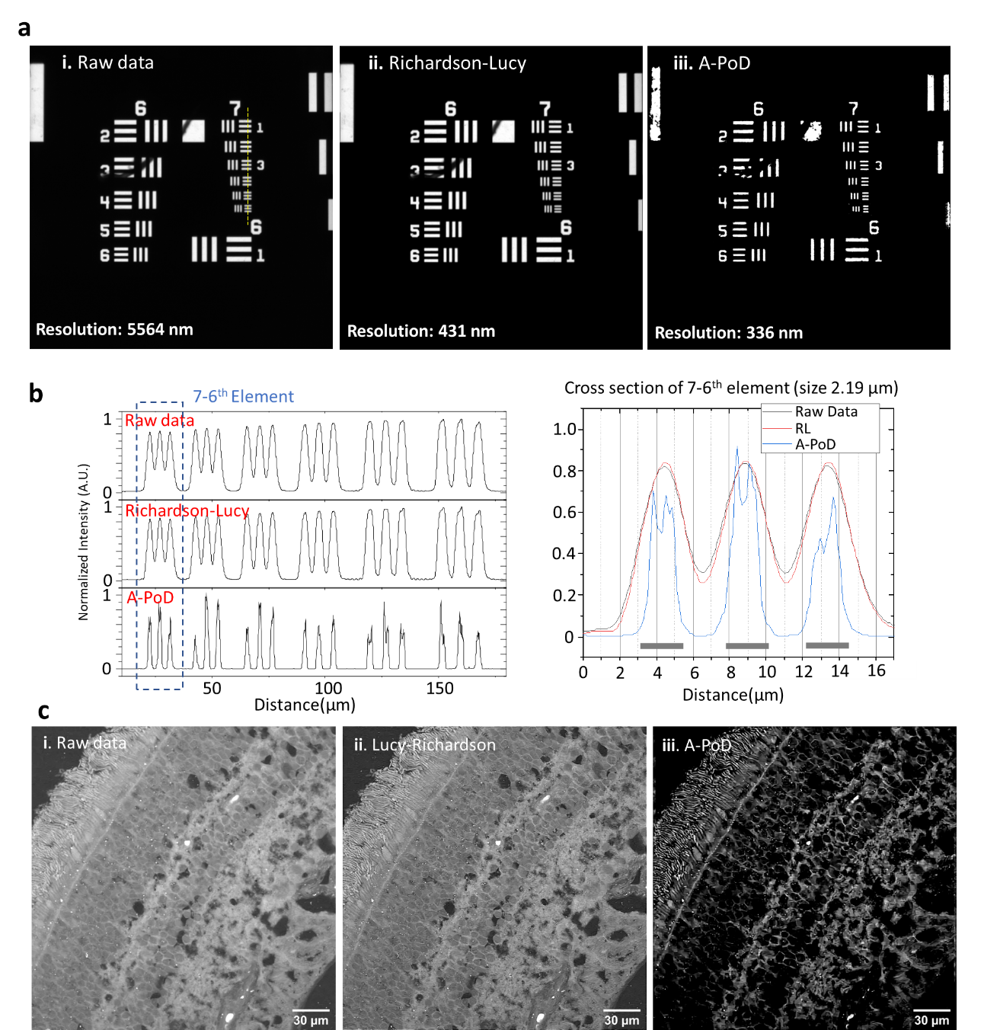
Extended Data Fig. 8 Comparison between A-PoD and the Richardson-Lucy method. a. USAF-1951 resolution target. The fluorescence image of the resolution target in the paper(65) was deconvolved using Richardson-Lucy algorithm (Deconvolutionlab2 program)(20). b. Intensity profiles of the yellow dotted line in figure A show the resolution difference. A-PoD result resolved each line perfectly, but Richardson-Lucy result could not resolve them. c. Deconvolution results of retinal tissue image. The raw image (i) was deconvolved with Richardson-Lucy algorithm (ii) and A-PoD (iii). The image contrast was significantly improved when we used A-PoD for deconvolution.

