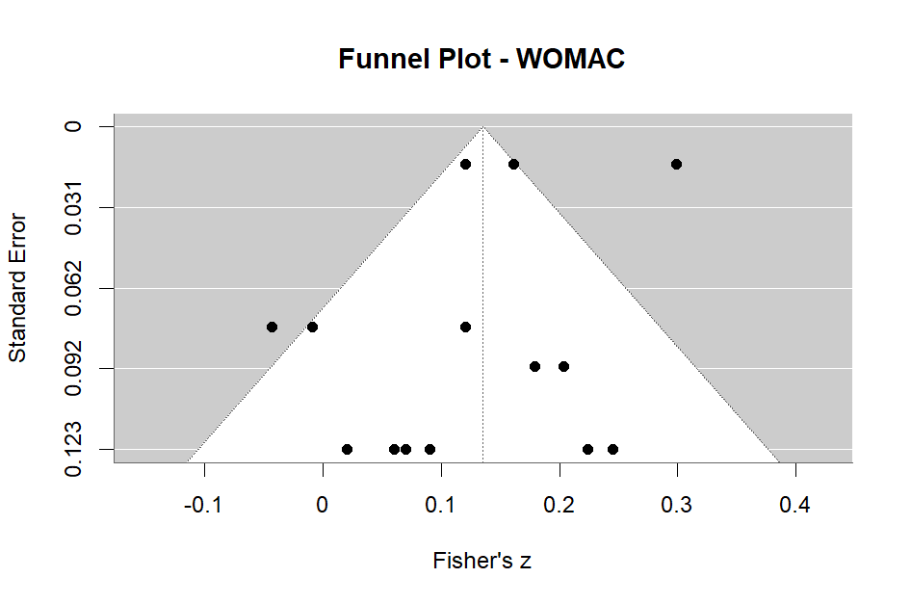
Funnel Plot for Self-Reported Pain, Stiffness, and Physical Function (The Western Ontario and McMaster Universities Arthritis Index [WOMAC] in Patients with Osteoarthritis
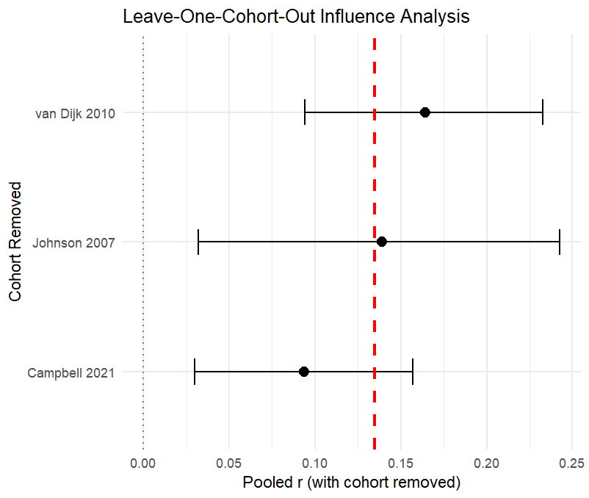
Leave One Out Plot for Self-Reported Pain, Stiffness, and Physical Function (The Western Ontario and McMaster Universities Arthritis Index [WOMAC] in Patients with Osteoarthritis

