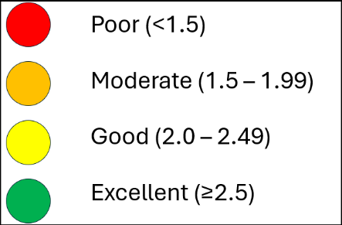
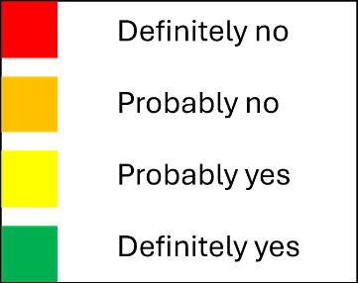
Table S4 Risk of bias assessment of the included studies using The Tool to Assess Risk of Bias in Cohort Studies (CLARITY Group at McMaster University).
First author, year | Item 1 | Item 2 | Item 3 | Item 4 | Item 5 | Item 6 | Item 7 | Item 8 | Quality
Ward, 2016a
Lin, 2024
Yusuf, 2011
Gavilán-Carrera, 2024
da Silva, 2024
Brandão, 2024
Agricola, 2013
Chen, 2020
Zeni, 2010
Chiu, 2005
Carvalho, 2020
Mertens, 2023
Campbell, 2021
Bethi, 2013
Poddubnyy, 2018
Coyle, 2021
Johnson, 2007
Beauchamp, 2016
Labad, 2018
Ward, 2016
Oppewal, 2014
Eurenius, 2007
Damen, 2009
van Dijk, 2010
Holla, 2010
Chen, 2018
Fukui, 2010
Protopopov, 2017
Hwang, 2021
Pisters, 2012
Dinh, 2008
Mertens, 2022
Schmidt, 2018
Riddle, 2012
Riddle, 2009

Items:
1. Was selection of exposed and non-exposed cohorts drawn from the same population?
2. Can we be confident in the assessment of exposure?
3. Can we be confident that the outcome of interest was not present at start of study?
4. Did the study match exposed and unexposed for all variables that are associated with the outcome of interest or did the statistical analysis adjust for these prognostic variables?
5. Can we be confident in the assessment of the presence or absence of prognostic factors?
6. Can we be confident in the assessment of outcome?
7. Was the follow up of cohorts adequate?
8. Were cointerventions similar between groups?

Each question can be answered with “Definitely no (high risk of bias)”, “Probably no”, “Probably yes”, and “Definitely yes (low risk of bias)”.

