Multi-modal Stacking Machine Learning Model for Predicting Lymph Node Metastasis in Cervical Cancer

ELECTRONIC SUPPLEMENTARY MATERIAL

Method S1： Morphological and Functional Image Analysis
Tumor size was defined as the maximum diameter measured across three orthogonal planes (axial, sagittal, and coronal) in accordance with the 2018 FIGO staging guidelines. Cervical stromal invasion depth and parametrial infiltration were assessed by integrating T2WI signal abnormality, DWI hyperintensity extension, and enhancement patterns on CE-T1WI.
Quantitative ADC values were measured using vendor-specific post-processing workstations. Regions of interest (ROIs) were manually delineated along tumor margins on each tumor-containing DWI slice by a board-certified radiologist (24 years of experience in gynecologic oncology imaging). Mean ADC values were extracted per slice, and the tumor-level ADC was calculated as the arithmetic mean across all slices. Areas of hemorrhage, necrosis, and cystic degeneration were systematically excluded.

Supplementary Figures

Figure S1. (a) Cluster evaluation curves showing Calinski–Harabasz indices across k = 2–10, with k = 3 identified as optimal; (b) Three-dimensional visualization of tumor habitat segmentation at k = 3, illustrating three distinct subregions and their voxel proportions.
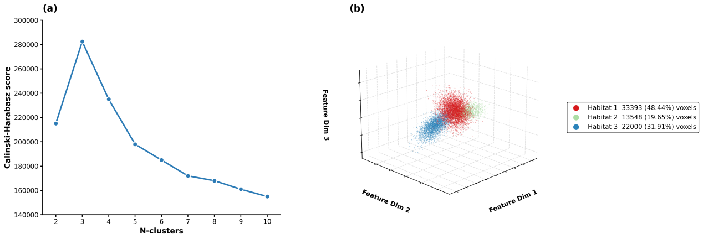

Fig. S2. SHAP beeswarm, heatmaps, and summary bar plots for model interpretability.
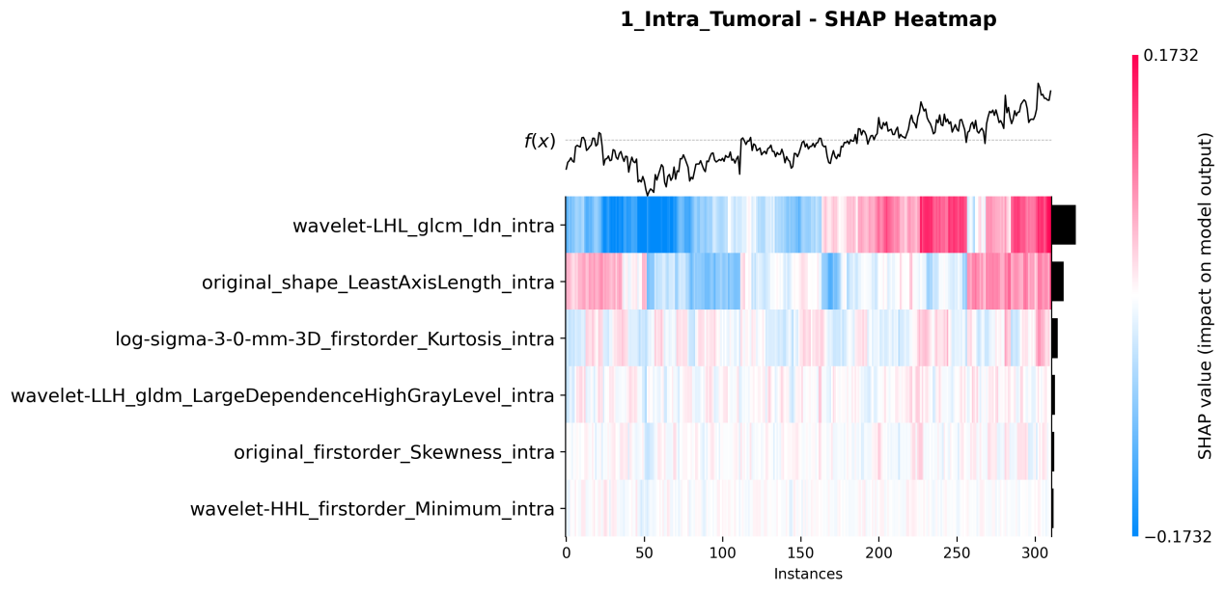
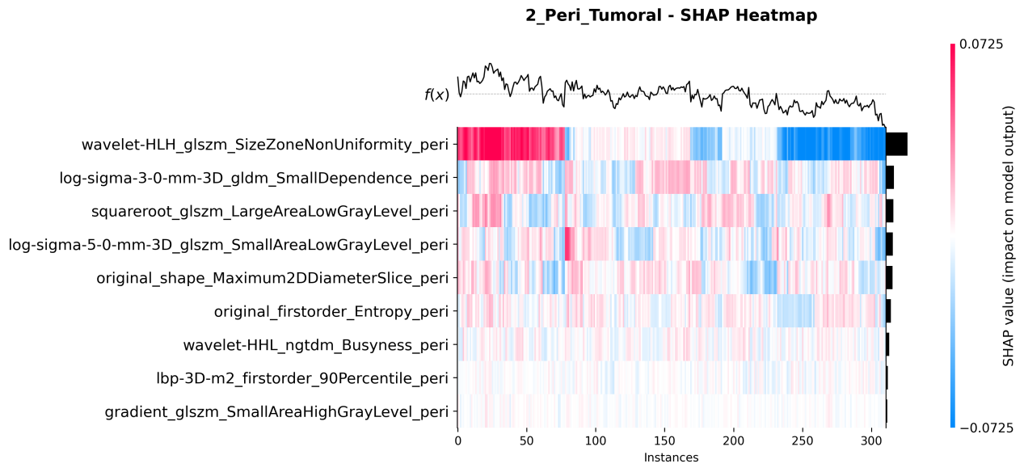
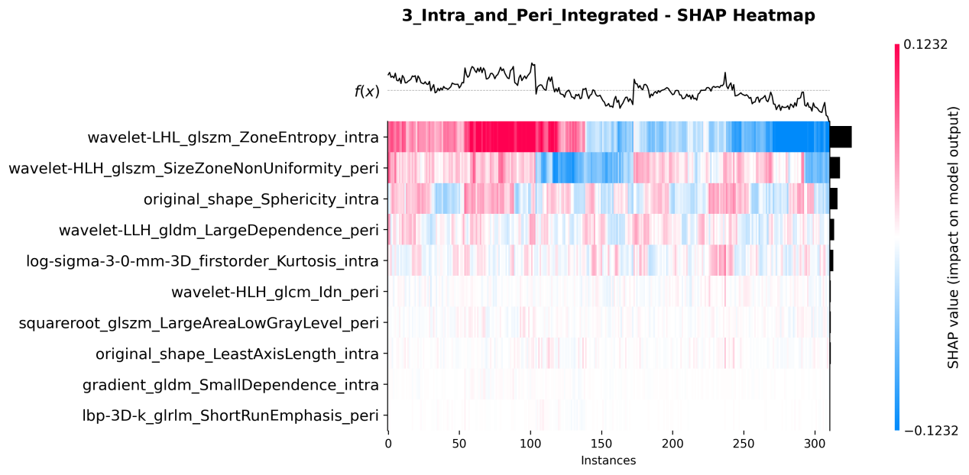
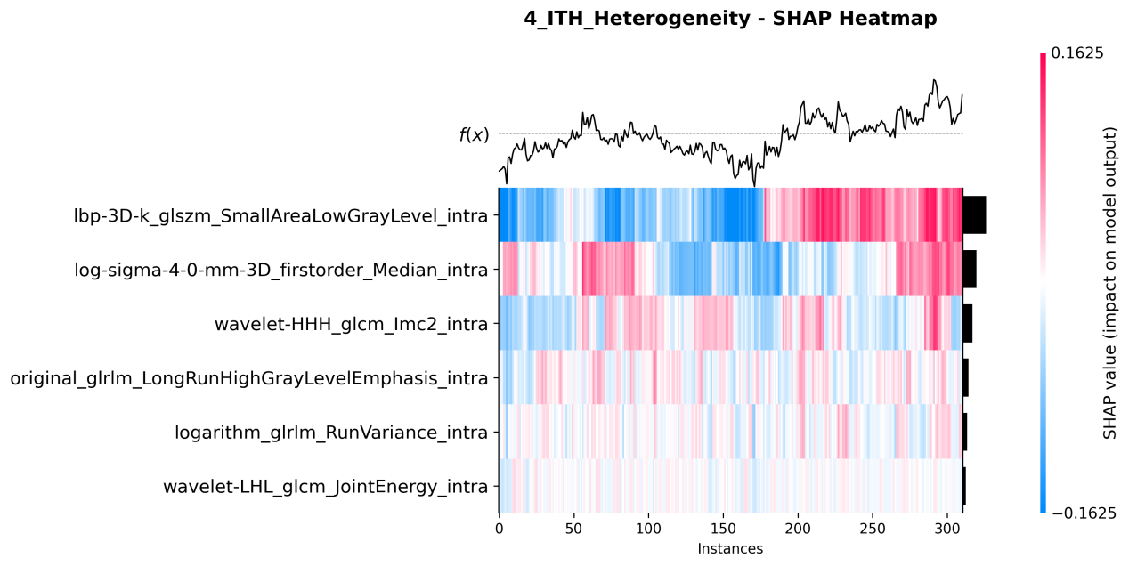
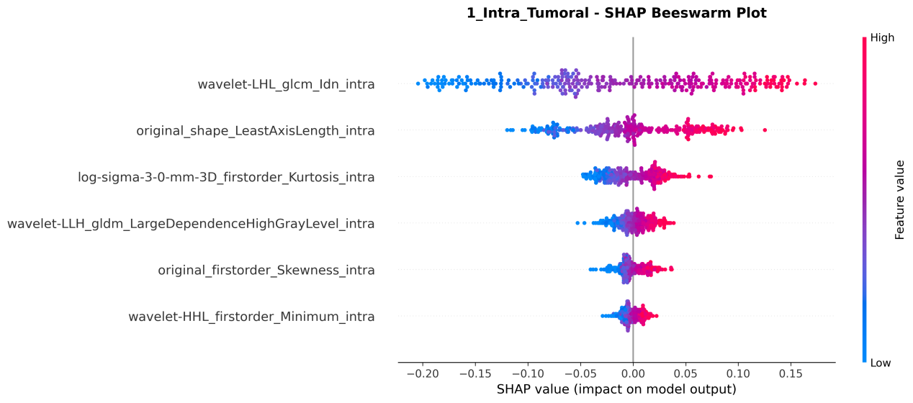
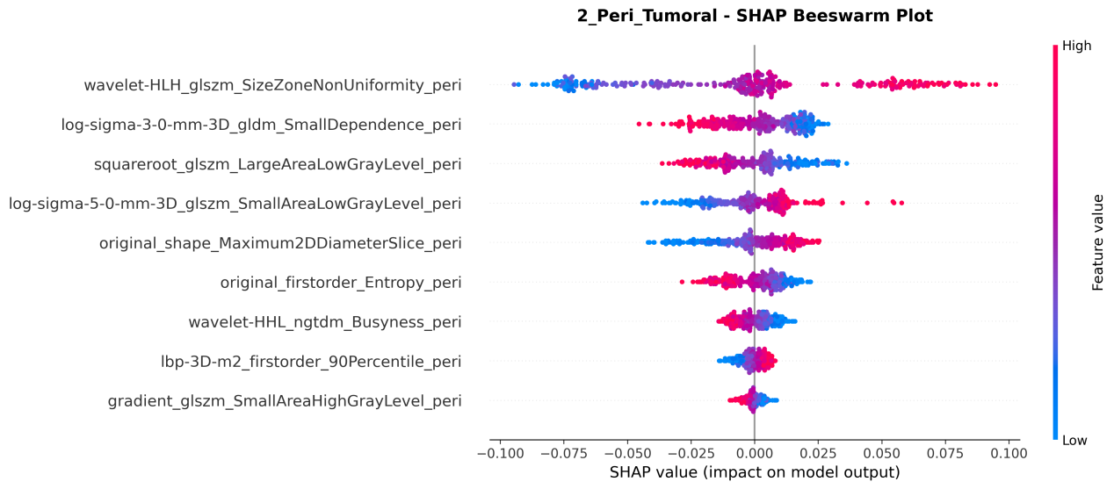
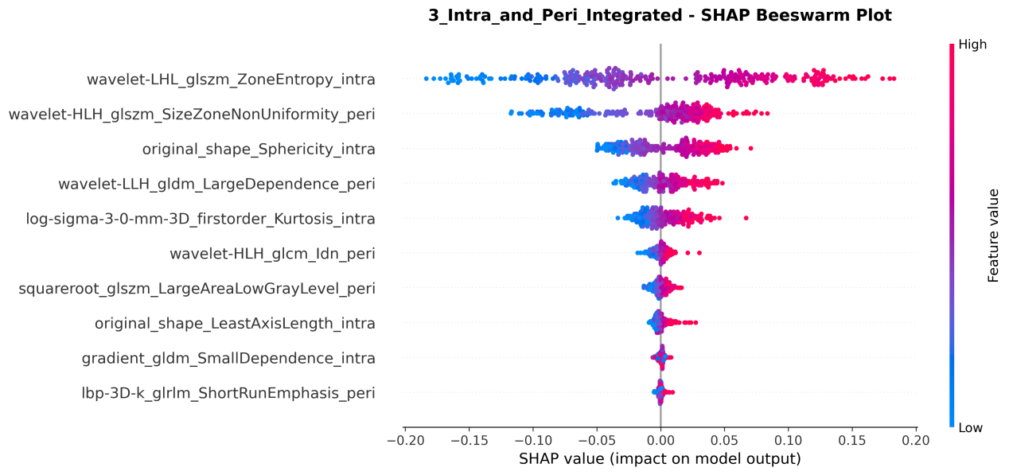
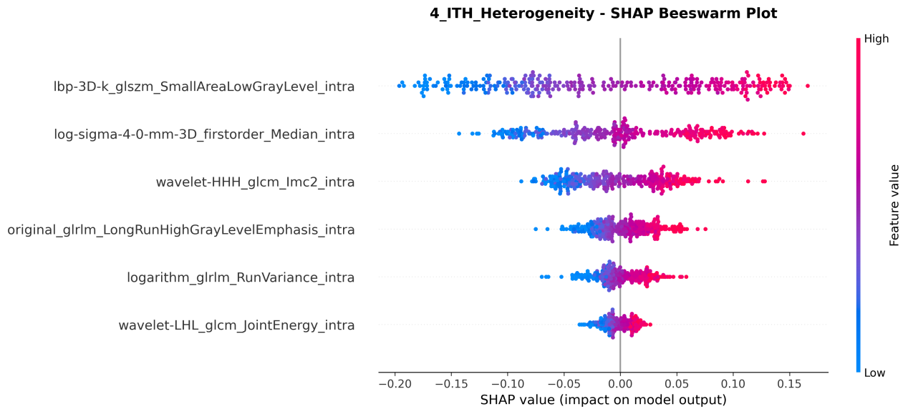
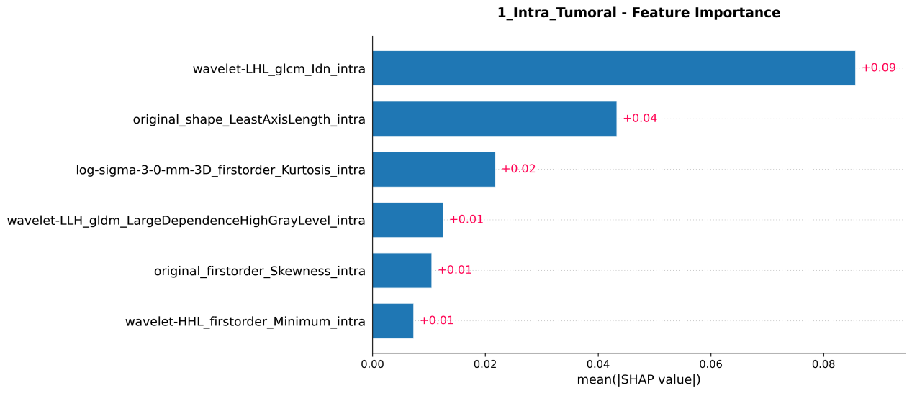
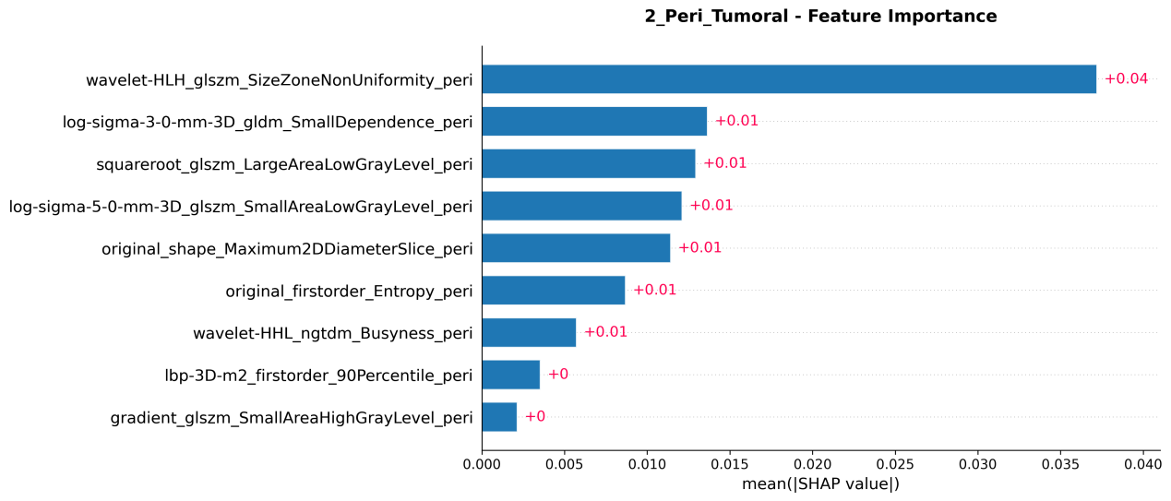
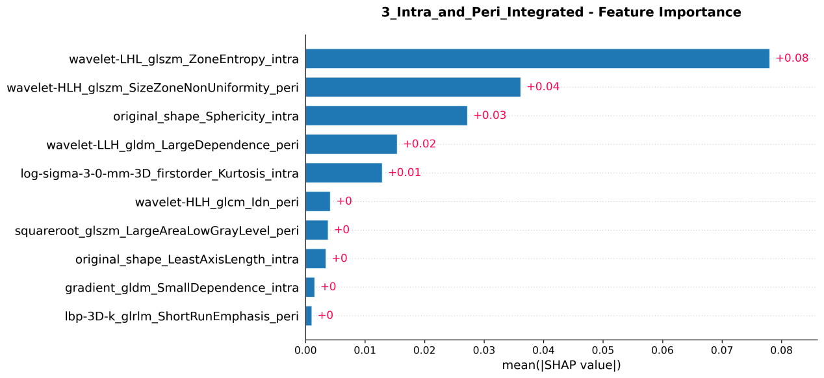
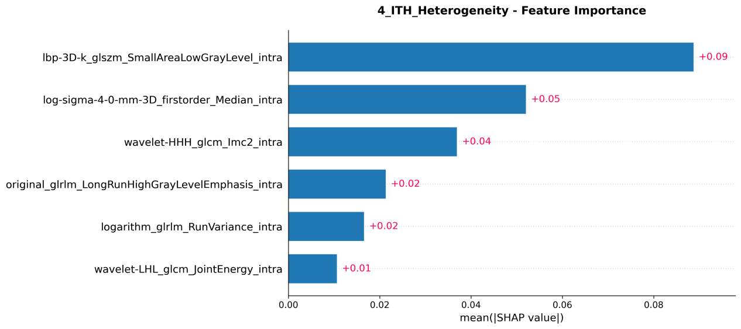

Fig. S3. Forest plot of clinicopathological features and habitat radiomics scores associated with LNM-positivity
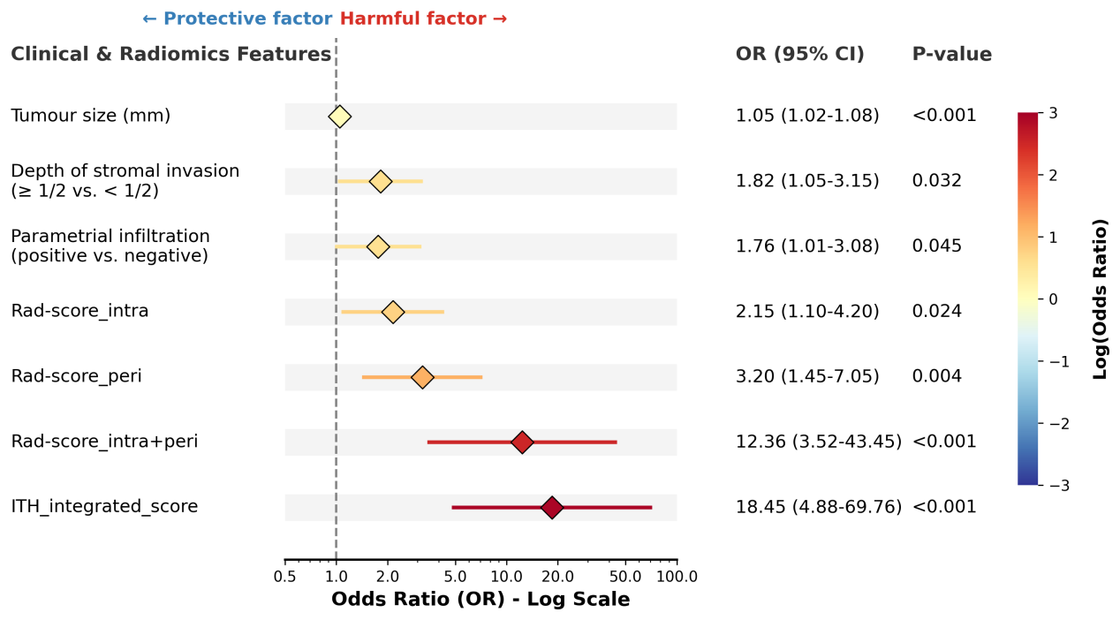

Supplementary Tables

Table S1. Scanning protocols for MRI system.

Sequences | Axial T1WI | Axial T2WI,FSE | Sagittal FS T2WI,FSE | Axial DWI,EPI | Axial contrast-enhanced,FSPGR
TR/TE (ms) | 500/8.5 | 4200/95 | 4000/130 | 2000/54 | 3.0/1.38
FOV (mm × mm) | 240×320 | 240×360 | 240×360 | 382×342 | 300×400
Matrix size | 320×299 | 300×400 | 450×298 | 382×342 | 300×400
Slice thickness (mm) | 5.0 | 5.0 | 5.0 | 4.0 | 2.0
Slice gap (mm) | 1 | 1 | 1 | 1 | 0
NEX | 2 | 2 | 2 | 2 | 2
b-value (s/mm²) | — | — | — | 0, 1000 | —

Note: FSE fast spin-echo; EPI echo planar imaging; FSPGR fast-spoiled gradient recalled echo; TR repetition time; TE echo time; FOV field of view; NEX number of excitations; T1WI T1-weighted imaging; T2WI T2-weighted imaging; DWI diffusion-weighted imaging

Table S2. LASSO-selected radiomics features and corresponding coefficients for intratumoral, peritumoral, combined Rad-scores, and ITH_integrated_scores.

Score | Features | Sequence | Coefficients / Importance
Rad-score_intra | wavelet-LHL_glcm_Idn | DWI | 0.083
(Based on XGBoost, 6 features) | original_shape_LeastAxisLength | DCE | 0.062
 | log-sigma-3-0-mm-3D_firstorder_Kurtosis | T2WI | 0.045
 | wavelet-LLH_gldm_LargeDependenceHighGrayLevel | DCE | 0.038
 | original_firstorder_Skewness | T2WI | 0.031
 | wavelet-HHL_firstorder_Minimum | DCE | 0.027
Rad-score_peri | wavelet-HLH_glszm_SizeZoneNonUniformity | DWI | 0.041
(Based on Elastic Net LR, 9 features) | original_shape_Maximum2DDiameterSlice | DCE | 0.035
 | log-sigma-5-0-mm-3D_glszm_SmallAreaLowGrayLevel | DWI | 0.028
 | lbp-3D-m2_firstorder_90Percentile | DCE | 0.015
 | gradient_glszm_SmallAreaHighGrayLevel | DCE | -0.011
 | original_firstorder_Entropy | T2WI | -0.019
 | wavelet-HHL_ngtdm_Busyness | DWI | -0.024
 | squareroot_glszm_LargeAreaLowGrayLevel | T2WI | -0.027
 | log-sigma-3-0-mm-3D_gldm_SmallDependence | T2WI | -0.036
Rad-score_intra+peri | wavelet-LHL_glszm_ZoneEntropy | T2WI | 0.075
(Based on DSCA, 10 features) | wavelet-HLH_glszm_SizeZoneNonUniformity | DWI | 0.063
 | original_shape_Sphericity | DCE | 0.055
 | log-sigma-3-0-mm-3D_firstorder_Kurtosis | T2WI | 0.042
 | wavelet-LLH_gldm_LargeDependence | DCE | 0.037
 | wavelet-HLH_glcm_Idn | T2WI | 0.029
 | original_shape_LeastAxisLength | DCE | 0.021
 | squareroot_glszm_LargeAreaLowGrayLevel | T2WI | 0.018
 | gradient_gldm_SmallDependence | T2WI | 0.015
 | lbp-3D-k_glrlm_ShortRunEmphasis | DWI | 0.011
ITH_integrated_score | lbp-3D-k_glszm_SmallAreaLowGrayLevel_intra | T2WI | 0.088
(Based on SVM, 6 features) | log-sigma-4-0-mm-3D_firstorder_Median_intra | DCE | 0.076
 | wavelet-HHH_glcm_Imc2_intra | DWI | 0.065
 | original_glrlm_LongRunHighGrayLevelEmphasis_intra | T2WI | 0.054
 | logarithm_glrlm_RunVariance_intra | DWI | 0.047
 | wavelet-LHL_glcm_JointEnergy_intra | DCE | 0.039

Table S3. Comparison of clinicopathological and radiomics features between two groups in the training cohort
Variable | LNM(-) (n=237) | LNM(+) (n=74) | p value
age, mean ± SD | 55.84 ± 11.93 | 47.65 ± 13.16 | <0.001
maximum_diameter, median (Q1, Q3) | 25.91 (20.64, 32.22) | 33.69 (26.69, 38.44) | <0.001
smoke_history |  |  | 0.598
No | 176 (74.3%) | 52 (70.3%)
Yes | 61 (25.7%) | 22 (29.7%)
HPV |  |  | 0.991
Negative | 33 (13.9%) | 11 (14.9%)
Positive | 204 (86.1%) | 63 (85.1%)
Delivery times |  |  | 0.574
< 3 | 130 (54.9%) | 44 (59.5%)
≥ 3 | 107 (45.1%) | 30 (40.5%)
FIGO_stage |  |  | 0.407
1 | 102 (43.0%) | 27 (36.5%)
2 | 123 (51.9%) | 40 (54.1%)
3 | 10 (4.2%) | 5 (6.8%)
4 | 2 (0.8%) | 2 (2.7%)
pathological_type |  |  | 0.039
Adenocarcinoma | 34 (14.3%) | 3 (4.1%)
Adenosquamous | 12 (5.1%) | 2 (2.7%)
Other | 4 (1.7%) | 0 (0.0%)
Squamous | 187 (78.9%) | 69 (93.2%)
pathological_grade |  |  | 0.006
Moderate | 43 (18.1%) | 7 (9.5%)
Poor | 161 (67.9%) | 64 (86.5%)
Well | 33 (13.9%) | 3 (4.1%)
Depth of stromal invasion |  |  | 0.005
< 1/2 | 99 (41.8%) | 17 (23.0%)
≥ 1/2 | 138 (58.2%) | 57 (77.0%)
parametrial_infiltration |  |  | 0.004
Negative | 155 (65.4%) | 34 (45.9%)
Positive | 82 (34.6%) | 40 (54.1%)
Ki67, median (Q1, Q3) | 60.00 (60.00, 80.00) | 60.00 (51.25, 70.00) | 0.181
LVI |  |  | 0.371
Negative | 86 (36.3%) | 22 (29.7%)
Positive | 151 (63.7%) | 52 (70.3%)
SCC-Ag, median (Q1, Q3) | 1.55 (0.95, 7.01) | 4.11 (1.30, 9.30) | <0.001
ADC, median (Q1, Q3) | 0.90 (0.73, 1.13) | 0.84 (0.74, 1.02) | 0.205
Rad-score_intra, median (Q1, Q3) | 0.04 (0.01, 0.19) | 0.18 (0.02, 0.38) | <0.001
Rad-score_peri, median (Q1, Q3) | 0.16 (0.08, 0.26) | 0.32 (0.20, 0.52) | <0.001
Rad-score_intra+peri, median (Q1, Q3) | 0.12 (0.06, 0.27) | 0.27 (0.10, 0.49) | <0.001
ITH_integrated_score, median (Q1, Q3) | 0.19 (0.15, 0.25) | 0.27 (0.18, 0.37) | <0.001
Note:
Rad-score_intra, intratumoral radiomics score; Rad-score_peri, peritumoral radiomics score; Rad-score_intra+peri, combined intratumoral and peritumoral radiomics score; ITH_integrated_score Intratumoral heterogeneity score integrated intratumoral and peritumoral

Table S4. DeLong test results comparing Meta-model with 5 base learns.
Cohort | Comparison | AUC (Stacking2) | AUC (Comparator) | DeLong Z-value | P-value
Tra | Meta vs C-LR | 0.915 | 0.685 | 7.521 | <0.001
 | Meta vs EN-LR | 0.915 | 0.752 | 6.214 | <0.001
 | Meta vs XGBoost (Intra) | 0.915 | 0.805 | 5.032 | <0.001
 | Meta vs SVM (Heterogeneity/ITH) | 0.915 | 0.882 | 2.845 | 0.004
 | Meta vs Stacking1 (Without ITH) | 0.915 | 0.89 | 2.512 | 0.012
Int-Val | Meta vs C-LR | 0.895 | 0.665 | 6.104 | <0.001
 | Meta vs EN-LR | 0.895 | 0.735 | 5.321 | <0.001
 | Meta vs XGBoost (Intra) | 0.895 | 0.785 | 4.215 | <0.001
 | Meta vs SVM (Heterogeneity/ITH) | 0.895 | 0.865 | 2.361 | 0.018
 | Meta vs Stacking1 (Without ITH) | 0.895 | 0.871 | 2.155 | 0.031
Ext-Val | Meta vs C-LR | 0.875 | 0.65 | 5.432 | <0.001
 | Meta vs EN-LR | 0.875 | 0.715 | 4.621 | <0.001
 | Meta vs XGBoost (Intra) | 0.875 | 0.765 | 3.514 | <0.001
 | Meta vs SVM (Heterogeneity/ITH) | 0.875 | 0.845 | 2.012 | 0.044
 | Meta vs Stacking1 (Without ITH) | 0.875 | 0.852 | 1.985 | 0.047

Abbreviations: Tra, training cohort; Int-Val, internal validation cohort; Ext-Val, external validation cohort; Meta, Meta-Model; AUC, area under the receiver operating characteristic curve; Z, DeLong Z-value; C-LR, logistic regression model based on clinical features; EN-LR, elastic net logistic regression; XGB, extreme gradient boosting; SVM, support vector machine; ITH, intratumoral heterogeneity.

