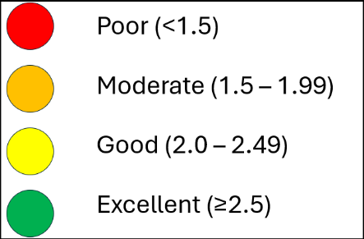
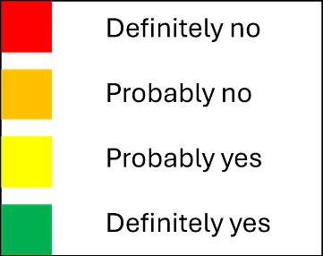
Table S4 Risk of bias assessment of the included studies using The Tool to Assess Risk of Bias in Cohort Studies (CLARITY Group at McMaster University).
First author, year | Item 1 | Item 2 | Item 3 | Item 4 | Item 5 | Item 6 | Item 7 | Quality
Katzmarzyk, 2007
Jun, 2021
Vaulerin, 2020
Kim, 2015
Multanen, 2021
Gando, 2021
Roman de Mettelinge, 2023
Gao, 2023
Ichinose, 2021
Watanabe, 2023
Menz, 2006
Tomás, 2018
Gando, 2017
Zhang, 2021
Bliekendaal, 2018
Hush, 2009
Willems, 2005a
Willems, 2005b
Wiemann, 2024
Borg, 2016
Sakari, 2010
Mason, 2007
Ballenberger, 2018
Trudelle-Jackson, 2014
Lundberg, 2017
Salo, 2012
Craig, 2006
Van Nieuwenhuyse, 2009
Stenholm, 2015
Koźlenia, 2021
Husu, 2012
Hämäläinen, 2006
Araújo, 2024
Ishiguro-Tanaka, 2025
Nishimura, 2011
Gill, 2013
Tainaka, 2009
Strøyer, 2008
Ponvel, 2024
Ikezoe, 2021
Beauchamp, 2014
Hamberg-van Reenen, 2006
Reijman, 2005
Kanchanomai, 2015
Mitchell, 2010

Items:
1. Was selection of exposed and non-exposed cohorts drawn from the same population?
2. Can we be confident in the assessment of exposure?
3. Can we be confident that the outcome of interest was not present at start of study?
4. Did the study match exposed and unexposed for all variables that are associated with the outcome of interest or did the statistical analysis adjust for these prognostic variables?
5. Can we be confident in the assessment of the presence or absence of prognostic factors?
6. Can we be confident in the assessment of outcome?
7. Was the follow up of cohorts adequate?

Each question can be answered with “Definitely no (high risk of bias)”, “Probably no”, “Probably yes”, and “Definitely yes (low risk of bias)”.

