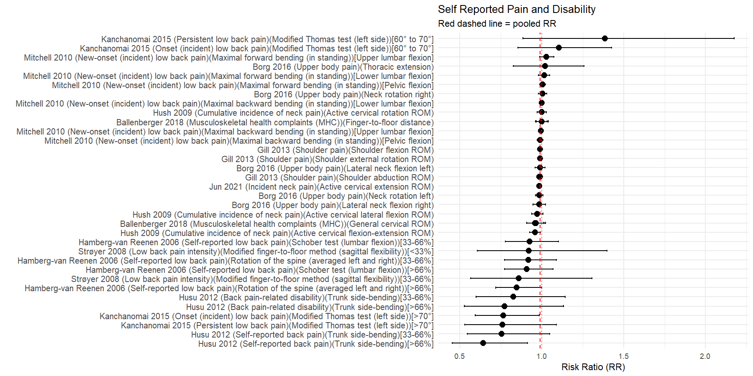
Forest Plot for Self-Reported Pain and Disability
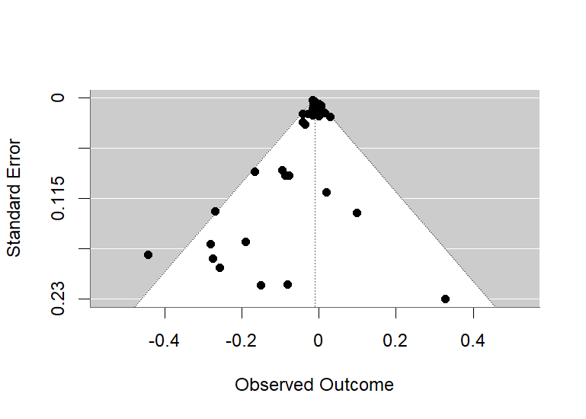
Funnel Plot for Self-Reported Pain and Disability Risk Analysis
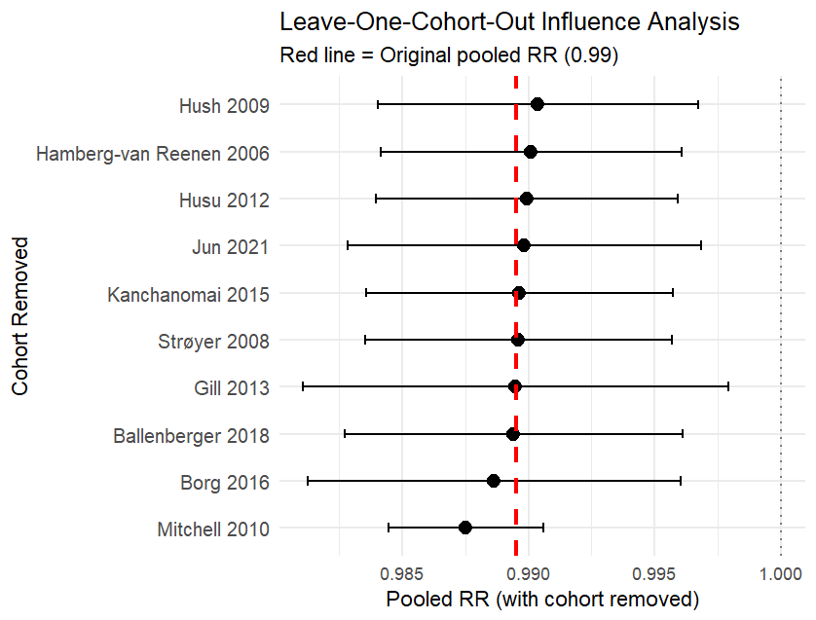
Leave One Out Plot for Self-Reported Pain and Disability Risk Analysis
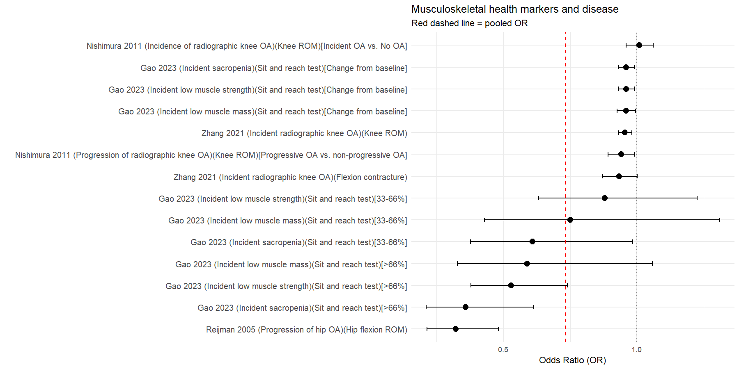
Forest Plot for Musculoskeletal Health Markers and Disease
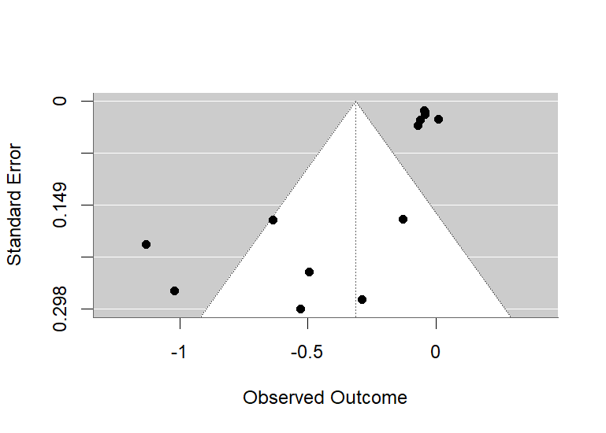
Funnel Plot for Musculoskeletal Health Markers and Disease Risk Analysis
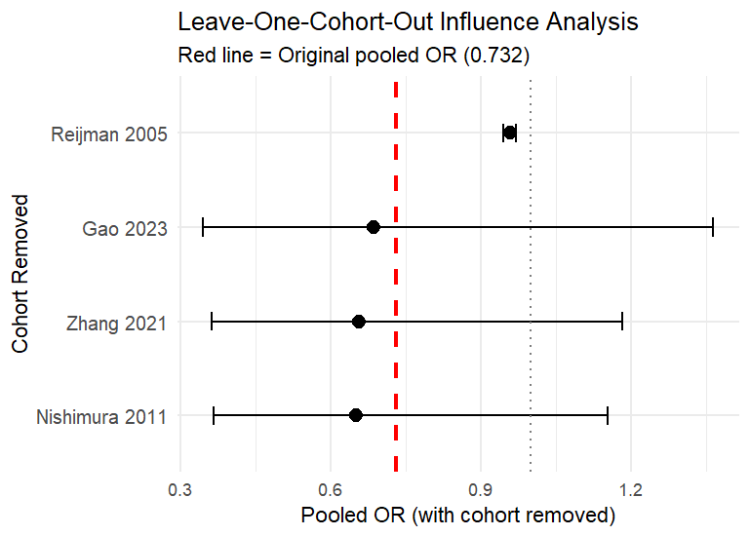
Leave One Out Plot for Musculoskeletal Health Markers and Disease Risk Analysis

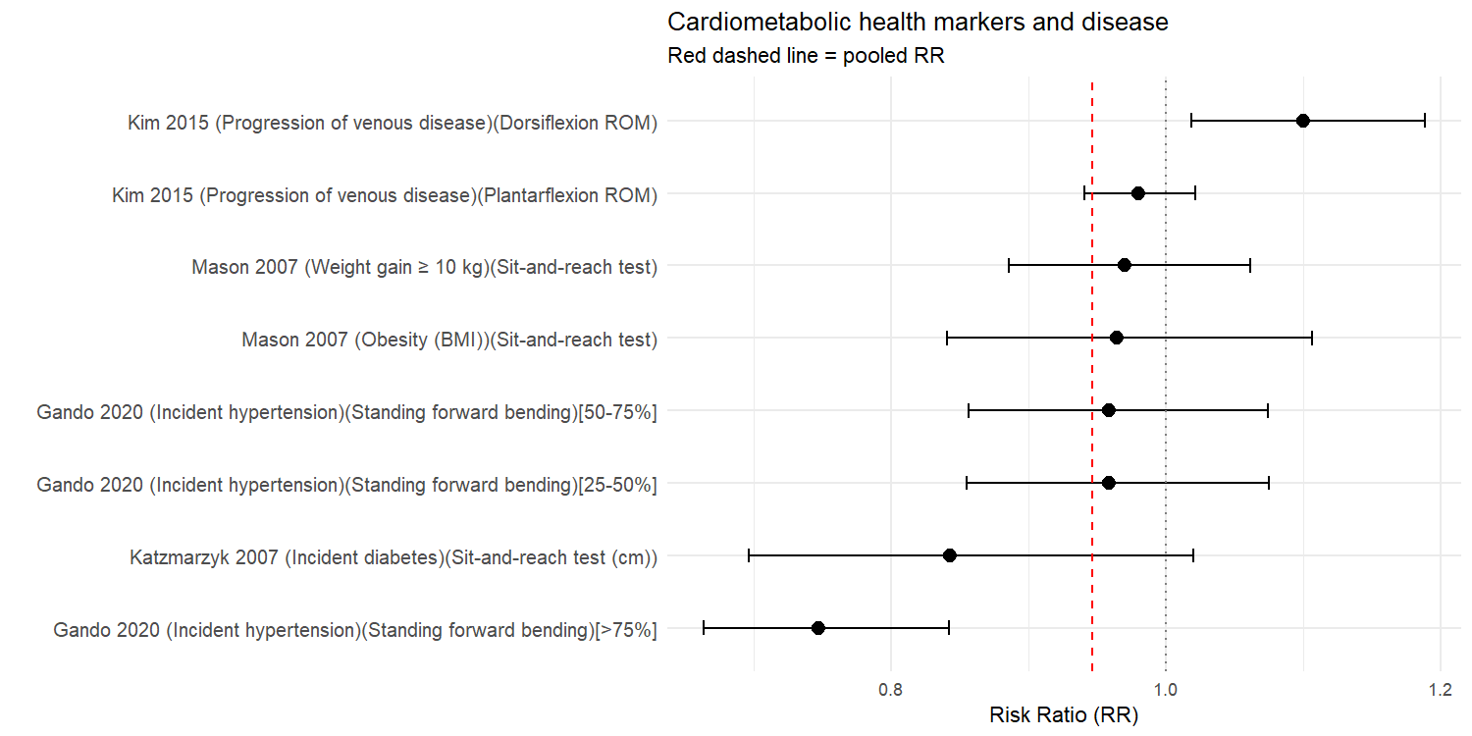
Forest Plot for Cardiometabolic Health Markers and Disease

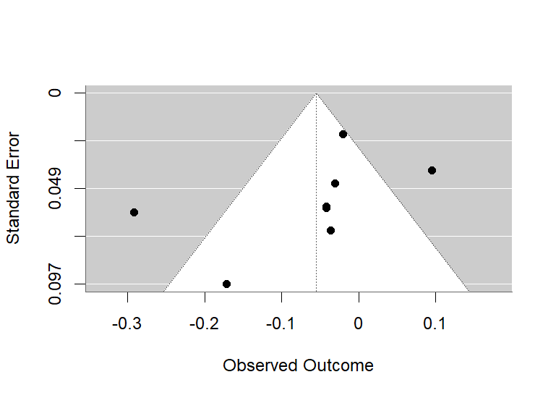
Funnel Plot for Cardiometabolic Health Markers and Disease Risk Analysis

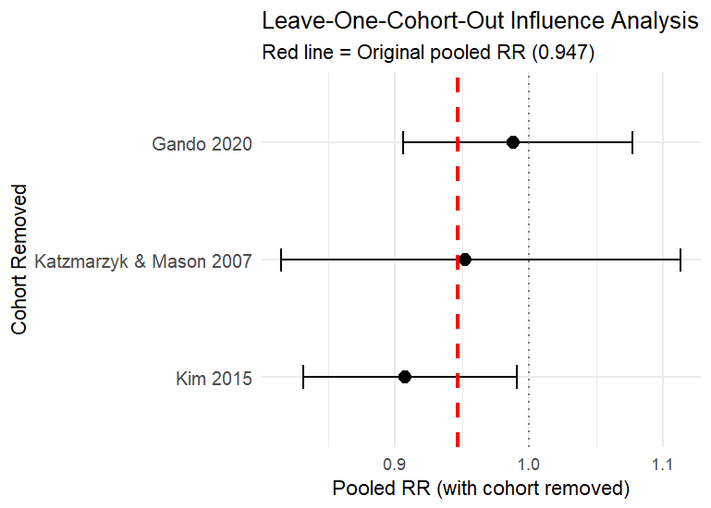
Leave One Out Plot for Cardiometabolic Health Markers and Disease Risk Analysis

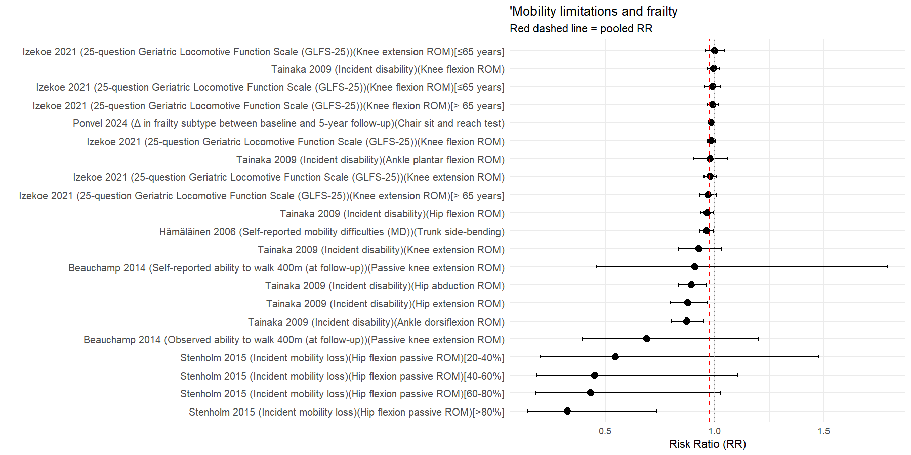
Forest Plot for Mobility Limitations and Frailty
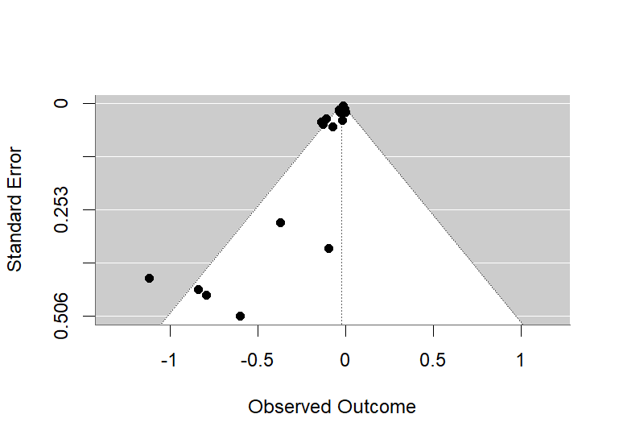
Funnel Plot for Mobility Limitations and Frailty Risk Analysis

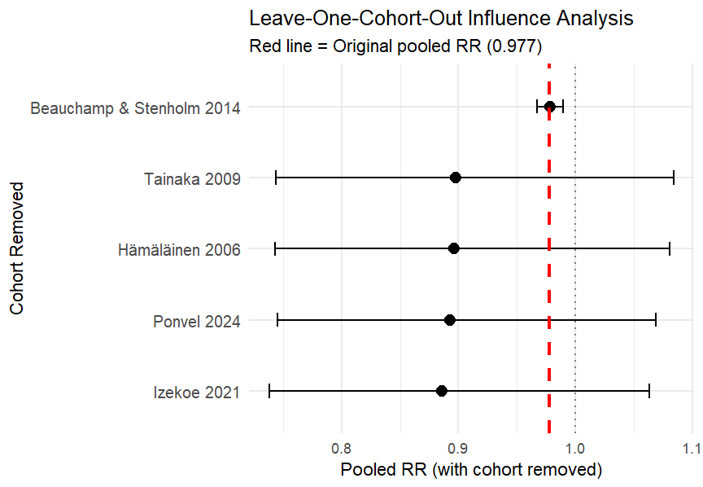
Leave One Out Plot for Mobility Limitations and Frailty Risk Analysis

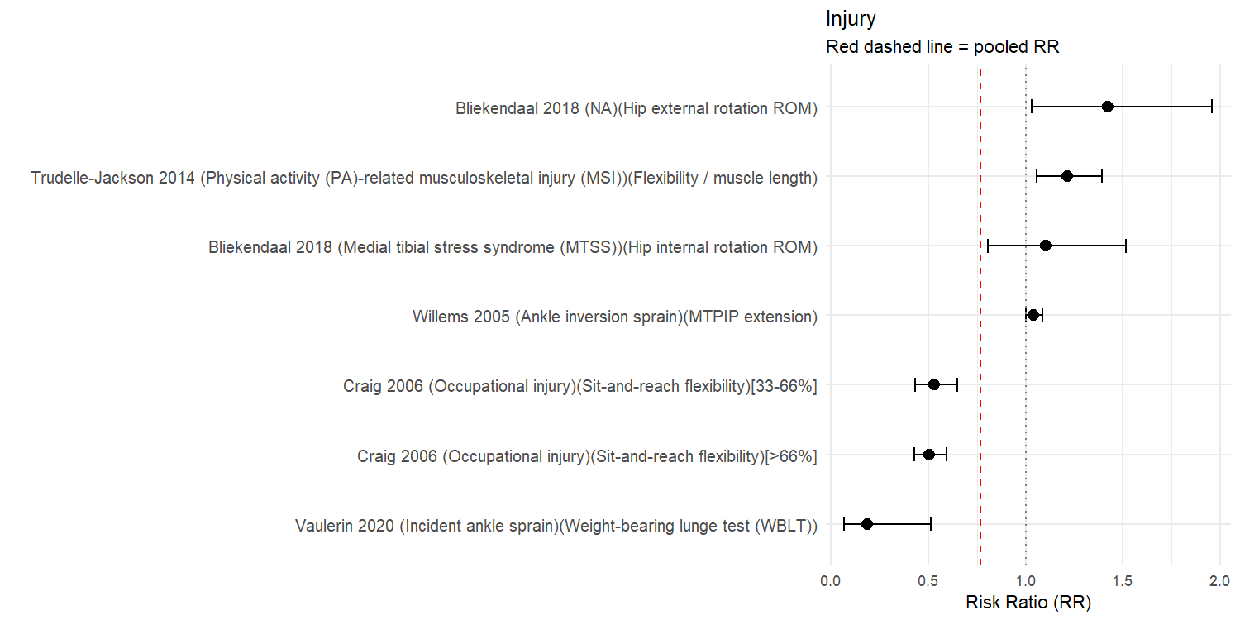
Forest Plot for Injury

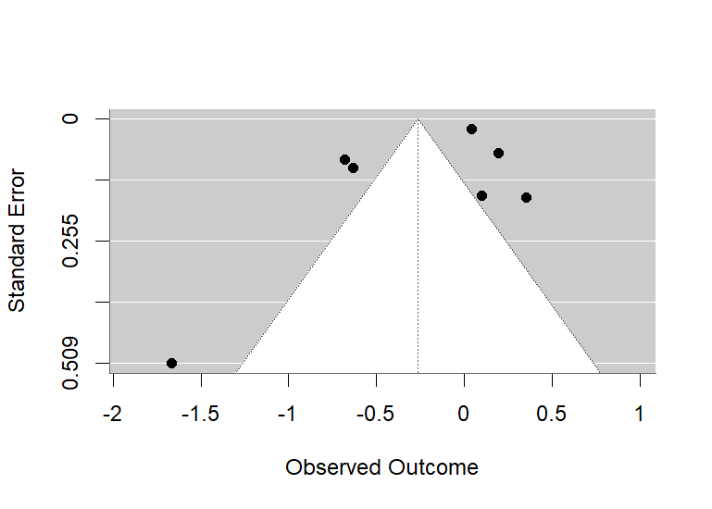
Funnel Plot for Injury Risk Analysis

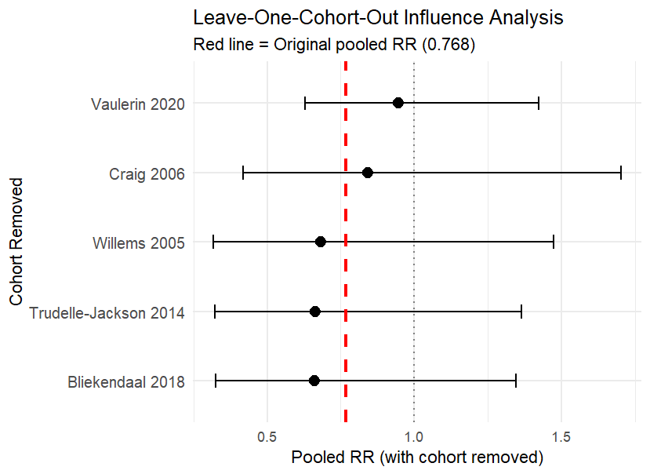
Leave One Out Plot for Injury Risk Analysis

