Supporting Information
Hanwen Liu¹, Ying Zhu², Haibo Cai^{1, *}, Yongchun Zhou^{2, *}
¹State Key Laboratory of Bioreactor Engineering, East China University of Science and Technology, 130 Meilong Road, Shanghai 200237, China.ORCID: 0000-0001-6449-8643.
²Shanghai Chemo Wanbang Biopharma Co., LTD. 1098 Yuegong Road, Shanghai 201508, China.
*Corresponding authors: Haibo Cai, E-mail address: caihaibo@ecust.edu.cn
Yongchun Zhou, E-mail address: zhouyc@chemowanbang.cn

Table1 Primer sequences for the SV40 promoter
Primer | Sequences（5’→3’）
SV40-F | GGTCGACCATCTCAATTAGTCAGCAACCATA
SV40-R | GCTGAGCTCTTGCAAAAGCCTAGGCCTT
Table 2 Primer sequences for the MAR
Primer | Sequences（5’→3’）
iMAR-F1 | CGACGCACGCGTGAATTCAGCAAGGTCG
iMAR-F2 | AAGCTTCGAATTCAGCAAGGTCGCCACGC
iMAR-R1 | GTCGACCAATAATCAATGTCCTATCAAGATA
iMAR-R2 | GGCGGCCGCAAATCTACTATCAAGATATTTA
gMAR-F1 | CGACGCACCGTGTCATCAAACAGAGAAAAAAGT
gMAR-F2 | AAGCTTCGTGTCATCAAACAGAGAAAAAAGT
gMAR-R1 | GCGTCGACTTAATTGGTTAAAAAAAATT
gMAR-R2 | TTGCGGCCGCCTTAATTGGTTAAAAAAAATTAT
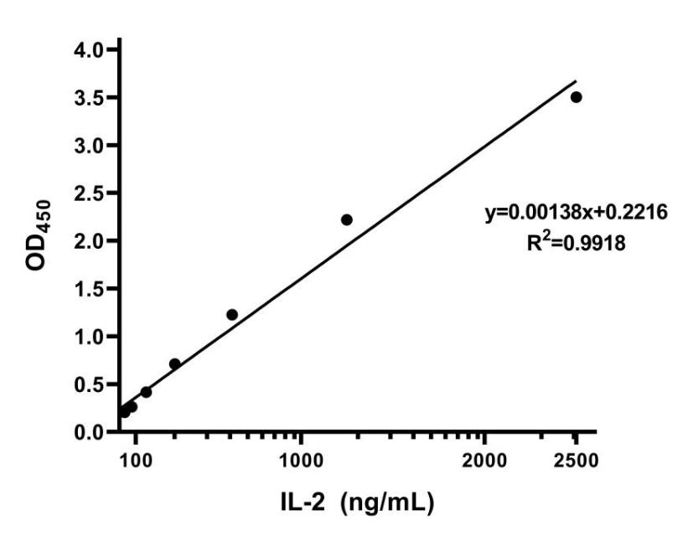
Fig. 1 Standard curves of IL-2 fusion protein

Table 3 Central combination experiment of selected variable range
Symbol | Factor | Level
 |  | -1 | 0 | +1
A |  | 1: 1 | 1: 2 | 1: 3
  DNA-to-PEI ratio
B | DNA-PEI incubation time (min) | 5 | 10 | 15
Table 4 Experimental design with Minitab
Experiment No. | DNA-to-PEI ratio | DNA-PEI incubation time
1 | -1 | -1
2 | 0 | 1
3 | 1 | 1
4 | -1 | 1
5 | 1 | 0
6 | 1 | -1
7 | -1 | 0
8 | 0 | -1
9 | 0 | 0
Table 5 Result of expansion of IL-2 Fc concentration
Experiment No. | DNA-to-PEI ratio | DNA-PEI incubation time | IL-2 fusion protein expression level (ng/mL)
1 | 1: 1 | 5 | 586.46
2 | 1: 2 | 15 | 632.25
3 | 1: 3 | 15 | 554.73
4 | 1: 1 | 15 | 592.64
5 | 1: 3 | 10 | 662.45
6 | 1: 3 | 5 | 599.17
7 | 1: 1 | 10 | 634.45
8 | 1: 2 | 5 | 646.91
9 | 1: 2 | 10 | 690.47

