Supplementary materials

Supplementary Figure 1. Flow diagram
Supplementary Figure 2. Association between relative grip strength and metabolic risk indicators across age groups
Supplementary Figure 1. Flow diagram
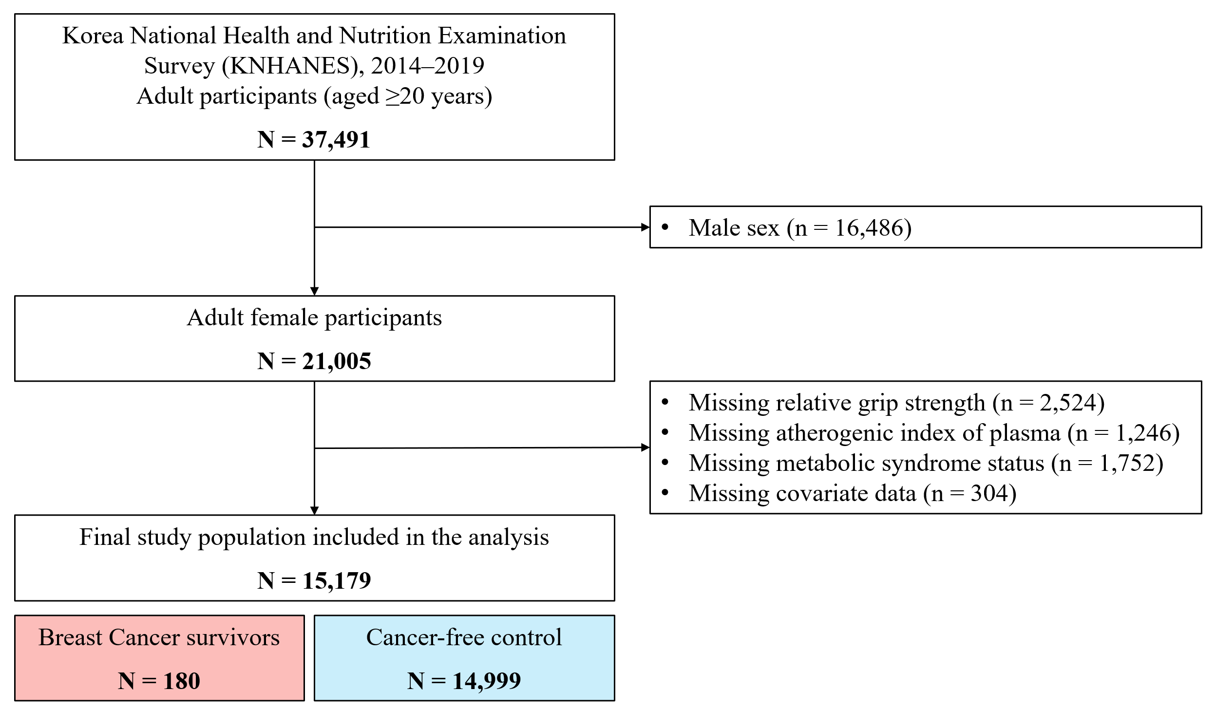

Supplementary Figure 2. Association between relative grip strength and metabolic risk indicators across age groups
