Table 5 Comparative ROC curves of SUVmax and SUVmax/THKmax for differential diagnosis between gastriclymphoma and gastric carcinoma.
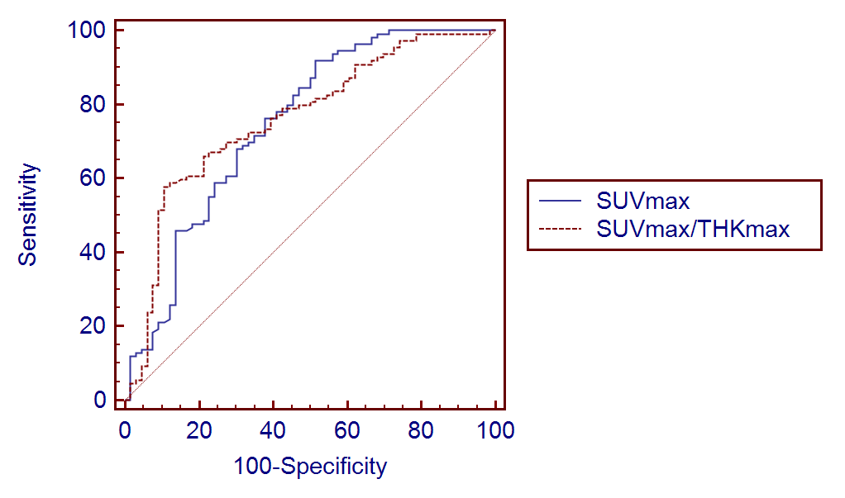
 | AUC | SE | 95%CI
SUVmax | 0.747 | 0.0404 | 0.676 to 0.809
SUVmax/THKmax | 0.760 | 0.0381 | 0.690 to 0.821

 | Sensitivity | Specificity | the best cutoff
SUVmax | 91.7% | 48.5% | 16.13
SUVmax/THKmax | 57.8% | 89.4% | 0.4155
ROC: Receiver-operating characteristic;SUVmax: Maximal standard uptake value; THKmax: Maximal thickness

