Supporting Information
Enhancement in the yield and properties of cellulose nanocrystals by two-batch addition of ammonium persulfate
Zhangyun Chen, Zhongyuan Xie, Hua Jiang*
College of Chemical Engineering, Nanjing Forestry University, Nanjing 210037, China

M1 The procedures for conductometric titrations
CNCs (50 mg) were suspended in 10 ml of 0.01 mol.l⁻¹ HCl solution and ultrasonicated for 5 min to disperse them. The suspension was then titrated against 0.01 mol.l⁻¹ NaOH. The carboxyl content (mmol/g) is given by the following equation:
$CC (mmol/g)=\frac{c×(V_{2}-V_{1})}{m}$ (1)
where c is the NaOH concentration (mol.l⁻¹), V₁ and V₂ are the amount of NaOH (ml), corresponding to the first and the second inflection points in the titration curve, respectively; m is the weight of the dried sample (g).
M2 The calculation for the crystallite parameters
The average size of crystallite and the d-spacing were calculated from the Scherrer’s and Bragg’s equations, respectively.
$L_{(hkl)}=\frac{kλ}{B_{(hkl)}cosθ}$ （2）
$d_{(hkl)}=\frac{λ}{2sinθ}$ （3）
where (hkl) is the lattice plane, L(hkl) is the size of crystallite, k isthe Scherrer’s constant (0.94), λ is the X-ray wavelength (0.154 nm), B _{3.} is the FWHM (full width half maximum) of the measured hkl reflection and 2θ is the corresponding Bragg’s angle. d_{(hkl)}is the d-spacing of the lattice plane _{(hkl)}.
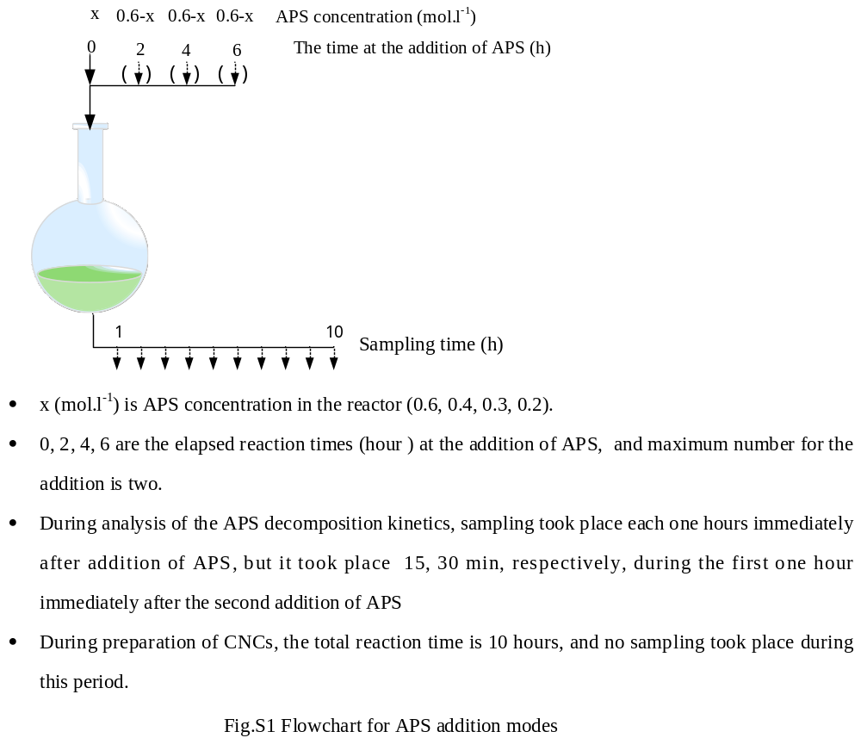

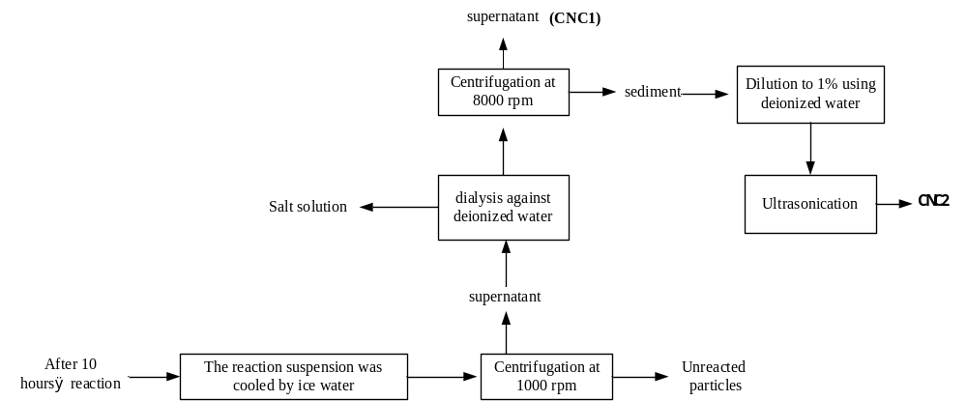

Fig. S2 The procedures for the separation of CNCs from the reaction suspension

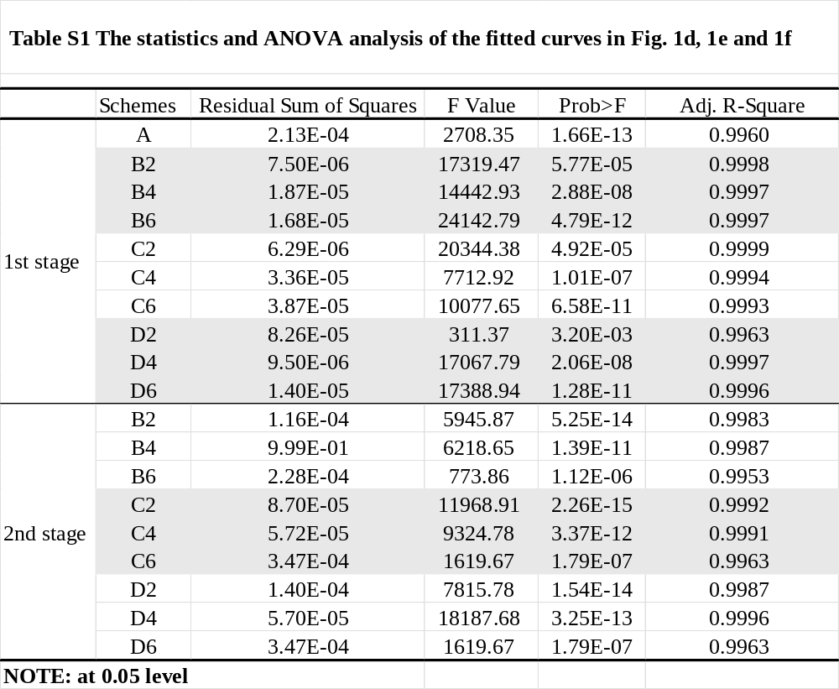

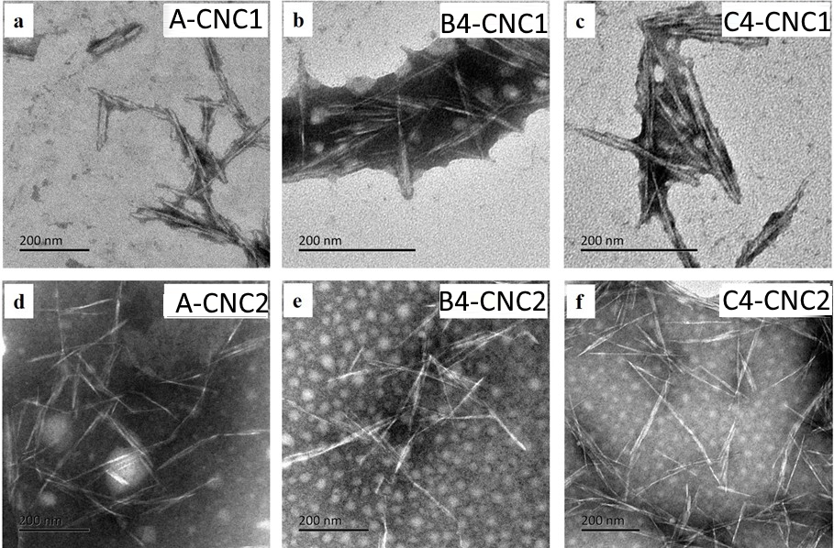
Fig. S3. TEM images of the CNCs.

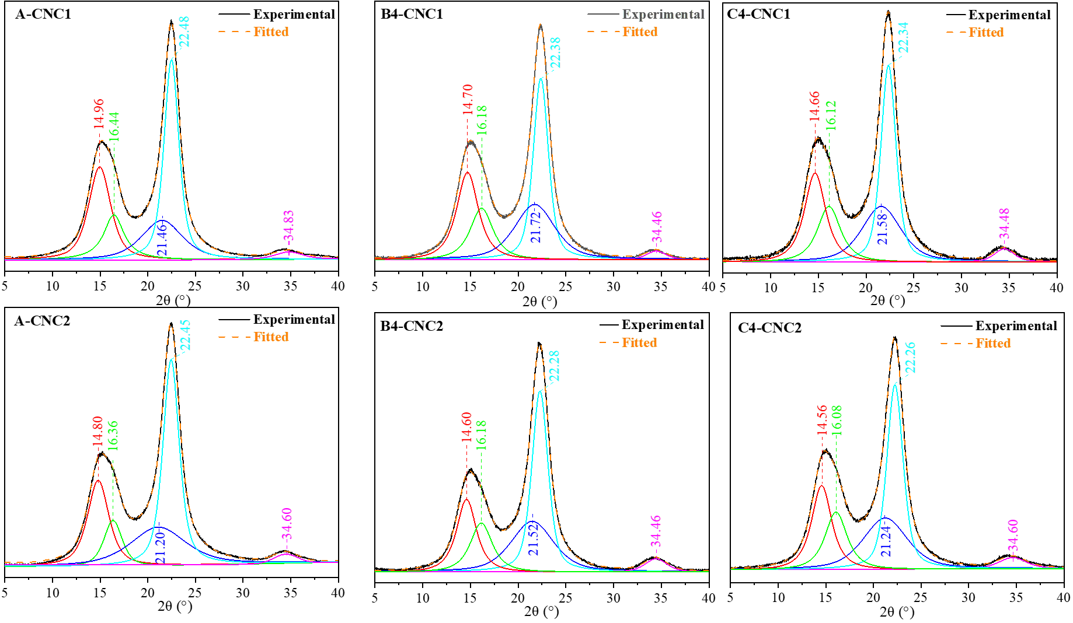
Fig. S4 The XRD patterns of the CNCs

* Correspondence: E-mail: jianghua@njfu.edu.cn

