Combined Survey Questionnaires Administered to Students, Patients, and Faculty

Student Survey Questions

Questions: |  | Answer Choices:
1 | How many weeks have you completed in your M3 year? | - 0 weeks  - 1-4 weeks  - 5-8 weeks  - 9-12 weeks  - 13-16 weeks  - 17-20 weeks  - 21-24 weeks
2 | What rotations have you completed to date? | - Pediatrics  - Ob/Gyn  - Neurology  - Psychiatry  - Surgery
3 | Did your work in this clinic improve…  - Your interest in primary care?  - Your communication skills?  - Your ability to develop an assessment and plan?  - Your confidence in caring for patients?  - Your ability to participate in continuity of care (including face-to-face, telephone encounters, telemedicine, and portal messages)?  - Opportunities to be directly observed?  - Opportunities for feedback?  - The amount of time you have to conduct a history and physical exam on each patient?  - Your ability to complete novel/unfamiliar clinical skills/maneuvers? | Use the following rating scale:  - Much Worse  - Worse  - No Change  - Improved  - Much Improved
4 | Would you recommend this experience to other students? | - Definitely would recommend  - Probably would recommend  - Neutral  - Probably would not recommend  - Definitely would not recommend
5 | What 3 words would describe your experience in this clinic model? | Free response

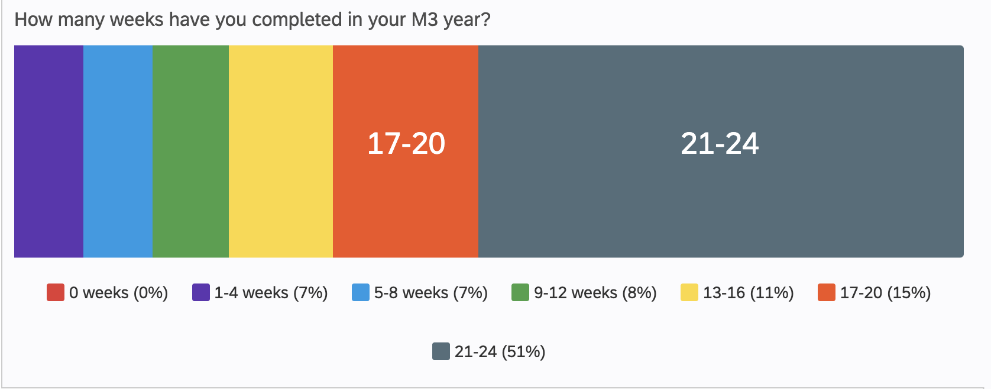

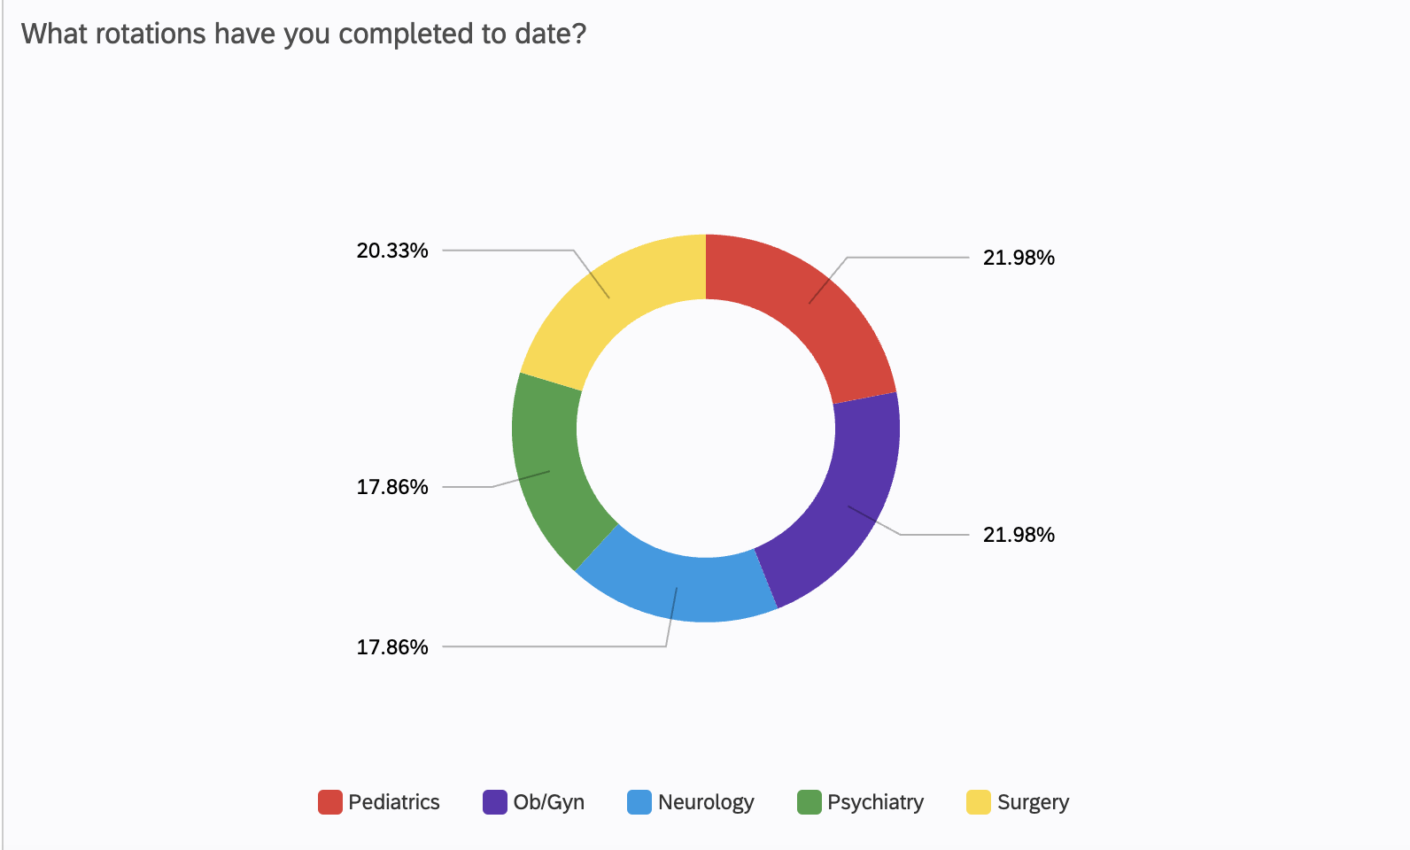

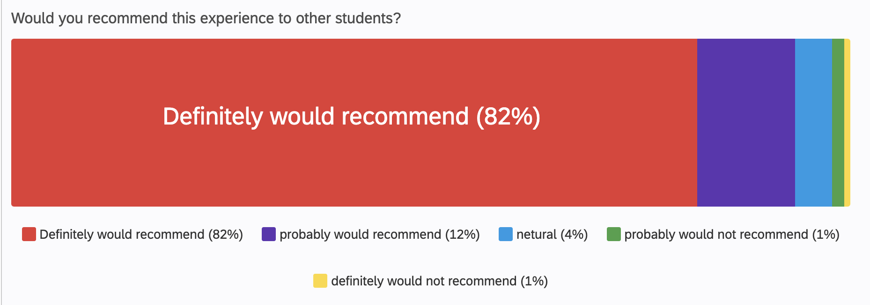

Patient Survey Questions

Rate your level of satisfaction (#1-5) regarding your health care team’s ability to:

- Address all your important medical problems.
- Adequately explain your care.
- Answer your questions during the visit.
- Explain your follow-up care.
- Rate your level of satisfaction (#1-5) with your interaction with the medical students

Rating Number: | Level of Satisfaction
1 | Extremely dissatisfied
2 | Somewhat dissatisfied
3 | Neither satisfied nor dissatisfied
4 | Somewhat satisfied
5 | Extremely satisfied

Faculty Survey Questions

Did your work in the new student clinic model provide adequate time to:
 | Question: | Answer Choices:
1 | Teach your patients | - Strongly agree  - Somewhat agree  - Neither agree nor disagree  - Somewhat disagree  - Strongly disagree
2 | Interact with patients
3 | Provide excellent care to patients
4 | Teach your student
5 | See your student grow related to essential skills and cases
6 | Have your student interview the patients prior to you seeing the patient
7 | Observe your student taking a history, perform a physical exam and/or provide counseling?
8 | Provide your student with feedback
9 | Would you recommend this clinic teaching model to other practices/clinical sites?
10 | What 3 words would describe your experience in this clinic model? | Free Response (Student-generated Word Cloud) as seen in Figure 1 in manuscript

