Proteomic Changes With Histological Changes 5-Years After Kidney Transplantation: Insights Into Disease Mechanisms In Obese Diabetic Recipients

Supplemental Methods and Results
Supplemental Methods
1. Baseline characteristics and immunosuppression
The most used maintenance protocol included tacrolimus, mycophenolate mofetil (MMF), +/- prednisone. Per protocol, the target tacrolimus trough is 8-10 ng/ml for the first month post-transplant and 6-8 ng/ml thereafter. MMF was initiated at a dose of 750mg twice daily and adjusted by treating physician for complications including rejection, BK viremia, infections, or leukopenia.
2.Histology
A 3µm thick section was cut from the FFPE block, stained with Mason Trichrome (TRI) and scanned into high-resolution digital image (Aperio® AT2 system scanner, Leica Microsystems, Inc., Buffalo Grove, IL; http:/www.aperio.com). One investigator morphometrically analyzed digital images, masked to clinical characteristics to minimize bias. The scanned digital images were magnified with Image Scope software (version 12.2.2.5015 Aperio®) onto a large touch-screen tablet. Trichrome stained slides were used to obtain percent interstitial fibrosis (IF)(1). Additionally, the total areas of all traced regions containing IF were divided by the area of cortex. From the number and areas of each individually traced fibrotic focus we calculated mean fibrotic focus area.
3. Morphometry in Kidney Histology
Briefly, high resolution digital images of PAS- and Mason Trichrome-stained biopsy sections were opened in Image Scope software (Aperio, version 12.4.3), and cortex, non-sclerosed glomeruli (NSG), globally sclerosed glomeruli (GSG), ischemic-appearing glomeruli, distinct inflammation and interstitial fibrosis and tubular atrophy (IFTA) foci were manually traced on large tablets. We identified ischemic-appearing glomeruli by the presence of periglomerular fibrosis, Bowman’s capsule thickening, and a wrinkled tuft (2). From the number of GSG and all glomeruli, we calculated the percentage of GSG. From the number of ischemic-appearing glomeruli and all non-sclerosed glomeruli, we calculated the percentage that was ischemic-appearing. The mean volume of all non-sclerosed glomeruli (including those that were ischemic-appearing) was calculated using the stereologic models(3). Mean cross-sectional tubular area was calculated by dividing the areas of all tubules in a 1mm² area of sampled cortex, by the number of all tubules, as previously reported (4). Percentage of inflammation was calculated by dividing the total area of all inflammation foci by the cortex area(5). Percentage of IFTA was calculated by diving the total area of all IFTA foci by the cortex area, and IFTA foci density was calculated by dividing the number of distinct IFTA foci by the cortex area (5). The three measures of mesangial expansion were available from the prior study (6, 7). The percentage of luminal stenosis due to arteriosclerosis was determined from the area of intima divided by the area of both intima and lumen (8). Finally, arteriolar hyalinosis density was calculated by dividing the number of AH lesions with the area of cortex.

4.1. Glomerular Extracellular Matrix -Enriched Samples
The analysis of extracellular matrix (ECM)-enriched was conducted using Triton X-100–insoluble pellet digests and liquid chromatography-mass spectrometry (LCMS). The eluate (the liquid of interest that results from the elution process) was introduced via a Nanospray Flex ion source (Thermo Fisher Scientific) into an Orbitrap Elite mass spectrometer with electron transfer dissociation capabilities (Thermo Fisher Scientific). Data acquisition was performed using the Nth Order Double Play feature in Xcalibur Software (version 2.2; Thermo Fisher Scientific). Fourier transform mass spectrometry (FTMS) MS1 scans were collected at a resolution of 240,000 across a mass-to-charge (m/z) range of 300 to 2000. Ion trap mass spectrometry (MS2) scans were acquired for up to 20 peaks per MS1 scan, with a minimum signal threshold of 5000 counts.
4.2. Tissue collection
Samples were 10um thick FFPE sections on PEN membrane slides and approximately 500 square micron areas were collected by laser capture microdissection (LCM) using a Zeiss PALM scope into 0.5ml tube caps containing 35ul 100mM Tris pH 8.2 / 0.005% Zwittergent 3-16 buffer.
4.3. Mass Spectrometry Data Analysis
The LCM captured samples were heated at 98°C for 60 minutes for the protein extraction step then processed using TCEP and iodoacetamide for reduction and alkylation followed by trypsin (Promega) digestion overnight. The extracted peptides were identified by nano-flow liquid chromatography electrospray tandem mass spectrometry (nanoLC-ESI-MS/MS) using a ThermoFinnigan QExactive Mass Spectrometer (Thermo Fisher Scientific, Bremen, Germany) coupled to a Thermo Ultimate 3000 RSLCnano HPLC system. Each digest peptide mixture was loaded onto a 330nl OPTI-PAK trap (Optimize Technologies, Oregon City, OR) packed with Halo 2.7um ES-C18 solid phase and chromatography was performed running a 2%B to 40%B gradient over 95 minutes with 0.2 % formic acid in both the A solvent (98%water/2%acetonitrile) and B solvent (80% acetonitrile/10% isopropanol/10% water) at 400 nl/min through a hand packed PicoFrit (New Objective, Woburn, MA) 100μm x 300mm column (Agilent PoroShell EC-C18, 2.7um). The Q-Exactive mass spectrometer experiment was a data dependent set up with a MS1 survey scan from 340-1600 m/z at resolution 70,000 (at 200m/z), followed by HCD MS/MS scans on the top 20 ions having a charge state of +2, +3, or +4, at resolution 17,500. The ions selected for MS/MS are placed on an exclusion list for 30 seconds. The MS1 AGC target is set to 3e6 and the MS2 target is set to 1e5 with max ion inject times of 150ms and 70ms respectively.
The raw data was processed with MaxQuant (2.0.3.0) using Andromeda search engine against the Swissprot human database, (ver. 2024_04) with a reverse version as a decoy database. The search parameters required full trypsin specificity, with carbamidomethyl cysteine as a fixed modification and oxidized methionine and protein N-terminal acetylation as variable modifications. Match between runs was active and iBAQ values were generated. Protein and peptide identifications were filtered at a 1% false discovery rate. The iBAQ values were median normalized and log2 transformed, then compared by student T-test analysis.
Supplemental Results
3.1 Proetomic Analysis
The median number of glomeruli dissected was 25 [IQR - 12] for DM/OB and 27.5 [IQR - 5.5] for nDM/nOB (p = 0.606), the median glomerular area was 535,296 [26,106] µm² for DM/OB and 533,932 [95,257] µm² for nDM/nOB (p = 0.747), and the median non-glomerular area was 517,610 [30,071] µm² for DM/OB and 524,510 [98,689] µm² for nDM/nOB (p = 0.822).

Supplemental Table 1: List of proteins expressed in Figure 2A
Gene | Protein name | Fold Change | Log10  P value | P value
EEF1B2 | Eukaryotic Translation Elongation Factor 1 Beta 2 | 6,22 | 1,41 | 0,0390
SPRR2A | Small Proline-Rich Protein 2A | 4,50 | 1,33 | 0,0472
LNP | Lunapark Endoplasmic Reticulum Morphology Regulator | 4,41 | 1,36 | 0,0433
POSTN | Periostin | 3,38 | 2,28 | 0,0052
SPRR1B | Small Proline-Rich Protein 1B | 2,99 | 2,51 | 0,0031
TNC | Tenascin | 2,96 | 2,46 | 0,0035
CFHR5 | Complement Factor H Related 5 | 2,67 | 1,43 | 0,0370
VDAC1 | Voltage-dependent anion-selective channel protein 1 | 2,59 | 2,44 | 0,0036
S100A8 | S100 Calcium Binding Protein A8 | 2,22 | 1,75 | 0,0179
PXDN | Peroxidasin | 2,05 | 2,42 | 0,0038
PIP | Phosphatidylinositol 5-phosphate 4-kinase type-2 gamma | 1,96 | 1,34 | 0,0457
COL15A1 | Collagen Type XV Alpha 1 Chain | 1,93 | 1,81 | 0,0157
COL6A1 | Collagen alpha-1(VI) chain | 1,84 | 2,27 | 0,0053
CTSG | Cathepsin G | 1,82 | 1,30 | 0,0497
S100A9 | S100A9 | 1,73 | 1,30 | 0,0499
IGHA2 | IGHA2 | 1,71 | 3,42 | 0,0004
TGFBI | Transforming growth factor-beta-induced protein ig-h3 | 1,69 | 3,01 | 0,0010
COL6A3 | Collagen alpha-3(VI) chain | 1,62 | 1,93 | 0,0119
COL6A2 | Collagen alpha-2(VI) chain | 1,61 | 1,61 | 0,0247
ATP12A | ATPase H⁺/K⁺ Transporting Non-Gastric Alpha Subunit | 1,59 | 1,47 | 0,0340
IGLC3 | Immunoglobulin Lambda Constant 3 | 1,58 | 3,10 | 0,0008
C9 | Complement component C9 | 1,57 | 1,50 | 0,0314
BDH2 | 3-Hydroxybutyrate Dehydrogenase Type 2 | 0,59 | 1,74 | 0,0182
NFASC | Neurofascin | 0,59 | 1,54 | 0,0285
CR1 | Complement receptor type 1 | 0,59 | 1,58 | 0,0264
HIST1H2BA | Histone Cluster 1 H2B Family Member A | 0,59 | 1,69 | 0,0206
PODXL | Podocalyxin-like Protein 1 | 0,59 | 1,69 | 0,0202
DMGDH | Dimethylglycine Dehydrogenase | 0,58 | 1,47 | 0,0342
PCBD1 | Pterin-4 Alpha-Carbinolamine Dehydratase 1 | 0,58 | 2,23 | 0,0059
H2AFV | H2A Histone Family Member V | 0,57 | 1,45 | 0,0354
SLC4A1 | Solute Carrier Family 4 Member 1 | 0,57 | 1,58 | 0,0263
CYB5A | Cytochrome b5 Type A | 0,57 | 1,41 | 0,0385
FTL | Ferritin Light Chain | 0,56 | 1,35 | 0,0448
KIRREL | Kin of IRRE-like Protein 1 | 0,56 | 1,32 | 0,0474
HMGB1 | High Mobility Group Box 1 | 0,56 | 1,56 | 0,0274
BLVRB | Biliverdin Reductase B | 0,55 | 1,45 | 0,0355
PKP4 | Plakophilin 4 | 0,55 | 1,41 | 0,0390
CKB | Creatine Kinase B-type | 0,55 | 1,76 | 0,0175
CA2 | Carbonic anhydrase 2 | 0,54 | 1,69 | 0,0203
ACAA2 | 3-ketoacyl-CoA thiolase | 0,53 | 1,74 | 0,0181
PARD3B | Partitioning Defective 3 Homolog B | 0,52 | 1,63 | 0,0233
ASL | Argininosuccinate lyase | 0,50 | 1,87 | 0,0135
HBA1 | Hemoglobin Subunit Alpha 1 | 0,45 | 3,20 | 0,0006
CA1 | Carbonic anhydrase 1 | 0,44 | 2,13 | 0,0075
KHK | Ketohexokinase (Fructokinase) | 0,43 | 1,81 | 0,0156
SUCLG1 | Succinyl-CoA Ligase Subunit Alpha | 0,43 | 1,81 | 0,0156
DDC | Dopa Decarboxylase | 0,42 | 1,32 | 0,0475
TJP2 | Tight Junction Protein 2 | 0,39 | 1,52 | 0,0299
ANK1 | Ankyrin-1 | 0,37 | 3,05 | 0,0009
FABP1 | Fatty Acid Binding Protein 1 (Liver) | 0,32 | 1,31 | 0,0495
UGDH | UDP-Glucose 6-Dehydrogenase | 0,31 | 1,31 | 0,0490
GGACT | γ -glutamylaminecyclotransferase | 0,30 | 5,07 | <0.00001
PSMD9 | Proteasome 26S Non-ATPase Regulatory Subunit 9 | 0,27 | 1,31 | 0,0493
MRPS36 | Mitochondrial Ribosomal Protein S36 | 0,27 | 1,53 | 0,0295
MARCKSL1 | Myristoylated Alanine Rich Protein Kinase C Substrate-Like 1 | 0,27 | 1,37 | 0,0428
ALAD | Delta-aminolevulinic acid dehydratase | 0,27 | 1,34 | 0,0462
HDGFRP3 | Hepatoma-Derived Growth Factor-Related Protein 3 | 0,27 | 1,43 | 0,0371
G3BP2 | Ras GTPase-Activating Protein-Binding Protein 2 | 0,26 | 1,33 | 0,0468
LRRFIP1 | eucine-Rich Repeat Flightless-Interacting Protein 1 | 0,25 | 1,32 | 0,0476
GGT1 | Gamma-Glutamyltransferase 1 | 0,25 | 1,64 | 0,0228
PAK1 | p21 (RAC1) Activated Kinase 1 Quinase | 0,24 | 1,54 | 0,0291
C1QBP | Complement Component 1 Q Subcomponent-Binding | 0,24 | 1,37 | 0,0429
EPHX2 | Epoxide Hydrolase 2 | 0,22 | 1,81 | 0,0154
NDUFV2 | NADH:Ubiquinone Oxidoreductase Core Subunit V2 | 0,22 | 1,32 | 0,0480
APOM | Apolipoprotein M | 0,22 | 1,66 | 0,0218
NDUFV1 | NADH:Ubiquinone Oxidoreductase Core Subunit V1 | 0,21 | 1,41 | 0,0386
LTBP1 | Latent Transforming Growth Factor Beta Binding Protein 1 | 0,21 | 1,44 | 0,0366
CARKD | Carbohydrate Kinase Domain-Containing | 0,21 | 1,66 | 0,0217
PDXK | Pyridoxal Kinase | 0,21 | 1,66 | 0,0217
DUSP3 | Dual Specificity Phosphatase 3 Fosfatase | 0,21 | 1,52 | 0,0300
LUC7L2 | LUC7 Like 2 Pre-mRNA Splicing Factor | 0,20 | 1,56 | 0,0274
UQCRQ | Ubiquinol-Cytochrome c Reductase, Complex III Subunit VII | 0,20 | 1,72 | 0,0192
FDPS | Farnesyl Diphosphate Synthase | 0,19 | 1,38 | 0,0414
SPTA1 | Spectrin Alpha Chain, Erythrocytic 1 | 0,19 | 1,84 | 0,0143
TYRO3 | TYRO3 Protein Tyrosine Kinase | 0,19 | 1,45 | 0,0352
SNRPA1 | Small Nuclear Ribonucleoprotein Polypeptide A | 0,19 | 1,47 | 0,0339
EIF3E | Eukaryotic Translation Initiation Factor 3 Subunit E | 0,19 | 1,66 | 0,0220
NADK2 | NAD Kinase 2 (Mitochondrial) | 0,19 | 1,41 | 0,0389
RBM4 | RNA Binding Motif Protein 4 | 0,17 | 1,52 | 0,0302
HIST1H2AC | Histone Cluster 1 H2A Family Member C | 0,16 | 1,41 | 0,0389
NDUFB9 | NADH dehydrogenase 1 beta subunit 9 | 0,15 | 2,04 | 0,0091
F12 | Coagulation Factor XII | 0,14 | 1,85 | 0,0141
SNCA | Alpha-Synuclein | 0,14 | 1,83 | 0,0149
NDUFS4 | NADH dehydrogenase iron-sulfur protein 4 | 0,13 | 1,84 | 0,0144
PLCB3 | Phospholipase C Beta 3 | 0,13 | 1,58 | 0,0266
GPRIN3 | G Protein Regulated Inducer of Neurite Outgrowth 3 | 0,12 | 2,09 | 0,0081
BPGM | Bisphosphoglycerate Mutase | 0,12 | 1,88 | 0,0131
HLA-DPB1 | Major Histocompatibility Complex, Class II, DP Beta 1 | 0,11 | 1,87 | 0,0135
H2AFY2 | H2A Histone Family, Member Y2 | 0,11 | 1,98 | 0,0104
IFITM3 | Interferon-Induced Transmembrane Protein 3 | 0,11 | 1,73 | 0,0187
GCHFR | GTP Cyclohydrolase 1 Feedback Regulator | 0,08 | 2,42 | 0,0038
DAD1 | Defender Against Cell Death 1 | 0,08 | 1,92 | 0,0119
Supplementary Table 1 lists glomerular proteins that are differentially expressed in diabetic/obese (DM/OB) patients compared to non-diabetic/non-obese (nDM/nOB) controls. Protein expression differences are presented as fold change: values greater than 1.0 indicate higher abundance in DM/OB, while values less than 1.0 indicate lower abundance relative to the nDM/nOB group.

Supplemental Table 2: List of proteins expressed in Figure 2B.
Gene | Protein name | Fold Change | Log10  P value | P value
SIPA1L1 | Signal-Induced Proliferation-Associated 1 Like 1 | 25,32 | 1,87 | 0,0136
KRTAP2-1 | Keratin - Contamination | 15,23 | 1,47 | 0,0342
EFHD2 | EF-Hand Domain Containing Protein D2 | 9,83 | 1,48 | 0,0334
CTNNA2 | Catenin Alpha 2 | 9,61 | 1,44 | 0,0362
TMEM192 | Transmembrane Protein 192 | 8,94 | 1,68 | 0,0209
ARF5 | ADP-Ribosylation Factor 5 Proteína GTPase | 8,50 | 1,46 | 0,0351
ATP6V1B1 | ATPase H+ Transporting V1 Subunit B1 | 8,40 | 1,41 | 0,0386
PXN | Paxillin | 8,02 | 1,46 | 0,0350
MYL1 | Myosin Light Chain 1 | 7,71 | 1,49 | 0,0326
AP2A2 | Adaptor-Related Protein Complex 2 Alpha 2 Subunit | 7,32 | 1,33 | 0,0468
ENO3 | Enolase 3 | 7,25 | 1,31 | 0,0485
MRPS23 | Mitochondrial Ribosomal Protein S23 | 6,63 | 1,31 | 0,0493
HSPB6 | Heat Shock Protein Beta-6 | 6,44 | 1,60 | 0,0254
STT3B | Oligosaccharyltransferase Complex | 6,33 | 1,55 | 0,0281
UBE2D3 | Ubiquitin Conjugating Enzyme E2 D3 | 6,29 | 1,39 | 0,0405
FRAS1 | Fraser Extracellular Matrix Complex Subunit 1 | 6,26 | 1,42 | 0,0376
SLC22A12 | Solute Carrier Family 22 Member 12 | 5,94 | 1,34 | 0,0456
GFM1 | G Elongation Factor, Mitochondrial 1 | 5,70 | 1,38 | 0,0421
CD74 | CD74 Molecule - MHC | 5,56 | 1,45 | 0,0355
FLII | Flightless I Actin Binding Protein | 4,88 | 1,35 | 0,0451
ACBD3 | Acyl-CoA Binding Domain Containing 3 | 4,76 | 1,33 | 0,0464
HLA-C | HLA-C | 4,69 | 1,34 | 0,0459
GSTM3 | Glutathione S-Transferase Mu 3 | 4,20 | 1,44 | 0,0367
C8A | Complement Component C8a | 4,09 | 1,54 | 0,0286
C6 | Complement Component 6 | 3,84 | 1,31 | 0,0493
APCS | Serum Amyloid P-component | 2,63 | 2,46 | 0,0035
C5 | Complement Component 5 | 2,54 | 1,78 | 0,0168
C9 | Complement Component 9 | 2,53 | 4,89 | 0,0000
C7 | Complement Component 7 | 2,38 | 3,02 | 0,0009
C8B | Complement Component C8b | 2,30 | 2,40 | 0,0040
AOX1 | Aldehyde Oxidase 1 | 2,25 | 1,69 | 0,0205
TGM2 | Transglutaminase 2 | 2,14 | 2,02 | 0,0096
ARPC1B | Actin Related Protein 2/3 Complex Subunit 1B | 2,06 | 1,56 | 0,0276
CRYAB | Alpha-Crystallin B Chain | 2,06 | 2,23 | 0,0058
SAA1 | Serum Amyloid A1 | 2,03 | 1,64 | 0,0229
USO1 | USO1 Vesicle Transport Factor | 1,99 | 1,45 | 0,0352
RPS15A | Ribosomal Protein S15a | 1,98 | 1,75 | 0,0176
FBLN5 | Fibulin-5 | 1,92 | 1,97 | 0,0106
PCK1 | Phosphoenolpyruvate Carboxykinase 1 | 1,87 | 1,62 | 0,0242
DGLUCY | D-Glucuronyl C5-Epimerase | 1,80 | 1,41 | 0,0389
SORBS1 | Sorbin | 1,79 | 1,73 | 0,0187
VTN | Vitronectin | 1,78 | 3,23 | 0,0006
FLOT1 | Flotillin-1 | 1,78 | 1,75 | 0,0176
CLU | Clusterin | 1,76 | 3,86 | 0,0001
HLA-DRA | HLA-DRA | 1,74 | 3,05 | 0,0009
PCYOX1 | Prenylcysteine Oxidase 1 | 1,72 | 1,79 | 0,0163
NDUFA9 | NADH:Ubiquinone Oxidoreductase Subunit A9 | 1,72 | 1,84 | 0,0143
COL6A1 | Collagen Type VI Alpha 1 Chain | 1,71 | 2,07 | 0,0084
PSAP | Prosaposin | 1,69 | 2,13 | 0,0074
KRT18 | Keratin - Contamination | 1,67 | 3,19 | 0,0006
PSMB1 | Proteasome Subunit Beta Type-1 | 1,65 | 1,70 | 0,0199
EMILIN1 | Elastin Microfibril Interfacer 1 | 1,64 | 2,09 | 0,0081
STT3A | Oligosaccharyltransferase Complex | 1,62 | 1,59 | 0,0259
VIM | Vimentin | 1,62 | 2,18 | 0,0066
ACTR1B | Actin Related Protein 1B | 1,62 | 1,98 | 0,0106
MYLK | Myosin Light Chain | 1,59 | 1,44 | 0,0361
AOC3 | Amine Oxidase Copper-Containing 3 | 1,59 | 1,76 | 0,0174
ESYT1 | Extended Synaptotagmin-1 | 1,58 | 1,87 | 0,0134
RAB6A | Ras-Related Protein Rab-6A | 1,56 | 1,54 | 0,0291
MYL12A | Myosin Light Chain 12A | 1,55 | 3,42 | 0,0004
COPA | Coatomer Subunit Alpha | 1,53 | 2,94 | 0,0011
SHANK3 | SH3 and Multiple Ankyrin Repeat Domains Protein 3 | 0,24 | 1,48 | 0,0331
DDN | Dendrin | 0,24 | 1,58 | 0,0263
DCTN4 | Dynactin Subunit 4 | 0,22 | 1,41 | 0,0386
PDHX | Pyruvate Dehydrogenase Complex Component X | 0,22 | 1,50 | 0,0317
PSPC1 | Paraspeckle Component 1 | 0,13 | 1,71 | 0,0195
ANXA13 | Annexin A13 | 0,11 | 2,10 | 0,0080
NDRG2 | N-Myc Downstream-Regulated Gene 2 | 0,11 | 1,70 | 0,0200
Supplemental Table 2 lists non-glomerular proteins that are differentially expressed in diabetic/obese (DM/OB) patients compared to non-diabetic/non-obese (nDM/nOB) controls. Protein expression differences are presented as fold change: values greater than 1.0 indicate higher abundance in DM/OB, while values less than 1.0 indicate lower abundance relative to the nDM/nOB group.

Supplemental Table 3: Association between proteomics and histopathology (Tervaert Scoring System)
🔺 Upregulated Proteins in DM/OB vs nDM/nOB (ordered by decreasing Fold Change)
Protein (Name) | Fold Change | F Value | P Value
TNC – Tenascin | 2.96 | 5.14 | 0.003
VDAC1 – Voltage-Dependent Anion Channel Protein 1 | 2.60 | 4.56 | 0.040
COL6A3 – Collagen Alpha-3(VI) Chain | 2.24 | 24.83 | < 0.0001
COL15A1 – Collagen Alpha-1(XV) Chain | 1.93 | 13.52 | 0.01
COL6A1 – Collagen Alpha-1(VI) Chain | 1.84 | 23.85 | 0.005
FERMT3 – Fermitin Family Homolog 3 | 1.85 | 11.54 | 0.003
PYGL – Glycogen Phosphorylase | 1.83 | 12.77 | 0.001
COL6A2 – Collagen Alpha-2(VI) Chain | 1.61 | 24.70 | < 0.0001
TGFBI – Transforming Growth Factor-Beta-Induced Protein IG-H3 | 1.63 | 14.12 | 0.001
C9 – Complement Component C9 | 1.57 | 6.05 | 0.020
IGHA1 – Immunoglobulin Heavy Constant Alpha 1 | 1.60 | 6.44 | 0.010
MYADM – Myeloid-Associated Differentiation Marker | 1.60 | 5.30 | 0.030
🔻 Downregulated Proteins in DM/OB vs nDM/nOB (ordered by increasing Fold Change)
Protein (Name) | Fold Change | F Value | P Value
PDXK – Pyridoxal Kinase | 0.21 | 9.09 | 0.005
GGACT – Gamma-Glutamylamine Cyclotransferase | 0.35 | 8.41 | 0.010
TJP2 – Tight Junction Protein ZO-2 | 0.40 | 4.74 | 0.040
FBP1 – Fructose-1,6-Bisphosphatase 1 | 0.50 | 6.54 | 0.010
MAP2 – Microtubule-Associated Protein 2 | 0.54 | 5.87 | 0.020
EPHX2 – Epoxide Hydrolase 2 | 0.57 | 6.84 | 0.010
DAG1 – Dystroglycan 1 (Alpha) | 0.62 | 6.00 | 0.020
Fold change was used to express the relative difference between two groups. Values greater than 1 indicate a higher value in DM/OB compared to nDM/nOB, while values less than 1 indicate the opposite. Multiple tests using ANOVA were applied.

Table 4: Association between proteomics and histopathology (Banff Score - Interstitial fibrosis (ci)
🔺 Upregulated Proteins in DM/OB (ordered by decreasing Fold Change)
Protein (Name) | Fold Change | F Value | P Value
ENO3 – Beta-Enolase | 7.25 | 5.91 | 0.02
HSPB6 – Heat Shock Protein Beta-6 | 6.44 | 6.35 | 0.03
EHD2 – EH Domain-Containing Protein 2 | 2.21 | 7.01 | 0.02
C9 – Complement Component C9a | 2.53 | 4.35 | <0.0001
CRYAB – Alpha-Crystallin B Chain | 2.06 | 4.86 | 0.003
FLII – Protein Flightless-1 Homolog | 2.12 | 4.73 | 0.0003
MYOF – Myoferlin | 2.02 | 4.76 | 0.02
APCS – Serum Amyloid P-Component | 1.88 | 11.13 | 0.001
VTN – Vitronectin V10 Subunit | 1.78 | 5.34 | 0.0004
CLU – Clusterin | 1.76 | 6.03 | 0.0001
VIM – Vimentin | 1.62 | 12.82 | 0.006
FBLN5 – Fibulin-5 (Q9UBX5) | 1.69 | 25.51 | 0.01
MYL12A – Myosin Regulatory Light Chain 12A | 1.64 | 4.21 | 0.0002
SORBS1 – Sorbin and SH3 Domain-Containing Protein 1 | 1.52 | 9.99 | 0.10
EFEMP1 – EGF-Containing Fibulin-Like ECM Protein 1 | 1.51 | 10.23 | 0.02

🔻 Downregulated Proteins in DM/OB (ordered by increasing Fold Change)
Protein (Name) | Fold Change | F Value | P Value
MT1H – Metallothionein-1H | 0.51 | 7.96 | 0.0008
NCLN – Nicalin | 0.51 | 5.48 | 0.01
MT1F – Metallothionein-1F | 0.53 | 5.51 | <0.0001
COA4 – Cytochrome c Oxidase Assembly Factor 4 (Mitochondrial) | 0.62 | 9.80 | 0.004
Fold change was used to express the relative difference between two groups. Values greater than 1 indicate a higher value in DM/OB compared to nDM/nOB, while values less than 1 indicate the opposite. Multiple tests using ANOVA were applied

Supplemental Figures
Supplemental Figure 1A. Histograms of glomerular protein expression in DM/OB individuals
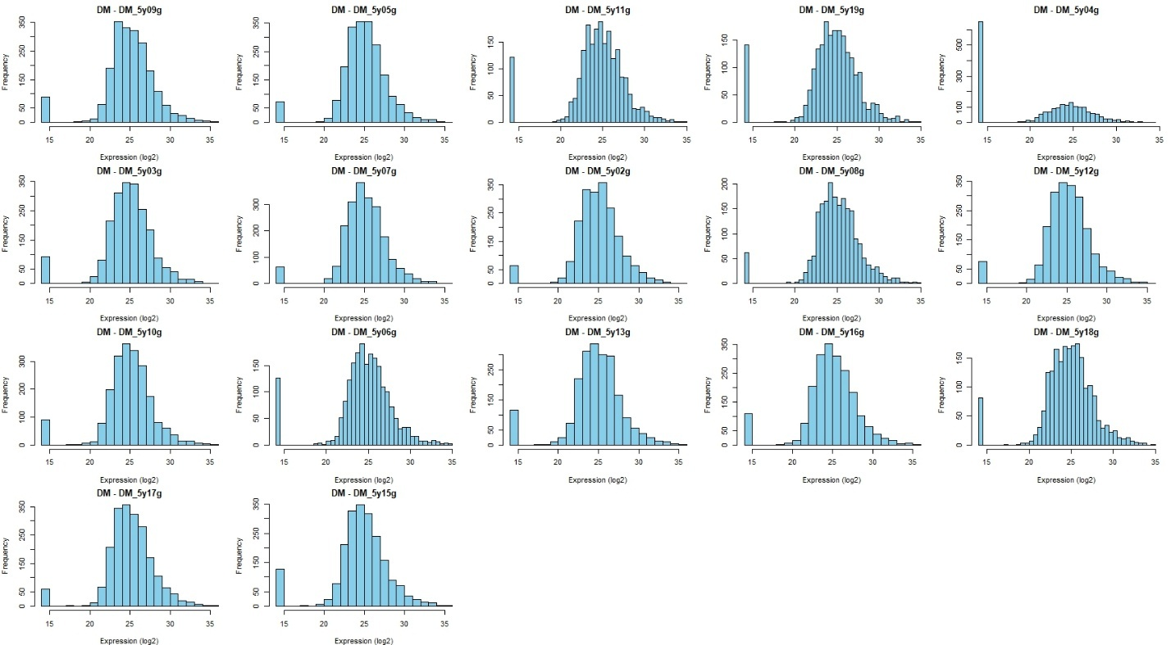
Histograms show the distribution of protein expression values for each diabetic/obese (DM/OB) individual based on glomerular compartment data. Each panel represents a single subject, with expression values distributed approximately normally across most samples. The bar at log₂ = 14 corresponds to imputed missing values, introduced to preserve matrix structure for statistical analysis, and clearly highlights the number of missing data points per individual. This visualization supports the consistency of expression patterns within the DM group and illustrates that imputation had minimal impact on the global distribution shape.

Supplemental Figure 1B. Histograms of glomerular protein expression in nDM/nOB individuals.
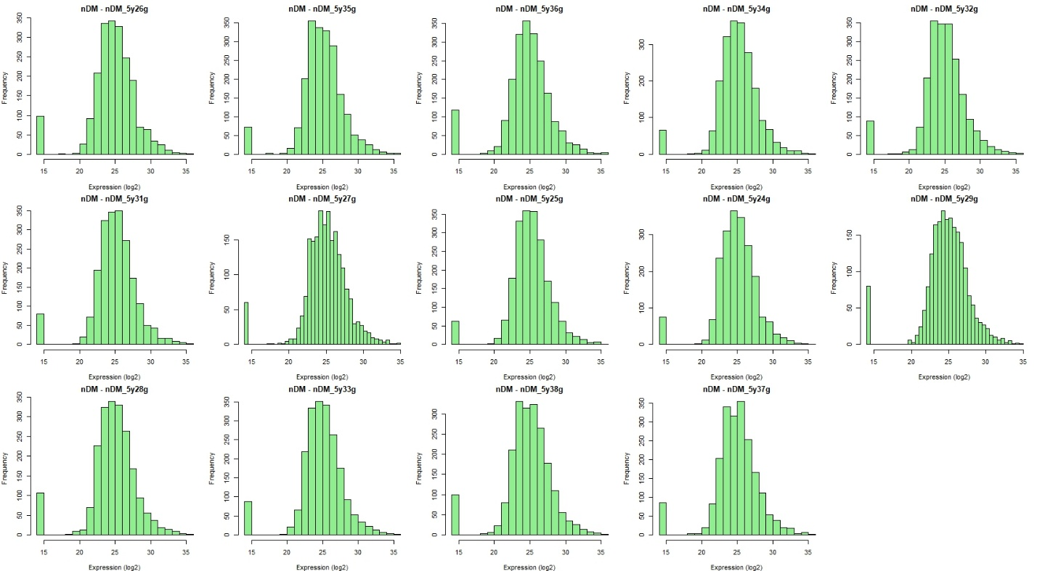
Histograms showing the distribution of protein expression values for each non-diabetic/non-obese (nDM/nOB) individual based on glomerular compartment data. Each panel represents a single subject, with expression values distributed approximately normally across most samples. The bar at log₂ = 14 corresponds to imputed missing values, introduced to preserve matrix structure for statistical analysis, and clearly highlights the number of missing data points per individual. This visualization supports the consistency of expression patterns within the DM group and illustrates that imputation had minimal impact on the global distribution shape.

Supplemental Figure 1C: Histograms of non-glomerular protein expression in DM/OB individuals
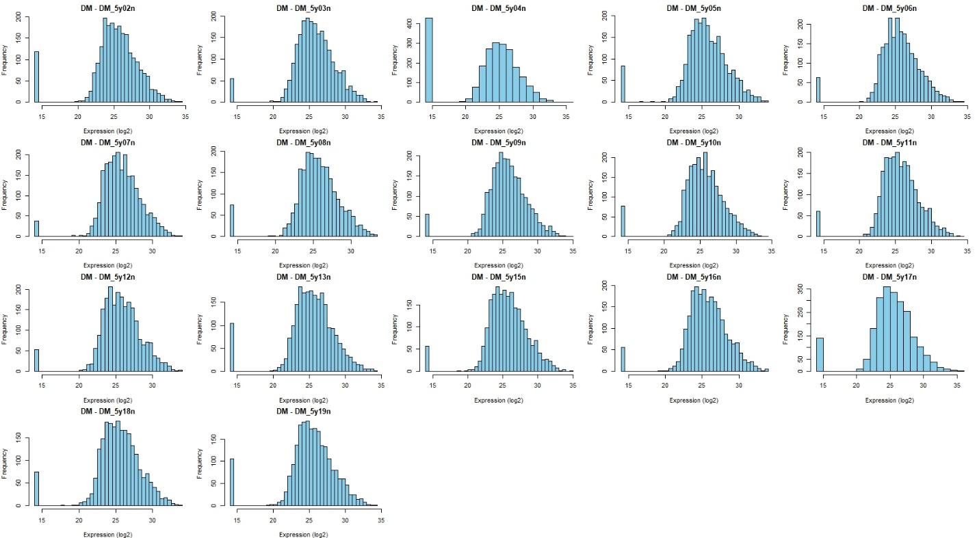
Histograms showing the distribution of protein expression values for each diabetic/obese (DM/OB) individual based on non-glomerular compartment data. Each panel represents a single subject, with expression values distributed approximately normally across most samples. The bar at log₂ = 14 corresponds to imputed missing values, introduced to preserve matrix structure for statistical analysis, and clearly highlights the number of missing data points per individual. This visualization supports the consistency of expression patterns within the DM group and illustrates that imputation had minimal impact on the global distribution shape

Supplemental Figure 1D: Histograms of non-glomerular protein expression in nDM/OB individuals.
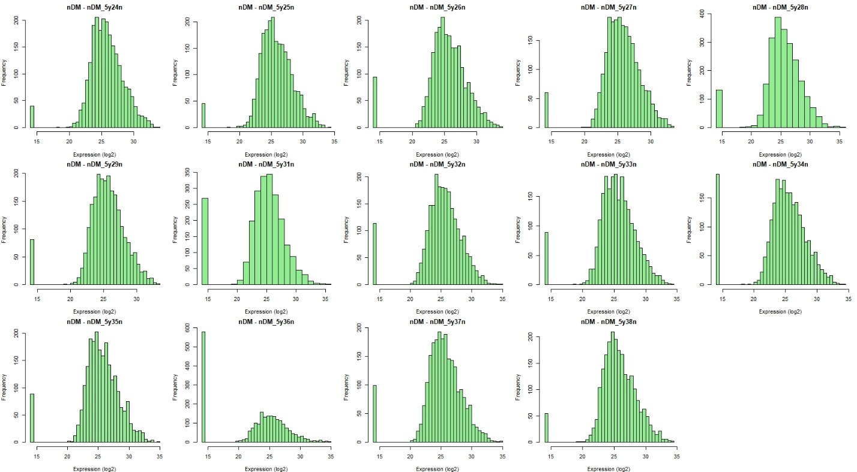
Histograms showing the distribution of protein expression values for each non-diabetic/non-obese (nDM/nOB) individual based on non-glomerular compartment data. Each panel represents a single subject, with expression values distributed approximately normally across most samples. The bar at log₂ = 14 corresponds to imputed missing values, introduced to preserve matrix structure for statistical analysis, and clearly highlights the number of missing data points per individual. This visualization supports the consistency of expression patterns within the DM group and illustrates that imputation had minimal impact on the global distribution shape.

Supplemental Figure 2: Kaplan-Meier survival curves comparing DM/OB and NDM/nOB
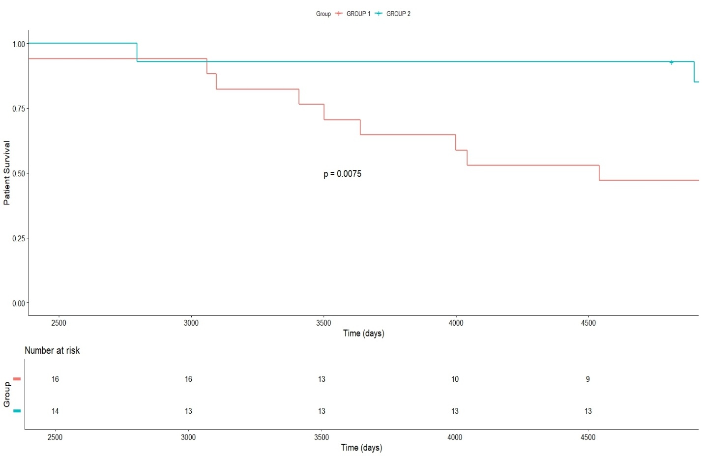
The x-axis represents time in days, and the y-axis represents the probability of patient survival. The p-value (p = 0.0075) from the log-rank test indicates a statistically significant difference between the two groups. Below the curves, the risk table displays the number of patients at risk at each time interval.

Supplemental Figure 3: COL6 Interaction Network Highlighting the Role of TGF-β, C9, VDAC, and TNC in ECM Remodeling and Mesangial Expansion
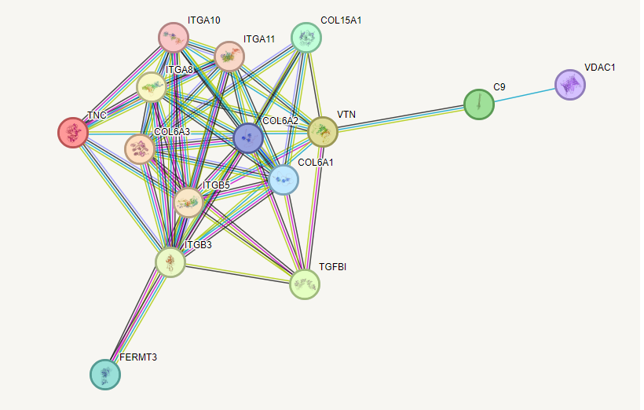
This figure presents the protein-protein interaction network centered around the COL6 family (COL6A1, COL6A2, COL6A3), demonstrating their interconnected roles in extracellular matrix (ECM) dynamics. The regulatory influence of TGF-β1 (TGFB1) on this network is emphasized, aligning with its well-documented contribution to mesangial expansion and fibrotic processes within the glomerulus. Additional proteins, such as C9 and VDAC1, suggest peripheral interactions that may contribute to broader cellular processes, including membrane attack complexes and mitochondrial regulation, respectively. TNC (tenascin C), a critical ECM glycoprotein, is also highlighted within the network, reflecting its role in tissue remodeling and integrin-mediated signaling pathways. Proteins such as ITGA10, ITGA11, ITGB5, and ITGB3 (pro-fibrotic integrins) further interact within this network, illustrating a coordinated interplay of ECM deposition and signaling mechanisms. This visualization supports prior knowledge of ECM deposition as a key factor in mesangial expansion while proposing additional molecular contributions from C9, VDAC1, and TNC (STRING Platform).
Supplemental Figure 4: Protein–Protein Interaction Network of Differentially Expressed Glomerular Proteins in Tervaert ≥2B Lesions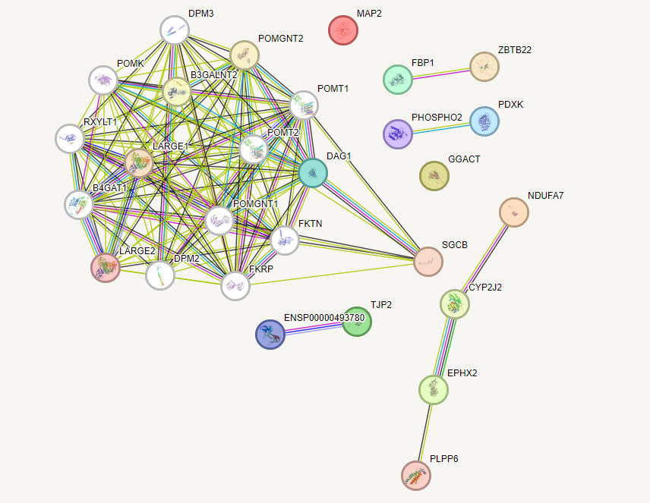
Protein–protein interaction network of glomerular proteins differentially expressed in biopsies with Tervaert ≥2B lesions.

Supplemental Figure 5: Integration of Complement System and Mitochondrial Functions in Non-Glomerular Compartmentalization
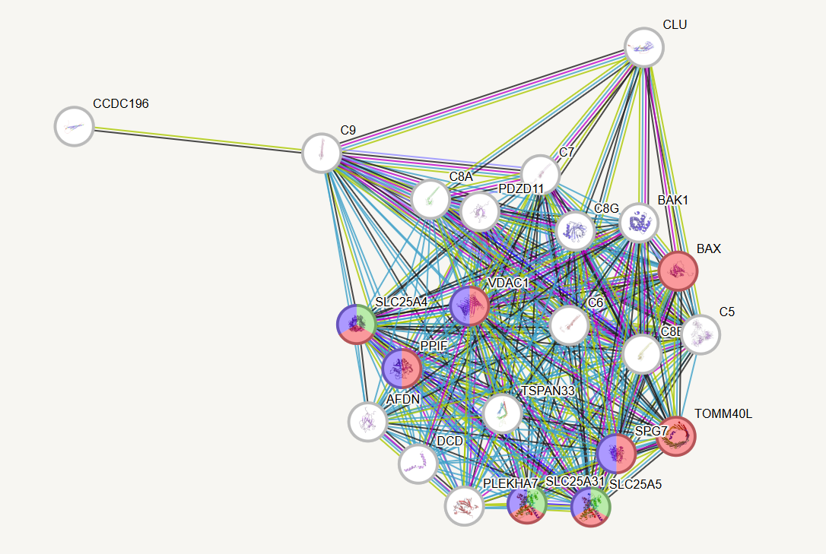
Network representation of interactions between key proteins involved in the complement system (e.g., C9, C8A, CLU) and mitochondrial-associated complexes (e.g., Mitochondrial permeability transition pore complex, ADP/ATP carrier protein, and Mitochondrial membrane proteins such as VDAC1 and BAX). This figure highlights the intersection of complement-mediated processes and mitochondrial dynamics within the non-glomerular compartment, suggesting a potential link between complement activation and mitochondrial dysfunction in disease contexts.
Supplemental Figure 6: Interaction Network of the Pyruvate Dehydrogenase (PDH) Complex and Regulatory Proteins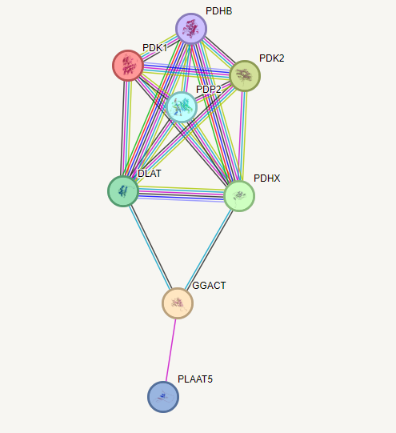
This STRING-derived network highlights the central PDH complex components (PDHB, DLAT, PDHX, and PDP2) and their strong interconnectivity

Supplemental References
1. Denic A, Morales MC, Park WD, Smith BH, Kremers WK, Alexander MP, et al. Using computer-assisted morphometrics of 5-year biopsies to identify biomarkers of late renal allograft loss. Am J Transplant. 2019.
2. Denic A, Bogojevic M, Subramani R, Park WD, Smith BH, Alexander MP, et al. Changes in Glomerular Volume, Sclerosis, and Ischemia at 5 Years after Kidney Transplantation: Incidence and Correlation with Late Graft Failure. J Am Soc Nephrol. 2023;34(2):346-58.
3. Weibel ER, Gomez DM. A principle for counting tissue structures on random sections. J Appl Physiol. 1962;17:343-8.
4. Elsherbiny HE, Alexander MP, Kremers WK, Park WD, Poggio ED, Prieto M, et al. Nephron hypertrophy and glomerulosclerosis and their association with kidney function and risk factors among living kidney donors. Clinical journal of the American Society of Nephrology : CJASN. 2014;9(11):1892-902.
5. Denic A, Rule AD, Park WD, Smith BH, Mejia MV, Kukla A, et al. IFTA Foci Density: An Unrecognized Highly Prognostic Measurement of Fibrosis in Kidney Transplant Biopsies. Kidney360. 2024;5(9):1341-9.
6. Denic A, Buglioni A, Turkevi-Nagy S, Mejia VM, Smith HB, Park DW, et al. Mesangial Expansion by Morphometry at 5 y After Kidney Transplantation: Incidence, Risk Factors, and Association With Graft Loss. Transplantation Direct. 2024;10(7):e1652.
7. Kukla A, Alexander MP, Turkevi-Nagy S, Merzkani M, Park W, Smith B, et al. Mesangial expansion at 5 years predicts death and death-censored graft loss after renal transplantation. Clinical transplantation. 2021;35(1):e14147.
8. Denic A, Alexander PM, Kaushik V, Lerman OL, Lieske CJ, Stegall DM, et al. Detection and Clinical Patterns of Nephron Hypertrophy and Nephrosclerosis Among Apparently Healthy Adults. American Journal of Kidney Diseases. 2016;68(1):58-67.

