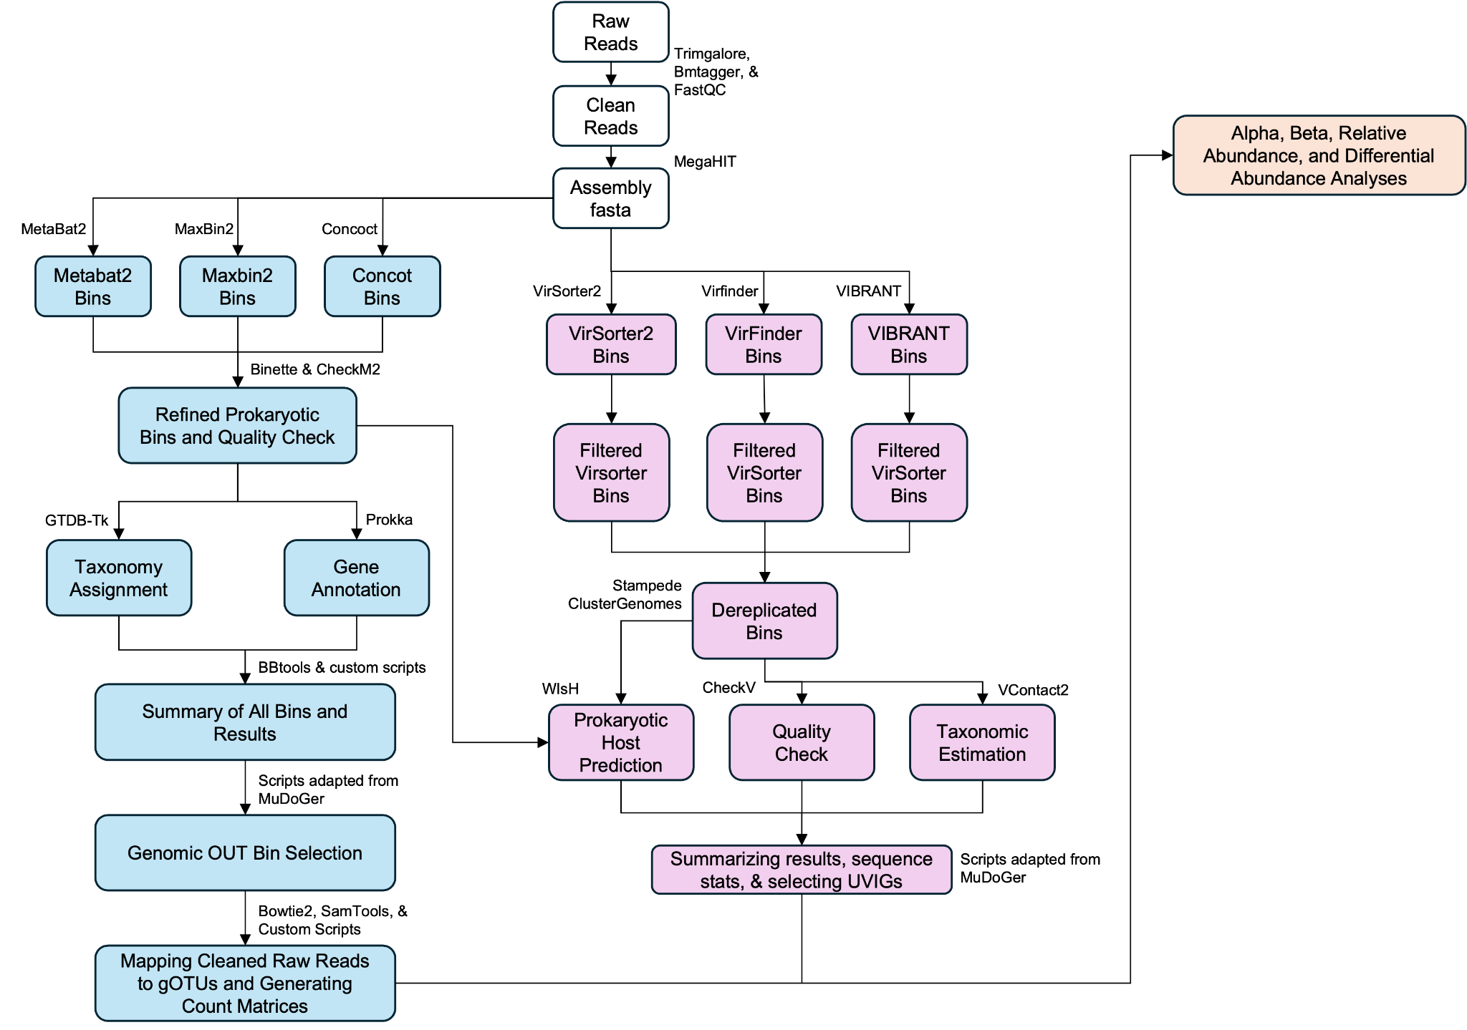
Supplementary Figure 1: Schematic diagram of bioinformatic pipeline used to generate metagenome assembled genomes (MAGs) for prokaryotes (pMAGS) and DNA viruses (vMAGS). White boxes = general raw read quality control and initial assembly generation. Blue boxes = pMAG pipeline. Purple boxes = vMAG bioinformatic pipeline. Orange box = Downstream R and RStudio analysis of pMAGs and vMAGs.

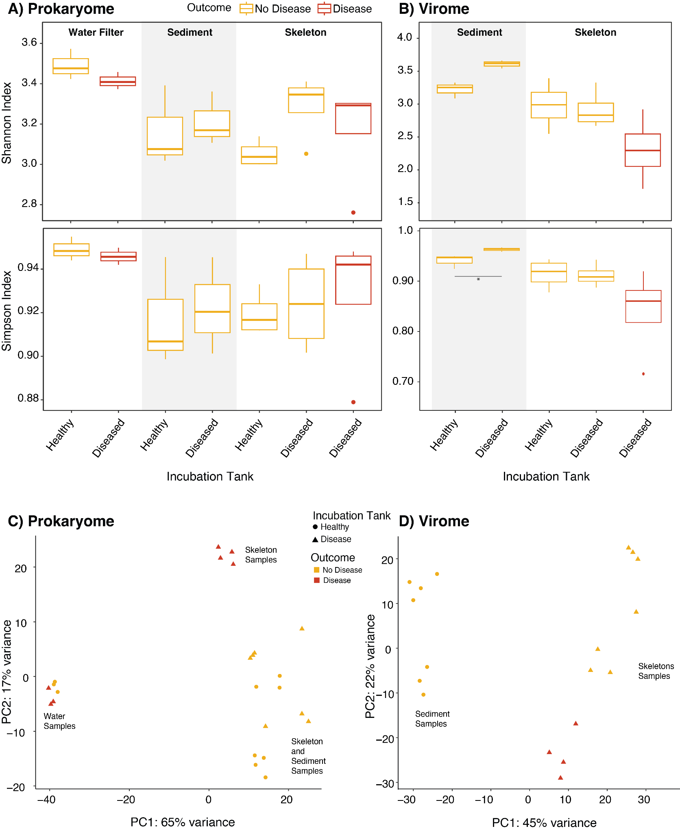

Supplemental Figure 2: A) Prokaryotic and B) viral alpha diversity (Shannon and Simpson) across substrate types: water filters (0.22um), sediment and skeleton, showing the experiment outcome (no disease or disease transmission). C) pMAG beta diversity principle components analysis plotting bray-curtis similarity across water, skeleton, and sediment samples. D) vMAG beta diversity plotting bray-curtis similarity across sediment and skeleton samples. For C) and D), shapes are the abiotic substrate incubation tanks (circle = healthy tank, triangle = disease tank), and colours are disease outcome (yellow = no disease transmission, red = successful disease transmission).

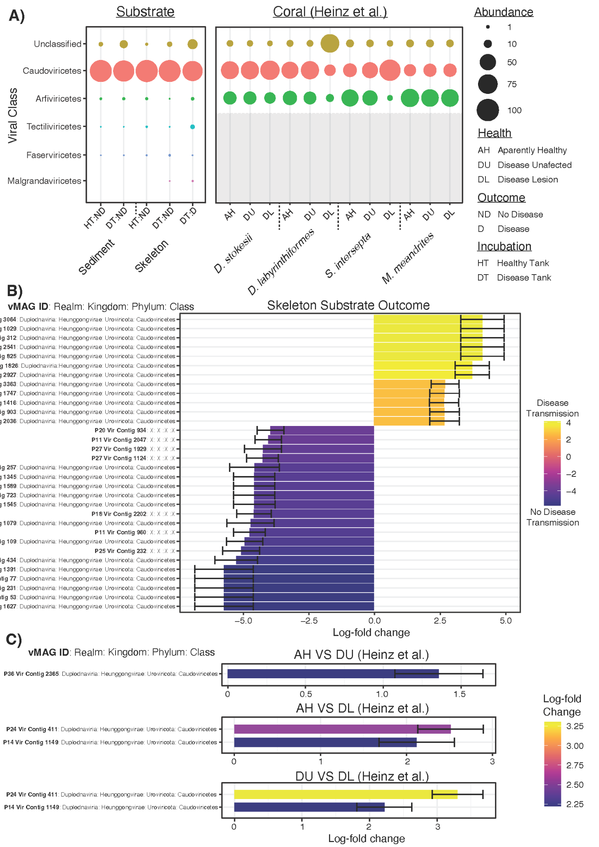
Supplementary Figure 3: (A) Viral community composition bubble plots showing vMAGs on the y-axis and substrate types (sediment and skeleton, including Heinz et al. 2024 coral samples from the species Diploria labyrinthiformis, Dichocoenia stokesii, Meandrina meandrites, Stephanocoenia intersepta) on the x-axis. The size of the bubble represents relative abundance, where the middle circle is the mean, the darkest circle is the lower bound standard deviation and the lighter circle represents the upper bound. (B) Differential abundance (ANCOM-BC) waterfall plot of skeleton outcome disease transmission compared to no disease transmission, where vMAG viral taxonomy is presented on the y-axis and log-fold change is represented on the x-axis. (C) Differential abundance waterfall plots for coral samples (Heinz et al. 2024) showing the vMAGs on the y-axis and the log2-fold change on the x-axis across the following comparisons: Apparently healthy (AH) vs. Diseased unaffected (DU); AH vs. Disease lesion (DL); and DU vs. DL.

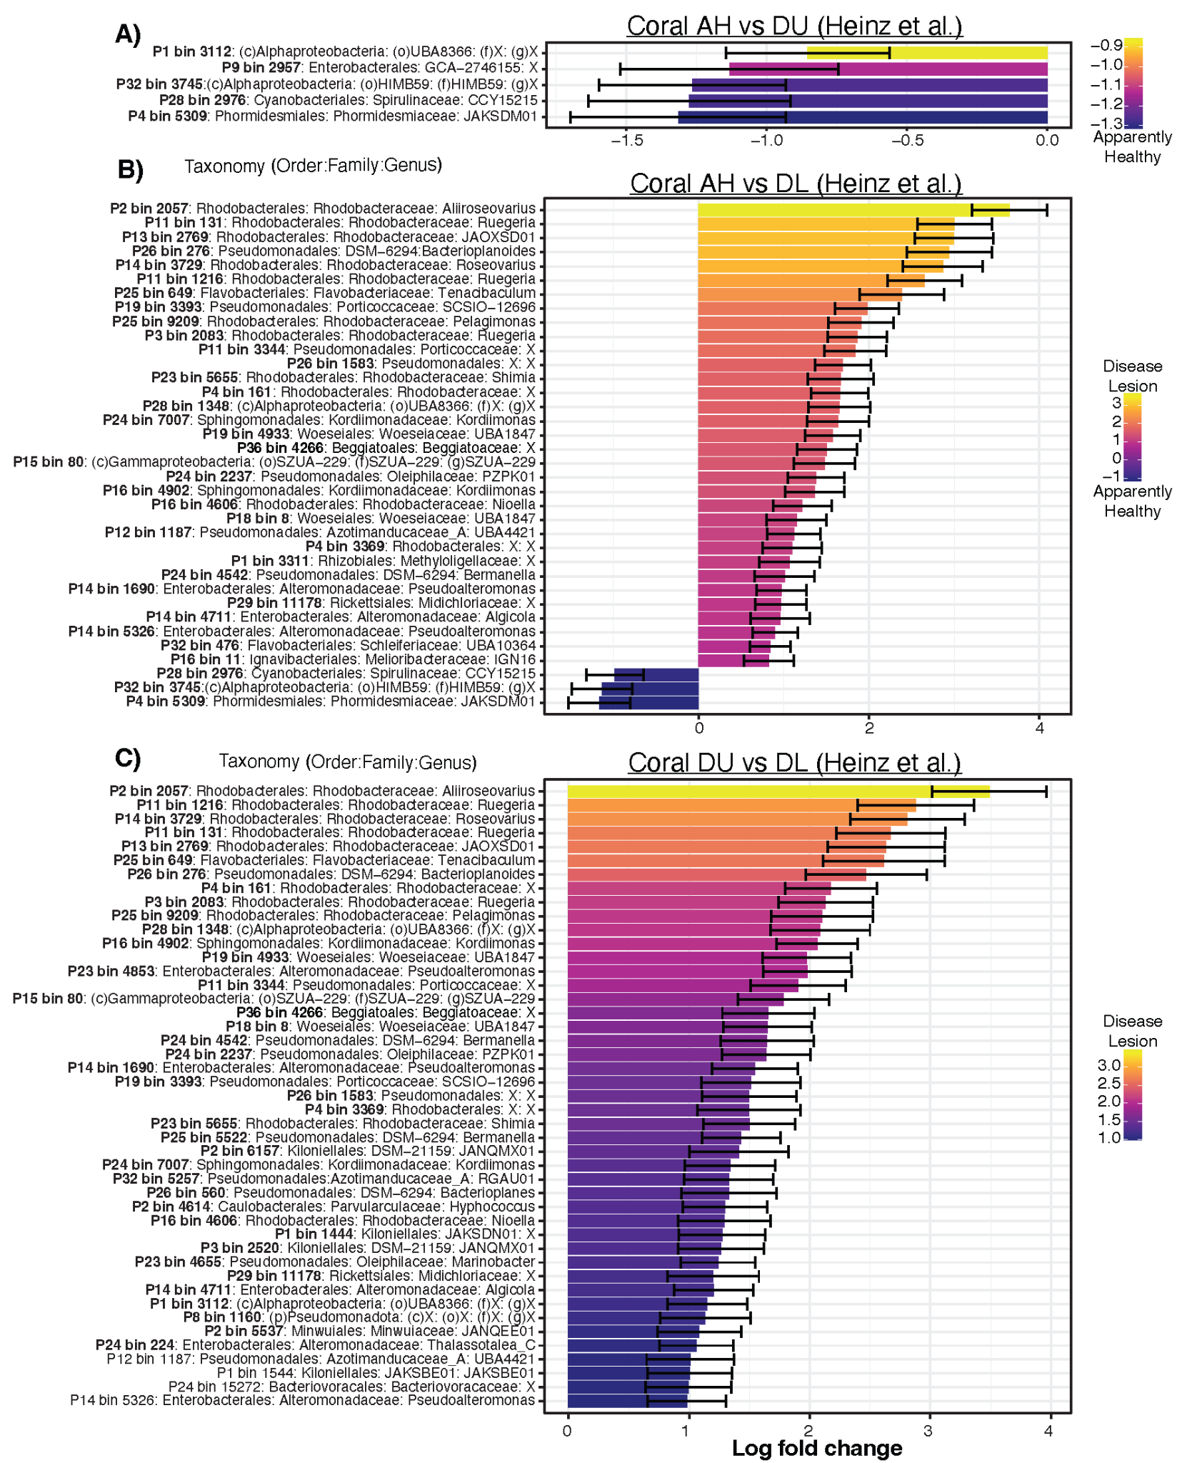
Supplemental Figure 4: (A-C) Differential abundance (ANCOM-BC) waterfall plots for pMAGs generated in this study and mapped to Heinz et al. (2024) coral data. Prokaryotic taxonomies (Order, Family, Genus) are listed on the y-axis and the Log-fold change is represented on the x-axis. (A) All apparently healthy (AH) coral samples compared to the disease unaffected (DU) samples. (B) Apparently healthy coral samples compared to disease lesion (DL), and (C) disease unaffected compared to disease lesion corals.

Supplementary File 1: List of pMAGs generated in this study, including their taxonomic string
Supplementary File 2: List of VMAGs generated in this study, including their taxonomic string
Supplementary File 3: pMAG differential abundance analyses results for this study and from Heinz et al. (2024).
Supplementary File 4: vMAG differential abundance analyses results for this study and from Heinz et al. (2024).

