Experimental Section
Solvents and reagentes were purchased from Aldrich and used as received. ¹H and ¹³C NMR spectra were recorded on a Bruker Avance III HD 400 spectrometer, equiped with BBO 5mm probe with z gradients (¹H NMR: 400 MHz; ¹³C NMR: 101 MHz).

1-Ethyl-2-(4-hydroxyphenyl) imidazole: Ethylamine (70% aqueous solution) (6.80 g; 105.0 mmol) was added at room temperature to a solution of 4-hydroxy benzaldehyde (12.2 g; 100.0 mmol) dissolved in methanol (75 mL) in a reaction flask. During the addition, the temperature rises gradually to 40 °C. The corresponding imine precipitated and the resulting suspension was stirred for an additional 10 min. After this time, ammonium carbonate ((NH₄)₂CO₃ 65.6%, 7.75 g; 53.0 mmol) was added in one single portion. Glyoxal (40% aqueous solution) (14.50 g; 100.0 mmol) dissolved in methanol (15 mL) was added dropwise, under stirring and holding the temperature at 40 °C. Carbon dioxide evolved during this last addition and the desired 1-ethyl-2-(4-hydroxyphenyl) imidazole precipitated. After the addition, the reaction mixture was stirred for an additional 30 min, maintaining the temperature at 40 °C. Then, ice-cold water (50 mL) was added to the reaction mixture previously cooled to 10 °C with an ice/water bath. The resulting light amber crystals were filtered on a Büchner funnel, washed with an ice-cold 1:2 methanol/water mixture (40 mL) and dried at room temperature. Yield: 6.60 g; 35.0 %. ¹H NMR (400 MHz, DMSO-d₆) δ: 7.37 (d, J = 8.8 Hz, 2H); 7.23 (d, J = 1.2 Hz, 1H); 6.93 (d, J = 1.2 Hz, 1H); 6.85 (d, J = 8.8 Hz, 2H), 3.97 (q, J = 7.2 Hz, 2H); 1.26 (t, J = 7.2 Hz, 3H). ¹³C NMR (100 MHz, DMSO-d₆) δ: 157.8, 146.7, 130.0, 127.5, 121.7, 120.5, 115.5, 41.2, 16.3.

1-Ethyl-3-methyl-2-(4-hydroxyphenyl) imidazolium iodide: 1-Ethyl-2-(4-hydroxyphenyl) imidazole (85.8 g, 456.4 mmol) was added to a reaction flask followed by acetonitrile (250 mL). The reaction mixture was stirred and heated to 70 °C and iodomethane (78.0 g, 547.7 mmol), diluted in acetonitrile (15 mL), was added dropwise over 50 min. After the addition, the reaction flask remained under stirring with heating at 70 °C for another 1 h. The reaction mixture was cooled with an external ice bath and ice-cold ethyl acetate (250 mL) was added to the flask in order to crystallize the product. The solid contents of the flask were filtered on a Büchner funnel, and the resulting crystals were washed with a few mililiters of ice-cold ethyl acetate. The product was obtained as pale amber crystals. Yield: 144.9 g; 96.2 %. ¹H NMR (400 MHz, DMSO-d₆) δ: 10.43 (s,1H); 7.92 (d, J= 2.0 Hz, 1H); 7.86 (d, J= 2.0 Hz, 1H); 7.54 (d, J= 8.8 Hz, 2H); 7.01 (d, J= 8.8 Hz, 2H); 3.99 (q, J= 7.2 Hz, 2H); 3.64 (s, 3H); 1.28 (t, J= 7.2 Hz, 3H). ¹³C NMR (100 MHz, DMSO-d₆) δ: 160.6, 144.2, 132.0, 123.08, 120.9, 116.2, 110.9, 43.4, 35.3, 14.9.

1 Ethyl-3-methyl-2-(4-oxyphenyl) imidazolium zwitterionic salt: 1-Ethyl-3-methyl-2-(4-hydroxyphenyl) imidazolium iodide (143.9 g; 436 mmol) was mixed in a beaker with distilled water (80 mL) and Ambersep 900 OH ion exchange resin (0.8 meq. OH⁻/mL; 600 mL; 480 meq OH⁻), previously washed with distilled water to pH 8. The resulting suspension was magnetically stirred at room temperature for 10 min. The iodide/hydroxide exchange in the aqueous solution was confirmed by performing a negative qualitative iodide test (sodium nitrite/sulfuric acid) on a small sample. The reaction mixture was filtered through a Büchner funnel and the resin was washed with water (350 mL). The combined filtrate solutions were evaporated under reduced pressure, resulting in a slightly yellowish solid. Yield: 79.9 g, 90.5 %. ¹H NMR (400 MHz, dmso-d₆) δ: 7.73 (d, J= 2.0 Hz, 1H); 7.66 (d, J= 2.0 Hz, 1H); 6.96 (d, J= 8.8 Hz, 2H); 6.15 (d, J= 8.8 Hz, 2H); 4.01 (q, J= 7.2 Hz, 2H); 3.65 (s, 3H); 1.31 (t, J= 7.2 Hz, 3H). ¹³C NMR (101 MHz, dmso-d₆) δ: 175.51, 147.41, 130.86, 122.04, 119.82, 119.75, 94.87, 43.08, 35.40, 14.99.

1-Methyl-3-benzyl-2-(4-hydroxyphenyl) imidazolium bromide: 1-Methyl-2-(4-hydroxyphenyl) imidazole (1.74 g; 10.0 mmol) was added to a round bottomed flask followed by acetonitrile (10 mL) and benzyl bromide (1.71 g; 10.0 mmol). The resulting suspension was stirred with heating at 75ºC for 1h, where gradual solubilization of the imidazole occurred. The resulting final solution was cooled to room temperature and after 24h the resulting crystals were filtered. The crude product obtained was recrystallized with acetonitrile yielding light straw-colored crystals. Yield: 2.40 g, 69.5 %. ¹H NMR (400 MHz, D₂O) δ: 7.64 (d, J = 2.2 Hz, 1H); 7.57 (d, J = 2.2 Hz, 1H); 7.39 (d, J = 8.8 Hz, 2H); 7.36-7.33 (m, 3H); 7.10 (d, J = 8.8 Hz, 2H); 7.09-7.06 (m, 2H); 5,18 (s, 2H); 3.76 (s, 3H). ¹³C NMR (101 MHz, D₂O) δ: 159.6, 145.3, 134.1, 132.2, 129.2, 128.8, 127.7, 123.3, 122.0, 116.6, 112.2, 52.0, 35.6.

1,3-Dimethyl-2-(4-hydroxyphenyl) imidazolium chloride: 1,3-dimethyl-2-(4-oxyphenyl) imidazolium zwitterionic salt (1.88 g, 10.0 mmol) was dissolved in aqueous hydrochloric acid (1.003N, 10.0 mL) and the resulting solution was evaporated under reduced pressure to dryness, yielding colorless crystals. Yield: 2.13g, 95.0 %. ¹H NMR (400 MHz, dmso-d6) δ: 7.88 (s, 2H); 7.55 (d, 2H, J= 8.8 Hz); 7.10 (d, 2H, J= 8.8 Hz); 3.69 (s, 6H). ¹³C NMR (101 MHz, dmso-d6) δ: 161.0, 144.7, 132.2, 122.9, 116.3, 110.7, 35.7.

1-Dodecyl-2-(4-hydroxyphenyl) imidazole: To a round bottomed reaction flask was added 4-hydroxybenzaldehyde (2.44 g; 20.0 mmol), methanol (30 mL) and n-dodecylamine (3.70 g; 20.0 mmol). The reaction mixture gradually warmed to about 40 °C, the corresponding imine precipitated and the resulting suspension was heated under reflux for an additional 30 minutes. After this time, the reaction mixture was cooled to 40 °C and ammonium carbonate ((NH4)₂CO₃ 65.6%, 1.46 g; 10.0 mmol) was added all at once. Glyoxal (40% aqueous solution, 2.90 g; 20.0 mmol) was then added dropwise while stirring and maintaining the temperature at 40 °C. Carbon dioxide evolved during this last addition. After the addition, the reaction mixture was stirred for an additional 30 minutes, maintaining the temperature at 40 ºC. Afterwards, water (100 mL) was added to the reaction solution and the reaction product was extracted with dichloromethane (3 x 20 mL). The combined organic extracts were dried over anhydrous magnesium sulfate and the solvent was evaporated. The crude product was subjected to chromatographic separation (silica gel column, elution solvents: hexane/ethyl acetate 60/40 and then ethyl acetate). R_{f} of the product: 0.57 (ethyl acetate). Yield: 2.12 g, 32.0%. ¹H NMR (400 MHz, CDCl₃) δ: 7.21 (d, J = 8.8 Hz, 2H); 7.09 (d, J = 1.6 Hz, 1H); 6.96 (d, J = 1.6 Hz, 1H); 6.70 (d, J = 8.5 Hz, 2H), 3.91 (t, J = 7.2 Hz, 2H); 1.75 – 1.65 (m, 2H); 1.35 – 1.15 (m, 18 H); 0.87 (t, J = 6.8 Hz, 3H). ¹³C NMR (101 MHz, CDCl₃) δ: 159.4, 148.2, 130.2, 126.6, 119.4, 116.0, 46.7, 31.9, 30.9, 29.6, 29.5, 29.4, 29.3, 29.0, 26.5, 22.6, 14.1

1-Dodecyl-3-methyl-2-(4-hydroxyphenyl) imidazolium iodide: To a round bottomed reaction flask was added 1-dodecyl-2-(4-hydroxyphenyl) imidazole (1.40 g, 4.3 mmol), ethyl acetate (5 mL) and iodomethane (0.80 g, 5.7 mmol). The content of the reaction flask was heated at 70 °C for 2 hours with stirring. After this time, the reaction mixture was placed overnight in the freezer, which induced crystallization of the reaction product. This was filtered and recrystallized once more from ethyl acetate, which provided straw-colored crystals. Yield: 1.44 g, 71.8 %. ¹H NMR (400 MHz, CDCl₃) δ: 7.69 (d, J = 2.0 Hz, 1H); 7.54 (d, J = 2.0 Hz, 1H); 7.37 (d, J = 9.0 Hz, 2H); 7.32 (d, J = 9.0 Hz, 2H), 3.99 (t, J = 7.4 Hz, 2H); 3.77 (s, 3H); 1.75 – 1.65 (m, 2H); 1.28 – 1.10 (m, 18 H); 0.79 (t, J = 6.8 Hz, 3H). ¹³C NMR (101 MHz, CDCl₃) δ: 160.9, 145.2, 131.6, 123.4, 121.2, 117.4, 110.3, 49.1, 36.7, 31.7, 29.9, 29.4, 29.3, 29.2, 29.1, 28.7, 26.1, 22.5, 13.9

¹H-NMR and ¹³C NMR spectrum for compounds:

Figure S1: ¹H NMR (400 MHz, dmso-d₆); 1-ethyl-2-(4-hydroxyphenyl) imidazole.

Figure S2: ¹³C NMR (101 MHz, dmso-d₆); 1-ethyl-2-(4-hydroxyphenyl) imidazole.

Figure S3: ¹H NMR (400 MHz, dmso-d₆) 1-ethyl-3-methyl-2-(4-hydroxyphenyl) imidazolium iodide.

Figure S4: ¹³C NMR (101 MHz, dmso-d₆) 1-ethyl-3-methyl-2-(4-hydroxyphenyl) imidazolium iodide.

Figure S5: ¹H NMR (400 MHz, dmso-d₆) 1-ethyl-3-methyl-2-(4-oxyphenyl) imidazolium zwitterionic salt.

Figure S6: ¹³C NMR (101 MHz, dmso-d₆) 1-ethyl-3-methyl-2-(4-oxyphenyl) imidazolium zwitterionic salt.

Figure S7: ¹H NMR (400 MHz, D₂O) 1-methyl-3-benzyl-2-(4-hydroxyphenyl) imidazolium bromide.

Figure S8: ¹H NMR (400 MHz, D₂O, expansion) 1-methyl-3-benzyl-2-(4-hydroxyphenyl) imidazolium bromide.

Figure S9: ¹³C NMR (101 MHz, D₂O) 1-methyl-3-benzyl-2-(4-hydroxyphenyl) imidazolium bromide.

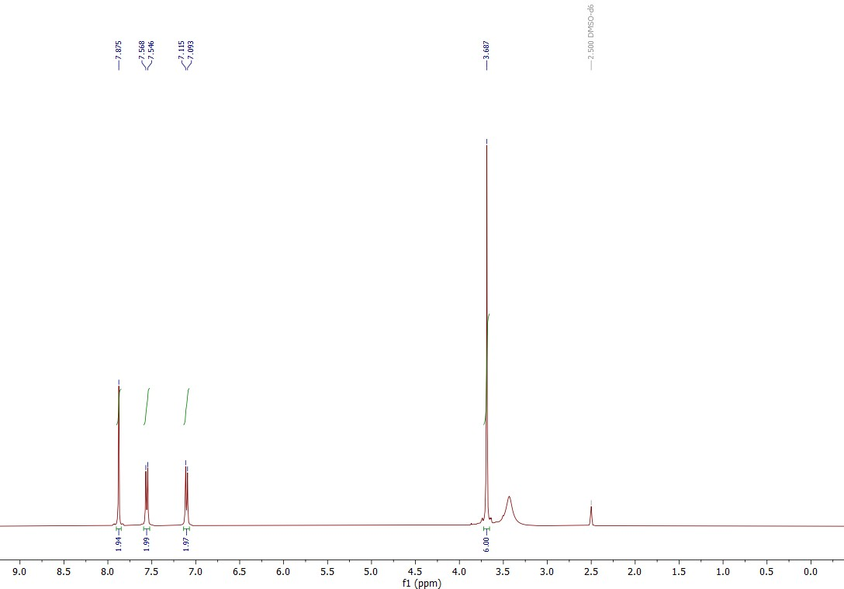
Figure S10: ¹H NMR (400 MHz, dmso-d₆) δ: Synthesis of 1,3-dimethyl-2-(4-hydroxyphenyl) imidazolium chloride.

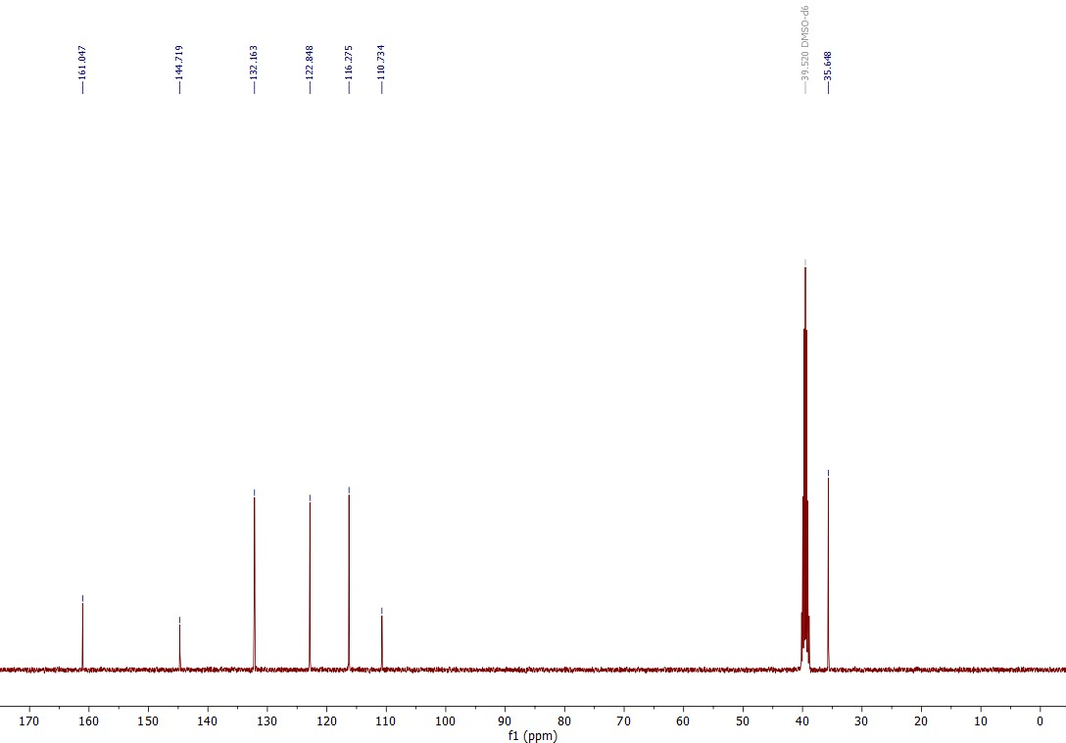
Figure S11: ¹³C NMR (101 MHz, dmso-d₆) δ: Synthesis of 1,3-dimethyl-2-(4-hydroxyphenyl) imidazolium chloride.

Figure S12: ¹H NMR (400 MHz, CDCl₃); 1-dodecyl-2-(4-hydroxyphenyl) imidazole.

Figure S13: ¹³C NMR (101 MHz, CDCl₃); 1-dodecyl-2-(4-hydroxyphenyl) imidazole

Figure S14: ¹H NMR (400 MHz, CDCl₃) 1-dodecyl-3-methyl-2-(4-hydroxyphenyl) imidazolium iodide.

Figure S15: ¹³C NMR (101 MHz, CDCl₃) 1-dodecyl-3-methyl-2-(4-hydroxyphenyl) imidazolium iodide.

Figure S16: ¹³C NMR (101 MHz, CDCl₃, expansion); 1-dodecyl-3-methyl-2-(4-hydroxyphenyl) imidazolium iodide.

