Table 1.
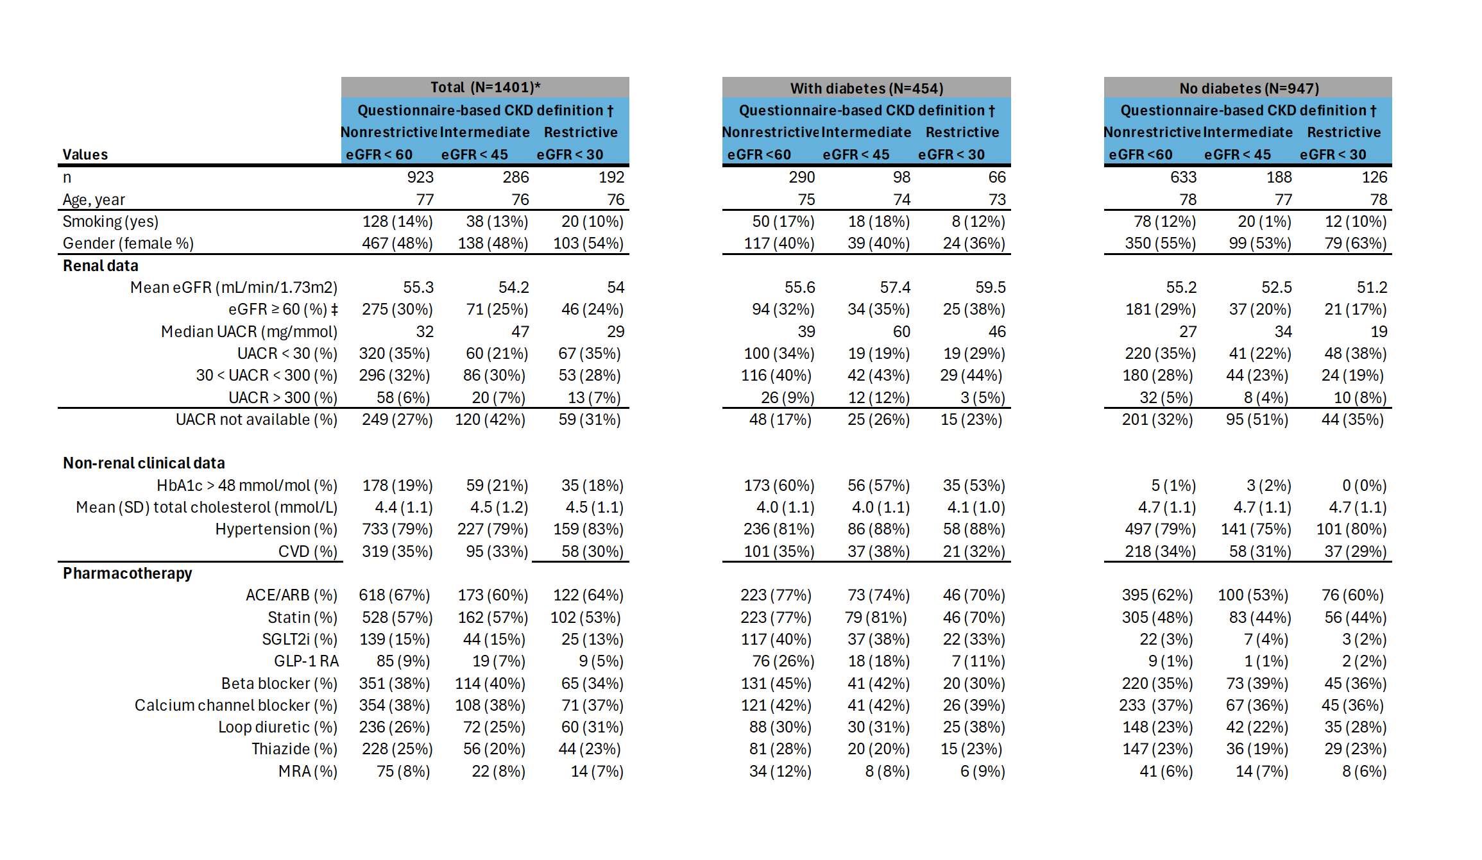

Footnotes to Table 1:
* Of the original 1497 patients in ATLAS, 96 patients from 10 clinics were excluded because the physician response to this question was missing or did not correspond to the three specified groups.
† Patients were allocated to one of the three diagnostic practice groups based on the response of their clinic’s physician representative to Question#4 of the previously described questionnaire (see Supplemental Data in Ref. ⁴), namely “What criteria do you use to diagnose CKD in a patient?”. Physicians could endorse different eGFR values as the threshold for diagnosis of CKD, corresponding to the Nonrestrictive, Intermediate and Restrictive thresholds shown here.
‡ Most recent measurement. Note that patients were included in ATLAS based on evidence in their medical records showing ≥1 eGFR value below 60 mL/min/1.73 m2 and/or ≥1 measurement of UACR above 30 mg/g.

