Supplementary information

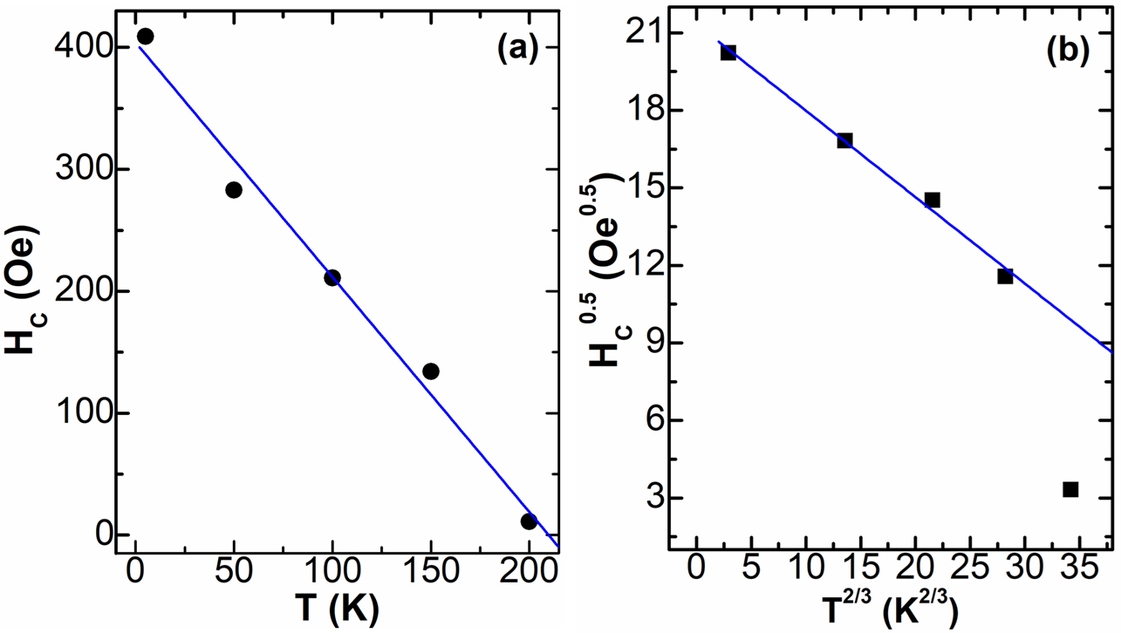

Fig. SI-1: (a) The weak domain wall model fitting given by $H_{C}\left(T\right)=H_{0}\left(1-\frac{T}{T_{0}}\right)$. (b) The strong domain wall model fitting given by $\sqrt{H_{C}}\left(T\right)=H_{0}\left[1-{\left(\frac{T}{T_{0}}\right)}^{2/3}\right]$. In both the figures, the symbols are the experimental data points, and the solid line is the best fit using the above equation.

Fig. SI-2: (a) and (b) show the magnetic field dependence of the magnetoresistance of the as-grown film and annealed film, respectively. The MR has been calculated using the formula $MR\left(\%\right)=\frac{ρ_{0}-ρ_{H}}{ρ_{0}}×100$. Figure (c) shows the variation of the room temperature MR with applied magnetic field. The magnetic field dependence of the peak MR of the two films is plotted in (d). The MR behaviour of the annealed films is far superior to the as-grown film.

